Shallow cumulus clouds decrease in proportion to tropical overturning circulation

Notes
The hypothesis for explaining shallow cumulus clouds is called the Dynamical Moisture (DiM) cloud equilibrium, choosing the mnemonic acronym because the reduction of clous dims the planetary albedo.
This behavior should be found in climate models. The hypothesis provides a way to narrow the expected spread of climate feedbacks from climate models. We should be able to look at climate feedbacks in models and say which of them is consistent. Models that are inconsistent with the DiM hypothesis require further explanation.
An-Yi is downloading ISCCP cloud fraction, cumulus mass flux (cm), and mean vertical velocity variables from amip (historical) and amip-p4k (historical SST + 4 K) from the 5 models where they are available in the CMIP6/CFMIP archive.

Abstract
Shallow cumulus clouds affect Earth’s planetary albedo and cloud feedback, and explain climate model sensitivity to atmospheric CO$​_{2}$. Previous studies have proposed that increased vertical mixing reduces cloud area by desiccating the relative humidity of the shallow cumulus layer. In a recent experiment, mass flux rather than humidity explains mesoscale cloud area, refuting the desiccation hypothesis. Models that reproduce this mesoscale correlation have weaker climate sensitivity. Here, we model the shallow cumulus cloud mass flux, with clouds whose moisture flux balances the drying of the shallow cumulus regime by the large-scale tropical atmospheric overturning circulation. This moisture balance predicts shallow cumulus clouds decrease with warming in proportion to the large scale circulation (about -5 % K⁻¹ by energetics). Matching the observed moisture budget and cloud top height distribution, the cloud model independently reproduces the mesoscale correlation of cloud fraction to cloud base mass flux previously found over the northeastern tropical Atlantic Ocean in EUREC4A.

Abstract - alternate ideas

Sensitivity of climate models to doubling CO2 has been explained by shallow cumulus cloud feedback. It has been proposed that increased vertical mixing reduces cloud fraction by desiccating the relative humidity of the shallow cumulus layer, yet models that reproduce the observed mesoscale correlation of cloud fraction to cloud-base mass flux have weaker cloud feedbacks, suggesting their clouds are relatively insensitive desiccation by mixing. Here we calculate shallow cumulus cloud feedback that results as shallow cumulus clouds decrease their moisture flux to compensate reduced drying by the large-scale circulation, which decreases about 5 % K–1 by energetic constraints. The proportionality to the humidity of both the cloud moisture flux and the large-scale drying suggests the clouds are insensitive to changes of humidity. Local differences in shallow cloud feedback among different climates can be explained by differences in their Hadley circulation and differences in changes of the ratio of cloud albedo to cloud mass flux.
Model cloud moisture and top height depend on the rate that clouds lose water to entrainment and precipitation. The cloud top height distribution is matched to satellite observations.

Introduction
The shallow cumulus regime has a mean cloud fraction of YY % and covers XX % of Earth’s oceans. It affects the climate, so that variation of shallow cumulus cloud feedback is the largest source of uncertainty in the climate sensitivity of climate models (Bony et al. 2005; Bony and Dufresne, 2006). Distinguishing the climate feedbacks due to changes the relative frequency of occurrence across regimes from cloud property changes within regimes, the largest mean climate feedback is the positive feedback due to reduction of shallow cumulus cloud amount within cloud regimes (Zelinka et al. 2025).
Sherwood et al. (2014) proposed that in a warmed climate, increased vertical mixing reduces cloud fraction by desiccating the shallow cumulus layer. Field observations from EUREC4A (Stevens et al. 2021; George et al. 2022) show clouds are correlated more strongly to mass flux than to relative humidity, challenging the importance of humidity and its desiccation by vertical mixing, and suggesting that vertical mixing processes are correlated with clouds (Vogel et al. 2022). Climate models that reproduce the observed mesoscale correlation of cloud fraction to cloud-base mass flux have weaker than average climate sensitivity (Vogel et al. 2022).
The mean moisture balance over shallow convective regions provides a way to physically infer the effect of climate change on the clouds, which can be used to understand mean climates of the shallow cumulus regime. In a steady climate, the moisture budget over the shallow cumulus regime is balanced. A change in the drying by the large scale circulation is thus compensated by the opposite moistening by the divergence of the shallow cumulus cloud eddy flux.
Here we model these cloud eddy fluxes for the large-scale circulation drying and observed clouds in the present climate [RESULT1]. The model assumes proportionality among cloud fraction, moisture flux, and mass flux in the climate average. Our modeled proportionality of mesoscale mass flux and cloud fraction is independently consistent with that observed in EUREC4A [RESULT2].
A reduction in equilibrium large scale tropical overturning circulation is expected in a warmed climate (Held and Soden 2006). Prescribing this reduced circulation to the cloud model shows the mean shallow cumulus mass flux and hence cloud fraction decreases in proportion to the reduction of the mean tropical circulation [RESULT3].
The Methods section describes the cloud ensemble model and observations used to tune it to the present climate.

Results
[Reorganize to sequentially show RESULTs 1-3]
Large scale mean drying is due to dry advection by horizontal $U$ and vertical $W$ wind by the descending branch compensating deep convection in the tropical overturning (Hadley) circulation. Because saturation specific humidity increases 7 % K⁻¹, and precipitation increases only 2 % K⁻¹, the tropospheric radiative-convective heat balance constrains the large scale tropical overturning ciruculation to about $dlnW=dlnU$ = 5 % per degree C of warming (Held and Soden, 2006). Subsidence in models approximately obeys this scaling.
In a balanced climate, moisture has no tendency. Thus, the large-scale advection $-W\left(∂q/∂z\right)$ and the divergence of the cloud moisture flux $-∂/∂z[M\left(q_{cld}-q_{env}\right)]$ moisture sources balance over a climatological season in the shallow cumulus cloud regime. Because clouds entrain and mix the environmental gradient, cloud and large-scale advective fluxes are both proportional to the humidity gradient. This factors out, leaving a proportionality between the large scale subsidence $W$ (and advection) and cloud mass flux $M$. This balance applies in the shallow cumulus regime to shallow cumulus clouds with tops below 4 km.
With a saturation humidity increase of $dlnq=$ 7 % K$​^{-1}$ and decrease $dlnF_{R}=dlnP=-2$ % K$​^{-1}$ of tropospheric radiative divergence and mean precipitation, energetic constraints decrease the mean tropical circulation $dlnW=dlnU=-5$ % K$​^{-1}$.
Here we evaluate the sensitivity of the mean cloud field to changes in its mean mass flux. The entrainment (and precipitation conversion) rates of an ensemble of plumes are tuned to match the observed environmental saturation- and specific humidity and the distribution of cloud top heights from satellites (Methods). The cloud ensemble moisture flux divergence balances large scale drying. Cloud fraction is assumed to be proportional to the mass flux.
A mass flux scheme for clouds estimates the mass flux for an ensemble of clouds with total moisture flux divergence constrained to balances large scale subsidence and advection drying, and with cloud top height distribution matches GOES satellite observations. The model generates cloud water and vertical velocity profiles for thousands of ~260x260 km² GOES satellite reflectance scenes. The mean mass flux binned as a function of scene mean reflectance is shown in Fig. REFLMASSFL. The resulting slope 2.4 % (mm s^{–1})⁻¹ [4.2 cm s⁻¹ %⁻¹] agrees with the correlations between cloud base mass flux and found from dropsonde circles in EUREC4A (Vogel et al. 2022). We use this proportionality between mass flux and reflectance to scale the response of shallow cumulus clouds to changes in the large scale circulation associated with climate.
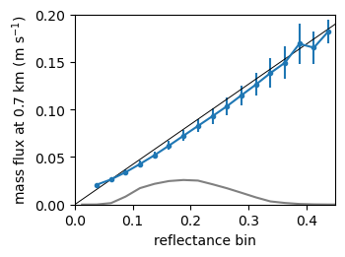
Figure REFLMASSFL. Modeled mean cloud base (700 m) mass flux for all scenes in each reflectance bin (blue points and whiskers). Black line shows a slope of
0.42 cm s^{–1} (% reflectance)^{–1}. Gray line shows relative number (10^{–5}) of scenes in each reflectance bin.

Data and Methods
Trade cumulus clouds are intermittent shallow convection in widespread regions of mean subsidence balancing deeper convection elsewhere. Water fluxes by the clouds are diagnosed to balance a simple vertical water budget for the trade cumulus cloud layer. The updraft area fraction is calculated over large (1000 km)² regions, assuming updraft cores are cloudy with saturated specific humidity. The horizontal-time ensemble mean trade cumulus water (vapor + liquid) flux due to updrafts and precipitation balances mean subsidence. Cloud mass flux is initialized at cloud base to match the mean observed surface evaporation minus precipitation.

Cloud ensemble $a_{i}(h_{i})$
We partition the all-sky mean eddy flux $G$ to the cloud categories $i$. Clouds with area fraction $a_{i}$ have cloud tops that reach $h_{i}$ as distributed in GOES satellite images (Fig. GOESCDF).
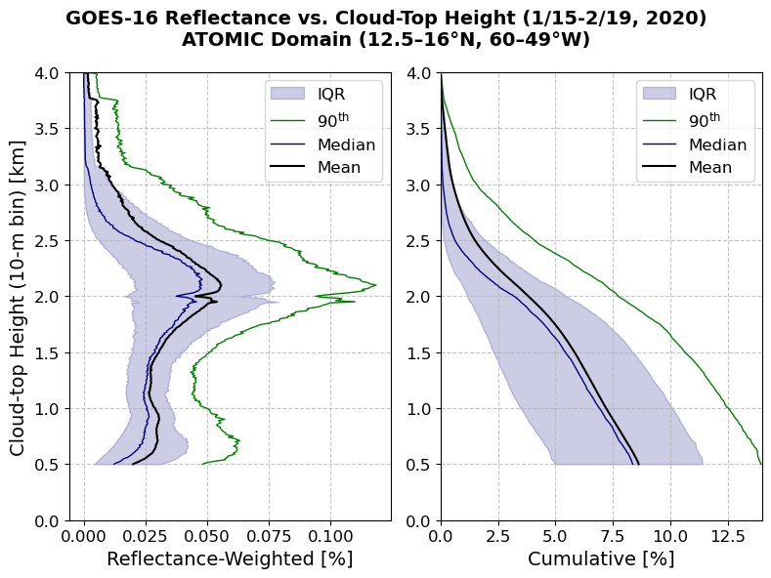
Figure GOESCDF. Vertical cumulative distribution of cloud area fraction.

Large scale eddy flux
The all-sky mean large scale eddy flux $G$ is the integral of the large-scale subsidence and horizontal advection source $S_{LS}$, with the cloud base moisture flux as the boundary condition:
$$G\left(z\right)=G_{CB}+G_{LS}\left(z\right),$$
with $G_{LS}\left(z\right)=\int_{z_{CB}}^{z}{S_{LS} dz'}$.
Partitioning the mass flux into the ensemble of clouds is an underconstrained problem. We close the problem by choosing vertically uniform flux in each cloud category $i$. The all-sky mean flux profile $G(z)$ has a flux difference at each height $h_{i}$ of ${\left(ΔG\right)}_{i}=G(h_{i+1})-G(h_{i})$. This flux difference is assumed to be carried by the clouds with area fraction $a_{i}$ and height $h_{i}$, so the mean flux in cloud category $i$ is vertically uniform, $F_{i}={a_{i}^{-1}\left(ΔG\right)}_{i}$. Fig. FEDDYMETHOD shows the distribution of fluxes $F_{i}$ to each height category. The cloud top height $h_{i}$ of each cloud is determined by its moisture sink rate parameter.
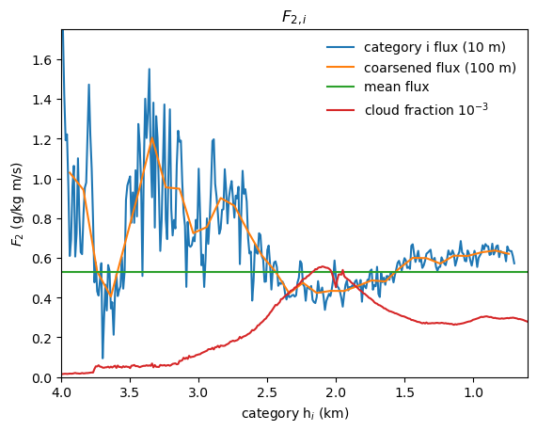
Figure FEDDYMETHOD. Vertically uniform cloudy-sky eddy flux $F_{2,i}$ from Method 2 at 10-m cloud top height $h_{i}$ resolution (blue), and 100-m resolution (orange). Mean flux over the cloud ensemble (green), weighted by cloud area fraction (red).

AMIP data
An-Yi is downloading ISCCP cloud fraction, cumulus mass flux (cm), and mean vertical velocity variables from CMIP6/CFMIP amip (historical) and amip-p4k (historical SST + 4 K) from 5 available models. Differences of the variables between amip-p4k and amip during January-February 1979-2014 in the North Atlantic shallow cumulus region (YY ° N, XX ° W) are used to compute the relative slopes $Δ\ln{C}, Δ\ln{W},$ and $Δ\ln{M}$ where $Δ$ is represents the difference per +1 K SST warming.

Model
From the diagnostic moisture closure, we compute the trade cumulus ensemble eddy flux $F_{i}\left(z\right)=F_{cld,i}\left(z\right)+F_{P,i}\left(z\right)$ due to cumulus updrafts and precipitation. Cloud updrafts are responsible for most of the eddy flux. A small part is contributed by precipitation. We will first model the water in the clouds, then their conversion to precipitation.

Clouds
A budget for steady total water $q_{T}$ in the updraft with velocity $w$ depends on its entrainment and precipitation sinks. The equations for the suspended liquid and water vapor in the cloud are
$$\frac{∂q_{l}}{∂t}=-w\frac{∂q_{l}}{∂z}-wγ-ϵwq_{l}-αwq_{l}$$and$$\frac{∂q_{v}}{∂t}=-w\frac{∂q_{v}}{∂z}+wγ-ϵw{(q}_{v}-q),$$
where $ϵ$ (km^{–1}) is the lateral entrainment coefficient, $α$ is the autoconversion of cloud liquid to precipitation, and $γ$ (<0) is the moist adiabatic condensation rate of water vapor (in a parcel) per unit height, $γ={\left(\frac{dq_{s}}{dz}\right)}_{m}=\left(\frac{dq_{s}}{dT}\right){\left(\frac{dT}{dz}\right)}_{m}.$ The dependence on this condensation rate is eliminated in the total cloud water balance equation. Summing the liquid and vapor, and taking the Eulerian total specific humidity $q_{T}$ to be steady,
$$\frac{∂q_{T}}{∂t}=0=-w\frac{∂q_{T}}{∂z}-ϵw{(q}_{T}-q)-αwq_{l}.$$QTBALANCEThough the total water is insensitive to the condensation rate $γ$, it implicitly depends on the saturation specific humidity $q_{s}$ in the cloud. The updraft advects moisture upwards, but the solution is quantitatively insensitive to the updraft velocity.
Above the cloud, $q_{l}=0$, so there is no autoconversion. Only entrainment relaxes humidity to that of the environment:
$$\frac{∂q_{T}}{∂z}=-ϵ\left(q_{T}-q\right).$$
In the cloud, $q_{l}=q_{T}-q_{s}$. Autoconversion removes cloud liquid, relaxing total water toward $q_{s}$, and entrainment relaxes total water toward $q$. Thus, equation QTBALANCE, written
$$\frac{∂q_{T}}{∂z}=-\left(ϵ+α\right)\left(q_{T}-\tilde{q}\right),$$QRELAXrelaxes at the total vertical sink rate $ϵ+α$, toward $\tilde{q}$. The intermediate humidity $\tilde{q}$ between $q$and $q_{s}$ is
$$\tilde{q}=(ϵq+αq_{s})/(ϵ+α)=\left(1-x\right)q+xq_{s}.$$QTILDE
The total sink rate $ϵ+α$ is a key parameter, which determines the cloud water, water flux, and cloud top height. Cloud liquid and water vapor profiles are computed for a handful of total sink rates in Fig. MOISTURECLOUDS.
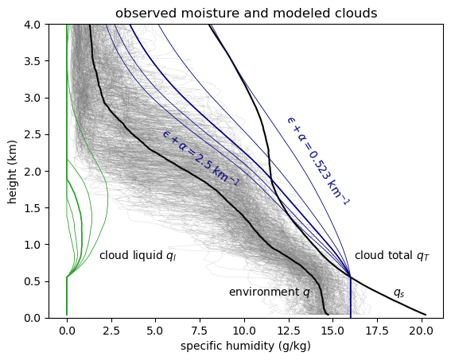
Figure MOISTURECLOUDS. Observed specific humidity from the ATOMIC Ron Brown radiosondes (gray), and their mean $q$ (black) and saturation specific humidity $q_{s}$. Cloud updraft total specific humidity $q_{T}$ (blue) and cloud liquid $q_{l}$ (green) for a range of total moisture sink rates $ϵ+α$ (entrainment and autoconversion coefficients, km^{–1}). Clouds transport moisture up, continuously diluting it toward a mixture between $q$ and $q_{s}$.
[ /home/deszoeks/Projects/ATOMIC/ATOMIC_GOES/julia/RHB/sonde/moisture_clouds.pdf ]
The profiles of $q_{T}$ predicted by this entraining-precipitating updraft model agree with the most humid air sampled on occasion by radiosondes. Cloud height is limited by entrainment of relatively dry air between 1.5-3 km, representing the mean distribution of the trade inversion. The clouds occupy a range of depths representative of trade cumulus clouds, with deeper clouds for lower rates of entrainment and autoconversion. The intermediate total sink rate of $ϵ+α=1.5 {km}^{-1}$ gives maximum cloud liquid specific humidity exceeding 0.8 g kg^{–1} over 0.7-1.5 km and cloud top height of 1.9 km.

Precipitation and updraft fluxes
Downward precipitation water flux within a cloud $F_{P}<0$ is generated by autoconversion $α$ from cloud liquid, For the updraft with no storage of cloud liquid water, the precipitation source is
$$-\frac{∂F_{P}}{∂z}=-αwq_{l}=xw\left(\frac{∂q_{l}}{∂z}+γ\right),$$where ($∂q_{l}/∂z+γ)$ is the total moisture source in the updraft. The ratio of the autoconversion to the total moisture sink $x=α/{(ϵ+α})$ is the precipitation efficiency.
The solution for each cloud type $i$ is found by numerically integrating the precipitation. The precipitation sink,
$$\frac{∂F_{P,i}}{∂z}=α_{i}w_{i}q_{l,i},$$instantaneously removes liquid water from the cloud and the column.
An example of the all-sky fluxes is computed for a single cloud with, $ϵ+α=1.5 {km}^{-1}$, $h=1.9$ km and all-sky cloud-base flux $G(z_{CB})=$ 145 W m^{–2} $=6.0×{10}^{-5}$ kg m^{–2} s^{–1} (Fig. QMASSFLX). For this case, $F$ goes to zero at 8 km. Precipitation increases downward below the cloud top. At a precipitation efficiency of ~0.5, the cloud-base precipitation $P_{CB}=|F_{P}|$ equals the mean surface precipitation, $P_{0}=$25 W m^{–2} $=9.0×{10}^{-6}$kg m^{–2} s^{–1}, observed on the research vessel Ron Brown during EUREC4A/ATOMIC. Evaporation was $E_{0}=$ 180 W m^{–2} $=6.5×{10}^{-5}$ kg m^{–2} s^{–1}. The mass flux is $M=G_{cld}/(q_{T}-q)$(Fig. QMASSFLX). Most of the flux (~90 %) is below 3 km in the trade cumulus layer. Most of the updraft moisture $q_{T}$ is vapor, and the moist updraft $q_{T}-q>0$ generates upward moisture flux, even above the cloud.
Fig. QMASSFLX is a simulation for a single cloud. The distribution of cloud top heights and the total water fluxes are used to constrain an ensemble of clouds at constant precipitation efficiency and varying sink rates ${\left(ϵ+α\right)}_{i}$.
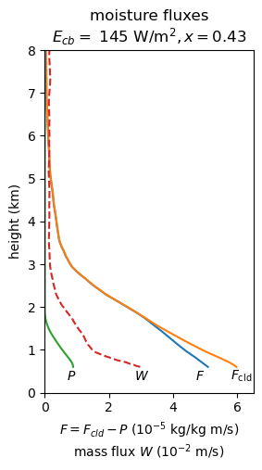
Figure QMASSFLX. Total moisture flux to balance the large-scale moisture sink (blue), cloud moisture flux (orange), and (downward) precipitation flux (green), and mass flux (red) from the model.
The cloud (a) total specific humidity and (b) cloud-environment humidity difference as a function of height and total sink rate parameter is shown for an ensemble of sink rates in Fig. WPROF. This is used to compute (c) cloud-mean vertical velocity for each cloud. The total mass flux is $M=∑a_{i}w_{i}$, where the total cloud area is $a=∑a_{i}$.

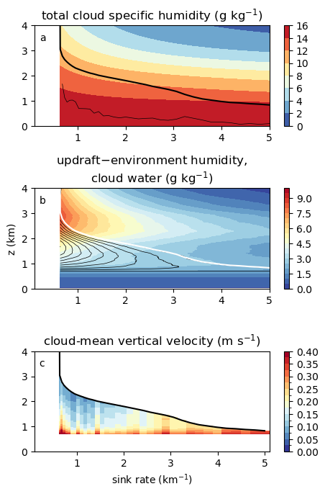
Figure WPROF. Modeled ensemble of clouds for precipitation efficiency $x=0.53$ as a function of total sink rate. (a) Cloud updraft total specific humidity $q_{T}$ (shaded), cloud top (thick black), and rescaled cloud area per unit sink rate (thin black); (b) cloud updraft total – environment specific humidity difference $q_{T}-q$ (shaded), and cloud liquid specific humidity $q_{l}$ (black contours); and (c) updraft vertical velocity.

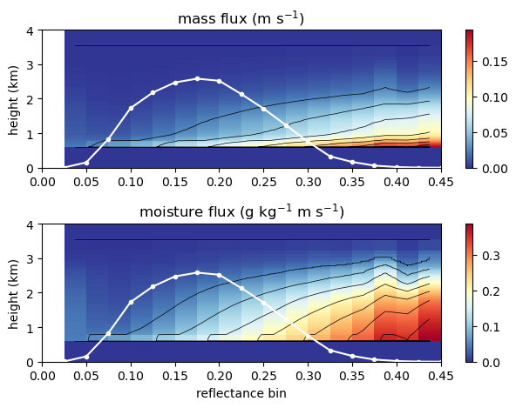
Figure MASSGFLUX. Model mass flux (a) and moisture flux (b) for 260$×$260 km^{–2} GOES scenes matching reflectance bins of 0-0.45, with precipitation efficiency $x=0.53$. White line shows the number (10^{–3}) of scenes in each 0.025 reflectance bin.

Cloud numerical solution
At each height and for each cloud category $i$,
$w_{i}q_{l,i}=F_{cld,i} q_{l,i}/(q_{T,i}-q)$ and $F_{cld,i}=F-F_{P_{i}}$. The precipitation equation is written in differential form as
$$dF_{P,i}=\frac{α_{i}q_{l,i}}{q_{T,i}-q}(F-F_{P,i}) dz.$$We integrate precipitation downward from the top of each cloud, $F_{P,i}\left(h_{i}\right)=0$, in trapezoidal vertical steps denoted by superscripts $k$,
$$F_{P,i}^{k}=-\frac{-\left(1+c_{i}^{k}\right)F_{P,i}^{k+1}+c^{k}F^{k}+c^{k+1}F^{k+1}}{1-c^{k}},$$where $c_{i}^{k}= {[α}_{i}q_{l,i}^{k} dz]/[2\left(q_{T,i}^{k}-q^{k}\right)]$.

Summary
[[For discussion on the compensation between cumulus and stratocumulus clouds: Myers and Norris (2014) show, all else being equal, subsidence reduces stratocumulus clouds. Cloud properties and within-regime feedbacks are similar between shallow cumulus and optically thicker stratocumulus clouds (Tselioudis et al., 2021; Zelinka et al. 2025), suggesting temperature-induced changes result in compensation between stratocumulus and shallow cumulus cloud types. Sherwood’s (2014) desiccation hypothesis describes a version of this competition, whereby shallow cumulus convection dries lower levels near cloud base that support stratocumulus clouds. Based on their similar behavior and feedbacks (Zelinka et al. 2025) we suggest considering the stratocumulus and shallow cumulus as a continuum. Regardless, here shallow cumulus clouds are nearly ubiquitous, to the exclusion of stratocumulus clouds, over the northern tropical Atlantic in January-February.]]

Appendix: buoyancy
The moisture flux constraint replaces a buoyancy closure for cloud model. The moisture closure is good for climate and seasonal time scales, but buoyancy should be used on weather time scales. Without doing anything to predict it, buoyancy in our cloud model is diagnosed from the density potential temperature $θ_{ρup}$ (i.e., “virtual temperature,” including the effect of the modeled water vapor and liquid water on density) of the entraining updraft parcel. The cloud height $h_{i}$ is comparable to the height at which the buoyancy $b=g(θ_{ρup}-θ_{ρenv})/θ_{ρenv}$ integrates to zero.
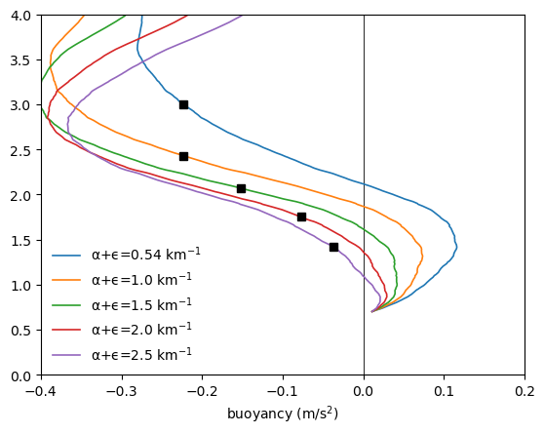
Fig will not be shown. Buoyancy integral is zero at the squares.

