Global cloud radiative effect
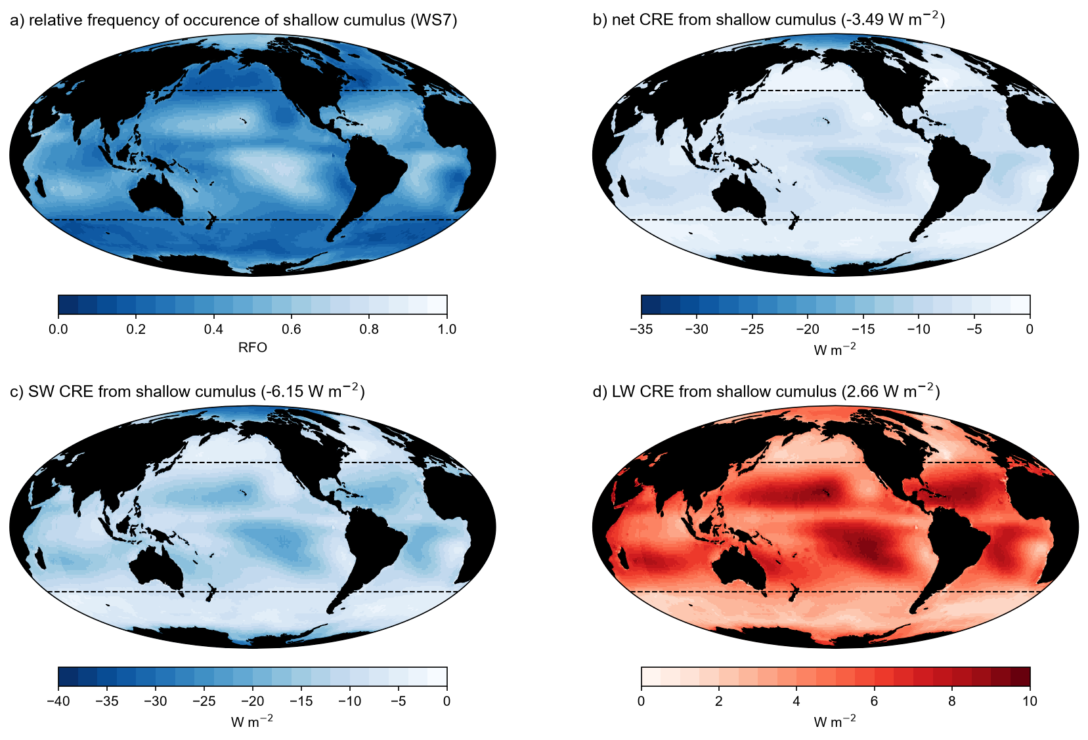
Figure GLOBALCRE. Shallow cumulus regime (ISCCP-H, Tselioudis et al., 2021) relative frequency of occurrence (RFO, a), shallow cumulus total cloud radiative effect (CRE, b), shortwave CRE (SW, c), and longwave CRE (LW, d) estimated by multiplying the cloud-top pressure – cloud optical thickness histograms with corresponding cloud radiative kernels (Zelinka et al., 2012).

Shallow cumulus is predominant cloud regime. Marine shallow cumulus clouds equatorward of 40 degrees latitude form in the subsiding tropical and subtropical latitudes with weak inversion strength (Figure GLOBALCRE a). The shallow cumulus (ISCCP-H weather state 7, Tselioudis et al., 2021) regime covers 37% (relative frequency of occurrence, RFO) of the oceans and 42% of tropical (40 S - 40 N) oceans. This tropical marine shallow cumulus regime covers 20% of Earth’s global surface area. Small changes in the albedo of shallow cumulus clouds thus leverage large radiative effects.
Shallow clouds cool the climate by reflecting shortwave (SW) solar radiation (Fig. GLOBALCRE c) of -20 W m⁻², which is offset by only +7 W m⁻² reduced outgoing longwave (LW) thermal radiation. The global CRE of tropical marine shallow cumulus clouds is -3.5 W m⁻², -6.2 W m⁻² SWCRE and +2.7 W m⁻² LWCRE (Fig. GLOBALCRE b,c,d). Fig. GLOBALCRE shows the importance shallow marine tropical clouds have in the climate system. Changes to the albedo-weighted fraction of shallow cumulus clouds scale with the RFO of the regime. We will return to the shallow cumulus RFO to estimate the global mean climate feedback from the modeled changes of shallow cumulus clouds.

RETURN IN METHODS to calculate the change in CRE.
Mean cloud fraction within the shallow cumulus regime approaches 0.40 (Tselioudis et al., 2021). Small clouds, especially clouds below 1 km, are overcounted by underfilled cloudy pixels with low optical depth (Fig. REFLALBEDO a). We estimate the albedo due to clouds, which is proportional to the cloud radiative effect (CRE). This albedo-weighted low cloud fraction is about 0.06 for clouds below 4 km (Fig. REFLALBEDO b).
First, we estimate changes to albedo-weighted cloud fraction in proportion to subsidence, which by radiative-convective energy balance, is robustly projected to decrease for a warming climate. We assume cloud fraction is proportional to cloud moisture flux, and moisture flux balances large-scale mean subsidence drying. Clouds below 1 km are radiatively important, but do not participate directly in this moisture balance. Rather, they are sensitively coupled to subcloud moisture flux and relative humidity.

