Decreasing hydrological circulation dims shallow cumulus clouds

Simon P. de Szoeke
An-Yi Huang
et al.

Abstract
Shallow cumulus clouds affect Earth’s planetary albedo and explain the spread in climate model sensitivities to atmospheric CO$​_{2}$. Desiccating the cloud layer by increasing vertical mixing has been proposed to reduce shallow cumulus clouds, but recent observations of mesoscale variability show that, rather than humidity, mass flux explains cloud fraction. Here we extend that result to the climate. A moisture balance model of the lower troposphere predicts shallow cumulus mass flux and cloud albedo decrease –5 to –8% K^{–1}. The cloud moisture flux decreases to balance the –5 % K^{–1} reduced drying by the atmospheric hydrological circulation. Increasing specific humidity +7% further reduces the mass flux (–2.6%) for the same moisture flux. Subcloud mean and turbulent fluctuations of RH change the cloud base cloud fraction, widening the local estimated shallow cloud change to –2.5 to –7.7 % K^{–1}. Shallow cumulus region shortwave cloud radiative dimming feedback is +0.5 to +1.6 W m^{–2} K^{–1} and the net local cloud radiative feedback is +0.4 to +1.3 W m^{–2} K^{–1}.

Introduction
The shallow cumulus cloud regime, with a mean cloud fraction of 0.2-0.4, covers ~15 % of Earth’s oceans (Stevens et al. 2019, Jacob et al, 2020). Satellite observations of the last decades show clearing of optically thin low clouds represents the strongest contribution to shortwave cloud feedback (Jin et al. 2026), and in models, clearing of shallow cumulus clouds dominates changes in the frequency of occurrence across different regimes (Zelinka et al. 2023). Low clouds in climate models usually decrease with warming (ISCCP, Zelinka et al., 2023; Webb and Lock, 2013; Webb et al. 2017, Jin et al. 2026), a positive shortwave radiative cloud feedback. Variety of this shallow cumulus feedback among models widens the spread of climate model projections of the sensitivity of temperature to CO₂ (Bony et al., 2006), especially for strongly subsiding regimes (Bony and Dufresne, 2005).
Low cloud is sensitive to humidity at cloud base (Sherwood et al. 2014; Brient et al. 2016; Vial et al. 2017). In the mixing-induced low cloud feedback, cumulus clouds and shallow circulations mix drier air downward, desiccating clouds near their lifting condensation level (LCL). CMIP3 models with more convective mixing were found to export more moisture from the boundary layer under warming, with the strength of this cloud desiccation explaining variations in their climate sensitivity (Sherwood et al. 2014).
In the winter northeastern tropical Pacific, EUREC4A airborne lidar and radar observed cloud-base cloud fraction of 5 % (Bony et al., 2022; Vogel et al., 2022). Satellite albedo from GOES shows shallow clouds have 3% cloud albedo below 1 km (by random overlap; 8 % by maximum overlap with other clouds below 4 km; Fig. REFLALBEDO). CMIP6 control simulations tend to have fewer and optically thicker clouds than observed over the northern tropical Atlantic in January-February (Fig. ALLCOSP). Observations and LES indicate that subcloud turbulence moderates cloud base moisture and cloud fraction (Nuijens et al. 2013; Bretherton et al. 2013; Brient et al. 2016; Vial et al. 2017).
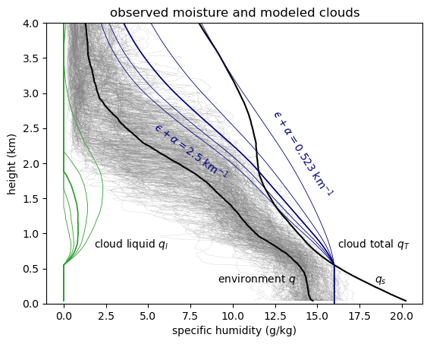
Fig REFLALBEDO. Vertical profile of fraction of cloudy pixels (black), cloud albedo weighted cloud fraction, and reflectance-weighted cloud fraction below 4 km from GOES 2x2-km pixels (a) in 10-m cloud top height bins, and (b) integrated downward. Reflectance is directly observed, and albedo is computed from cloud optical thickness. Cloud frequency fully counts pixels with optically thin clouds, so cloud weighted albedo and reflectance are less than cloud frequency of occurrence (Fig. GOESISCCP). Cloud albedo scales the shortwave radiative effect. [Figure MOISTURECLOUDS.] (c) Observed specific humidity from the ATOMIC Ron Brown radiosondes (gray), and their mean $q$ (black) and saturation specific humidity $q_{s}$. Cloud updraft total specific humidity $q_{T}$ (blue) and cloud liquid $q_{l}$ (green) for a range of total moisture sink rates $ϵ+α$ (entrainment and autoconversion coefficients, km^{–1}). Clouds transport moisture up, continuously diluting it toward a mixture between $q$ and $q_{s}$.
[ATOMIC_GOES/julia/RHB/sonde/moisture_clouds.pdf]

In the mixing-induced low cloud mechanism, increased vertical mixing reduces cloud fraction in a warmed climate by desiccating the shallow cumulus layer. Yet EUREC4A field observations (Stevens et al. 2021; George et al. 2022) show clouds are correlated more strongly (r = 0.72) to cloud-base mass flux than to relative humidity. This challenges the importance of humidity and suggests that vertical mixing processes are instead positively correlated with local shallow cumulus clouds.

The DIM mechanism
The mechanism introduced here, decrease in mass flux (DIM), predicts shallow cumulus clouds decrease in proportion to the reduction of the mean tropical large-scale circulation. The mechanism is based on 4 relationships:
(1) The large-scale tropical overturning circulation slows –5% K⁻¹ with climate due to the radiatively-constrained +2% increase in precipitation and +7% increase in specific humidity (Held and Soden, 2006, HS06; Vecchi and Soden, 2007).
(2) In a steady climate, the moisture budget is balanced. The mean horizontal and subsidence advection dry the lower troposphere in subsiding shallow cumulus regions. Mean advective drying is compensated the divergence of the shallow cumulus eddy moisture flux, $0=-∂/∂z\left[M\left(q_{c}-q\right)-P\right]-W({∂q}/{∂z)}$, where $M$is the cumulus mass flux, $q_{c}$ is the cloud humidity, $q$ is the environmental humidity. The subsidence component $-W({∂q}/{∂z)}$ here stands for the full moisture advection. It scales with the hydrological cycle. For constant humidity, the large-scale mean moisture advection decreases –5% in response to the circulation $W$.
(3) The saturation and environmental humidity $q$, cloud humidity $q_{c}$, increase +7% K⁻¹. The local precipitation also depends on $q_{c}$. Factoring out the proportional change of all the humidities, moisture balance then implies the mass flux is proportional to the circulation, $M∝W$.
(4) The shallow cumulus cloud fraction is proportional to mass flux, $C∝M$. Cloud mass flux is $M=Cw_{c}$, where $w_{c}$ is the in-cloud vertical velocity. EUREC4A cloud base mass flux is correlated to cloud fraction (r=0.72) with proportionality $C/M=$ 2.4-4.0 % (cm s^{–1})^{–1} (Vogel et al., 2022). Assuming constant mean in-cloud optical depth, changes in mean cloud albedo and reflectance are due to changes in the cloud fraction and mass flux, so $R∝A∝C∝M$. A mass flux cloud model that balances mean advection drying and produces the observed distribution of cloud top heights finds the proportionality $M/R$ = 4.2 cm s^{–1} of mass flux to mean reflectance among GOES scenes.
The DIM hypothesis, ${ΔC}/C={ΔM}/M={ΔW}/W,$ is a simple explanation for the change of clouds with the climate that predicts the shallow cumulus cloud albedo dims with warming at a rate ${d\ln{C}}/{dT}≈-5 \% K^{-1}$. This generates a positive cloud radiative feedback that scales with the planetary albedo of present shallow cumulus clouds.

Cloud and flux model
To predict the response of shallow cumulus clouds to climate, we separate the known changes from thermodynamics and circulation from the properties of cloud geometry, turbulence, and microphysics expected not to change. The autoconversion of cloud droplets to precipitation, the lateral entrainment rate, and the ratio of the area of active updraft to cloud area, are parameterized to match emergent properties of the clouds in the present climate and are not expected to change with thermodynamic and circulation responses to CO₂.
A mass flux model consisting of an ensemble of entraining and precipitating cloud plumes with different moisture sink rates simulates cloud humidity, cloud top height, mass fluxes, and moisture fluxes (see Methods). The moisture sink rate parameterizes turbulence-scale entrainment and precipitation conversion processes within the clouds. Plumes with weaker moisture sink rates have higher cloud tops. Cloud specific humidity $q_{c}$ and liquid specific humidity $q_{l}$ are illustrated with several moisture sink rates in Fig. REFLALBEDO. The fraction of clouds at each moisture sink rate is set to match the cloud top height distribution of satellite observations (Fig. REFLALBEDO) below 4 km. The large-scale subsiding branch of the tropical hydrological cycle dries the shallow cumulus boundary layer (Fig. LSADV). Requiring the clouds to balance the large scale advective drying, we assess the effect of large-scale circulation $W$ and environmental moisture $q$ on the cloud mass flux $M$.
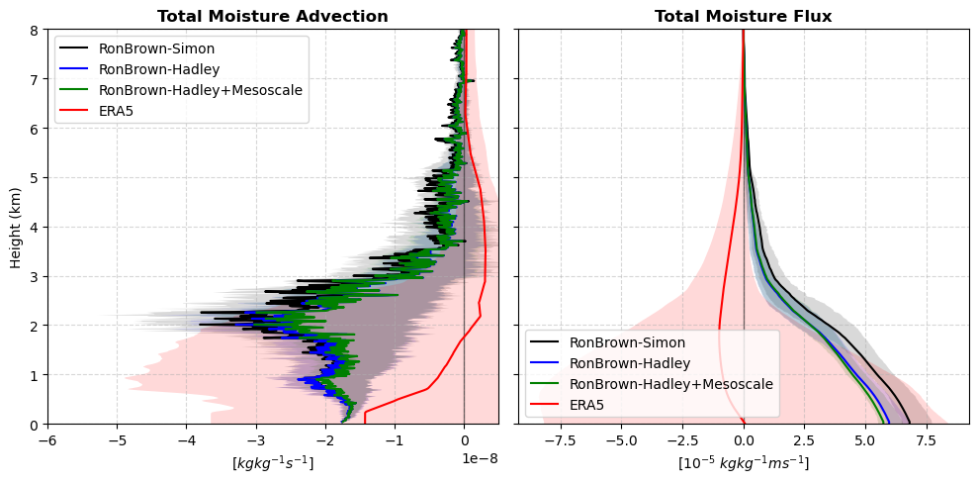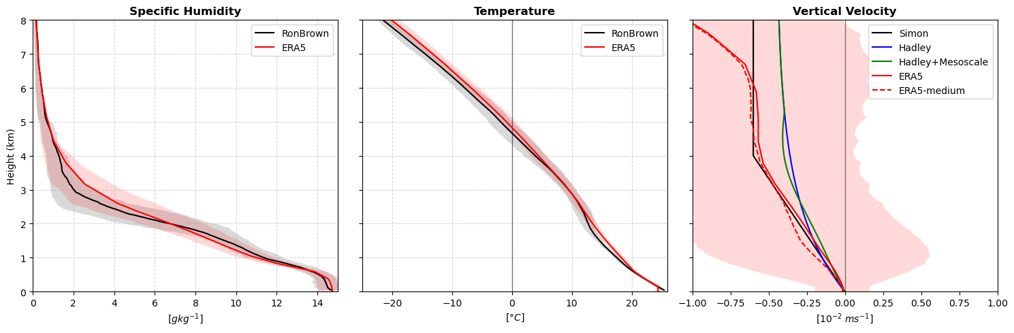
Fig. LSADV. Large scale subsidence velocity (m s^{–1}) and 3-D specific humidity advection (drying) prescribed for the shallow cumulus model experiments.
Climate feedbacks also depend on changes in shallower stratocumulus clouds near cloud base. We model the fraction of stratocumulus clouds from the relative humidity (RH) and turbulent moisture fluxes in the subcloud layer. They are sensitive to small (1%) changes of both moisture flux and RH.

Results

Mass flux and cloud albedo
The cloud model generates cloud water and vertical velocity profiles for thousands of ~280x280 km² GOES satellite reflectance scenes. The scene-mean mass flux binned as a function of reflectance and cloud albedo (albedo-weighted cloud fraction $C_{A}$) is shown in Fig. REFLMASSFL. The near proportionality of mass flux to cloud albedo suggests that clouds have a mean albedo-weighted in-cloud updraft velocity $w_{A}≈$ 67 cm s⁻¹. This proportionality of cloud albedo to mass flux $C_{A}∝M$ is used to infer the change in cloud albedo from the mass flux shallow cumulus cloud model. The slope $dC_{A}/dM=$1.5 % [cm s^{–1}]⁻¹ is slightly lower than the cloud base mass flux and cloud fraction observed from dropsonde circles in EUREC4A (2.4 - 4.0 % [cm s^{–1}]⁻¹; Vogel et al. 2022). The EUREC4A lidar-radar cloud fraction is probably more sensitive to mass flux it sees optically thinner clouds than the GOES. Additionally, while our model generates base cloud mass flux as a function of the GOES cloud field, EUREC4A, only about half (r² = 0.52) of the mass flux variation (mainly from mesoscale vertical velocity) is correlated with the clouds.
The slight increase in the slope of the modeled mass flux to cloud albedo up to cloud albedo of 0.3, beyond which there are very few scenes, describes by a quadratic fit (dashed line, Fig. REFLMASSFL). This increase of the modeled mass flux for more reflective scenes implies increasing in-cloud updraft velocity $w_{A}=dM/dC_{A}=0.54+1.2C_{A}$, with $C_{A}$ as a unitless ratio. Greater mesoscale clustering of nearer, larger, and deeper clouds for higher scene-mean albedo might explain the in-cloud vertical velocity. Were shallow stratocumulus clouds responsible for the increase of cloud albdeo, they would not increase the in-cloud vertical velocity.
Figure REFLMASSFL. Modeled cloud base (700 m) mass flux for 21 044 (128x128 pixel $≈$ 280x280 km^{–2}) GOES scenes averaged in 0.025- cloud albedo (blue) and reflectance (orange) bins. Black line shows a slope of 0.67 cm s^{–1} %^{–1}, suggesting mean albedo-weighted cloud fraction increases $S=$ 1.5 % (cm s^{–1})^{–1} with cloud base mass flux. Thin lines show relative number of scenes per bin. Clouds above 4 km are excluded.
[ATOMIC_GOES/julia/make_cth_albedo_histogram.jl
ATOMIC_GOES/julia/mass_flux_by_refl_albedo.png]

Climate experiments
A series of experiments predict the mass and moisture flux for cloud updrafts with decreased large scale moisture flux and moister atmospheric soundings, corresponding to +1 K surface temperature warming. Each experiment has a set of updrafts with identical moisture sink rates as the control simulation. The cloud top height distribution from the control simulation sets the distribution of sink rates for the control and the experiments. A new cloud top height and cloud flux is solved for each updraft in each experiment.
Large-scale climate perturbations are applied cumulatively to model experiments. Changes relative to the control experiment ${ΔM}/{M_{ctl}}$ are shown in Table 1. The first experiment, subsidence-5%, decreases the large-scale subsidence $W$ by –5% (HS06), corresponding to saturation vapor pressure increasing +7% K⁻¹ and large-scale drying increasing +2% K⁻¹. The reduction of subsidence is accompanied by a +2% increase of the mean cloud-base moisture flux $E_{cb}$ in experiment Ecb+2%. The thermodynamic profile and the cloud field are identical to the control in these experiments. These two experiments are presented together in Table 1. The effect of reducing the large-scale subsidence is to reduce mass flux $ΔM/M_{ctl}=$–5 % in proportion to the subsidence. The balance of the cloud top moisture flux divergence and the large-scale dry advection source (mostly subsidence) are not affected by the cloud base moisture flux, and the clouds are identical in Ecb+5% as in subsidence-5%.
The specific humidity and saturation specific humidity profiles $q$ and $q_{s}$ increase by +7% in experiment q&qs+7% (keeping RH constant). Reduced subsidence and increased specific humidity are the two basic features expected to change in the tropical climate, so we call this the DIM experiment.
Increasing specific humidity increases the vertical moisture gradient and cloud-environment humidity difference $q_{c}-q$. The mass flux $M$ required for the cloud moisture flux $M(q_{c}-q)$ to balance the large-scale drying decreases –2.6% more than subsidence-5%. Increasing the specific humidity reduces clouds about half as much again as decreasing the subsidence.
For the same reason, greater environmental humidity at cloud levels increases clouds. Increasing the environmental humidity decreases the excess humidity of the cloud$q_{c}-q.$ This increases the mass flux required to get the same moisture flux $M\left(q_{c}-q\right)$ required by the model. Experiment lclRH+0.003 increases environmental relative humidity by
$$RH=RH_{ctl}+0.05\left(1-RH_{ctl}\right)(2z_{CB}-z)/2z_{CB},$$increasing the RH by 0.3% (absolute) at cloud base. This RH perturbation increases clouds (decreases clouds less) $ΔC/C_{ctl}$ = +2.7% compared to the DIM (q&qs+7%) experiment.
For surface evaporation $E∝Uq_{s}\left(1-RH\right)$ to increase +2% K^{–1} in proportion to precipitation, the product of wind speed and saturation deficit $U(1-RH)$ must decrease –5% K^{–1}. One extreme is for the wind speed to decrease –5% K ^{–1}, consistent with the slowing of the circulation. In that case, $E$ increases but RH remains constant. In another extreme, wind speed is constant the surface relative humidity RH increases to quench the surface relative saturation deficit $1-RH$ by –5 % K^{–1}. In this case, sfcRH+0.014, mean surface RH = 0.73 increases at most +0.014 K^{–1} (absolute). Though surface RH increases, RH below cloud base does not affect the clouds. The cloud base is expected to form at the lifting condensation level, at a constant RH.

Table 1. Relative change of shallow cumulus cloud fraction $ΔC/C_{ctl}$, where experiments represent conditions for +1 K of warming relative to the control simulation. The q&qs+7% experiment has –5% reduced subsidence, +2% increased moisture flux, and +7% increased humidity. Absolute change of the shortwave (SW), longwave (LW) and total cloud radiative effect ($Δ$CRE) are calculated from a cloud radiative kernel.
experiment | $ΔM/M_{ctl}$  (%) | $Δ$SWCRE  (W m^{–2}) | $Δ$LWCRE  (W m^{–2}) | $Δ$CRE  (W m^{–2})
subsidence-5%, Ecb+2% | –5.00 | +1.02 | –0.18 | +0.84
q&qs+7% | –7.56 | +1.55 | –0.27 | +1.28
lclRH+0.003 | –5.01 | +1.03 | –0.18 | +0.85

LCL clouds
The net cloud radiative effect depends on the change of albedo by both shallow cumulus and LCL clouds. Our model projects that shallow cumulus clouds decrease with reduced large-scale overturning and increased specific humidity. The moist updraft plumes of a mass flux model do not represent the turbulent subcloud thermals forming the lowest clouds near the LCL. We simulate LCL clouds from the fraction of subcloud thermals exceeding saturation by modeling subcloud relative humidity fluctuations produced and dissipated by turbulence (Methods: LCL clouds).
LCL clouds change up to ±8% K^{–1}. The cloud change scales strongly with the parameter $c$ that describes how much $1-{\overline{RH}}_{sfc}$ (rather than wind speed) decreases to damp the surface evaporation. The sign of the change is uncertain: clouds decrease when the cloud base RH is constant ($b=0$) and increase when cloud base saturation deficit scales linearly with surface saturation deficit ($b=1$).
Assuming 1/3 of low clouds are LCL clouds that change by ±8% K^{–1}, and 2/3 are shallow cumulus that decrease –7.56 % K^{–1}, the total effect would be for clouds below 4 km to decrease with a range of –7.7 to –2.4 % K^{–1}. This corresponds to local low cloud shortwave dimming of +0.5 to +1.6 W m^{–2} K^{–1} and total cloud radiative feedback of +0.4 to +1.3 W m^{–2} K^{–1}.

Summary
A model simulates the ensemble of cumulus cloud with eddy moisture flux divergence in hydrological balance with the large-scale circulation drying and observed cloud top heights. It reproduces the ratio of mesoscale mass flux to cloud albedo consistent with the proportionality observed in EUREC4A and physically extends that proportionality to climatological mean cloud albedo and mass flux. Model experiments show the mean shallow cumulus mass flux and cloud fraction decrease in proportion to the reduction of the mean tropical circulation expected in a warmed climate (HS06).
The decrease in mass flux (DIM) hypothesis extrapolates observational evidence linking cloud fraction to mass flux $C∝M$ to changes expected from a balanced water budget with a weakening hydrological circulation. Cloud parameterizations used in climate models must satisfy many global constraints, few of which make them suited to faithfully simulate the moisture flux and cloud fraction of shallow cumulus clouds (Vial et al., 2017, Nuijens et al., 2015). Our shallow cumulus model represents cloud-scale turbulent processes with a spectrum of total moisture sink rates representing lateral entrainment and precipitation. Each moisture sink rate determines a profile of cloud humidity $q_{c}$ and a cloud top height. Our model closure is to distribute the frequency of cloud moisture sink rates to yield the observed distribution of shallow cumulus cloud top height and moisture flux divergence. The model reproduces the observed proportionality of albedo-weighted cloud fraction to mass flux $C/M=$ 1.5 % (cm s^{–1})^{–1}.
Differences from the predictions of the DIM mechanism in climate change simulations suggest variation in the response of the subsidence drying over the shallow cumulus region, or variations of the proportionalities of clouds or mass flux to the subsidence. A different relationship divergence of the mass flux to the subsidence $d\ln{M}=d\ln{W}$ is possible if either the entrainment or the vertical structure of convective moisture flux changes. The DIM hypothesis predicts the change in area of low clouds responsible for the moisture flux, but does not account for secondary desiccation of optically thick stratocumulus clouds, found near cloud base in most climate models. Divergence of the vertically developed shallow cumulus cloud fraction from $d\ln{C}=d\ln{M}$ is possible if the ratio of the cloud area fraction $C$to the active updraft area $C_{a}$ with moisture flux $w_{up}\left(q_{cld}-q_{env}\right)$ changes for clouds in a different climate. Our projections are valid as long as ratio of total cloud area to the area of active cloud updrafts $C/{C_{a}}$, which depends on cloud-scale processes, is constant. Previous studies have found $C/{C_{a}}≈2$ (Siebesma et al. 2003, Vogel et al. 2020).
Cloud properties and within-regime radiative feedbacks are similar for low clouds (Tselioudis et al., 2021; Zelinka et al. 2025). Shifts of optically thicker stratocumulus to optically thinner shallow cumulus clouds could result in partial compensation between their radiative effects. The mixing-induced low cloud feedback describes a version of this competition, whereby mixing by precipitating convection dries lower levels and evaporates extensive and optically thick stratocumulus clouds, in the global average. All else equal, subsidence is found to reduce lower stratocumulus clouds (Myers and Norris, 2014).
The mass flux model simulates updraft plumes, but not stratocumulus clouds coupled to subcloud turbulence. A model for turbulent humidity fluctuations shows LCL clouds may increase or decrease, depending subtle changes in subcloud moisture flux and cloud base relative humidity.

Methods

Low clouds in trade cumulus regions
Trade cumulus clouds are intermittent shallow convection in widespread regions of mean subsidence balancing deeper convection elsewhere. Figure GOESISCCP shows cloud top height and cloud optical thickness histograms observed from the 2-km pixel GOES observations in the Northern Atlantic shallow cumulus region 12.5-16 °N, 60-49 °W, 2020 Jan 15 - February 20 from a GOES retrieval (Minnis et al., 2008; W. Smith, NASA SATCORP) and the CERES Flux By Cloud Type (FBCT; Sun et al., 2022). Most of the GOES clouds are below 680 hPa (37% cloud fraction) with cloud optical thickness $τ=$ 0.3-9.4 (Fig. GOESISCCP a). The FBCT histogram is similar (36% cloud fraction below 680 hPa; Fig. GOESISCCP b) but has (2-3x) greater optical thickness than GOES, possibly because of the greater independence of cloud fraction and optical thickness for the 1-km MODIS pixels used by FBCT. FBCT also observes more 800-680 hPa cloud tops (15%) than GOES (7.4%).
Low clouds in five CMIP6 preindustrial control simulations in the Cloud Feedback Model Intercomparison Project (CFMIP) have greater optical thicknesses than observed over the northern tropical Atlantic in January-February. Model-mean cloud optical thickness is mainly $τ=$ 1.3 to 23, with few clouds thinner than $τ$ = 3.6, (Fig. ALLCOSP).
There are two modes in the vertical structure of the shallow cumulus clouds (Fig. REFLALBEDO; Jacob et al. 2020). The first, just above cloud base at 0.5-1.0 km, has high frequency of occurrence but low albedo and reflectance. Many of these lowest clouds are generated in boundary layer updrafts smaller than the ~700 depth of the subcloud layer and thus do not fill the 2-km GOES pixels, lowering the effective cloud albedo. Clouds not filling the pixel and allowing it to be partly transparent to the longwave, may account for the vertical spread of the cloud top height of the lower mode, estimated from cloud top infrared emission. The second vertical mode is observed below the trade inversion at 1.5-2.5 km. It has a cloud fraction half as large as the cloud base mode, but clouds above 1.5 km are responsible for an albedo of 0.05 of the total 0.07 integrated over the lower 4 km.
Top-of-atmosphere cloud radiative effect (CRE) of the low clouds (p>680 hPa) is computed from the Zelinka et al. (2012) cloud radiative kernel using the cloud top pressure and optical thickness from GOES (Fig. GOESISCCP c), and FBCT radiative fluxes in each bin minus clear-sky radiative flux (Fig. GOESISCCP d). CRE changes for climate experiments are estimated from cloud amount changes predicted by our shallow cumulus cloud model.
Mean cloud reflectance and albedo are computed at each 10-m height from 0.5-4 km from visible optical depth of daylight 2x2 km² pixels (Fig. REFLALBEDO). Pixels at solar zenith angle >75 ° and deeper than 4 km are excluded. Cloud albedo is calculated with a two-stream approximation for inelastic scattering, $α_{c}=\left(1-g\right)τ/(2μ_{0}+\left(1-g\right)τ)$, from the cloud optical thickness $τ$, asymmetry parameter $g≈0.85$, and solar zenith angle cosine $μ_{0}=cos⁡(θ_{0})$ (Coakley and Chylek 1975, Tornow et al. 2020). The albedo-weighted cloud fraction (Fig. REFLALBEDO) below 4 km is a proxy for the cloud albedo of Northern Tropical Atlantic maritime clouds during EUREC4A (Jan 15-Feb 12 2020 at 12.5-16 °N, 60-49 °W). GOES mean cloud albedo is slightly less than the mean reflectance. The GOES cloud fraction (Figs. REFLALBEDO and GOESISCCP) is greater than the cloud albedo because the albedo is less than unity for fully cloudy pixels with low optical thickness.
Figure GOESISCCP. Cloud fraction histograms by cloud top pressure and cloud optical thickness within 12.5-16 °N, 60-49 °W, for (a) GOES-16 from 2020 Jan 15- February 20 23:40 and (b) CERES Flux By Cloud Type (FBCT) Jan-Feb for 2019, 2020, and 2021. Corresponding (c) GOES and (d) FBCT shortwave CRE. GOES shortwave CRE for clouds below 680 hPa is –20 W m^{–2} (–14 W m^{–2} for FBCT).
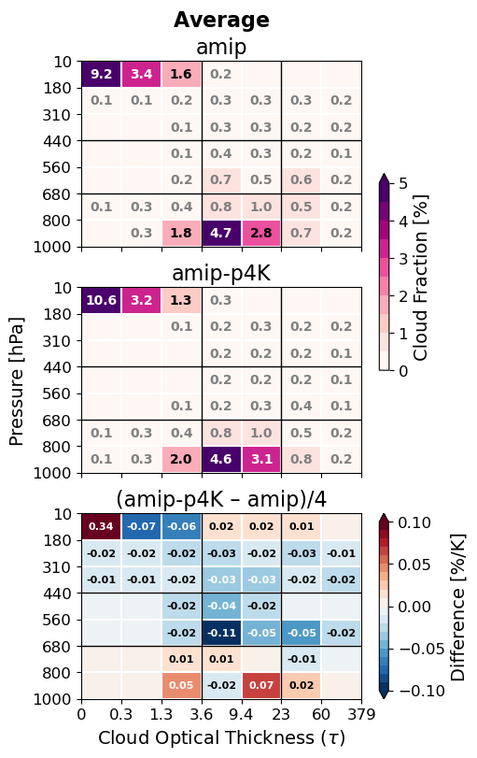
Figure ALLCOSP. Cloud top pressure and cloud optical thickness histograms for the 5-model mean of Cloud Feedback Model Intercomparison Project (CFMIP Webb et al. 2012) Atmospheric (AMIP) preindustrial control simulations.

The large-scale moisture budget

Clouds with average albedo $a_{i}$ have cloud tops that reach $h_{i}$ in GOES satellite images (Fig. REFLALBEDO). We partition the all-sky mean eddy flux $G$ to $G_{i}$ of cloud categories $i$ that reach these heights. We also interpret albedos $a_{i}$ as a proxy for cloud area fraction. This interpretation is valid if the reflectance is representative of clouds with high optical thickness. Not all shallow cumulus clouds have high optical thickness, yet we retain this albedo-weighted fraction as a radiatively relevant measure of clouds.
The all-sky mean eddy flux of moisture $G$ is the integral of the large-scale source $S_{LS}$,
$$G\left(z\right)=G_{CB}+\int_{z_{CB}}^{z}{S_{LS} dz^{'}},$$with the cloud base moisture flux $G_{CB}$ as the boundary condition. The large-scale moisture source $S_{LS}$ is drying due to subsidence and horizontal advection$.$
We partition the moisture flux into a vertically uniform flux for each cloud of height $h_{i}$. The all-sky mean flux profile $G\left(z\right)$ has a flux difference $G_{i}=G\left(h_{i+1}\right)-G\left(h_{i}\right)$ at each discrete height, where the vertically uniform moisture flux from cloud $i$ detrains at the cloud top. This flux difference is assumed to be carried by the clouds with (albedo-weighted) area fraction $a_{i}$ and height $h_{i}$. The cloud top height $h_{i}$ of each modeled shallow cumulus cloud is determined by its moisture sink rate parameter.
The all-sky flux $G=aF$ is the product of cloud area and in-cloud flux $F$. The all-sky mass flux $M=aw$ likewise corresponds to the in-cloud vertical velocity $w$. The model divides clouds and their fluxes into categories $i:$
$$M_{i}=a_{i}w_{i}, \\ G_{i}=a_{i}F_{i}=a_{i}w_{i}{\left(Δq\right)}_{i}=M_{i}{\left(Δq\right)}_{i}, \\ F_{i}=w_{i}{\left(Δq\right)}_{i}$$where total fluxes are summed over the categories, $G=\sum_{i}{G_{i}}$, $F=\sum_{i}{F_{i}}$, and $M=\sum_{i}{M_{i}}$, $w=\sum_{i}{a_{i}w_{i}/A}$. Figure FEDDYMETHOD shows the distribution of in-sky fluxes $F_{i}=G_{i}/a_{i}$ in each cloud top height category.
Water fluxes by clouds are diagnosed to balance a simple vertical water budget for the trade cumulus cloud layer. The updraft area fraction is calculated over large (1000 km)² regions, assuming updraft cores are cloudy with saturated specific humidity. Cloud mass flux is initialized at cloud base to match the mean observed surface evaporation minus precipitation. From the moisture closure, the in-cloud eddy flux due to cumulus updrafts and precipitation is $F_{i}\left(z\right)=F_{c,i}\left(z\right)+F_{p,i}\left(z\right)$. Cloud updrafts are responsible for most of the eddy flux. A small part is contributed by precipitation. We will first model the water in the clouds, then their conversion to precipitation.
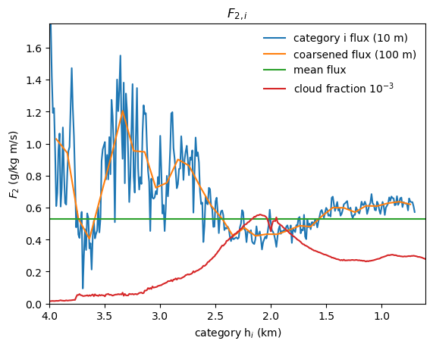
Figure FEDDYMETHOD. Vertically uniform cloudy-sky eddy flux $F_{2,i}$ from Method 2 at 10-m cloud top height $h_{i}$ resolution (blue), and 100-m resolution (orange). Mean flux over the cloud ensemble (green), weighted by cloud albedo (red).

Cumulus cloud model
A budget for steady total water $q_{c}$ in the updraft with velocity $w$ depends on its entrainment and precipitation sinks. The equations for the suspended liquid $q_{l}$ and water vapor $q_{v}$ specific humidity in the cloud are
$${∂q_{l}}/{∂t}=-w\left({∂q_{l}}/{∂z}\right)-wγ-ϵwq_{l}-αwq_{l} \\ {∂q_{v}}/{∂t}=-w\left({∂q_{v}}/{∂z}\right)+wγ-ϵw\left(q_{v}-q\right),$$where $ϵ$ (km^{–1}) is the lateral entrainment coefficient, $α$ is the autoconversion of cloud liquid to precipitation, and $γ={\left({dq_{s}}/{dz}\right)}_{m}=\left({dq_{s}}/{dT}\right){\left({dT}/{dz}\right)}_{m}<0$ is the moist adiabatic condensation rate of water vapor per unit height. The dependence on $γ$ is eliminated in the total cloud water $q_{c}$ equation,
$${∂q_{c}}/{∂t}=0=-w({∂q_{c}}/{∂z})-ϵw(q_{c}-q)-αwq_{l}$$QTBALANCE.The updraft advects moisture upwards, but the solution for $q_{T}$ is quantitatively insensitive to the updraft velocity and to the moisture flux. In the cloud, $q_{l}=q_{c}-q_{s}$, autoconversion removes cloud liquid, relaxing total water toward $q_{s}$, and entrainment relaxes total water toward $q$. Thus, equation QTBALANCE is written in terms of the total vertical sink rate $ϵ+α$,
$${∂q_{c}}/{∂z}=-\left(ϵ+α\right)\left(q_{c}-\tilde{q}\right),$$QRELAXrelaxing $q_{c}$ to the intermediate humidity $\tilde{q}={(ϵq+αq_{s})}/{(ϵ+α)}=\left(1-x\right)q+xq_{s}$. The total sink rate $ϵ+α$ determines the cloud water, water flux, and cloud top height. We call the ratio $x=α/{\left(ϵ+α\right)}$ of the autoconversion to the total moisture sink the precipitation efficiency. Cloud liquid and water vapor profiles are computed for many total sink rates ${\left(ϵ+α\right)}_{i}$, resulting in the cloud top heights $h_{i}$ (Fig. REFLALBEDO).
The profiles of $q_{c}$ predicted by this entraining-precipitating updraft model agree with the most humid air sampled on occasion by radiosondes. Cloud height (where $q_{c}$ reaches 0) is limited by entrainment of relatively dry air between 1.5-3 km, representing the mean distribution of the trade inversion. The clouds occupy a range of depths representative of trade cumulus clouds, with deeper clouds for lower rates of entrainment and autoconversion. The intermediate total sink rate of $ϵ+α≈0.5 {km}^{-1}$ gives maximum cloud liquid specific humidity exceeding 0.8 g kg^{–1} and cloud top height of ~3 km.

Precipitation and updraft moisture fluxes
Shallow cumulus clouds generate weak precipitation, reversing a fraction of the updraft total cloud water flux. Precipitation water flux within a cloud $F_{P}<0$ is generated by autoconversion $α$ from cloud liquid. For the updraft with no storage of cloud liquid water, the precipitation source is
$$-{∂F_{p}}/{∂z}=-αwq_{l}=xw\left({∂q_{l}}/{∂z}+γ\right),$$where $∂q_{l}/∂z+γ$ is the total moisture source in the updraft.
The solution for each cloud type $i$ is found by numerically integrating the precipitation downward from $F=0$ at cloud top. The precipitation sink, ${∂F_{p,i}}/{∂z}=α_{i}w_{i}q_{l,i},$ instantaneously removes liquid water from the cloud and the column.
An example of the all-sky fluxes is computed for a single cloud with, $ϵ+α=1.5 {km}^{-1}$, $h=1.9$ km and all-sky cloud-base flux $G\left(z_{CB}\right)=$ 145 W m^{–2} $=6.0×{10}^{-5}$ kg m^{–2} s^{–1} (Fig. QMASSFLX). For this case, $F$ goes to zero at 8 km. Precipitation increases downward below the cloud top. At a precipitation efficiency of ~0.5, the cloud-base precipitation $P_{CB}=\left|F_{P}\right|$ equals the mean surface precipitation, $P_{0}=$25 W m^{–2} $=9.0×{10}^{-6}$kg m^{–2} s^{–1}, observed on the research vessel Ron Brown during EUREC4A/ATOMIC. Evaporation was $E_{0}=$ 180 W m^{–2} $=6.5×{10}^{-5}$ kg m^{–2} s^{–1}. The mass flux is $M={G_{cld}}/{q_{T}-q}$ (Fig. QMASSFLX). Most of the flux (~90 %) is below 3 km in the trade cumulus layer. Most of the updraft moisture $q_{T}$ is vapor, and the moist updraft $q_{T}-q>0$ generates upward moisture flux, even above the cloud.
The cloud (a) total specific humidity and (b) cloud-environment humidity difference as a function of height and total sink rate parameter is shown for an ensemble of sink rates in Fig. WPROF. This is used to compute (c) cloud-mean vertical velocity for each cloud. The total mass flux is $M=∑a_{i}w_{i}$, where the total cloud area is $a=∑a_{i}$.
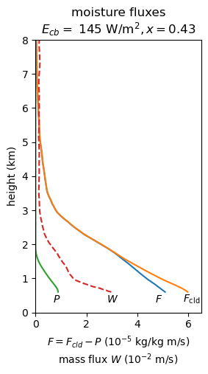
Figure QMASSFLX. Cloud moisture flux $F_{c}$ (orange), and (downward) precipitation flux $P=-F_{P}$ (green), and mass flux $M$(red) modeled for a single cloud with total moisture flux $F$ (blue).
Figure WPROF. Modeled ensemble of clouds for precipitation efficiency $x=0.53$ as a function of total sink rate. (a) Cloud updraft total specific humidity $q_{T}$ (shaded), cloud top (thick black), and rescaled cloud area per unit sink rate (thin black); (b) cloud updraft total – environment specific humidity difference $q_{T}-q$ (shaded), and cloud liquid specific humidity $q_{l}$ (black contours); and (c) updraft vertical velocity.
[trade-cu-model/src/julia/control_qv_qc_w]

Numerical integration of cloud fluxes
At each height and for each cloud category $i$, $w_{i}q_{l,i}=F_{c,i}{q_{l,i}}/{\left(q_{c,i}-q\right)}$ and $F_{c,i}=F-F_{P_{i}}$. The precipitation equation is written in differential form,
$$dF_{P,i}=\frac{α_{i}q_{l,i}}{\left(q_{T,i}-q\right)\left(F-F_{P,i}\right)dz}.$$Precipitation is integrated downward, from $F_{P,i}\left(h_{i}\right)=0$ at the top $h_{i}$of each cloud, in trapezoidal vertical steps with decreasing superscript $k$,
$$F_{P,i}^{k}=-\frac{-\left(1+c_{i}^{k}\right)F_{P,i}^{k+1}+c^{k}F^{k}+c^{k+1}F^{k+1}}{1-c^{k}},$$where $c_{i}^{k}={\left[α_{i}q_{l,i}^{k} dz\right]}/{\left[2\left(q_{T,i}^{k}-q^{k}\right)\right]}$.

Cloud radiative effect
The observed GOES low ($p_{c}>$ 680 hPa) cloud fraction $C_{0}\left(τ,p_{c}\right)$counts pixels in cloud optical thickness $τ$ and cloud top pressure $p_{c}$ (Minnis et al. 2008) bins. The shortwave (SW), longwave (LW), and total cloud radiative effect (CRE) is estimated from the Zelinka et al. (2012) cloud radiative kernel $K(τ,p_{c})$: ${CRE}_{0}=\sum_{τ,p_{c}}{C_{0}\left(τ,p_{c}\right) K(τ,p_{c})}$. Total, shortwave (SW), and longwave (LW) CRE changes $ΔCRE={CRE}_{0}\left({ΔC}/{C_{ctl}}\right)$ are multiplied by the relative modeled change in the shallow cumulus albedo ${ΔC}/{C_{ctl}}=ΔM/M_{ctl}$ for the shallow cumulus experiments (Table 1). The CRE for low clouds, assumed comprised 2/3 of shallow cumulus (SC) clouds and 1/3 of LCL clouds, is computed by weighting the relative changes of SC and LCL clouds,
$$ΔCRE={{CRE}_{0}\left(\left(2/3\right){ΔC_{SC}}/{C_{SC}}+{ΔC_{LCL}}/{C_{LCL}}\right)}/{C_{0}},$$from their respective models.

LCL clouds
Large-eddy simulation (LES; (Bretherton et al. 2013, Blossey et al. 2013) and observations (Bony et al., 2021; Vogel et al., 2022; Fig. REFLALBEDO) have a cloud fraction maximum of about 5 % near the cloud base. We scale this LCL cloud fraction from the subcloud relative humidity and moisture fluxes and test the sensitivity of relative humidity (RH) at cloud base. RH may be constant (Held and Shell XXXX) or increase slightly to the damp the surface evaporation to +2 % K^{–1}.
The LCL cloud fraction is the fraction of air from the moist subcloud boundary layer thermals that reaches saturation at cloud base (Sommeria and Deardorff, 1977; Mellor 1977). For a normal distribution of relative humidity in the subcloud layer, the mean fraction of the thermals that are saturated at cloud base is $C_{CB}=\left(1-\operatorname{erf}\left(s\right)\right)/2,$where $s={\left(1-{\overline{RH}}_{CB}\right)}/{σ_{RH}}$ is the mean relative saturation deficit normalized by the standard deviation of RH. Cloud fraction changes strongly inversely to $s$ according to ${d\ln{C_{CB}}}/{d\ln{s}}≈-3.2$. The cloud-base cloud fraction observed by combined radar and lidar is 0.054 $±$0.031% in EUREC4A (BASTALIAS, Bony et al., 2022; Vogel et al., 2022). Cloud base cloud fraction $C_{CB}=0.055$matches the observations for $s_{0}=1.13$.
The distribution of the saturation deficit depends on the mean humidity, the subcloud gradient, and the moisture flux. The standard deviation of specific humidity is solved from production-dissipation balance for the subcloud specific humidity variance ${∂\overline{q^{'2}}}/{∂t}=0$,
$$0=-u^{*}q^{*}\left({∂\overline{q}}/{∂z}\right)-χ_{q}.$$Humidity variance is produced by flux $u^{*}q^{*}=\overline{w^{'}q^{'}}$ and gradient ${∂\overline{q}}/{∂z}$. It dissipates with rate $χ_{q}={k_{1}u^{*}σ_{q}^{2}}/{z_{CB}}$ from turbulent stirring and viscous mixing of humidity fluctuations, where $k_{1}$ is a constant and $z_{CB}$ is the cloud base height. Shear production is greater than buoyancy production. Solving for humidity variance, the friction velocity $u^{*}={\overline{u^{'}w^{'}}}^{1/2}$ cancels and $σ_{q}^{2}={q^{*}\left(q_{sfc}-q_{CB}\right)}/{k_{1}}.$Then the RH standard deviation at cloud base, $$σ_{RH}={σ_{q}}/{q_{s,CB}}={\left[{q^{*}\left(q_{sfc}-q_{CB}\right)}/{\left(k_{1}q_{s,CB}^{2}\right)}\right]}^{1/2},$$depends on the humidity scale $q^{*}$, the subcloud mean humidity difference $q_{sfc}-q_{CB}$, and the cloud-base saturation specific humidity $q_{s,CB}$. Absent another reason, we assume specific humidity gradient scales as +7% K^{–1}, so the change of ${\left(q_{sfc}-q_{CB}\right)}/{q_{s,CB}}$ cancels and
$$d\ln{σ_{RH}}=\left(1/2\right)\left[d\ln{q^{*}}- d\ln{q_{s,CB}}\right].$$The surface evaporation $E=ρLu^{*}q^{*}$ and cloud-base moisture flux increase +2 % K^{–1} to balance the increase of precipitation. From factoring the evaporation,
$$d\ln{E}=d\ln{U}+d\ln{q_{s}}+d\ln\left(1-{\overline{RH}}_{sfc}\right)=d\ln{u^{*}}+d\ln{q^{*}}.$$
The change of the mean normalized saturation deficit is
$$d\ln{s}=d\ln\left(1-{\overline{RH}}_{CB}\right)+\left(1/2\right)\left(d\ln{q_{s,CB}}-d\ln{q^{*}}\right),$$with $d\ln{q^{*}}=d\ln{E}-d\ln{U}$. We evaluate this as
$$d\ln{s}=-c(b-1/2)(d\ln{q_{s}}-d\ln{E})$$a function of two parameters $b$ and $c$, not known precisely but bounded by 0 and 1. The coefficient $b={d\ln\left(1-{\overline{RH}}_{CB}\right)}/{d\ln{(1-{\overline{RH}}_{sfc})}}$ is the ratio of the cloud base RH saturation deficit $1-{\overline{RH}}_{CB}$ to the surface saturation deficit, which is 0 for constant cloud base RH, and 1 for cloud base mean saturation deficit scaling as surface saturation deficit $1-{\overline{RH}}_{sfc}$.

The coefficient $c={d\ln{(1-{\overline{RH}}_{sfc})}}/{\left(d\ln{E}-d\ln{q_{s}}\right)}$, is the damping of the change of the surface flux by the increase of surface RH. For constant surface wind speed, $c=1$. Otherwise, the evaporation is damped also by decreasing wind speed. At $c=0$, the wind speed controls the flux entirely and surface RH is constant. Solving for the relative change of $s$ in terms of the parameters yields $d\ln{s}=-c\left(b-1/2\right)\left(d\ln{q_{s}}-d\ln{E}\right).$ ($d\ln{q_{s}}-d\ln{E}=+5 \% K^{-1}>0$, and $c>0$)

The LCL cloud model predicts cloud changes of either sign, depending on how strongly the cloud base saturation deficit scales with surface saturation deficit. The parametric dependence $-c\left(b-1/2\right)$ contoured in Fig. BCSENS is between –0.5 and +0.5 and multiplies +5 % K^{–1} to give $d\ln{s}$. Relative changes of $s$ and cloud base clouds have a symmetric response to the sensitivity to cloud base saturation deficit $b$. Clouds increase at most by $ΔC_{CB}/C_{CB}$ = +0.08 for ${Δs}/s=-0.025$, and decrease by at most $ΔC_{CB}/C_{CB}$ = –0.08 for ${Δs}/s=+0.025$.
Figure BCSENS. Change of the mean normalized saturation deficit $d\ln{s}=-\left(b-1/2\right)\left(1-c\right)\left(d\ln{q_{s}}-d\ln{E}\right)$ and the resulting cloud-base cloud fraction $d\ln{C_{CB}}=-3.2 d\ln{s}.$ The relative change of $s$ is ${Δs}/s=$–0.025 to +0.025, and of cloud base cloud fraction $C_{CB}$ is ${ΔC_{CB}}/{C_{CB}}=$ +0.08 to –0.08. Cloud base clouds are unchanged for $c=1$ or $b=1/2$. The parameter $b={d\ln\left(1-{\overline{RH}}_{CB}\right)}/{d\ln{(1-{\overline{RH}}_{sfc})}}$ is the sensitivity of the cloud-base saturation deficit to the surface saturation deficit, and
Cloud base clouds do not change for $c^{'}=0, c=1$ or $b=1/2$. For $c=1,$ decreasing wind speed –5% K^{–1} damps the evaporation to +2% K^{–1}, and surface saturation deficit and RH are constant, having no effect on clouds. Clouds are most sensitive at $c=0$, when wind does not change and $1-{\overline{RH}}_{sfc}$ decreases (RH increases) to damp the surface evaporation. For $b=0$, saturation deficit $1-{\overline{RH}}_{CB}$ is constant. Then increasing the specific humidity more strongly than the flux narrows the width of the RH, decreasing clouds. For $b=1$, surface and cloud base saturation deficits decrease proportionally, so cloud-base RH and clouds increase. At $b=$ 1/2, the two competing effects—increasing mean RH and narrowing its standard deviation $σ_{RH}$—balance.
Scaling $s_{0}=1.13$ by (1 - 0.025) = 0.975 K^{–1}, for cloud base saturation deficit $1-{\overline{RH}}_{CB}$ decreasing proportional to that at the surface, yields a cloud-base cloud fraction $C_{CB}\left(0.975s_{0}\right)=0.060,$an absolute increase of 0.005 K^{–1} (relative +8% K^{–1}). Increasing the surface humidity but keeping the cloud base humidity constant decreases the LCL clouds by the same amount. LCL clouds could thus significantly modify the predicted reduction of shallow cumulus clouds. The net cloud changes depend on the partitioning of the original clouds into cumulus clouds and LCL clouds that are strongly coupled to the subcloud layer. The large uncertainties in the change of conditions that drive the LCL clouds bound the results for the sum of the shallow cumulus and LCL clouds. Assuming 1/3 of the clouds are LCL clouds that change by ±8% K^{–1}, and 2/3 are shallow cumulus that decrease –7.56 % K^{–1}, the total effect would be for clouds to decrease with a range of –7.7 to –2.4 % K^{–1}.
This simple scaling of the LCL clouds to the subcloud RH fluctuations demonstrates the sensitivity of the clouds to the mean RH, RH gradients, and moisture flux. The sign of the change of LCL clouds depends on subtle changes in surface humidity that may be compensated by the effect of wind on the surface evaporation; and to what degree cloud base humidity increases with surface humidity.

Data sources
Data are available from their references and/or links provided here. GOES daylight visible reflectance, cloud optical thickness, and cloud top pressure retrievals (Minnis et al. 2008) are provided by NASA Langley Cloud and Radiation Research Group, https://satcorps.larc.nasa.gov/prod/exp/atomic-2020/visst-pixel-netcdf/ (courtesy W. Smith). CERES FBCT (Sun et al., 2022) data are provided at https://www.earthdata.nasa.gov/data/catalog/larc-cloud-cer-fluxbycldtyp-month-terra-aqua-modis-edition4a. Data from EUREC4A/ATOMIC radiosondes (Stephan et al., 2021) are provided at the AERIS EUREC4A data catalog https://observations.ipsl.fr/aeris/eurec4a-data/PRODUCTS/MERGED-MEASUREMENTS/RADIOSOUNDINGS/v3.0.0/level2/.

References

