Supplement: Mesoscale organization vertically stretches the cloud distribution
Mesoscale organization clusters clouds together, leading to larger cloud updrafts, and updrafts entraining moister air from their surroundings. The cumulus mass flux model parameterizes the effect of mesoscale clustering through the total moisture sink rate. The moisture sink rates were distributed according to the observed humidity profile and cloud top height distribution. The moisture sink rate depends on the geometric, turbulent, and microphysical properties of the clouds, which we assume not to change in our climate experiments. In this section we consider the implications of changing the moisture sink rate.
The distance over which moisture is removed from the cloud is inversely proportional to the sink rate. Multiplying the moisture sink rate by $K$and squashing the vertical scale of the humidity profile $q^{'}\left(z\right)=q\left(Kz\right)$ entrains the same water over a shorter vertical distance, squashing the cloud top exactly to $h^{'}=h/K$. Thus, for equal subsidence $W$, the eddy flux $G^{'}\left(z\right)=G(Kz)$ balances the equivalently squashed subsidence drying, resulting in exactly the same cloud fractions and fluxes as before at the lower heights $h^{'}.$
Changing the sink rates changes the cloud top height distribution and cloud top moisture flux divergence $∂G/∂z$. The cloud moisture flux both responds to the humidity profile and balances its advection by subsidence. Clouds thus conspire to modify the environmental humidity gradient and the subsidence drying, to establish a new balance, $0=-∂G/∂z-W(∂q/∂z)$, with a different distribution of total moisture sink rates. Including large scale divergence $D$, the general solution is
$$G\left(z\right)=-Wq+{\left(Wq\right)}_{CB}+D\int_{z_{CB}}^{z}{q dζ}.$$This yields a balanced eddy flux profile for any humidity and subsidence profile. The humidity profile determines the cloud distribution. A stretched distribution of moisture sink rates, representing changes in the size and clustering of the cumulus clouds, yields the eddy flux profile to balance the subsidence.
Increased mesoscale organization and reduced sink rates would result in deeper clouds, balancing subsidence advection from deeper distribution of humidity with a weaker gradient. Deeper moisture profiles associated with increased mesoscale organization would reduce the humidity gradient. We have no observational basis for inferring changes in mesoscale organization or moisture sink rates. Reduced humidity gradients in CMIP3 models, have been taken as evidence for the mixing-induced desiccation of low clouds.
[[OLD
Experiments are run with the moisture sink rate for each cloud category reduced or augmented by $±$5% from the control.
Since cloud category $i$ is only a numerical index of the discretized sink rate, redistributing the moisture flux $G(z)$ to the clouds generated by the perturbed moisture sink rates ${\left(α+ϵ\right)}_{i}^{'}$ results in a new numerical discretization of the same cloud field that represents the same climate. Instead, our moisture sink rate experiment, holds the cloud reflectance-weighted fractional areas ${a_{i}^{'}=a}_{i}$ constant and recompute $M_{i}^{'}$, $G_{i}^{'}$, $w_{i}^{'}$, and $F_{i}^{'}$ for the modified sink rates ${\left(α+ϵ\right)}_{i}^{'}$. The clouds rise deeper for weaker sink rates and reach shorter cloud top heights for stronger sink rates (Fig. SINKZTOP).
The in-cloud vertical velocities $w$ and cloud liquid $q_{l}=\max{(q_{c}-q_{s})}$ are shown in Fig. SINKWQL. For a given thermodynamic profile (and precipitation efficiency), cloud water $q_{c}$ and cloud top height $h$are completely determined by the moisture sink rate $α+ϵ$. Clouds with the same cloud top height have the same sink rate and cloud water profile $q_{c}$. The scalar cloud fraction $a_{i}$ and moisture flux $F_{i}$ for each category $i$ completely determine everything else about plumes of category $i$, namely mass flux and vertical velocity profiles $M_{i}, w_{i}$.
[perturbued balanced G, q profiles. Setting up these experiments will take a few days. First idealize the $q$ profile from observations, and do a control experiment. Stretch and squash the humidity profile by 5%. Scale W and D down by 5%, as before.]
]]

Figure SINKZTOP. Cloud top height experiments sink-5% and sink+5% compared to the control experiment. Greater sink rates limit the height of clouds.
sink_expmt_ztop.pdf
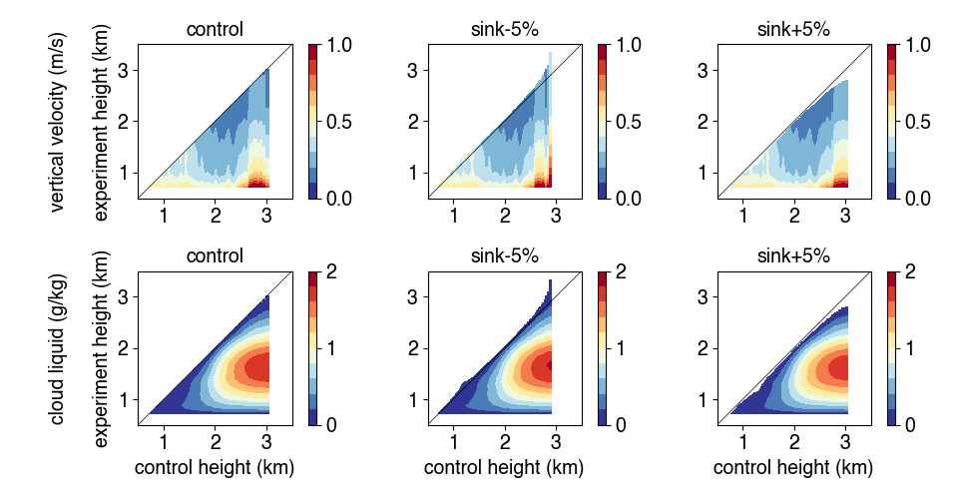
Figure SINKWQL. (a,b,c) Vertical velocity $w$ and cloud liquid (d,e,f) specific humidity $q_{l}=\max{(q_{c}-q_{s})}$ for (a,d) the control, (b,e) moisture sink rates multiplied by 0.95, and (c,f) sink rates multiplied by 1.05.
[trade-cu-model/src/julia/experiment_cloud_w_ql]
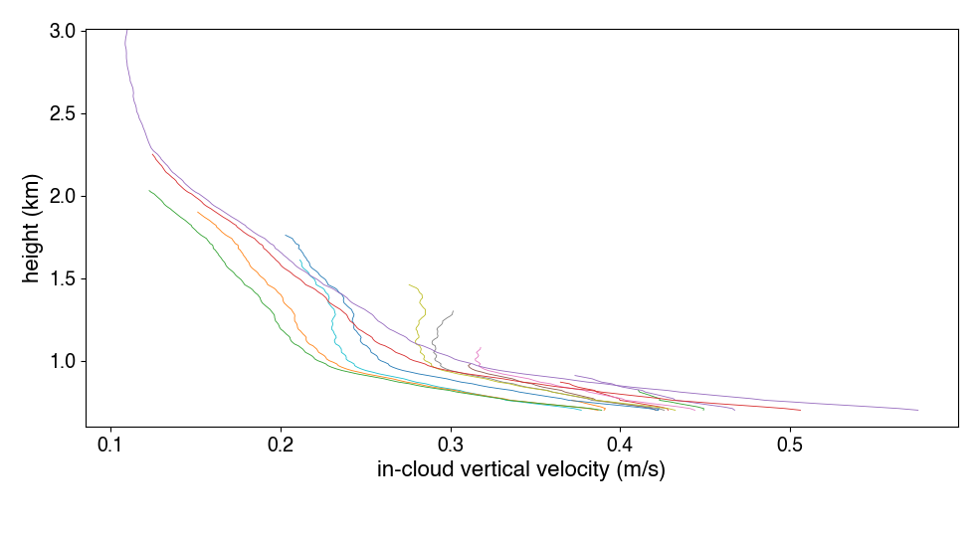
Figure INCLOUDW. In-cloud vertical velocity for the cumulus plumes for 15 moisture sink rates represented in the control simulation.
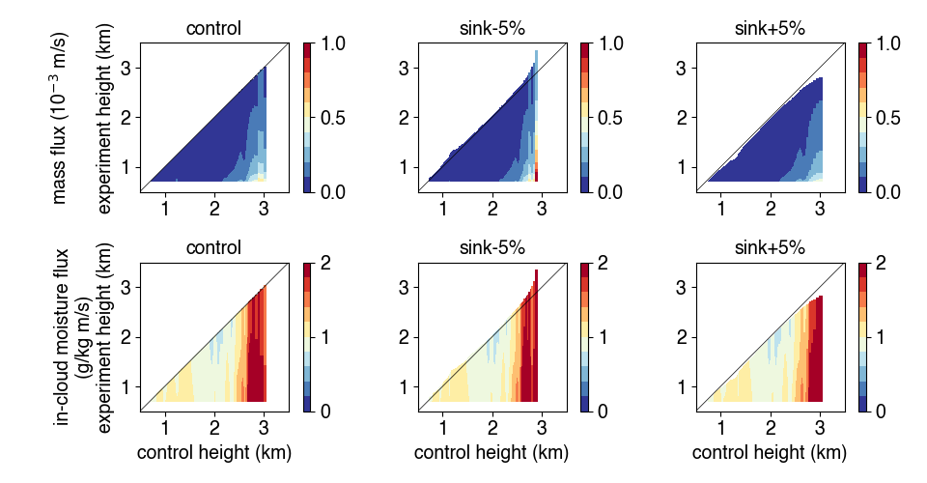
Figure SINKFM. Mass flux $M$ (top) and in-cloud moisture flux $F$ (bottom) for the control experiment, each sink rate diminished by -5%, and each sink rate augmented by +5%. The x-axis shows the control simulation cloud top height $h_{i}$.
[trade-cu-model/src/julia/experiment_cloud_M_F]
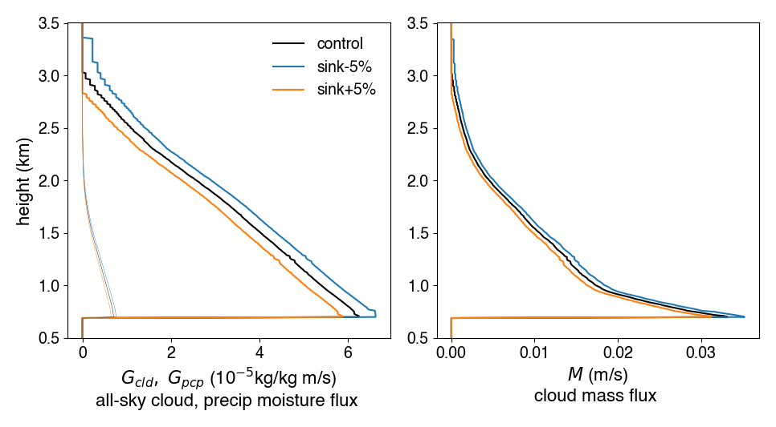
Figure SINKALLSKY. All-sky (a) updraft (thick) and precipitation (thin) moisture fluxes and (b, right) mass flux.

