Shallow cumulus clouds decrease with decreasing tropical overturning circulation

Abstract
Shallow cumulus clouds affect Earth’s planetary albedo and cloud feedback, and explain climate model sensitivity to atmospheric CO$​_{2}$. Increased vertical mixing was previously proposed to reduce cloud area by desiccating the relative humidity of the shallow cumulus layer. Recent observations refute this desiccation hypothesis by showing that mass flux rather than humidity explains mesoscale cloud area, and show that models reproducing this mesoscale correlation have weaker climate sensitivity. Here we predict a decrease of shallow cumulus cloud fraction using a heuristic model of clouds whose moisture flux balances the drying by the large-scale tropical atmospheric overturning circulation. The moisture balance predicts clouds decrease with warming in proportion to the large scale circulation, which in turn decreases –5 % K⁻¹ surface temperature by energetics. Tuned to the observed moisture budget and cloud top height distribution, the cloud model independently reproduces the mesoscale correlation of cloud fraction to cloud base mass flux found over the northeastern tropical Atlantic Ocean in EUREC4A. The –5 % K^{–1} reduction of cloud fraction locally decreases cloud shortwave radiative cooling by 1.6 W m^{–2}.

Abstract - alternate ideas

Sensitivity of climate models to atmospheric CO2 has been explained by shallow cumulus cloud feedback. It has been proposed that increased vertical mixing reduces cloud fraction by drying the shallow cumulus layer, yet observations show cloud fraction is related to cloud base mass flux rather than humidity, suggesting clouds are relatively insensitive to desiccation by mixing. Here we hypothesize that, in a steady climate, the moisture flux by shallow cumulus clouds balances drying by the large scale circulation. From this model, shallow cumulus cloud fraction decreases in proportion to the reduction of their mass flux and the (–5 % K^{–1}) reduction of their large-scale circulation. Humidity changes increase both large-scale drying and cloud moisture flux, with cancelling effects on cloud fraction. Local differences in shallow cloud feedback among different climates can be explained by differences in their Hadley circulation and differences in changes of the ratio of cloud albedo to cloud mass flux.

Introduction
The shallow cumulus regime has a mean cloud fraction of YY % and covers XX % of Earth’s oceans. Variation of shallow cumulus cloud feedback is the largest source of uncertainty in the sensitivity of climate models (Bony et al. 2005; Bony and Dufresne, 2006) to increasing CO2.
Climate models have optically thick ($τ=$ 1.3-23) clouds (ISCCP, Zelinka XXXX, Webb XXXX) near cloud base. Changes of clouds at cloud base amplify low cloud feedbacks and widen the spread of climate projections. Positive feedbacks due to reduction of cloud amount within shallow cumulus cloud regimes dominates feedbacks from changes in the frequency of occurrence (days per month) across the regimes (Zelinka et al. 2023). Low cloud amount is sensitive to humidity at cloud base (Sherwood et al. 2014; Brient et al. 2016; Vial et al. 2017), contributing to the low cloud feedback. In the shallow cumulus cloud feedback, cumulus clouds mix drier air downward, desiccating more extensive cloud-base clouds. Unconstrained differences in the representation of this feedback are hypothesized to account for spread of climate sensitivity.
The strength of the shallow cumulus cloud feedback has been questioned on several grounds: (1) Observations and LES suggest that subcloud layer turbulence moderates cloud base moisture and cloud fraction (Nuijens et al. 2013; Brient et al. 2016; Vial et al. 2017; Vogel et al. 2022; Bretherton et al. 2013). (2) In the winter northeastern tropical Pacific, satellite shallow cumulus clouds have 0.5-3 km heights and weak cloud fraction at cloud base (3 % by random overlap or 8 % by maximum overlap; Fig. 1). EUREC4A airborne lidar and radar cloud-base cloud fraction is only 5.4 % (BASTILIAS XXXX, Vogel et al. 2022). (3) All CMIP6 atmosphere models in the Cloud Forcing Intercomparison Project (CFMIP) have excessive stratocumulus clouds ($3.6≤τ<23)$ in the northern tropical Atlantic, but these stratocumulus clouds increase with warming in 4 of 5 models, a negative feedback (Huang et al. 2026).
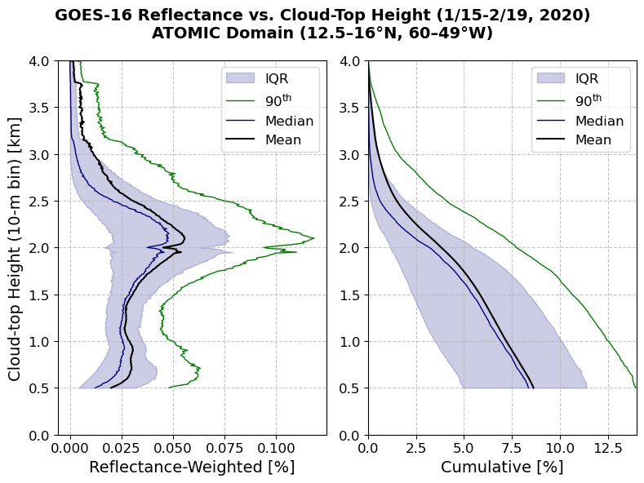
Fig 1.
Sherwood et al. (2014) proposed that in a warmed climate, increased vertical mixing reduces cloud fraction by desiccating the shallow cumulus layer. Field observations from EUREC4A (Stevens et al. 2021; George et al. 2022) show clouds are correlated more strongly to mass flux than to relative humidity, challenging the importance of humidity and its desiccation by vertical mixing, and suggesting that vertical mixing processes are correlated with clouds (Vogel et al. 2022). Climate models that reproduce the observed mesoscale correlation of cloud fraction to cloud-base mass flux have weaker than average climate sensitivity (Vogel et al. 2022).
The mean moisture balance over shallow convective regions provides a way to physically infer the effect of climate change on the clouds, which can be used to understand mean climates of the shallow cumulus regime. In a steady climate, the moisture budget over the shallow cumulus regime is balanced. A change in the drying by the large scale circulation is thus compensated by the opposite moistening by the divergence of the shallow cumulus cloud eddy flux.

The DIM hypothesis
The Dynamical Inhibition of Moisture (DIM) cloud equilibrium hypothesis, predicts the direct effect of large-scale circulation on shallow cumulus clouds. For a climatological mean with a balanced moisture budget, the DIM hypothesis predicts a reduction of shallow cumulus clouds, dimming the planetary albedo, with a weak positive feedback that scales with the shallow cumulus cloud fraction.
In the dynamical inhibition of moisture flux (DIM) hypothesis, shallow cumulus cloud fraction $C$ decreases in proportion to the reduction of subsidence $W$ in the shallow cumulus region. The hypothesis depends on three relationships:
- Subsidence decreases with warming ($d\ln{W}/dT<0$). Based on energetics, Held and Soden (2006, HS06) hypothesize and Vecchi and Soden (2007) estimate $d\ln{W}/dT≈-5 \% K^{-1}$. (Vecchi and Soden show 11% reduction of subsidence for +2.3 K) Variation in the change in subsidence among several CMIP6 climate models is correlated to their warming (Fig. GCMSUBS). While the multi-model variability agrees with HS06, there is variety among the models, which would change the drying by the mean subsidence.

- The vertical cloud moisture flux divergence source balances the drying sink by large scale advection (mostly subsidence) $W$. The steady moisture balance is,
$0=-∂/∂z [M\left(q_{cld}-q_{env}\right)-P]-W∂q_{env}/∂z$,
where $M(q_{cld}-q_{env})$ is the cloud moisture flux, $M$ is the mass flux, $q_{env}$ is the environmental mean humidity, and $P$ (>0) is the precipitation. Factoring the specific humidity dependence from each terms, $M∝W$. We will show precipitation also scales with the mass flux and the humidity. [We compare cumulus mass flux $M$ and $W$ from CFMIP models in Fig. CFMWa.] Imposing moisture balance, we assess the effect of large scale circulation $W$ and environmental moisture $q_{env}$ on the cloud mass and moisture flux profiles.

- The shallow cumulus cloud fraction $C$ is proportional to mass flux, $C∝M$. This is supported by the cloud mass flux definition, $M=Cw_{cld}$. It results from a heuristic model with entrainment rates tuned to reproduce moisture balance with the observed distribution of cloud top heights. [Cumulus mass flux and low cloud fraction from CFMIP models (Cloud Forcing Project, Webb et al. XXXX; COSP REF XXXX) are compared in present (AMIP) and warming (AMIP-p4K) simulations to assess $C∝M∝W$ in Fig. CFMW.]
In sum, the hypothesis predicts $d\ln{C}=d\ln{M}=d\ln{W}$ and $d\ln{C}/dT≈-5 \% K^{-1}$. It is the simplest possible explanation for the fractional change of the shallow cumulus clouds with climate.
Discussion:
Differences from this behavior in climate change simulations suggest (1) variation in the response of the subsidence drying over the shallow cumulus region, or (2 and 3) variations of the proportionalities of clouds or mass flux to the subsidence. A different relationship from $d\ln{M}=d\ln{W}$ is possible if either the entrainment or the vertical structure of convective moisture flux changes. The DIM hypothesis predicts the change in area of low clouds responsible for the moisture flux, but does not account for secondary desiccation of the optically thick stratocumulus clouds at cloud base in most climate models. Divergence of the vertically developed shallow cumulus cloud fraction from $d\ln{C}=d\ln{M}$ is possible if the ratio of the cloud area fraction $C$to the “active” updraft area $A$ with moisture flux $w_{up}(q_{cld}-q_{env})$ changes for clouds in a different climate. [Vogel or ref therein says $C/A≈2$???]
The hypotheses (parts 2 and 3) $d\ln{C}=d\ln{M}=d\ln{W}$ depend on cloud-scale and smaller processes, which are parameterized in climate models. Cloud parameterizations used in these models must satisfy many global constraints, but might not be suited to faithfully simulate the moisture flux and cloud fraction of shallow cumulus clouds.
In our heuristic shallow cumulus model, cloud-scale turbulent processes are represented by lateral entrainment into clouds. Each entrainment rate determines a profile of a cloud’s moisture $q_{cld}$ and determines its cloud top height. We find a spectrum of entrainment rates that give the observed shallow cumulus cloud top height distribution and moisture flux divergence in the present climate. This entrainment distribution represents cloud-scale processes like cloud parameterizations determined from observations and/or large-eddy simulations. The entrainment distribution approximately reproduces the proportionality of cloud fraction to mass flux $C∝M$.
The model for the ensemble of cumulus clouds is described in the methods. The model (1) simulates the cloud eddy fluxes for the large-scale circulation drying and observed clouds in the present climate. It independently reproduces the proportionality of mesoscale mass flux to cloud fraction observed in EUREC4A, and demonstrates mean proportionality among average cloud fraction and mass flux (2). Finally, the model shows (3) the mean shallow cumulus mass flux and cloud fraction decreases in proportion to the reduction of the mean tropical circulation expected in a warmed climate (HS06).
[[MOVE DOWN into RESULTS: The cloud moisture flux also scales with moisture, but the cloud fraction scales with the mass flux. The entrainment rate is the parameter for the cloud- and turbulence-scale processes. We expect to be unchanged by the temperature of the climate. Specifying the entrainment rate distribution allows the cloud top height distribution to change to match the large scale drying term in a changed climate.]]

Results

R1: Cloud fluxes for present large-scale drying
Moisture is steady in a balanced climate. Thus, the large-scale advection and the divergence of the cloud moisture flux balance in the shallow cumulus cloud regime. Clouds entrain and mix the environmental moisture, so cloud and large-scale advective fluxes are both proportional to the mean humidity gradient. The humidity dependence of the cloud humidity difference and the dry advection down the mean moisture gradient cancels, leaving a proportionality between the large scale advection $W$ and cloud mass flux $M$. This balance applies to shallow cumulus clouds with tops below ~4 km.
Cloud updraft plumes start at 700 m. Plume moisture is prognosed by entraining and detraining specific humidity with the surroundings, $∂q_{T}/∂z=-ϵ\left(q_{T}-q\right).$ [equation ENTRAINMETHOD] The entrainment determines the cloud top height. The distribution of entrainment rates are set to match the cloud top height distribution of GOES satellite observations. Plumes have temperature equal to their environment, in the approximation that expansion cooling balances the condensation heating. Total water in excess of the saturation specific humidity condenses as cloud liquid.

R2: Cloud fraction is proportional to mass flux
A mass flux model predicts cloud fraction that is proportional to mass flux, in agreement with EUREC4A observations (Vogel et al. 2022). The model generates cloud water and vertical velocity profiles for thousands of ~260x260 km² GOES satellite reflectance scenes. The mean mass flux binned as a function of scene mean reflectance is shown in Fig. REFLMASSFL. The resulting slope 2.4 % (mm s^{–1})⁻¹ [4.2 cm s⁻¹ %⁻¹] agrees with the correlations between cloud base mass flux and cloud fraction observed from dropsonde circles in EUREC4A (2.4 – X.X % (mm s^{–1})⁻¹; Vogel et al. 2022).
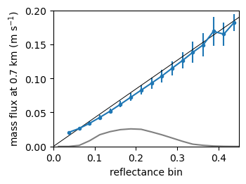
Figure REFLMASSFL. Modeled mean cloud base (700 m) mass flux for all scenes in each reflectance bin (blue points and whiskers). Black line shows a slope of
0.42 cm s^{–1} (% reflectance)^{–1}. Gray line shows relative number (10^{–5}) of scenes in each reflectance bin.

R3: Shallow cumulus cloud fraction decreases in proportion to the reduction of the mean tropical circulation
We use the proportionality between cloud mass flux and reflectance to scale the response of shallow cumulus clouds to changes in the large scale circulation. Saturation specific humidity increases $d\ln{q}=$ +7 % K^{–1} and precipitation increases +2 % K⁻¹, therefor the tropospheric radiative-convective heat balance constrains the large scale tropical overturning circulation to decrease about $d\ln{W}=$ –5 % K^{–1} (Held and Soden, 2006). Subsidence in models approximately obeys this scaling (Fig. GCMSUBS),
Figure GCMSUBS. Change in mean subsidence for the region 10-20 °N, 20-60 °W compared to global mean surface temperature change estimated from equilibrium climate sensitivity (ECS) from 11 CMIP6 climate models. –5 % K^{–1} of +30 hPa day^{–1} = –1.5 hPa day^{–1} K^{–1} (subsidence $ω>0$). Variation of the subsidence to the ECS among models follows the HS06 sensitivity line, but all models underpredict the decrease in subsidence compared to HS06, perhaps because the region extends to 10 °N where $W$ is influenced by the upward branch of the Hadley Circulation.
/Users/deszoeks/Projects/ATOMIC/cmip6/src/axes_5.pdf

Cloud-base clouds
While shallow cumulus decrease with reduced large-scale overturning, local scaling of the moist turbulent subcloud boundary layer suggests that cloud base clouds increase by about the same amount. The net cloud radiative effect depends on the relative amount of shallow cumulus vs. cloud-base clouds.
The cloud top height distribution in GOES observations is uniform with no maximum near cloud base. In some observations and large-eddy simulation (LES) models, however, a cloud fraction maximum of about 5 % is found at cloud base (Bretherton et al. XXXX, Blossey et al. XXXX, Vogel et al. 2022).
The coherent cloudy updraft plumes of our mass flux model are not representative of cloud-base clouds, where moisture condenses from turbulent subcloud thermals. Cloud-base cloud fraction is the fraction of air that reaches saturation at cloud base (Sommeria and Deardorff, 1977; Mellor 1977). For a normal distribution of relative humidity, the cloud fraction is
$$C_{CB}=\left(1-erf\left(s\right)\right)/2$$with the argument $s=(1-{RH}_{CB})/σ_{RH}$, which measures the mean saturation deficit at cloud base relative to the standard deviation of RH.
The mean standard deviation of the specific humidity is found from production-dissipation balance of specific humidity variance,
$$0=-\overline{w'q'}\left(∂\overline{q}/∂z\right)-χ_{q}.$$where $χ_{q}$ is the humidity variance dissipation for the subcloud layer from the surface to cloud base $z_{CB}$ with uniform humidity gradient $∂\overline{q}/∂z$. The dissipation (dimensions $\left[χ_{q}\right]=\left[q'^{2}\right]/time$) is parameterized
$$χ_{q}=k_{1}u^{*}σ_{q}^{2}/z_{CB},$$where $u^{*}={\left(τ/ρ\right)}^{1/2}$ is the friction velocity. The humidity variance resulting from the production-dissipation balance,
$$σ_{q}^{2}=\overline{w'q'}\left(q_{0}-q_{CB}\right)/\left(k_{1}u^{*}\right),$$depends on the surface to cloud base humidity difference $q_{0}-q_{CB}=-z_{CB}\left(∂\overline{q}/∂z\right)$ and the moisture flux $\overline{w'q'}$.
Factoring the flux $\overline{w'q'}=u^{*}q^{*}$into the friction velocity and humidity scale in the specific humidity standard deviation,
$$σ_{q}={\left(u^{*}q^{*}\left(q_{0}-q_{CB}\right)/({k_{1}u}^{*})\right)}^{1/2}={\left(q^{*}\left(q_{0}-q_{CB}\right)/k_{1}\right)}^{1/2},$$and dividing by the saturation specific humidity, the standard deviation of relative humidity RH at cloud base is
$$σ_{RH}={\left(q^{*}\left(q_{0}-q_{CB}\right)/{(k_{1}q}_{sCB}^{2})\right)}^{1/2}.$$It scales with the flux humidity scale $q^{*}$, the subcloud mean humidity difference, and the saturation specific humidity.

Scaling with warming
If wind speed and the vapor transfer coefficient stay the same and $q_{s}$ increases by +7 % K^{–1}, the sensitivity of the surface evaporation flux $E_{0}=ρLC_{E}Uq_{s}(1-RH)$ is limited to +2 % K^{–1}. This is achieved by quenching the surface relative saturation deficit $1-RH$ by –5 % K^{–1}. Taking the mean surface relative humidity at which vapor evaporates in the tropical circulation to be RH = 0.73, the relative saturation deficit 1-RH = 0.27 decreases by –5 % K^{–1} to 1–RH = 0.26, an absolute increase of RH of about +0.01 K^{–1}.
The surface evaporation and cloud-base moisture flux that balance the decrease of precipitation also increase +2 % K^{–1}. We expect the wind and friction velocity $u^{*}$ to remain constant, and the humidity scale $q^{*}$ increases +2 % K^{–1} with the flux. The other specific humidities in $σ_{RH}$ scale with the saturation humidity at +7% K^{–1},
$$dln⁡σ_{RH}=\frac{1}{2}[dln⁡q^{*}+dln⁡(q_{0}-q_{CB})]-dln⁡q_{sCB}=\frac{1}{2}[0.02+0.07]-0.07=-0.025.$$The argument of the error function scales as,
$$dln⁡s=dln⁡(1-{\overline{RH}}_{CB})-dln⁡σ_{RH}=-0.05-(-0.025)=-0.025.$$
The cloud-base cloud fraction is 0.054 $±$0.031 % in EUREC4A (from BASTALIAS, Bony et al., 2022; Vogel et al., 2022). This is near
$$C_{CB}=\left(1-erf\left(s_{0}\right)\right)/2=0.055,$$which is obtained for $s_{0}=1.13$. Scaling $s_{0}$ by 0.975 K^{–1} gives cloud-base cloud fraction
$$C_{CB}\left(0.975s_{0}\right)=0.06,$$a +9 % K^{–1} increase in cloud-base clouds. This 0.005 K^{–1} increase of the cloud-base clouds closely offsets the –0.005 K^{–1} decrease of the shallow cumulus clouds.

Data and Methods
Trade cumulus clouds are intermittent shallow convection in widespread regions of mean subsidence balancing deeper convection elsewhere. Figure MODISISCCP shows ISCCP-H cloud top height and optical thickness cloud fraction histograms observed from the 1-km pixel MODIS observations in the Northern Atlantic shallow cumulus region (80-20°W, 15-35°N) for January-February of 2019-2021. These high-resolution observations avoid partially cloudy pixels and are designed to be compared to COSP satellite simulators in climate models. Most (29.1%) of the clouds are below 800 hPa with cloud optical thickness between 1.3-9.4.
Water fluxes by the clouds are diagnosed to balance a simple vertical water budget for the trade cumulus cloud layer. The updraft area fraction is calculated over large (1000 km)² regions, assuming updraft cores are cloudy with saturated specific humidity. The horizontal-time ensemble mean trade cumulus water (vapor + liquid) flux due to updrafts and precipitation balances mean subsidence. Cloud mass flux is initialized at cloud base to match the mean observed surface evaporation minus precipitation.

Cloud ensemble $a_{i}(h_{i})$
We partition the all-sky mean eddy flux $G$ to the cloud categories $i$. Clouds with area fraction $a_{i}$ have cloud tops that reach $h_{i}$ as distributed in GOES satellite images (Fig. GOESCDF).

Figure GOESCDF. Vertical cumulative distribution of cloud area fraction.

Large scale eddy flux
The all-sky mean large scale eddy flux $G$ is the integral of $S_{LS},$the large-scale subsidence and horizontal advection source, with the cloud base moisture flux as the boundary condition:
$$G\left(z\right)=G_{CB}+G_{LS}\left(z\right),$$
with $G_{LS}\left(z\right)=\int_{z_{CB}}^{z}{S_{LS} dz'}$.
$$G\left(z\right)=G_{CB}+G_{LS}\left(z\right)$$

Partitioning the mass flux into the ensemble of clouds is an underconstrained problem. We close the problem by choosing vertically uniform flux in each cloud category $i$. The all-sky mean flux profile $G(z)$ has a flux difference at each height $h_{i}$ of ${\left(ΔG\right)}_{i}=G(h_{i+1})-G(h_{i})$. This flux difference is assumed to be carried by the clouds with area fraction $a_{i}$ and height $h_{i}$, so the mean flux in cloud category $i$ is vertically uniform, $F_{i}={a_{i}^{-1}\left(ΔG\right)}_{i}$. Fig. FEDDYMETHOD shows the distribution of fluxes $F_{i}$ to each height category. The cloud top height $h_{i}$ of each cloud is determined by its moisture sink rate parameter.
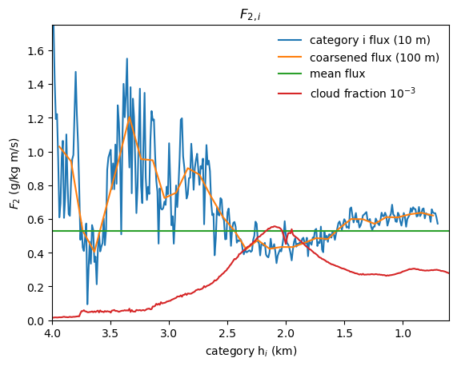
Figure FEDDYMETHOD. Vertically uniform cloudy-sky eddy flux $F_{2,i}$ from Method 2 at 10-m cloud top height $h_{i}$ resolution (blue), and 100-m resolution (orange). Mean flux over the cloud ensemble (green), weighted by cloud area fraction (red).

AMIP data
An-Yi is downloading ISCCP cloud fraction, cumulus mass flux (cm), and mean vertical velocity variables from CMIP6/CFMIP amip (historical) and amip-p4k (historical SST + 4 K) from 5 available models. Differences of the variables between amip-p4k and amip during January-February 1979-2014 in the North Atlantic shallow cumulus region (YY ° N, XX ° W) are used to compute the relative slopes $Δ\ln{C}, Δ\ln{W},$ and $Δ\ln{M}$ where $Δ$ is represents the difference per +1 K SST warming.

Model
From the diagnostic moisture closure, we compute the trade cumulus ensemble eddy flux $F_{i}\left(z\right)=F_{cld,i}\left(z\right)+F_{P,i}\left(z\right)$ due to cumulus updrafts and precipitation. Cloud updrafts are responsible for most of the eddy flux. A small part is contributed by precipitation. We will first model the water in the clouds, then their conversion to precipitation.

Clouds
A budget for steady total water $q_{T}$ in the updraft with velocity $w$ depends on its entrainment and precipitation sinks. The equations for the suspended liquid and water vapor in the cloud are
$$\frac{∂q_{l}}{∂t}=-w\frac{∂q_{l}}{∂z}-wγ-ϵwq_{l}-αwq_{l}$$and$$\frac{∂q_{v}}{∂t}=-w\frac{∂q_{v}}{∂z}+wγ-ϵw{(q}_{v}-q),$$
where $ϵ$ (km^{–1}) is the lateral entrainment coefficient, $α$ is the autoconversion of cloud liquid to precipitation, and $γ$ (<0) is the moist adiabatic condensation rate of water vapor (in a parcel) per unit height, $γ={\left(\frac{dq_{s}}{dz}\right)}_{m}=\left(\frac{dq_{s}}{dT}\right){\left(\frac{dT}{dz}\right)}_{m}.$ The dependence on this condensation rate is eliminated in the total cloud water balance equation. Summing the liquid and vapor, and taking the Eulerian total specific humidity $q_{T}$ to be steady,
$$\frac{∂q_{T}}{∂t}=0=-w\frac{∂q_{T}}{∂z}-ϵw{(q}_{T}-q)-αwq_{l}.$$QTBALANCEThough the total water is insensitive to the condensation rate $γ$, it implicitly depends on the saturation specific humidity $q_{s}$ in the cloud. The updraft advects moisture upwards, but the solution for $q_{T}$ is quantitatively insensitive to the updraft velocity and to the moisture flux.
Above the cloud, $q_{l}=0$, so there is no autoconversion. Only entrainment relaxes humidity to that of the environment:
$$\frac{∂q_{T}}{∂z}=-ϵ\left(q_{T}-q\right).$$
In the cloud, $q_{l}=q_{T}-q_{s}$. Autoconversion removes cloud liquid, relaxing total water toward $q_{s}$, and entrainment relaxes total water toward $q$. Thus, equation QTBALANCE is, written
$$\frac{∂q_{T}}{∂z}=-\left(ϵ+α\right)\left(q_{T}-\tilde{q}\right),$$QRELAXrelaxing $q_{T},$ at the total vertical sink rate $ϵ+α$, toward the humidity
$$\tilde{q}=(ϵq+αq_{s})/(ϵ+α)=\left(1-x\right)q+xq_{s}.$$QTILDE
between $q$and $q_{s}$.
[q and cloud top where q=qs depends only on the sounding and cloud base initial condition, so it can be computed from the sounding, without the flux condition. In practice, cloud top heights are computed for different total sink rates, giving a map between the two. Then these clouds ]
The total sink rate $ϵ+α$ is a key parameter, which determines the cloud water, water flux, and cloud top height. Cloud liquid and water vapor profiles are computed for a handful of total sink rates in Fig. MOISTURECLOUDS.
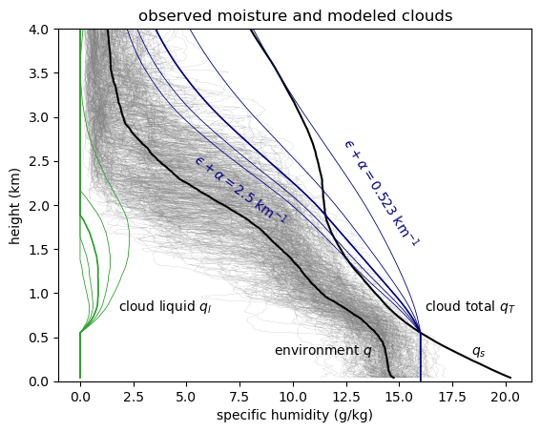
Figure MOISTURECLOUDS. Observed specific humidity from the ATOMIC Ron Brown radiosondes (gray), and their mean $q$ (black) and saturation specific humidity $q_{s}$. Cloud updraft total specific humidity $q_{T}$ (blue) and cloud liquid $q_{l}$ (green) for a range of total moisture sink rates $ϵ+α$ (entrainment and autoconversion coefficients, km^{–1}). Clouds transport moisture up, continuously diluting it toward a mixture between $q$ and $q_{s}$.
[ /home/deszoeks/Projects/ATOMIC/ATOMIC_GOES/julia/RHB/sonde/moisture_clouds.pdf ]
The profiles of $q_{T}$ predicted by this entraining-precipitating updraft model agree with the most humid air sampled on occasion by radiosondes. Cloud height is limited by entrainment of relatively dry air between 1.5-3 km, representing the mean distribution of the trade inversion. The clouds occupy a range of depths representative of trade cumulus clouds, with deeper clouds for lower rates of entrainment and autoconversion. The intermediate total sink rate of $ϵ+α=1.5 {km}^{-1}$ gives maximum cloud liquid specific humidity exceeding 0.8 g kg^{–1} over 0.7-1.5 km and cloud top height of 1.9 km.

Precipitation and updraft fluxes
Downward precipitation water flux within a cloud $F_{P}<0$ is generated by autoconversion $α$ from cloud liquid, For the updraft with no storage of cloud liquid water, the precipitation source is
$$-\frac{∂F_{P}}{∂z}=-αwq_{l}=xw\left(\frac{∂q_{l}}{∂z}+γ\right),$$where ($∂q_{l}/∂z+γ)$ is the total moisture source in the updraft. The ratio of the autoconversion to the total moisture sink $x=α/{(ϵ+α})$ is the precipitation efficiency.
The solution for each cloud type $i$ is found by numerically integrating the precipitation. The precipitation sink,
$$\frac{∂F_{P,i}}{∂z}=α_{i}w_{i}q_{l,i},$$instantaneously removes liquid water from the cloud and the column.
An example of the all-sky fluxes is computed for a single cloud with, $ϵ+α=1.5 {km}^{-1}$, $h=1.9$ km and all-sky cloud-base flux $G(z_{CB})=$ 145 W m^{–2} $=6.0×{10}^{-5}$ kg m^{–2} s^{–1} (Fig. QMASSFLX). For this case, $F$ goes to zero at 8 km. Precipitation increases downward below the cloud top. At a precipitation efficiency of ~0.5, the cloud-base precipitation $P_{CB}=|F_{P}|$ equals the mean surface precipitation, $P_{0}=$25 W m^{–2} $=9.0×{10}^{-6}$kg m^{–2} s^{–1}, observed on the research vessel Ron Brown during EUREC4A/ATOMIC. Evaporation was $E_{0}=$ 180 W m^{–2} $=6.5×{10}^{-5}$ kg m^{–2} s^{–1}. The mass flux is $M=G_{cld}/(q_{T}-q)$(Fig. QMASSFLX). Most of the flux (~90 %) is below 3 km in the trade cumulus layer. Most of the updraft moisture $q_{T}$ is vapor, and the moist updraft $q_{T}-q>0$ generates upward moisture flux, even above the cloud.
Fig. QMASSFLX is a simulation for a single cloud. The distribution of cloud top heights and the total water fluxes are used to constrain an ensemble of clouds at constant precipitation efficiency and varying sink rates ${\left(ϵ+α\right)}_{i}$.
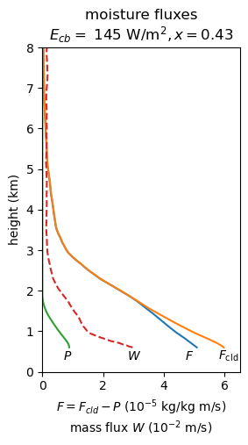
Figure QMASSFLX. Total moisture flux to balance the large-scale moisture sink (blue), cloud moisture flux (orange), and (downward) precipitation flux (green), and mass flux (red) from the model.
The cloud (a) total specific humidity and (b) cloud-environment humidity difference as a function of height and total sink rate parameter is shown for an ensemble of sink rates in Fig. WPROF. This is used to compute (c) cloud-mean vertical velocity for each cloud. The total mass flux is $M=∑a_{i}w_{i}$, where the total cloud area is $a=∑a_{i}$.

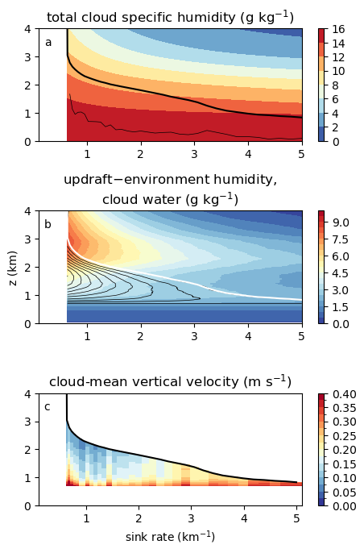
Figure WPROF. Modeled ensemble of clouds for precipitation efficiency $x=0.53$ as a function of total sink rate. (a) Cloud updraft total specific humidity $q_{T}$ (shaded), cloud top (thick black), and rescaled cloud area per unit sink rate (thin black); (b) cloud updraft total – environment specific humidity difference $q_{T}-q$ (shaded), and cloud liquid specific humidity $q_{l}$ (black contours); and (c) updraft vertical velocity.

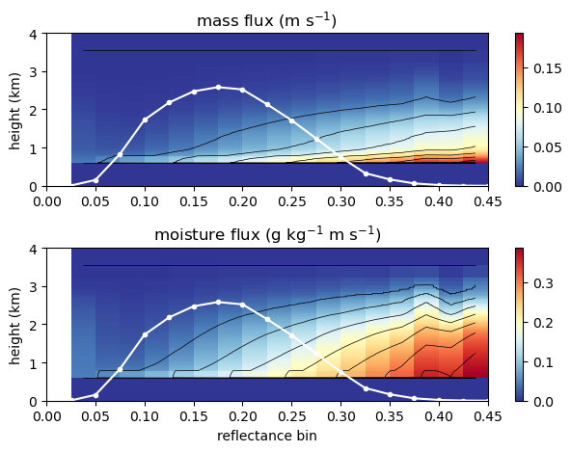
Figure MASSGFLUX. Model mass flux (a) and moisture flux (b) for 260$×$260 km^{–2} GOES scenes matching reflectance bins of 0-0.45, with precipitation efficiency $x=0.53$. White line shows the number (10^{–3}) of scenes in each 0.025 reflectance bin.

Cloud numerical solution
At each height and for each cloud category $i$,
$w_{i}q_{l,i}=F_{cld,i} q_{l,i}/(q_{T,i}-q)$ and $F_{cld,i}=F-F_{P_{i}}$. The precipitation equation is written in differential form as
$$dF_{P,i}=\frac{α_{i}q_{l,i}}{q_{T,i}-q}(F-F_{P,i}) dz.$$We integrate precipitation downward from the top of each cloud, $F_{P,i}\left(h_{i}\right)=0$, in trapezoidal vertical steps denoted by superscripts $k$,
$$F_{P,i}^{k}=-\frac{-\left(1+c_{i}^{k}\right)F_{P,i}^{k+1}+c^{k}F^{k}+c^{k+1}F^{k+1}}{1-c^{k}},$$where $c_{i}^{k}= {[α}_{i}q_{l,i}^{k} dz]/[2\left(q_{T,i}^{k}-q^{k}\right)]$.

Summary
[[For discussion on the compensation between cumulus and stratocumulus clouds: Myers and Norris (2014) show, all else being equal, subsidence reduces stratocumulus clouds. Cloud properties and within-regime feedbacks are similar between shallow cumulus and optically thicker stratocumulus clouds (Tselioudis et al., 2021; Zelinka et al. 2025), suggesting temperature-induced changes result in compensation between stratocumulus and shallow cumulus cloud types. Sherwood’s (2014) desiccation hypothesis describes a version of this competition, whereby shallow cumulus convection dries lower levels near cloud base that support stratocumulus clouds. Based on their similar behavior and feedbacks (Zelinka et al. 2025) we suggest considering the stratocumulus and shallow cumulus as a continuum. Regardless, here shallow cumulus clouds are nearly ubiquitous, to the exclusion of stratocumulus clouds, over the northern tropical Atlantic in January-February.]]

Figure MODISISCCP. ISCCP-H joint histogram of 1-km pixel cloud fraction in 7 optical thickness and cloud top pressure bins in the North Atlantic shallow cumulus region (12.5-16 °N, 60-49 °W) in Jan-Feb of 2019-2021.
Figure GOESISCCP. GOES-16 (a) cloud fraction by cloud type for 12.5-16 °N, 60-49 °W, 2020 Jan 15- February 28. (b) Shortwave cloud radiative effect (CRE) for each cloud top pressure and optical depth. The total cloud radiative effect for clouds below 680 hPa is 32 W m^{–2}. Reducing low cloud fraction by –5 % K^{–1} would have a local radiative effect of +1.6 W m^{–2} K^{–1}.

Appendix: buoyancy
The moisture flux constraint replaces a buoyancy closure for cloud model. The moisture closure is good for climate and seasonal time scales, but buoyancy should be used on weather time scales. Without doing anything to predict it, buoyancy in our cloud model is diagnosed from the density potential temperature $θ_{ρup}$ (i.e., “virtual temperature,” including the effect of the modeled water vapor and liquid water on density) of the entraining updraft parcel. The cloud height $h_{i}$ is comparable to the height at which the buoyancy $b=g(θ_{ρup}-θ_{ρenv})/θ_{ρenv}$ integrates to zero.
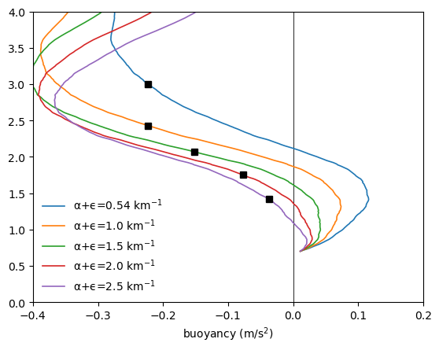
Fig will not be shown. Buoyancy integral is zero at the squares.

