Constraining Precipitation Efficiency
In the low-cloud regime of interest, the precipitation efficiency ($x$) is defined as the ratio of the auto-conversion rate ($α$) of precipitation to the sum of the auto-conversion and entrainment ($ε$) rates:
$$x=\frac{α}{α+ε} .$$
The auto-conversion rate (${km}^{-1}$) represents the rate at which condensed water droplets (suspended liquid water) precipitate out, thereby reducing the liquid water content within the cloud. The entrainment rate (${km}^{-1}$) represents the rate at which dry air mixes into the cloud, reducing the total water mixing ratio (i.e., decreasing water vapor content). Both processes act as sinks for total water in the cloud. Therefore, the sum ($α+ε$) is referred to as the total sink rate, and the ratio of $α$ to this total sink rate defines the precipitation efficiency ($x$).
To determine an appropriate precipitation efficiency for a cloud ensemble (i.e., low clouds spanning a range of cloud-top heights), we use a trade cumulus model, constrained by observed sounding and satellite data, to identify the precipitation efficiency that yields a weighted precipitation value closest to the observed mean.

Cloud fraction inferred from cloud-top height distribution
Using cloud-top height (CTH) estimates from GOES-16 satellite imagery (20-min temporal resolution) during 15 January–19 February 2020, we infer the cloud fraction ($a_{cld}$) of individual low clouds below 4 km within the North Atlantic trade-wind region (12.5–16°N, 60–49°W; ATOMIC domain). We first remove all pixels with CTH greater than 4 km, since our focus is on in low clouds. The remaining CTH values are then sorted into 10-m vertical bins, and the CTH distribution is computed for each image, weighted by the reflectance of each pixel (Fig. 1, left panel). Specifically, for each vertical bin we compute:
$$\frac{\sum{r_{i}}}{N} ,$$
where $N$ is the total number of valid pixels in the domain and $r$ is the reflectance of pixel $i$. Because reflectance retrievals are only available during daytime, this results in 1192 usable images and corresponding CTH vertical distribution profiles. To infer cloud fraction, we vertically accumulate the CTH distributions from the top (4 km) downward, and then take the average across time (1192 images). This yields cloud fraction as a function of cloud-top height over the range 0.5–4 km. The resulting cloud-top-dependent cloud fraction is shown in the right panel of Figure 1 (black line).

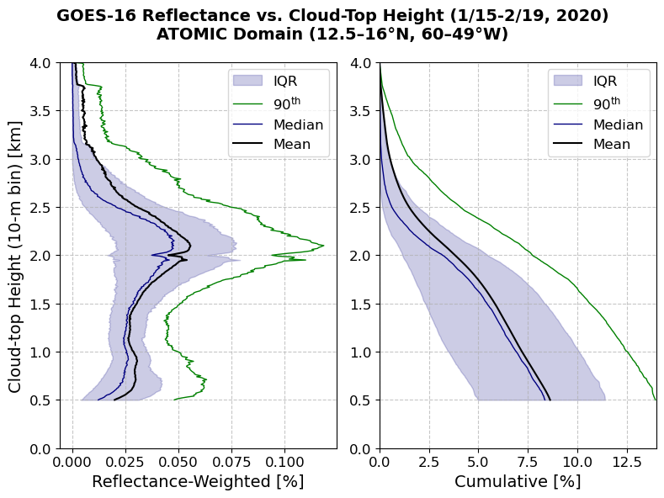
Figure 1. Cloud-top height distributions using 10 m vertical bins. (Left) Vertical distribution of cloud-top height, weighted by cloud-top reflectance, for clouds below 4 km. (Right) Cumulative cloud-top height distribution obtained by integrating downward from 4 km.

Constraining precipitation efficiency
Because the moisture flux within clouds must balance the prescribed large-scale advection and subsidence, we compute a two-dimensional spectrum of cloud-base precipitation rates (Fig. 2b) by varying the total sink rate ($α+ε$) from 0.5 to 5 ${km}^{-1}$ and the precipitation efficiency ($x$) from 0 to 1. The precipitation rate at the cloud base is obtained by integrating downward from each cloud-top height (CTH), determined as the level where liquid water content first reaches zero just above the cloud top. Shading in Figure 2a and 2b represents the CTH and corresponding cloud-base precipitation rate ($P$), respectively, as functions of precipitation efficiency ($x$) and total sink rate ($α+ε$).
Since cloud fraction ($a_{cld}$) is a function of CTH, it can also be expressed as a function of precipitation efficiency and total sink rate by interpolating the cloud-fraction distribution onto the CTH field shown in Figure 2a (contour lines). The maximum cloud fraction for the cloud ensemble in this trade-wind region is approximately 8%.
We then calculate the weighted precipitation rate for each sink rate by multiplying the precipitation ($P_{j}$) by its corresponding cloud fraction ($a_{cld, j}$). The overall mean precipitation as a function of precipitation efficiency is then obtained by summing over all sink rates and normalizing by total cloud fraction ($a_{cld}$):
$$P\left(x\right)=\frac{\sum_{j}{P_{j}(x)a_{cld, j}(x)}}{a_{cld}} .$$
Figure 2c shows the resulting weighted mean precipitation as a function of precipitation efficiency. Excluding unrealistically high efficiencies (close to 1), we find that the precipitation efficiency ($x$) producing a mean precipitation rate closest to the observed mean ($25.4 {Wm}^{-2}≅0.03 mm{hr}^{-1}$) is approximately 0.51.

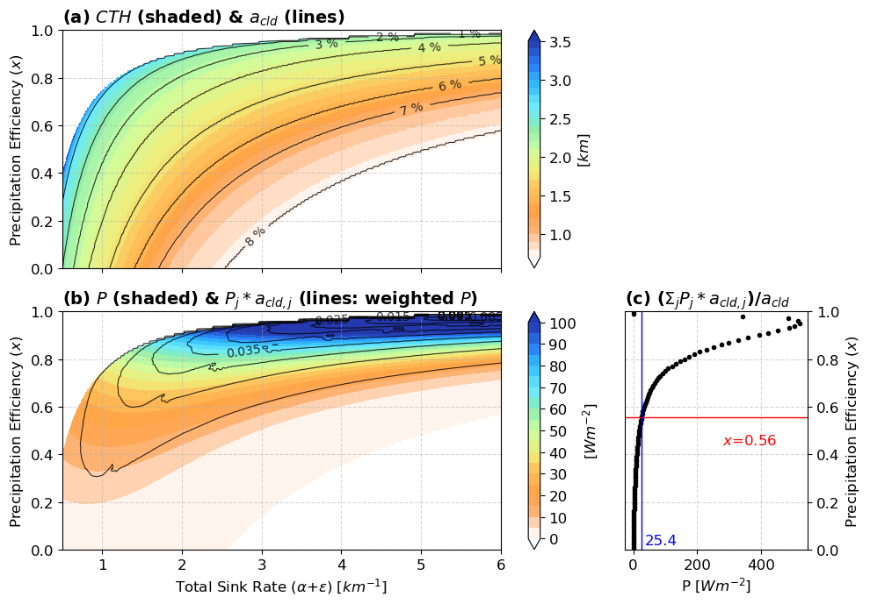
Figure 2. Constraining precipitation efficiency. (a) Cloud-top height (CTH) distribution (shading) from the model and the corresponding cumulative cloud fraction ($a_{cld}$, contour lines) derived from satellite observations, shown across varying total sink rates ($α+ε$) and precipitation efficiencies ($x$). (b) Cloud-base precipitation ($P$, shaded) from the model and the weighted precipitation (contours), computed as precipitation multiplied by cloud fraction ($P_{j}*a_{cld, j}$). (c) Sum of weighted precipitation divided by cloud fraction ($a_{cld}$) as a function of precipitation efficiency. The blue value ($25.4 {Wm}^{-2}≅0.03 mm{hr}^{-1}$) represents the observed mean precipitation rate from the Ronald Brown ship measurements. The red value ($x=0.51$) denotes the precipitation efficiency that yields the weighted precipitation closest to the observed value.

The precipitation efficiency ($x$) is now constrained at 0.51, the resulting precipitation distribution is expressed as a function of total sink rate, corresponding to varying cloud-top heights and their respective cloud fractions ($a_{cld, j}$). As shown in Figure 3, the cumulative weighted precipitation ($P$, blue dashed line) for the ensemble of clouds is $25.4 {Wm}^{-2}$, consistent with the observed mean value.

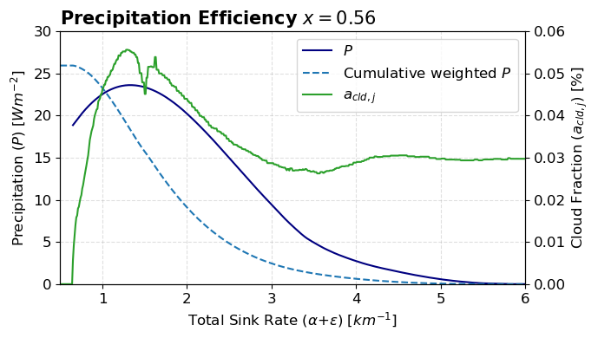
Figure 3. Precipitation distribution for a range of total sink rates. The precipitation efficiency is fixed at $x=0.51$. The model precipitation ($P$) is shown by the blue solid line (left y-axis). The cumulative weighted precipitation is shown by the blue dashed line (left y-axis), and the cloud fraction of each sink rate ($a_{cld, j}$) is shown by the green solid line (right y-axis).

