Decreasing hydrological circulation dims shallow cumulus clouds

Simon P. de Szoeke
An-Yi Huang
Andrea Jenney
Patrick C. Andrews

Abstract
Shallow cumulus clouds affect Earth’s planetary albedo and explain the spread in climate model sensitivity to atmospheric CO$​_{2}$. Desiccating the cloud layer by increasing vertical mixing has been proposed to reduce shallow cumulus clouds, but recent observations of mesoscale variability show that, rather than humidity, mass flux explains cloud fraction. To balance precipitation with radiative cooling, the tropospheric circulation decreases –5 % per K mean surface temperature. Here we estimate the effect of mean surface temperature changes on shallow cumulus clouds. Moisture balance of the lower troposphere predicts shallow cumulus mass flux and cloud albedo decrease by –5 % K^{–1} in proportion to the reduced circulation. Increasing specific humidity +7% for the same moisture flux further reduces cumulus mass flux (–2.8%). Subcloud mean and turbulent fluctuations of RH change the cloud base cloud fraction, widening the local estimated shallow cloud change to –2.5 to –7.8 % K^{–1}. Shallow cumulus clouds dim with a radiative feedback of +0.5 to +1.6 W m^{–2} and the net local cloud radiative feedback of +0.4 to +1.3 W m^{–2} per K warming of mean surface temperature.

Introduction
The shallow cumulus cloud regime, with a mean cloud fraction of 0.2-0.4, covers ~15 % of Earth’s oceans (Stevens et al. 2019, Jacob et al, 2020). Satellite observations of the last decades show clearing of optically thin low clouds represents the strongest contribution to shortwave cloud feedback (Jin et al. 2026), and in models, clearing of shallow cumulus clouds dominates changes in the frequency of occurrence across different regimes (Zelinka et al. 2023). Low cloud amounts, especially in subsiding regions, mostly decrease with warming in climate models (ISCCP, Zelinka et al., 2023; Webb and Lock, 2013; Webb et al. 2017, Jin et al. 2026). This positive shallow cumulus feedback varies among models, widening the spread of climate model projected temperature sensitivity to CO₂ (Bony and Dufresne, 2005; Bony et al., 2006).
Low cloud fraction is sensitive to humidity at cloud base (Sherwood et al. 2014; Brient et al. 2016; Vial et al. 2017). In the mixing-induced low cloud feedback, cumulus clouds and shallow circulations mix drier air downward, desiccating clouds near their lifting condensation level (LCL). CMIP3 models with more convective mixing were found to export more moisture from the boundary layer under warming, with the strength of this cloud desiccation explaining variations in their temperature sensitivity (Sherwood et al. 2014).
In the northern tropical Atlantic in Jan-Feb 2020, airborne lidar and radar observed cloud-base cloud fraction of 5 % (Bony et al., 2022; Vogel et al., 2022). Satellite albedo from GOES shows shallow clouds have 3-8% cloud albedo due to clouds below 1 km (depending on overlap, Fig. REFLALBEDO). CMIP6 control simulations tend to have fewer and optically thicker clouds than observed over the northern tropical Atlantic in January-February (Methods Fig. ALLCOSP). Observations and LES show that subcloud turbulence moderates cloud base moisture and cloud fraction (Nuijens et al., 2013; Bretherton et al., 2013; Brient et al., 2016; Vial et al., 2017).
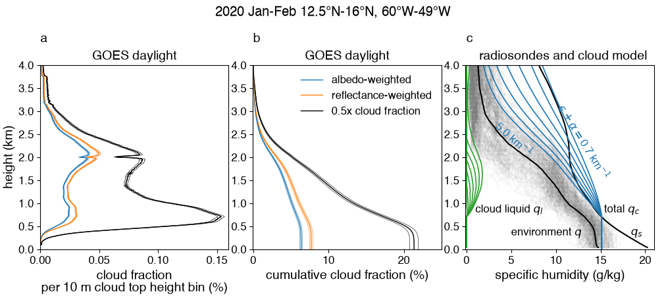
Fig REFLALBEDO. Vertical profile of fraction of cloudy pixels (black), cloud albedo-weighted cloud fraction, and reflectance-weighted cloud fraction below 4 km from GOES 2x2-km pixels for 2020 Jan 15 – Feb 19 12.5-16 °N, 60-49 ° W (a) in 10-m cloud top height bins, and (b) integrated downward. Reflectance is directly observed, and albedo is computed from cloud optical thickness (methods: Low clouds in trade cumulus regions). Cloud frequency counts pixels with optically thin clouds, so albedo- and reflectance-weighted cloud fraction are less than cloud pixel fraction (Fig. GOESISCCP). Shortwave cloud radiative effect is proportional to cloud albedo. (c) Observed specific humidity from radiosondes (gray), and their mean $q$ (black) and saturation specific humidity $q_{s}$. Cloud updraft total specific humidity $q_{T}$ (blue) and cloud liquid $q_{l}$ (green) for a range of total (entrainment + autoconversion; $ϵ+α$) moisture sink rate (km^{–1}).
[/Users/deszoeks/Projects/ATOMIC/trade-cu-model/src/julia/albedo_vs_time_height_modelcloud.jl
shcu_cloud_albedo_refl_cloudmodel.pdf]

In the mixing-induced low cloud mechanism, increased vertical mixing reduces cloud fraction in a warmer climate by desiccating the shallow cumulus layer. Yet EUREC4A field observations (Stevens et al. 2021; George et al. 2022) show tradewind shallow cumulus clouds are correlated more strongly (r = 0.72) to cloud-base mass flux than to relative humidity. This challenges the importance of humidity and suggests that vertical mixing processes are instead positively correlated with local shallow cumulus clouds.
The vertical distribution of cloud top height (Fig. REFLALBEDO a,b) shows most cloud tops are below 3 km, with a strong decrease of cloud tops between 2-3 km, corresponding to the humidicline in the radiosonde specific humidity (Fig. REFLALBEDO c) associated with the trade inversion. This structure suggests divergence of shallow cumulus moisture flux in the trade inversion matches subsidence advection of dry air from above 3 km.

The DIM mechanism
The decrease in mass flux (DIM) mechanism predicts shallow cumulus clouds decrease in proportion to the reduction of the mean tropical large-scale circulation. It is based on four relationships:
(1) The saturation and environmental humidity $q$ and cloud humidity $q_{c}$ increase +7% per K mean surface temperature warming. (2) The large-scale tropical circulation slows with by about –5% K⁻¹ due to the specific humidity and a +2% increase in precipitation (Held and Soden, 2006, HS06; Vecchi and Soden, 2007). (3) Shallow cumulus regions have steady mean moisture: large-scale advection (mostly subsidence) dries the lower troposphere and cumulus moisture flux moistens it, $$0=-∂/∂z\left[M\left(q_{c}-q\right)-P\right]-(advection),$$where $M$is the cumulus mass flux, $P$ is precipitation, $q_{c}$ is the cloud humidity, and $q$ is the environmental humidity. Cumulus moisture fluxes that balance the large-scale drying are modeled for an ensemble of cumulus clouds.
Factoring out the change of the humidities, the mass flux is proportional to the circulation, $M∝W$. (4) The shallow cumulus cloud fraction $C$is proportional to mass flux, $M=Cw$, where $w$ is the in-cloud vertical velocity. This is supported by field observations where cloud base $M$ from mesoscale divergence was correlated (r=0.72) to $C$with $C/M=$ 2.4-4.0 % (cm s^{–1})^{–1} (Vogel et al., 2022). Assuming constant in-cloud optical depth, changes in the pixel- or scene-mean albedo due to clouds $A$ (hereafter cloud albedo) are assumed proportional to cloud fraction, and hence mass flux, $C∝M$. We assume scene-mean cloud area fraction $C$ is equal to the scene-mean albedo due to clouds $A$.
The DIM hypothesis, ${ΔC}/C={ΔM}/M={ΔW}/W,$ is a simple explanation for the change of clouds with the climate that predicts how the average albedo due to shallow cumulus clouds dims with warming. This dimming generates a positive cloud radiative feedback that scales with the present global mean albedo due to shallow cumulus clouds.

Cloud and flux model
To predict the response of shallow cumulus clouds to climate, we separate the expected thermodynamic and circulation changes from the properties of cloud geometry, turbulence, and microphysics, which we assume not to change. The autoconversion of cloud droplets to precipitation, the lateral entrainment rate, and the ratio of the area of active updraft to cloud area, are parameterized to match emergent properties of the clouds in the present climate and are not expected to change with thermodynamic and circulation responses to CO₂.
A mass flux model consisting of an ensemble of entraining and precipitating cloud plumes with different moisture sink rates simulates cloud humidity, cloud top height, mass fluxes, and moisture fluxes (see Methods). The moisture sink rate parameterizes turbulence-scale entrainment and precipitation conversion processes within the clouds. Plumes with weaker moisture sink rates have higher cloud tops. Cloud specific humidity $q_{c}$ and liquid specific humidity $q_{l}$ are illustrated with several moisture sink rates in Fig. REFLALBEDO. The fraction of clouds at each moisture sink rate is set to match the cloud top height distribution of satellite observations (Fig. REFLALBEDO) below 4 km. The large-scale subsiding branch of the tropical circulation dries the shallow cumulus boundary layer (methods Fig. LSADV). Requiring the clouds to balance the large scale advective drying, we assess the effect of large-scale circulation $W$ and environmental moisture $q$ on the cloud mass flux $M$.

Results

Climate experiments
Control simulations are run with the present moisture profile and large scale drying. The fraction of clouds at each (entrainment + precipitation) moisture sink rate is obtained by balancing the cloud-top moisture flux divergence to the advective drying. Experiments predict the mass flux for cloud updrafts with weaker large scale advective drying and moister atmospheric soundings, corresponding to +1 K surface temperature warming. Each experiment has a set of updrafts with identical distribution of moisture sink rates as the control simulation. The cloud top height and cloud flux is solved for each moisture sink rate, specific humidity, and saturation specific humidity profile.
The DIM experiment consists of reduced large scale advection (–5%) and increased specific humidity and saturation specific humidity (+7%), two basic features expected to change in the tropical climate. Table 1 shows changes $ΔM/M_{ctl}={M_{exp}}/{M_{ctl}}-1$ relative to the control experiment. The changes are further separated in experiments adv-5% and q&qs+7%. Experiment adv-5% reduces large scale drying (HS06), decreasing mass flux by $ΔM/M_{ctl}=$ –5 %. In experiment Ecb+2%, cloud base vapor flux $E_{cb}$ has no additional effect on the mass flux. In addition to the reduced advective drying, in experiment q&qs+7%, specific humidity and saturation specific humidity increase +7%, keeping RH constant, further reducing clouds to 7.56 %.
Increasing specific humidity increases the vertical moisture gradient and the cumulus cloud-environment humidity difference $q_{c}-q$. The mass flux $M$ required for the cloud moisture flux $M(q_{c}-q)$ to balance the large-scale drying decreases by –7.56% compared to the control simulation, –2.6% more than subsidence-5%. Also increasing the specific humidity reduces clouds about 1.5 times as much as just decreasing the subsidence.
Relative humidity changes can explain changes to surface evaporation expected with warming. For surface evaporation $E∝Uq_{s}\left(1-RH\right)$ to increase +2% K^{–1} (i.e., in proportion with precipitation) the product of wind speed and saturation deficit $U(1-RH)$ must decrease by –5% K^{–1}. One extreme is for the wind speed to decrease –5% K ^{–1}, consistent with the slowing of the circulation. In that case, $E$ increases while RH remains constant. In another extreme, wind speed stays constant, so the surface relative humidity RH increases, quenching the surface relative saturation deficit $1-RH$ by –5 % K^{–1}. In this case, mean surface RH = 0.73 increases at most +0.014 K^{–1} (absolute). Though surface RH increases, RH below cloud base does not affect the clouds. The cloud base is expected to form at the lifting condensation level, at a constant RH. Experiment lclRH+0.003 increases environmental relative humidity with the linear profile,
$$RH=RH_{ctl}+0.05\left(1-RH_{ctl}\right)(2z_{CB}-z)/2z_{CB}.$$This increases the RH by 0.3% (absolute) at cloud base. This RH perturbation decreases clouds by –5.01%, $ΔC/C_{ctl}$ +2.7% compared to the DIM experiment.

Table 1. Relative change of shallow cumulus cloud fraction $ΔC/C_{ctl}$, where experiments represent conditions for +1 K of warming relative to the control simulation. The q&qs+7% experiment has –5% reduced subsidence, +2% increased moisture flux, and +7% increased humidity. Absolute change of the shortwave (SW), longwave (LW) and total cloud radiative effect ($Δ$CRE) are calculated from a cloud radiative kernel.
experiment | $$ΔF_{c}/F_{c}$$  (%) | $ΔF_{p}/F_{p}$ (%) | $ΔM/M_{ctl}$  (%) | $Δ$SWCRE  (W m^{–2}) | $Δ$LWCRE  (W m^{–2}) | $Δ$CRE  (W m^{–2})
subsidence-5% | –5.00 | –5.00 | –5.00 | +1.03 | –0.18 | +0.86
DIM (q&qs+7%) | –1.12 | –0.65 | –7.70 | +1.58 | –0.28 | +1.30
lclRH+0.003 | –0.90 | 0.96 | –5.03 | +1.03 | –0.18 | +0.85
lclRH+0.006 | –0.62 | 2.66 | –2.17 | +0.45 | –0.08 | +0.37
x=0.635 | 0.16 | 1.84 | +0.62 | –0.13 | 0.02 | –0.10

Mass flux and cloud albedo
The cloud model generates cloud water and vertical velocity profiles for thousands of ~280x280 km² GOES satellite reflectance scenes within 2020 Jan-Feb 12.5-16 °N, 60-49° W. The scene-mean mass flux binned as a function of reflectance and cloud albedo (calculated as cloud albedo weighted cloud fraction $C_{A}$) is shown in Fig. REFLMASSFL. The near proportionality of mass flux to cloud albedo suggests that clouds have a mean albedo-weighted in-cloud updraft velocity $w_{A}≈$ 67 cm s⁻¹. This proportionality of cloud albedo to mass flux $A∝M$ is used to infer the proportional relationship between cloud albedo and mass flux. The slope $dA/dM=$1.5 % [cm s^{–1}]⁻¹ is slightly lower than $dC/dM$ observed by lidar and radar cloud fraction and mass flux from dropsonde circles in EUREC4A (2.4 - 4.0 % [cm s^{–1}]⁻¹; Vogel et al. 2022). This is likely because the lidar-radar cloud fraction $C$detects optically thinner clouds that are underestimated by the GOES albedo-weighted cloud fraction $A$. Only about half (r² = 0.52) of the observed mass flux variance is correlated with the clouds, additionally increasing the observational $dC/dM$ estimate compared to the mass flux modeled from the GOES clouds.
The modeled mass flux increases slightly for scenes with brighter albedo $A$ due to clouds, implying in-cloud updraft velocity $w_{A}=dM/dA=0.54+1.2C_{A}$, increases with $A$. Greater mesoscale clustering of nearer, larger, and deeper clouds for higher scene-mean albedo might explain the increasing in-cloud vertical velocity. The mass flux model and JOANNE observations describe shallow cumulus clouds modulated by mass flux $M$. Stratocumulus clouds, coupled to subcloud turbulence, are not expected to be correlated to the mass flux.
Figure REFLMASSFL. Modeled cloud base (700 m) mass flux for 21 044 (128x128 pixel $≈$ 280x280 km^{–2}) Jan 15 – Feb 19 12.5-16 °N, 60-49 ° W GOES scenes averaged in 0.025 bins of mean cloud albedo (blue) and mean reflectance (orange). Black line shows a slope of $dM/dC_{A}$= 0.67 cm s^{–1} %^{–1}. A quadratic fit shows increasing $M$ with $C_{A}$ (dashed line). Thin lines show relative number of scenes per bin. Clouds above 4 km are excluded. [ATOMIC_GOES/julia/make_cth_albedo_histogram.jl
ATOMIC_GOES/julia/mass_flux_by_refl_albedo.png
move down]

LCL clouds
Climate feedbacks depend on changes in clouds found in a transition layer near the shallow cumulus cloud base, where they are directly coupled to the subcloud turbulence and moisture (Albright et al. 2023). The cloud-base clouds are modeled from the distribution subcloud relative humidity fluctuations produced and dissipated by turbulence (Methods: LCL clouds). Cloud fraction changes of ±8% K^{–1} result from reasonable surface relative humidity (RH) and turbulent moisture fluxes. These changes in the cloud-base clouds are used to estimate uncertainty of the total shallow cloud feedback.
The cloud-base cloud fraction scales with a parameter $c$ that describes how much the surface mean saturation deficit $1-\overline{RH}$ decreases, compared to wind speed, to damp the surface evaporation. Clouds decrease when the cloud-base saturation deficit is invariant and clouds increase when it scales linearly with surface saturation deficit.
About 19% of satellite-observed cloud albedo is due to clouds below 1 km (Fig. REFLALBEDO b). Assuming these are cloud-base clouds that change relatively by ±8% K^{–1}, and 81% are shallow cumulus that decrease –7.8 % K^{–1}, the total effect of all clouds below 4 km to decrease with a range of –7.7 to –2.4 % K^{–1}. This corresponds to local low cloud shortwave dimming of +0.5 to +1.6 W m^{–2} K^{–1} and total cloud radiative feedback of +0.4 to +1.3 W m^{–2} K^{–1}.

Summary
A model of trade cumulus regimes simulates the ensemble of cumulus cloud with eddy moisture flux divergence in hydrological balance with the large-scale circulation drying and observed cloud top heights. It reproduces the ratio of mesoscale mass flux to cloud albedo consistent with the proportionality observed in EUREC4A and physically extends that proportionality to climatological mean cloud albedo and mass flux. Model experiments show the mean shallow cumulus mass flux and cloud fraction decrease in proportion to the reduction of the mean tropical circulation expected in a warmed climate (HS06).
The decrease in mass flux (DIM) hypothesis extrapolates observational evidence linking cloud fraction to mass flux $C∝M$ to changes expected from a balanced water budget with a weakening hydrological circulation. Cloud parameterizations used in climate models must satisfy many global constraints, few of which make them suited to faithfully simulate the moisture flux and cloud fraction of shallow cumulus clouds (Vial et al., 2017, Nuijens et al., 2015). Our shallow cumulus model represents cloud-scale turbulent processes with a spectrum of total moisture sink rates representing lateral entrainment and precipitation. Each moisture sink rate determines a profile of cloud humidity $q_{c}$ and a cloud top height. Our model closure is to distribute the frequency of cloud moisture sink rates to yield an observed distribution of shallow cumulus cloud top height and moisture flux divergence. The model reproduces the observed proportionality of albedo-weighted cloud fraction to mass flux $C/M=$ 1.5 % (cm s^{–1})^{–1}.
The DIM mechanism projects clouds decrease –7.6 %, mostly from decreasing subsidence, and secondarily from increasing specific humidity. Variation in subsidence drying, and variation of the proportionalities, $ΔC/C=ΔM/M=ΔW/W,$ of clouds, mass flux, and subsidence over the shallow cumulus region, would alter this projection. The shallow cumulus cloud fraction is assumed proportional to the mass flux $ΔC/C=ΔM/M$. The area ratio $C/{C_{up}}$ of the cloud to the updraft responsible for the mass flux ($M=wC_{up}$) is about 2 (Siebesma et al., 2003; Vogel et al., 2020). The moisture budget requires
$\left(ΔM/M\right)(Δ(q_{c}-q)/(q_{c}-q))=(ΔW/W)(Δ(∇q)/∇q).$ Disproportional changes of the large-scale moisture gradient $Δq$to the cloud-environment moisture difference $q_{c}-q$ would change the proportionality of mass flux to subsidence $ΔM/M=ΔW/W$.
The DIM mechanism predicts the change in area of low clouds responsible for the moisture flux but does not account for secondary desiccation of optically thick stratocumulus clouds found near cloud base in climate models. Radiative effects are similar for stratocumulus and shallow cumulus clouds (Tselioudis et al., 2021; Zelinka et al. 2025). Shifts from optically thicker stratocumulus to optically thinner shallow cumulus clouds could result in some compensation between their radiative effects. Mixing-induced low cloud feedback, wherein mixing by precipitating convection dries lower levels and evaporates extensive and optically thick stratocumulus clouds, describes a version of this compensation. Though subsidence is a common precondition for stratocumulus clouds, all else being equal, greater subsidence dries reduces stratocumulus clouds (Myers and Norris, 2014).
The mass flux model simulates updraft plumes, but not stratocumulus clouds coupled to subcloud turbulence. A model for turbulent humidity fluctuations shows LCL clouds may increase or decrease, depending on subtle changes in subcloud moisture flux and cloud base relative humidity.

Methods

Low clouds in trade cumulus regions
Trade cumulus clouds are intermittent shallow convection in widespread regions of mean subsidence balancing deeper convection elsewhere. Figure GOESISCCP shows cloud top height and cloud optical thickness histograms observed from the 2-km pixel GOES observations in the Northern Atlantic shallow cumulus region 12.5-16 °N, 60-49 °W, 2020 Jan 15 - February 20 from a GOES retrieval (Minnis et al., 2008; W. Smith, NASA SATCORP) and the CERES Flux By Cloud Type (FBCT; Sun et al., 2022). Most of the GOES clouds are below 680 hPa (37% cloud fraction) with cloud optical thickness $τ=$ 0.3-9.4 (Fig. GOESISCCP a). The FBCT histogram is similar (36% cloud fraction below 680 hPa; Fig. GOESISCCP b) but has (2-3x) greater optical thickness than GOES, possibly because of the greater independence of cloud fraction and optical thickness for the 1-km MODIS pixels used by FBCT. FBCT also observes more 800-680 hPa cloud tops (15%) than GOES (7.4%).
Low clouds in five CMIP6 preindustrial control simulations in the Cloud Feedback Model Intercomparison Project (CFMIP) have greater optical thicknesses than observed over the northern tropical Atlantic in January-February. Model-mean cloud optical thickness is mainly $τ=$ 1.3 to 23, with few clouds thinner than $τ$ = 3.6, (Fig. ALLCOSP).
There are two modes in the vertical structure of the shallow cumulus clouds (Fig. REFLALBEDO; Jacob et al. 2020). The first, just above cloud base at 0.5-1.0 km, has high frequency of occurrence but low albedo and reflectance. Many of these lowest clouds are generated in boundary layer updrafts smaller than the ~700 depth of the subcloud layer and thus do not fill the 2-km GOES pixels, lowering the effective cloud albedo. Clouds not filling the pixel and allowing it to be partly transparent to the longwave, may account for the vertical spread of the cloud top height of the lower mode, estimated from cloud top infrared emission. The second vertical mode is observed below the trade inversion at 1.5-2.5 km. It has a cloud fraction half as large as the cloud base mode, but clouds above 1.5 km are responsible for an albedo of 0.05 of the total 0.07 integrated over the lower 4 km.
Top-of-atmosphere cloud radiative effect (CRE) of the low clouds (p>680 hPa) is computed from the Zelinka et al. (2012) cloud radiative kernel using the cloud top pressure and optical thickness from GOES (Fig. GOESISCCP c), and FBCT radiative fluxes in each bin minus clear-sky radiative flux (Fig. GOESISCCP d). CRE changes for climate experiments are estimated from cloud amount changes predicted by our shallow cumulus cloud model.
Mean cloud reflectance and albedo are computed at each 10-m height from 0.5-4 km from visible optical depth of daylight 2x2 km² pixels (Fig. REFLALBEDO). Pixels at solar zenith angle >75 ° and deeper than 4 km are excluded. Cloud albedo is calculated with a two-stream approximation for inelastic scattering, $α_{c}=\left(1-g\right)τ/(2μ_{0}+\left(1-g\right)τ)$, from the cloud optical thickness $τ$, asymmetry parameter $g≈0.85$, and solar zenith angle cosine $μ_{0}=cos⁡(θ_{0})$ (Coakley and Chylek 1975, Tornow et al. 2020). The albedo-weighted cloud fraction (Fig. REFLALBEDO) below 4 km is a proxy for the cloud albedo of Northern Tropical Atlantic maritime clouds during EUREC4A (Jan 15-Feb 12 2020 at 12.5-16 °N, 60-49 °W). GOES mean cloud albedo is slightly less than the mean reflectance. The GOES cloud fraction (Figs. REFLALBEDO and GOESISCCP) is greater than the cloud albedo because the albedo is less than unity for fully cloudy pixels with low optical thickness.
Figure GOESISCCP. Cloud fraction histograms by cloud top pressure and cloud optical thickness within 12.5-16 °N, 60-49 °W, for (a) GOES-16 from 2020 Jan 15- February 20 23:40 and (b) CERES Flux By Cloud Type (FBCT) Jan-Feb for 2019, 2020, and 2021. Corresponding (c) GOES and (d) FBCT shortwave CRE. GOES shortwave CRE for clouds below 680 hPa is –20 W m^{–2} (–14 W m^{–2} for FBCT).
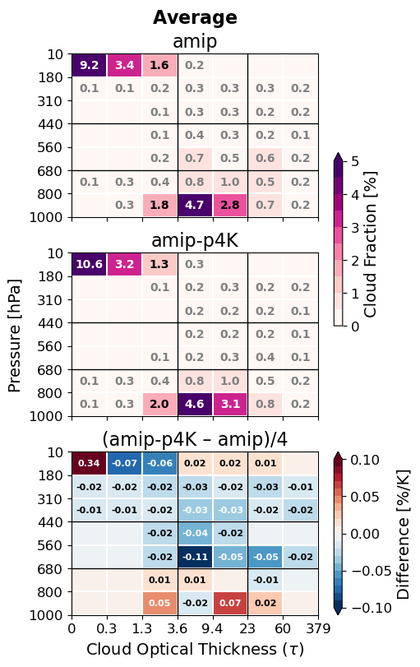
Figure ALLCOSP. Cloud top pressure and cloud optical thickness histograms for the 5-model mean of Cloud Feedback Model Intercomparison Project (CFMIP Webb et al. 2012) Atmospheric (AMIP) preindustrial control simulations.

The large-scale moisture budget
Clouds with average albedo $A_{i}$ have cloud tops that reach $h_{i}$ in GOES satellite images (Fig. REFLALBEDO). We discretize the all-sky mean eddy flux $G=aF$, where $F$ is the in-cloud updraft flux, to clouds reaching height $h_{i}$. We use cloud albedo-weighted cloud fraction $a_{i}$. This fraction is proportional to the radiative effect of the clouds and approaches cloud fraction for clouds with high optical thickness. The all-sky mean eddy flux of moisture $G$ is the integral of the large-scale source $S_{LS}$,
$$G\left(z\right)=G_{CB}+\int_{z_{CB}}^{z}{S_{LS} dz^{'}},$$with the cloud base moisture flux $G_{CB}$ as the boundary condition. The large-scale moisture source $S_{LS}$ is drying due to subsidence and horizontal advection.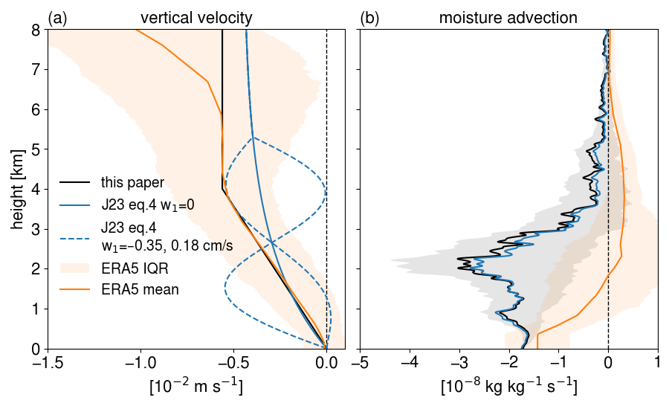
Fig. LSADV. (a) Large scale subsidence velocity (m s^{–1}) and (b) specific humidity advection prescribed for the shallow cumulus model experiments (black), estimated from hourly ECMWF reanalysis (ERA5; orange), and prescribed to the Cloud Botany control and strongest mesoscale vertical velocity simulations (Jansson et al. 2023) within 12.5-16 °N, 60-49 ° W. Shading shows interquartile ranges of ERA5 subsidence and advection (orange) and of vertical advection due to variability among radiosonde profiles (gray).
[advection.png]
We partition the moisture flux into a vertically uniform flux for each cloud top height $h_{i}$. The discrete flux difference $G_{i}=G\left(h_{i+1}\right)-G\left(h_{i}\right)$ is assumed to be carried by the clouds with (albedo-weighted) cloud fraction $a_{i}$. The cloud top height $h_{i}$ of each modeled shallow cumulus cloud is determined by its moisture sink rate parameter.
The all-sky flux $G=aF$ is the product of cloud area and in-cloud flux $F$. The all-sky mass flux $M=aw$ likewise corresponds to the in-cloud vertical velocity $w$. The model divides clouds and their fluxes into categories $i:$
$$M_{i}=a_{i}w_{i}, \\ G_{i}=a_{i}F_{i}=a_{i}w_{i}{\left(Δq\right)}_{i}=M_{i}{\left(Δq\right)}_{i}, \\ F_{i}=w_{i}{\left(Δq\right)}_{i}$$where total fluxes are summed over the categories, $G=\sum_{i}{G_{i}}$, $F=\sum_{i}{F_{i}}$, and $M=\sum_{i}{M_{i}}$, $w=\sum_{i}{a_{i}w_{i}/A}$. Figure FEDDYMETHOD shows the distribution of in-sky fluxes $F_{i}=G_{i}/a_{i}$ in each cloud top height category.
Water fluxes by clouds are diagnosed to balance a simple vertical water budget for the trade cumulus cloud layer. The updraft area fraction is calculated over large (1000 km)² regions, assuming updraft cores are cloudy with saturated specific humidity. Cloud mass flux is initialized at cloud base to match the mean observed surface evaporation minus precipitation. From the moisture closure, the in-cloud eddy flux due to cumulus updrafts and precipitation is $F_{i}\left(z\right)=F_{c,i}\left(z\right)+F_{p,i}\left(z\right)$. Cloud updrafts are responsible for most of the eddy flux. A small part is contributed by precipitation. We will first model the water in the clouds, then their conversion to precipitation.
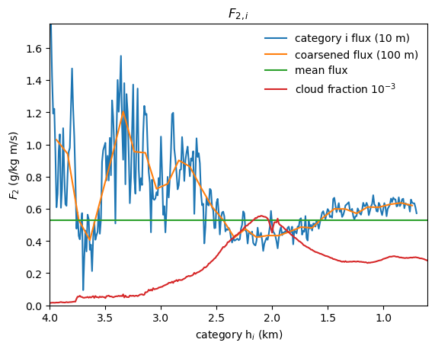
Figure FEDDYMETHOD. Vertically uniform cloudy-sky eddy flux $F_{2,i}$ from Method 2 at 10-m cloud top height $h_{i}$ resolution (blue), and 100-m resolution (orange). Mean flux over the cloud ensemble (green), weighted by cloud albedo (red).

Cumulus cloud model
A budget for steady total water $q_{c}$ in the updraft with velocity $w$ depends on its entrainment and precipitation sinks. The equations for the suspended liquid $q_{l}$ and water vapor $q_{v}$ specific humidity in the cloud are
$${∂q_{l}}/{∂t}=-w\left({∂q_{l}}/{∂z}\right)-wγ-ϵwq_{l}-αwq_{l} \\ {∂q_{v}}/{∂t}=-w\left({∂q_{v}}/{∂z}\right)+wγ-ϵw\left(q_{v}-q\right),$$where $ϵ$ (km^{–1}) is the lateral entrainment coefficient, $α$ is the autoconversion of cloud liquid to precipitation, and $γ={\left({dq_{s}}/{dz}\right)}_{m}=\left({dq_{s}}/{dT}\right){\left({dT}/{dz}\right)}_{m}<0$ is the moist adiabatic condensation rate of water vapor per unit height. The dependence on $γ$ is eliminated in the total cloud water $q_{c}$ equation,
$${∂q_{c}}/{∂t}=0=-w({∂q_{c}}/{∂z})-ϵw(q_{c}-q)-αwq_{l}$$QTBALANCE.The updraft advects moisture upwards, but the solution for $q_{T}$ is quantitatively insensitive to the updraft velocity and to the moisture flux. In the cloud, $q_{l}=q_{c}-q_{s}$, autoconversion removes cloud liquid, relaxing total water toward $q_{s}$, and entrainment relaxes total water toward $q$. Thus, equation QTBALANCE is written in terms of the total vertical sink rate $ϵ+α$,
$${∂q_{c}}/{∂z}=-\left(ϵ+α\right)\left(q_{c}-\tilde{q}\right),$$QRELAXrelaxing $q_{c}$ to the intermediate humidity $\tilde{q}={(ϵq+αq_{s})}/{(ϵ+α)}=\left(1-x\right)q+xq_{s}$. The total sink rate $ϵ+α$ determines the cloud water, water flux, and cloud top height. We call the ratio $x=α/{\left(ϵ+α\right)}$ of the autoconversion to the total moisture sink the precipitation efficiency. Cloud liquid and water vapor profiles are computed for many total sink rates ${\left(ϵ+α\right)}_{i}$, resulting in the cloud top heights $h_{i}$ (Fig. REFLALBEDO).
The profiles of $q_{c}$ predicted by this entraining-precipitating updraft model agree with the most humid air sampled on occasion by radiosondes. Cloud height (where $q_{c}$ reaches 0) is limited by entrainment of relatively dry air between 1.5-3 km, representing the mean distribution of the trade inversion. The clouds occupy a range of depths representative of trade cumulus clouds, with deeper clouds for lower rates of entrainment and autoconversion. The intermediate total sink rate of $ϵ+α≈0.5 {km}^{-1}$ gives maximum cloud liquid specific humidity exceeding 0.8 g kg^{–1} and cloud top height of ~3 km.

Precipitation and updraft moisture fluxes
Shallow cumulus clouds generate weak precipitation, reversing a fraction of the updraft total cloud water flux. Precipitation water flux within a cloud $F_{P}<0$ is generated by autoconversion $α$ from cloud liquid. For the updraft with no storage of cloud liquid water, the precipitation source is
$$-{∂F_{p}}/{∂z}=-αwq_{l}=xw\left({∂q_{l}}/{∂z}+γ\right),$$where $∂q_{l}/∂z+γ$ is the total moisture source in the updraft.
The solution for each cloud type $i$ is found by numerically integrating the precipitation downward from $F=0$ at cloud top. The precipitation sink, ${∂F_{p,i}}/{∂z}=α_{i}w_{i}q_{l,i},$ instantaneously removes liquid water from the cloud and the column.
An example of the all-sky fluxes is computed for a single cloud with, $ϵ+α=1.5 {km}^{-1}$, $h=1.9$ km and all-sky cloud-base flux $G\left(z_{CB}\right)=$ 145 W m^{–2} $=6.0×{10}^{-5}$ kg m^{–2} s^{–1} (Fig. QMASSFLX). For this case, $F$ goes to zero at 8 km. Precipitation increases downward below the cloud top. At a precipitation efficiency of ~0.5, the cloud-base precipitation $P_{CB}=\left|F_{P}\right|$ equals the mean surface precipitation, $P_{0}=$25 W m^{–2} $=9.0×{10}^{-6}$kg m^{–2} s^{–1}, observed on the research vessel Ron Brown during EUREC4A/ATOMIC. Evaporation was $E_{0}=$ 180 W m^{–2} $=6.5×{10}^{-5}$ kg m^{–2} s^{–1}. The mass flux is $M={G_{cld}}/{q_{T}-q}$ (Fig. QMASSFLX). Most of the flux (~90 %) is below 3 km in the trade cumulus layer. Most of the updraft moisture $q_{T}$ is vapor, and the moist updraft $q_{T}-q>0$ generates upward moisture flux, even above the cloud.
The cloud (a) total specific humidity and (b) cloud-environment humidity difference as a function of height and total sink rate parameter is shown for an ensemble of sink rates in Fig. WPROF. This is used to compute (c) cloud-mean vertical velocity for each cloud. The total mass flux is $M=∑a_{i}w_{i}$, where the total cloud area is $a=∑a_{i}$.
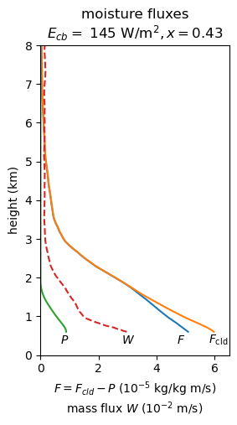
Figure QMASSFLX. Cloud moisture flux $F_{c}$ (orange), and (downward) precipitation flux $P=-F_{P}$ (green), and mass flux $M$(red) modeled for a single cloud with total moisture flux $F$ (blue).
Figure WPROF. Modeled ensemble of clouds for precipitation efficiency $x=0.53$ as a function of total sink rate. (a) Cloud updraft total specific humidity $q_{T}$ (shaded), cloud top (thick black), and rescaled cloud area per unit sink rate (thin black); (b) cloud updraft total – environment specific humidity difference $q_{T}-q$ (shaded), and cloud liquid specific humidity $q_{l}$ (black contours); and (c) updraft vertical velocity.
[trade-cu-model/src/julia/control_qv_qc_w]

Numerical integration of cloud fluxes
At each height and for each cloud category $i$, $w_{i}q_{l,i}=F_{c,i}{q_{l,i}}/{\left(q_{c,i}-q\right)}$ and $F_{c,i}=F-F_{P_{i}}$. The precipitation equation is written in differential form,
$$dF_{P,i}=\frac{α_{i}q_{l,i}}{\left(q_{T,i}-q\right)\left(F-F_{P,i}\right)dz}.$$Precipitation is integrated downward, from $F_{P,i}\left(h_{i}\right)=0$ at the top $h_{i}$of each cloud, in trapezoidal vertical steps with decreasing superscript $k$,
$$F_{P,i}^{k}=-\frac{-\left(1+c_{i}^{k}\right)F_{P,i}^{k+1}+c^{k}F^{k}+c^{k+1}F^{k+1}}{1-c^{k}},$$where $c_{i}^{k}={\left[α_{i}q_{l,i}^{k} dz\right]}/{\left[2\left(q_{T,i}^{k}-q^{k}\right)\right]}$.

Cloud radiative effect
The observed GOES low ($p_{c}>$ 680 hPa) cloud fraction $C_{0}\left(τ,p_{c}\right)$counts pixels in cloud optical thickness $τ$ and cloud top pressure $p_{c}$ bins (Minnis et al. 2008). The shortwave (SW), longwave (LW), and total cloud radiative effect (CRE) is estimated from the Zelinka et al. (2012) cloud radiative kernel $K(τ,p_{c})$: ${CRE}_{0}=\sum_{τ,p_{c}}{C_{0}\left(τ,p_{c}\right) K(τ,p_{c})}$. Total, shortwave (SW), and longwave (LW) CRE changes $ΔCRE={CRE}_{0}\left({ΔC}/{C_{ctl}}\right)$ are multiplied by the relative modeled change in the shallow cumulus albedo ${ΔC}/{C_{ctl}}=ΔM/M_{ctl}$ for the shallow cumulus experiments (Table 1). The CRE for all low clouds is computed by weighting the relative changes of shallow cumulus (SC, $f_{SC}=0.81$) and CB clouds,
$$ΔCRE={CRE}_{0}\left(f_{SC}{ΔC_{SC}}/{C_{SC}}+\left(1-f_{SC}\right){ΔC_{CB}}/{C_{CB}}\right).$$

Cloud-base clouds
Large-eddy simulation (LES; (Bretherton et al. 2013, Blossey et al. 2013) and observations (Bony et al., 2021; Vogel et al., 2022; Fig. REFLALBEDO) have a cloud fraction maximum of about 5 % near the cloud base. We scale this LCL cloud fraction from the subcloud relative humidity and moisture fluxes and test the sensitivity of relative humidity (RH) at cloud base. RH may be constant (Held and Shell XXXX) or increase slightly to the damp the surface evaporation to +2 % K^{–1}.
The LCL cloud fraction is the fraction of air from the moist subcloud boundary layer thermals that reaches saturation at cloud base (Sommeria and Deardorff, 1977; Mellor 1977). For a normal distribution of relative humidity in the subcloud layer, the mean fraction of the thermals that are saturated at cloud base is $C_{CB}=\left(1-\operatorname{erf}\left(s\right)\right)/2,$where $s={\left(1-{\overline{RH}}_{CB}\right)}/{σ_{RH}}$ is the mean relative saturation deficit normalized by the standard deviation of RH. Cloud fraction changes strongly inversely to $s$ according to ${d\ln{C_{CB}}}/{d\ln{s}}≈-3.2$. The cloud-base cloud fraction observed by combined radar and lidar is 0.054 $±$0.031% in EUREC4A (BASTALIAS, Bony et al., 2022; Vogel et al., 2022). Cloud base cloud fraction $C_{CB}=0.055$matches the observations for $s_{0}=1.13$.
The distribution of the saturation deficit depends on the mean humidity, the subcloud gradient, and the moisture flux. The standard deviation of specific humidity is solved from production-dissipation balance for the subcloud specific humidity variance ${∂\overline{q^{'2}}}/{∂t}=0$,
$$0=-u^{*}q^{*}\left({∂\overline{q}}/{∂z}\right)-χ_{q}.$$Humidity variance is produced by flux $u^{*}q^{*}=\overline{w^{'}q^{'}}$ and gradient ${∂\overline{q}}/{∂z}$. It dissipates with rate $χ_{q}={k_{1}u^{*}σ_{q}^{2}}/{z_{CB}}$ from turbulent stirring and viscous mixing of humidity fluctuations, where $k_{1}$ is a constant and $z_{CB}$ is the cloud base height. Shear production is greater than buoyancy production. Solving for humidity variance, the friction velocity $u^{*}={\overline{u^{'}w^{'}}}^{1/2}$ cancels and $σ_{q}^{2}={q^{*}\left(q_{sfc}-q_{CB}\right)}/{k_{1}}.$Then the RH standard deviation at cloud base, $$σ_{RH}={σ_{q}}/{q_{s,CB}}={\left[{q^{*}\left(q_{sfc}-q_{CB}\right)}/{\left(k_{1}q_{s,CB}^{2}\right)}\right]}^{1/2},$$depends on the humidity scale $q^{*}$, the subcloud mean humidity difference $q_{sfc}-q_{CB}$, and the cloud-base saturation specific humidity $q_{s,CB}$. Absent another reason, we assume specific humidity gradient scales as +7% K^{–1}, so the change of ${\left(q_{sfc}-q_{CB}\right)}/{q_{s,CB}}$ cancels and
$$d\ln{σ_{RH}}=\left(1/2\right)\left[d\ln{q^{*}}- d\ln{q_{s,CB}}\right].$$The surface evaporation $E=ρLu^{*}q^{*}$ and cloud-base moisture flux increase +2 % K^{–1} to balance the increase of precipitation. From factoring the evaporation,
$$d\ln{E}=d\ln{U}+d\ln{q_{s}}+d\ln\left(1-{\overline{RH}}_{sfc}\right)=d\ln{u^{*}}+d\ln{q^{*}}.$$
The change of the mean normalized saturation deficit is
$$d\ln{s}=d\ln\left(1-{\overline{RH}}_{CB}\right)+\left(1/2\right)\left(d\ln{q_{s,CB}}-d\ln{q^{*}}\right),$$with $d\ln{q^{*}}=d\ln{E}-d\ln{U}$. We evaluate this as
$$d\ln{s}=-c(b-1/2)(d\ln{q_{s}}-d\ln{E})$$a function of two parameters $b$ and $c$, not known precisely but bounded by 0 and 1. The coefficient $b={d\ln\left(1-{\overline{RH}}_{CB}\right)}/{d\ln{(1-{\overline{RH}}_{sfc})}}$ is the ratio of the cloud base RH saturation deficit $1-{\overline{RH}}_{CB}$ to the surface saturation deficit, which is 0 for constant cloud base RH, and 1 for cloud base mean saturation deficit scaling as surface saturation deficit $1-{\overline{RH}}_{sfc}$.

The coefficient $c={d\ln{(1-{\overline{RH}}_{sfc})}}/{\left(d\ln{E}-d\ln{q_{s}}\right)}$, is the damping of the change of the surface flux by the increase of surface RH. For constant surface wind speed, $c=1$. Otherwise, the evaporation is damped also by decreasing wind speed. At $c=0$, the wind speed controls the flux entirely and surface RH is constant. Solving for the relative change of $s$ in terms of the parameters yields $d\ln{s}=-c\left(b-1/2\right)\left(d\ln{q_{s}}-d\ln{E}\right).$ ($d\ln{q_{s}}-d\ln{E}=+5 \% K^{-1}>0$, and $c>0$)

The LCL cloud model predicts cloud changes of either sign, depending on how strongly the cloud base saturation deficit scales with surface saturation deficit. The parametric dependence $-c\left(b-1/2\right)$ contoured in Fig. BCSENS is between –0.5 and +0.5 and multiplies +5 % K^{–1} to give $d\ln{s}$. Relative changes of $s$ and cloud base clouds have a symmetric response to the sensitivity to cloud base saturation deficit $b$. Clouds increase at most by $ΔC_{CB}/C_{CB}$ = +0.08 for ${Δs}/s=-0.025$, and decrease by at most $ΔC_{CB}/C_{CB}$ = –0.08 for ${Δs}/s=+0.025$.
Figure BCSENS. Change of the mean normalized saturation deficit $d\ln{s}=-\left(b-1/2\right)\left(1-c\right)\left(d\ln{q_{s}}-d\ln{E}\right)$ and the resulting cloud-base cloud fraction $d\ln{C_{CB}}=-3.2 d\ln{s}.$ The relative change of $s$ is ${Δs}/s=$–0.025 to +0.025, and of cloud base cloud fraction $C_{CB}$ is ${ΔC_{CB}}/{C_{CB}}=$ +0.08 to –0.08. Cloud base clouds are unchanged for $c=1$ or $b=1/2$. The parameter $b={d\ln\left(1-{\overline{RH}}_{CB}\right)}/{d\ln{(1-{\overline{RH}}_{sfc})}}$ is the sensitivity of the cloud-base saturation deficit to the surface saturation deficit, and
Cloud base clouds do not change for $c^{'}=0, c=1$ or $b=1/2$. For $c=1,$ decreasing wind speed –5% K^{–1} damps the evaporation to +2% K^{–1}, and surface saturation deficit and RH are constant, having no effect on clouds. Clouds are most sensitive at $c=0$, when wind does not change and $1-{\overline{RH}}_{sfc}$ decreases (RH increases) to damp the surface evaporation. For $b=0$, saturation deficit $1-{\overline{RH}}_{CB}$ is constant. Then increasing the specific humidity more strongly than the flux narrows the width of the RH, decreasing clouds. For $b=1$, surface and cloud base saturation deficits decrease proportionally, so cloud-base RH and clouds increase. At $b=$ 1/2, the two competing effects—increasing mean RH and narrowing its standard deviation $σ_{RH}$—balance.
Scaling $s_{0}=1.13$ by (1 - 0.025) = 0.975 K^{–1}, for cloud base saturation deficit $1-{\overline{RH}}_{CB}$ decreasing proportional to that at the surface, yields a cloud-base cloud fraction $C_{CB}\left(0.975s_{0}\right)=0.060,$an absolute increase of 0.005 K^{–1} (relative +8% K^{–1}). Increasing the surface humidity but keeping the cloud base humidity constant decreases the LCL clouds by the same amount. LCL clouds could thus significantly modify the predicted reduction of shallow cumulus clouds. The net cloud changes depend on the partitioning of the original clouds into cumulus clouds and LCL clouds that are strongly coupled to the subcloud layer. The large uncertainties in the change of conditions that drive the LCL clouds bound the results for the sum of the shallow cumulus and LCL clouds. Assuming 1/3 of the clouds are LCL clouds that change by ±8% K^{–1}, and 2/3 are shallow cumulus that decrease –7.56 % K^{–1}, the total effect would be for clouds to decrease with a range of –7.7 to –2.4 % K^{–1}.
This simple scaling of the LCL clouds to the subcloud RH fluctuations demonstrates the sensitivity of the clouds to the mean RH, RH gradients, and moisture flux. The sign of the change of LCL clouds depends on subtle changes in surface humidity that may be compensated by the effect of wind on the surface evaporation; and to what degree cloud base humidity increases with surface humidity.

Data sources
Data are available from their references and/or links provided here. GOES daylight visible reflectance, cloud optical thickness, and cloud top pressure retrievals (Minnis et al. 2008) are provided by NASA Langley Cloud and Radiation Research Group, https://satcorps.larc.nasa.gov/prod/exp/atomic-2020/visst-pixel-netcdf/ (courtesy W. Smith). CERES FBCT (Sun et al., 2022) data are provided at https://www.earthdata.nasa.gov/data/catalog/larc-cloud-cer-fluxbycldtyp-month-terra-aqua-modis-edition4a. Data from EUREC4A/ATOMIC radiosondes (Stephan et al., 2021) are provided at the AERIS EUREC4A data catalog https://observations.ipsl.fr/aeris/eurec4a-data/PRODUCTS/MERGED-MEASUREMENTS/RADIOSOUNDINGS/v3.0.0/level2/.

References

