Mesoscale circulations associated with shallow marine convection derived from infrared GOES measurements
Last updated 6/16/26

Observations (ATOMIC/EUREC4a) and Vogel et al. 2022
The EUREC4A field campaign, the European counterpart to the American-led ATOMIC, took place from January – February 2020 over the tropical North Atlantic near Barbados. The intent of the campaign was to observe the atmospheric conditions associated with marine shallow convection embedded within a trade wind regime. Shallow marine clouds are an important component of the global energy balance, reflecting downwelling solar radiation back out to space, and contribute to model spread in global warming projections. For this campaign, multiple types of aircraft were chartered, each equipped with a variety of sensors including dropsondes, lidar, and radar. A major component of the campaign involved deploying dropsonde batches from the HALO aircraft around the perimeter of a 220km diameter circular area over the course of a month. To capture a wide range of conditions, the aircraft flew at varying times of day, taking the same circular path each time. One lap around the circle took approximately 80 minutes. Results from the EUREC4A campaign are published in the JOANNE dataset and available here: https://doi.org/10.25326/246.
In the JOANNE dataset, dropsonde measurements of horizontal wind velocities are used to compute the circle-averaged vertical velocity (W) and wind divergence (D) from the altitude of deployment (~10 km) to the surface. Vertical velocity was first calculated in Vogel et al. 2022 (https://doi.org/10.1038/s41586-022-05364-y) before its publication in the JOANNE dataset. Note that the JOANNE-derived W and the Vogel-derived W are nearly identical and may be used interchangeably (r=0.98, p <0.001).
In addition to W, the authors compute the sub-cloud layer entrainment (E) as the ratio of observed buoyancy fluxes at the surface and the top of the sub-cloud layer. To calculate the fluxes, observed values of humidity, temperature and the horizontal wind from the EUREC4A campaign are treated with a bulk flux algorithm and observed SSTs are sourced from the RV Meteor or AutoNaut Caravela.
In Vogel et al. 2022, the calculation of W and E serves to evaluate the mixing-desiccation hypothesis which theorizes that an increase in E in the sub-cloud layer should follow an increase in the upwards mass flux (M) produced by shallow convection. This would drive a reduction in sub-cloud-layer relative humidity and thus, low-level cloud fraction, indicating a negative feedback exists between the convective mass flux and low-level cloudiness.
The mass budget is written in terms of the height of sub-cloud-layer height (h), which would increase (decrease) in height as relative humidity decreases (increases)
$$\frac{∂h}{∂t}+{\vec{v}}_{h}∙∇h=E+W-M$$
In equilibrium, or on climatological scales, this can be simplified to:
$$M=E+W$$
allowing for M to be computed through the sum of the E and W terms.
On average, the authors find M to approximate E, and variability in M to be contributed by both E and W. At the hourly level, M and E are significantly correlated (r = 0.6, R² = 0.36, p < 0.001, slope = 1.22 [1.05, 1.39]) according to a total least squares analysis, while 3-hour averages yield slightly lower correlations (r = 0.55, R² = 0.30, p = 0.004, slope 1.29 [0.99, 1.59]). M and W are also moderately correlated at both the 1-hourly level (r = 0.61, R² = 0.38, p < 0.001, slope = 1.20 [1.04, 1.37]) and 3-hourly level (r = 0.66, R² = 0.44, p < 0.001, slope = 1.16 [0.91, 1.41]).
These results indicate that while E and relative humidity are negatively correlated as expected (M $∝$ relative humidity), W is positively correlated with humidity, suggesting that the negative feedback induced thermodynamically by E is balanced dynamically by W. Furthermore, measurements of cloud fraction show a strong positive correlation to M (r = 0.72), not a negative one. The authors note that cloud fraction (which is observed separately from W and E using the BASTILIAS radar aboard the ATR aircraft) is only highly correlated to their calculated mass flux when averaged over 3-hr intervals and that the correlation may be weaker at shorter timescales. This is because although the ATR flies concurrently with the HALO aircraft which measures W, it is restricted to a much smaller portion of the western averaging circle. Therefore, the observed cloud fraction is not directly comparable to the mass flux which is calculated over the entirety of the averaging area.
The EUREC4A campaign – which has provided invaluable in situ observations of shallow marine cumuli – is limited by its relatively small temporal and spatial scales. Geostationary satellites, such as the GOES constellation, however, offer broad spatial coverage and a continuous record spanning several decades back. With a reasonable mathematical model, satellite measurements of cloud top height and cloud-top brightness could be tuned and constrained by the EUREC4A observations to estimate the mesoscale circulation of shallow marine convective systems.

Calculating divergence and the divergent wind field associated with shallow marine convection from GOES IR measurements

The GOES satellite network provides infrared (IR) measurements of cloud top reflectivity and cloud top height at a 2-km horizontal resolution every 20 minutes. Using a cloud moisture balance model, these can be used to compute the mesoscale divergence and divergent wind field. ∆x and ∆y are used in the computation to normalize differences in pixel size across the GOES domain due to beam divergence.

Methodology
In the model, mass fluxes are diagnosed through a vertical water budget with widespread subsidence in clear-sky areas balancing shallow cloud updrafts. Cloud updrafts ($F_{cld}$) contribute the vast majority of the climatological eddy flux and are defined as:
$$F_{cld}=W(q_{up}-q)$$
where $W$ is vertical velocity (m/s) multiplied by the cloud fraction, $q_{up}$ is the updraft specific humidity (g/kg), and $q$ is the environmental specific humidity (g/kg). Solving for the cloud specific humidity can yield a variety of cloud-top heights as determined through the the total sink rate, which is calculated by prescribing scalar values to the autoconversion of cloud liquid water to precipitation and to entrainment. Weaker total sink rates will produce taller cloud tops due to a reduction in cloud column drying, and vice versa.
For each sink rate and its corresponding cloud-top height value, a vertical velocity (w) vertical profile for the cloud can be computed. Thus, a vertical velocity value can be determined directly from GOES observation of cloud top height. Because w is only computed for cloudy pixels and does not resolve inter-cloud eddies, all w values are positive (upwards). Note that the lower-case ‘w’ here denotes an instantaneous, pixel-sized, upward vertical velocity whereas in the above section, the upper-case ‘W’ used in the Vogel paper and JOANNE dataset denotes a spatially-large, time-averaged value of both upward and downward fluxes. The large W in the cloud eddy flux is technically a mass flux.
To calculate divergence, GOES cloud top heights are masked out above 3.6km to limit the cloud field to shallow convection, and cloud base is uniformly assumed to be 0.6km above the surface. Cloud base height, or the lifting condensation level, fluctuates little in marine environments (ref?). A computed vertical velocity value (m/s) at cloud base is then assigned to each cloudy grid point, corresponding to its cloud top height.
The vertical velocity field is then multiplied by the cloud-top reflectivity and normalized by pixel size, yielding a convective mass flux$:$
$$M_{GOES}=\frac{w_{GOES}*a_{refl.}}{a_{pixel}}$$
GOES reflectivity acts as a proxy for cloud fraction, and they are strongly correlated (r=0.79. r² = 0.62, p <0.001 with a slope close to 1). Cloud fraction values are sourced from Vogel et al. 2022 and are detailed above. Units for mass flux are in m/s but could be changed to kg m⁻² s⁻¹ by multiplying in the density of air per unit volume (1.275 kg m⁻³). For $a_{refl.}$, values range from 0 – 1 and are unitless. The range of reflectivity values is normalized by the 5th and 95th percentiles to reduce the influence of extremely bright or dark pixels, and reflectivity values in excess of either percentile are clipped to 1 or 0, respectively. $a_{pixel}$ values range from ~0.90 to ~1.2 with a plurality of grid points receiving an adjustment of 1 and are unitless.
Excluded grid points, such as high clouds (>3.6km) and clear-sky pixels, have so far been treated quantitatively as being equal to 0 m/s. High clouds can take a range of forms (deep convection, cirri) and we make no distinction between them, making it unclear as to what their aggregate w magnitude or sign might be. For this reason, as well as to minimize their influence, pixels that qualify as ‘high cloud’ are kept at 0 m/s.
Subsidence in clear-sky pixels, however, is needed to accurately compute the divergent field and to compute w at the synoptic scale (upper-case W) for comparison with observations such as the EUREC4A field campaign. We assume that over large domains W ~ 0 and that the $M_{GOES}$ upward flux must be compensated by sinking in clear sky pixels. The same subsidence value ($w_{clear}$) is assigned to every clear sky pixel in the domain and is calculated by:
$$w_{clear}=\frac{\sum{w_{ cloud}}}{\# of clear sky gridpoints}$$
where:
$$\# of clear sky gridpoints=Total \# of gridpoints-\# of cloudy gridpoints$$
Note that the total number of grid points excludes high cloud grid points. Once the w field is comprised of both the cloud model-derived upward mass fluxes and the compensating downward flux, the divergence and divergent wind can be calculated.

Calculating Divergence and the Divergent Wind
Using mass continuity, the horizontal divergence ($-{\vec{∇}}_{H}∙\vec{ν})$ can be assumed to be equal to the vertical velocity:
$$\frac{∂w}{∂z}=-{\vec{∇}}_{H}∙\vec{ν}$$
If we parse
$\frac{∂w}{∂z}$ $\frac{w_{cloud base}-w_{surface}}{∆z}$
and assume that w at the surface must be zero, then
$\frac{∂w}{∂z}$ $\frac{w_{cloud base}}{0.6km}$.
This equation solves for horizontal divergence in the sub-cloud layer, which extends from the surface to cloud base. We can then solve for the irrotational portion of the sub-cloud divergent wind by solving Poisson’s equation:
$$∇∙\vec{ν}=∇^{2}χ=\frac{∂w}{∂z}$$
where $χ$ (chi) is the velocity potential (m²/s). We have found that Poisson’s equation is best solved using a fast-Fourier transform and prescribing Neumann boundary conditions (BCs) rather than Dirichlet BCs. However, Neumann BCs are periodic and induce spurious influence between velocity potential gradients on opposite sides of the domain. To account for this, we pad the domain with extra rows and columns and taper the BC values to ~0 by multiplying by 0.95 until the BC value is negligible.
This is code is publicly available at https://github.com/patrickcarlandrews/GOES-derived-Mesoscale-Divergence.

Notes on Methodology
- The weakest sink rates produce w values at cloud base significantly stronger than the w values of comparable but slightly stronger sink rates. We suspect these w values may be spuriously large as they are one to two orders of magnitude larger than the observed values from the EUREC4A campaign. As a remedy, we manually identify the sink rates producing spuriously large w values and replace them with the weaker value at 0.9km.
- Our model may be less accurate if a significant amount of high cloud is present in the domain or within the averaging area. The correlation between the derived GOES w field and the observed EUREC4A w field increases when we remove instances where high clouds comprise >10% of the averaging area or >2% of the entire domain. High clouds have several effects:
  - They obscure low clouds, changing their representation in the derived w field from a positive value to 0. This results in an underestimation of the upwards mass flux.
  - They concentrate the compensatory subsidence. If high clouds comprise a significant portion of the domain, then the w_{clear} calculation produces a stronger subsidence value concentrated over fewer points.
- For similar reasons to #2, the model is sensitive to the size of the domain. Shrinking (or expanding) the domain will change the sum of the upwards mass flux, the number of clear sky and cloudy pixels, and ultimately the w_{clear} value. For this reason, it is advisable to keep the domain large rather than small as these effects will be more pronounced over a smaller domain.
- Similar to reasons #2 and #3, any regional averaging within the domain will be sensitive to the averaging area size. This is somewhat self-evident, however, in our correlation with JOANNE, it was important to get precise averaging circle radii and adjust the averaging area size accordingly for the most accurate correlation.
- While coherent cloud systems may extend over the land surface, certain assumptions such as cloud base height do not hold up over in this environment. As such, and with the exception of small islands, any large amount of land should be omitted from the domain. The code provided above does not remove or mask out GOES pixels over land, so the domain must be manually altered to do so.

How well do the GOES-derived fields match observations?
Testing confirms that GOES-derived fields are sensitive to several factors throughout the calculation, some of which are detailed above in Notes on Methodology. The following adjustments and procedures are used in the calculation of correlations between Vogel/JOANNE and GOES:
- High GOES-derived w values (>0.6 m/s) are attenuated according to the method described above in Notes on Methodology.
- A python function is used to approximate a circular averaging area – like the one used in EUREC4A – and calculate an average for the circle over the rectangular GOES grid points.
- The exact diameter of each completed dropsonde loop is available in the JOANNE dataset. Thus, rather than relying on the provided average diameter of 220km, a more precise value can be utilized to best match the GOES averaging circle with the EUREC4A one.
- Values that occur before sunrise or after sunset, or very close to either, are omitted as GOES reflectance values fall to 0 or are heavily biased due to the insolation angle.
- If high clouds comprise > 2% of the averaging area or 20% of the domain, the value is omitted.
- Previous calculations allowed reflectance values >1 (but no higher than ~1.4). This, however, was found to contribute to the skewed W and divergence fields, and values are instead clipped at 1.
- High cloud pixels (cloud top > 3.6km) = 0, clear-sky pixels = -w_{clear}. Note that for mass flux comparisons, clear-sky pixels are set to 0, leaving only positive w values.
- The GOES domain is tightened to cut out the South American continent where the shallow marine convection model does not apply.
- For any area-averaged variable in the JOANNE dataset such as W or divergence, the mean time during dropsonde deployment is provided. Because it took about 80 minutes to complete a circle, a certain amount of error is introduced into the calculation as clouds move in and out of the averaging region during the flight. However, we found that aligning the GOES measurement with the average time yielded similar values to using the start and end times of the dropsonde deployment and then averaging them together.

In the plot below, GOES sub-cloud divergence area averages (orange) are plotted against the JOANNE sub-cloud area-averaged observations (blue) over the course of the EUREC4A campaign. Initial results indicate that while our model can accurately compute the sign of the observed JOANNE divergence and vertical velocity in the sub-cloud layer, and despite myriad adjustments, GOES values are still about an order of magnitude larger on average than those in JOANNE. This may be due to simplifications of the cloud field made in the mathematical model such averaging over inter-cloud turbulence or the uniform subsidence field. Our model also does not consider the amplifying and dampening effects of gravity waves on the W field. However, this bias is mostly uniform through the GOES results, and as such, a scaling coefficient is developed to better match GOES W magnitudes to observations.

The scaling coefficient ($∝$) is calculated as:
$$∝ = m_{norm}*\frac{σ_{JOANNE}}{σ_{GOES}}$$
where $m_{norm}$ is the slope of the normalized correlation between 3-hr averages of GOES and JOANNE and $σ$ is the standard deviation of each respective dataset. To calculate the slope, each 3-hr average is first normalized by its dataset’s standard deviation. Uncertainty in each 3-hour average is calculated as the standard error of the mean which is computed by dividing the standard deviation of its constituent data point by the square root of their count. Some 3-hourly averages contain only one or two points for reasons expressed above in Notes on Methodology. Then, a total least squares regression, which presumes error in both axes, is applied to compute the best-fit line i.e. the $m_{norm}$. This yields a scaling coefficient of 0.1733. This coefficient was calculated using both divergence and vertical velocity and both produced the same value. This was expected as the divergence, in both JOANNE and GOES, is derived directly from the vertical velocity field.
Applying the scaling coefficient significantly improves the model’s accuracy:
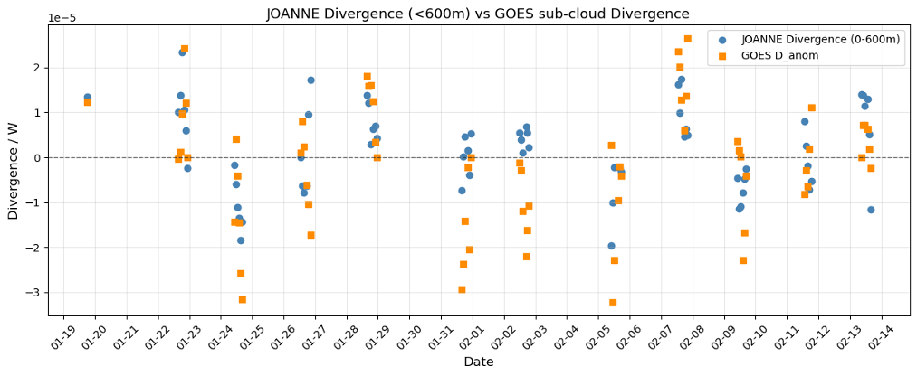

With these adjustments, including the applications of the fudge factor, the 3-hr GOES W flux is found to correlate moderately well with the Vogel W (r = 0.52, p = 0.008, R² = 0.38) via total least squares analysis:
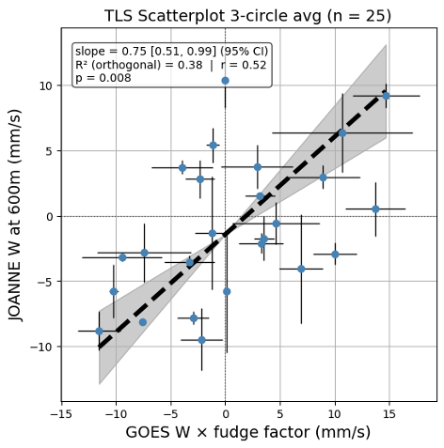
Like in JOANNE, here the upper-case W represents large-scale vertical motion that includes both cloud updrafts and subsidence. A standard t-distribution is assumed for the 95th confidence interval slope calculation with n minus 2 degrees of freedom. Error bars are calculated as described above. R² is computed from the orthogonal residuals which are the distances from each point to the line in the x and y directions.
Divergence, which is computed directly from W, is similarly correlated:
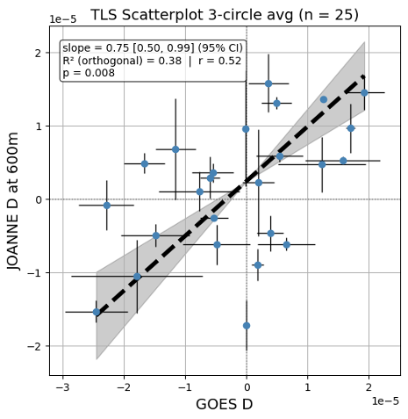
We also compare the GOES-derived mass flux, which is the area average of the W field with both high clouds and clear-sky pixels set to 0, with the mass flux computed in Vogel et al. (2022).
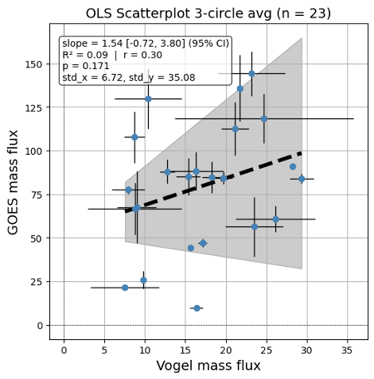
The correlation between them is weak ( r = 0.30) and is not significant. These mass fluxes may not directly comparable, as the Vogel mass flux is computed as the sum of the observed hourly W and E fields, and the GOES mass flux is derived instantaneously from the cloud-top height field.

