Abstract #2091011

Decreasing hydrological circulation dims shallow cumulus clouds

Simon P. de Szoeke
An-Yi Huang
Andrea Jenney
Patrick Andrews

Abstract
Shallow cumulus clouds affect Earth’s planetary albedo and explain the spread in climate model sensitivities to atmospheric CO$​_{2}$. Desiccating the cloud layer by increasing vertical mixing has been demonstrated to reduce shallow cumulus clouds in climate models, but recent observations show that, rather than humidity, mass flux explains mesoscale variation of shallow cumulus cloud fraction. Here, we demonstrate the decrease in mass flux (DIM) hypothesis for shallow cumulus clouds. A cloud model constrained by moisture balance in the lower troposphere predicts shallow cumulus mass flux and cloud albedo decrease –5 to –8%/K in response to the –5 %/K reduced drying expected from the large-scale atmospheric hydrological circulation. For the same moisture flux, increasing specific humidity +7% reduces the mass flux –2.6%. The lowest clouds near the lifting condensation level (LCL) respond differently than the shallow cumulus: subcloud mean and turbulent fluctuations of RH change the LCL cloud fraction, widening the local estimated shallow cloud change to –2.5 to –7.7 %/K. The local shallow cumulus regional shortwave cloud radiative dimming feedback due to shallow cumulus and LCL clouds is +0.5 to +1.6 W/m²/K; the shortwave plus longwave local cloud radiative feedback is +0.4 to +1.3 W/m²/K.

Plain language summary
Reflection of sunlight by shallow cumulus clouds cools the climate, so the response of clouds is an important predictor of how much temperature changes due to greenhouse gases. Predicting what will happen to these small clouds in global climate models is not easy. Recent observations of marine shallow cumulus clouds over the tropical Atlantic Ocean suggest that cloud area is proportional to cloud mean upward air transport. Based on this relationship, a model factors cloud and moisture transport changes into to updraft and moisture changes, and relates these to large-scale changes in precipitation and atmospheric circulation that climate models predict with confidence. In this model, clouds decrease -5% when the large-scale hydrological overturning of the tropical atmosphere decreases, dimming the reflection of sunlight.

Scientific Session A049 – Boundary Layer Clouds Across Scales: Processes, Regimes, and Earth System Coupling
Seeking contributions that uncover cloud processes, identify cloud regimes, improve parameterizations, and accelerate scientific discovery

Decreasing Hydrological Circulation Dims Shallow Cumulus Clouds
Simon P de Szoeke, An-Yi Huang, Andrea M Jenney and Patrick Andrews, Oregon State University, Corvallis, United States

Abstract Text:
Shallow cumulus clouds affect Earth’s planetary albedo and explain the spread in climate model sensitivities to atmospheric CO2. Desiccating the cloud layer by increasing vertical mixing has been demonstrated to reduce shallow cumulus clouds in climate models, but recent observations show that, rather than humidity, mass flux explains mesoscale variation of shallow cumulus cloud fraction. Here, we demonstrate the decrease in mass flux (DIM) hypothesis for shallow cumulus clouds. A cloud model constrained by moisture balance in the lower troposphere predicts shallow cumulus mass flux and cloud albedo decrease –5 to –8%/K in response to the –5 %/K reduced drying expected from the large-scale atmospheric hydrological circulation. For the same moisture flux, increasing specific humidity +7% reduces the mass flux –2.6%. The lowest clouds near the lifting condensation level (LCL) respond differently than the shallow cumulus: subcloud mean and turbulent fluctuations of RH change the LCL cloud fraction, widening the local estimated shallow cloud change to –2.5 to –7.7 %/K. The local shallow cumulus regional shortwave cloud dimming radiative feedback due to shallow cumulus and LCL clouds is +0.5 to +1.6 W/m²/K. The shortwave plus longwave local cloud radiative feedback is +0.4 to +1.3 W/m²/K.
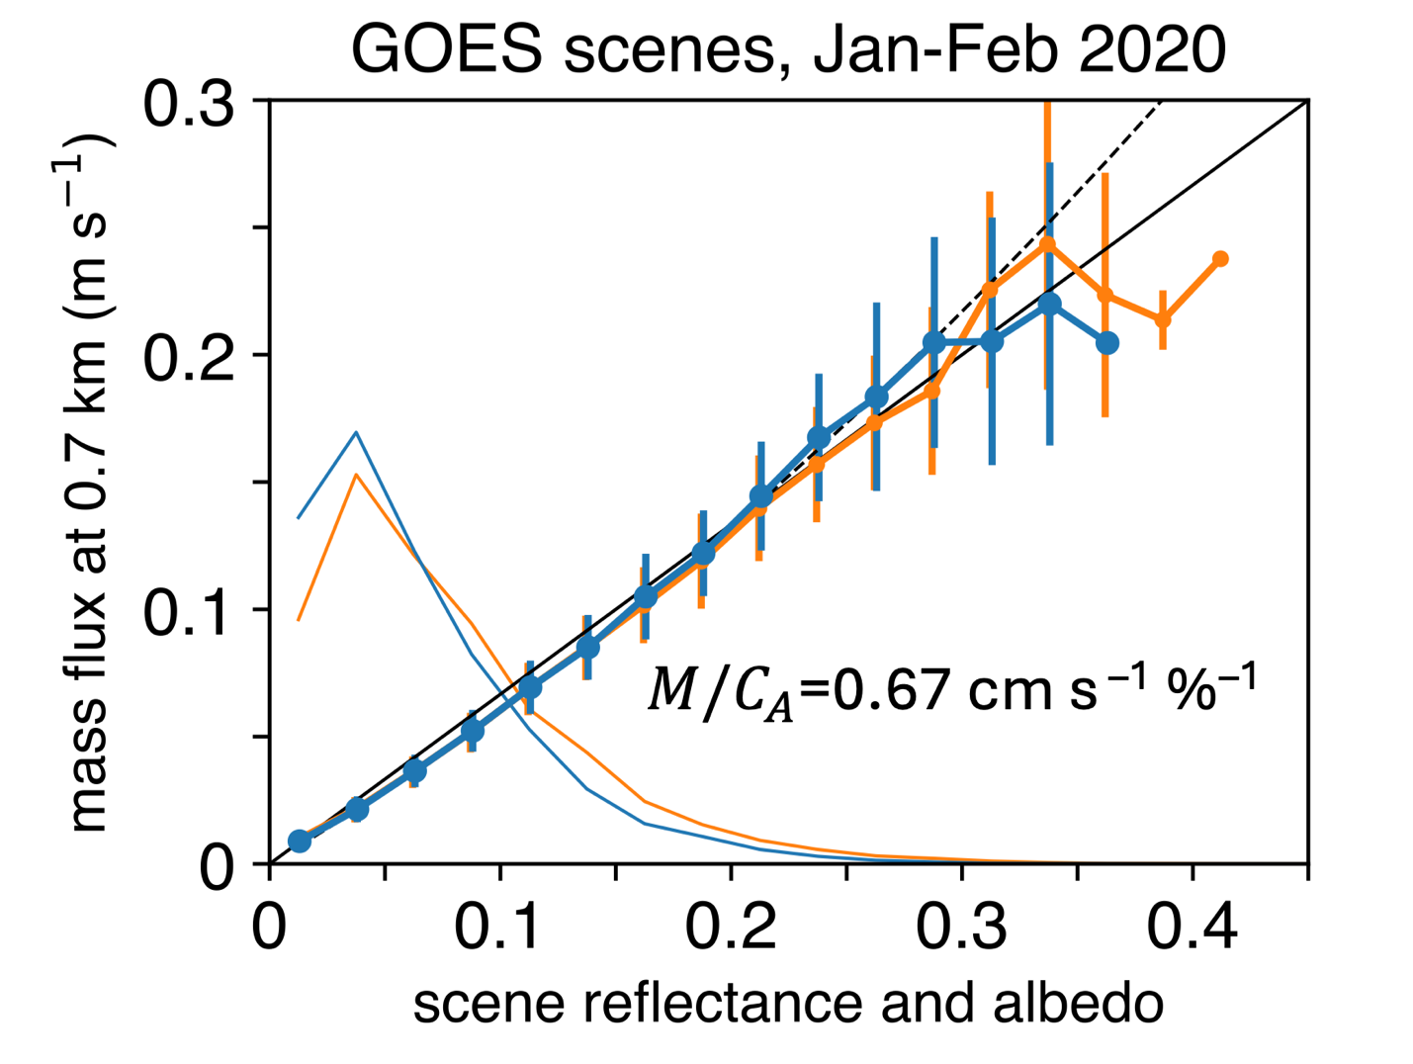

Plain-Language Summary:
Reflection of sunlight by shallow cumulus clouds cools the climate, so the response of clouds is an important predictor of how much temperature changes due to greenhouse gases. Predicting what will happen to these small clouds in global climate models is not easy. Recent observations of marine shallow cumulus clouds over the tropical Atlantic Ocean suggest that cloud area is proportional to cloud mean upward air transport. Based on this relationship, a model factors cloud and moisture transport changes into to updraft and moisture changes, and relates these to large-scale changes in precipitation and atmospheric circulation that climate models predict with confidence. In this model, clouds decrease -5% when the large-scale hydrological overturning of the tropical atmosphere decreases, dimming the reflection of sunlight.
Session Selection:
A049. Boundary Layer Clouds Across Scales: Processes, Regimes, and Earth System Coupling
Submitter's E-mail Address:
simon.deszoeke@oregonstate.edu
Abstract Title:
Decreasing Hydrological Circulation Dims Shallow Cumulus Clouds
Requested Presentation Type:
Assigned by Program Committee (oral, poster, or GeoBurst)
Recording Permission Given?
Yes
Previously Published?:
No
Abstract Payment:
Paid (agu-agu26-2091011-0262-6112-1177-3664)

I would not like to volunteer at this time
First Presenting Author
Presenting Author
Simon P de Szoeke
Primary Email: simon.deszoeke@oregonstate.edu
Affiliation(s):
Oregon State University
Corvallis 97331 (United States)
Oregon State University
Corvallis 97331 (United States)
Second Author
An-Yi Huang
Primary Email: huangany@oregonstate.edu
Affiliation(s):
Oregon State University
Corvallis 97331 (United States)
Third Author
Andrea M Jenney
Primary Email: ajenney@uci.edu
Affiliation(s):
Oregon State University
Corvallis 97331 (United States)
Fourth Author
Patrick Andrews
Primary Email: patrick.andrews@oregonstate.edu
Affiliation(s):
Oregon State University
Corvallis 97331 (United States)
If necessary, you can make changes to your abstract submission
To access your submission in the future, point your browser to: User Portal
Your Abstract ID# is: 2091011.
Any changes that you make will be reflected instantly in what is seen by the reviewers.
After the abstract proposal is submitted, you are not required to go through all submission steps to make edits. For example, click the "Authors" step in the Abstract Submission Control Panel to edit the Authors and then click save or submit.
When you have completed your submission, you may close this browser window or submit another abstract proposal: Call for Abstracts.

