On the moisture balance of the trade cumulus layer
[./ATOMIC/ATOMIC_GOES/julia/RHB/sonde/massflux.docx]

Abstract
Climate models demonstrate marine trade cumulus clouds decrease with warming, a positive feedback. However, recent observations suggest increased cloud mass flux by mesoscale circulations moistens the cloud layer. [If cumulus mass flux increases with temperature, this implies a negative feedback.] Here we propose a model of the cloud ensemble to diagnose the mass, moisture, and precipitation fluxes. The sum of updraft rain moisture flux balances prescribed large-scale advection and subsidence. Entrainment and rain autoconversion water sink parameters are varied to generate an ensemble of clouds with top heights observed from satellites. The model predicts the curvature observed of water stable isotope concentrations in clouds and throughout the trade cumulus layer; suggesting continuous entrainment and autoconversion, absent in simple pseudoadiabats and mixing lines, are responsible for the observed curvature. The model diagnoses mass fluxes from cloud top heights, allowing estimates of subcloud mesoscale divergent wind from satellite images.

Introduction
The marine trade cumulus cloud regime covers a large fraction of the world oceans. Where trade cumulus predominates, cloud albedo is variable with an average of ~0.1. Climate sensitivity depends strongly on the low cloud feedback, determined in large part by the response of low trade cumulus clouds to warming (Bony, Sherwood et al. 2014). Models that generate more trade cumulus clouds in a warmer climate have mean climates that warm less; and those in which the circulation in a warmer climate dries the clouds warm more. The moisture of the cloud layer, and the resulting cloud fraction, is a competition between 1) the drying by large-scale advection and subsidence and 2) the moistening by the updrafts of the clouds themselves mixing up subcloud water vapor from near the ocean surface.
The response of the trade cumulus cloud ensemble determines whether the cumulus layer significantly dries, reducing the clouds in a warmer climate. Observations from the EUREC4A dropsonde circles show upward cloud base mass flux compensates large-scale divergence, limiting entrainment of dry air into the subcloud layer (Vogel et al. 2022). Rather than desiccating the cloud layers, stronger cumulus cloud base mass flux within dropsonde circles with stronger divergence buffers the cloud fraction. This cumulus cloud response to the mesoscale circulation works against the cloud desiccation responsible for strong low cloud feedback and high climate sensitivity in models. We propose an alternative test of whether the cloud ensemble mass flux responds the same on the climate scale.
[mostly too long:] Vogel et al. (2022) infers cloud base mass flux from the sub-cloud mixed layer mass budget. The mesoscale divergence estimated from dropsonde circles is highly variable. Are the mesoscale mass flux and cloud fraction response representative of a response to climate? Here we instead assume the mean profile of moisture is in steady state averaged throughout the trade cumulus region. The cumulus cloud ensemble moisture flux, and the hence mass flux, balances the mean advection and subsidence. We model cloud moisture and mass fluxes to agree with cloud top height profiles and atmospheric radiosondes from EUREC4A. The cloud heights, the moisture profile, and the large-scale advection and subsidence drying can be individually altered to simulate climate change conditions.
Here we present a simple model based on moisture balance between the large-scale drying and cloud moistening effects. The model is solved for the mean thermodynamic sounding, surface evaporation and precipitation, and vertical distribution of clouds observed during the ATOMIC/EUREC4A field experiment in January-February 2020. The model diagnoses the cloud moisture flux and mass fluxes required to balance the large scale drying in the present trade cumulus regime. Sensitivity experiments predict what happens to the cloud mass and moisture flux if saturation humidity increases, mean humidity decreases, and large-scale subsidence decrease, respectively.

Model
Trade cumulus clouds are intermittent shallow convection in widespread regions of mean subsidence balancing deeper convection elsewhere. Water fluxes by the clouds are diagnosed to balance a simple vertical water budget for the trade cumulus cloud layer. The updraft area fraction is calculated over large (1000 km)² regions, assuming updraft cores are cloudy with saturated specific humidity. The horizontal-time ensemble mean trade cumulus water (vapor + liquid) flux due to updrafts and precipitation balances mean subsidence. Cloud mass flux is initialized at cloud base to match the mean observed surface evaporation minus precipitation.
The eddy flux retains a steady climatological moisture profile. Updrafts, including clouds, are responsible for most of the eddy flux. A small part is contributed by precipitation. From this diagnostic moisture closure, we compute the trade cumulus ensemble eddy flux $F=F_{cld}-P$ by cumulus updrafts $F_{cld}=W\left(q_{up}-q\right)$ and precipitation $P$. We first model the updraft water, clouds, then their conversion to precipitation. Finally these fluxes are solved to balance the large scale forcing in subsection EDDY FLUX.

Cloud updraft water
A budget for steady total water $q_{T}$ in the updraft depends on its entrainment and precipitation sinks. The equations for the suspended liquid and water vapor in the cloud are
$$\frac{∂q_{l}}{∂t}=-W\frac{∂q_{l}}{∂z}-Wγ-ϵWq_{l}-αWq_{l}$$and$$\frac{∂q_{v}}{∂t}=-W\frac{∂q_{v}}{∂z}+Wγ-ϵW{(q}_{v}-q),$$
where $ϵ$ and $α$ (km^{–1}) are the lateral entrainment coefficient and the autoconversion of cloud liquid to precipitation, and $γ$ (<0) is the moist adiabatic condensation rate of water vapor (in a parcel) per unit height, $γ={\left(\frac{dq_{s}}{dz}\right)}_{m}=\left(\frac{dq_{s}}{dT}\right){\left(\frac{dT}{dz}\right)}_{m}.$ The dependence on this condensation rate is eliminated in the total cloud water balance equation. Summing the liquid and vapor, and taking the Eulerian total specific humidity $q_{T}$ to be steady,
$$\frac{∂q_{T}}{∂t}=0=-W\frac{∂q_{T}}{∂z}-ϵW{(q}_{T}-q)-αWq_{l}.$$QTBALANCEThough the total water is insensitive to the condensation rate $γ$, it implicitly depends on the saturation specific humidity $q_{s}$ in the cloud. The updraft advects moisture upwards, but the solution is quantitatively insensitive to the mass flux.
Above the cloud, $q_{l}=0$, so there is no autoconversion. Only entrainment relaxes humidity to that of the environment:
$$\frac{∂q_{T}}{∂z}=-ϵ\left(q_{T}-q\right).$$
In the cloud, $q_{l}=q_{T}-q_{s}$. Autoconversion removes cloud liquid, relaxing total water toward $q_{s}$, and entrainment relaxes total water toward $q$. Thus, equation QTBALANCE, written
$$\frac{∂q_{T}}{∂z}=-\left(ϵ+α\right)\left(q_{T}-\tilde{q}\right),$$relaxes vertically toward the intermediate humidity between $q$and $q_{s}$,
$$\tilde{q}=(ϵq+αq_{s})/(ϵ+α)=\left(1-x\right)q+xq_{s},$$QTILDE
weighted by the precipitation efficiency $x=α/{\left(ϵ+α\right)}$.
Solutions for total cloud specific humidity $q_{T}$ and $q_{l}={max(0, q}_{T}-q_{s})$ are shown in Fig. MOISTURECLOUDS for a range of total moisture sink coefficients $ϵ+α$ from $\sim 0.5 {km}^{-1}$ to $2.5 {km}^{-1}$. Initial specific humidity is 15.3 g kg^{–1}, matching saturation at cloud base $z_{CB}$ = 600 m. Parcels entrain immediately and cloud liquid water autoconverts to precipitation. The parcel may not exceed saturation until it is slightly higher than $z_{CB}$ because of its moisture sinks. Total parcel specific humidity is compared to saturation humidity of the environment to determine cloud liquid water.
The profiles of $q_{T}$ predicted by this entraining-precipitating updraft model agree with the most humid air sampled on occasion by radiosondes. Clouds height is limited by entrainment of relatively dry air between 1.5-3 km, representing the mean distribution of the trade inversion. The clouds occupy a range of depths representative of trade cumulus clouds, with deeper clouds for lower rates of entrainment and autoconversion. The intermediate total sink rate of $ϵ+α=1.5 {km}^{-1}$ gives maximum cloud liquid specific humidity exceeding 0.8 g kg^{–1} over 0.7-1.5 km and cloud top height of 1.9 km. This total sink will be used in control simulations a single monolithic cloud.
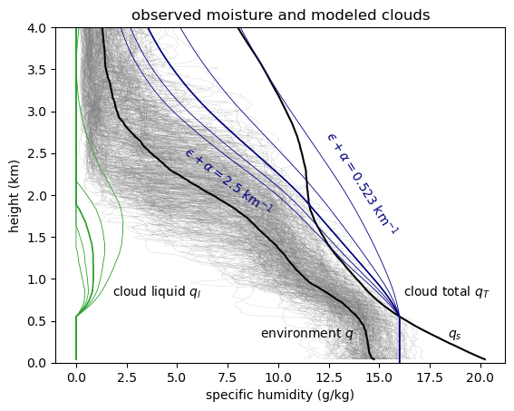
Figure MOISTURECLOUDS. Observed specific humidity from the ATOMIC Ron Brown radiosondes (gray), and their mean $q$ (black) and saturation specific humidity $q_{s}$. Cloud updraft total specific humidity $q_{T}$ (blue) and cloud liquid $q_{l}$ (green) for a range of total moisture sink rates $ϵ+α$ (entrainment and autoconversion coefficients, km^{–1}). Clouds transport moisture up, continuously diluting it toward a mixture between $q$ and $q_{s}$.
[ /home/deszoeks/Projects/ATOMIC/ATOMIC_GOES/julia/RHB/sonde/moisture_clouds.pdf ]

A range of cloud liquid water and cloud top height is produced by varying the total entrainment and precipitation sink, $ϵ+α$ in Fig. CLOUDTOPHT. The lowest cloud from the model, with top at 690 m, is for a sink of $ϵ+α$ = 4 km^{–1}. Clouds vanish for any stronger a sink. The highest cloud top representative of trade cumulus clouds, at 3.54 km, is produced for $ϵ+α$ = 0.523 [WAS 0.44] km^{–1}. Clouds with sink rate of less than 0.523 km^{–1} transport water up and generate clouds to the full depth of the tropopause like deep convection, with a minimum cloud fraction at the 3.6-km trade inversion. The parcel model generates deep convective clouds above the cloud minimum at the trade inversion. This is an intuitive but unintended result of our model. We caution against quantitative interpretation of clouds above the trade inversion, because the model neglects processes relevant to deep convection such as ice, buoyancy, latent heating, and radiation.

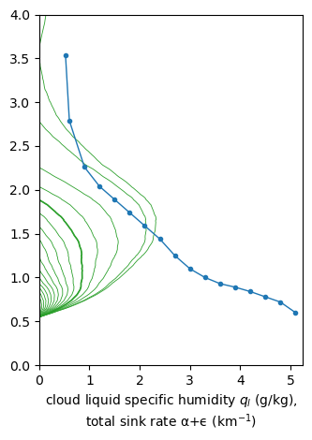
Figure CLOUDTOPHT. Clouds of different specific humidity and heights simulated for different total (entrainment + autoconversion) sink rates.
[/home/deszoeks/Projects/ATOMIC/ATOMIC_GOES/julia/RHB/sonde/cloud_top_heights.pdf]

Precipitation
Precipitation flux $P$ (downward > 0) is parameterized by autoconversion $α$ from cloud liquid, For the updraft with no storage of cloud liquid water, the precipitation source is
$$\frac{∂P}{∂z}=-αWq_{l}=xW\left(\frac{∂q_{l}}{∂z}+γ\right),$$where ($∂q_{l}/∂z+γ)$ is the total moisture source in the updraft and $x=α/{(ϵ+α})$ is the precipitation efficiency, i.e., the ratio of the autoconversion to the total (entrainment + autoconversion) moisture sink.

Eddy flux
We write the horizontal mean moisture budget with no total moisture tendency as,
$$0=A-\frac{∂F}{∂z}.$$The first term is the prescribed large-scale advection and subsidence of mean environmental vapor. The second term is the convergence of the total eddy moisture flux by cloud up- and downdrafts, and precipitation. Specific humidity tendency has diurnal cycles that average out over a day. Integrating this balance vertically from cloud base, the eddy moisture flux is
$$F\left(z\right)=F\left(z_{CB}\right)-\int_{z_{CB}}^{z}{A dz}.$$For cloud base vapor flux of $F_{CB}=$ 145 W m^{–2}, the total flux $F=F_{cld}-P$ goes to zero at about 8 km (Fig. QMASSFLX).
We parameterize the eddy flux due to clouds $F_{cld}$ by a mass flux scheme consisting of updrafts and downdrafts,
$$F_{cld}=a_{up}w_{up}\left(q_{up}-q\right)+a_{dn}w_{dn}\left(q_{dn}-q\right).$$The cloud updraft mass flux is the product of the cloudy area fraction and the mean velocity in the clouds $W=a_{up}w_{up}$. The compensating descending mass flux of clear air $-W=a_{dn}w_{dn}$ has much weaker $w_{dn}$ over the larger clear area $a_{dn}$. The mass flux due to updrafts and downdrafts sums to zero, $a_{up}w_{up}+a_{dn}w_{dn}=0$. As is common, we assume that the humidity of the descending air between the clouds is nearly equal to the mean humidity so
$\left|q_{up}-q\right|≫\left|q_{dn}-q\right|$, and
$$F_{cld}=WΔq= W\left(q_{up}-q\right).$$
These fluxes are shown in Fig. QMASSFLXa. The flux at cloud base is set to $F_{cld}\left(z_{CB}\right)=$ 145 W m^{–2} $=6.0×{10}^{-5}$ kg m^{–2} s^{–1}. The cloud-base precipitation $P\left(z_{CB}\right)=P_{0}$ is set to the surface precipitation. The mean surface evaporation is $E_{0}=$ 180 W m^{–2} $=6.5×{10}^{-5}$ kg m^{–2} s^{–1} and surface precipitation is $P_{0}=$25 W m^{–2} $=9.0×{10}^{-6}$kg m^{–2} s^{–1}, observed on the Ron Brown during EUREC4A/ATOMIC.
To calculate the profiles in Fig. QMASSFLX, the total flux is first estimated which balances the large-scale moisture sink. Precipitation removes water from the total flux, requiring the cloud mass flux $F_{cld}$ to be stronger than the total. Using the precipitation parameterization, the moisture budget allows us to simultaneously solve for the cloud flux and precipitation $F_{cld}-P=F$ (Fig. QMASSFLX). Evaluating the analytical integral of $F_{cld}$ still involves a numerical vertical integral, so we directly integrate the differential equation from cloud base with vertical step $dz$,
$$dF_{cld}=dF+dP=dF-α{(q_{l}/Δq)F}_{cld} dz,$$with a marching scheme for $F_{cld}$,
$$F_{cld,k+1}=\frac{F_{k+1}-F_{k}+F_{cld,k}(1-Q_{k}dz)}{1+Q_{k+1}dz},$$where $Q_{k}=α{\left(q_{l}/Δq\right)}_{k}/2$ and $Δq=q_{T}-q$ is the difference between the total water $q_{T}$ in the updraft and the environment $q$. We use $q_{T}$ found for $ϵ+α=1.5 {km}^{-1}$ (Fig. MOISTURECLOUDS) to solve for the cloud flux $F_{cld}=W\left(q_{T}-q\right)$ and precipitation flux $P$. Precipitation efficiency is set to obtain physical solutions with zero fluxes
$F_{cld}\left(z_{top}\right)=P\left(z_{top}\right)=0$ at cloud top and
$$F_{cld}\left(z_{CB}\right)={E_{CB}≤E}_{0} \\ P\left(z_{CB}\right)=P_{0}$$at cloud base. For $ϵ+α=1.5 {km}^{-1}$, the model returns the observed precipitation $P_{0}=25$ W m^{–2} at cloud base for $x=0.39???$ (autoconversion $α=0.585$ km^{–1} and entrainment $ϵ=$0.915 km^{–1};
WAS $x=0.25$ (autoconversion $α=0.375$ km^{–1} and entrainment $ϵ=$1.125 km^{–1}; Fig. QMASSFLXa).

Integrating precipitation instead
Integrating the precipitation flux $P$ directly is done by substituting $F_{cld}=F+P$ in
$$dF_{cld}=dF-α(q_{l}/Δq)F_{cld} dz=dF-α(q_{l}/Δq)(F+P) dz.$$Precipitation is numerically integrated from initial value $P(z_{CT})=0$ at cloud top, downward through the cloud ($q_{l}>0$) with trapezoidal steps,
$$P_{k}=\frac{\left(1+c_{k}\right)P_{k+1}+c_{k}F_{k}+c_{k+1}F_{k+1}}{1-c_{k}}$$where $c_{k}= α{(q_{l}/Δq)}_{k}/2 dz$. The cloud-base precipitation is calculated (Fig. PRECIPHEIGHT). Precipitation for trade cumulus clouds depends on the autoconversion
$α=x(α+ϵ)$. An ensemble of clouds with different precipitation efficiency and total sink rate parameters results in a range of cloud top height. The cloud top height distribution is matched to that of the satellite observations, and the total precipitation is match to
Cloud top height generated by the varying parameters has a bifurcation around 3.6 km. Trade cumulus clouds are vertically bounded below 3.6 km by the trade inversion in the sounding, but clouds with weak sink rate retain enough total moisture to continue past the trade inversion and do not stop until they reach the tropopause. The model predicts this bifurcation based on water closure alone, without considering the effect of buoyancy. While this prediction qualitatively matches expectations for tropical clouds, we caution against interpreting it too strongly, as the model lacks features that would quantitatively constrain deep convection, such as ice and buoyancy. We limit our interpretation to the trade cumulus clouds.
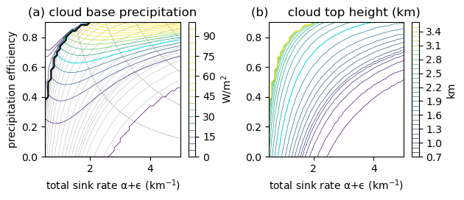
Figure PRECIPHEIGHT. [mean_mass_flux.ipynb precip_height.*]
The mass flux is $W=F_{cld}/Δq$(Fig. QMASSFLXb). The mean updraft velocity at each height is then $w_{up}=W/a_{up}$ where $a_{up}$ is the cloud area. The humidity gradient $∂q/∂z$ and cloud fraction $a_{up}$ decay with height.
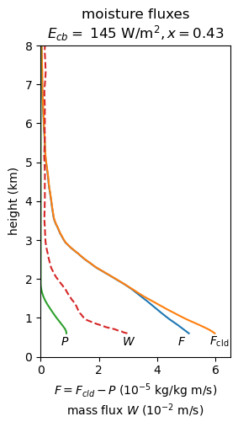
Figure QMASSFLX. Total moisture flux to balance the large-scale moisture sink (blue), cloud moisture flux (orange), and (downward) precipitation flux (green), and mass flux (red) from the model.
The vertical moisture fluxes balance large scale advection and subsidence of moisture. Most of this moisture flux is below 3 km and most of the mass flux is below 2 km. The cloud and total eddy moisture flux balance subsidence drying at the strong moisture derivative at the top of the trade cumulus layer at 2-3 km. The strong difference at 2-3 km between the dry environment and the cloud updraft, whose specific humidity is proportional to the saturation specific humidity, achieves the moisture flux there. Precipitation is zero at cloud top (1.7 km) and integrates downward proportional to cloud liquid water, confining it in the lower cloud layer.
We model the mean $q_{l}$ of the cumulus ensemble with a single monolithic cloud of 1.7 km depth (Fig. MOISTURECLOUDS). Clouds still exist above 1.7 km, but the average humidity transported by this monolithic updraft is between saturation and the mean surroundings. We expect the emergent result is accurate that the eddy flux is mostly by vapor transport above 1.7 km. In or out of clouds, eddies transport mostly water vapor, and secondarily liquid water.

Isotope model
The stable isotope (deuterium and oxygen-18) ratios of the cloud water can also be diagnosed from the cloud model. Analogous to the equation for the steady total (vapor + liquid) cloud water specific humidity $q_{T}$, the total cloud water isotope specific humidity $q_{iT}$gradient is,
$$\frac{∂q_{iT}}{∂z}=-ϵ\left(q_{iT}-q_{i}\right)-αq_{il}.$$Total isotope specific humidity is entrained and detrained, and liquid water is converted to precipitation. This equation is used to step vertically from an initial cloud isotope composition at cloud base.
Isotope ratio $R=μq_{i}/q$ is reported as a standard number concentration using delta notation $δ=R/R_{s}-1$, where $μ$ is the ratio of the isotope gas constant to the abundant water gas constant and $R_{s}$ is a standard isotope ratio for mean ocean water. The vapor and liquid isotope ratios are in equilibrium in the cloud, $R_{l}={α_{e}R}_{v}$, where $α_{e}>1$ is the equilibrium fractionation coefficient for liquid over vapor. We write the isotope specific humidities in terms of the ordinary specific humidities,
$$q_{i}=R_{env}q \\ q_{iT}=R_{T}q_{T} \\ q_{iv}=R_{v}q_{v} \\ q_{il}=α_{e}R_{v}q_{l}.$$
The isotope ratio of the vapor is
$$R_{v}=\frac{R_{T}q_{T}}{q_{v}+α_{e}q_{l}}.$$
Figure CLOUDISO shows the cloud isotope solution for the cloud model with total sink $α+ϵ=1.5×{10}^{-3}$ and precipitation efficiency $x=0.43$. An idealized environmental profile of isotopes with $δ_{env}=-70×{10}^{-3}$ at the surface and a gradient of $-10×{10}^{-3}$ km⁻¹ below 2 km is entrained into the cloud. The total isotope ratio is depleted by entrainment and autoconversion. The cloud vapor is depleted more strongly than the total cloud water at first, with the small contribution of liquid water specific humidity $q_{l}$ having the relatively enriched isotope ratio $δ_{l}≈0$ in equilibrium with the cloud. Near cloud top, the vapor isotope ratio increases to meet the total isotope ratio at cloud top. As the total isotope ratio continues to decrease steadily due to entrainment and autoconversion sinks, the vapor isotope ratio increases because there is diminishing liquid water.
Thus, the isotope profiles provide an additional constraint on the model. The eddy flux divergence source of rare isotope to the atmosphere must balance the large scale subsidence and advection of the isotope profile in steady state,
$$-\frac{∂F_{i}}{∂z}+A_{i}=-\frac{∂}{∂z}(W\left(q_{iT}-q_{i}\right)-P_{i})+A_{i}=0.$$
The precipitation sink subtracted from the flux
$$\frac{∂P_{i}}{∂z}=-αWq_{il}$$instantaneously removes liquid water from the atmosphere to the surface.
$$-\frac{∂}{∂z}\left(W\left(q_{iT}-q_{i}\right)\right)-αWq_{il}+A_{i}=0.$$
Explicitly simulating the large-scale subsidence of the assumed isotope profile,
$$A_{i}=-\overline{w}\frac{∂q_{i}}{∂z}+residual$$The residual includes horizontal advection of isotopes and sources not simulated by the model.
$$-\frac{∂}{∂z}\left(W\left(q_{iT}-q_{i}\right)\right)-αWq_{il}-\overline{w}\frac{∂q_{i}}{∂z}+residual=0$$
$$-\frac{∂}{∂z}\left(Wq_{iT}+\left(\overline{w}-W\right)q_{i}\right)-αWq_{il}+q_{i}\frac{∂\overline{w}}{∂z} +residual=0.$$
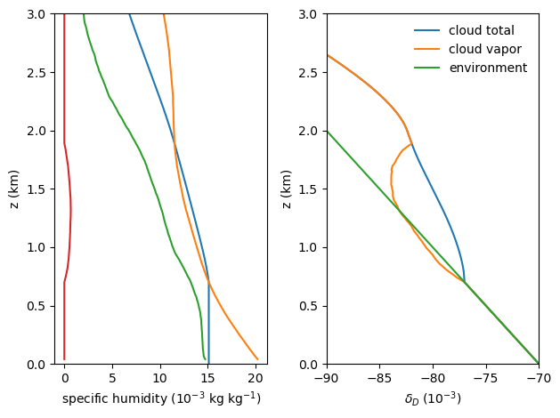
Figure CLOUDISO. Cloud total and vapor deuterium isotope ratios for a single-cloud model with total sink $α+ϵ=1.5×{10}^{-3}$ precipitation efficiency $x=0.43$, and an idealized environmental profile of isotopes of $-70×{10}^{-3}$ at the surface and a gradient of $-10×{10}^{-3}$ km⁻¹ below 2 km.

Cloud ensemble
The cloud model simulates the flux due to a single updraft. Now we model the ensemble of cumulus clouds as a function of their total moisture sink $(ϵ+α)$ and precipitation efficiency. Clouds with weaker total moisture sink $(ϵ+α)$ reach greater maximum height $h$. The clouds are matched to the observed cloud top height distribution. Regardless of height, each cloud in the ensemble is initialized with the same cloud base flux and balances the same large-scale subsidence, in proportion to its fractional area in the ensemble, so that the cloud ensemble also balances the mean large-scale forcing.
The flux $F_{j}=F_{cld,j}-P_{j}$ for each cloud height type $j$ with fractional area $a_{i}$ sums to the mean large-scale flux $F=\sum_{j}{a_{j}F_{j}}/a_{cld}$. Mass flux due to cloud type $j$ is due to the cloud area $a_{j}$ and also the compensating subsiding area so that $\sum_{j}{a_{j}}/a_{cld}=1$. A solution is for each cloud category to balance the large-scale moisture flux $F_{j}=F.$ This implies $F=F_{cld,j}-P_{j}$. The observed distribution of cloud top height $h_{j}$ determines the distribution of the total sink ${\left(ϵ+α\right)}_{j}$. The precipitation of the resulting ensemble $\sum_{j}{a_{j}P_{j}}/a_{cld}=P$ sums to the mean precipitation. The mean precipitation constrains the precipitation efficiency $x$.
If instead $F_{j}$ is a function of $F, a_{j},$ and other cloud parameters, $f(F,a_{j}, …)=F_{cld,j}-P_{j}$, then we might algebraically solve
The mass flux $W_{j}$ of cloud type $j$ can be retrieved from the cloud water flux
$$F_{cld,j}=W_{j}(q_{T}-q_{j}),$$and its vertical velocity is $w_{j}=W_{j}/a_{j}=F_{cld,j}/[a_{j}(q_{T}-q_{j})].$

Data
Radiosonde thermodynamic profiles
The humidity profile is the average of the ATOMIC/EUREC4A radiosondes released in Jan-Feb 2020 from the research vessel Ron Brown. Among the superset of radiosonde profiles from all platforms in EUREC4A, the Ron Brown radiosondes provide a sufficient ensemble mean located northeast of Barbados, away from deeper convection farther south. Figure HUMIDIFF shows the humidity observations from these sondes, and the saturation specific humidity $q_{s}$ of their mean temperature profile. The mean humidity difference $Δq=q_{s}-q$ in moisture flux calculation is approximately 2 g kg^{–1} in the trade cumulus layer (0.5-2 km). The stronger humidity difference of 8 g kg^{–1} at 3 km, around the maximum height of trade cumulus clouds increases the moisture flux by the fewer deep trade cumulus clouds that reach this level.
GOES satellite cloud height
We use the cloud area as $a_{up}$ at each height from the GOES-R satellite retrievals. The GOES 2-km resolution makes visible the energy-generating cloud scales responsible for the eddy flux. The dynamics at this scale couple to smaller-scale updrafts and downdrafts, and to turbulence. And yet, the 2 km scale itself is too small to be representative of an ensemble of cloud updrafts and downdrafts. The cloud area fraction is computed as a function of height from the cumulative distribution of GOES cloud top brightness temperature, assuming maximum overlap (i.e., clouds extend from cloud base to the level corresponding to the pixel brightness temperature). Cloud top temperature is mapped to height using the mean temperature profile of radiosondes released from the Ron Brown research vessel during ATOMIC/EUREC4A.
The cloud area fraction $a\left(z_{top}\right)$ reaching each cloud top height indicates how the mass and moisture fluxes by clouds and precipitation are distributed in the domain. We solve for mass flux $W=F_{cld}/(q_{T}-q)$ and updraft velocity profiles,$$w_{up}=\frac{W}{a}=\frac{F_{cld}}{a(q_{T}-q)},$$for the cloud top height in the satellite retrieval.
We shall now model the spectrum of cloud top heights by varying $α+ϵ$, then retune $x$ so that the spectrum of clouds gives the surface precipitation $P_{0}.$ Varying $α+ϵ$ generates clouds of different height $h$, defined by the top where liquid water $q_{l}=0$ (Fig. MOISTURECLOUDS). Suppose that the total mass flux $W=\int_{z_{CB}}^{z_{top}}{(dW/dh) dh}$ is a sum of mass fluxes from these clouds of different heights from cloud base to the highest cloud top $z_{top}$, with the mass flux density $dW/dh$. Then the cloud flux is
$$F_{cld}=\int_{z_{CB}}^{z_{top}}{dW/dh \left[q_{T}\left(h\right)-q\right] dh},$$where $dW/dh$ and $q_{T}$ depend on cloud height $h.$ The flux $F(z_{top})$ is only due to the highest cloud, and the change of the flux moving downward is
$${dF}_{cld}=W_{h}\left(q_{T}\left(h\right)-q\right) dh=\left(q_{s}-q\right) dW.$$The last equation uses ${q_{T}=q}_{s}$ at cloud top, where $q_{l}=0$ exactly. Below cloud top, for each cloud with top
$$dF_{cld}=dF+dP=dF-α{(q_{l}/Δq)F}_{cld} dz,$$[[(the equation at bottom of p. 4)]]
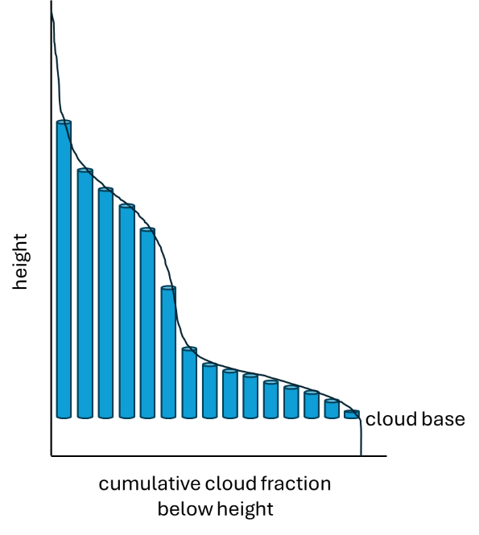
Figure CLOUDBELOWHEIGHT. Schematic of cloud fraction below each height. Tubes represent an ensemble “rank” of cumulus clouds that transport mass and moisture from cloud base to cloud top, for the cumulative cloud fraction below the cloud top height. Mass and moisture fluxes are distributed among the clouds, based on their height.

[ ]
Figure GOESCLOUDAREA. A GOES 2-km IR brightness temperature image.
[ ]
Figure GOESCDF. Vertical cumulative distribution of cloud area fraction.
!!!!!! How does GOES change over the diurnal cycle? !!!!!!

Sensitivity to the sounding
What effect does warming the sounding have on the mass flux? First, assume that the large-scale forcing is the same, and change only the local humidity profiles. In so doing, we assume radiative-convective equilibrium results in the same large-scale circulation. That is, the large scale deep convective latent heating balances nearly the same radiative cooling, resulting in the same subsidence over the trade cumulus boundary layer.
- Keep RH constant, increase q_s(T) and q. With compensations, cloud is almost unchanged.
- Keep q constant, increase q_s(T) by adding constant $dT_{0}$. This results in a sounding with very dry RH.
- Reduce the lapse rate, so add $dT = dT_{0} -γ'z$, and adjust qs, q accordinly
We computed the cloud for our model with relative humidity held constant and a warming of $ΔT=+1$ °C. This experiment increases saturation specific humidity to $q_{s}^{'}=\left(1+δ\right)q_{s}$, by $δ=$ +6% by Clausius Clapeyron (at 25 °C). Yet because of compensations, this increases $q_{l}$ insignificantly, by only 0.12%. [Humidity does not depend on changes in lapse rate of the environment in this experiment.]
If $q_{T}-q$ increases 6% at constant RH, 6% less mass flux $W$ is requred to balance the same large-scale moisture forcing. Clouds being moister relative to their environment would reduce the equilibrium mass flux that balances the large-scale drying, and probably reduce the cloud fraction. [[This seems basic. Too simple? Has anyone proposed it already? We need to look.]]
If the large-scale circulation also spins down in a warmer climate, then the subsiding environment of the trade cumulus clouds will be relatively drier than the surface, increasing $q_{T}-q$ and reducing equilibrium mass flux needed to balance the large scale drying. [[Is this simulated by models with wet-get-wetter behavior???]]
Increasing the updraft-environment humidity difference $q_{T}-q$ also increases entrainment. Increasing $q_{s}$ (6%), corresponding to an increase of 1 °C, but keeping the environment $q$ constant reduces cloud liquid water to 41 % of that of the ATOMIC/EUREC4A control case.

### OLD:

Holes in the trade cumulus
The cloud radiative effect is strongly correlated with the size of holes in the trade cumulus layer (Janssen et al 2022???). We use the distance transform, which gives hole size, and the connectedness of each hole to its neighbors. The holes are not strongly correlated to cloud morphologies described as Sugar, Gravel, Flowers, and Fish. These cloud morphologies are more strongly related to the wind regime and momentum transports by the cumulus ensemble (Nuijens et al. 2022 QJRMS, Savazzi et al. 2022).
In light of our mean water transports computed above, we suppose that the clear regions between clouds act as watersheds, collecting subcloud boundary layer moisture that converges and feeds cloud updraft mass and moisture flux. The area and (physical and optical) depth of clouds are related to their updraft mass flux and their detrainment of radiatively visible and emissive clouds and water vapor.

