Shallow cumulus clouds decrease with decreasing tropical overturning circulation

Abstract
Shallow cumulus clouds affect Earth’s planetary albedo. Their cloud feedback explains the spread in climate model sensitivities to atmospheric CO$​_{2}$. Desiccation of the cloud layer by increased vertical mixing has been proposed to reduce shallow cumulus clouds, but recent observations show that, rather than humidity, mesoscale mass flux variations explain cloud area. Here, we extend that result to climate change. A moisture balance model of the lower troposphere predicts a 5-7% K⁻¹ decrease of shallow cumulus mass flux and thus cloud albedo. The reduced cloud moisture flux balances reduced drying by the large-scale tropical atmospheric overturning circulation, which has been shown to decrease –5 % K⁻¹ by energetics. A –5 % K^{–1} reduction of shallow cumulus cloud albedo decreases local cloud shortwave radiative cooling by 1.6 W m^{–2}.

Introduction
The shallow cumulus cloud regime, with a mean cloud fraction of 0.2-0.4, covers ~15 % of Earth’s oceans (Stevens et al. [NARVAL] 2019, Jacob et al, 2020). Satellite observations of the last decades show clearing of optically thin low clouds represents the strongest contribution to shortwave cloud feedback (Jin et al. 2026), and in models, clearing of shallow cumulus clouds in that cloud regime dominate feedbacks from changes in the frequency of occurrence (days per month) among different regimes (Zelinka et al. 2023). Low clouds in climate models tend to decrease with warming (ISCCP, Zelinka et al., 2023; Webb and Lock, 2013; Webb et al. 2017, Jin et al. 2026), a positive shortwave radiative cloud feedback. Variety of this shallow cumulus feedback among models widens the spread of climate model projections of the sensitivity of temperature to CO2 (Bony et al., 2006), especially for strongly subsiding regimes (Bony and Dufresne, 2005).
Low cloud amount is sensitive to humidity at cloud base (Sherwood et al. 2014; Brient et al. 2016; Vial et al. 2017). In the mixing-induced low cloud feedback, cumulus clouds and shallow circulations mix drier air downward, desiccating clouds near their lifting condensation level (LCL). Models with more convective mixing export increasingly more moisture from the boundary layer under warming, accounting for the spread of climate sensitivity in CMIP3 models (Sherwood et al. 2014).
In the winter northeastern tropical Pacific, EUREC4A airborne lidar and radar observed cloud-base cloud fraction of 5.4 % (BASTILIAS; Chazette et al., 2020; Bony et al., 2022; Vogel et al., 2022). Satellite albedo from GOES shows shallow clouds have 3% cloud albedo below 1 km (by random overlap; 8 % by maximum overlap with clouds below 4 km; Fig. REFLALBEDO). Observations and LES indicate that subcloud turbulence moderates cloud base moisture and cloud fraction (Nuijens et al. 2013; Brient et al. 2016; Vial et al. 2017; Vogel et al. 2022; Bretherton et al. 2013). The 5 CMIP6 models with historical and +4 K atmospheric simulations in the Cloud Forcing Intercomparison Project (CFMIP) have stratocumulus clouds (optical thickness of 3.6 to 23) in the northern tropical Atlantic, but few clouds with optical thickness <3.6. The fraction and/or optical thickness of these stratocumulus clouds increases with warming in most of the models (Huang et al. 2026, pers. communication).
Fig REFLALBEDO. Vertical profile of fraction of cloudy pixels (black), cloud albedo weighted cloud fraction, and reflectance-weighted cloud fraction below 4 km from GOES 2x2-km pixels (a) in 10-m cloud top height bins, and (b) integrated downward. Reflectance is directly observed, and albedo is computed from cloud optical thickness. Cloud frequency fully counts pixels with optically thin clouds, so cloud weighted albedo and reflectance are less than cloud frequency of occurrence (Fig. M-GOESISCCP). Cloud albedo scales the shortwave radiative effect.

In the mixing-induced low cloud mechanism, increased vertical mixing reduces cloud fraction in a warmed climate by desiccating the shallow cumulus layer. Field observations from EUREC4A (Stevens et al. 2021; George et al. 2022) show clouds are correlated more strongly (r = 0.72) to cloud-base mass flux than to relative humidity, challenging the importance of humidity and suggesting that vertical mixing processes are correlated with local shallow cumulus clouds.
The mechanism introduced here, decrease in mass flux (DIM), predicts shallow cumulus clouds decrease in proportion to the reduction of the mean tropical large-scale circulation based on 4 relationships:
(1) The large-scale tropical overturning circulation slows –5% K⁻¹ with climate due to the radiatively-constrained +2% increase in precipitation and +7% increase in specific humidity (Held and Soden, 2006, HS06; Vecchi and Soden, 2007). The mean horizontal advection and subsidence advection dry the lower troposphere.
(2) In a steady climate, the moisture budget is balanced. In the shallow cumulus regime, mean advective drying (mostly subsidence) is compensated the divergence of the shallow cumulus eddy moisture flux, $0=-∂/∂z\left[M\left(q_{c}-q\right)-P\right]-W({∂q}/{∂z)}$, where $M$is the cumulus mass flux, $q_{c}$ is the cloud humidity, $q$ is the environmental humidity. We write only the subsidence component $-W({∂q}/{∂z)}$, but the full moisture advection scales with the hydrological cycle. For constant humidity, the large-scale mean moisture advection decreases –5% in response to the circulation $W$.
(3) The saturation and environmental humidity $q$, cloud humidity $q_{c}$, and precipitation $P$ increase +7% K⁻¹. Factoring out the proportional change of all the humidities, moisture balance then implies $M∝W$.
(4) The shallow cumulus cloud fraction responsible for the cloud radiative effect is proportional to mass flux, $C∝M$. The cloud mass flux definition is $M=Cw_{c}$. Cloud base mass flux depends on cloud base cloud fraction with slope ${dC}/{dM}=$ 2.4-4.0 % (cm s^{–1})^{–1} (Vogel et al., 2022). GOES mean cloud albedo is slightly less than the mean reflectance. Assuming in-cloud optical depths are invariant, changes in mean albedo and mean reflectance are due to changes in the cloud fraction and mass flux, so $R∝A∝C∝M$. We show the slope of mass flux to mean reflectance, for a model tuned to reproduce moisture balance and the observed distribution of cloud top heights, is $dM/dR=$ 4.2 cm s^{–1} among GOES scenes with a mass flux cloud model (results subsection 1).
The DIM hypothesis, $ΔA/A=ΔM/M=ΔW/W$ is a simple explanation for the change of clouds with the climate, predicting the shallow cumulus cloud albedo dims with warming ${d\ln{A}}/{dT}≈-5 \% K^{-1}$. This generates a positive radiative feedback that scales with the planetary albedo of shallow cumulus clouds.

Cloud and flux model
To predict the response of shallow cumulus clouds to climate, we separate the known changes from thermodynamics and circulation, from the properties of cloud geometry, turbulence, and microphysics expected not to change. The autoconversion of cloud droplets to precipitation, the lateral entrainment rate, and the ratio of the area of active updraft to cloud area, are set to match emergent properties of the clouds in the present climate and are not expected to change with thermodynamic and circulation responses to CO2.
A mass flux model of entraining and precipitating cloud plumes simulates cloud humidity, cloud top height, mass fluxes, and moisture fluxes (see Methods). Updraft water in excess of the saturation specific humidity condenses as cloud liquid. Cloud and large-scale advective fluxes are both proportional to the mean humidity gradient. The total moisture sink rate (vapor entrainment and liquid autoconversion) parameterizes turbulence-scale processes within the clouds and determines the cloud humidity and cloud top height. Plumes with weaker sink rates have higher cloud tops. A distribution of moisture sink rates is set to match the cloud top height distribution of GOES satellite observations. Holding the moisture sink rates constant and requiring cloud moisture flux to balance the large scale advective drying below 4 km, we assess the effect of large-scale circulation $W$ and environmental moisture $q$ on the cloud mass flux and moisture flux profiles.

Results

Cloud albedo is proportional to mass flux
The cloud model generates cloud water and vertical velocity profiles for thousands of ~260x260 km² GOES satellite reflectance scenes. The scene-mean mass flux binned as a function of mean reflectance is shown in Fig. REFLMASSFL. The resulting slope 2.4 % (cm s^{–1})⁻¹ agrees with the correlations between cloud base mass flux and cloud fraction observed from dropsonde circles in EUREC4A (2.4 - 4.0 % [mm s^{–1}]⁻¹; Vogel et al. 2022). The sensitivity of the GOES scene-mean reflectance is at the low end of the range of sensitivity from EUREC4A cloud base cloud fraction, presumably because optically thin clouds contribute more to the cloud fraction than to the mean reflectance. This slope suggests that in the mean, clouds have a constant in-cloud updraft velocity $w_{c}≈$ 4.2 cm s⁻¹. The proportionality of cloud albedo to mass flux $d\ln{A}=d\ln{M}$ is used to infer the change in cloud albedo from the mass flux shallow cumulus cloud model.
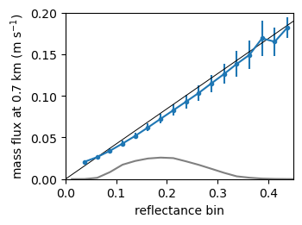
Figure REFLMASSFL. Modeled mean cloud base (700 m) mass flux for all scenes in each reflectance bin (blue points and whiskers). Black line shows a slope of 0.42 cm s^{–1} (% reflectance)^{–1}, suggesting mean cloud reflectance increases $S=$ 2.4% per 1 cm s^{–1} of cloud base mass flux. Gray line shows relative number (10^{–5}) of scenes in each reflectance bin.

Climate experiments
A series of experiments predict the mass and moisture flux for cloud updrafts with decreased large scale moisture flux and moister atmospheric soundings, corresponding to a 1 K of surface temperature warming. Each experiment has a set of updrafts with identical total sink rates to the updrafts in the control simulation. The cloud top height distribution from the control simulation sets the distribution of sink rates for the experiments, and the cloud top height and cloud flux is solved for each cloud in each experiment. Experiments in the series are ordered so that each modification builds cumulatively on the previous modifications. The result of each experiment is compared to the control experiment. The relative changes in total shallow cumulus cloud albedo for the experiment-control $\ln{({A_{x}}/{A_{ctl}})}$ are shown in Table 1.
The first experiment, subsidence-5%, decreases the large-scale subsidence $W$ by -5% (HS06), corresponding to saturation vapor pressure increasing +7% K⁻¹ and large-scale drying increasing +2% K⁻¹. The reduction of subsidence is accompanied by a +2% increase of the mean moisture flux $E_{cb}$ in experiment Ecb+2%. Th thermodynamic profile and the cloud field are identical to the control in these experiments. The effect of reducing the large-scale subsidence is to reduce mass flux and cloud albedo -5.1% ($=\ln{0.95}$), in proportion to the subsidence. The balance of the cloud top moisture flux divergence and the large-scale dry advection source (mostly subsidence) are not affected by the cloud base moisture flux, and the clouds are identical in Ecb+5% as in subsidence-5%.
The next experiments assess the sensitivity to the humidity profile. The specific humidity and saturation specific humidity profiles $q, q_{s}$ increase by +7%, keeping constant relative humidity, in experiment q&qs+7%. Increasing specific humidity decreases the mass flux and cloud albedo by increasing the vertical moisture gradient and cloud-environment humidity difference $q_{c}-q$. This decreases the mass flux $M$ (-2.7%) required to achieve the moisture flux $M(q_{c}-q)$ that balances the large-scale subsidence drying. This thermodynamic effect reduces clouds about half as much again as the subsidence.
For the same reason, greater environmental humidity at cloud levels increases clouds. Increasing the environmental humidity decreases the excess humidity of the cloud$q_{c}-q,$increasing the mass flux required for the same moisture flux $M\left(q_{c}-q\right).$One experiment increases environmental relative humidity in the subcloud and cloud layer below $2z_{CB}$ to
$$RH=RH_{ctl}+0.05\left(1-RH_{ctl}\right)(2z_{CB}-z)/2z_{CB},$$increasing the RH by 0.3% (absolute) at cloud base. The resulting increase of clouds (+2.7%).
For surface evaporation $E=ρLC_{E}Uq_{s}\left(1-RH\right)$ to increase +2% K^{–1} in proportion to precipitation, where $q_{s}$ increases +7% K⁻¹ and other parameter remain constant, the surface relative humidity RH must increase to quench the surface relative saturation deficit $1-RH$ by –5 % K^{–1}. The mean surface RH = 0.73 thus increases (absolutely) +0.014 K^{–1}. Though this flux scaling says surface RH increases, the RH below cloud base does not affect the clouds. The cloud base is expected to form at the lifting condensation level, at a constant RH among the control and the experiment simulations.

Table 1. Relative change of shallow cumulus cloud fraction $ΔC/C_{ctl}$, where experiments represent conditions for +1 K of warming relative to the control simulation. The DIM experiment has -5% reduced subsidence, +2% increased moisture flux, and +7% increased humidity. Absolute change of the cloud radiative effect ($Δ$CRE).
experiment | $ΔC/C_{ctl}$  (%) | $Δ$SWCRE  (W m^{–2}) | $Δ$LWCRE  (W m^{–2}) | $Δ$CRE  (W m^{–2})
subsidence-5%, Ecb+2% | –5.00 | +1.02 | –0.18 | +0.84
q&qs+7% (DIM) | –7.56 | +1.55 | –0.27 | +1.28
lclRH+0.003 | –5.01 | +1.03 | –0.18 | +0.85

The cloud radiative effect (SWCRE) is estimated for GOES low clouds (height below 680 hPa) with a cloud radiative kernel (Zelinka et al., 2012) with GOES cloud optical thickness and cloud top pressure retrievals (Minnis et al. 2008; data available on AERIS or NCEI provided by W. Smith, pers. communication). CRE for the experiments is multiplied by the relative change in the shallow cumulus albedo $ΔA/A_{ctl}$that is proportional to the mass flux $ΔM/M_{ctl}$ (Table 1).

Discussion
Differences from the predictions of the DIM mechanism in climate change simulations suggest variation in the response of the subsidence drying over the shallow cumulus region, or variations of the proportionalities of clouds or mass flux to the subsidence. A different relationship from $d\ln{M}=d\ln{W}$ is possible if either the entrainment or the vertical structure of convective moisture flux changes. The DIM hypothesis predicts the change in area of low clouds responsible for the moisture flux, but does not account for secondary desiccation of optically thick stratocumulus clouds, found near cloud base in most climate models. Divergence of the vertically developed shallow cumulus cloud fraction from $d\ln{C}=d\ln{M}$ is possible if the ratio of the cloud area fraction $C$to the active updraft area $C_{a}$ with moisture flux $w_{up}\left(q_{cld}-q_{env}\right)$ changes for clouds in a different climate. [Ref in Vogel says $C/{C_{a}}≈2$???]
The hypotheses $d\ln{C}=d\ln{M}=d\ln{W}$ depend on cloud-scale and smaller processes, which are parameterized in climate models. Cloud parameterizations used in these models must satisfy many global constraints, but might not be suited to faithfully simulate the moisture flux and cloud fraction of shallow cumulus clouds. (Vial et al., 2017, Nuijens et al., 2015)
In our heuristic shallow cumulus model, cloud-scale turbulent processes are represented by lateral entrainment into clouds. Each entrainment rate determines a profile of a cloud’s moisture $q_{c}$ and determines its cloud top height. We find a spectrum of entrainment rates that give the observed shallow cumulus cloud top height distribution and moisture flux divergence in the present climate. This entrainment distribution represents cloud-scale processes like cloud parameterizations determined from observations and/or large-eddy simulations. The entrainment distribution approximately reproduces the proportionality of cloud albedo to mass flux $A∝M$.

Summary
A model for the ensemble of cumulus clouds in mean moisture balance (1) simulates the cloud eddy fluxes for the large-scale circulation drying and observed clouds in the present climate. It independently produces the ratio of mesoscale mass flux to cloud albedo observed in EUREC4A, and (2) physically extends the proportionality to climatological mean cloud albedo and mass flux. Finally, the model shows (3) the mean shallow cumulus mass flux and cloud fraction decrease in proportion to the reduction of the mean tropical circulation expected in a warmed climate (HS06).
Cloud properties and within-regime feedbacks are similar between shallow cumulus and optically thicker stratocumulus clouds (Tselioudis et al., 2021; Zelinka et al. 2025), so shifts from stratocumulus to shallow cumulus could result in partial compensation between their radiative effects. The mixing-induced low cloud feedback describes a version of this competition in the global average, whereby mixing by precipitating convection dries lower levels and evaporates extensive and optically thick stratocumulus clouds. All else equal, subsidence is found to reduce lower stratocumulus clouds (Myers and Norris, 2014). CFMIP models have both stratocumulus and shallow cumulus clouds over the northern tropical Atlantic in January-February (COSP figure), but the observed clouds are nearly exclusively shallow cumulus.
While the mass flux model’s lowest clouds increase with RH, we caution against extrapolating the mass flux model to extensive stratocumulus clouds found near cloud base. Qualitatively unlike the updraft plumes simulated by the mass flux model, stratocumulus clouds form in a layers of vertical gradients and diffusive turbulent eddies. An alternative model for cloud fraction changes related to humidity and fluxes in the turbulent subcloud layer (Supplement LCL Clouds) demonstrates that weak changes in humidity . Eddy diffusivity and mass flux schemes are needed to simulate interactions of shallow cumulus and stratocumulus clouds in climate models.

Methods
Trade cumulus clouds are intermittent shallow convection in widespread regions of mean subsidence balancing deeper convection elsewhere. Figure GOESISCCP shows cloud top height and cloud optical thickness histograms observed from the 2-km pixel GOES observations in the Northern Atlantic shallow cumulus region 12.5-16 °N, 60-49 °W, 2020 Jan 15 - February 20 (Minnis et al., 2008; W. Smith, NASA SATCORP). Most (29.1%) of the GOES clouds are below 800 hPa with cloud optical thickness between 1.3-9.4. CERES Flux By Cloud Type (FBCT) histograms compiled from 1 km MODIS pixels (Fig. MODISISCCP) are similar, but have a factor of about (2.7) greater optical thicknesses, possibly because of
There are two modes in the vertical structure of the shallow cumulus clouds (Fig. REFLALBEDO); Jacob et al. 2020). The first, just above cloud base at 0.5-1.0 km, has high frequency of occurrence but low albedo and reflectance. Many of these lowest clouds are generated in boundary layer updrafts smaller than the ~700 depth of the subcloud layer and thus do not fill the 2-km GOES pixels, lowering the effective pixel albedo. Clouds not filling the pixel or with low longwave optical thickness may account for significant a wide spread of the cloud top height of the lower mode, estimated from cloud top infrared temperature. We expect retrievals based on lower resolution pixels may identify clouds, but overestimate the cloud top temperature, underestimate the cloud top height, overestimate the cloud fraction, and underestimate the cloud optical depth. The second vertical mode is observed below the trade inversion at 1.5-2.5 km. It has half the cloud fraction as the cloud mode just above cloud base, but its albedo is greater. Clouds from 1.5-4 km are responsible for an albedo of 0.05 of the total 0.07 integrated over the lower 4 km.
Figure GOESISCCP. Cloud fraction histograms by cloud top pressure and cloud optical thickness within 12.5-16 °N, 60-49 °W, for (a) GOES-16 from 2020 Jan 15- February 20 23:40 and (b) CERES Flux By Cloud Type (FBCT) Jan-Feb for 2019, 2020, and 2021. Corresponding (c) GOES and (d) FBCT shortwave CRE. GOES shortwave CRE for clouds below 680 hPa is –20 W m^{–2} (–14 W m^{–2} for FBCT).

Mean cloud reflectance and albedo are computed at each 10-m height from 0.5-4 km from visible optical depth of daylight 2x2 km² pixels (Fig. REFLALBEDO). Pixels at solar zenith angle >75 ° and deeper than 4 km are excluded. Cloud albedo is calculated with a two-stream approximation for inelastic scattering, $α_{c}=\left(1-g\right)τ/(2μ_{0}+\left(1-g\right)τ$, from the cloud optical thickness $τ$, asymmetry parameter $g=0.85$, and solar zenith angle cosine $μ_{0}=cos⁡(θ_{0})$ (Coakley and Chylek 1975, Meador and Weaver 1980, Tornow et al. 2020). The albedo-weighted cloud fraction below 4 km is a proxy for the cloud albedo of Northern Tropical Atlantic maritime clouds during EUREC4A, Jan 15-Feb 12, 2020 at 12.5-16 °N, 60-49 °W (Fig. REFLALBEDO). The GOES cloud fraction (Figs. REFLALBEDO and GOESISCCP) is greater than the cumulative cloud albedo below 4-km (Fig. REFLALBEDO) because the reflectance is less than unity for fully cloudy pixels with low optical thickness.
Cloud radiative effect is computed from radiative kernels (Zelinka et al. 2012 ???2015??? ), using the optical depth from the GOES retrieval, and then scaled by shallow cumulus cloud model perturbation experiments (Fig. GOESISCCP).

Cloud ensemble $a_{i}$

We partition the all-sky mean eddy flux $G$ to cloud categories $i$. Clouds with albedo $a_{i}$ have cloud tops that reach $h_{i}$ in daylight GOES satellite images (Fig. REFLALBEDO).

We also interpret albedos $a_{i}$ as a proxy for cloud area fraction. This interpretation is valid if the reflectance is representative of clouds with high optical thickness. Estimates of cloud optical thickness disagree for shallow cumulus clouds, perhaps due to very small clouds resulting in partially cloudy pixels. Not all shallow cumulus clouds have high optical thickness, yet we retain this reflectance-weighted fraction as a the radiatively relevant measure of cloud albedo.

Large scale eddy flux
The all-sky mean large scale eddy flux $G$ is the integral of the large-scale subsidence and horizontal advection source $S_{LS}$, with the cloud base moisture flux $G_{CB}$ as the boundary condition:
$$G\left(z\right)=G_{CB}+\int_{z_{CB}}^{z}{S_{LS} dz^{'}}.$$The large-scale moisture source $S_{LS}$ is drying due to subsidence and horizontal advection$.$
We partition the moisture flux into a vertically uniform flux in each cloud category $i$. The all-sky mean flux profile $G\left(z\right)$ has a flux difference $G_{i}=G\left(h_{i+1}\right)-G\left(h_{i}\right)$ at each discreate height $h_{i}$, where the vertically uniform moisture flux from cloud $i$ detrains at the cloud top. This flux difference is assumed to be carried by the clouds with (reflectance-weighted) area fraction $a_{i}$ and height $h_{i}$. The cloud top height $h_{i}$ of each cloud is determined by its moisture sink rate parameter.
The all-sky flux $G=aF$ is the product of cloud area and in-cloud flux $F$. The all-sky mass flux $M=aw$ likewise corresponds to the in-cloud vertical velocity $w$. The model divides clouds and their fluxes into categories $i:$
$$M_{i}=a_{i}w_{i}, \\ G_{i}=a_{i}F_{i}=a_{i}w_{i}{\left(Δq\right)}_{i}=M_{i}{\left(Δq\right)}_{i}, \\ F_{i}=w_{i}{\left(Δq\right)}_{i}$$where total fluxes are summed over the categories, $G=\sum_{i}{G_{i}}$, $F=\sum_{i}{F_{i}}$, and $M=\sum_{i}{M_{i}}$, $w=\sum_{i}{a_{i}w_{i}/A}$. Figure FEDDYMETHOD shows the distribution of in-sky fluxes $F_{i}=G_{i}/a_{i}$ in each height category.
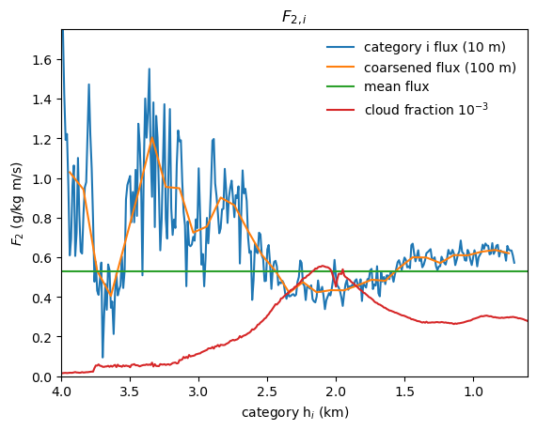
Figure FEDDYMETHOD. Vertically uniform cloudy-sky eddy flux $F_{2,i}$ from Method 2 at 10-m cloud top height $h_{i}$ resolution (blue), and 100-m resolution (orange). Mean flux over the cloud ensemble (green), weighted by cloud albedo (red).

Model of cloud mass flux
Water fluxes by the clouds are diagnosed to balance a simple vertical water budget for the trade cumulus cloud layer. The updraft area fraction is calculated over large (1000 km)² regions, assuming updraft cores are cloudy with saturated specific humidity. The horizontal-time ensemble mean trade cumulus water (vapor + liquid) flux due to updrafts and precipitation balances mean subsidence. Cloud mass flux is initialized at cloud base to match the mean observed surface evaporation minus precipitation.
From the diagnostic moisture closure, we compute the trade cumulus ensemble eddy flux $F_{i}\left(z\right)=F_{c,i}\left(z\right)+F_{p,i}\left(z\right)$ due to cumulus updrafts and precipitation. Cloud updrafts are responsible for most of the eddy flux. A small part is contributed by precipitation. We will first model the water in the clouds, then their conversion to precipitation.

Cumulus cloud model
A budget for steady total water $q_{c}$ in the updraft with velocity $w$ depends on its entrainment and precipitation sinks. The equations for the suspended liquid $q_{l}$ and water vapor $q_{v}$ specific humidity in the cloud are
$${∂q_{l}}/{∂t}=-w\left({∂q_{l}}/{∂z}\right)-wγ-ϵwq_{l}-αwq_{l} \\ {∂q_{v}}/{∂t}=-w\left({∂q_{v}}/{∂z}\right)+wγ-ϵw\left(q_{v}-q\right),$$where $ϵ$ (km^{–1}) is the lateral entrainment coefficient, $α$ is the autoconversion of cloud liquid to precipitation, and $γ={\left({dq_{s}}/{dz}\right)}_{m}=\left({dq_{s}}/{dT}\right){\left({dT}/{dz}\right)}_{m}<0$ is the moist adiabatic condensation rate of water vapor per unit height. The dependence on $γ$ is eliminated in the total cloud water $q_{c}$ equation,
$${∂q_{c}}/{∂t}=0=-w({∂q_{c}}/{∂z})-ϵw(q_{c}-q)-αwq_{l}$$QTBALANCE.The updraft advects moisture upwards, but the solution for $q_{T}$ is quantitatively insensitive to the updraft velocity and to the moisture flux. There is no autoconversion above the cloud, $q_{l}=0$, so only entrainment relaxes humidity to that of the environment, ${∂q_{c}}/{∂z}=-ϵ\left(q_{c}-q\right).$ In the cloud, $q_{l}=q_{c}-q_{s}$, autoconversion removes cloud liquid, relaxing total water toward $q_{s}$, and entrainment relaxes total water toward $q$. Thus, equation QTBALANCE is, written in terms of the total vertical sink rate $ϵ+α$,
$${∂q_{T}}/{∂z}=-\left(ϵ+α\right)\left(q_{c}-\tilde{q}\right),$$QRELAXrelaxing $q_{c}$ to the intermediate humidity $\tilde{q}={(ϵq+αq_{s})}/{(ϵ+α)}=\left(1-x\right)q+xq_{s}$. The total sink rate $ϵ+α$ determines the cloud water, water flux, and cloud top height. The ratio of the autoconversion to the total moisture sink $x=α/{\left(ϵ+α\right)}$ is the precipitation efficiency. Cloud liquid and water vapor profiles are computed for many total sink rates (Fig. MOISTURECLOUDS).
The profiles of $q_{c}$ predicted by this entraining-precipitating updraft model agree with the most humid air sampled on occasion by radiosondes. Cloud height is limited by entrainment of relatively dry air between 1.5-3 km, representing the mean distribution of the trade inversion. The clouds occupy a range of depths representative of trade cumulus clouds, with deeper clouds for lower rates of entrainment and autoconversion. The intermediate total sink rate of $ϵ+α=1.5 {km}^{-1}$ gives maximum cloud liquid specific humidity exceeding 0.8 g kg^{–1} over 0.7-1.5 km and cloud top height of 1.9 km.

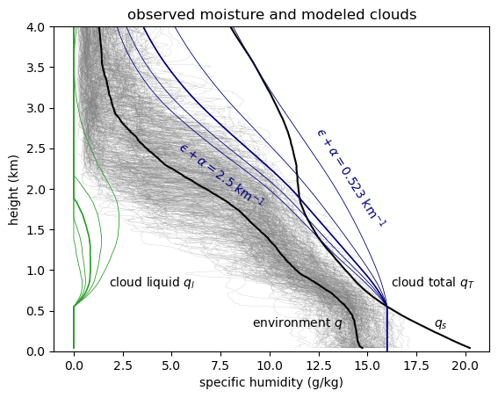
Figure MOISTURECLOUDS. Observed specific humidity from the ATOMIC Ron Brown radiosondes (gray), and their mean $q$ (black) and saturation specific humidity $q_{s}$. Cloud updraft total specific humidity $q_{T}$ (blue) and cloud liquid $q_{l}$ (green) for a range of total moisture sink rates $ϵ+α$ (entrainment and autoconversion coefficients, km^{–1}). Clouds transport moisture up, continuously diluting it toward a mixture between $q$ and $q_{s}$.
[ /home/deszoeks/Projects/ATOMIC/ATOMIC_GOES/julia/RHB/sonde/moisture_clouds.pdf ]

Precipitation and updraft moisture fluxes
Downward precipitation water flux within a cloud $F_{P}<0$ is generated by autoconversion $α$ from cloud liquid. Precipitation reverses a fraction of the updraft total water flux. For the updraft with no storage of cloud liquid water, the precipitation source is
$$-{∂F_{p}}/{∂z}=-αwq_{l}=xw\left({∂q_{l}}/{∂z}+γ\right),$$where $∂q_{l}/∂z+γ$ is the total moisture source in the updraft.
The solution for each cloud type $i$ is found by numerically integrating the precipitation. The precipitation sink, ${∂F_{p,i}}/{∂z}=α_{i}w_{i}q_{l,i},$ instantaneously removes liquid water from the cloud and the column.
An example of the all-sky fluxes is computed for a single cloud with, $ϵ+α=1.5 {km}^{-1}$, $h=1.9$ km and all-sky cloud-base flux $G\left(z_{CB}\right)=$ 145 W m^{–2} $=6.0×{10}^{-5}$ kg m^{–2} s^{–1} (Fig. QMASSFLX). For this case, $F$ goes to zero at 8 km. Precipitation increases downward below the cloud top. At a precipitation efficiency of ~0.5, the cloud-base precipitation $P_{CB}=\left|F_{P}\right|$ equals the mean surface precipitation, $P_{0}=$25 W m^{–2} $=9.0×{10}^{-6}$kg m^{–2} s^{–1}, observed on the research vessel Ron Brown during EUREC4A/ATOMIC. Evaporation was $E_{0}=$ 180 W m^{–2} $=6.5×{10}^{-5}$ kg m^{–2} s^{–1}. The mass flux is $M={G_{cld}}/{q_{T}-q}$ (Fig. QMASSFLX). Most of the flux (~90 %) is below 3 km in the trade cumulus layer. Most of the updraft moisture $q_{T}$ is vapor, and the moist updraft $q_{T}-q>0$ generates upward moisture flux, even above the cloud.
Fig. QMASSFLX is a simulation for a single cloud. The distribution of cloud top heights and the total water fluxes are used to constrain an ensemble of clouds at constant precipitation efficiency and varying sink rates ${\left(ϵ+α\right)}_{i}$.
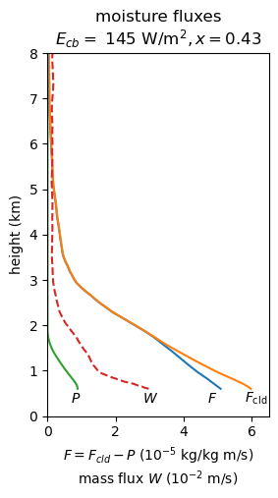
Figure QMASSFLX. Cloud moisture flux $F_{c}$ (orange), and (downward) precipitation flux $P=-F_{P}$ (green), and mass flux $M$(red) modeled for a single cloud with total moisture flux $F$ (blue).
The cloud (a) total specific humidity and (b) cloud-environment humidity difference as a function of height and total sink rate parameter is shown for an ensemble of sink rates in Fig. WPROF. This is used to compute (c) cloud-mean vertical velocity for each cloud. The total mass flux is $M=∑a_{i}w_{i}$, where the total cloud area is $a=∑a_{i}$.

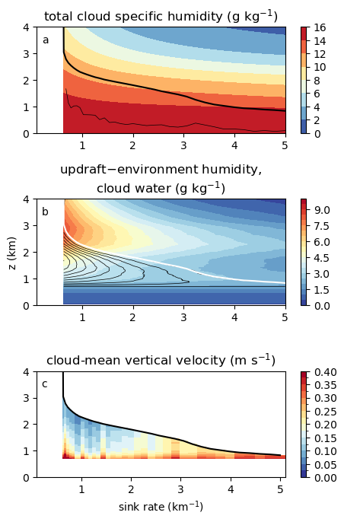
Figure WPROF. Modeled ensemble of clouds for precipitation efficiency $x=0.53$ as a function of total sink rate. (a) Cloud updraft total specific humidity $q_{T}$ (shaded), cloud top (thick black), and rescaled cloud area per unit sink rate (thin black); (b) cloud updraft total – environment specific humidity difference $q_{T}-q$ (shaded), and cloud liquid specific humidity $q_{l}$ (black contours); and (c) updraft vertical velocity.

Numerical integration
At each height and for each cloud category $i$, $w_{i}q_{l,i}=F_{c,i}{q_{l,i}}/{\left(q_{c,i}-q\right)}$ and $F_{c,i}=F-F_{P_{i}}$. The precipitation equation is written in differential form,
$$dF_{P,i}=\frac{α_{i}q_{l,i}}{\left(q_{T,i}-q\right)\left(F-F_{P,i}\right)dz}.$$Precipitation is integrated downward, from $F_{P,i}\left(h_{i}\right)=0$ at the top $h_{i}$of each cloud, in trapezoidal vertical steps with decreasing superscript $k$,
$$F_{P,i}^{k}=-\frac{-\left(1+c_{i}^{k}\right)F_{P,i}^{k+1}+c^{k}F^{k}+c^{k+1}F^{k+1}}{1-c^{k}},$$where $c_{i}^{k}={\left[α_{i}q_{l,i}^{k} dz\right]}/{\left[2\left(q_{T,i}^{k}-q^{k}\right)\right]}$.

Data sources
Data are available from their references and/or links provided here. GOES daylight visible reflectance, cloud optical thickness, and cloud top pressure retrievals (Minnis et al. 2008) are provided by NASA Langley Cloud and Radiation Research Group, https://satcorps.larc.nasa.gov/prod/exp/atomic-2020/visst-pixel-netcdf/ (courtesy W. Smith). CERES FBCT (Sun et al., 2022) data are provided at https://www.earthdata.nasa.gov/data/catalog/larc-cloud-cer-fluxbycldtyp-month-terra-aqua-modis-edition4a. Data from EUREC4A/ATOMIC radiosondes (Stephan et al., 2021) are provided at the AERIS EUREC4A data catalog https://observations.ipsl.fr/aeris/eurec4a-data/PRODUCTS/MERGED-MEASUREMENTS/RADIOSOUNDINGS/v3.0.0/level2/.

Supplement: LCL clouds
Our model projects that shallow cumulus clouds decrease with reduced large-scale overturning, but a local scaling of the moist turbulent subcloud boundary layer suggests that clouds at the LCL increase by a similar amount. Large-eddy simulation (LES; (Bretherton et al. 2013, Blossey et al. 2013) and observations (Bony et al., 2021; Vogel et al., 2022; Fig. REFLALBEDO) have a cloud fraction maximum of about 5 % near the cloud base. The net cloud radiative effect depends on the relative amount of shallow cumulus vs. LCL clouds. [[A stochastic cumulus mass flux model can be used to represent the bimodality and memory of cumulus updrafts (Sakradzija 2015).]]
LCL clouds, where moisture condenses from turbulent subcloud thermals, are not represented by the moist updraft plumes of a mass flux model. We scale the LCL cloud fraction from the subcloud relative humidity and moisture fluxes. Relative humidity (RH) at cloud base is considered to be constant (Held and Shell XXXX), but RH increases slightly at the surface to moderate the surface evaporation, which increases +2 % K^{–1} with precipitation.
The LCL cloud fraction is the fraction of air from the moist subcloud boundary layer thermals that reach saturation at cloud base (Sommeria and Deardorff, 1977; Mellor 1977). For a normal distribution of relative humidity in the subcloud layer, the mean fraction of the thermals that are saturated at cloud-base is $C_{CB}=\left(1-\operatorname{erf}\left(s\right)\right)/2$with $s={\left(1-{RH}_{CB}\right)}/{σ_{RH}}$ measuring the saturation deficit at cloud base relative to the standard deviation of RH.
The standard deviation of the specific humidity is solved from production-dissipation balance of the subcloud specific humidity variance,
$$0=-\overline{w^{'}q^{'}}\left({∂\overline{q}}/{∂z}\right)-χ_{q}.$$The humidity flux is $\overline{w^{'}q^{'}}$ and the humidity variance dissipates at the rate $χ_{q}={k_{1}u^{*}σ_{q}^{2}}/{z_{CB}}$ from turbulent mixing of humidity gradients. Shear production, with friction velocity $u^{*}={\left(τ/ρ\right)}^{1/2},$ produces more turbulence than buoyancy production; $k_{1}$ is a constant and $z_{CB}$ is the cloud base height. The production-dissipation balance yields,
$$σ_{q}^{2}=\overline{w^{'}q^{'}}\left(q_{sfc}-q_{CB}\right)/(k_{1}u^{*})=q^{*}\left(q_{sfc}-q_{CB}\right)/k_{1}.$$Dividing the humidity standard deviation $σ_{q}$ by the saturation specific humidity, the RH standard deviation,
$$σ_{RH}={\left[{q^{*}\left(q_{0}-q_{CB}\right)}/{\left(k_{1}{q_{s}^{2}}_{CB}\right)}\right]}^{1/2},$$scales with the humidity scale $q^{*}$, the subcloud mean humidity difference, and the cloud-base saturation specific humidity.
The surface evaporation, humidity scale $q^{*}$, and cloud-base moisture flux increase +2 % K^{–1} to balance the increase of precipitation. The specific humidities in $σ_{RH}$ scale with the saturation humidity at +7% K^{–1},
$$d\ln{σ_{RH}}=(1/{2)}\left[d\ln{q^{*}}+ d\ln\left(q_{0}-q_{CB}\right)\right]-d\ln{q_{sCB}}=-0.025.$$
The cloud base saturation deficit ${1-\overline{RH}}_{CB}$ decreases –5 % K^{–1}. The argument $s$ of the error function scales as,
$$d\ln{s}=d\ln\left(1-{\overline{RH}}_{CB}\right)-d\ln{σ_{RH}}=-0.025.$$
The cloud-base cloud fraction observed by combined radar and lidar is 0.054 $±$0.031% in EUREC4A (BASTALIAS, Bony et al., 2022; Vogel et al., 2022). This is obtained for $s_{0}=1.13$. Scaling $s_{0}$ by (1 - 0.025) = 0.975 K^{–1} yields a cloud-base cloud fraction
$$C_{CB}\left(0.975s_{0}\right)=0.06,$$an increase of +9% K^{–1}. This absolute 0.005 K^{–1} increase of the cloud-base clouds almost offsets the -7.9% decrease of the shallow cumulus clouds, both of which depend on the original cumulus and stratocumulus cloud fraction.

Supplement: Mesoscale organization
Mesoscale organization clusters clouds together, leading to larger cloud updrafts, and updrafts entraining moister air from their surroundings. The cumulus mass flux model parameterizes the effect of mesoscale clustering through the total moisture sink rate. The moisture sink rates were distributed according to the observed humidity profile and cloud top height distribution. The moisture sink rate depends on the geometric, turbulent, and microphysical properties of the clouds, which we assume not to change in our climate experiments. In this section we consider the implications of changing the moisture sink rate.
The distance over which moisture is removed from the cloud is inversely proportional to the sink rate. Multiplying the moisture sink rate by $K$and squashing the vertical scale of the humidity profile $q^{'}\left(z\right)=q\left(Kz\right)$ entrains the same water over a shorter vertical distance, squashing the cloud top exactly to $h^{'}=h/K$. Thus, for equal subsidence $W$, the eddy flux $G^{'}\left(z\right)=G(Kz)$ balances the equivalently squashed subsidence drying, resulting in exactly the same cloud fractions and fluxes as before at the lower heights $h^{'}.$
Changing the sink rates changes the cloud top height distribution and cloud top moisture flux divergence $∂G/∂z$. The cloud moisture flux both responds to the humidity profile and balances its advection by subsidence. Clouds thus conspire to modify the environmental humidity gradient and the subsidence drying, to establish a new balance, $0=-∂G/∂z-W(∂q/∂z)$, with a different distribution of total moisture sink rates. Including large scale divergence $D$, the general solution is
$$G\left(z\right)=-Wq+{\left(Wq\right)}_{CB}+D\int_{z_{CB}}^{z}{q dζ}.$$This yields a balanced eddy flux profile for any humidity and subsidence profile. The humidity profile determines the cloud distribution. A stretched distribution of moisture sink rates, representing changes in the size and clustering of the cumulus clouds, yields the eddy flux profile to balance the subsidence.
Increased mesoscale organization and reduced sink rates would result in deeper clouds, balancing subsidence advection from deeper distribution of humidity with a weaker gradient. Deeper moisture profiles associated with increased mesoscale organization would reduce the humidity gradient. We have no observational basis for inferring changes in mesoscale organization or moisture sink rates. Reduced humidity gradients in CMIP3 models, have been taken as evidence for the mixing-induced desiccation of low clouds.
[[OLD
Experiments are run with the moisture sink rate for each cloud category reduced or augmented by $±$5% from the control.
Since cloud category $i$ is only a numerical index of the discretized sink rate, redistributing the moisture flux $G(z)$ to the clouds generated by the perturbed moisture sink rates ${\left(α+ϵ\right)}_{i}^{'}$ results in a new numerical discretization of the same cloud field that represents the same climate. Instead, our moisture sink rate experiment, holds the cloud reflectance-weighted fractional areas ${a_{i}^{'}=a}_{i}$ constant and recompute $M_{i}^{'}$, $G_{i}^{'}$, $w_{i}^{'}$, and $F_{i}^{'}$ for the modified sink rates ${\left(α+ϵ\right)}_{i}^{'}$. The clouds rise deeper for weaker sink rates and reach shorter cloud top heights for stronger sink rates (Fig. SINKZTOP).
The in-cloud vertical velocities $w$ and cloud liquid $q_{l}=\max{(q_{c}-q_{s})}$ are shown in Fig. SINKWQL. For a given thermodynamic profile (and precipitation efficiency), cloud water $q_{c}$ and cloud top height $h$are completely determined by the moisture sink rate $α+ϵ$. Clouds with the same cloud top height have the same sink rate and cloud water profile $q_{c}$. The scalar cloud fraction $a_{i}$ and moisture flux $F_{i}$ for each category $i$ completely determine everything else about plumes of category $i$, namely mass flux and vertical velocity profiles $M_{i}, w_{i}$.
[perturbued balanced G, q profiles. Setting up these experiments will take a few days. First idealize the $q$ profile from observations, and do a control experiment. Stretch and squash the humidity profile by 5%. Scale W and D down by 5%, as before.]
]]

Figure SINKZTOP. Cloud top height experiments sink-5% and sink+5% compared to the control experiment. Greater sink rates limit the height of clouds.
sink_expmt_ztop.pdf
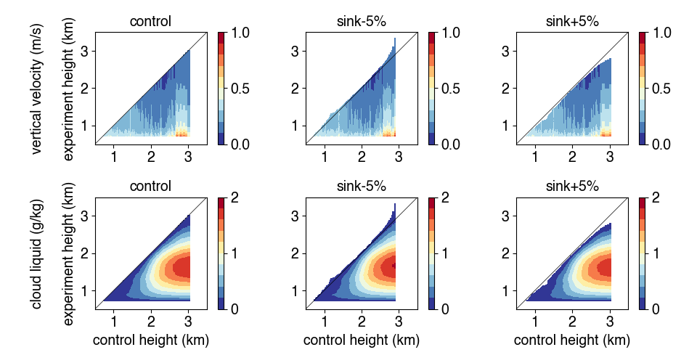
Figure SINKWQL. (a,b,c) Vertical velocity $w$ and cloud liquid (d,e,f) specific humidity $q_{l}=\max{(q_{c}-q_{s})}$ for (a,d) the control, (b,e) moisture sink rates multiplied by 0.95, and (c,f) sink rates multiplied by 1.05.
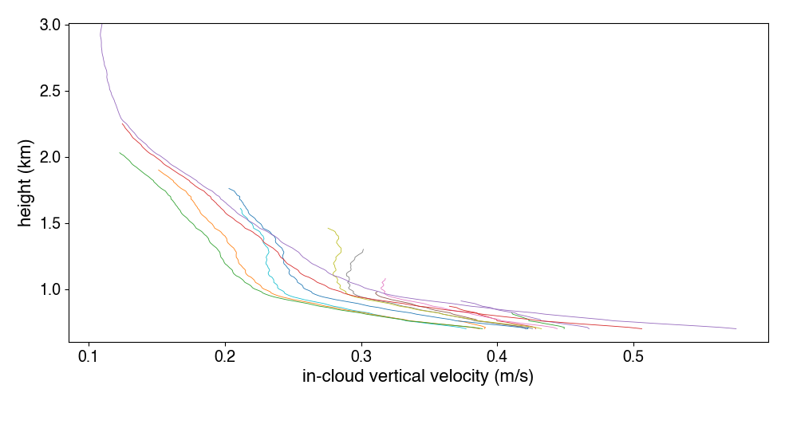
Figure INCLOUDW. In-cloud vertical velocity for the cumulus plumes for 15 moisture sink rates represented in the control simulation.

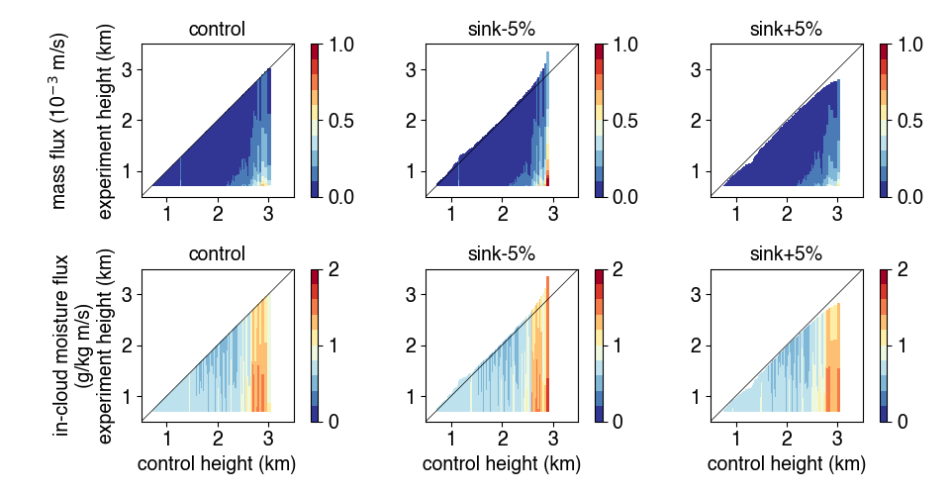
Figure SINKFM. Mass flux $M$ (top) and in-cloud moisture flux $F$ (bottom) for the control experiment, each sink rate diminished by -5%, and each sink rate augmented by +5%. The x-axis shows the control simulation cloud top height $h_{i}$.

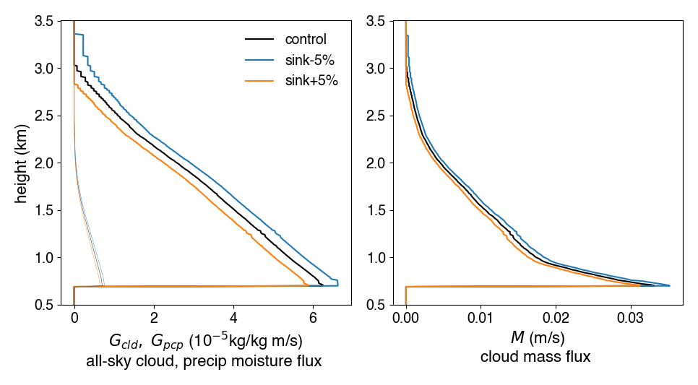
Figure SINKALLSKY. All-sky (a) updraft (thick) and precipitation (thin) moisture fluxes and (b, right) mass flux.

