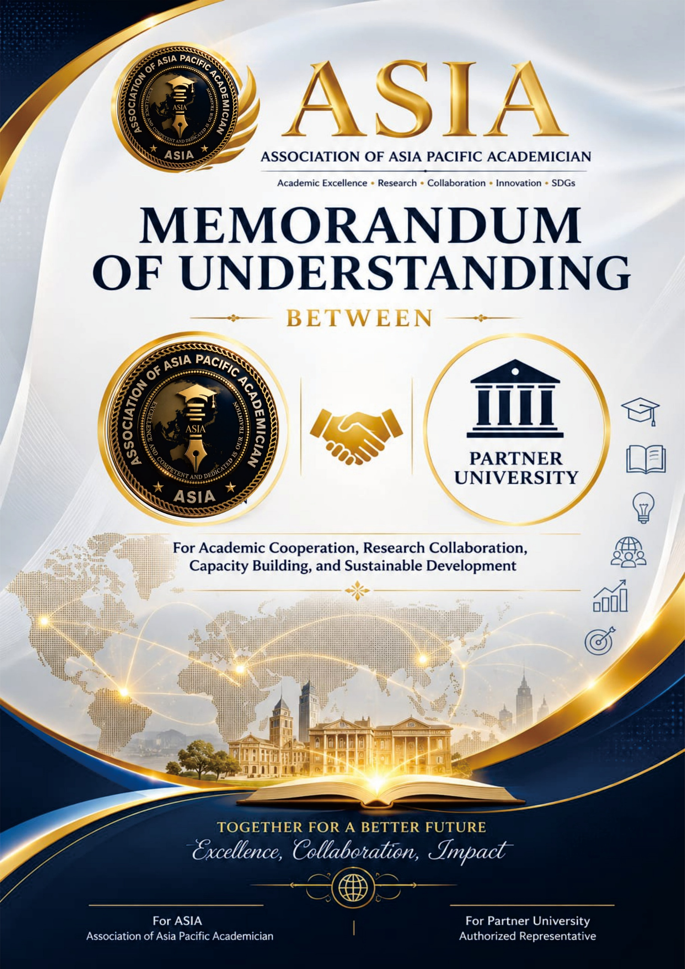


THIS MEMORANDUM OF UNDERSTANDING is made on the __ day of _________ in this year 20XX.

BETWEEN

ASSOCIATION OF INDONESIAN ACCOUNTING LECTURERS (ADAI), an international academic and professional association established in 2023, dedicated to advancing academic collaboration, research, innovation, professional development, and international cooperation among academicians and higher education institutions across the Asia-Pacific region. located at Perjuangan Street No. 80 B, Sei Kera Hilir District. Medan City North Sumatera Indonesia 20222.
AND
………………………………….., an institute of higher learning incorporated pursuant to (address), (hereinafter referred to as “……………”) and will include its lawful representatives and permitted assigns of the other part;
(hereinafter referred to singularly as “the Participant” and collectively as “the Participants”),

WHEREAS
The Participants are desirous of entering into this Memorandum of Understanding (hereinafter referred to as “MOU”) to declare their respective intentions and to establish a basis of direct cooperation and collaboration in the fields of research, education and training programs of mutual interest, between the Participants upon the provisions as contained herein.


THE PARTICIPANTS HAVE REACHED the following understandings:

PARAGRAPH 1
OBJECTIVE
The Participants, subject to the provisions of this MOU and the laws, rules, regulations and national policies from time to time in force in each Participant’s country, will endeavour to establish, promote and develop on a basis of direct cooperation and collaboration in the field of research, education and training programs of mutual interest.

PARAGRAPH 2
AREAS OF COOPERATION
2.1 Each Participant will, subject to the laws, rules, regulation and national policies from time to time in force, governing the subject matter in their respective countries, endeavour to take necessary steps to encourage and promote cooperation in the following areas:
1.1 Academic Collaboration: Exchange of faculty members for short-term teaching assignments, joint supervision of research projects, and establishment of a platform for sharing educational resources.
1.2 Student Exchange Programs: Creation of a framework for student exchange, allowing undergraduate and graduate students from both institutions to spend a semester or academic year studying abroad.
1.3 Professional Development: Organization of joint professional development programs, such as seminars, conferences, or workshops, focusing on specific areas of expertise or emerging trends in education.
1.4 Research Collaboration: Establishment of a mechanism for joint research projects, including sharing of research findings, collaborative studies, and joint applications for research grants.
1.5 Exchange of Knowledge and Resources: Establishment of an online platform or resource center for sharing academic journals, publications, teaching materials, and other relevant resources.

1.6 Sustainable Development Goals (SDG) Initiatives: Promotion of joint academic and institutional initiatives that support the United Nations Sustainable Development Goals (SDGs), including collaborative research, academic events, student projects, and community engagement activities that contribute to sustainable social, environmental, and economic development.
1.7 Certification and Professional Competency Development: Development of joint certification programs, professional competency training, micro-credential programs, and capacity-building initiatives for lecturers, researchers, students, and professionals in various academic and professional fields.

1.8 International Conference and Academic Forum: Organization of international conferences, academic forums, symposiums, guest lectures, and scholarly meetings to promote global academic discourse, knowledge exchange, and institutional networking.
1.9 Joint Publication and Knowledge Dissemination: Collaboration in journal publication, book chapters, proceedings, policy papers, academic reports, and other scholarly publications to enhance academic visibility and knowledge contribution at regional and international levels.
1.10 Academic Mobility and Visiting Scholar Program: Promotion of academic mobility programs, including visiting lecturer programs, visiting scholar programs, international academic visits, student mobility, and cross-border academic engagement.
1.11 Innovation, Digital Learning, and Artificial Intelligence: Collaboration in digital academy programs, online learning, artificial intelligence literacy, educational technology, digital transformation, and innovation-based academic development.
1.12 Quality Assurance, Accreditation, and Institutional Development: Cooperation in quality assurance, academic program development, curriculum review, accreditation preparation, institutional benchmarking, and continuous improvement of higher education governance.

1.13 Academic Competition and Talent Development: Organization of international academic competitions, student innovation contests, business plan competitions, research competitions, poster competitions, and other talent development programs.

1.14 Community Engagement and SDGs-Based Empowerment: Implementation of international community service programs, social innovation projects, SDGs-based community empowerment, and collaborative activities that strengthen the social impact of higher education institutions.


1.15 Awards, Recognition, and Academic Excellence: Development of joint awards, recognition programs, academic achievement appreciation, institutional excellence awards, and professional recognition for outstanding academicians, researchers, students, and partner institutions.

1.16 Young Academician and Future Leadership Network: Establishment of a platform for young academicians, early-career researchers, graduate students, and future academic leaders to collaborate in research, publication, leadership development, innovation, and international networking.
1.17 ASIA Institutional Membership
As an integral part of this partnership, the Partner Institution shall become and maintain its status as an Institutional Member of the Association of Asia Pacific Academician (ASIA) throughout the effective period of this Agreement. Institutional Membership shall serve as the primary framework for accessing and participating in ASIA’s academic, research, professional, certification, publication, mobility, conference, competition, quality assurance, innovation, recognition, and international networking programs.

PARAGRAPH 3
EXCHANGE PROCEDURE
3.1 The procedures to be followed in establishing any exchange scheme or programme or any form of cooperative work under this MOU will be as follows:
3.1.1 Proposals for any form of cooperative work which falls under the scope and fields of academic link and cooperation provided in this MOU will be submitted through liaison officers designated by both Participants;
3.1.2 The names of the liaison officers designated by both Participants will be made known to each other in writing from time to time.
3.1.3 The liaison officers will jointly decide on any proposals for any form of cooperative work, provided that the final approval for any exchange scheme, programme or any form of cooperative work under this MOU will be decided and confirmed in writing under the signatures of the Rector of UNISSA and the Chairman of Association of Indonesian Accounting Lecturers.
3.1.4 The liaison officer who will prepare and supervise the program to be implemented and present a joint annual report about the activities of this MOU to both Participants.

3.1.5 The scope, terms and conditions of any approved exchange scheme, programme or any form of cooperative work will be provided in an Addendum to this MOU as and when the need arises.
3.1.6 The exchange of staff, students or teaching, research and Library materials need not be reciprocal simultaneously.

PARAGRAPH 4
FINANCIAL ARRANGEMENTS
4.1 This MOU will not give rise to any financial obligation by one Participant to the other.
4.2 Except as otherwise set out in this MOU, each Participant will bear its own cost and expenses in relation to this MOU.
4.3 The financial arrangements in establishing any exchange scheme or programme or any form of cooperative work under this MOU will be based on the following principles:
4.3.1 Charges for all activities will, where appropriate, be based on cost recovery as far as possible;
4.3.2 Where it is not possible to follow the principle mentioned in Paragraph 4.3.1 above in specific cases, commitment to funding for any activity will be decided upon by discussion and in writing on a case by case basis;
4.3.3 Expenses to be incurred or arising from any exchange scheme or programme or any form of cooperative work under this MOU such as advisory visits and staff attachments, will be negotiated and decided upon mutually in writing and by the signatures of the Rector of UNISSA and Chairman of ADAI.

PARAGRAPH 5
EFFECT OF MOU
This MOU serves only as a record of the Participants’ intentions and does not constitute or create, and is not intended to constitute or create, obligations under domestic or international law and will not give rise to any legal process and will not deemed to constitute or create any legally binding or enforceable obligations, express or implied.


PARAGRAPH 6
AMENDMENTS
6.1 Either Participant may request in writing an amendment or modification of all or any part of this MOU.
6.2 Any amendment or modification which has been decided to by both Participants will be reduced into writing and will form part of this MOU.
6.3 Such amendment or modification will come into effect on such date as may be determined by the Participants.
6.4 Any amendment or modification will not prejudice the rights and obligations arising from or based on this MOU prior or up to the date of such revision, modification or amendment.
PARAGRAPH 7
SUSPENSION
Each Participant reserves the right for reasons of national security, national interest, public order or public health to suspend temporarily, either in whole or in part, the implementation of this MOU which suspension will take effect immediately after notification has been given to the other Participant through diplomatic channels.

PARAGRAPH 8
ENTRY INTO EFFECT, DURATION AND TERMINATION
8.1 This MOU will come into effect on the date of signing and will remain in effect for a period of five (5) years.
8.2 This MOU may be extended for a further period as may be agreed in writing by the Participants.
8.3 Each Participant may terminate this MOU by giving the other Participant at least three (3) months written notice of that intention.
8.4 Notwithstanding of Paragraph 8.3 above, the provisions of this MOU or any other written agreements in respect of any on-going exchange scheme, programme or any form of cooperative work under this MOU will continue to apply until their completion unless both Participants mutually decide in writing to the earlier termination of the scheme, programme or cooperative work.


PARAGRAPH 9
PROTECTION OF INTELLECTUAL PROPERTY RIGHTS
9.1 The protection of intellectual property rights will be enforced in conformity with the respective national laws, rules and regulations of the Participants and with other international agreement signed by both Participants.
9.2 The use of the name, logo and/or official emblem of any of the Participants on any publication, document and/or paper is prohibited without the prior written approval of either Participant.
9.3 Notwithstanding anything in Paragraph 9.1 above, the intellectual property rights in respect of any technological development and any products and services development, carried out :-
9.3.1 Jointly by the Participants or research results obtained through the joint activity effort of the Participants, will be jointly owned by the Participants in accordance with the provisions to be mutually decided upon; and
9.3.2 Solely and separately by the Participant or the research results obtained through the sole and separate effort of the Participant, will be solely owned by the Participant concerned.

PARAGRAPH 10
CONFIDENTIALITY
10.1 Each Participant will observe the confidentiality and secrecy of documents, information and other data received from or supplied to, the other Participant during the period of the implementation of this MOU or any other agreements made pursuant to this MOU.
10.2 For purposes of Paragraph 10.1 above, such documents, information and data include any documents, information and data which is disclosed by a Participant (the Disclosing Participant) to the other Participant (the Receiving Participant) prior to, or after, the execution of this MOU, involving technical, business, marketing, policy, know-how, planning, project management and other documents, information, data and/or solutions in any form, including but not limited to any document, information or data which is designated in writing to be confidential or by its nature intended to be for the knowledge of the Receiving Participant or if orally given, is given in the circumstances of confidence.

10.3 Both Participants agree that the provisions of this Paragraph 10 will continue to have effect between the Participants notwithstanding the termination of this MOU.

PARAGRAPH 11
NO AGENCY
Nothing contained herein is to be constituted a joint venture partnership or formal business organization of any kind between the Participants or so to constitute either Participant as the agent of the other.

PARAGRAPH 12
SETTLEMENT OF DISPUTES
Any difference or dispute between the Participants concerning the interpretation and/or implementation and/or application of any of the provisions of this MOU will be settled amicably through mutual consultation and/or negotiations between the Participants through diplomatic channels, without reference to any third parties or international tribunal.

PARAGRAPH 13
NOTICES
Any communication under this MOU will be in writing in the English language and delivered personally or sent by registered mail to the address or sent to the electronic mail address or facsimile number of ASIA or …………, as the case may be, shown below or to such other address or electronic mail address or facsimile number as either Participant may have notified the sender and will, unless otherwise provided herein, be deemed to be duly given or made when delivered to the recipient at such address or electronic mail address or facsimile number which is duly acknowledged:
To ASIA: : ASSOCIATION OF ASIA PACIFIC ACADEMICIAN
Association of Indonesian Accounting Lecturers
Jl. Perjuangan No. 80 B
Kelurahan Sei Kera Hilir
Kecamatan Medan Perjuangan
Medan – Sumatera Utara
Indonesia


Tel: + 62 813-7006-2009

Fax: -

Email:admin@apacific.org
Website: www.apacific@org
To (…………): : UNIVERSITY…………………………………..
(Adress),
………………………………………………………….
Tel: +
Fax: +
Email:


The foregoing record represents the understandings reached between ASIA and ……….. upon the matters referred to therein.

SIGNED IN DUPLICATE at UNISSA on this __ day ______in this year of _______ in the English Language by the authorised signatories on behalf of the Participants.

For and on behalf of |  | For and on behalf of
ASSOCIATION OF ASIA PACIFIC ACADEMICIAN,  INDONESIA |  | UNIVERSITY…………………  (COUNTRY)
……………………………………………………..…..  DR. ARFAN IKHSAN LUBIS  President |  | ……………………….….……………………………  DR...................................  Rector
In the presence of  ……………………………………………………………..  DR.  Registrar  Dated: | In the presence of  ……………………………………………………………..  ................................................  Registrar  Dated:

