# **D**[**etective Conan**](https://detectiveconanepisodeshdhighquality.blogspot.com/)

### **Detective Conan Episode 3 high resolution**

[February 18, 2022](https://detectiveconanepisodeshdhighquality.blogspot.com/2022/02/detective-conan-episode-3-high.html)



source: <https://ww4.detectiveconanepisodes.com/detective-conan-episode-3-english-subbed-watch-online/>

Ayumi Yoshida (吉田歩美 Yoshida Ayumi) also known Amy Yeager in the Funimation dub, is a major recurring character of the anime and manga series, Detective Conan (also known as Case Closed). She is a member of the Detective Boys and harbours strong romantic feelings for Conan Edogawa.Adapted from the manga of the same name, Sazae-san is by far the longest-running anime series of all time, with over 2500 episodes to date.Like Mickey said, Detective Conan is one of the longest running anime and manga series, starting in 1996. A majority of the episodes are fillers meaning that it does not progress the plot or be noted later on. Meaning, there is no endinSubaru is one of the few characters who knows Conan is .....BUT, we fans still have hope. Like Mickey said, Detective Conan is one of the longest running anime and manga series, starting in 1996. A majority of the episodes are fillers meaning that it does not progress the plot or be noted later on. Meaning, there is no ending. Ayumi Yoshida (吉田歩美 Yoshida Ayumi) also known Amy Yeager in the Funimation dub, is a major recurring character of the anime and manga series, Detective Conan (also known as Case Closed). She is a member of the Detective Boys and harbours strong romantic feelings for Conan Edogawa.Subaru is one of the few characters who knows ConanAyumi Yoshida (吉田歩美 Yoshida Ayumi) also known Amy Yeager in the Funimation dub, is a major recurring character of the anime and manga series, Detective Conan (also known as Case Closed). She is a member of the Detective Boys and harbours strong romantic feelings for Conan Edogawa.Adapted from the manga of the same name, Sazae-san is by far the longest-running anime series of all time, with over 2500 episodes to date. Like Mickey said, Detective Conan is one of the longest running anime and manga series, starting in 1996. A majority of the episodes are fillers meaning that it does not progress the plot or be noted later on. Meaning, there is no ending. But we fans still have hope

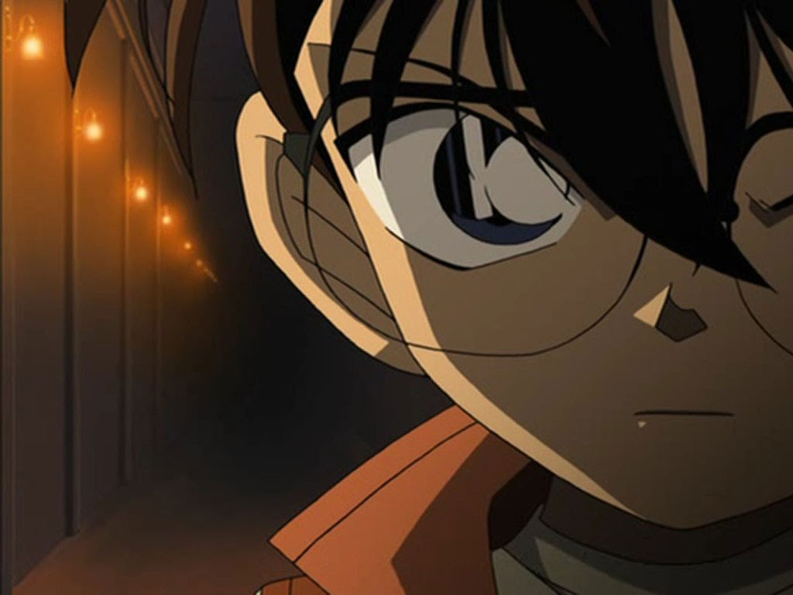

Ayumi Yoshida (吉田歩美 Yoshida Ayumi) also known Amy Yeager in the Funimation dub, is a major recurring character of the anime and manga series, Detective Conan (also known as Case Closed). She is a member of the Detective Boys and harbours strong romantic feelings for Conan Edogawa.Sazae-san is the story of a family living in a fictitious town in Japan (Shimokitazawa) set sometime in the late sixties or early seventies. The protagonist is Sazae Fuguta who, at age 26 is still not married. She enjoys her life, does what she wants and does not listen to her parents' attempts to persuade her to get married. Though she has serious character flaws, she is generally portrayed as a good person with a strong ethical code.Keep your gear safe and in one place with the zippered compartments of this sleek backpack. Front organizer pocket has pen loop and pockets for a calculator, cards, a media player and more. Padded tablet sleeve fits most 10-inch tablets. Main compartment holds books or clothes for an overnight trip. Zippered front pocket keeps small item at hand. Media pocket features an earbud port; Side mesh water bottle pockets; Sternum strap stabilizes the load; S-curved straps made from air mesh and foam provide comfort.Our Bigger Carry-On suitcase is lightweight and sized to fit in the overhead bin of most major airlines, or pop easily onto a train or into a car. Perfect for longer trips, its interior compression system and hidden laundry bag make it easy to pack all of your essentials. With a durable polycarbonate hard shell, and 360° spinner wheels that ensure a smooth ride, this suitcase is built to last.Subscribe to our newsletter to keep up with everything CTA. Sign up for regular updates, geared towards peak times of the year and important changes at CTA.

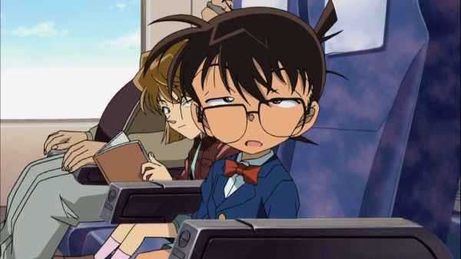

Saturday Night Live, NBC's Emmy Award-winning late-night comedy showcase, enters its 45th season for another year of laughs, surprises and great performances.Ayumi Yoshida (吉田歩美 Yoshida Ayumi) also known Amy Yeager in the Funimation dub, is a major recurring character of the anime and manga series, Detective Conan (also known as Case Closed). She is a member of the Detective Boys and harbours strong romantic feelings for Conan Edogawa.Sazae-san is a TV anime series produced by Fuji Television Network. Adapted from the manga of the same name, Sazae-san is by far the longest-running anime series of all time, with over 2500 episodes to date.Subaru is one of the few characters who knows Conan is Shinichi Kudo.We’re fans, just like you. We want answers. AND, we want the show to keep going. The more it goes, the better it is for us!The Showa era is the period of Japanese history corresponding to the reign of the Showa Emperor, Hirohito, from December 25, 1926 until his death on January 7, 1989. The Showa era corresponds with the reign of the Shōwa Emperor, Hirohito. The series covers 1964 to 1965 in the fictional Japanese city Mito – a place inspired by real-life Kimitsu, located in Kanto region .Truly the epitome of the adage, "When life gives you lemons, make lemonade," this classic Japanese manga series follows the life-lessons, relationships and romantic interactions of Sazae and her family - which is usually awkward. But that's okay! She's also remarkably incisive and practical when it comes to figuring out everyone else's problems.Our Bigger Carry-On suitcase is lightweight and sized to fit in the overhead bin of most major airlinesor pop easily onto a train or into a car. Perfect for longer trips, its interior compression system and hidden laundry bag make it easy to pack all of your essentials. With a durable polycarbonate hard shell, and 360° spinner wheels that ensure a smooth ride, this suitcase is built to last.



The Bigger Carry-On suitcase is lightweight and sized to fit in the overhead bin of most major airlines, or pop easily onto a train or into a car. Perfect for longer trips, its interior compression system and hidden laundry bag make it easy to pack all of your essentials. With a durable polycarbonate hard shell, and 360° spinner wheels that ensure a smooth ride, this suitcase is built to last.This is a 30-inch TV built to exceed the expectations of home theater enthusiasts. The native 4K panel delights the eyes with stunning resolution and incredibly robust contrast, while the full-array backlight with local dimming ensures an incredible range of HDR brightness levels. Everything from web browsing to gaming feels snappy and responsive thanks to the quad-core processor, which also upscales Full HD content to 4K without adding in artifacts or noise."Ayumi Yoshida (吉田歩美 Yoshida Ayumi) also known Amy Yeager in the Funimation dub, is a major recurring character of the anime and manga series, Detective Conan (also known as Case Closed). She is a member of the Detective Boys and harbours strong romantic feelings for Conan Edogawa.Adapted from the manga of the same name, Sazae-san is by far the longest-running anime series of all time, with over 2500 episodes to date.BUT, we fans still have hope. Like Mickey said, Detective Conan is one of the longest running anime and manga series, starting in 1996. A majority of the episodes are fillers meaning that it does not progress the plot or be noted later on. Meaning, there is no ending. Subaru is one of the few characters who knows Conan is Shinichi Kudo.But we fans still have hope. Like Mickey said, Detective Conan is one of the longest running anime and manga series, starting in 1996. A majority of the episodes are fillers meaning that it does not progress the plot or be noted later on. Meaning, there is no endinLike Mickey said, Detective Conan is one of the longest running anime and manga series, starting in 1996. A majority of the episodes are fillers meaning that it does not progress the plot or be noted later on. Meaning, there is no endinCertified Refurbished Essentials BundleAdapted from the manga of the same name, Sazae-san is by far the longest-running anime series of all time, with over 2500 episodes to date. The adventures of a housewife named Sazae and her family (and duck-shaped pet bird) on the island of Tarō have been drawing audiences since 1969 when it was first called Machan no Nikki

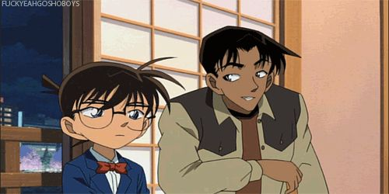

The Sazae-san manga series was created by Machiko Hasegawa, which has been serialized in the Asahi Shimbun since 1946. The manga series was adapted into an anime television series produced by Fuji TV and broadcast on the network from October 5, 1969 to present, spanning over 2,500 episodes and is ongoing."Sazae-san" is the longest-running animated show in history, with more than 2200+ episodes to date.Detective Conan, known as Case Closed in the United States due to legal concerns, is a Japanese detective manga series written and illustrated by Gosho Aoyama. It was serialized in Shogakukan's Weekly Shōnen Sunday on January 19, 1994, and has been collected into 97 tankōbon volumes as of December 18, 2015. Due to legal considerations with the name Detective Conan, the English language releases from Funimation and Viz were renamed to Case Closed. The story follows an amateur detective who was transformed into a child while investigating a mysterious organization and solves a multitude of cases while impersonating his friend's father and other characters.Forever21 Faux Leather Mini Backpack - 100% Vinyl. Snap button closure with adjustable buckle straps. Lined interior with back wall zip pocket. Approx. 8"" W x 10"" H x 4.5"" D.detective stories about a genius boy who solves various mysteries.The Bigger Carry-On suitcase is lightweight and sized to fit in the overhead bin of most major airlines, or pop easily onto a train or into a car. Perfect for longer trips, its interior compression system and hidden laundry bag make it easy to pack all of your essentials. With a durable polycarbonate hard shell, and 360° spinner wheels that ensure a smooth ride, this suitcase is built to last.The legendary anime series has been airing for over twenty years, longer than most people have been alive. The series is infamous for its fillers and recycled footage, a habit it picked up back in the day when the creator had to take a long hiatus. This lead to viewers dropping the series prematurely because they couldn't tell what's going on anymore.Be amazed and laugh like never before watching this man transform himself into beloved characters such as Mario, Pikachu, Sonic or Aladdin.2011 GI Joe Pursuit of Cobra Jungle-Viper

# [**detective conan**](https://detectiveconanepisodeshdhighquality.blogspot.com/)

### **Detective Conan Episode 2 HD RESOLUTION**

[February 18, 2022](https://detectiveconanepisodeshdhighquality.blogspot.com/2022/02/detective-conan-episode-2-hd-resolution.html)



score: <https://ww4.detectiveconanepisodes.com/detective-conan-episode-2-english-subbed-watch-online/>

Detective Conan is one of the longest running anime and manga series, starting in 1996. A majority of the episodes are fillers meaning that it does not progress the plot or be noted later on. Meaning, there is no ending.Ayumi Yoshida (吉田歩美 Yoshida Ayumi) also known Amy Yeager in the Funimation dub, is a major recurring character of the anime and manga series, Detective Conan (also known as C. She is a member of the Detective Boys and harbours strong romantic feelings for Conan Edogawa.Like Mickey said, Detective Conan is one of the longest running anime and manga series, starting in 1996. A majority of the episodes are fillers meaning that it does not progress the plot or be noted later on. Meaning, there is no ending.Detective Conan is the story of Jimmy Kudo, a high school detective who sometimes works with the police to solve cases. His life takes a dramatic turn when he is attacked by members of a black organization and forced to ingest an experimental poison.To his surprise, the poison transforms him into a child instead of killing him. From that point on, he takes on the alias Conan Edogawa and continues solving cases. He meets all sorts of people along the way and slowly starts unraveling the mystery behind his transformation.A story about a boy who was transformed into a little kid because of a antagonist's poison. Then he move on to live with this girl that the boy liked before he turned into his little self. This anime has ran for quite some time now and doesn't seem to end soon.When children's shoeshine boy Jimmy Kudo is fed a mysterious substance by a pair of nefarious men in black, he is transformed into an adult. He decides to use his new identity to find out who poisoned him, but becomes entangled in a web of mysteries and crimes and explores the darker side of human nature along the way.Measures 4.5"L x 2.5"W x 5.3"H and a mere 6.1 oz, t..

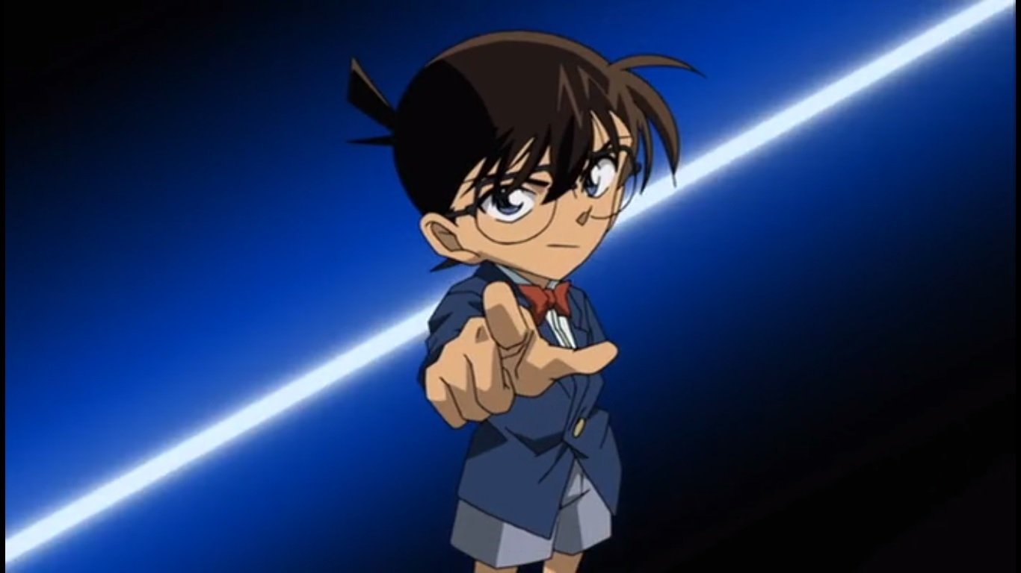

he Bigger Carry-On's telescoping handle and sturdy 360° spinner wheels guarantee smooth maneuvering for years to come."Anne Sullivan Macy was born on April 14, 1866. She was the first blind and deaf person to earn a Bachelor of Arts degree. She taught Helen Keller how to communicate using sign language.Ayumi Yoshida (吉田歩美 Yoshida Ayumi), also known Amy Yeager in the Funimation dub, is a major recurring character of the anime and manga series, Detective Conan (also known as Case Closed). She is a member of the Detective Boys and harbours strong romantic feelings for Conan Edogawa.One of the longest running anime and manga series, starting in 1996. A majority of the episodes are fillers meaning that it does not progress the plot or be noted later on.After a chance encounter where Shinichi saves her from the men in Black, Satomi forms a special relationship with him throughout the story. Immediately after being introduced to her, she develops feelings for Misae's nephew but cannot remember his name or face as a result of Shinichi's constant changes and disguises. Even so, she remains determined to see him again and eventually becomes an important ally in his ongoing battle against the criminal syndicate that attempted to murder him.The Detective Conan anime is already infamous, not in a good way, for being one of the longest running shows in Japan, having spanned well over 600 episodes since its debut in 1996. This makes it far longer than most anime series, and even longer than more popular shows like One Piece or Dragon Ball Z. That's alright, however - but fans have been asking why there aren't any signs of it ever ending. The truth is that Detective Conan has no definitive ending planned at all.How many episodes are available on this website?This is a review for Detective Conan: The Dimensional Sniper. In the movie, a sniper is targeting the guest of honor for their murder however all of them must have witnesses during the attempt to not activate the Dimensional Snap. If you're in that situation, you're seemingly trapped for eternity. That's pretty much the story.I give it an 8 out of 10 mainly because this movie had one of the best openings so far, and an interesting plot.Story:

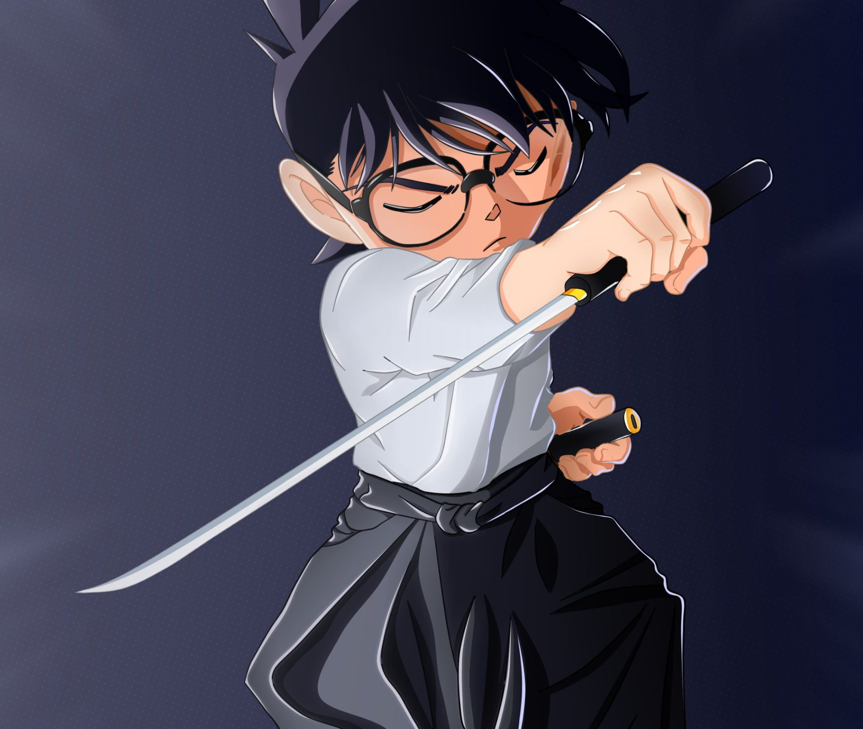

I felt like it was both fresh (because we don't usually see movies involving snipers) but also derivative (like how they often use death game scenarios). For those who are unfamiliar with how it works, basically a death game requires two things: someone who sets up the scenario and some victims.Detective Conan (名探偵コナン Meitantei Konan, lit. Great Detective Conan), officially translated as Case Closed in English, is a Japanese detective manga series written and illustrated by Gosho Aoyama. It was serialized in Shogakukan's Weekly Shōnen Sunday on January 19, 1994, and has been collected into 95 tankōbon volumes as of August 10, 2018. Due to legal considerations with the name Detective Conan, the English language release was renamed to Case ClosedThe Case Closed anime series, known as Meitantei Conan (名探偵コナン? lit. Great Detective Conan, officially translated as Detective Conan) in Japan, features a large number of recurring fictional characters originally created by Gosho Aoyama, some of which are based on other literary or media personas.This is a piece of pure art, which book set with so many episodes and stories will drive you nuts. The series is unique and has its own style, even though it lacks the description of what happens with Shinichi's high school friends (except the Detective Boys and some friends who serve as additional problems to solve).Detective Conan: The Fist of Blue Sapphire is a 2019 Japanese animated film directed by Tomoka Nagaoka and written by Takahiro Okura. It is the twenty-third installment of the Case Closed film series based on the manga series of the same name by Gosho Aoyama, following the 2018 film Detective Conan: Zero the Enforcer. The film follows Conan Edogawa who investigates a robbery in Singapore.The '80s was a great time for anime and one of the best series was Doraemon, about a robotic cat from the future that helps a young boy with any problem he encounters. Of course, everything always backfires on the kid but hey, that's why we love him!Not only did this series teach me valuable lessons like math and science but I also learned how to be kind; even if you get hurt you should never give up because your friends will always come through in the end!Set two years after the original detective conan series, Conan Edogawa is now a teen and shinichi’s loveinterest.

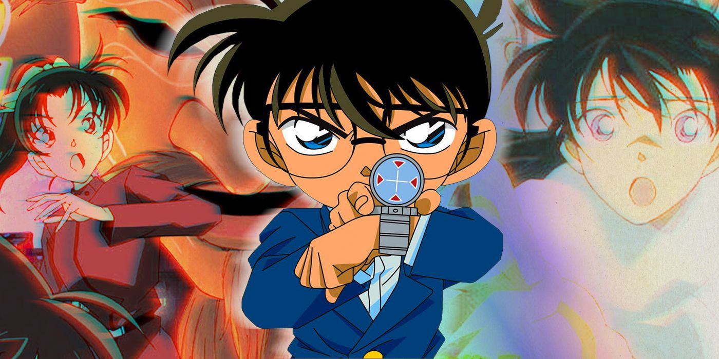

This season takes place in a more modern setting with more modern technology but Shinichi has to solve problems without it since he has been shrunken again. Shinichi finds out more about his father’s past and goes to America at times to find clues and trace back his mother’s past as well.Ayumi obviously has a huge crush on Conan for being intelligent and brave. Some would argue that when she gets older she may even begin to fall in love with him. This relationship causes unsettlement between Genta and Mitsuhiko who also have a crush on Ayumi.Like Mickey said, Detective Conan is one of the longest running anime and manga series, starting in 1996. A majority of the episodes are fillers meaning that it does not progress the plot or be noted later on. Meaning, there is no ending.Detective Conan is one of the longest running anime and manga series, starting in 1996. A majority of the episodes are fillers meaning that it does not progress the plot or be noted later on.Ayumi Yoshida is a main character of the both the anime and manga Detective Conan. She is a member of the Detective Boys and harbours strong romantic feelings for Conan Edogawa.Detective Conan is one of the longest running anime and manga series, starting in 1996. It follows Shinichi Kudo (called Jimmy Kudo in Case Closed), a high school detective who had been accidentally shrunk right into a child's body as a result of antigen made by a criminal organization. It has over 900 episodes, 19 movies and much more still ongoing.Ayumi and Mitsuhiko have been best friends for a long time. Genta also joined them in the Detective Boys after Professor Agasa noticed that he was interested in mysteries and detective work.Although Ayumi and Mitsuhiko have been friends for much longer than Conan has known either of them, he is almost always seen with the Boy Detectives as well. They can find him easily thanks to the calling device invented by Professor Agasa, although Conan himself often uses these devices to lead the group on his own cases.

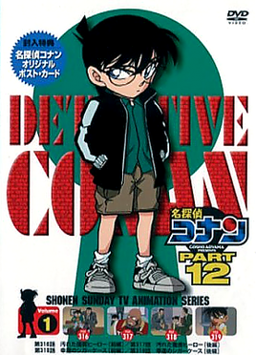

From the popular anime Detective Conan, Ayumi Yoshida is featured wearing a cute school girl outfit.One of the longest running anime and manga series, Detective Conan follows Shinichi who, as Conan, starts living with Ran and her father Kogoro, both whom are private detectives. He solves a multitude of cases while impersonating Kogoro. Many of the characters in Detective Conan have especial abilities that have been carefully thought about and incorporated into the story. Usually these abilities are scientific or based on real life detective techniques. But can be exaggerated for better effect.'Conan Edogawa is the pseudonym used by Shinichi Kudo in his 'shrunken' form. He is a famous teenage detective who helps the police solve cases that would usually be impossible for them to solve. Conan is introduced as Rachel Moore's neighbor and house-sitter when she leaves for Tokyo as a transfer student. A majority of the time, he is known to get into risky situations. However, he always manages to escape due to his quick thinking abilities and preparation by using gadgets he has at hand. Although the majority of the characters call him Conan Edogawa, some people know he is actually Shinichi Kudo such as Ai Haibara and Subaru Okiya. Haibara knows it because she also suffers from an APTX 4869 poisoning and Okiya found out while spying on Conan as a suspect of KID. As his cover getting blown became more likely, he has become more careful around people that knew him beforehand to make sure they do not discover he is Shinichi Kudo.Visit our store!Like Mickey said, Detective Conan is one of the longest running anime and manga series, starting in 1996. A majority of the episodes are fillers meaning that it does not progress the plot or be noted later on. Meaning, there is no ending.Like Mickey said, Detective Conan is one of the longest running anime and manga series, starting in 1996. A majority of the episodes are fillers meaning that it does not progress the plot or be noted later on.')Detective Conan is one of the longest running anime and manga series, starting in 1996. Ayumi serves as Shinichi Izumi's main love interest and forms a special relationship with him throughout the story.This is a list of characters who appear in the manga Detective Conan (also known as Case Closed). This list is split between the primary characters who are first introduced in the early arcs of the story and only play minor roles later on, those who join during he course of the series, and those who only show up for a single story arc.Detective Conan is a Japanese manga series written and illustrated by Gosho Aoyama. It was serialized in Shogakukan's Weekly Shōnen Sunday on January 19, 1994, and has been collected into 98 tankōbon volumes as of April 10, 2019. Due to legal problems with the name Detective Conan, the English language releases from Funimation and Viz were renamed to Case ClosedIts time to show love for the detective boys.Conan loves Sharon for her cool attitude, fearless attitude and her love for soccer.Shinichi Kudo is a high-school detective who sometimes works with the police to solve cases. During an investigation, he is attacked by members of a crime syndicate known as the Black Organization. They force him to ingest an experimental poison, but instead of killing him, the poison transforms him into a child. Adopting the pseudonym Conan Edogawa and keeping his true identity a secret, Kudo lives with his childhood friend Ran Mouri and her father Kogorō, who is a private detective.

# [**detective conan**](https://detectiveconanepisodeshdhighquality.blogspot.com/)

### **Detective Conan Episode 2 English High Quality**

[February 18, 2022](https://detectiveconanepisodeshdhighquality.blogspot.com/2022/02/detective-conan-episode-2-english-high.html)



source: <https://ww4.detectiveconanepisodes.com/detective-conan-episode-2-english-subbed-watch-online/>

Detective Conan is one of the longest running anime and manga series, starting in 1996. A majority of the episodes are fillers meaning that it does not progress the plot or be noted later on. Meaning, there is no ending.Ayumi Yoshida (吉田歩美 Yoshida Ayumi) also known Amy Yeager in the Funimation dub, is a major recurring character of the anime and manga series, Detective Conan (also known as Case Closed). She is a member of the Detective Boys and harbours strong romantic feelings for Conan Edogawa.Like Mickey said, Detective Conan is one of the longest running anime and manga series, starting in 1996. A majority of the episodes are fillers meaning that it does not progress the plot or be noted later on. Meaning, there is no ending.Detective Conan is the story of Jimmy Kudo, a high school detective who sometimes works with the police to solve cases. His life takes a dramatic turn when he is attacked by members of a black organization and forced to ingest an experimental poison.To his surprise, the poison transforms him into a child instead of killing him. From that point on, he takes on the alias Conan Edogawa and continues solving cases. He meets all sorts of people along the way and slowly starts unraveling the mystery behind his transformation.A story about a boy who was transformed into a little kid because of a antagonist's poison. Then hemove on to live with this girl that the boy liked before he turned into his little self. This anime has ran for quite some time now and doesn't seem to end soon.When children's shoeshine boy Jimmy Kudo is fed a mysterious substance by a pair of nefarious men in black, he is transformed into an adult. He decides to use his new identity to find out who poisoned him, but becomes entangled in a web of mysteries and crimes and explores the darker side of human nature along the way.Measures 4.5"L x 2.5"W x 5.3"H and a mere 6.1 oz, the Bigger Carry-On's telescoping handle and sturdy 360° spinner wheels guarantee smooth maneuvering for years to come."Anne Sullivan Macy was born on April 14, 1866

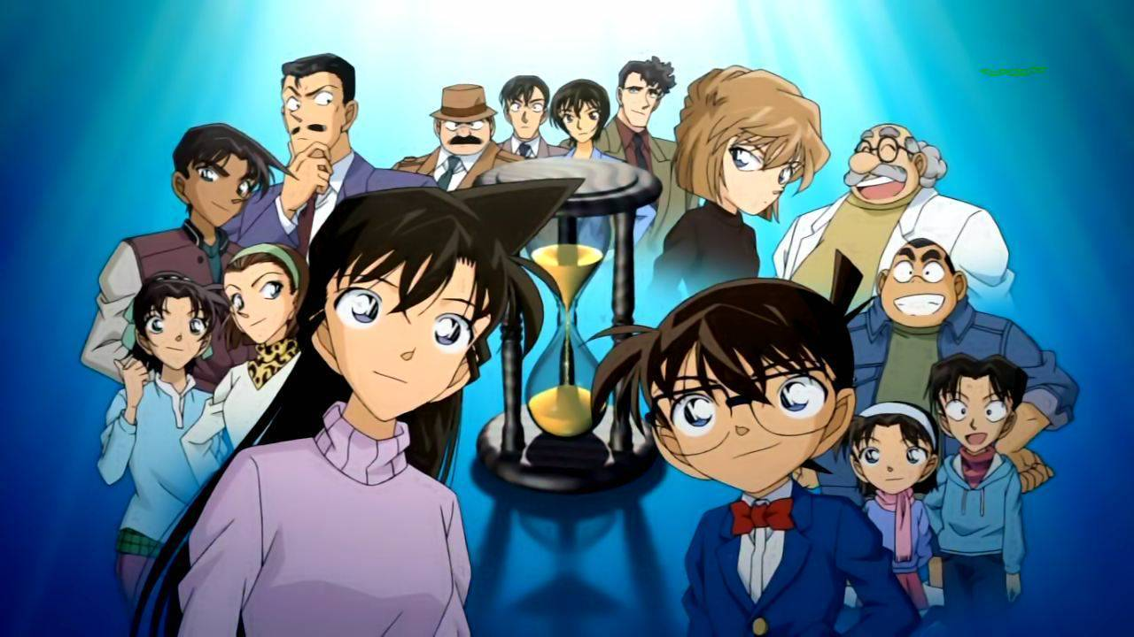

. She was the first blind and deaf person to earn a Bachelor of Arts degree. She taught Helen Keller how to communicate using sign language.Ayumi Yoshida (吉田歩美 Yoshida Ayumi), also known Amy Yeager in the Funimation dub, is a major recurring character of the anime and manga series, Detective Conan (also known as Case Closed). She is a member of the Detective Boys and harbours strong romantic feelings for Conan Edogawa.One of the longest running anime and manga series, starting in 1996. A majority of the episodes arefillers meaning that it does not progress the plot or be noted later on.After a chance encounter where Shinichi saves her from the men in Black, Satomi forms a special relationship with him throughout the story. Immediately after being introduced to her, she develops feelings for Misae's nephew but cannot remember his name or face as a result of Shinichi's constant changes and disguises. Even so, she remains determined to see him again and eventually becomes an important ally in his ongoing battle against the criminal syndicate that attempted to murder him.The Detective Conan anime is already infamous, not in a good way, for being one of the longest running shows in Japan, having spanned well over 600 episodes since its debut in 1996.

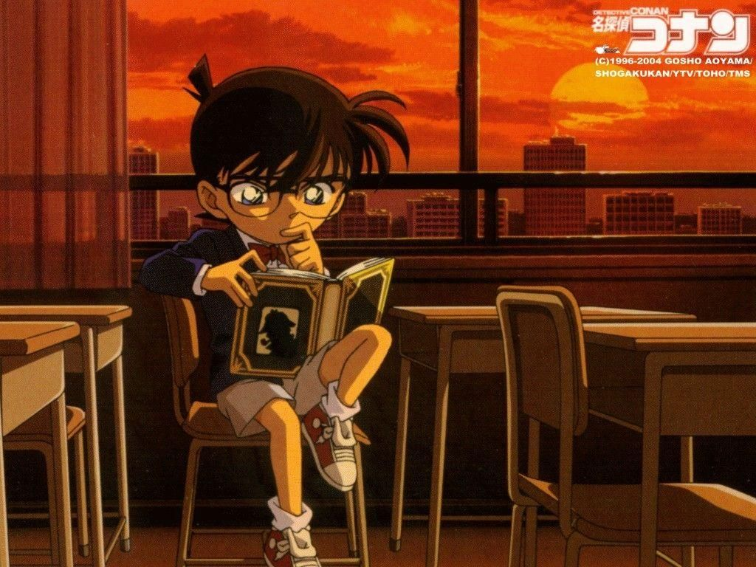

This makes it far longer than most anime series, and even longer than more popular shows like One Piece or Dragon Ball Z. That's alright, however - but fans have been asking why there aren't any signs of it ever ending. The truth is that Detective Conan has no definitive ending planned at all.How many episodes are available on this website?This is a review for Detective Conan: The Dimensional Sniper. In the movie, a sniper is targeting the guest of honor for their murder however all of them must have witnesses during the attempt to not activate the Dimensional Snap. If you're in that situation, you're seemingly trapped for eternity. That's pretty much the story.I give it an 8 out of 10 mainly because this movie had one of the best openings so far, and an interesting plot.Story: I felt like it was both fresh (because we don't usually see movies involving snipers) but also derivative (like how they often use death game scenarios). For those who are unfamiliar with how it works, basically a death game requires two things: someone who sets up the scenario and some victims.

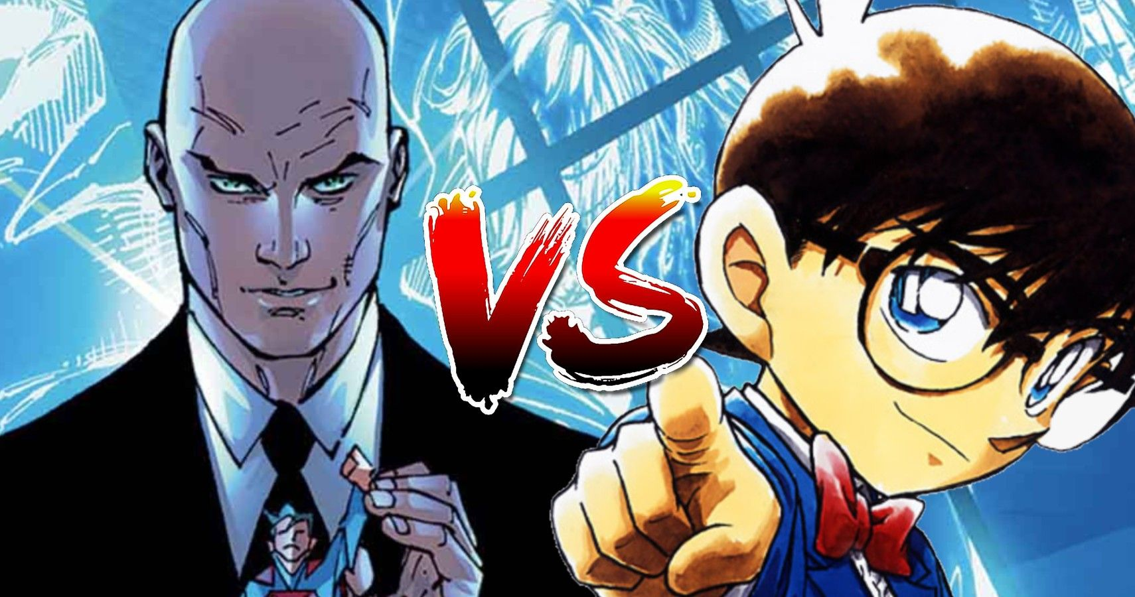

Detective Conan (名探偵コナン Meitantei Konan, lit. Great Detective Conan), officially translated as Case Closed in English, is a Japanese detective manga series written and illustrated by Gosho Aoyama. It was serialized in Shogakukan's Weekly Shōnen Sunday on January 19, 1994, and has been collected into 95 tankōbon volumes as of August 10, 2018. Due to legal considerations with the name Detective Conan, the English language release was renamed to Case ClosedThe Case Closed anime series, known as Meitantei Conan (名探偵コナン? lit. Great Detective Conan, officially translated as Detective Conan) in Japan, features a large number of recurring fictional characters originally created by Gosho Aoyama, some of which are based on other literary or media personas.This is a piece of pure art, which book set with so many episodes and stories will drive you nuts. The series is unique and has its own style, even though it lacks the description of what happens with Shinichi's high school friends (except the Detective Boys and some friends who serve as additional problems to solve).Detective Conan: The Fist of Blue Sapphire is a 2019 Japanese animated film directed by Tomoka Nagaoka and written by Takahiro Okura. It is the twenty-third installment of the Case Closed film series based on the manga series of the same name by Gosho Aoyama, following the 2018 film Detective Conan: Zero the Enforcer. The film follows Conan Edogawa who investigates a robbery in Singapore.

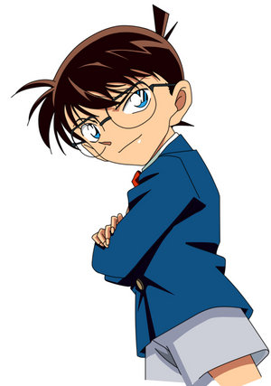

The '80s was a great time for anime and one of the best series was Doraemon, about a robotic cat from the future that helps a young boy with any problem he encounters. Of course, everything always backfires on the kid but hey, that's why we love him!Not only did this series teach me valuable lessons like math and science but I also learned how to be kind; even if you get hurt you should never give up because your friends will always come through in the end!Set two years after the original detective conan series, Conan Edogawa is now a teen and shinichi’s love interest. This season takes place in a more modern setting with more modern technology but Shinichi has to solve problems without it since he has been shrunken again. Shinichi finds out more about his father’s past and goes to America at times to find clues and trace back his mother’s past as well.

# [**detective conan**](https://detectiveconanepisodeshdhighquality.blogspot.com/)

### **DETECTIVE CONAN EPISODES HD QUALITY**

[February 18, 2022](https://detectiveconanepisodeshdhighquality.blogspot.com/2022/02/detective-conan-episodes-hd-quality.html)



source: <https://ww4.detectiveconanepisodes.com/>

Does detective conan have a storyline?m/Like Mickey said, Detective Conan is one of the longest running anime and manga series, starting in 1996. A majority of the episodes are fillers meaning that it does not progress the plot or be noted later on. Meaning, there is no endingDetective Conan has a main storyline. It really does make sense, Conan tried to find out the one who had caused his miniaturization and the identity of the BDetective Conan is an ongoing anime series that started in 1996. So far 876 episodes of Detective Conan have been aired. With a total of 242 reported filler episodes, Detective Conan has a high filler percentage of 28%.Shinichi Kudo is a high school detective who sometimes works with the police to solve cases. During an investigation, he is attacked by members of a crime syndicate known as the Black Organization. They force him to ingest an experimental poison, but instead of killing him, the poison transforms him into a child. Adopting the pseudonym Conan Edogawa and keeping his true identity a secret, Kudo lives with his childhood friend Ran Mouri and her father Kogoro, who is a private detective.Detective Conan has a ongoing storyline with several plots, the main one being to find and bring down the black organization.The plot of Detective Conan consists of a series of individual cases (called books, or files in the Funimation dub) that are usually solved in a single episode.Storyline of Detective Conan.Detective Conan is a Japanese detective manga series written and illustrated by Gosho Aoyama. It has been serialized in Shogakukan's Weekly Shōnen Sunday since January 19, 1994, and has been collected into 92 tankōbon volumes as of January 2019. Due to legal problems with the name Detective Conan, the English language releases from Funimation and Viz..



were renamed to Case Closed. The story follows an amateur detective who was transformed into a child while investigating a mysterious organization and solves a multitude of cases while impersonating his friend's father and other characters.I'd give it a 5/5 if you haven't watched it yet. It's an excellent anime with many interesting mysteries for you to solve along with Conan. Even if you don't want to solve the mysteries, the plot and story are witty, charming, and will pull at your heartstringsIn honor of the launch of season 3 of The Crown, Oscar-winner Olivia Colman has listed her favorite movies, which include some hidden gems. In our recent interview with Paddington 2 star Hugh Grant, he said Colman and co-star Ben Whishaw made him want to be in their movie. Turner Classic Movies has also added programming highlights to commemorate the November release of film director Nobuhiko Obayashi’s The Discreet Charm of the Bourgeoisie (1972).Opinion by Renad Farid Alsulami Aug 2, 2017, 1:35 PMThere's a simple fact of life that many of us are all too quick to forget: we're human, and humans make mistakes. So do teachers, CEOs and celebrities even! We sometimes gets things wrong - but being able to put our hands up…Besides, Detective Conan has a main storyline. Conan tries to find out the one who had caused his miniaturization and the identity of the Black Organization. The main plot is simple - Getting back to normalcy i.e. becoming a high school boy again, and eliminating the Black Organization without alerting them that Kudo Shinichi is actually Edogawa Conan. Over the course of the series, 23..



characters have come to know that Conan Edogawa is actually Shinichi Kudo (11 of which are not manga canon). In addition, Ran Mouri has noticed similarities between the two and Kogoro Mouri, Wataru Takagi, and Rei Furuya have shown signs of doubting that Conan is just "very smart".Conan is a detective who has shrunk down to the size of a little boy because of a poison that he took, and he uses Conan to solve crimes. The show is about 17 years old (1996). The main plot is simple - Getting back to normalcy i.e. becoming a high school boy again and eliminating the Black Organization without alerting them that Kudo Shinichi is actually Edogawa Conan.Is Detective Conan ever ending? Like Mickey said, Detective Conan is one of the longest running anime and manga series, starting in 1996. A majority of the episodes are fillers meaning that it does not progress the plot or be noted later on. Meaning, there is no endingOver the course of the series, 23 characters have come to know that Conan Edogawa is actually Shinichi Kudo (11 of which are not manga canon). In addition, Ran Mouri has noticed similarities between the two and Kogoro Mouri, Wataru Takagi and Rei Furuya have shown signs of doubting that Conan is just "very smart".detective conan, is one of the longest running anime and manga series, starting in 1996. A majority of the episodes are fillers meaning that it does not progress the plot or be noted later on.Detective Conan has a main storyline. Conan tried to find out the one who had caused his miniaturization and the identity of the Black Organization.Conan Edogawa (江戸川 コナン Edogawa Konan) is a high school detective who works to solve mysteries. His true identity is Shinichi Kudo, a 17 year old high school detective whom shrunk into a child's body after being poisoned (paramethoxyamphetamine) by members from a mysterious crime syndicate known as the Black Organization. In his shrunken state, Conan helps solve cases in such a way that the police can't do it on their own. The police believe that Conan is a distant relative of Professor Agasa. They also believe that he is too smart for his own good, which Conan goes along with to keep his true identity secret.

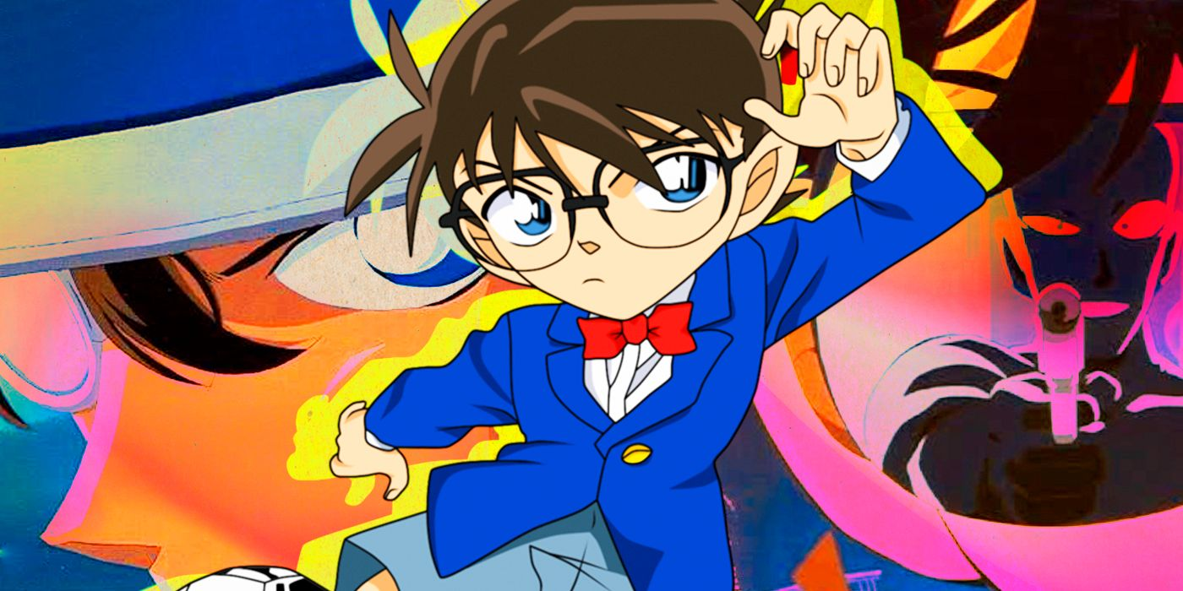

Shinichi, who is 17 years old, has his body shrunk to 7 years old after witnessing a crime by the two members of a mysterious syndicate. He's living with Ran, who is 16 years old, as Conan Edogawa.Detective Conan is an ongoing Japanese detective manga series written and illustrated by Gosho Aoyama. It was serialized in Shogakukan's Weekly Shōnen Sunday on January 19, 1994, and has been collected into 96 tankōbon volumes as of April 10, 2019.The fact that even Conan’s slide whistle is no longer normal makes it even more obvious that this show means business (well, as much as detective Conan means business). There are not many series that are still going so strong, but I guess the silly cases with the occasional deadly and serious one appeals to a lot of people, myself included and zinc are among the top contaminants of tap water. With the whole house replacement filter, you can be free from worrying about drinking clean tap water. It even removes sediment down to 15 micron!Thanks for the A2A! I’m not sure if this is exactly what you’re looking for, but here’s a detailed timeline of the anime. Hope it helps! Before I get into the timeline itself, there are some things that need to be said. First off:Besides, Detective Conan has a main storyline. Conan tried to find out the one who had caused his miniaturization and the identity of the Black Organization.The main plot is simple - Getting back to normalcy i.e. becoming a high school boy again and eliminating the Black Organization without alerting them that Kudo Shinichi is actually Edogawa Conan.Like Mickey said, Detective Conan is one of the longest running anime and manga series, starting in 1996....Detective Conan has a main storyline. Conan tried to find out the one who had caused his miniaturization and the identity of the Black Organization.The main plot is simple - Getting back to normalcy i.e. becoming a high school boy again and eliminating the Black Organization without alerting them that Kudo Shinichi is actually Edogawa Conan.Is Detective Conan ever ending"Does Detective Conan have a storyline?" -

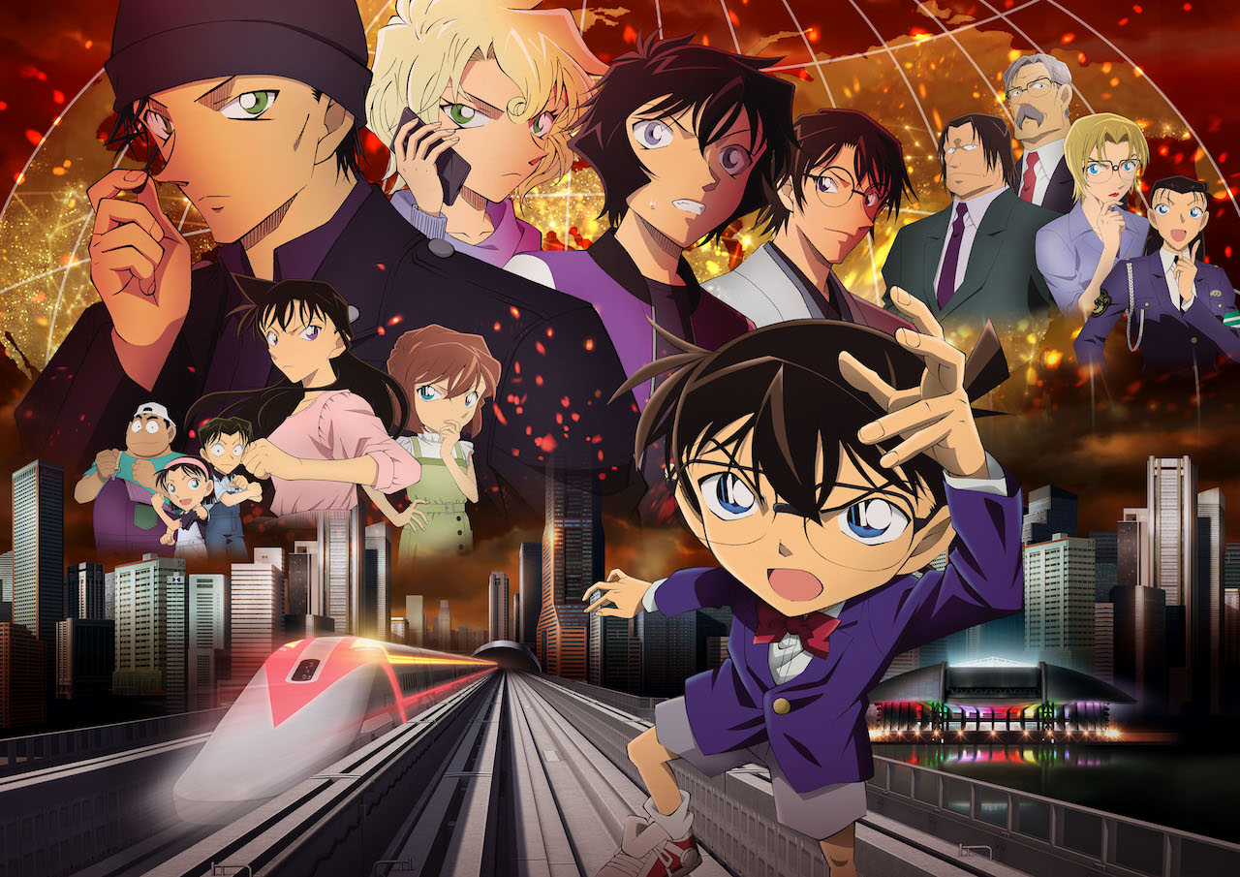

Detective Conan is a manga written and illustrated by Gosho Aoyama and serialized in Shogakukan's Weekly Shōnen Sunday since January 19, 1994. The stories are about an elementary student named Jimmy Kudo who solves mysteries and crimes through reasoning, logic, the help of his friends and some luck as well. At the beginning of the series, he is poisoned by members of a mysterious syndicate known as the Black Organization and forced to consume an experimental poison known as APTX 4869 which de-ages him into a child instead of killing him. From that point onwards, he takes on a new guise based on his favorite mystery writer, Arthur Conan Doyle, becoming Conan Edogawa and continues to solve crimes with his friend while trying to find a cure for himself and break free from the Black Organization.Detective Conan is a Japanese detective manga series written and illustrated by Gosho Aoto. It has been serialized in Shogakukan's Weekly Shōnen Sunday since January 1994, and has been collected into 98 tankōbon volumes as of April 2019. The story follows the adventures of Shinichi Kudo (also called Jimmy Kudo in some versions), a high school detective who was accidentally transformed into a child while investigating a mysterious organization; and his neighbor Ran Mori, who worries about his strange behavior. As Conan, he frequently helps the police solve cases (with his childhood friend Detective Inspector Mouri usually on the scene) while covertly investigating the organization responsible for his current state, hoping to reverse the effects someday.Conan Edogawa is the alias used by Shinichi Kudo in his shrunken form. He is a famous teenage detective who helps the police solve cases. His current alias is derived from the mystery writers Arthur Conan Doyle and Ranpo Edogawa.Whether the show ends or not, It will last for a very long time. Detective Conan has a huge fan..

<https://detectiveconanepisodeshdhighquality.blogspot.com/2022/02/detective-conan-episodes-hd-quality.html>