Differential PTM Detection using deltaMasses

A Quantum Leap in Protein Research



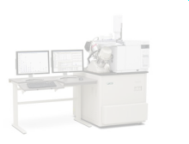
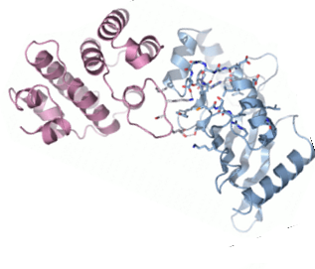

deltaMasses

- Software package
- Discovers protein modifications
- No changes to laboratory equipment
- Compares all MS/MS spectra against each other
- Tool for protein modification based biomarker discovery
- 367 installations in 185 laboratories, 30 countries

How it works: When you fragment a peptide, a certain fragmentation spectrum will result. Imagine the same peptide, but now with a modified residue. The spectrum will be very similar; the signals now separate into two sets: the first set consists of fragments without the modification; the second consists of fragments containing the modified resiude. This can be visualized by „green“ and „red“ channels, respectively. deltaMasses automatically detects such fragmentation spectra showing "paired" characteristics.
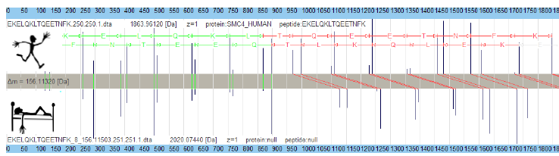Green channel = no modification; mass unchanged. Red channel = fragment contains modification.
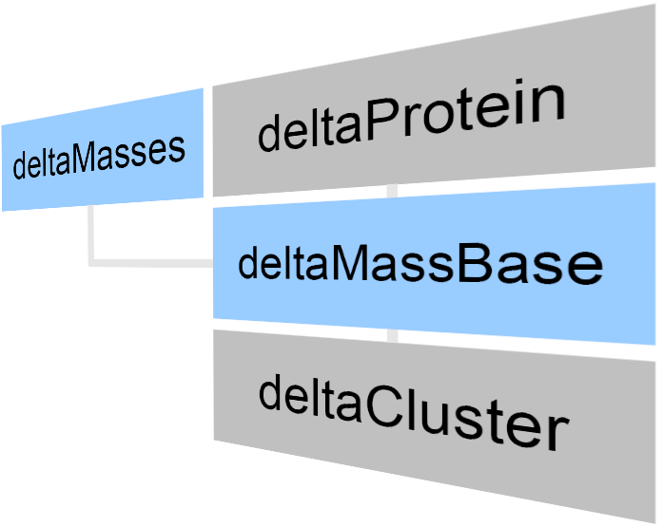

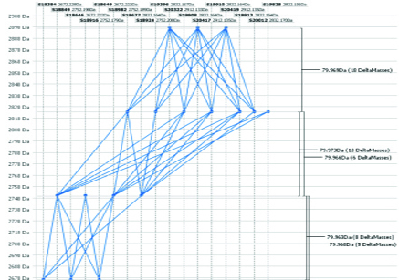A threefold phosphorylated peptide displayed by deltaProtein
deltaMasses consists of four parts

- PTM detection module
- deltaProtein, the visualization platform
- deltaMassBase, the database system
- deltaCluster, the supercomputing extension

deltaMasses

- The main PTM detection tool
- Easily installed and used
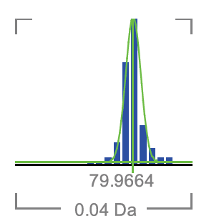deltaMass fingerprint
- Runs on Windows 64 bit (Windows 7 or 8)I
- Implements the deltaMass Fingerprint
- Connects to Mascot Servers

deltaProtein

- The PTM analysis and display system
- Spectrum identification by correlation
- You need to have a Discovery Edition
- Needs deltaMassBase installed
- Detects multiply-modified peptides
- Improved protein characterization


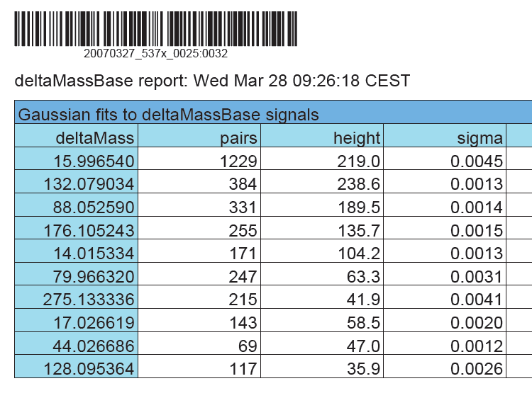pdf reports provided

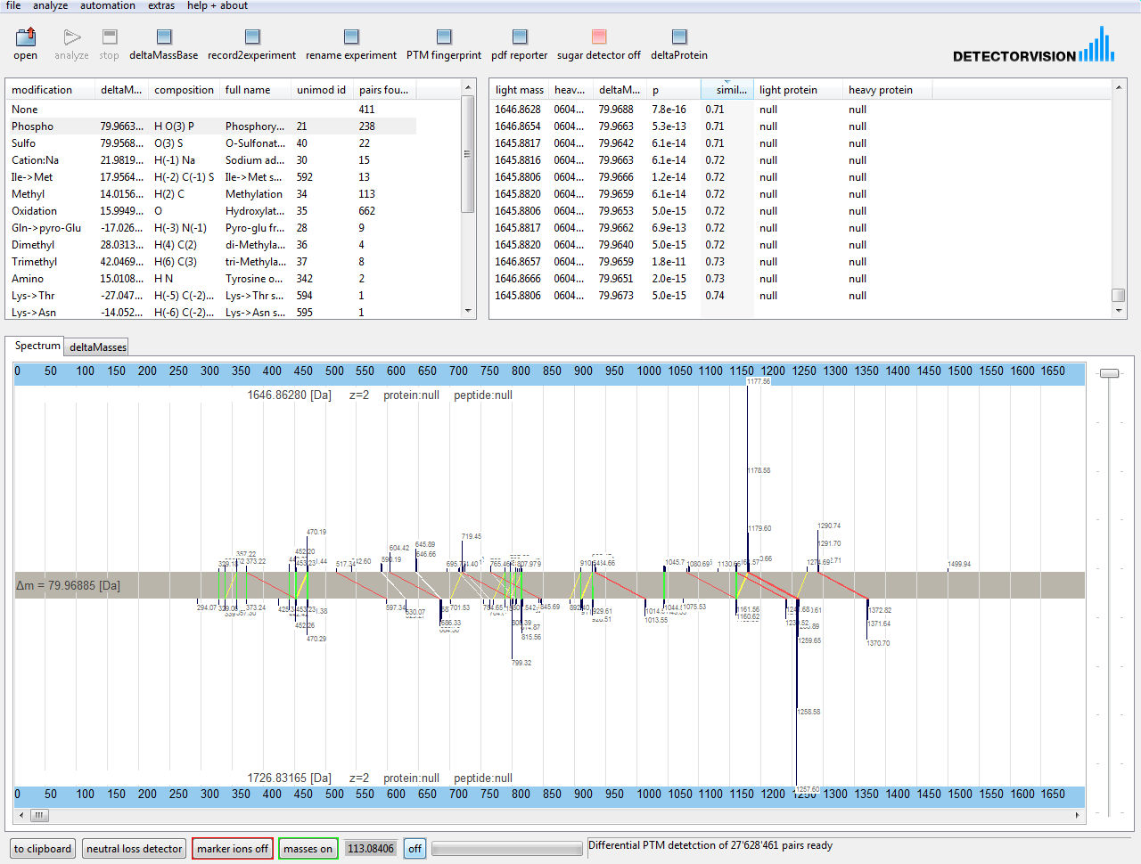deltaMasses PTM Discovery Workstation. Screenshot. Learn more from MS/MS data you allready aquired and identify previously unexplained spectra
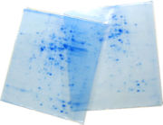deltaMasses can be used for LC-workflows and 2D-gels after high-accuracy mass spectrometry

deltaMassBase

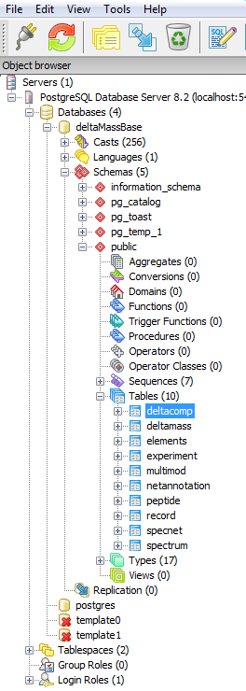
- The database system
- Runs the free of charge postgreSQL system
- Keeps track of up to a million spectra
- Included in Discovery and Personal Edition
- Required to use deltaProtein or deltaCluster
- Hub for protein modification based biomarker discovery

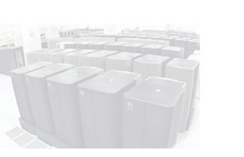
deltaCluster
- The multicore / supercomputing extension
- Ideal for Windows Quadcore+ Systems
- Needs deltaMassBase installed
- Compares spectra across runs

Example: deltaCluster on an HP xw8600
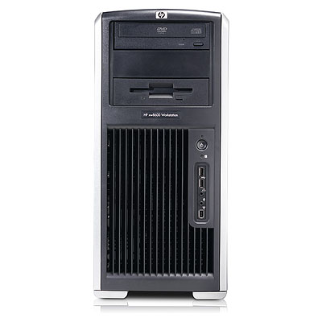
On an HP xw8600 double quadcore desktop, comparing 500'000 spectra against each other runs about 7 times faster than on a comparable single core CPU. This example deltaCluster computation consists of 125 billion MSMS comparisons and is done in less than a day.

References
- Database independent detection of isotopically labeled MS/MS spectrum pairs
http://dx.doi.org/10.1016/j.jchromb.2004.12.009

- The Mass Distance Fingerprint: A statistical framework for de novo detection of predominant modifications using high-accuracy mass spectrometry http://dx.doi.org/10.1016/j.jchromb.2007.04.0

- Protein identification by spectral networks analysis http://www.pnas.org/cgi/content/abstract/104/15/6140

- Modificomb, a new proteomic tool for mapping substoichiometric PTMs, ... http://www.mcponline.org/cgi/content/abstract/5/5/935

Buy a Discovery Edition license
- Contact info@detectorvision.com for a license
- Includes one year of free updates
- Available for Windows 7 / 8 on 64bit architectures

Get a free Personal Edition license

- Request a free Personal Edition license at www.detectorvision.com/download.html

I Minimum system recommendations: 8 Gigabyte RAM, Display 1680*1050 pixels. Multicore processor recommended ( best buy: Intel I7 2600 K )

