Documentation mascot_2_deltaMasses_exporter.pl

About
Version: 0.9 (Release candidate).
mascot_2_deltaMasses_exporter.pl (referred to as „exporter“) is a Perl script used together with Mascot Daemon. Using Mascot Daemon, this scripts exports the .mgf and .xml format into an export directory for direct use with deltaMasses.
The exporter is not part of the official deltaMasses distribution, and there is no warranty for it.

Requirements
- valid license and installation of Mascot Server 2.3
- a Windows PC with Mascot Daemon installed
- You have at least some experience with Mascot Daemon
- Perl uncluding LWP::simple installed on Mascot Daemon PC

For more information about Mascot Daemon, see
http://www.matrixscience.com/daemon.html
In case you do large scale Proteomics experiments, have a Mascot Server and do not use Mascot Daemon, we would recommend the Matrix Science trainings, see
http://www.matrixscience.com/training.html

Installation and Configuration

Step 0 print documentation
Print this document

Step 1 create two directories
On the PC from which you use mascot Daemon, make sure that the two directories
C:/detectorvision/scripts and C:/detectorvision/mascot_export exist. If not, create them.

Step 2 copy script
Copy the script to C:/detectorvision/scripts/mascot_2_deltaMasses_exporter.pl (or any location you want to)

Step 3 configure Mascot address
You have to configure the location of your MASCOT_SERVER: Open the exporter script with notepad. See the #CONFIGURATION section and change the http adresse marked in green to the value used in your lab. Lines starting with a hashmark (#) are comments.
#CONFIGURATION#################################################################
#URL to your mascot server (e.g. http://www.mycompany.com/mascot)
my $MASCOT_SERVER = 'http://localhost/mascot';

If you want to, also the $LOGFILE and $MASCOT_EXPORT_DIRECTORY can be changed in the CONFIGURATION section to your needs.

Step 4 validate
Using a Windows command shell, cd into C:\detectorvision\scripts and execute
perl mascot_2_deltaMasses_exporter.pl
If you get the following response the installation is OK.
----------------------
testing Mascot Server
validation OK
If your validation is not OK, contact your system administrator.

Step 5 add the exporter to Daemon
Open Mascot Daemon's Taks Editor and click onto „External processes”.
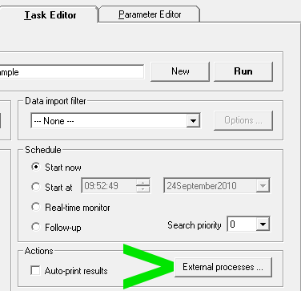

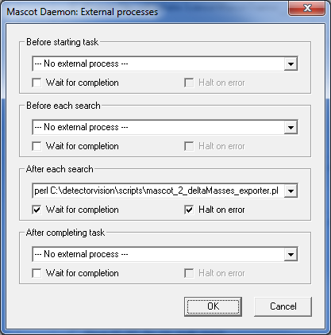
Paste the following line into „After each search” and check “wait for completion” and “Halt on error”.
perl C:\detectorvision\scripts\mascot_2_deltaMasses_exporter.pl "<resultfilepath>" "<datafilepath>" "<datafilename>"

Step 6 Use it
If you now run searches via Mascot Daemon, the exporter will export .mgf and .xml files into the
MASCOT_EXPORTER_DIRECTORY.
If your original .mgf input file was named myPeakfile and the Mascot search had the search result stored to Fxyz.dat, the exporter will generate two files,
MASCOT_EXPORTER_DIRECTORY/Fxyz_myPeakfile.mgf
MASCOT_EXPORTER_DIRECTORY/Fxyz_myPeakfile.xml

These two files can be loaded into deltaMasses (just load the .mgf file, the .xml file will be read automatically).

