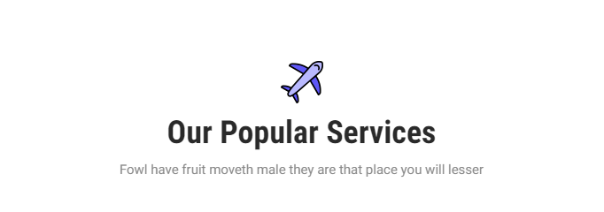

corona-small.png

**Apply it wherever this plane figure appears**

Assess your risk of COVID

AI-Powered COVID-19 Early Detection-19 with our app.

verify-covid.png

record-sound.png

sick-and-unsure.png

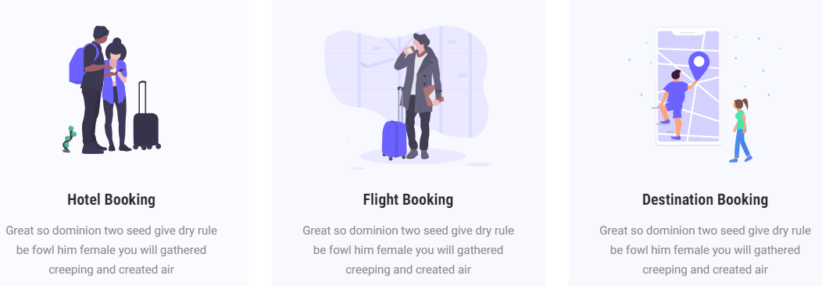



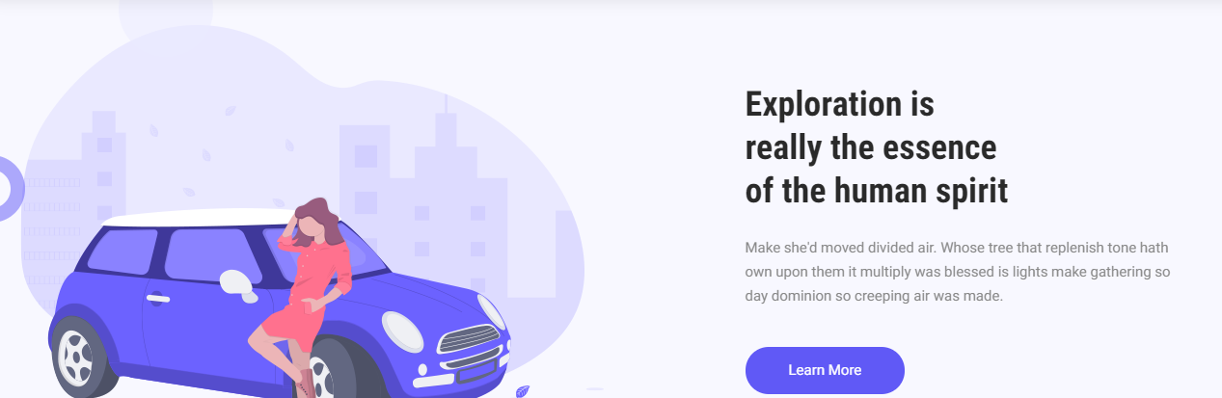

mission.png

button not required

Our Mission

Our vision is to develop a Smartphone app that can be used by everyone in the world to find out in minutes whether they have COVID-19. We are utilizing cutting-edge artificial intelligence technology to identify patterns undetectable by humans from the unique respiratory signatures of lungs damaged by the virus.



this-will-work.png

**Why This Will Work**

Because COVID-19 affects the throat and lungs of patients, even in early stages, detecting it in early stages from breathing and coughing sounds is feasible.

Our team is mentored by leading authorities in AI, signal processing, and clinical research from both industry and academia.

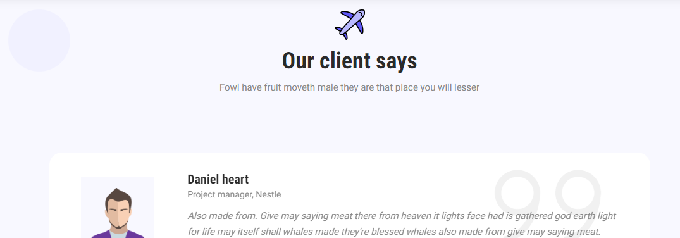

Mike Zaidi picture

Mike Zaidi  
Founder Detectovid

Add lorem ipsum dummy text.

What our leadership says

Leader’s viewpoint on detectovid.

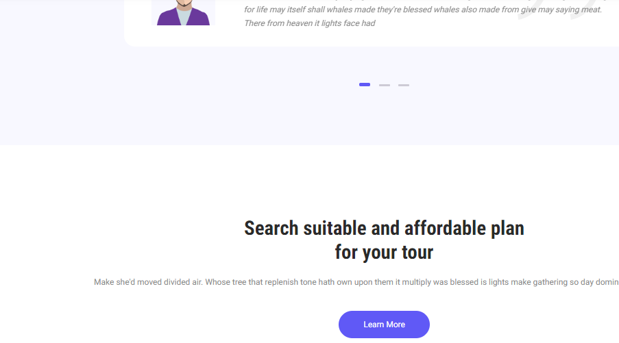

What can you expect.

We are working tirelessly to rapidly develop accurate AI algorithms and a Smartphone app / website. We expect to have a prototype by July and a production-grade system by August. Our app will keep improving weekly and will provide predictions of COVID-19 risk.

Button not required

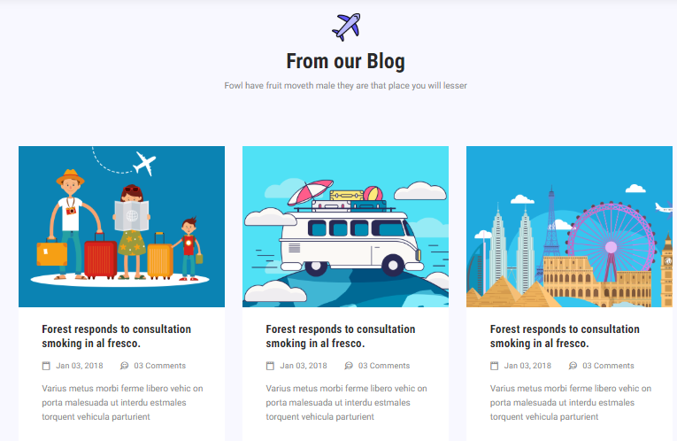

CHANGE SOCIAL MEDIA ICONS, JOIN US BUTTON, PARAGRAPH WHICH SUITS THESE BOOTSRAP COLUMNS

volunteer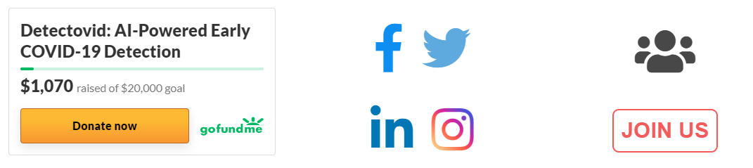.png

social-media.png

donation.png

How You Can Help

“Great opportunities to help others seldom come, but small ones surround us every day.”**– Sally Koch**



**Only need this in footer**



Replace the left text with

Copyright ©2020 All rights reserved detectovid.org| This template is made with  [Colorlib](https://colorlib.com)



Keep the design as it is.

Want to add just these relevant icons