**Assignment No.1**

**Name: Yadnesh Patil**

**PRN No. 12010274**

**Roll No. 23**

1. **Change your password to a password you would like to use for the remainder of the semester.**

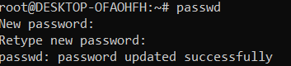

1. **Display the system’s date.**



1. **Count the number of lines in the /etc/passwd file.**



1. **Find out who else is on the system.**

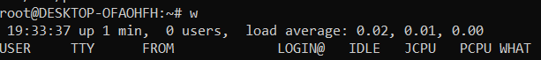

1. **Direct the output of the man pages for the date command to a file named  *mydate* .**



1. **Create a subdirectory called  *mydir* .**



1. **Move the file  *mydate*  into the new subdirectory.**



1. **Go to the subdirectory  *mydir*  and copy the file  *mydate*  to a new file called  *ourdate***



1. **List the contents of  *mydir* .**



1. **Do a long listing on the file  *ourdate*  and note the permissions.**

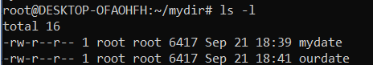

1. **Display the name of the current directory starting from the root.**



1. **Move the files in the directory  *mydir*  back to the HOME directory.**



1. **List all the files in your HOME directory.**

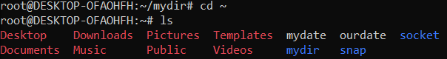

1. **Display the first 5 lines of  *mydate* .**

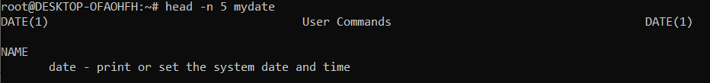

1. **Display the last 8 lines of  *mydate* .**

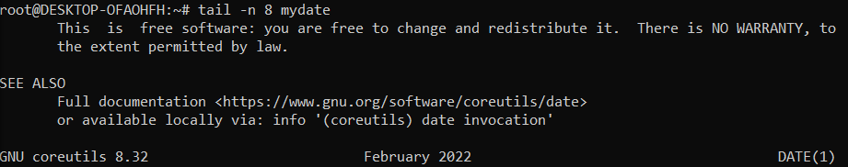

1. **Remove the directory  *mydir* .**



1. **Redirect the output of the long listing of files to a file named  *list* .**

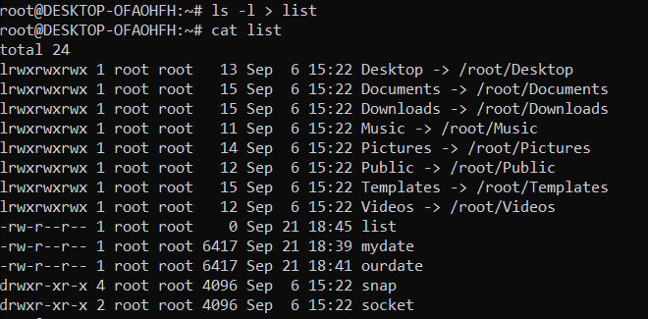

1. **Select any 5 capitals of states in India and enter them in a file named capitals1. Choose 5 more capitals and enter them in a file named capitals2. Choose 5 more capitals and enter them in a file named capitals3. Concatenate all 3 files and redirect the output to a file named capitals.**

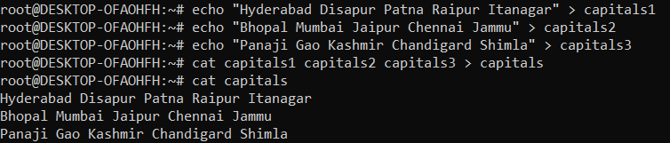

1. **Concatenate the file capitals2 at the end of file capitals.**

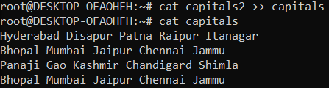

1. **Redirect the file capitals as an input to the command “wc –l”.**



1. **Give read and write permissions to all users for the file capitals.**



**22. Give read permissions only to the owner of the file capitals. Open the**

**file, make some changes and try to save it. What happens ?**



**Write operations were restricted on capitals file**

**23. Create an alias to concatenate the 3 files capitals1, capitals2, capitals3**

**and redirect the output to a file named capitals. Activate the alias and**

**make it run.**

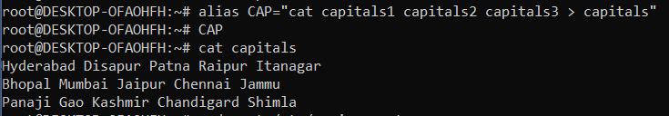

**24. What are the environment variables PATH, HOME and TERM set to on**

**your terminal ?**



**25. Find out the number of times the string “the” appears in the file mydate.**



**26. Find out the line numbers on which the string “date” exists in mydate.**



**27. Print all lines of mydate except those that have the letter “i” in them.**

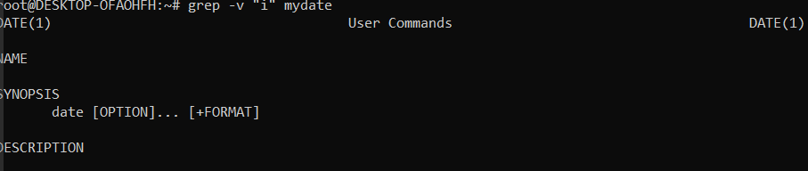

**28. List 5 states in north east India in a file mystates. List their corresponding**

**capitals in a file mycapitals. Use the paste command to join the 2 files.**

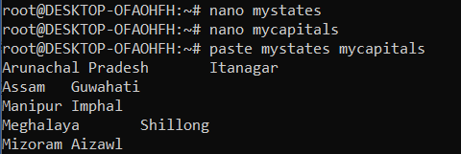

**29. Use the cut command to print the 1 st and 3 rd columns of the /etc/passwd**

**file for all students in this class.**

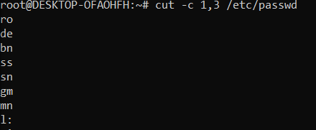

**30. Count the number of people logged in and also trap the users in a file**

**using the tee command.**

