Observations:

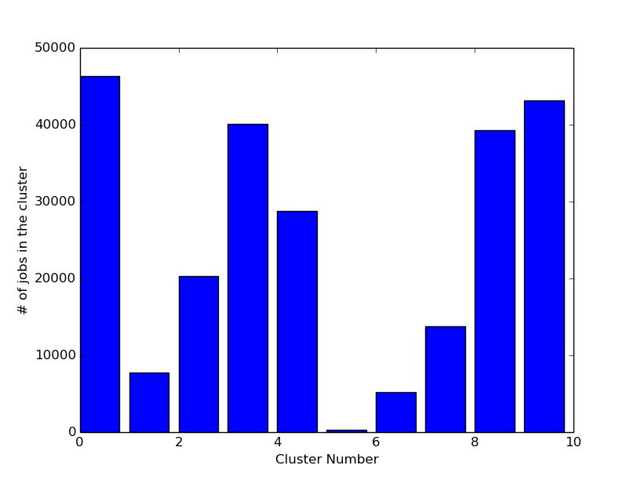

This figure shows the distribution of the # of jobs across clusters. From this we can see that Cluster 0, 3, 8 and 9 have the maximum number of jobs.

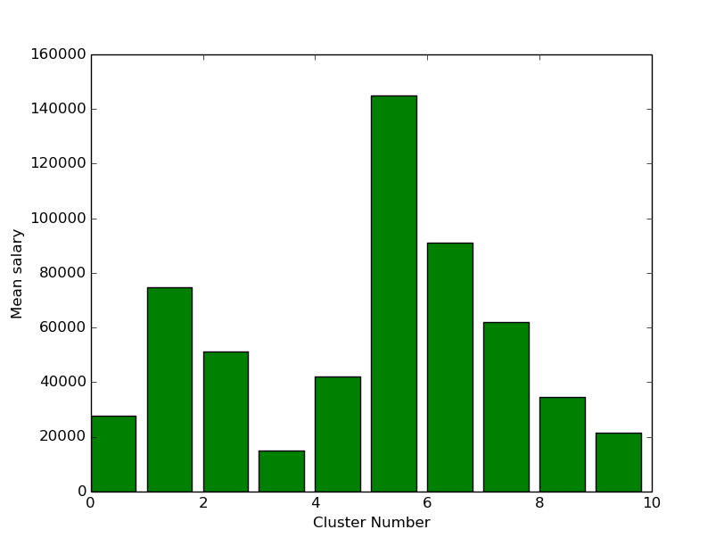

This figure shows the distribution of Mean salary across clusters. From this figure we can deduce that the cluster number with the maximum mean salaries have the minimum number of jobs in them. This is in accordance with the known economic fact that greater the value of a job, lesser is the number of jobs available.(it is a variation of the law of demand and supply)

 | Mean(salary) | Median(sal) | Maximum(sal) | Minimum(sal) | #of elements
Cluster-0 | 27752.85 | 27500 | 31171 | 24610 | 46260
Cluster-1 | 74761.55 | 75000 | 82875 | 68371 | 7694
Cluster-2 | 51204.09 | 50000 | 56500 | 46713 | 20315
Cluster-3 | 14806.11 | 15000 | 18130 | 5000 | 40056
Cluster-4 | 42173.68 | 42500 | 46674 | 38395 | 28763
Cluster-5 | 144791.33 | 134400 | 200000 | 120000 | 239
Cluster-6 | 91001.36 | 90000 | 115200 | 82920 | 5190
Cluster-7 | 61912.85 | 62499 | 68256 | 56560 | 13797
Cluster-8 | 34596.71 | 35000 | 38379 | 31180 | 39306
Cluster-9 | 21455.33 | 21500 | 24604 | 18132 | 43148

We did a keyword analysis as well. We found out the mean, maximum and minimum salaries associated with particular keywords in the data set(Keywords in the job title and not the job description). But to make sure that we have taken the important words we take only the words that appear more than 250 times.

These are the keywords that have the maximum mean salaries associated with them:

('Locum', 76830)
('Architect', 64927)
('Director', 63907)
('Solution', 62662)
('Lawyer', 60609)
('SAP', 58788)
('Agile', 57205)
('Investment', 56814)
('Oracle', 56741)
('Dynamics', 56593)
('Interim', 55908)
('BI', 55804)
('Banking', 55525)
('Change', 55418)
('Global', 54959)
('Principal', 54910)
('Partner', 54860)
('Regulatory', 54702)
('Risk', 54695)
('SharePoint', 54681)

Correspondingly these are the keywords that have the minimum salaries associated with it:

('Apprentice', 8330)
('Cleaner', 12969)
('Labourer', 13845)
('Operative', 14310)
('Commis', 15698)
('Receptionist', 16049)
('Teaching', 16296)
('Cleaning', 16507)
('Assistants', 16977)
('Outbound', 17542)
('De', 17926)
('Nursery', 18028)
('Partie', 18029)
('Clerk', 18062)
('Driver', 18080)
('Purchase', 18096)
('de', 18163)
('Relief', 18222)
('Ledger', 18294)
('Workers', 18401)

This gives us some really interesting insights about the highest paying and the lowest paying jobs.

It seems that Apprentices, Receptionist, Assistants, Drivers, Workers(of different sort) have the lowest paying jobs.

Similarly, Architects, Lawyers, Bankers, Strategists etc have the highest paying jobs.

We also analyzed the TF-IDF of the the top 50 most important words in each cluster across various clusters. We will present the results of those in the report.

The top relevant words with the highest variance across each clusters are:

('Assistant', 233.34610587375465)
('Locum', 199.87886869763923)
('Manager', 183.23777956982946)
('Sales', 109.38785798417592)
('GP', 98.834931384450073)
('Senior', 72.316918313921391)
('Engineer', 63.874954924285689)
('Executive', 58.571312565037609)
('Doctor', 54.922539730818116)
('Director', 52.597005021455928)
('Support', 49.720049664143453)
('Administrator', 49.183061014725418)
('Developer', 45.40777178701817)
('Nurse', 29.663225145640794)
('Service', 28.267715553655037)
('Customer', 26.961720482311755)
('Business', 26.300711147664483)
('Chef', 25.206005750715242)
('Head', 23.520510988579492)
('Care', 21.795951485063409)

The top relevant words with the highest deviation from the mean(variance tends to amplify the difference) across each clusters are:

('Assistant', 0.38533148628153591)
('Manager', 0.35475360517892002)
('Sales', 0.28739958259803483)
('Locum', 0.2837139836716488)
('Senior', 0.24218290947764765)
('Executive', 0.20335696172464235)
('GP', 0.19730601192440583)
('Engineer', 0.19420693482005524)
('Support', 0.17833770585225289)
('Administrator', 0.17830155902494982)
('Director', 0.17164544508348836)
('Developer', 0.15938023799034273)
('Doctor', 0.14706487230396159)
('Service', 0.14608975651605019)
('Nurse', 0.13732094345724796)
('Chef', 0.13420081543835063)
('Head', 0.12292637960648362)
('Customer', 0.12248126515404903)
('Business', 0.11755899495685511)
('Care', 0.11544430761205232)

Hence, these are the words whose relevance across the document changes the most. We used the following algorithm to calculate TF-IDF:

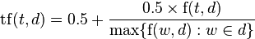

Note that this formulation of TF-IDF takes into account the length of the document and hence words occurring more frequently in longer documents do not have a higher TF(i.e. TF is normalized).

Few most frequent relevant words and its distribution across clusters.

 | Manager | Engineer | Sales | Developer | Executive | Analyst | Nurse | Administrator
Cluster-0 | 8099 | 5400 | 3539 | 2091 | 2684 | 1550 | 2478 | 543
Cluster-1 | 1776 | 668 | 315 | 591 | 102 | 380 | 38 | 41
Cluster-2 | 6366 | 2138 | 875 | 1654 | 280 | 1058 | 146 | 143
Cluster-3 | 1895 | 386 | 3422 | 208 | 1351 | 293 | 554 | 2614
Cluster-4 | 8235 | 4219 | 1546 | 2573 | 548 | 1538 | 507 | 280
Cluster-5 | 27 | 12 | 3 | 6 | 0 | 4 | 0 | 0
Cluster-6 | 913 | 356 | 199 | 503 | 64 | 368 | 93 | 48
Cluster-7 | 4125 | 1170 | 691 | 990 | 306 | 642 | 130 | 71
Cluster-8 | 5186 | 2123 | 3875 | 765 | 2856 | 1045 | 1824 | 1659

This gives us some insight about the most common type of jobs that are available in the country.

The most frequent job categories:

('IT Jobs', 38483)
('Engineering Jobs', 25174)
('Accounting & Finance Jobs', 21846)
('Healthcare & Nursing Jobs', 21076)
('Sales Jobs', 17272)
('Teaching Jobs', 12637)
('Hospitality & Catering Jobs', 11351)
('PR', 8854)
('Trade & Construction Jobs', 8837)
('HR & Recruitment Jobs', 7713)
('Admin Jobs', 7614)
('Retail Jobs', 6584)
('Customer Services Jobs', 6063)
('Legal Jobs', 3939)
('Manufacturing Jobs', 3765)
('Logistics & Warehouse Jobs', 3633)
('Social work Jobs', 3455)
('Consultancy Jobs', 3263)
('Travel Jobs', 3126)
('Scientific & QA Jobs', 2489)
('Charity & Voluntary Jobs', 2332)
('Energy', 2255)
('Creative & Design Jobs', 1605)
('Maintenance Jobs', 1542)

KDE Images:

You can also paste the KDE images that I had mailed you before.

