Syncing sometimes fails due to storage failure in one branch

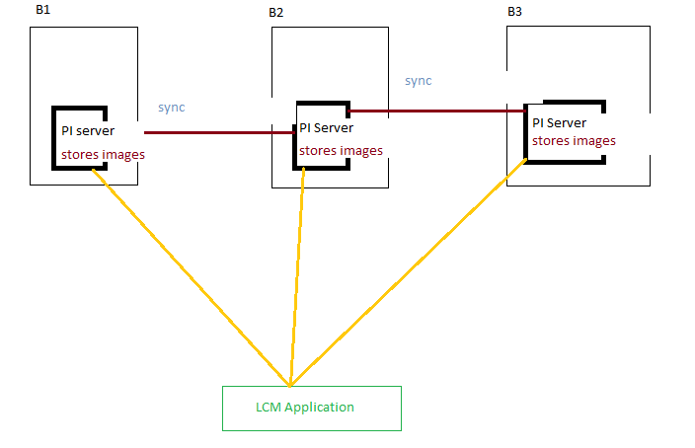

We need a solution that centralizes our image storage and scales automatically.

**Solution**

I recommend Amazon Elastic File System, commonly called Amazon EFS, a serverless, set-and-forget solution that you can use to share file data without provisioning or managing storage

Using Amazon EFS, you can create shared network drives so that your branches can access pet client photos from a central location, and you can restrict access with file-level permissions

Amazon EFS provides petabyte-scale storage that grows and shrinks automatically as you add and remove files.

Also, by default, for file systems using standard storage classes, every EFS object is redundantly stored across multiple Availability Zones. Amazon EFS is even designed to sustain concurrent device failures by quickly detecting and repairing any lost redundancy.

Steps

The mount target provides an IP address for an endpoint to which the instance can mount the file system.

Here the mount target will be EFS

The web servers attach the mount target located within their AZ as a local folder on the instance.

The instances can now read and write data in the EFS file system as if it were stored locally. All other instances with access to the EFS file system will see the changes. The file system grows and shrinks automatically as files are added or removed.

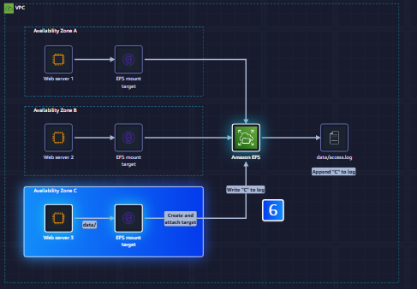

Steps

1. Launch EFS
2. Mount file system to amazon EC2 instance
3. Connect second EC2 instance to same file system
4. share file between two instances

Multiple AZ’s in same VPC

Three webserver in 3 AZ’s

W1 – AZ1

W2 – AZ2

W3 – AZ3

EFS needs NFS rule. So add inbound NFS rule to existing Webserver SG

This existing SG is linked to all three web servers which are in single VPC

EFS > Create File system > name of the VPC where our webservers are present

We need to add mount target

AZ1 – Mount target = Webserver SG

AZ2 – Mount target = Webserver SG

AZ3—Mount target = Webserver SG

This webserver SG is same for all three Webservers

Attach the EFS

Install EFS mount helper on the instance

sudo yum install -y amazon-efs-utils