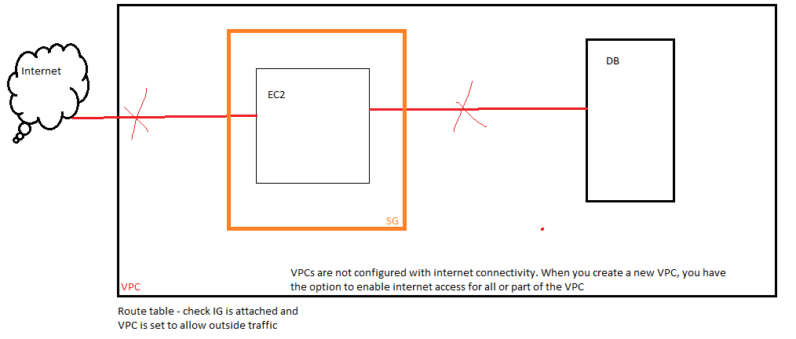

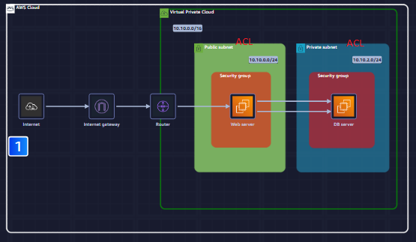

Web Server is deployed in public subnet and DB is deployed in private subnet

Web Server IP – 10.10.0.0/24

DB Instance – 10.10.2.0/24

SGWS – Allows port 80 for HTTP connection

We can configure route table to allow traffic to public subnet only via IG

Web server will communicate with DB server via port 3306

So, DB servers SG must be configured to allow port 3306 incoming connection

Steps

1. EC2
2. We have two instance Web server and DB server
3. Web server has a public IP, but we cannot reach it
4. Now, click on web server instance, it has networking option where we can find it subnet id
5. In subnet ID there is a route table
6. A NAT gateway is a network address translation (NAT) service. With a NAT gateway, instances in a private subnet can connect to services outside your VPC. External services, however, cannot initiate a connection with those instances.
7. Here we see subnet ID of Web server has two routes
   1. One route sends local traffic to the local network only.
   2. The other route sends all other traffic to the internet through a NAT gateway
   3. 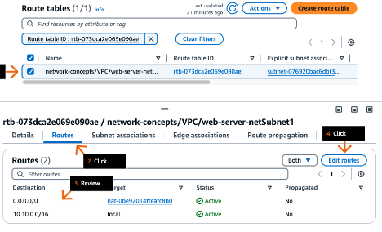
8. We don’t need Nat route so we delete it
9. An internet gateway serves two purposes
   1. Provide a target in your VPC route tables for internet-routable traffic.
   2. Perform network address translation (NAT) for instances that have been assigned public IPv4 addresses.

Now, this subnet of which webserver is part of is reachable from Internet

But, Instance is reachable or not we need to check and for that we need to check web server Security Group

1. SG> Inbound rules> create rule
2. 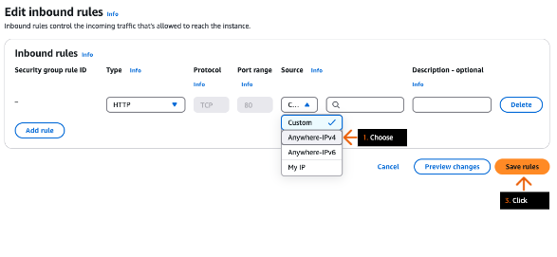
3. We add outbound rule because we don’t know what port internet user listens to
4. 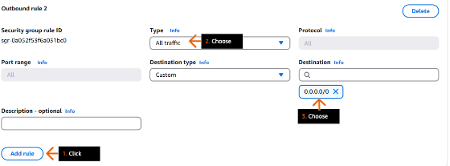
5. In its outbound rule check if traffic to port 3306 is allowed
6. Port 3306 is default port of mysql

