kubectl version --client

minikube start –driver=hyperv/virtualbox -> this will hold the cluster

minikube delete

minikube dashboard

minikube is a virtual machine ruuning on our local machine and hence cannot assign multiple public IPS

minikube dashboard

Starts Kubernetes dashboard

Deployments manage a pod for you. You can also create multiple deployments.

We still need docker to run images. Because Kubernetes manages containers

docker build . ->create an image

pod – contains container

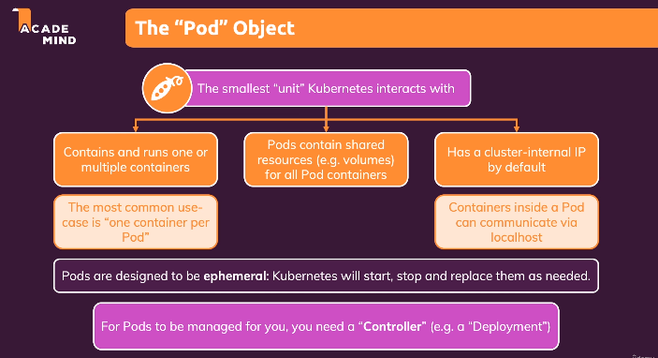

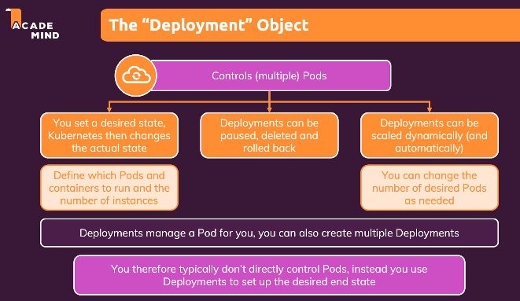

minikube status

kubectl get deployments

kubectl get pods

kubectl create deployment first-app --image=dett0ll/kub-first-app

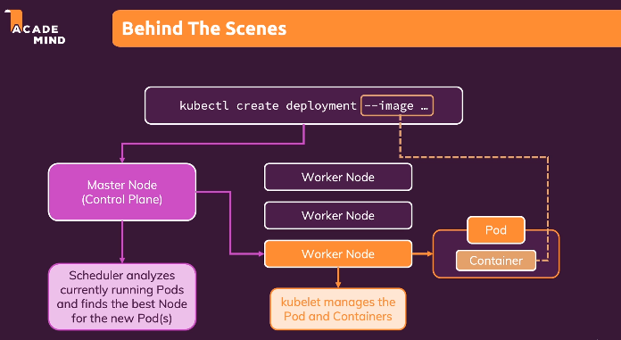

The above command deploys master mode which runs pod. This node is deployed to Worked node which has less work. The pod runs the container that has the image mentioned during deployment

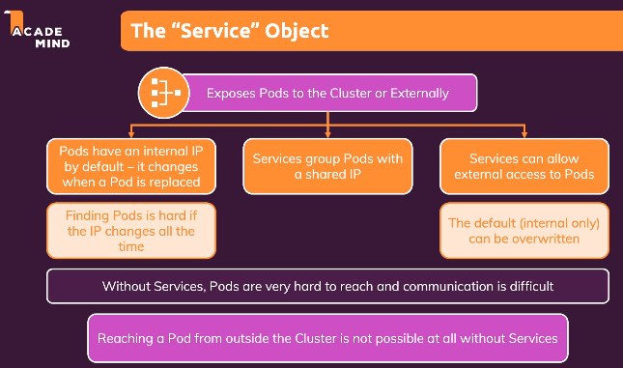

kubectl expose deployment first-app --type=LoadBalancer --port=8080 - >expose the pod

PS C:\Windows\system32> kubectl get services

There is no public IP

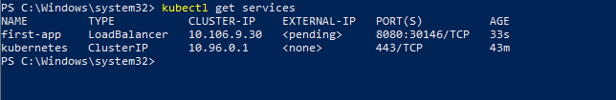

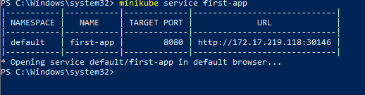

<http://172.17.219.118:30146/> - this url can be used to view the application. Which is running in the container running on the pod

kubectl scale deployments/first-app --replicas=3

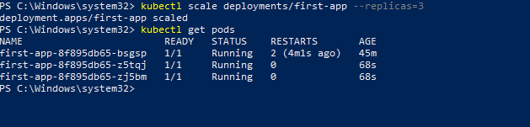

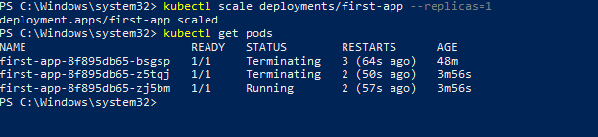

If we make changes to source code

We need to rebuild image

Push image to dockerhub

kubectl set image deployment/first-app kub-first-app=academind/kub-first-app

name of the deployment and kub-first-app is the container name where the image will be running

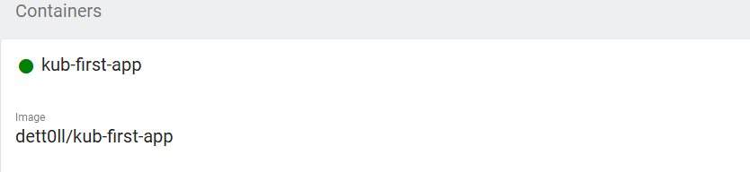

Lets say we made a new change to source code

In this case we can rebuild image with tag

docker build –t academind/kub-first-app:2 .

same can be pushed to dockerhub

docker push academind/kub-first-app:2 .

kubectl set image deployment/first-app kub-first-app=academind/kub-first-app:2

To check status of deployment

kubectl rollout status deployment/first-app

In case of deployment failure die to some issue. It will not shutdown the old pod until new is up and running

So in this case we need to rollback the update

kubectl rollout undo deployment/first-app

kubectl delete service first-app

kubectl delete deployment first-app

It will ensure all pods and deployments are deleted