SYSDEV 3-2 – Web Server System

LIST OF NAMES
Bragado, Reizel
Domingo, John Henryx
Flores, Sean Daryll
Jose, John Bairon
Legatic, Mark James

SUBJECT TEACHER
Dabriel Nikiloz G. Sioson

Project Overview
The Goal of this project is to build a Linux Web Server System that includes web server, security, monitoring, backup, and documentation.

- Directory Structure Creation
Project Directory is “systemadmin-project” with the subdirectories for architecture, scripts, monitoring, backup, docs, and group_members
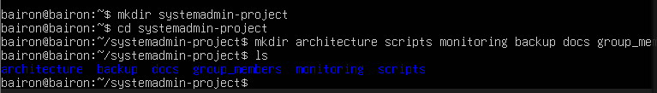
- PROJECT README
A README.md file created containing the project, components, and group members.
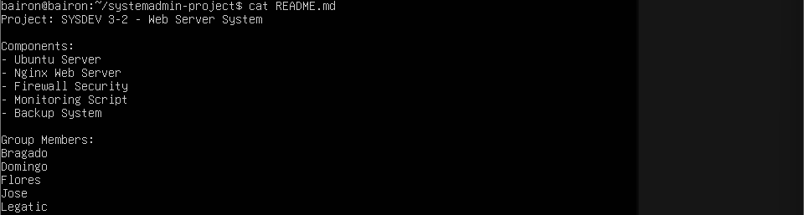

- Install the Web Server
The Nginx web server was installed and the service status is verified
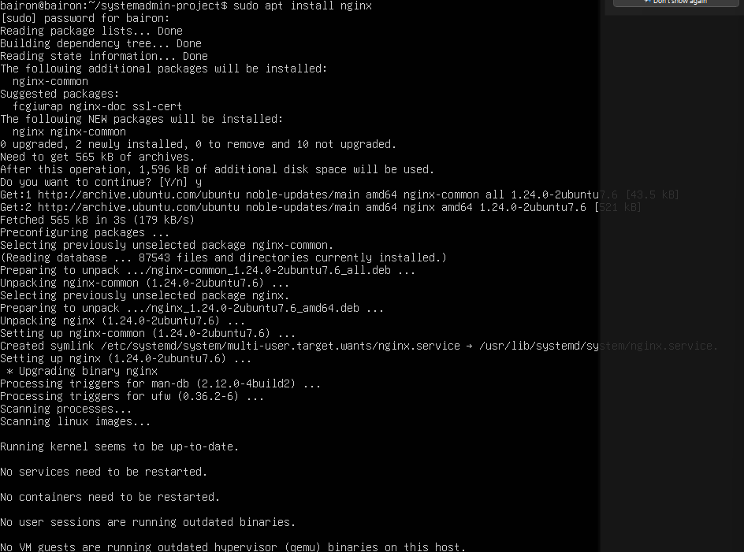

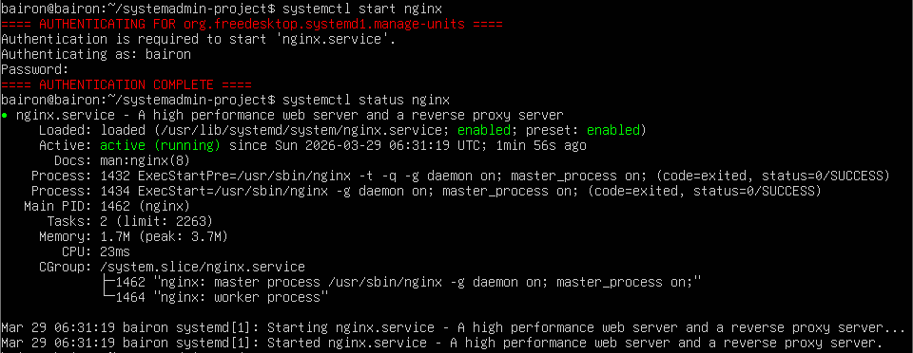

- Enable Security Firewall
The UFW (Uncomplicated Firewall) was enabled, and rules were set to allow “Nginx Full” traffic.
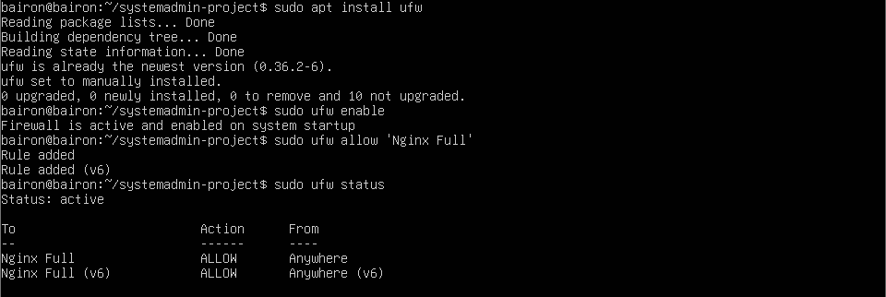

- Create Monitoring Script
The monitoring script (monitoring.sh) was created to check system uptime, memory usage, and disk space.
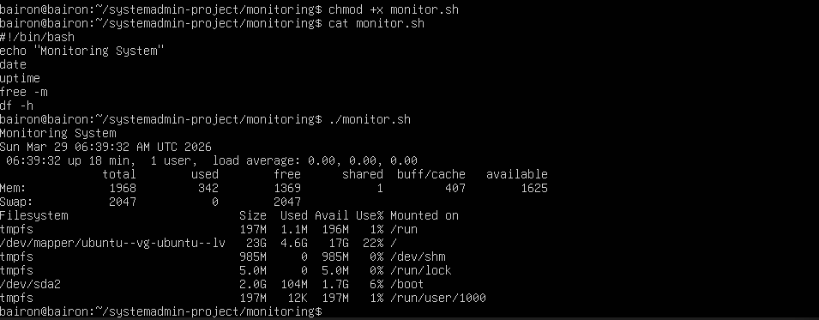

- Create Backup Script
A backup script (backup.sh) was created to archive the web server directort (/var/www/html)
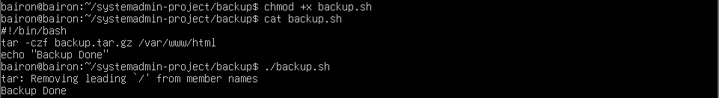

- Set Backup Schedule
Cronjob was scheduled to execute the backup script every minute
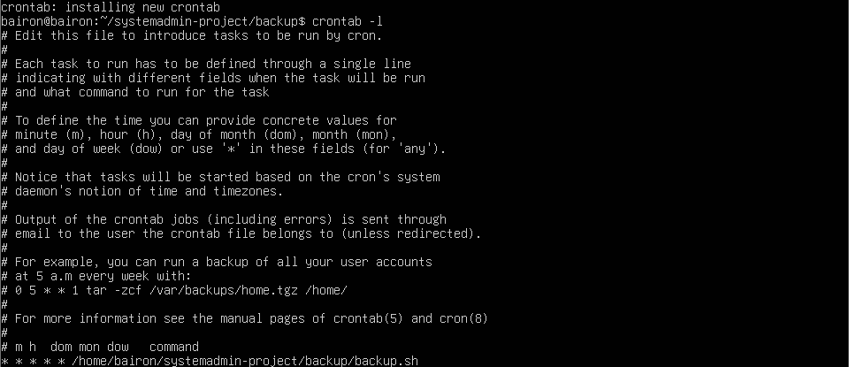

- Document the Runbook
A RUNBOOK.md file was created to document the commands for starting, stopping, checking status, and restoring backups of the server

