**PURBANCHAL UNIVERSITY**



DEPARTMENT OF COMPUTER ENGINEERING

KHWOPA ENGINEERING COLLEGE  
LIBALI-8, BHAKTAPUR

A PROJECT PROPOSAL

ON

“E-Blood Bank”

A project proposal submitted for the partial fulfillment of requirements for the degree of Bachelor of Engineering in Computer Engineering (Eighth Semester)

**SUBMITTED BY:**

Dipesh Deuja (730314)

Kareena Bade (730318)

Sanam Suwal (730334)

Sujata Shrestha (730344)

**SUBMITTED TO:**

DEPARTMENT OF COMPUTER ENGINEERING

KHWOPA ENGINEERING COLLEGE

14th December 2020

# ABSTRACT

Usually, Blood banks suffer frequent shortage of blood and hence, advertisements are frequently seen on social networks urging healthy individuals to donate blood for patients who urgently require blood transfusion. So, in order to reduce this problem in case of emergencies, we have proposed this project titled “E-Blood Bank” which is an Android application that allows the users to search and notify donors of specific blood group based on their location, in a short period of time. This application will not only display the list of donors but also facilitated with tracking the location of the nearby donors. We are including SMS and email services such that the donors can locate the requires when the request is generated for blood. Online Blood Bank (OBB) System assists in the process of blood donation whenever required the most. It consists of an application interface for the users of the system and it also uses database for storing the donor’s data, blood bank details and hospital details. It includes algorithm which detects accurate location of the donors, identifies the donors who are available nearby to the location of requester and notifies them. In order to donate blood through the app, one has to register himself by providing all the required details. These details must be valid and true so that they can be tracked at the time of emergency. When all the information is accepted by the Admin, the donor will be further to the list of registered donors. GPS module is included in order to locate the donors. Thus, only registered members, who want to donate blood, are able to access the service.

Keywords: *E-Blood Bank, GPS, Android Application*

# Table of Content

ABSTRACT i

Table of Content ii

List of figures iii

List of abbreviation iv

CHAPTER 1 1

INTRDOUCTION 1

1.1 Background 1

1.2 Motivation 2

1.3 Statement of Problems 2

1.4 Objectives 2

1.5 Our Approach 2

1.6 Scope 2

CHAPTER 2 3

LITERATURE REVIEW 3

CHAPTER 3 5

PROJECT MANAGEMENT 5

3.1 Project Member Information 5

3.2 Feasibility Study 5

3.3 Work Breakdown Structure 5

CHAPTER 4 7

METHODOLOGY 7

4.1 Context Diagram 7

4.2 Use-Case Diagram 8

4.3 ER Diagram 9

4.4 Flowchart 10

4.5 Tools and Platform 11

CHAPTER 5 12

EXPECTED RESULTS 12

REFERENCES 13

# List of figures

|  |  |  |  |
| --- | --- | --- | --- |
| **Fig No.** | **Fig Name** |  | **Page No.** |
| 3.1 | Work Schedule |  | 6 |
| 4.1 | Context Diagram |  | 7 |
| 4.2 | Use case Diagram |  | 8 |
| 4.3 | ER diagram |  | 9 |
| 4.4 | Flowchart of E-blood bank |  | 10 |

# List of abbreviation

|  |  |
| --- | --- |
| GPS | Global Positioning System |
| SGT | Smartphone GPS tracking |
| CBIS | Computer Based Information Systems |
| GUI | Graphical User Interface |
| UPSI | Universiti Pendidikan Sultan Idris |
| OBB | Online Blood Bank |

CHAPTER 1

# INTRDOUCTION

## 1.1 Background

Blood Donation is one of the most significant contributions towards the society. Millions of people need blood transfusions each year. Some may need blood during surgery and others depend on it after an accident or because they have a disease that requires blood components. Blood can be donated by two means [8]. whole blood donation and apheresis donation. Currently, the world depends on technology and everyone from the young to the old seem to be deeply involved. Due to rapid development of technology, it plays a significant role in the modern life of people and it’s an important element in today’s society.

In existing system is time consuming to provide request with the blood when in need and it just alert on donation eligibility and blood donation sites location navigation. The existing system also provides information on the upcoming events that will take place in National Blood Center through push messages and event notification. This give pries the need of such system which is available to everyone and can be used for blood management. The proposed system is a way to handle blood management and provide to hospital with blood in emergency in shortest time possible. This system will locate the nearest blood donor in cases of emergencies and in fastest way. At the same time, the admin (user) of the system analyze the blood donor details such as type of blood will notify the blood donor. The proposed system is a way to handle blood management and provide blood in emergency in shortest time possible.

**Location Tracking:** A location tracking system is a well-established technology in this era which is very safe and reliable technology. It detects the current geolocation of a target, which may be anything from a vehicle to an item in a manufacturing plant to a person. A GPS navigation device built into your car or a smartphone with a GPS chip. Using GPS enabled mobile phone (smartphone) to collect route data is another relatively new but rapidly advancing technique used in research [9]. It have significantly increased the frequency and quality of available spatio- temporal data [10]. In urban settings, smartphone GPS tracking has been employed mainly in transportation and mobility studies. GPS can pinpoint a device's location with accuracy and by comparing coordinates, the statistics can be used to calculate a devices direction of movement and speed. In this case, location data can be recorded at one minute intervals, and each location is tagged with corresponding estimate of accuracy [11]. Smartphones and tablets is use on a regular basis day. One of the best features for using GPS tracking system is that it is compatible with mobile phones, and easy to use as other application on mobile phone. It has been suggested that newer consumer-oriented technologies such as smartphone and wearable activity tracker might address these challenges. Moreover, such devices are intuitively appealing since users already use them and thus may remember to use them more easily [12] The data collection approach presented here is cost effective, accessible and user-friendly as participant use their own smart phone and do not need to carry a GPS logger or download a specific software application [9]. This significantly reduces investments cost, the potential loss of the research equipment and the need for training for participation. However, there is limitation of using mobile phones (smartphone) such as battery life and skepticism about using personal phones for research [7].

One of the current technologies being used is location tracking. A tracking system is a well- This study is aim to develop and evaluate the impact of tracking system in the blood shortage situation which is the urgent requirement of the fresh blood.

## 1.2 Motivation

In this era of modernity, we have found that the greatest predicament that exists is the cost of living and saving lives has become higher, and unfortunately life itself has lost its worth to us. Similarly, Manual systems and organizing blood donation campaigns are time consuming, laborious, and costly as compared to Computer Based Information Systems (CBIS). Organizers need to go to the nearest blood bank to inform and get necessary things to organize blood donation campaigns which is more time consuming and difficult task. Hence in order to convert this laborious and time-consuming task to easy and user friendly one, we thought of this system which is an android application that allows the users to search donors of specific blood group based on their location, in a short period of time.

## 1.3 Statement of Problems

* Unavailability of blood during emergency
* Even willing donor can’t reach to the place where blood is needed due to lack of communication or information
* Blood donation announcement in social media has not been too effective

## 

## 1.4 Objectives

The objective of this project is:

* To bridge the communication/information gap between blood banks, hospitals, donors and needy people using android user interface and GPS tracking service.

## 1.5 Our Approach

Our approach is to develop a network of helpful hands in need through an android application that allows the users; Recipient: to search or locate the donors of specific blood group and Donors: to find the place where there is need of his/her blood group, based on their location with the help of GPS module.

## 1.6 Scope

* Real-time availability of donor as per blood group.
* Willing person can donate where needed which fulfills any shortage in blood bank.
* Blood donation campaign or any other related social awareness information can notify to all the registered users with ease.
* This system will build maintain a proper communication between donor and recipients including blood banks, hospitals and health centers.

CHAPTER 2

# LITERATURE REVIEW

Blood is one of the most critical elements and its truly referred to as river of life. Blood donation is one of the most significant contributions towards the society. Millions of people need blood transfusions each year. There are number of emergency situation where urgent blood is required. As we moved forward to our research saw many programmers has also realized the same thing and contributed their part for the society.

In one of the papers, a group of programmers had proposed a technique of Blood Bank Automation using Android application in which blood inventory will be managed and automated on line. In this application the administrator accesses the whole information about blood bank management system related to donor. User can quickly check for blood banks or hospitals in the emergency situation you can find the matching of particular or related blood group and reach to the particular location through the App. Through this app user can get the list of blood banks in nearby area [1].

Next, the project Android Blood Bank system is developed so that users can view the information about registered blood donors and receiver such as name, address, and other such personal information along with their details of blood group and other medical information of donor and receiver. The proposed system also has a login page where in the user is required to register and only then can view the availability of blood and may also register to donate blood if he/she wishes to. This proposed system requires internet access continuously. Thus, this application helps to select the right donor online instantly using medical details along with the blood group. The main aim of developing this application is to reduce the time to a great extent that is spent in searching for the right donor and the availability of blood required. Thus, this application provides the required information in no time and also helps in quicker decision making. The project Android Blood Bank system is developed so that users can view the information about registered blood donors such as name, address, and other such personal information along with their details of blood group and other medical information of donor. The project also has a login page where in the user is required to register and only then can view the availability of blood and may also register to donate blood if he/she wishes to [2].

This next study aims to develop and evaluate the impact of tracking system in the blood shortage situation which is the urgent requirement of the fresh blood and to improve the communication between the hospital and donor. This system locates the nearest blood donor in cases of emergencies in fastest and easiest way using GPS. The findings on the views of user on the aspects of interface design, navigation and functionality of the web-based application that is developed are presented. Data analysis was done based on the questionnaire received from few users which are student from Universiti Pendidikan Sultan Idris (UPSI). The findings of this study were analyzed according to the objectives and the research questions of the project. Keywords: Blood Donation, Tracking System, GPS [3].

The next one is E-Blood Bank is an Android application which allows the user to search donors of specific blood group based on their location, in a short period of time. This application will not only display the list of donors but also facilitated with tracking the location of the nearby donors and providing SMS alerts to them, so that the patient can be served with blood soon. In order to donate blood through the app, one has to register himself by providing all the required details. These details must be valid and true so that they can be tracked at the time of emergency. When all the information is accepted by the Admin, the donor will be further to the list of registered donors. GPS module is included in order to locate the donors. Thus, only registered members, who want to donate blood, are able to access the service. Cloud- based services are proved very vital in urgent blood delivery as they care able to central and immediate access to donor’s data and location from anywhere and anytime [4].

Location Based Online Blood Bank System using Global Positioning System and nearest neighbor algorithm used for primary blood transfusion services. The main aim is to provide fast and efficient way to gain attention of potential donors in the need of hour. We are including SMS and email services such that the donors can locate the requires when the request is generated for blood. Online Blood Bank (OBB) System assists in the process of blood donation. It consists of an application which is present on the donor’s website which acts as an interface for the users of the system and it also uses database for storing the donor’s data, blood bank details and hospital details. If there is need of blood, the donor with the required blood group is identified and notified of the requirement. It includes algorithm which detects accurate location of the donors, identifies the donors who are available nearby to the location of requester and notifies them. By creating an online location-based web-portal where blood banks and hospitals can look for donors in their nearby area who will be available in quick time. And also keep record of donor’s health report to evaluate quickly [5].

Online Blood Bank Management System Using Android Application mainly compromises of things which includes price variations along with stock handlings, increase in blood types which may lead to increase in human blood infrastructure and categories to be managed. This project is developed with an aim where users can view the knowledge of nearby hospitals, blood banks and also the three important perspectives which includes the hospital, blood bank and patient/donor. This system is provided with security authentication where users have to login if already registered or as a brand-new user must register per their form of perspective. This project requires internet connection so as to fulfil the necessities. The system will confirm that just in case of need, the blood is made available to the patient. This paper is targeted on Online Blood Donation Management System which is an android application with supporting mobile application aimed to function a communication tool between patients (who need blood) and donor [6].

CHAPTER 3

# PROJECT MANAGEMENT

In order to design this **E-Blood Bank**, first we will design the conceptual concept. We will draw the flow of program on the basis of the so generated concept. And we will design the program on the basis of these concepts.

## 3.1 Project Member Information

For this project, we have a group of four members:

|  |  |
| --- | --- |
| **Name** | **Roll No.** |
| Dipesh Deuja | 730314 |
| Kareena Bade | 730318 |
| Sanam Suwal | 730334 |
| Sujata Shrestha | 730344 |

## 3.2 Feasibility Study

The objectives of feasibility study are not solving the problem but to acquire a sense of its scope. During the study, the problem definition is crystallized and aspects of the problem to be included in the system are determined. Consequently, constant benefits are estimated and the greater reliability at this stage. This is a bridge in between the user requirements and the outputs. The proposed system will be reliable for tracking the user’s location and notifying them i.e. notifying the donor around shortest location radius when recipients demand or need the blood specifying a category.

## 3.3 Work Breakdown Structure

The four group members will work on the different modules. During the course of work, each member will communicate with each other so that no problem arises in the future. As all the task will be tracked in Github, there will not be any hassle on combining all the modules.

|  |  |  |  |  |  |  |  |  |  |
| --- | --- | --- | --- | --- | --- | --- | --- | --- | --- |
| S.  N | Week Job  Description | 1st  Week | 2nd  Week | 3rd  Week | 4th  Week | 5th  Week | 6th  Week | 7th  Week | 8th  Week |
| 1. | Problem  Identification |  |  |  |  |  |  |  |  |
| 2. | Analysis |  |  |  |  |  |  |  |  |
| 3. | Design |  |  |  |  |  |  |  |  |
| 4. | Coding |  |  |  |  |  |  |  |  |
| 5. | Testing and  Debugging |  |  |  |  |  |  |  |  |
| 6. | Documentation |  |  |  |  |  |  |  |  |

Fig 3.1: Work Schedule

CHAPTER 4

# METHODOLOGY

For developing E-Blood Bank, various phases and methods will be proceeded with the help of various software, tools and programming languages. We do have planned to initiate our work in a prototyping model so all the worst-case scenarios are well traversed first and to utilize best fit parameters.

We plan to design the application that is accessible to not only hospitals but all the users. Since GPS tracking is previously purposed, we will be trying to use travelling sales man problem to find the nearest blood donor location. Tracking the blood donor through navigation will help predicting the time to reach and the donor who takes shortest time during emergencies would be prioritized first during the emergency demand mode.

In our project, we will develop a mobile application using Flutter and use GPS to track all the users and the locations.

## 4.1 Context Diagram

Fig 4.1: Context Diagram

## 4.2 Use-Case Diagram

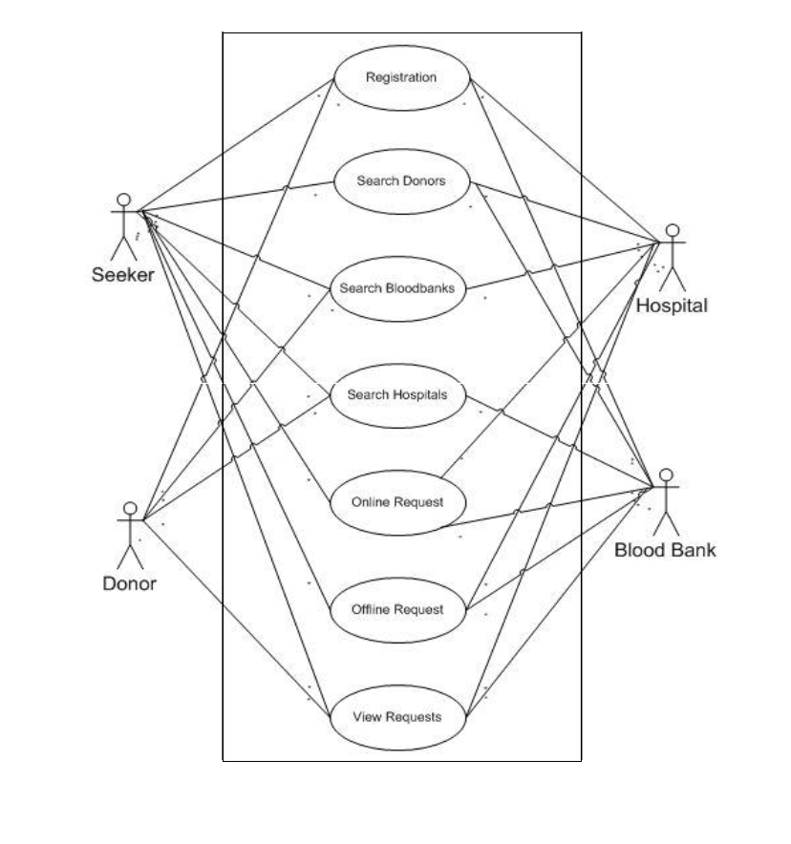 Fig 4.2: Use case Diagram

## 4.3 ER Diagram

Fig 4.3: ER diagram

## 4.4 Flowchart

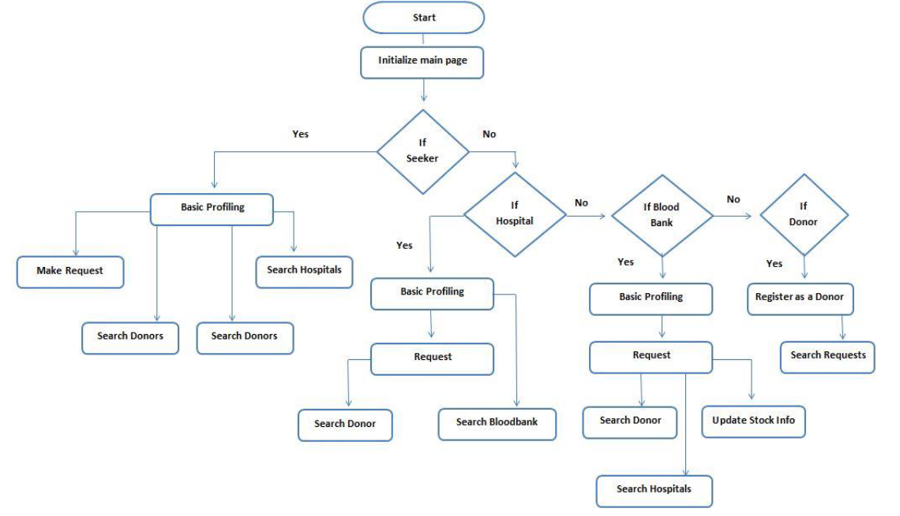

Fig 4.4: Flowchart of E-blood bank

## 4.5 Tools and Platform

1. VS Code IDE
2. Flutter
3. Android Studio
4. Windows
5. Android

CHAPTER 5

# EXPECTED RESULTS

**E-Blood Bank** will be able to notify the users as per their role in our system. When there is any need of blood for recipient, he/she will press an emergency button for the demand of the blood mentioning a blood group and place. Then our system will scan the donors registered in the app near the area. The donor that would take least time to reach the blood seeker will be prioritized first which will be calculated by our system. Available possible donors residing nearby locations will be notified via alert buzzer in app or SMS if required and the location information through GPS system in our mobile application will be provide to them. Besides, navigation makes every tough journey easy. Our system will also notify our users about the upcoming or ongoing related campaigns as well. All these will surely prevent any shortage of blood in hospitals, blood banks and help the one in need in a convenient and in short period of time.

# REFERENCES

[1] Shirsath, K., Wagh, S. and Risodkar, P., 2020. Blood Bank Connect Android Application. International Journal for Research in Engineering Application & Management, pp.168-171.

[2] Vikas Bhingare, Sagar Dhangare, Pradip Gorade, Dipak Kathar , Bhagwan Kurhe., 2018. Blood Donor Tracker By using GPS. International Journal for Research in Engineering Application & Management, Vol-4 Issue-2 2018

[3] Nur Fatini Zahidah Binti Zakaria, Zulhafiza binti Zainal Abidin, Muhammad Asyraf bin Abdullah Zawawi. Bloodbuddy: a Tracking System for Blood Donor Using GPS. Journal of Engineering, Technology & Applied Science 2020, 2(2): 86-102

[4] Shubham Pande, Shweta Mate, Pradnya Mawal, Ayusha Jambulkar, Prof. N. S. More. E-Blood Bank Application Using Cloud Computing. Department of Information Technology, Smt. Kashibai Navle College of Engineering ,India, Volume: 05 Issue: 02 | Feb-2018

[5] R. Suchitra, M. Lalithya Sannitha, J. Ravikanth, G. Anusha & B. Abhilash, Assistant Professor, Location_Based_Online_Blood_Bank_System, Department of CSE, Lendi Institute of Engineering and Technology, Vizianagaram, India, Vol. 3, Issue 4, Apr 2019,pp. 1-4

[6] Mange, M. and Shaikh Mohammad, B., 2020. Online Blood Bank Management System Using Android Application. SSRN Electronic Journal,.

[7] tamberger, L., Riper, C. J., Keller, R., Brownlee, M. & Rose, J. (2018). A GPS Tracking Study of Recreationists in an Alaskan Protected Area. Applied Geography, 93: 92-102. doi:10.1016/j.apgeog.2018.02.011

[8] PORTAL MyHEALTH. 2020. Blood Donation - PORTAL Myhealth. [online] Available at: <http://www.myhealth.gov.my/en/blood-donation/> [Accessed 12 December 2020].

[9] Korpilo, S., Virtanen, T. & Lehvävirta, S. (2017). Smartphone GPS Tracking—Inexpensive and Efficient Data Collection on Recreational Movement. Landscape and Urban Planning, 157: 608-617. doi:10.1016/j.landurbplan.2016.08.005.

[10] Adle, A., Galpern, P. & Doyle-Baker, P. (2018). Measuring the Use of Green Space with Urban Resource Selection Functions: An Application Using Smartphone GPS Locations. Landscape and Urban Planning, 179: 107-115.

[11] Alpern, P., Ladle, A., Uribe, F. A., Sandalack, B. & Doyle-Baker, P. (2018). Assessing Urban Connectivity Using Volunteered Mobile Phone GPS Locations. Applied Geography, 93: 37-46. doi:10.1016/j.apgeog.2018.02.009.

[12] Ardy, J., Veinot, T. C., Yan, X., Berrocal, V. J., Clarke, P., Goodspeed, R. & Vydiswaran, V. V. (2018). User Acceptance of Location-Tracking Technologies in Health Research: Implications for Study Design and Data Quality. Journal of Biomedical Informatics, 79: 7-19. doi:10.1016/j.jbi.2018.01.003.