**PURBANCHAL UNIVERSITY**



**DEPARTMENT OF COMPUTER ENGINEERING**

**KHWOPA ENGINEERING COLLEGE  
LIBALI-2, BHAKTAPUR**

**A PROJECT REPORT**

**ON**

**E-BLOOD BANK SYSTEM**

Project work submitted in fulfillment of requirements for the award of the degree of Bachelor of Engineering in Computer Engineering Eighth Semester)

**SUBMITTED BY**

Dipesh Deuja (730314)

Kareena Bade (730318)

Sanam Suwal (730334)

Sujata Shrestha (730344)

**UNDER THE SUPERVISION OF**

(Er. Suresh Ghatuwa)

**SUBMITTED TO:**

DEPARTMENT OF COMPUTER ENGINEERING KHWOPA ENGINEERING COLLEGE

August 2021

**DEPARTMENT OF COMPUTER ENGINEERING**

**KHWOPA ENGINEERING COLLEGE**

**LIBALI-2, BHAKTAPUR**

**CERTIFICATE**

This is to certify that the project entitled “**E-BloodBank System**” submitted by Mr. Sanam Suwal, Ms. Kareena Bade, Mr. Dipesh Deuja and Ms. Sujata Shrestha in a partial fulfillment of the requirements for the Eighth Semester in Computer Engineering of Purbanchal University, is a bonafide work to the best of our knowledge and may be placed before the examination Board for their consideration.

**Panel of Examiners:**

**Names Signature Date**

**External**

Er.

Assistant Professor

Central Department of Computer Science and Technology

Tribhuvan University, Kritipur

**Supervisor**

**Er. Suresh Ghatuwa**

**HOD**

**Er. Bikash Chawal**

ACKNOWLEDGEMENT

Firstly, we deem it a pleasure to acknowledge our sense of gratitude to the department of Computer Engineering for providing us a strong academic atmosphere and the opportunity to explore our ideas and skills beyond the academic syllabus through the project.

We take this opportunity to express our deepest and sincere gratitude to our HoD Er. Bikash Chawal, for his insightful advice, motivating suggestions needed for this project and also for his constant encouragement and advice throughout our Bachelor’s program. Also, we would also like to reciprocate our gratitude towards all the lecturers who have supported throughout the project with their ideas and friends who have cooperated in our projects with their different perspective.

Finally, we would like to offer our sincere thanks to our supervisor **Er. Suresh Ghatuwa** for boosting our efforts and moral by his valuable advices and suggestions regarding the project, giving us realization of the practical scenario of the project and supporting us for tackling with various difficulties. His incisive, guidance and timely advice encouraged us to complete the project with constant flow of energy throughout the entire project despite of his busy schedule.

**Group Members**

1. Dipesh Deuja (730314)

2. Kareena Bade (730318)

3. Sanam Suwal (730334)

4. Sujata Shrestha (730344)

ABSTRACT

Let us plot a scenario of urgent blood requirements and a blood bank near you is out of the blood. Also, advertisements are frequently seen on social networks urging healthy individuals to donate blood for patients who urgently require a blood transfusion. It is where our project titled the "E-Bloodbank" system comes in handy. E-Bloodbank System is an android application as well as a web application that connects the blood needy and honest blood donors of our community. This system allows the users to search and notify donors of specific blood groups based on their location as quickly as possible. Both the android and web application shares the same database through a flask API. This application not only displays the list of donors but also facilitates tracking the location of the nearby donors. This system uses a distance matrix to calculate the shortest traveling distance between the available app users within a given range. With this, the users can be notified about health-related events such as blood donation campaigns. This system assists in the process of blood donation whenever required the most. It consists of an application interface for the users of the system and it also uses a database for storing the donor’s data, blood bank details, and hospital details. It tracks the location of the donors through the (Global Positioning System) GPS, identifies the donors who are available nearby the location of the requester, and notifies them about the urgency. Users are provided with a catchy User Interface (UI) for registration and posting the blood requests. The registration validation is done manually by the admin. Validated users can use the full features of the system. Location is tracked to locate the donors and notify the users about the events near them.

Keywords: *E-BloodBank, GPS, Android Application, API, Web application, shortest path, UI, Distance matrix.*

Table of Content

ACKNOWLEDGEMENT iii

ABSTRACT iv

Table of Content v

List of figures vii

List of abbreviation viii

CHAPTER 1 1

INTRDOUCTION 1

1.1 Background 1

1.2 Motivation 2

1.3 Statement of Problems 2

1.4 Objectives 2

1.5 Our Approach 2

1.6 Scope 2

CHAPTER 2 3

LITERATURE REVIEW 3

CHAPTER 3 6

SYSTEM ANALYSIS 6

3.1 Functional Requirement 6

3.2 Non Functional Requirement 6

3.2.1 Reliability 6

3.2.2 Maintainability 6

3.2.3 Performance 6

3.2.4 Profitability 6

3.3 Feasibility study 7

3.3.1 Operational feasibility 7

3.3.2 Technical feasibility 8

3.3.3 Schedule feasibility 8

2.3.4 Economic feasibility 8

CHAPTER 4 9

METHODOLOGY 9

4.1 Software Development Approach 9

4.2 System Overview 10

Frontend 10

Backend 10

4.3 Technologies/Algorithms Used 11

4.3.1 Perpendicular distance calculator (Spherical approach) 11

4.3.2 Geographic Distance Matrix Generator 13

4.3.3 Google Maps Platform 14

CHAPTER 5 15

SYSTEM DESIGN AND ARCHITECTURE 15

5.1 Context Diagram 15

5.2 Use-Case Diagram 16

5.3 ER Diagram 17

5.4 Flowchart 18

5.6 Tools and Platform 19

CHAPTER 6 21

RESULTS AND DISCUSSIONS 21

6.1 Overview 21

6.2 Snapshots 22

CHAPTER 7 36

CONCLUSION AND RECOMMENDATIONS 36

7.1 Conclusion 36

7.2 Future Recommendations 36

REFERENCES 37

List of figures

|  |  |  |  |
| --- | --- | --- | --- |
| **Fig No.** | **Fig Name** |  | **Page No.** |
| 5.1 | Context Diagram |  | 15 |
| 5.2 | Use case Diagram |  | 16 |
| 5.3 | ER diagram |  | 17 |
| 5.4 | Flowchart of E-blood bank |  | 18 |
| 6.1.1 | Flutter App Start Slider View |  | 22 |
| 6.1.2 | Flutter App Sign Up |  | 23 |
| 6.1.3 | Flutter App Login |  | 24 |
| 6.1.4 | Password Reset via OTP code |  | 25 |
| 6.1.5 | User Dashboard |  | 26 |
| 6.1.6 | Search Donor by Blood group |  | 27 |
| 6.1.7 | Request for blood |  | 28 |
| 6.1.8 | Notifications and Donor Profile |  | 29 |
| 6.1.9 | Blood banks and Logout Page |  | 30 |
| 6.1.10 | Newsfeed Page |  | 31 |
| 6.1.11 | Google Map Navigation |  | 32 |
| 6.1.12 | Web Homepage |  | 33 |
| 6.1.13 | Web Login page |  | 34 |
| 6.1.14 | Web Registration page |  | 34 |
| 6.1.15 | Web Dashboard |  | 35 |

List of abbreviation

|  |  |
| --- | --- |
| GPS | Global Positioning System |
| SGT | Smartphone GPS tracking |
| CBIS | Computer Based Information Systems |
| GUI | Graphical User Interface |
| UPSI | Universiti Pendidikan Sultan Idris |
| API | Application Programming Interface |
| OBB | Online Blood Bank |
| UI | User Inteface |

CHAPTER 1

# INTRDOUCTION

## 1.1 Background

Blood Donation is one of the most significant contributions towards the society. Millions of people need blood transfusions each year. Some may need blood during surgery and others depend on it after an accident or because they have a disease that requires blood components. Blood can be donated by two means [8]; whole blood donation and apheresis donation. Currently, the world depends on technology and everyone from the young to the old seem to be deeply involved. Due to rapid development of technology, it plays a significant role in the modern life of people and it’s an important element in today’s society.

In existing system, it is time consuming to provide request with the blood when in need and it just alert on donation eligibility and blood donation sites location navigation. The existing system also provides information on the upcoming events that will take place in National Blood Center through push messages and event notification. This give pries the need of such system which is available to everyone and can be used for blood management. The proposed system is a way to handle blood management and provide to hospital with blood in emergency in shortest time possible. This system will locate the nearest blood donor in cases of emergencies and in fastest way. At the same time, the admin (user) of the system analyze the blood donor details such as type of blood will notify the blood donor. The proposed system is a way to handle blood management and provide blood in emergency in shortest time possible.

**Location Tracking:** A location tracking system is a well-established technology in this era which is very safe and reliable technology. It detects the current geolocation of a target, which may be anything from a vehicle to an item in a manufacturing plant to a person. A GPS navigation device built into your car or a smartphone with a GPS chip. Using GPS enabled mobile phone (smartphone) to collect route data is another relatively new but rapidly advancing technique used in research [9]. It have significantly increased the frequency and quality of available spatio-temporal data [10]. In urban settings, smartphone GPS tracking has been employed mainly in transportation and mobility studies. GPS can pinpoint a device's location with accuracy and by comparing coordinates, the statistics can be used to calculate a devices direction of movement and speed. In this case, location data can be recorded at one minute intervals, and each location is tagged with corresponding estimate of accuracy [11]. Smartphones and tablets is use on a regular basis day. One of the best features for using GPS tracking system is that it is compatible with mobile phones, and easy to use as other application on mobile phone. It has been suggested that newer consumer-oriented technologies such as smartphone and wearable activity tracker might address these challenges. Moreover, such devices are intuitively appealing since users already use them and thus may remember to use them more easily [12] The data collection approach presented here is cost effective, accessible and user-friendly as participant use their own smart phone and do not need to carry a GPS logger or download a specific software application [9]. This significantly reduces investments cost, the potential loss of the research equipment and the need for training for participation. However, there is limitation of using mobile phones (smartphone) such as battery life and skepticism about using personal phones for research [7].

One of the current technologies being used is location tracking. A tracking system is a well- This study is aim to develop and evaluate the impact of tracking system in the blood shortage situation which is the urgent requirement of the fresh blood.

## 1.2 Motivation

In this era of modernity, we have found that the greatest predicament that exists is the cost of living and saving lives has become higher, and unfortunately life itself has lost its worth to us. Similarly, Manual systems and organizing blood donation campaigns are time consuming, laborious, and costly as compared to Computer Based Information Systems (CBIS). Organizers need to go to the nearest blood bank to inform and get necessary things to organize blood donation campaigns which is more time consuming and difficult task. Hence in order to convert this laborious and time-consuming task to easy and user friendly one, we thought of this system which is an android application that allows the users to search donors of specific blood group based on their location, in a short period of time.

## 1.3 Statement of Problems

* Unavailability of blood during emergency
* Even willing donor can’t reach to the place where blood is needed due to lack of communication or information
* Blood donation announcement in social media has not been too effective

## 1.4 Objectives

The objective of this project is:

* To bridge the communication/information gap between blood banks, hospitals, donors and needy people using android user interface and GPS tracking service.

## 1.5 Our Approach

Our approach is to develop a network of helpful hands in need through an android application that allows the users; Recipient: to search or locate the donors of specific blood group and Donors: to find the place where there is need of his/her blood group, based on their location with the help of GPS module.

## 1.6 Scope

* Real-time availability of donor as per blood group.
* Willing person can donate where needed which fulfills any shortage in blood bank.
* Blood donation campaign or any other related social awareness information can notify to all the registered users with ease.
* This system will build maintain a proper communication between donor and recipients including blood banks, hospitals and health centers.

CHAPTER 2

# LITERATURE REVIEW

Blood is one of the most critical elements and it’s truly referred to as river of life. Blood donation is one of the most significant contributions towards the society. Millions of people need blood transfusions each year. There are number of emergency situation where urgent blood is required. As we moved forward to our research saw many programmers has also realized the same thing and contributed their part for the society.

In one of the papers, a group of programmers had proposed a technique of Blood Bank Automation using Android application in which blood inventory will be managed and automated on line. In this application the administrator accesses the whole information about blood bank management system related to donor. User can quickly check for blood banks or hospitals in the emergency situation you can find the matching of particular or related blood group and reach to the particular location through the App. Through this app user can get the list of blood banks in nearby area [1].

Next, the project Android Blood Bank system is developed so that users can view the information about registered blood donors and receiver such as name, address, and other such personal information along with their details of blood group and other medical information of donor and receiver. The proposed system also has a login page where in the user is required to register and only then can view the availability of blood and can also register to donate blood if he/she wishes to. This proposed system requires internet access continuously. Thus, this application helps to select the right donor online instantly using medical details along with the blood group. The main aim of developing this application is to reduce the time to a great extent that is spent in searching for the right donor and the availability of blood required. Thus, this application provides the required information in no time and also helps in quicker decision making. The project Android Blood Bank system is developed so that users can view the information about registered blood donors such as name, address, and other such personal information along with their details of blood group and other medical information of donor. The project also has a login page where in the user is required to register and only then can view the availability of blood and can also register to donate blood if he/she wishes to [2].

This next study aims to develop and evaluate the impact of tracking system in the blood shortage situation which is the urgent requirement of the fresh blood and to improve the communication between the hospital and donor. This system locates the nearest blood donor in cases of emergencies in fastest and easiest way using GPS. The findings on the views of user on the aspects of interface design, navigation and functionality of the web-based application that is developed are presented. Data analysis was done based on the questionnaire received from few users which are student from Universiti Pendidikan Sultan Idris (UPSI). The findings of this study were analyzed according to the objectives and the research questions of the project. Keywords: Blood Donation, Tracking System, GPS [3].

The next one is E-Blood Bank is an Android application which allows the user to search donors of specific blood group based on their location, in a short period of time. This application will not only display the list of donors but also facilitated with tracking the location of the nearby donors and providing SMS alerts to them, so that the patient can be served with blood soon. In order to donate blood through the app, one has to register himself by providing all the required details. These details must be valid and true so that they can be tracked at the time of emergency. When all the information is accepted by the Admin, the donor will be further to the list of registered donors. GPS module is included in order to locate the donors. Thus, only registered members, who want to donate blood, are able to access the service. Cloud- based services are proved very vital in urgent blood delivery as they care able to central and immediate access to donor’s data and location from anywhere and anytime [4].

Location Based Online Blood Bank System using Global Positioning System and nearest neighbor algorithm used for primary blood transfusion services. The main aim is to provide fast and efficient way to gain attention of potential donors in the need of hour. We are including SMS and email services such that the donors can locate the required when the request is generated for blood. Online Blood Bank (OBB) System assists in the process of blood donation. It consists of an application which is present on the donor’s website which acts as an interface for the users of the system and it also uses database for storing the donor’s data, blood bank details and hospital details. If there is need of blood, the donor with the required blood group is identified and notified of the requirement. It includes algorithm which detects accurate location of the donors, identifies the donors who are available nearby to the location of requester and notifies them. By creating an online location-based web-portal where blood banks and hospitals can look for donors in their nearby area who will be available in quick time. And also keep record of donor’s health report to evaluate quickly [5].

Online Blood Bank Management System Using Android Application mainly compromises of things which includes price variations along with stock handlings, increase in blood types which may lead to increase in human blood infrastructure and categories to be managed. This project is developed with an aim where users can view the knowledge of nearby hospitals, blood banks and also the three important perspectives which includes the hospital, blood bank and patient/donor. This system is provided with security authentication where users have to login if already registered or as a brand-new user must register per their form of perspective. This project requires internet connection so as to fulfil the necessities. The system will confirm that just in case of need, the blood is made available to the patient. This paper is targeted on Online Blood Donation Management System which is an android application with supporting mobile application aimed to function a communication tool between patients (who need blood) and donor [6].

Next one is a Blood bank developed using mobile application that’s helps to assist blood bank organizations in managing information that they have. The application, Blood Donation Notification Application (BDNA) use Haversine formula to calculate the nearest blood bank from the blood bank from the blood donor’s current location. This system mainly depend upon the type of users, namely donors and blood bank administrators, where former is using a mobile application. The donors can be anybody that download the mobile app, whether or not they have donated their blood to any blood bank. The administration officers in the blood bank organizations that manage all of the information in the blood bank [13].

In one of the research paper the system used GPS and Cloud Computing to determine quickest path for reaching the necessary Blood Benefactors. This system reduces in the corruption in the Blood Bank. In this system, user need to register their information and demand from purchaser for blood, music region of individual with GPS; Step three Check If blood benefactor is accessible to send the warning from E blood bank programming to close by enrolled Donors. Stage 4: If GPS of the individual is no longer ON then ship the warning dependent on enrolled address. Stage 5: Check requirements for blood gift like HB, Weight, various variables, and past Blood Donation Date. Stage 6: If conditions are comfortable to acknowledge it. Stage 7: If Conditions are never again delighted at that point transport the warning to different contributors who are close by and furthermore qualified. And the main drawback for this system is the application and is anything but difficult to fathom the challenges [14].

CHAPTER 3

# SYSTEM ANALYSIS

## 3.1 Functional Requirement

The functional requirements of this system includes followings requirements:

* The system must be able to track last updated GPS location of each user as an input for distance matrix to find the accurate travelling distance between the users.
* System must be able to deliver notifications to the Donors about the urgency of blood in the community.
* System must be able to notify about the health-related events organized by the local and government bodies around the area.
* System must be able to provide contact information about the nearest and available blood banks.
* System must be able to post request by any user who wishes to collect blood for the patients.

## 3.2 Non Functional Requirement

Non-functional requirements are more critical than functional requirements. A system user can usually find ways to work around a system function that doesn’t really meet their needs but if the non-functional requirements are not met, then the system will have no importance. The points below focus on the non-functional requirement of the system.

### 3.2.1 Reliability

The system is fed with genuine information about the blood bank and health centers. Also the user registration is verified by the admin manually which makes it quiet reliable.

### 3.2.2 Maintainability

The system is implemented with proper documentation and good programming practice. So, the system can be maintained time and again whenever relevant.

### 3.2.3 Performance

The system uses Flutter user interface as well as flask API and is designed to yield maximum possible efficiency.

### 3.2.4 Profitability

The system is designed as web based and android based application so it becomes portable to desktops and other platforms.

## 3.3 Feasibility study

After performing requirement and functional analyses, the next step is feasibility study. This phase of study is very important one for every project builder. One must know how much the project is feasible which he/she is going to make. Four types of feasibility analyses have been performed.

### 3.3.1 Operational feasibility

Operational feasibility study measures the urgency of the problem (survey and study phase). During the operational feasibility study, we have tried to answer the following questions that address the issues:

#### Performance

Does the proposed system provide the adequate throughput and the response time?

Yes, the system provides adequate throughput and response time.

#### Information

Does the system provide users and administrators with timely, pertinent, accurate, and useful information?

Yes, the system provides timely, pertinent, accurate and useful information.

#### Economy

Does the system provide the adequate service level and capacity to reduce the costs of the business or increase the profits of the business?

If this project is to be implemented in real time, the profits of the business are likely to increase as it provides a better method of security for the server. Also various methods to increase the productivity of the web being accessed through the server can be implemented on the basis of the information provided by this system so it is useful in increasing the economy of the system.

#### Efficiency

Does the system make maximum use of available resources including people time?

This system is efficient. Our main aim is to produce maximum output from minimum resources. This system runs concurrently with other systems in the server and uses only limited amount of resources from the server so the system is very much efficient on the basis of time.

#### Services

Does the system provide desirable and reliable services to the users? Is the system flexible and expandable?

Yes, it provides desirable and reliable services to the users. The database used to map IP of the users to the location is a reliable one thus the system is reliable. This system is flexible as well as expandable. We can successfully use this system to help in deriving information required for other systems. This system can act as a base for the development of other complex and useful systems with recommendations and AI embedded.

### 3.3.2 Technical feasibility

This is also important study, which is performed by every project builder. Technical feasibility study determined whether the project is technically feasible or not. It studies whether the required technology for the system is mature enough to be applied to solve our problems and whether it is practically applicable or not. If we can't afford the technology then the project is technically infeasible and in that case we have to choose alternative solution.

During technical feasibility, we have found that our project is technically feasible i.e. the technology used in our project is applicable and easily affordable. Our project only requires basic resources that are commonly used so technically no problem occurs in our project.

### 3.3.3 Schedule feasibility

Schedule feasibility study is very important to make a project successful. It helps the developer to finish the project within specified deadline. If the project is completed beyond this deadline then it is worthless to the customers. After doing this study, we have found that our project is perfectly scheduled to be completed within the specified deadline

### 2.3.4 Economic feasibility

The bottom line is many projects are economic feasibility. During the early phases of the project, economic feasibility analysis amounts to little more than judging whether the possible benefits of solving the problems are worthwhile. Costs are practically impossible to estimate at this stage because the end user's requirements and alternative technical solutions have not been identified. However, as soon as specific requirements and solutions have been identified then the analyst can weigh the cost and benefits of each alternative. So, every project builder must analyze the economic feasibility because if the cost is higher than estimated one at the early phase then the project developer has to give a suitable reason for the cost being higher. We have also analyzed our project and found it to be economically feasible as well.

CHAPTER 4

# METHODOLOGY

## 4.1 Software Development Approach

All the procedures for developing the software are carried out following the agile development methodology. We used the scrum framework of agile development. It is a simple frame-work for effective team collaboration on complex software projects. The scrum framework consists of scrum teams and their associated roles, events, artifacts and rules. Each component within the framework serves a specific purpose and is essential to scrum’s success and usage

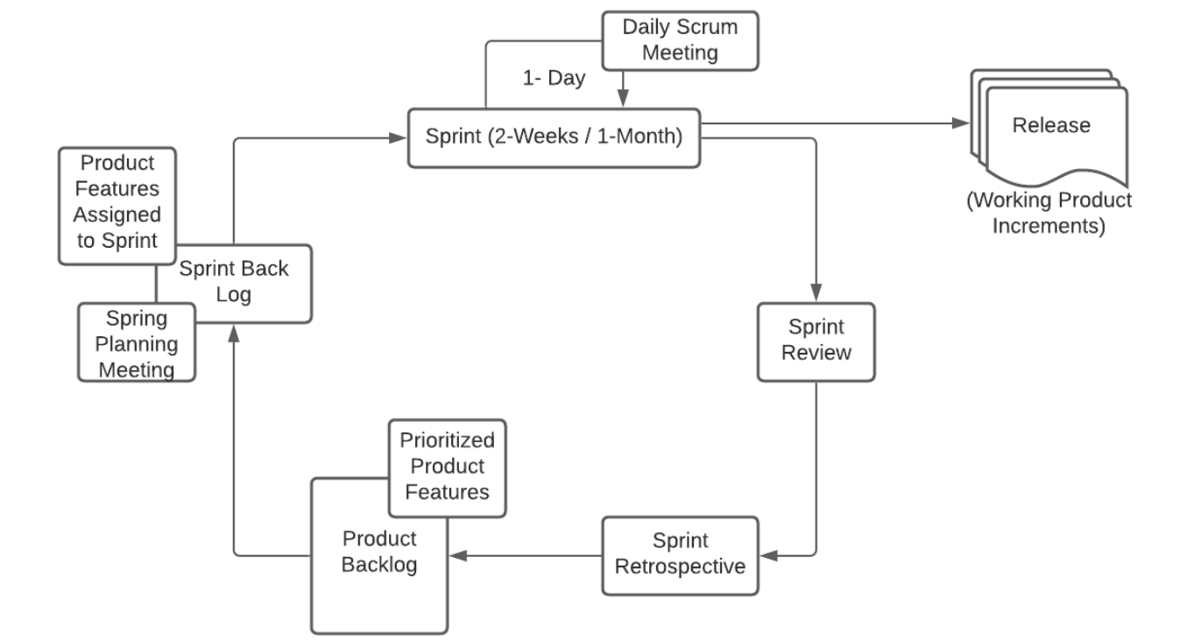

4.1.1: Scrum Framework of Agile Model

In scrum, the prescribed events are used to create regularity. All events are time-boxed events. The heart of scrum is a sprint, we use a sprint span of 3 to 4 weeks during which a potentially releasable product increment is created. A newsprint starts immediately after the conclusion of previous sprint. Sprints consist of the sprint planning, daily scrums, the development work, the sprint review and the sprint retrospective.

As per the scrum framework team needs to be divided into 3 parties (i.e. product owner, developers and scrum master). However, the project being for educational purpose, only developers and scrum master are included in scrum team. In the team, developers carried out all tasks required to build increments of valuable output in every sprint while scrum master is responsible for removing impediments to ability of the team to deliver the product goals and deliverable.

During the project our supervisor acted as the scrum master.

Scrum Team

Scrum Master

(Supervisor)

Developers

(Team Members)

Fig 4.1.2: Scrum Team

## 4.2 System Overview

### Frontend

This system is a distributed social service system with client-server programming, which help people, especially in need of blood during emergencies by providing information related to nearest blood donor. Here, the frontend application is seen in screen of an android mobile as well as in web application. People using this system are supposed to be the client with their mobile phones or laptops (PCs).

We used dart, python language for programming. We tried to use high level design methodology and detailed design methodology for designing this system. With the help of this application client will be able to post Blood requests, get location of nearest donor available for specific blood group. This System has an eye catching GUI interface that any user can easily understand. We used Flutter, Flask, Jinja, CSS and JavaScript for designing the GUI interface.

### Backend

SQLite3 and SQL Alchemy is used for storing data. Although different approaches of connecting database are used by mobile application and web application they get connected to same database. This means all the devices sync up the data from single database. This database is hosted locally at the moment and can be hosted in the cloud for production purpose.

The devices are connected through a custom made flask API. This means, any requests made by the user generates a POST / GET / PUT requests to a web route that travels through our API. Any requests besides the API calls are forbidden. The API then performs the queries requested by the user and sends notification codes about the success or failure of the query.

The data-type used by our API for input and output is JSON data format.

Large amount of data are to be maintained for this application which are to be arranged properly and modified as per needs. A database administrator has the authentication to edit, modify and update the data of the database.

## 4.3 Technologies/Algorithms Used

The overall concept that is the framework for any distance related algorithm is shown below.

### 4.3.1 Perpendicular distance calculator (Spherical approach)

The spherical approach for deriving perpendicular distances is accomplished by determining the intersection of two great circles.

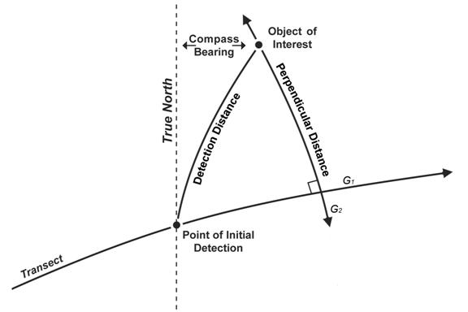

Fig 4.3.1: Distance in Spherical Form

A great circle is a circle that is produced by the intersection of the Earth's surface with a plane passing through the center of the Earth. The shortest distance between two points on the Earth's surface is an arc or segment of a great circle. The first great circle (G1) referenced by this method is the great circle passing through the start and end point of the transect leg. The second great circle (G2) intersects G1 at a 90 degree angle and passes through the geographic location of a sighting or object of interest. The perpendicular distance is the shortest arc length between the object of interest and the intersection of G1 and G2.

In this method, the angle is just a compass bearing. Thus, the angle is not relative to the transect leg nor the survey platform but instead represents the angle east of True North. The benefits of this spherical approach to calculating perpendicular distance are 1) the result is "geometrically" correct, 2) coordinate data are derived for each object of interest, and 3) the resulting perpendicular distance is not affected by navigational error or orientation of the survey platform. This spherical approach assumes that 1) the Earth is a perfect sphere, 2) the observers or survey platform implement great circle navigation rather than rhumb line navigation (simply following a course of constant bearing), and 3) the observers correct their compass for magnetic declination and magnetic signature of the survey platform. The geographic coordinates of the object of interest are derived post survey from the geographic coordinates of the observers or survey platform at the time of initial detection (Latobs and Lonobs), the detection distance (D), and the bearing to the object of interest (θooi) using following equations;

Latitude ooi = arcsin

Longitude ooi=

where r is the radius of the spherical representation of the Earth. It is important to note that D and r must be in the same units of measurement and the calculation of Longitudeooi utilizes derived Latitudeooi not Latitudeobs. The initial step in calculating perpendicular distance using spherical geometry is to transform the geographic coordinate system into a three dimensional Cartesian coordinate system so that each geographic coordinate pair (i.e., latitude and longitude) is represented as a vector with three terms (i.e., x y z). For this transformation, 0 ≤ longitude ≤ 2π and latitude is actually defined as the colatitude (π - latitude) where 0 ≤ colatitude ≤ π. This transformation is applied to the spherical coordinates for the start of the transect leg (Ts), the end of the transect leg (Te) and the derived location of the object of interest (Pooi).

Vector *i =*=

The second step is to cross normalize the vectors representing the start (Ts) and end (Te) of the transect leg, which produces a vector (T) that has unit length and is perpendicular to the great circle (G1) passing through the start and end of the transect leg.

T=

The next step is to calculate the dot product of T and Pooi which will equal the cosine of the angle between vector T, the center or origin of the Earth (O), and the Pooi.

=

The difference between θTOPooi and π / 2 is the angle subtended by the segment of the great circle (G2) passing through the object of interest (Pooi) and perpendicular to the transect leg, that represents our perpendicular distance. The length of such great-arc segment is the perpendicular distance (δpd) and can be obtained by multiplying by r, the radius of the spherical representation of the Earth. The resulting perpendicular distance will be in the same units as r.

### 4.3.2 Geographic Distance Matrix Generator

The Geographic Distance Matrix Generator is a platform-independent Java application that implements the same powerful suite of spherical functions as the Perpendicular Distance Calculator to compute all pair wise distances from a simple list of geographic coordinates.

In the fields of phylogeography and landscape genetics, biologists attempt to detect patterns in the distribution of genetic variation across different spatial scales. The most commonly known process is isolation by distance (IBD), under which genetic similarity decreases with geographic distance. Barriers to migration of organisms can hinder gene flow, thus increasing genetic distance, even if populations are not far apart. With the increasing availability of mobile GPS technology, every scientist can obtain latitude-longitude coordinates for target organisms, which can later be used in regression analyses in conjunction with genetic distances, or matrix associations with permutations for statistical testing, as well as multiple matrix correlations when testing for more complex biogeographic and ecological scenarios (Mantel and partial Mantel tests, respectively).The Geographic Distance Matrix Generator can be used to easily generate distance matrices needed for these types of analyses.

The Geographic Distance Matrix Generator assumes that the Earth is a perfect sphere. The application uses the semi-major axis of the WGS84 reference system as the default radius of the Earth. WGS84 is the default reference system (datum) used by most GPS receivers, and should be fine for most calculations, however, if your localities were collected in a different reference system you should use semi-major axis for that reference system as the radius of the earth. To change the radius, just type in the new radius in the text box next to the spheroid pulldown menu. The radius is expected to be in meters.

### 4.3.3 Google Maps Platform

#### The Maps Static API

This API lets us embed a Google Maps image on our web page without requiring JavaScript or any dynamic page loading. The Maps Static API service creates our map based on URL parameters sent through a standard HTTP request and returns the map as an image we can display on your web page.

#### Maps SDK for Android overview

With the Maps SDK for Android, add maps to your Android app including Wear OS apps using Google Maps data, map displays, and map gesture responses. We can also provide additional information for map locations and support user interaction by adding markers, polygons, and overlays to your map. The SDK supports both the Kotlin and Java programming languages and provides additional libraries and extensions for advanced features and programming techniques.

.

CHAPTER 5

# SYSTEM DESIGN AND ARCHITECTURE

## 5.1 Context Diagram

Fig 5.1: Context Diagram

## 5.2 Use-Case Diagram

Fig 5.2: Use case Diagram

## 5.3 ER Diagram

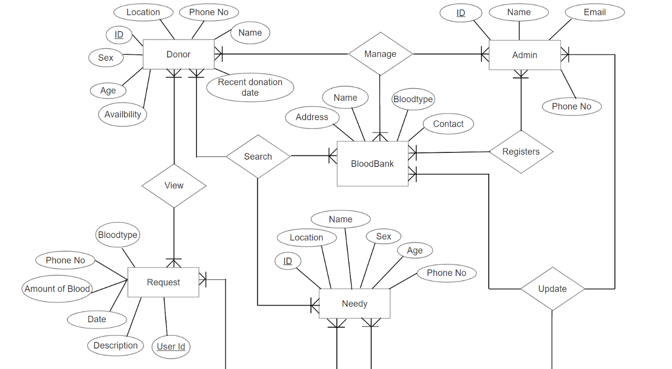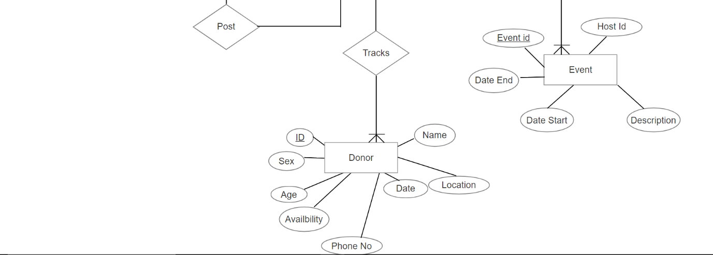

Fig 5.3: ER diagram

## 5.4 Flowchart

Start

Registration

Initialized Main Page

Login

Approve

New User

If Admin

Yes

No

-Manage Event

-Manage Blood bank Info

-Register Login for Blood bank

-View status

Yes

No

If

Bloodbank

If Donor

No

-View Request

-Update Announcement

-Edit Blood Availability

-Update Stack Info

Yes

-Edit availability

-View Announcement

-View Requests

-Search the donors and seekers

-View Announcement

-Search Donors

-Search Blood banks

-Make Requests

-Emergency Blood Request

-Edit Request

-View Donors near location

Fig 5.4: Flowchart of E-blood bank

## 5.6 Tools and Platform

1. **VS Code IDE**

Visual Studio Code is a streamlined code editor with support for development operations like debugging, task running, and version control that aims to provide just the tools a developer needs for a quick code-build-debug cycle and leaves more complex workflows to fuller featured IDEs such as Visual Studio IDE. Visual Studio Code is a lightweight but powerful source code editor which runs on your desktop and is available for Windows, macOS and Linux. It comes with built-in support for JavaScript, TypeScript and Node.js and has a rich ecosystem of extensions for other languages (such as C++, C#, Java, Python, PHP, Go) and runtimes (such as .NET and Unity).

1. **Flutter**

Flutter is Google’s UI toolkit for building beautiful, natively compiled applications for mobile, web, and desktop from a single codebase with features like fast development, expressive and flexible UI and native performance. Flutter’s hot reload feature helps you quickly and easily experiment, build UIs, add features, and fix bugs. Hot reload works by injecting updated source code files into the running Dart Virtual Machine (VM). After the VM updates classes with the new versions of fields and functions, the Flutter framework automatically rebuilds the widget tree, allowing you to quickly view the effects of your changes.

1. **Android Studio**

Android Studio is the fastest developer tool for building apps on every type of Android device with various exciting features such as visual layout editor, APK analyzer, fast emulator, intelligent code editor, flexible build system and real time profilers. Android Studio is the official integrated development environment (IDE) for Google's Android operating system, built on JetBrains' IntelliJ IDEA software and designed specifically for Android development. It is available for download on Windows, macOS and Linux based operating systems or as a subscription-based service in 2020. It is a replacement for the Eclipse Android Development Tools (E-ADT) as the primary IDE for native Android application development.

1. **Windows**

Microsoft Windows is a graphical operating system that provides a way to store files, run software, play games, watch videos and connect to the internet. It is a platform where we run our web application.

1. **Android**

Android is the platform where the flutter application can be run. It may be any android phones. When a device goes from just working to actually making life easier, Android is behind it. It’s the reason your GPS avoids traffic, your watch can text and your Assistant can answer questions. It’s the operating system inside 2.5 billion active devices. Everything from 5G phones to stunning tablets, Android powers them all. Android is open to everyone: developers, designers and device makers. That means more people can experiment, imagine and create things the world has never seen.

1. **SQLite 3**

SQLite 3 is a self-contained, file-based SQL database that comes bundled with python and can be used in any of your python applications without having to install any additional software. SQLite is an in-process library that implements a self-contained, server-less, zero-configuration, transactional SQL database engine. The code for SQLite is in the public domain and is thus free for use for any purpose, commercial or private. SQLite is the most widely deployed database in the world with more applications than we can count, including several high-profile projects.

SQLite is an embedded SQL database engine. Unlike most other SQL databases, SQLite does not have a separate server process. SQLite reads and writes directly to ordinary disk files. A complete SQL database with multiple tables, indices, triggers, and views, is contained in a single disk file. The database file format is cross-platform - you can freely copy a database between 32-bit and 64-bit systems or between big-endian and little-endian architectures. These features make SQLite a popular choice as an Application File Format. SQLite database files are a recommended storage format by the US Library of Congress. Think of SQLite not as a replacement for Oracle but as a replacement for fopen().

1. **Flask**

Flask is a micro web framework written in python that supports extensions that can add application features as if they were implemented in flask itself. Flask depends on the Jinja template engine and the Werkzeug WSGI toolkit. The documentation for these libraries can be found at:

* Jinja documentation
* Werkzeug documentation

1. **Python**

Python is an interpreted, high-level and general-purpose programming language that supports multiple programming paradigms including structured, object oriented and functional programming.

CHAPTER 6

# RESULTS AND DISCUSSIONS

## 6.1 Overview

As proposed earlier, our approach starts with creating a user friendly user interface for users in both platforms (i.e. mobile and desktop). We have tried three different approaches for calculating the distance between two geometric locations.

Our first approach included calculating distance between two points using normal distance formula. Since we needed the travelling distance in spherical surface (i.e. Earth), this initial idea was terminated.

Next, we had the perpendicular distance calculator (Spherical approach). This approach was satisfactory enough to give the distance between two points taking the curve surface of globe into consideration. But this approach also failed to give the travelling distance for humans. Since we do not navigate by air, we need a concrete approach to find the travelling distance between two points.

This is where the Geographical Distance Matrix Generator came in handy. This whole approach is made easy through google maps platform. Unfortunately, they charges certain amount for using their services.

Finally we came in conclusion to use the best available method (i.e. the Geographical Distance Matrix generator) to calculate the travelling distance between multiple geographical locations. This takes latitude and longitude of different destination points and a starting point as an input and calculates all the possible travelling distance between them. The users are prioritized in ascending order of the distance and hence further services of our E-Blood Bank system is proceeded

Further services includes the user interface design of the E-Bloodbank System. Users are authorized to post and view the blood requests posted by the needy. Also emergency contact numbers and blood bank contact information are saver available in the system.

## 6.2 Snapshots

Screenshots of the works done are as follows:

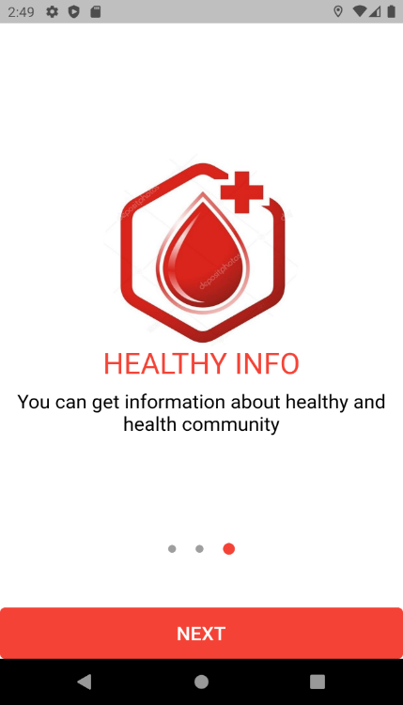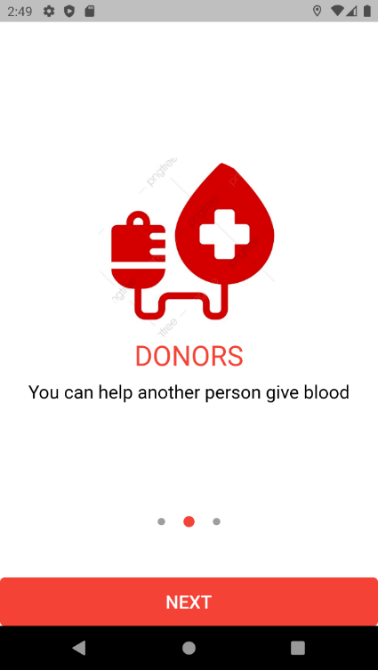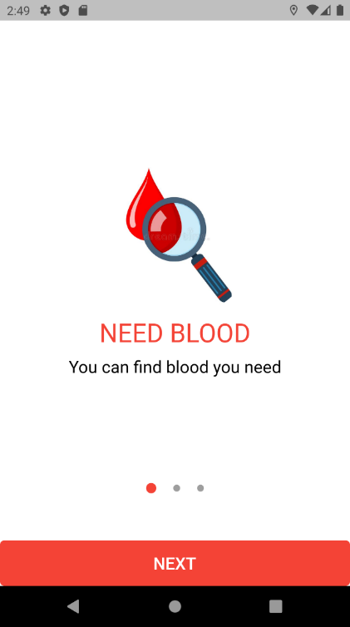

Fig 6.1.1: Flutter App Start Slider View

This is the starting of our flutter application that includes the slider view as shown in the above figures.

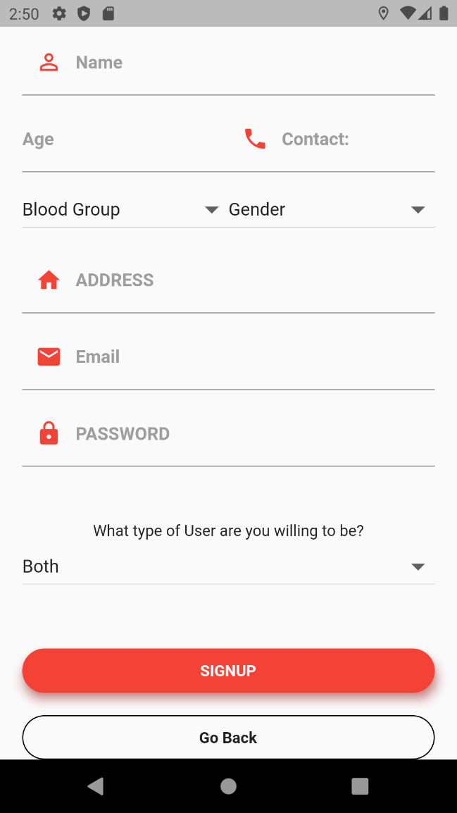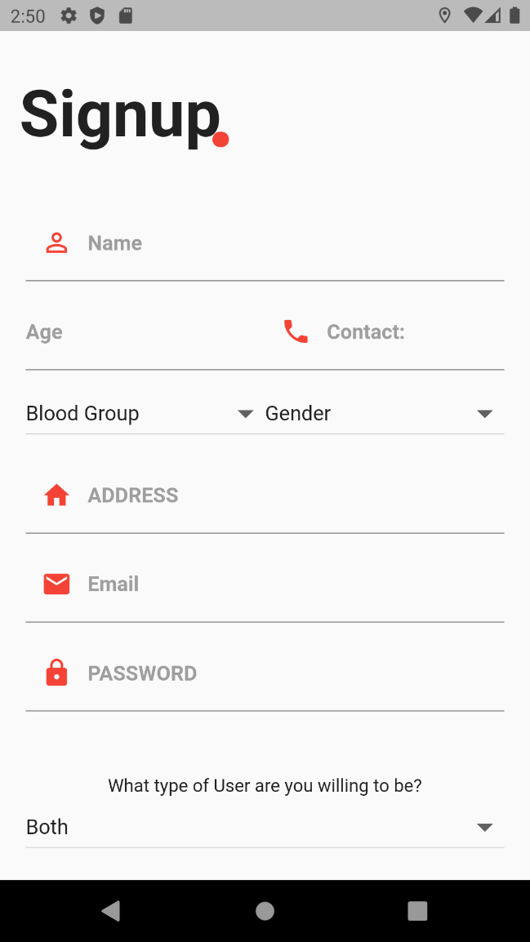

Fig 6.1.2: Flutter App Sign Up

This is a registration page for the users. We have provided registration for donor and needy through the app. The admin registration is temporarily removed in other to limit the super admins and focus on the other parts of the application as well. Also, the blood bank registrations authority is given to the admin only. This is done so to validate the events that are published in this app.

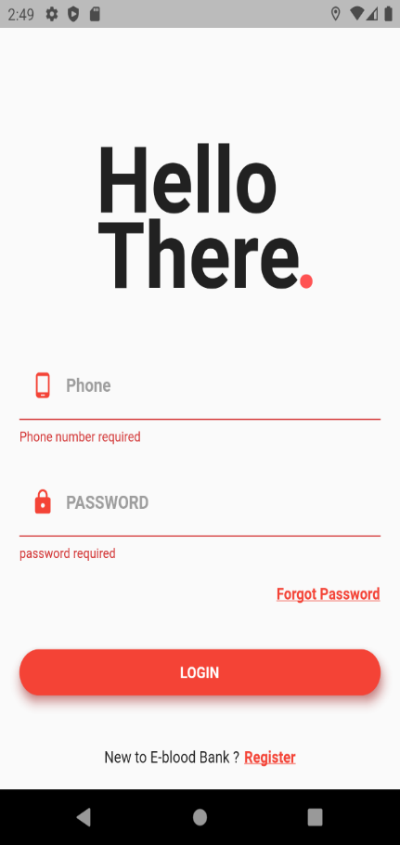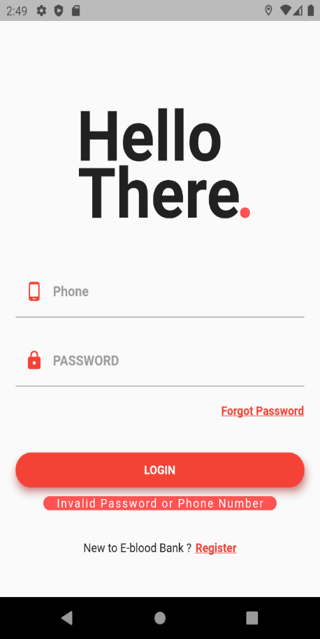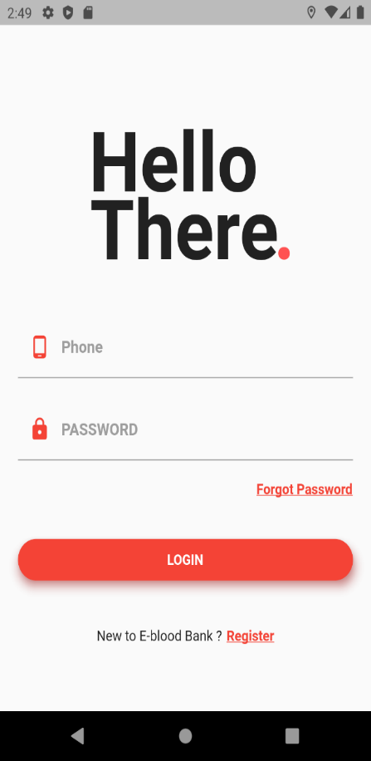

Fig 6.1.3: Flutter App Login

This is the login page where user login is provided. In other to use the app, user must first log into the system. The login is prioritized because we need the location of the device and user details to give efficient availability of donors during emergency search. In other to make the location and user unique, thi s page is provided. For any user to log into the system, one must be the registered user.

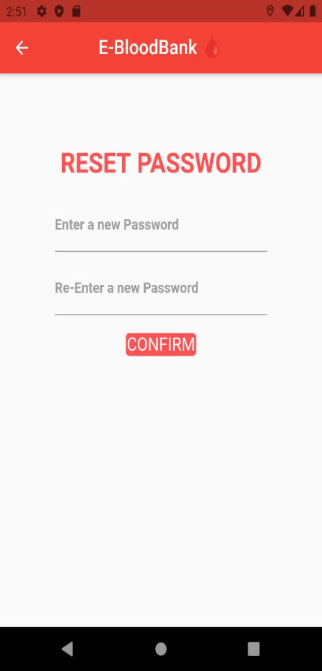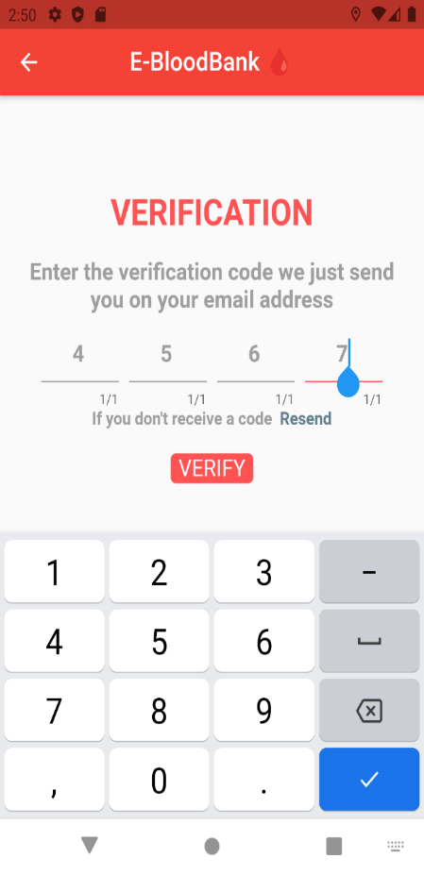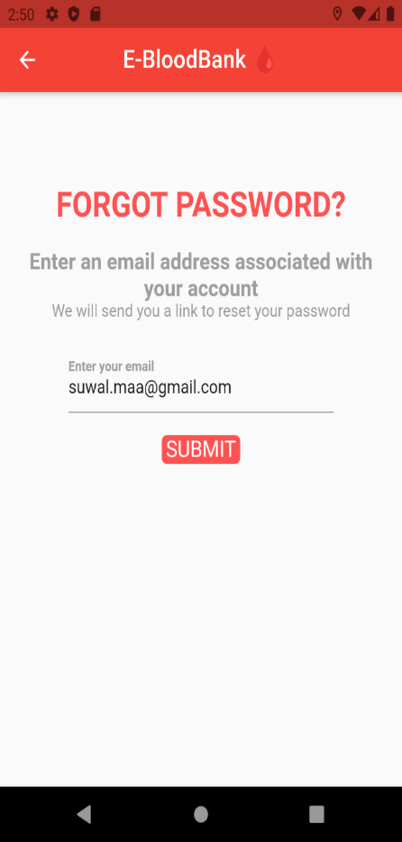

Fig 6.1.4: Password Reset via OTP code

The above shown figure is the forgot-password and password reset page where the user gets the OTP code through their email address. After the verification, the user can reset the password and assign a new password.

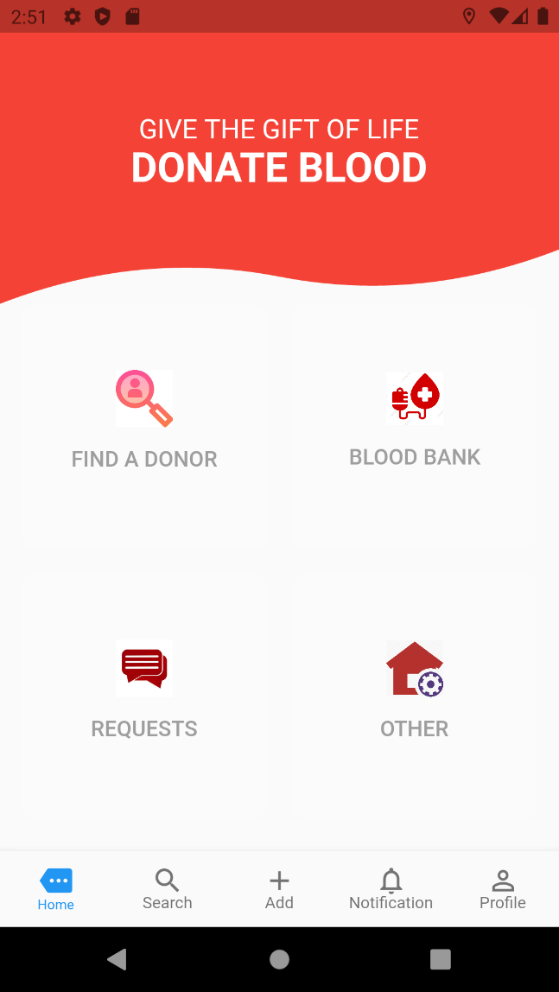

Fig 6.1.5: User Dashboard

This is the page displayed in the mobile application after the user login. Through this dashboard user is able to:

* Find the donors available
* Find blood banks near the user
* Post blood request
* Get ambulance and help line details etc.

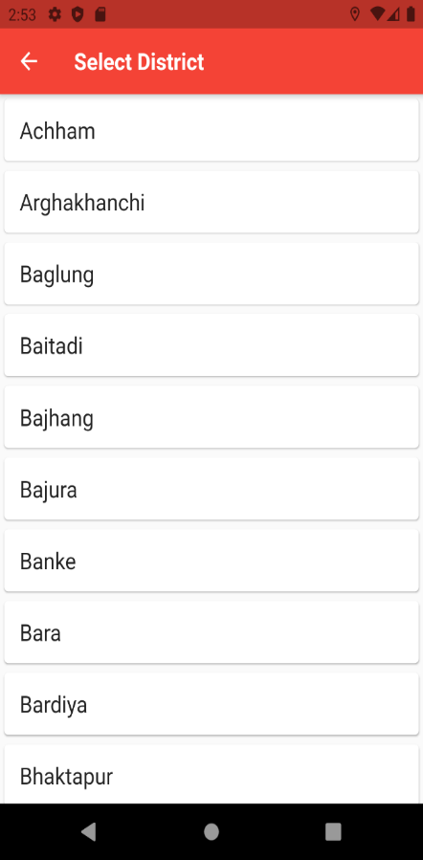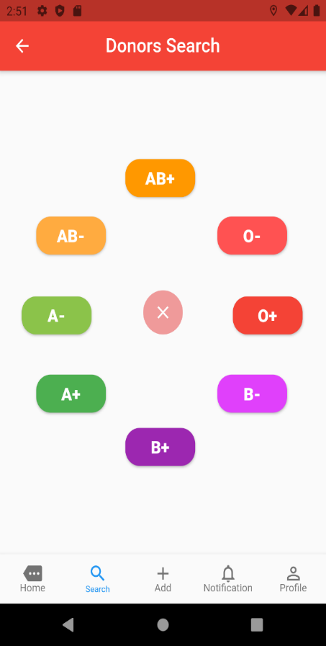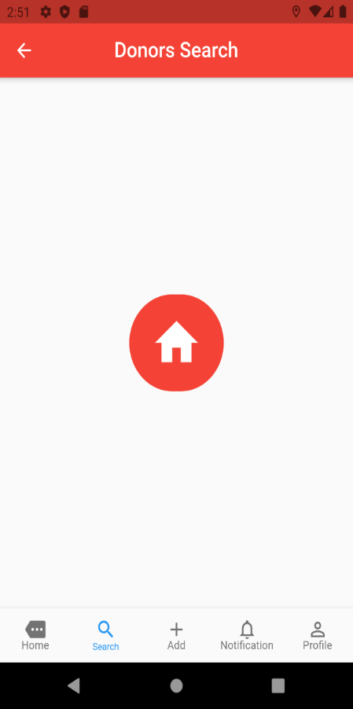

Fig 6.1.6: Search Donor by Blood group

The above figure shows the search donor by blood group page where any registered user can search the donors on the basis of blood groups and also the districts.

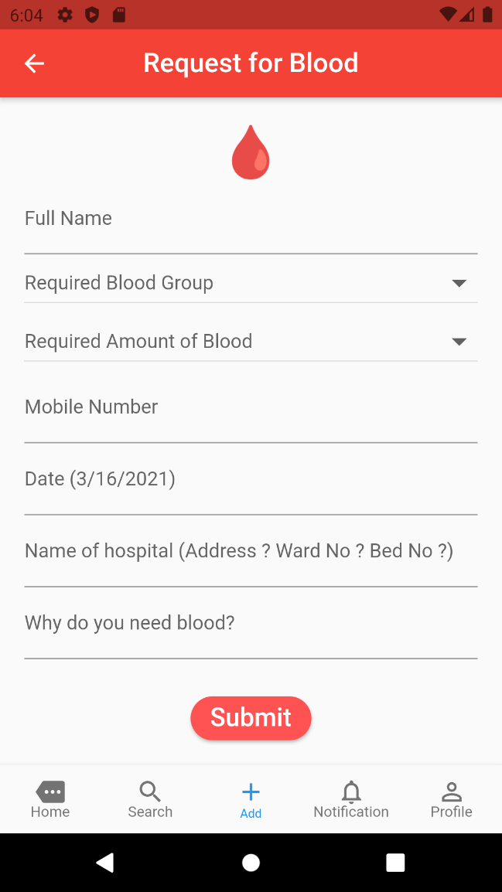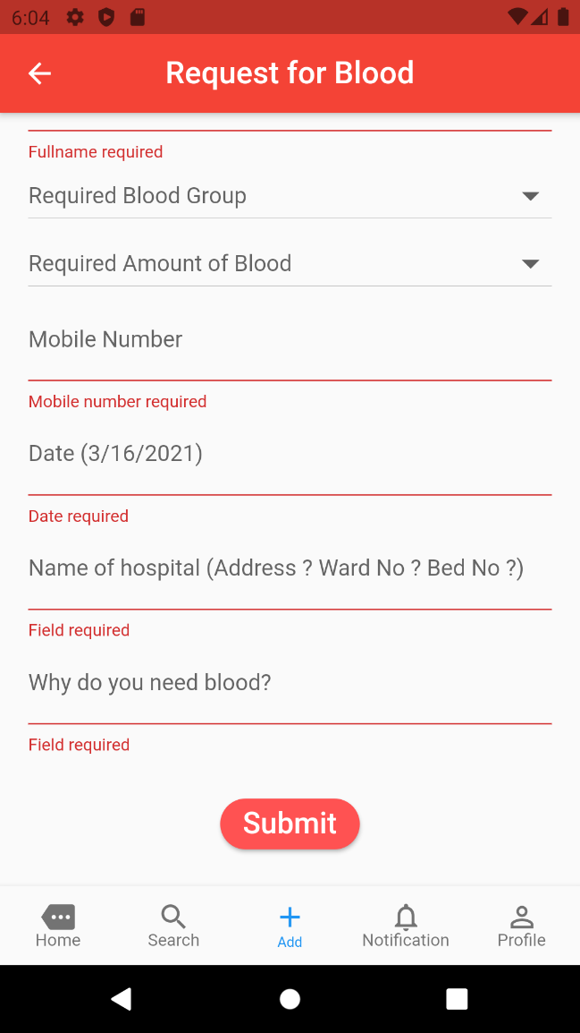

Fig 6.1.7: Request for blood

The above figure shows the request blood page from where any registered user can request for the required blood of any type with the valid reason.

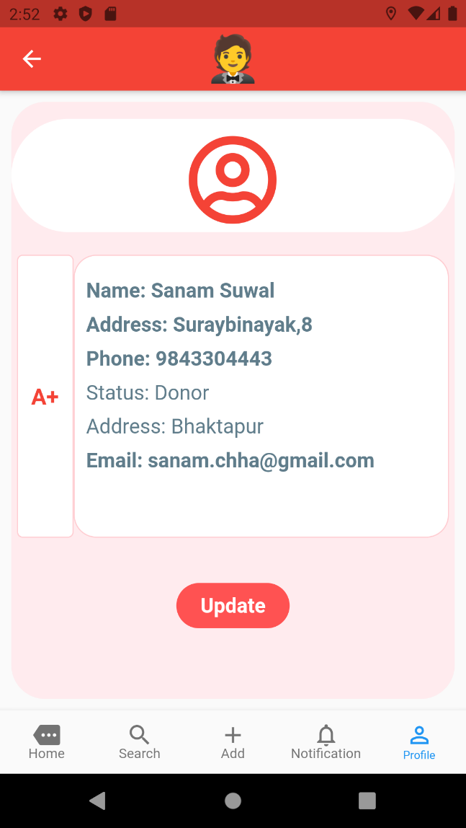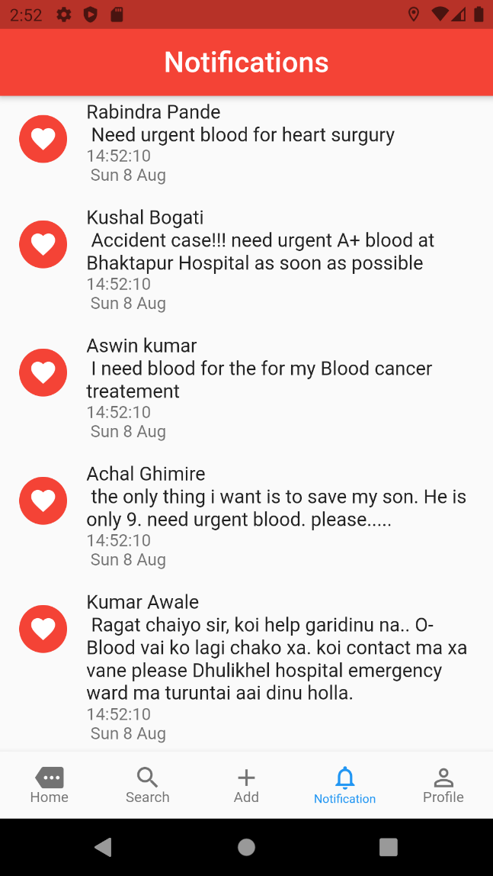Fig 6.1.8: Notifications and Donor Profile

The above figures shows the notifications and donor profile page for the users through which user can see the notifications, view their profiles and also update or edit their profiles.

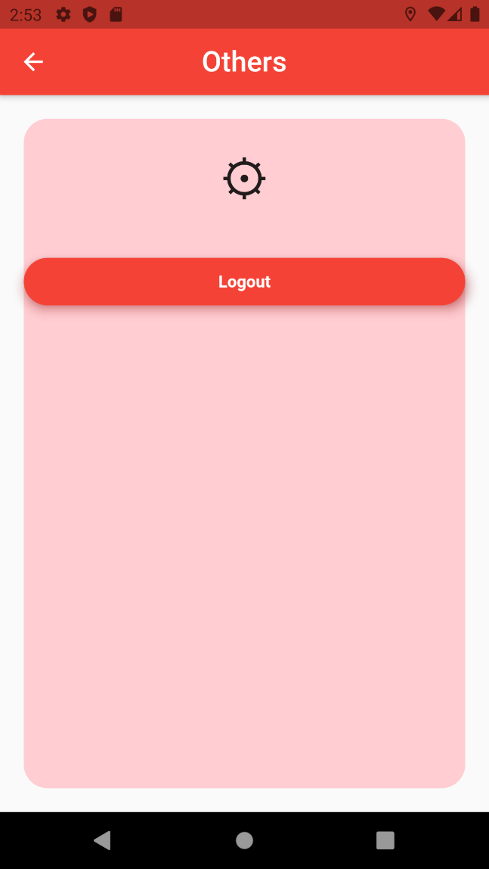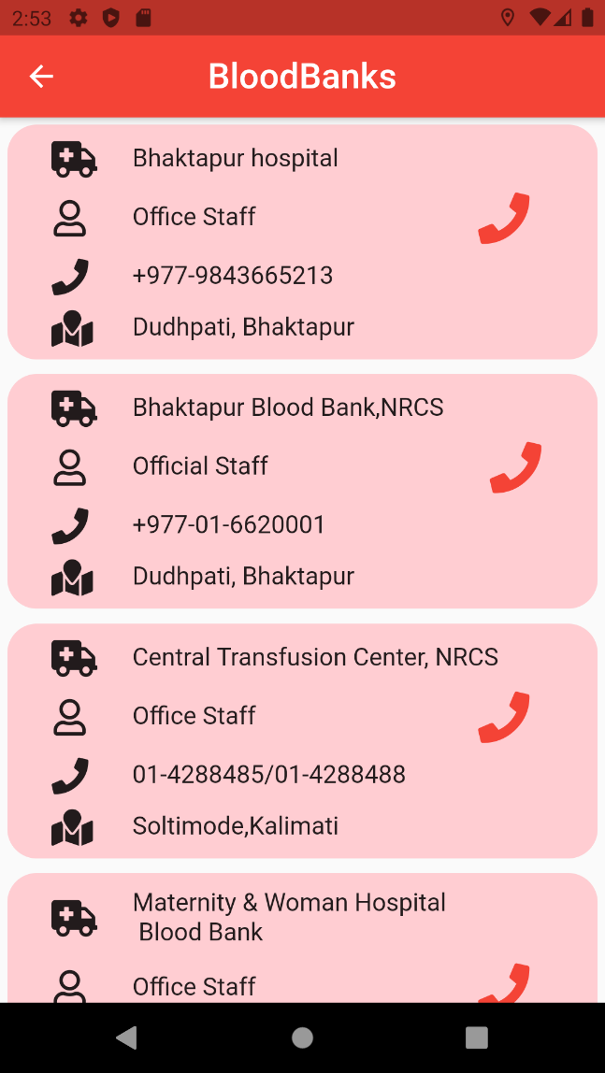Fig 6.1.9: Blood banks and Logout Page

The above figures shows the blood bank and logout page for the users through which users can get the information about the blood banks.

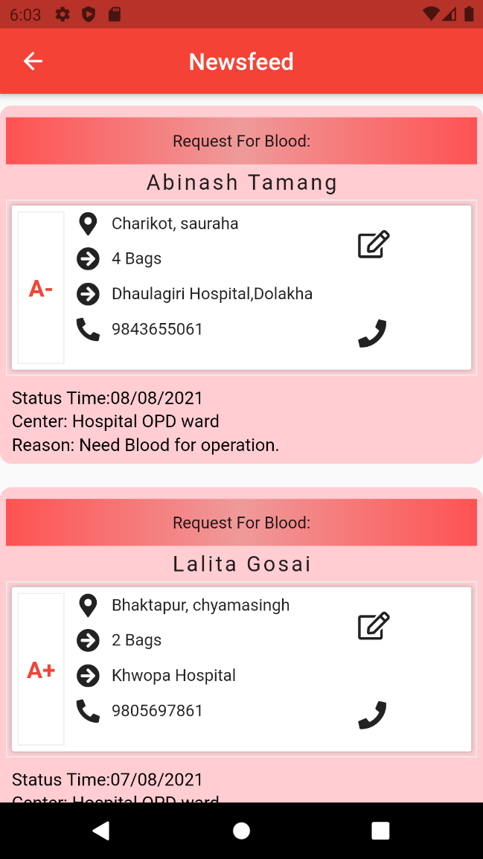

Fig 6.1.10: Newsfeed Page

The above figure shows the Newsfeed page for the users where the users can view, edit and also share their posts including their full name, contact, required number of bags of blood, type of blood along with the reason for blood, status time and center of the blood bank.

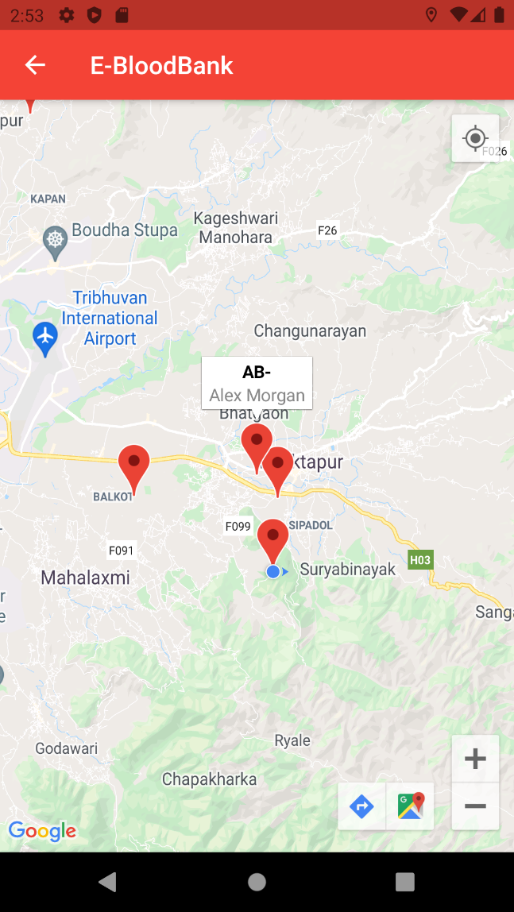

Fig 6.1.11: Google Map Navigation

This is the page showing current location of the user’s device. The location is tracked using the GPS enabled on the mobile device. For the location the permission is first asked as shown in the second screenshot. As the GPS of the device is changed the map location changes concurrently giving current location of the device all the time or recent active location of the device.

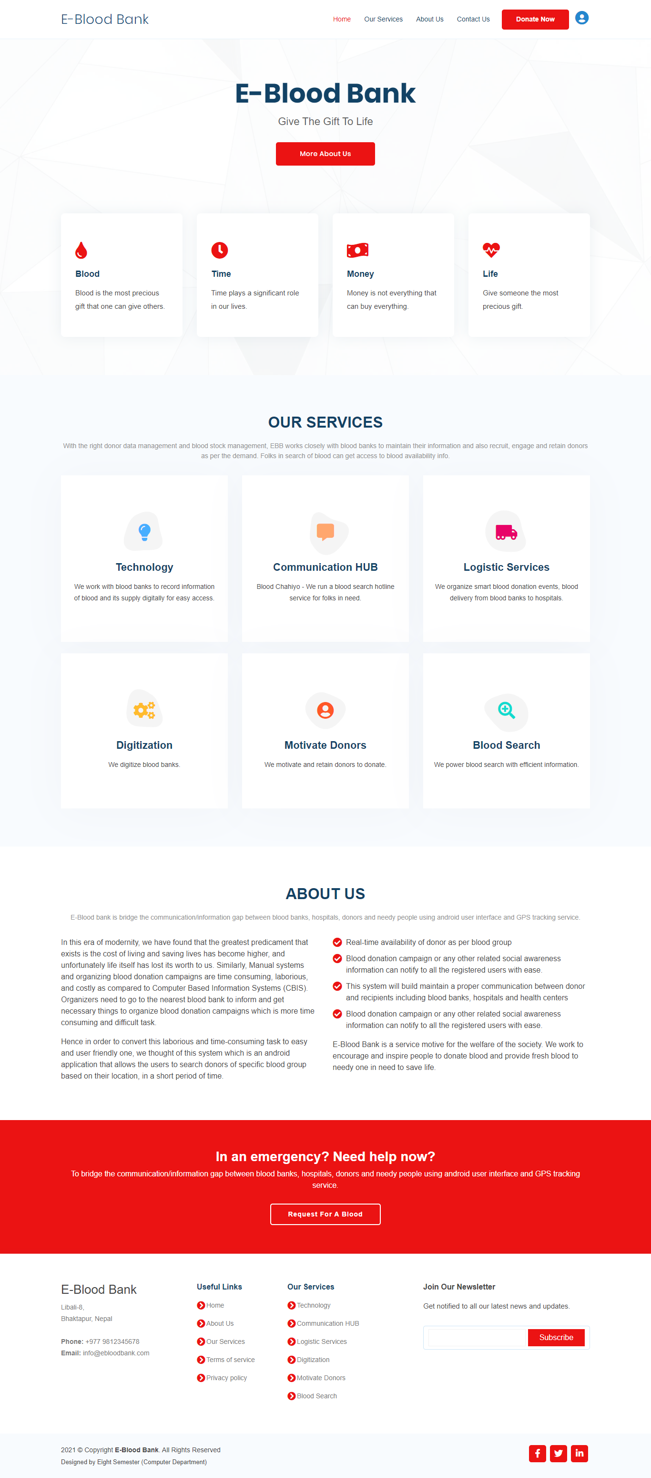

Fig 6.1.12: Web Homepage

This is the website homepage of our system (E-Blood Bank). This page simply addresses the services we provide, along with about us section and other useful links and call to actions.

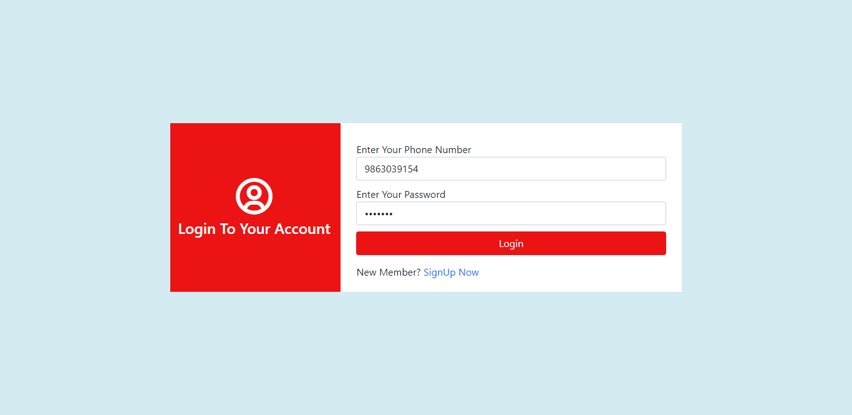

Fig 6.1.13: Web Login page

This is the login page that provide access to the authorized users. The credentials required to login is user’s phone number and password entered or provided to our system during registration.

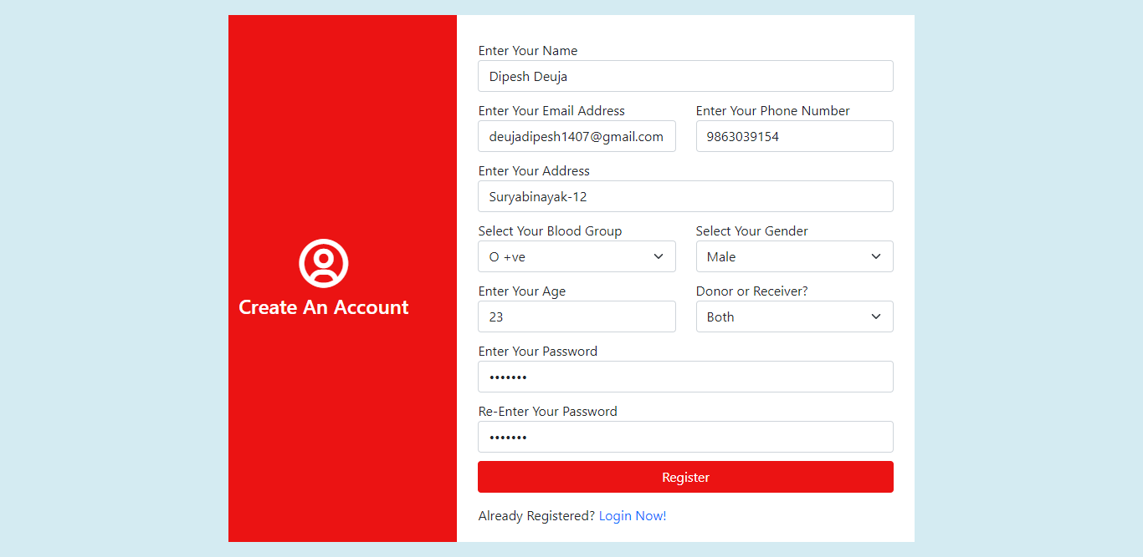

Fig 6.1.14: Web Registration page

This is the registration page that helps to create account in our system. The fields required for the registration process are user’s full name, email address, phone number, address, blood group, gender, age, user type (Donor, Receiver or Both) and password. The phone number and password set during the registration process is required during logging into the system.

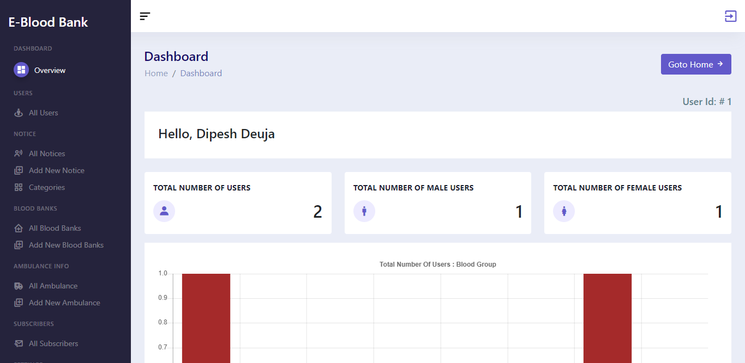

Fig 6.1.15: Web Dashboard

After the authorized users sign in to our system, they will be navigated to the dashboard. Some elements or data are only accessible or visible to the admin, likewise, total number users and other user stats and graphs. Also, admin can add and manage blood banks info, ambulance info and can publish the notice as well. Other normal users can only access their profile and view the blood bank, ambulance info as well as can read the notice published by the admin.

CHAPTER 7

# CONCLUSION AND RECOMMENDATIONS

## 7.1 Conclusion

Finally, we were able to build a system which is an android application as well as a web application that connects the blood needy and honest blood donors of our community. This system allows the users to search and notify donors of specific blood groups based on their location as quickly as possible. Both the android and web application shares the same database through a flask API. This application not only displays the list of donors but also facilitates tracking the location of the nearby donors.

This system uses a distance matrix to calculate the shortest traveling distance between the available app users within a given range. With this, the users can be notified about health-related events such as blood donation campaigns. This system assists in the process of blood donation whenever required the most. It consists of an application interface for the users of the system and it also uses a database for storing the donor’s data, blood bank details, and hospital details. It tracks the location of the donors through the (Global Positioning System) GPS, identifies the donors who are available nearby the location of the requester, and notifies them about the urgency. Users are provided with a catchy User Interface (UI) for registration and posting the blood requests. The registration validation is done manually by the admin. Validated users can use the full features of the system. Location is tracked to locate the donors and notify the users about the events near them.

## 7.2 Future Recommendations

Further Enhancements of the system can be given in following points:

* Use of online direction API in order to show the traveling path with fewer traffic. The updates of live traffic feed will help to avoid the routes with traffic jams and non-casual events.
* Can be improvised to embed pulse tracker
* SOS feature can be added that will notify the user’s relatives if any irregularities in pulse is detected

REFERENCES

**Research Papers:**

[1] Shirsath, K., Wagh, S. and Risodkar, P., 2020. Blood Bank Connect Android Application. International Journal for Research in Engineering Application & Management, pp.168-171.

[2] Vikas Bhingare, Sagar Dhangare, Pradip Gorade, Dipak Kathar , Bhagwan Kurhe., 2018. Blood Donor Tracker By using GPS. International Journal for Research in Engineering Application & Management, Vol-4 Issue-2 2018

[3] Nur Fatini Zahidah Binti Zakaria, Zulhafiza binti Zainal Abidin, Muhammad Asyraf bin Abdullah Zawawi. Bloodbuddy: a Tracking System for Blood Donor Using GPS. Journal of Engineering, Technology & Applied Science 2020, 2(2): 86-102

[4] Shubham Pande, Shweta Mate, Pradnya Mawal, Ayusha Jambulkar, Prof. N. S. More. E-Blood Bank Application Using Cloud Computing. Department of Information Technology, Smt. Kashibai Navle College of Engineering ,India, Volume: 05 Issue: 02 | Feb-2018

[5] R. Suchitra, M. Lalithya Sannitha, J. Ravikanth, G. Anusha & B. Abhilash, Assistant Professor, Location_Based_Online_Blood_Bank_System, Department of CSE, Lendi Institute of Engineering and Technology, Vizianagaram, India, Vol. 3, Issue 4, Apr 2019,pp. 1-4

[6] Mange, M. and Shaikh Mohammad, B., 2020. Online Blood Bank Management System Using Android Application. SSRN Electronic Journal,.

[7] tamberger, L., Riper, C. J., Keller, R., Brownlee, M. & Rose, J. (2018). A GPS Tracking Study of Recreationists in an Alaskan Protected Area. Applied Geography, 93: 92-102. doi:10.1016/j.apgeog.2018.02.011

[8] PORTAL MyHEALTH. 2020. Blood Donation - PORTAL Myhealth. [online] Available at: <http://www.myhealth.gov.my/en/blood-donation/> [Accessed 12 December 2020].

[9] Korpilo, S., Virtanen, T. & Lehvävirta, S. (2017). Smartphone GPS Tracking—Inexpensive and Efficient Data Collection on Recreational Movement. Landscape and Urban Planning, 157: 608-617. doi:10.1016/j.landurbplan.2016.08.005.

[10] Adle, A., Galpern, P. & Doyle-Baker, P. (2018). Measuring the Use of Green Space with Urban Resource Selection Functions: An Application Using Smartphone GPS Locations. Landscape and Urban Planning, 179: 107-115.

[11] Alpern, P., Ladle, A., Uribe, F. A., Sandalack, B. & Doyle-Baker, P. (2018). Assessing Urban Connectivity Using Volunteered Mobile Phone GPS Locations. Applied Geography, 93: 37-46. doi:10.1016/j.apgeog.2018.02.009.

[12] Ardy, J., Veinot, T. C., Yan, X., Berrocal, V. J., Clarke, P., Goodspeed, R. & Vydiswaran, V. V. (2018). User Acceptance of Location-Tracking Technologies in Health Research: Implications for Study Design and Data Quality. Journal of Biomedical Informatics, 79: 7-19. doi:10.1016/j.jbi.2018.01.003.

[13]_Blood_Donation_Notification_System_Based_on_Donor's_Location_Using_Haversine

_Formula

[14] International Journal of Engineering and Advanced Technology (IJEAT) ISSN: 2249-

8958, Volume-9 Issue-2, December, 2019

**Websites:**

[1] (2017, October 10). Find-a-Donor. <https://www.behance.net/gallery/66760809/Find-A-Donor>

[2] *Blood bank management system*. (2021, March 21). Blood Bank Management System. https://t4tutorials.com/blood-bank-management-system-project-android-mobile-app-project-final-year-projects-for-csseit/