**PURBANCHAL UNIVERSITY**



**DEPARTMENT OF COMPUTER ENGINEERING**

**KHWOPA ENGINEERING COLLEGE  
LIBALI-8, BHAKTAPUR**

**A MID DEFENSE REPORT**

**ON**

**E-Blood Bank**

A project Mid-Defense submitted for the partial fulfillment of requirements for the degree of Bachelor of Engineering in Computer Engineering (Eighth Semester)

**SUBMITTED BY:**

Dipesh Deuja (730314)

Kareena Bade (730318)

Sanam Suwal (730334)

Sujata Shrestha (730344)

**Under the Supervision of**

Er. Suresh Ghatuwa

**SUBMITTED TO:**

DEPARTMENT OF COMPUTER ENGINEERING

KHWOPA ENGINEERING COLLEGE

15th March 2021

Acknowledgement

Firstly, we deem it a pleasure to acknowledge our sense of gratitude to the department of Computer Engineering for providing us a strong academic atmosphere and the opportunity to explore our ideas and skills beyond the academic syllabus through the project.

We take this opportunity to express our deepest and sincere gratitude to our HoD Er. Rina Manandhar, for her insightful advice, motivating suggestions for this project and also for her constant encouragement and advice throughout our Bachelor’s program. We are deeply indebted to our DHoD Er Bikash Chawal for providing valuable suggestions and for supporting the project.

Also, we would also like to reciprocate our gratitude towards all the lecturers who have supported through the project with their ideas and friends who have cooperated in our projects with their different views.

Finally, we would like offer our sincere thanks to our supervisor **Er. Suresh Ghatuwa** for boosting our efforts and moral by his valuable advises and suggestion regarding the project, giving us realization of the practical scenario of the project and supporting us in tackling various difficulties.. His incisive, guidance and timely advice encouraged us to complete the project with constant flow of energy throughout the entire project despite of his busy schedule.

**Group Members**

1. Dipesh Deuja (730314)

2. Kareena Bade (730318)

3. Sanam Suwal (730334)

4. Sujata Shrestha (730344)

ABSTRACT

Usually, Blood banks suffer frequent shortage of blood and hence, advertisements are frequently seen on social networks urging healthy individuals to donate blood for patients who urgently require blood transfusion. So, in order to reduce this problem in case of emergencies, we have proposed this project titled “E-Blood Bank” which is an Android application as well as web application that allows the users to search and notify donors of specific blood group based on their location, in a short period of time. Both the android and web application shares the same database through a flask API. This application will not only display the list of donors but also facilitated with tracking the location of the nearby donors. We are aiming to include SMS and email services for the donors when the request is generated for blood. Online Blood Bank (OBB) System assists in the process of blood donation whenever required the most. It consists of an application interface for the users of the system and it also uses database for storing the donor’s data, blood bank details and hospital details. It includes algorithm which detects accurate location of the donors, identifies the donors who are available nearby to the location of requester and notifies them. In order to donate blood through the app, one has to register himself by providing all the required details. These details must be valid and true so that they can be tracked at the time of emergency. When all the information is accepted by the Admin, the donor will be further to the list of registered donors. GPS module is included in order to locate the donors. Thus, only registered members, who want to donate blood, are able to access the service.

Keywords: *E-Blood Bank, GPS, Android Application, API, webapp, shortest path.*

Table of Content

Acknowledgement i

ABSTRACT ii

Table of Content iii

List of figures iv

List of abbreviation v

CHAPTER 1 1

INTRDOUCTION 1

1.1 Background 1

1.2 Motivation 2

1.3 Statement of Problems 2

1.4 Objectives 2

1.5 Our Approach 2

1.6 Scope 2

CHAPTER 2 3

LITERATURE REVIEW 3

CHAPTER 3 5

PROJECT MANAGEMENT 5

3.1 Project Member Information 5

3.2 Feasibility Study 5

CHAPTER 4 7

METHODOLOGY 7

4.1 Context Diagram 7

4.2 Use-Case Diagram 8

4.3 ER Diagram 9

4.4 Flowchart 10

4.5 Our approach 11

4.6 Tools and Platform 13

CHAPTER 5 14

5.1 Work Done 14

5.2 Work to be done 19

REFERENCES 20

List of figures

|  |  |  |  |
| --- | --- | --- | --- |
| **Fig No.** | **Fig Name** |  | **Page No.** |
| 4.1 | Context Diagram |  | 7 |
| 4.2 | Use case Diagram |  | 8 |
| 4.3 | ER diagram |  | 9 |
| 4.4 | Flowchart of E-blood bank |  | 10 |
| 5.1.1 | Flutter App Sign Up |  | 11 |
| 5.1.2 | Flutter App Login |  | 12 |
| 5.1.3 | User Dashboard |  | 13 |
| 5.1.4 | Google Map Navigation |  | 14 |
| 5.1.5 | Web Dashboard |  | 15 |
| 5.1.6 | User Registration in Webpage |  | 15 |

List of abbreviation

|  |  |
| --- | --- |
| GPS | Global Positioning System |
| SGT | Smartphone GPS tracking |
| CBIS | Computer Based Information Systems |
| GUI | Graphical User Interface |
| UPSI | Universiti Pendidikan Sultan Idris |
| API | Application Programming Interface |
| OBB | Online Blood Bank |

CHAPTER 1

# INTRDOUCTION

## 1.1 Background

Blood Donation is one of the most significant contributions towards the society. Millions of people need blood transfusions each year. Some may need blood during surgery and others depend on it after an accident or because they have a disease that requires blood components. Blood can be donated by two means [8]; whole blood donation and apheresis donation. Currently, the world depends on technology and everyone from the young to the old seem to be deeply involved. Due to rapid development of technology, it plays a significant role in the modern life of people and it’s an important element in today’s society.

In existing system, it is time consuming to provide request with the blood when in need and it just alert on donation eligibility and blood donation sites location navigation. The existing system also provides information on the upcoming events that will take place in National Blood Center through push messages and event notification. This give pries the need of such system which is available to everyone and can be used for blood management. The proposed system is a way to handle blood management and provide to hospital with blood in emergency in shortest time possible. This system will locate the nearest blood donor in cases of emergencies and in fastest way. At the same time, the admin (user) of the system analyze the blood donor details such as type of blood will notify the blood donor. The proposed system is a way to handle blood management and provide blood in emergency in shortest time possible.

**Location Tracking:** A location tracking system is a well-established technology in this era which is very safe and reliable technology. It detects the current geolocation of a target, which may be anything from a vehicle to an item in a manufacturing plant to a person. A GPS navigation device built into your car or a smartphone with a GPS chip. Using GPS enabled mobile phone (smartphone) to collect route data is another relatively new but rapidly advancing technique used in research [9]. It have significantly increased the frequency and quality of available spatio- temporal data [10]. In urban settings, smartphone GPS tracking has been employed mainly in transportation and mobility studies. GPS can pinpoint a device's location with accuracy and by comparing coordinates, the statistics can be used to calculate a devices direction of movement and speed. In this case, location data can be recorded at one minute intervals, and each location is tagged with corresponding estimate of accuracy [11]. Smartphones and tablets is use on a regular basis day. One of the best features for using GPS tracking system is that it is compatible with mobile phones, and easy to use as other application on mobile phone. It has been suggested that newer consumer-oriented technologies such as smartphone and wearable activity tracker might address these challenges. Moreover, such devices are intuitively appealing since users already use them and thus may remember to use them more easily [12] The data collection approach presented here is cost effective, accessible and user-friendly as participant use their own smart phone and do not need to carry a GPS logger or download a specific software application [9]. This significantly reduces investments cost, the potential loss of the research equipment and the need for training for participation. However, there is limitation of using mobile phones (smartphone) such as battery life and skepticism about using personal phones for research [7].

One of the current technologies being used is location tracking. A tracking system is a well- This study is aim to develop and evaluate the impact of tracking system in the blood shortage situation which is the urgent requirement of the fresh blood.

## 1.2 Motivation

In this era of modernity, we have found that the greatest predicament that exists is the cost of living and saving lives has become higher, and unfortunately life itself has lost its worth to us. Similarly, Manual systems and organizing blood donation campaigns are time consuming, laborious, and costly as compared to Computer Based Information Systems (CBIS). Organizers need to go to the nearest blood bank to inform and get necessary things to organize blood donation campaigns which is more time consuming and difficult task. Hence in order to convert this laborious and time-consuming task to easy and user friendly one, we thought of this system which is an android application that allows the users to search donors of specific blood group based on their location, in a short period of time.

## 1.3 Statement of Problems

* Unavailability of blood during emergency
* Even willing donor can’t reach to the place where blood is needed due to lack of communication or information
* Blood donation announcement in social media has not been too effective

## 

## 1.4 Objectives

The objective of this project is:

* To bridge the communication/information gap between blood banks, hospitals, donors and needy people using android user interface and GPS tracking service.

## 1.5 Our Approach

Our approach is to develop a network of helpful hands in need through an android application that allows the users; Recipient: to search or locate the donors of specific blood group and Donors: to find the place where there is need of his/her blood group, based on their location with the help of GPS module.

## 1.6 Scope

* Real-time availability of donor as per blood group.
* Willing person can donate where needed which fulfills any shortage in blood bank.
* Blood donation campaign or any other related social awareness information can notify to all the registered users with ease.
* This system will build maintain a proper communication between donor and recipients including blood banks, hospitals and health centers.

CHAPTER 2

# LITERATURE REVIEW

Blood is one of the most critical elements and its truly referred to as river of life. Blood donation is one of the most significant contributions towards the society. Millions of people need blood transfusions each year. There are number of emergency situation where urgent blood is required. As we moved forward to our research saw many programmers has also realized the same thing and contributed their part for the society.

In one of the papers, a group of programmers had proposed a technique of Blood Bank Automation using Android application in which blood inventory will be managed and automated on line. In this application the administrator accesses the whole information about blood bank management system related to donor. User can quickly check for blood banks or hospitals in the emergency situation you can find the matching of particular or related blood group and reach to the particular location through the App. Through this app user can get the list of blood banks in nearby area [1].

Next, the project Android Blood Bank system is developed so that users can view the information about registered blood donors and receiver such as name, address, and other such personal information along with their details of blood group and other medical information of donor and receiver. The proposed system also has a login page where in the user is required to register and only then can view the availability of blood and may also register to donate blood if he/she wishes to. This proposed system requires internet access continuously. Thus, this application helps to select the right donor online instantly using medical details along with the blood group. The main aim of developing this application is to reduce the time to a great extent that is spent in searching for the right donor and the availability of blood required. Thus, this application provides the required information in no time and also helps in quicker decision making. The project Android Blood Bank system is developed so that users can view the information about registered blood donors such as name, address, and other such personal information along with their details of blood group and other medical information of donor. The project also has a login page where in the user is required to register and only then can view the availability of blood and may also register to donate blood if he/she wishes to [2].

This next study aims to develop and evaluate the impact of tracking system in the blood shortage situation which is the urgent requirement of the fresh blood and to improve the communication between the hospital and donor. This system locates the nearest blood donor in cases of emergencies in fastest and easiest way using GPS. The findings on the views of user on the aspects of interface design, navigation and functionality of the web-based application that is developed are presented. Data analysis was done based on the questionnaire received from few users which are student from Universiti Pendidikan Sultan Idris (UPSI). The findings of this study were analyzed according to the objectives and the research questions of the project. Keywords: Blood Donation, Tracking System, GPS [3].

The next one is E-Blood Bank is an Android application which allows the user to search donors of specific blood group based on their location, in a short period of time. This application will not only display the list of donors but also facilitated with tracking the location of the nearby donors and providing SMS alerts to them, so that the patient can be served with blood soon. In order to donate blood through the app, one has to register himself by providing all the required details. These details must be valid and true so that they can be tracked at the time of emergency. When all the information is accepted by the Admin, the donor will be further to the list of registered donors. GPS module is included in order to locate the donors. Thus, only registered members, who want to donate blood, are able to access the service. Cloud- based services are proved very vital in urgent blood delivery as they care able to central and immediate access to donor’s data and location from anywhere and anytime [4].

Location Based Online Blood Bank System using Global Positioning System and nearest neighbor algorithm used for primary blood transfusion services. The main aim is to provide fast and efficient way to gain attention of potential donors in the need of hour. We are including SMS and email services such that the donors can locate the requires when the request is generated for blood. Online Blood Bank (OBB) System assists in the process of blood donation. It consists of an application which is present on the donor’s website which acts as an interface for the users of the system and it also uses database for storing the donor’s data, blood bank details and hospital details. If there is need of blood, the donor with the required blood group is identified and notified of the requirement. It includes algorithm which detects accurate location of the donors, identifies the donors who are available nearby to the location of requester and notifies them. By creating an online location-based web-portal where blood banks and hospitals can look for donors in their nearby area who will be available in quick time. And also keep record of donor’s health report to evaluate quickly [5].

Online Blood Bank Management System Using Android Application mainly compromises of things which includes price variations along with stock handlings, increase in blood types which may lead to increase in human blood infrastructure and categories to be managed. This project is developed with an aim where users can view the knowledge of nearby hospitals, blood banks and also the three important perspectives which includes the hospital, blood bank and patient/donor. This system is provided with security authentication where users have to login if already registered or as a brand-new user must register per their form of perspective. This project requires internet connection so as to fulfil the necessities. The system will confirm that just in case of need, the blood is made available to the patient. This paper is targeted on Online Blood Donation Management System which is an android application with supporting mobile application aimed to function a communication tool between patients (who need blood) and donor [6].

CHAPTER 3

# PROJECT MANAGEMENT

In order to design this **E-Blood Bank**, first we will design the conceptual concept. We will draw the flow of program on the basis of the so generated concept. And we will design the program on the basis of these concepts.

## 3.1 Project Member Information

For this project, we have a group of four members:

|  |  |
| --- | --- |
| **Name** | **Roll No.** |
| Dipesh Deuja | 730314 |
| Kareena Bade | 730318 |
| Sanam Suwal | 730334 |
| Sujata Shrestha | 730344 |

## 3.2 Feasibility Study

3.2.1 Technical Feasibility

We have used SQLite3 for the server from where most part of the data management tasks are carried. And for the closest donor response we have intended to use the Dijkstra Algorithm after pin pointing the available location of donor with required blood group. Simple location (i.e. latitude and longitude) will be provided as input from the device which is then processed through the algorithm giving the nearest donor details and location in time of blood urgency. So, we can conclude this project as a feasible one.

3.2.2 Operational Feasibility

We intend to develop an android application with a flutter framework for front end and a python as a backend for the algorithm use and data management in server. Also, we have used the Geolocation tracking services from user’s mobile device in other to track the exact location of the user whenever needed. By far, we have created both android and web interface with current moving location tracking of the user device and of course with user’s permission.

3.2.3 Economic Feasibility

The total expenditure if the project is in computational power. For computational power, we used Intel core i5 9th generation PC that were available to us. For smooth running of the android application we had to use RAM more than 6GB to run an android emulator. But after deploying the application any user with android version greater than 4.0 will be able to run and use this app smoothly. So, the project is economically feasible.

3.2.4 Scheduling Feasibility

Schedule we have managed to meet the deadline of project is mentioned in Gantt chart. Here is proper management of time as we can for this project is done. We have given almost top priority for the User Interface design and the algorithm optimism by the help of which any blood needy will be able to find the closest donors. Documentation remains as important as any other task so throughout the whole project documenting each and every work will be continued. For this in every week we have developed the weekly report and in every meeting, minutes of that particular meeting is taken for the works to be done in next week. Thus, within our time management skill we are ensured this project will be schedule feasible.

CHAPTER 4

# METHODOLOGY

For developing E-Blood Bank, various phases and methods will be proceeded with the help of various software, tools and programming languages. We do have planned to initiate our work in a prototyping model so all the worst-case scenarios are well traversed first and to utilize best fit parameters.

We plan to design the application that is accessible to not only hospitals but all the users. Since GPS tracking is previously purposed, we will be trying to use travelling sales man problem to find the nearest blood donor location. Tracking the blood donor through navigation will help predicting the time to reach and the donor who takes shortest time during emergencies would be prioritized first during the emergency demand mode.

In our project, we will develop a mobile application using Flutter and use GPS to track all the users and the locations.

## 4.1 Context Diagram

Fig 4.1: Context Diagram

## 4.2 Use-Case Diagram

Fig 4.2: Use case Diagram

## 4.3 ER Diagram

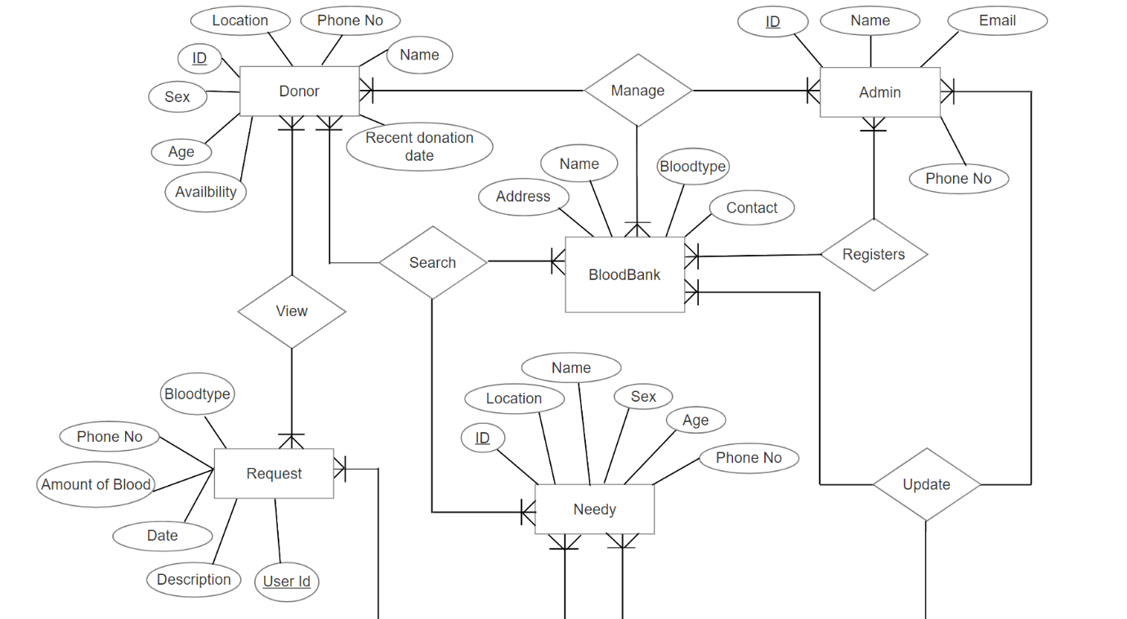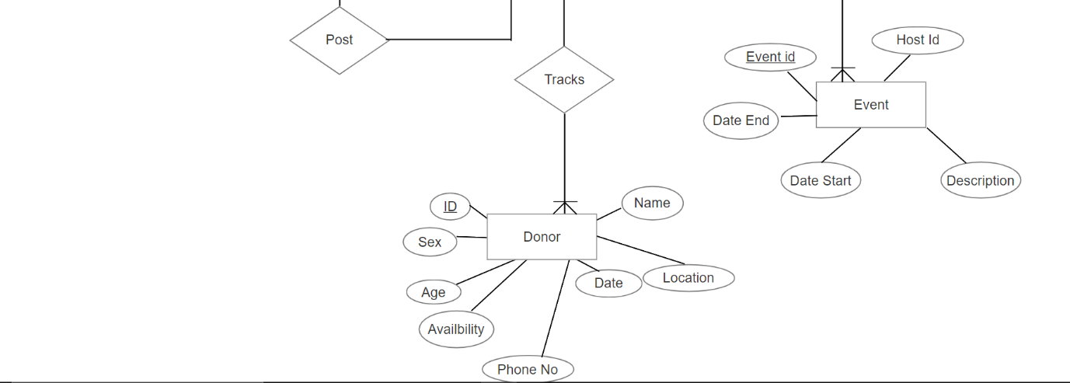

Fig 4.3: ER diagram

## 4.4 Flowchart

Start

Registration

Initialized Main Page

Login

Approve

New User

If Admin

Yes

No

-Manage Event

-Manage Blood bank Info

-Register Login for Blood bank

-View status

Yes

No

If

Bloodbank

If Donor

No

-View Request

-Update Announcement

-Edit Blood Availability

-Update Stack Info

Yes

-Edit availability

-View Announcement

-View Requests

-Search the donors and seekers

-View Announcement

-Search Donors

-Search Blood banks

-Make Requests

-Emergency Blood Request

-Edit Request

-View Donors near location

Fig 4.4: Flowchart of E-blood bank

## 4.5 Our approach

We plan to design the application that is accessible to not only hospitals but all the users. Since GPS tracking is previously purposed, we will be trying to use travelling sales man problem to find the nearest blood donor location. Tracking the blood donor through navigation will help predicting the time to reach and the donor who takes shortest time during emergencies would be prioritized first during the emergency demand mode.

The user has to provide which blood group he requires so that only those blood banks and donors are plotted on the map. The location of blood bank will be retrieved from Google API and the location of donor will be his current location and it will be retrieved using Google API. Now, we have also provided a facility for the users that they can select their location via from registered location, current location and provided location. To select the provided location he has to plot this location on map with help of plotter instead of typing the entire address. The distance between the user and each blood bank or each donor will be calculated by Haversine.

The Haversine formula is as follows:

lat = lat2 – lat1 …… (1)

long = long2 – long1 …..(2)

a = sin2 ( lat/2) + cos (lat1).cos (lat2).sin2 (long/2)……. (3)

c = 2.y2 ( a, (1-a)) ...…. (4)

d=R.c ….… (5)

a = square of half of the straight line distance between two points.

c= great circle distance expressed in radians.

The Dijkstra’s shortest path algorithm is used to find out the shortest path from users to the blood banks or donors. Working of Dijkstra’s algorithm is necessary because if the blood bank you are visiting is not able to provide your necessity then you should know which blood bank should be visited or to call that particular blood bank. The working of Dijkstra’s algorithms is given below.

**Dijkstra’s shortest path Algorithm:** It maintains a list of unvisited vertices.

1. Assign to every blood bank a tentative distance value: set it to zero for our initial node (current location of the user where he started to search for blood banks) and to infinity for all blood banks.

2. Set the initial node as current. Mark all blood banks unvisited. Create a set of all the unvisited blood banks called the unvisited set.

3. For the current blood bank, consider all of its unvisited neighbors (neighboring blood banks) and calculate their tentative distances. Compare the newly calculated tentative distance to the current assigned value and assign the smaller one. For example as shown in figure no. 1, if the current blood bank A is marked with a distance of 7, and the edge connecting it with a neighbour B has length 2, then the distance to B (through A) will be 7 + 2 = 9. If B was previously marked with a distance greater than 9 then change it to 9. Otherwise, keep the current value.

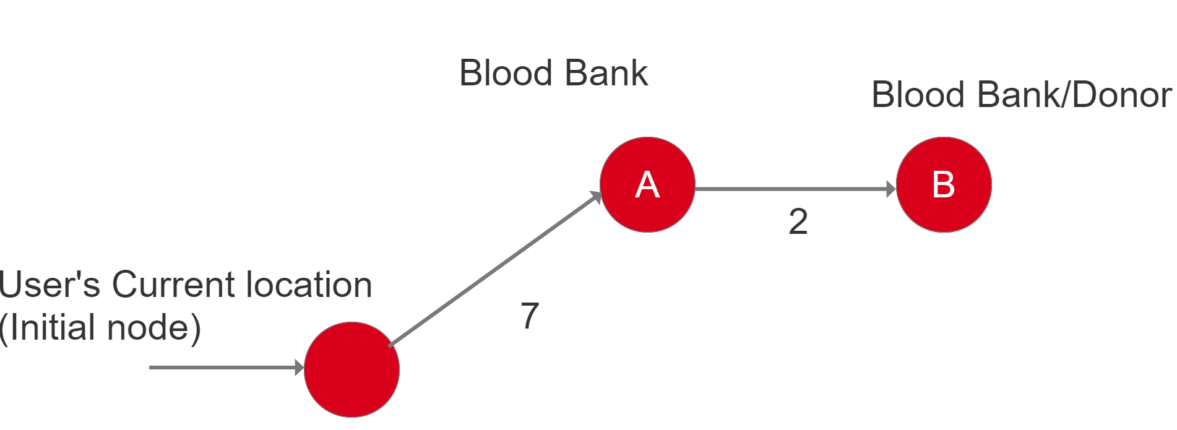

4. When we are done considering all of the neighbours of the current blood bank, mark the current blood bank as visited and remove it from the unvisited set. A visited blood bank will never be checked again.

5. If the destination blood bank has been marked visited (when planning a route between two specific blood bank) or if the smallest tentative distance among the blood bank in the unvisited set is infinity (when planning a complete traversal; occurs when there is no connection between the initial node(user’s location) and remaining unvisited blood banks), then stop. The algorithm has finished.

6. Otherwise, select the unvisited blood bank that is marked with the smallest tentative distance, set it as the new "current blood bank", and go back to step 3.

In our project, we will develop a mobile application using Flutter and use GPS to track all the

users and the locations. When the blood bank and donor are plotted on the map after clicking

on that particular bank or donor, information regarding them like contact details will be

provided and also the urgency of requirement can be given.

## 4.6 Tools and Platform

1. **VS Code IDE**

Visual Studio Code is a streamlined code editor with support for development operations like debugging, task running, and version control that aims to provide just the tools a developer needs for a quick code-build-debug cycle and leaves more complex workflows to fuller featured IDEs such as Visual Studio IDE.

1. **Flutter**

Flutter is Google’s UI toolkit for building beautiful, natively compiled applications for mobile, web, and desktop from a single codebase with features like fast development, expressive and flexible UI and native performance.

1. **Android Studio**

Android Studio is the fastest developer tool for building apps on every type of Android device with various exciting features such as visual layout editor, APK analyzer, fast emulator, intelligent code editor, flexible build system and real time profilers.

1. **Windows**

Microsoft Windows is a graphical operating system that provides a way to store files, run software, play games, watch videos and connect to the internet. It is a platform where we run our web application.

1. **Android**

Android is the platform where the flutter application can be run. It may be any android phones.

1. **SQLite 3**

SQLite 3 is a self-contained, file-based SQL database that comes bundled with python and can be used in any of your python applications without having to install any additional software.

1. **Flask**

Flask is a micro web framework written in python that supports extensions that can add application features as if they were implemented in flask itself.

1. **Python**

Python is an interpreted, high-level and general-purpose programming language that supports multiple programming paradigms including structured, object oriented and functional programming.

CHAPTER 5

# 5.1 Work Done

As promised, we have first completed the whole data management system in both android application and web application for the E-Bloodbank proposed by us. We have used flutter to design the android user interface and python flask for the web application. By connecting the localhost we have shared single server for both android and web application through a flask API. As mentioned above we have used SQLite3 for the database server.

Screenshots of the works done are as follows:

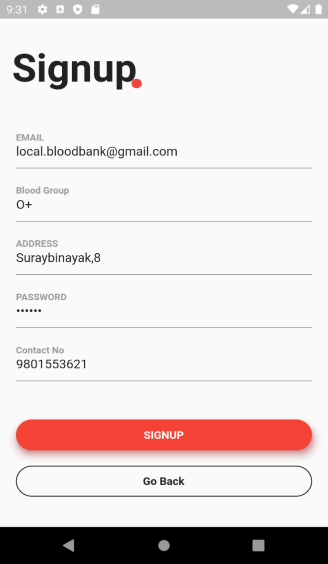

Fig 5.1.1: Flutter App Sign Up

This is a registration page for the users. We have provided registration for donor and needy through the app. The admin registration is temporarily removed in other to limit the super admins and focus on the other parts of the application as well. Also, the blood bank registrations authority is given to the admin only. This is done so to validate the events that are published in this app.

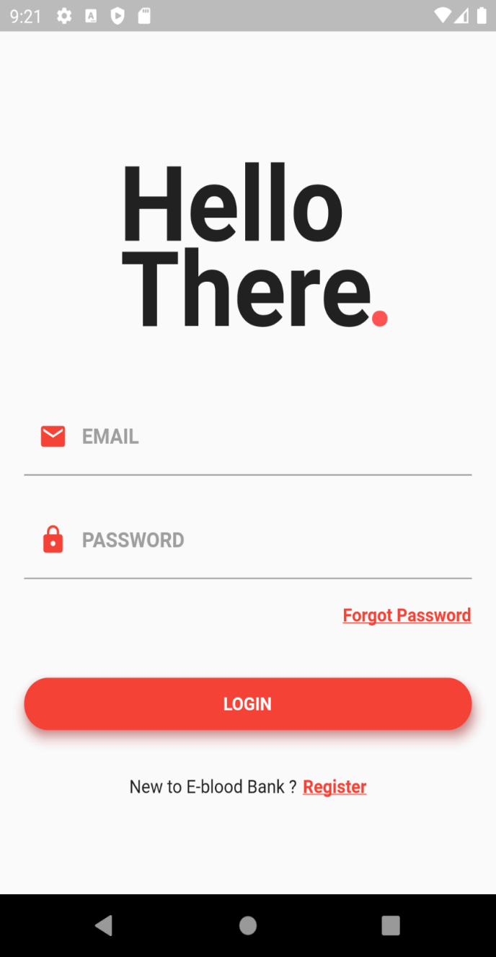Fig 5.1.2: Flutter App Login

This is the login page where user login is provided. In other to use the app, user must first log into the system. The login is prioritized because we need the location of the device and user details to give efficient availability of donors during emergency search. In other to make the location and user unique, this page is provided.

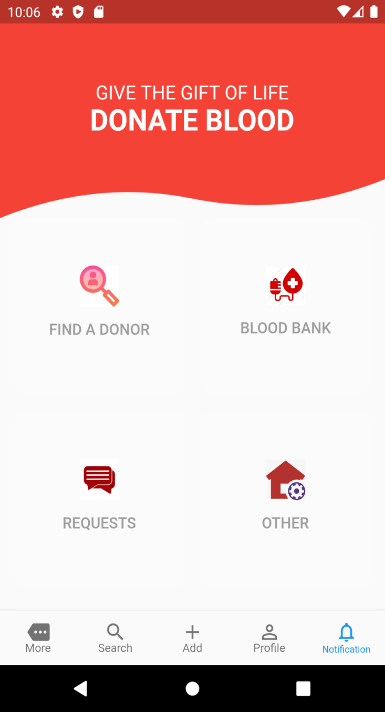Fig 5.1.3: User Dashboard

This is the page displayed in the mobile application after the user login. Through this dashboard user is able to:

* Find the donors available
* Find blood banks near the user
* Post blood request
* Get ambulance and help line details etc.

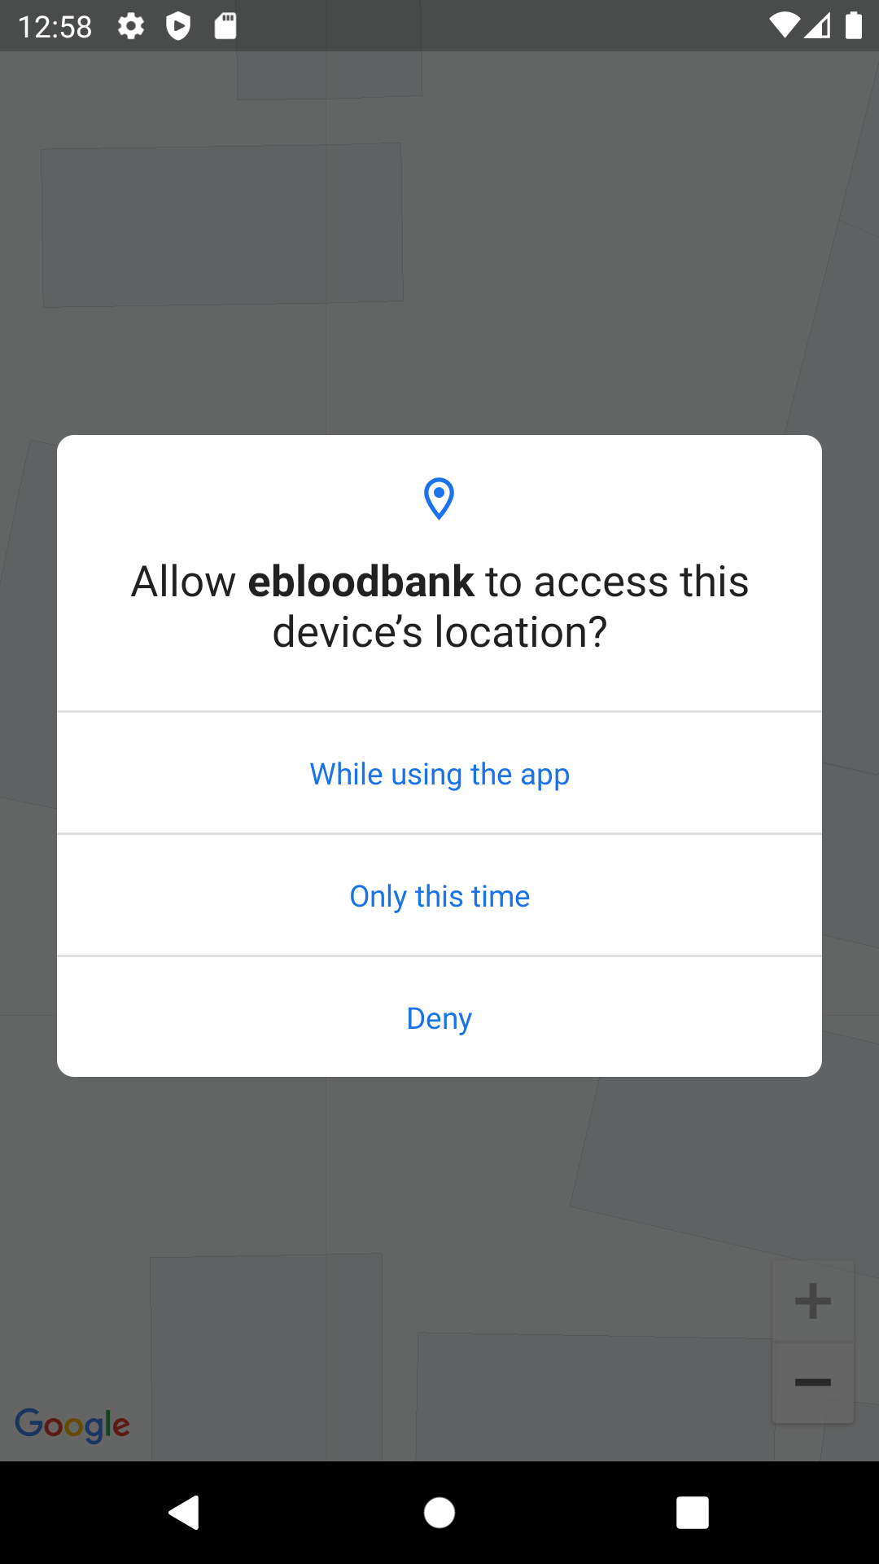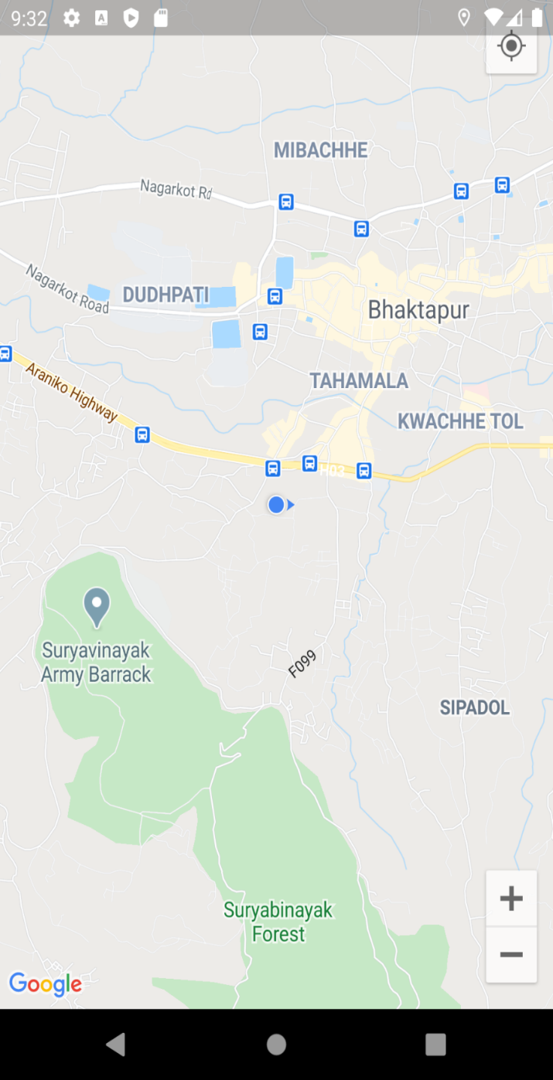Fig 5.1.4: Google Map Navigation

This is the page showing current location of the users device. The location is tracked using the GPS enabled on the mobile device. For the location the permission is first asked as shown in the second screenshot. As the GPS of the device is changed the map location changes concurrently giving current location of the device all the time or recent active location of the device.

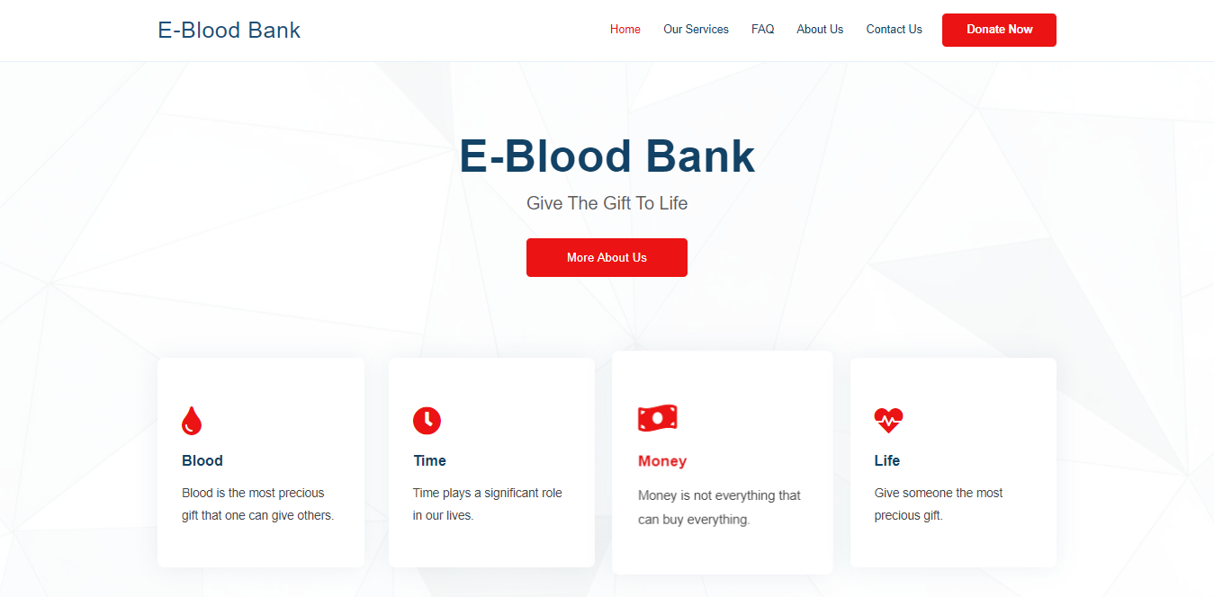Fig 5.1.5: Web Dashboard

This is the Dashboard for the users in the web application.

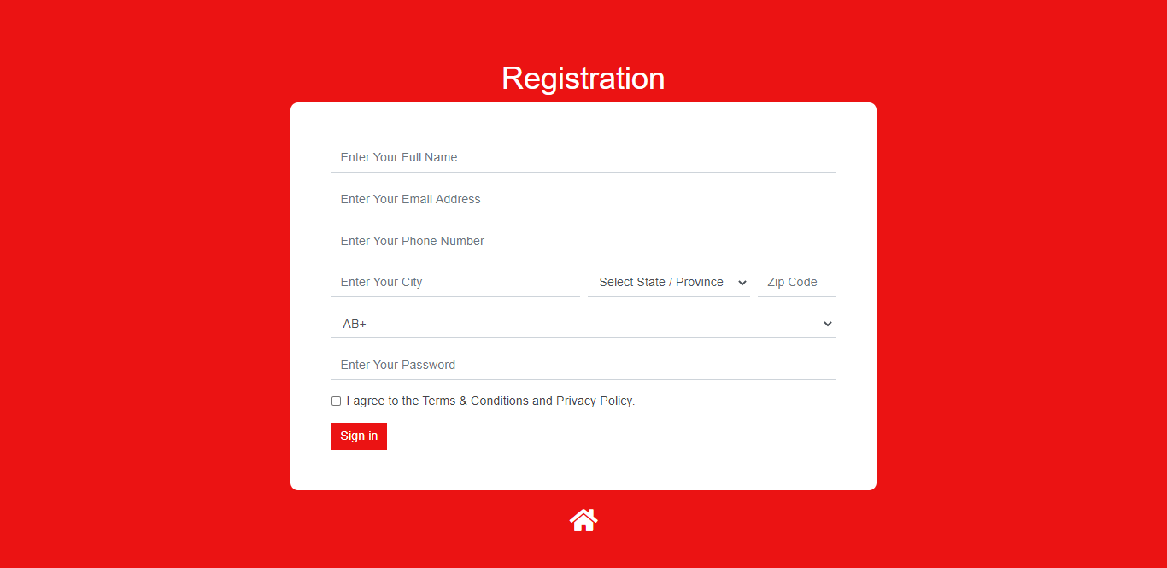

Fig 5.1.6: User Registration in Webpage

Hence, under flutter application, we completed the users-login, donor details, and the google map navigation with current location update. Similarly under web application, we completed the registration/login page for the users along with the user dashboard. User registration and locations for both the flutter application and web application are managed in databases using SQLite 3. Hence, we completed the overall UI design and the database management till now.

# 5.2 Work to be done

We are still working on the implementation of shortest path algorithm. So the algorithm implementation is yet to be done in our project.

In the other hand the user interface for both mobile application and web application needs to be enhanced.

Also we are working on the path finding techniques and analyzing the ways of implementing the algorithm.

# REFERENCES

[1] Shirsath, K., Wagh, S. and Risodkar, P., 2020. Blood Bank Connect Android Application. International Journal for Research in Engineering Application & Management, pp.168-171.

[2] Vikas Bhingare, Sagar Dhangare, Pradip Gorade, Dipak Kathar , Bhagwan Kurhe., 2018. Blood Donor Tracker By using GPS. International Journal for Research in Engineering Application & Management, Vol-4 Issue-2 2018

[3] Nur Fatini Zahidah Binti Zakaria, Zulhafiza binti Zainal Abidin, Muhammad Asyraf bin Abdullah Zawawi. Bloodbuddy: a Tracking System for Blood Donor Using GPS. Journal of Engineering, Technology & Applied Science 2020, 2(2): 86-102

[4] Shubham Pande, Shweta Mate, Pradnya Mawal, Ayusha Jambulkar, Prof. N. S. More. E-Blood Bank Application Using Cloud Computing. Department of Information Technology, Smt. Kashibai Navle College of Engineering ,India, Volume: 05 Issue: 02 | Feb-2018

[5] R. Suchitra, M. Lalithya Sannitha, J. Ravikanth, G. Anusha & B. Abhilash, Assistant Professor, Location_Based_Online_Blood_Bank_System, Department of CSE, Lendi Institute of Engineering and Technology, Vizianagaram, India, Vol. 3, Issue 4, Apr 2019,pp. 1-4

[6] Mange, M. and Shaikh Mohammad, B., 2020. Online Blood Bank Management System Using Android Application. SSRN Electronic Journal,.

[7] tamberger, L., Riper, C. J., Keller, R., Brownlee, M. & Rose, J. (2018). A GPS Tracking Study of Recreationists in an Alaskan Protected Area. Applied Geography, 93: 92-102. doi:10.1016/j.apgeog.2018.02.011

[8] PORTAL MyHEALTH. 2020. Blood Donation - PORTAL Myhealth. [online] Available at: <http://www.myhealth.gov.my/en/blood-donation/> [Accessed 12 December 2020].

[9] Korpilo, S., Virtanen, T. & Lehvävirta, S. (2017). Smartphone GPS Tracking—Inexpensive and Efficient Data Collection on Recreational Movement. Landscape and Urban Planning, 157: 608-617. doi:10.1016/j.landurbplan.2016.08.005.

[10] Adle, A., Galpern, P. & Doyle-Baker, P. (2018). Measuring the Use of Green Space with Urban Resource Selection Functions: An Application Using Smartphone GPS Locations. Landscape and Urban Planning, 179: 107-115.

[11] Alpern, P., Ladle, A., Uribe, F. A., Sandalack, B. & Doyle-Baker, P. (2018). Assessing Urban Connectivity Using Volunteered Mobile Phone GPS Locations. Applied Geography, 93: 37-46. doi:10.1016/j.apgeog.2018.02.009.

[12] Ardy, J., Veinot, T. C., Yan, X., Berrocal, V. J., Clarke, P., Goodspeed, R. & Vydiswaran, V. V. (2018). User Acceptance of Location-Tracking Technologies in Health Research: Implications for Study Design and Data Quality. Journal of Biomedical Informatics, 79: 7-19. doi:10.1016/j.jbi.2018.01.003.