* Topic 1
  + Grade Comments
    - FEATURE: - 5
    - The Feature is too large and takes up more than 1/3 of the screen area.

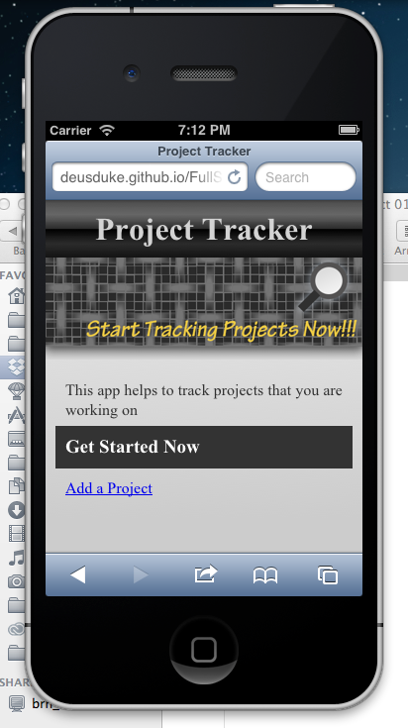

On the simulator, my iPod, and my Android phone the CTA is well within the 1/3 requirements.  The header above the CTA was not meant to be a part of the CTA.  The header (gradient with "ProjectTracker") was not meant to be a part of the CTA.

* Topic 2
  + Grade Comments
    - SEARCH: -10
    - The app should contain a semantic search field which was not required to function in week 1, but will need to function in week 2.

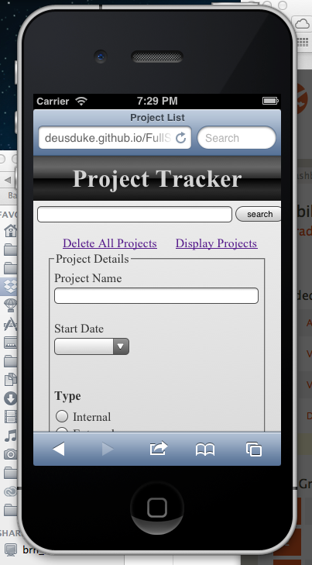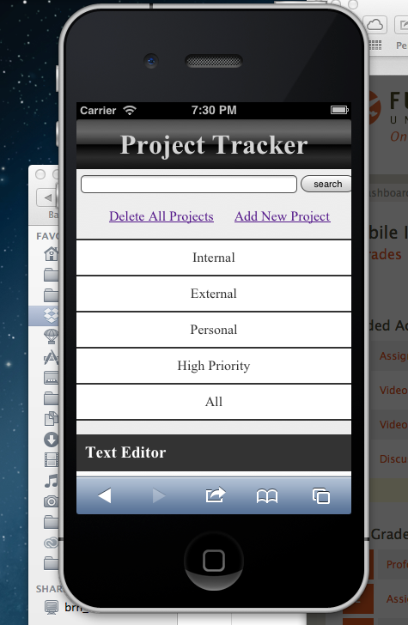

The app does contain a search field at the top

* Topic 3
  + Grade Comments
    - The app was to contain 5 browse categories, this app contains none.



The app also contains 5 categories, however they only display when viewing projects, not when editing.  Also the categories do not work as I was under the impression that they didn't need to work until week 02.