[Note to the group: everything highlighted in yellow needs to be filled in. Select all and clear the highlight before printing, then delete this line.]
[NAME OF SCHOOL / UNIVERSITY]
[Address of the School, City, Province]
[College / Department]
BARBERBOOK PH: AN ONLINE APPOINTMENT AND HAIRCUT
PREFERENCE SYSTEM FOR LOCAL BARBERSHOPS
Concept Paper
A Concept Paper Presented to the Faculty of the
[College / Department]
[Name of School / University]
In Partial Fulfillment of the Requirements for the Subject
[Subject Code and Title, e.g. Capstone Project 1]
[Course / Program, e.g. Bachelor of Science in Information Technology]
Submitted by:
TIEMPO, MARK JOSHUA
[SURNAME, First Name of Member 2]
[SURNAME, First Name of Member 3]
[SURNAME, First Name of Member 4]
Submitted to:
[NAME OF PROFESSOR / ADVISER]
[Position, e.g. Capstone Adviser]
September 2026

I. PROJECT TITLE
BarberBook PH: An Online Appointment and Haircut Preference System for Local Barbershops
II. PROPONENTS
The following students of [Course / Program], [Name of School], are the proponents of this study:
- Mark Joshua Tiempo
- [Full name of member 2]
- [Full name of member 3]
- [Full name of member 4]
Adviser: [Name of Professor / Adviser]
Proposed duration: October 2026 to March 2027
III. BACKGROUND OF THE STUDY
Getting a haircut is a normal part of the week for most Filipino men, but the way appointments are handled in most local barbershops has not really changed. Customers still walk in, take a seat, and wait for their turn. During weekends, paydays, and before school events or fiestas, the waiting time can reach one to two hours. Some customers leave and just come back another day, which means the shop loses a sale and the customer loses time.
Barbershops that already accept reservations usually do it through Facebook Messenger or text message. The problem with this setup is that the schedule is only in the head of the owner or written in a notebook. Messages get buried, two customers are sometimes booked at the same time, and the shop has no easy way to check how many customers came in during the week or which barber is the most requested.
There is also a second problem that customers complain about often. Even when they finally sit on the chair, it is hard to explain the haircut they want. Many customers show a screenshot from social media, and some just say "the usual" or "short on the sides." Because the request is not written down anywhere, the barber has to guess, and the customer sometimes goes home unhappy with the result. Younger customers in particular follow trending hairstyles such as the mid taper fade, two block, and textured fringe, and they want to be sure that the barber understands the exact style before the cut starts.
Based on these observations, the proponents want to develop a simple web based booking system for local barbershops in the Philippines. Aside from reserving a slot, the system will let the customer choose a hairstyle from a picture gallery, select a preferred barber, and save personal haircut preferences that the barber can read before the appointment. The proponents believe that a system like this is doable within one school year and is useful to small barbershops that cannot afford expensive salon software.
IV. STATEMENT OF THE PROBLEM
This study aims to develop an online appointment and haircut preference system for local barbershops. Specifically, the study seeks to answer the following questions:
- What are the current problems encountered by barbershop owners and customers in the existing walk in and messaging based booking practice?
- What features are needed in an online booking system that will address the problems in scheduling, waiting time, and communication of haircut preferences?
- How can the proposed system be developed using free and available web technologies?
- How acceptable is the proposed system to the target users in terms of functionality, usability, reliability, and performance efficiency based on ISO/IEC 25010?
V. OBJECTIVES OF THE STUDY
General Objective
The general objective of this study is to design, develop, and evaluate a web based appointment and haircut preference system for local barbershops in [City / Municipality].
Specific Objectives
Specifically, this study aims to:
- Identify the problems in the current booking practice of the partner barbershop through interview and observation;
- Design a website with a simple and easy to use interface where a customer can create an account, choose a barbershop, and reserve an available date and time;
- Develop a hairstyle gallery with photos, including updated trending hairstyles for men, so that the customer can select the exact haircut he wants;
- Provide a feature that allows the customer to select a preferred barber and to save personal haircut preferences such as guard number, length on top, and beard trim;
- Develop an administrator side for the barbershop owner to manage barbers, working hours, available slots, and the daily list of appointments;
- Add automatic email or SMS confirmation and reminder so that the customer will not forget the schedule; and
- Evaluate the acceptability of the developed system using a survey questionnaire based on the ISO/IEC 25010 software quality model.
VI. SCOPE AND LIMITATIONS
Scope
The proposed system is a web based application that can be opened using a browser on a mobile phone, tablet, or computer. It will cover the following:
- Customer registration and login;
- Searching and viewing of participating barbershops with their address, operating hours, services, and price list;
- Hairstyle gallery with photos, grouped into categories such as trending, fades, classic, and textured;
- Selection of a preferred barber, or the option to choose any available barber;
- Saved haircut preferences and short notes for the barber;
- Calendar and time slot booking, where slots that are already taken are automatically hidden;
- Booking summary, confirmation, rescheduling, and cancellation;
- Email or SMS confirmation and reminder;
- Administrator dashboard for the barbershop owner showing the daily queue, barber schedules, and a simple report of bookings per day, per week, and per barber; and
- Customer rating and short feedback after the appointment.
Limitations
The following are outside the coverage of this study:
- The system will not process online payment. Payment will still be made at the shop, and the system will only reserve the slot.
- The system will not include payroll, inventory of supplies, or accounting features of the barbershop.
- The system will not use artificial intelligence to show how the haircut will look on the face of the customer. The hairstyle gallery will only use reference photos provided by the partner barbershop.
- The system will be tested on one partner barbershop only, although the design will allow more than one shop to be added later.
- Walk in customers who do not use the internet are still accommodated by the shop, and the owner will encode them manually in the dashboard.
- The system requires an internet connection to work.
VII. SIGNIFICANCE OF THE STUDY
The result of this study will be beneficial to the following:
- Barbershop owners. The system will give them an organized schedule, lessen double booking, and provide simple reports that can help them decide on shop hours and staffing.
- Barbers. They will know in advance who their customers are for the day and what haircut is requested, which makes the work faster and lessens misunderstanding.
- Customers. They will save time because they no longer have to wait in line, and they can be more confident that the haircut they receive is the one they asked for.
- The proponents. The study will let the proponents apply what they learned in programming, database management, and systems analysis and design in an actual small business setting.
- Future researchers. The study can serve as a reference for other students who want to develop a booking or scheduling system for other kinds of small service businesses such as salons, dental clinics, and repair shops.
VIII. PROPOSED FEATURES
The table below summarizes the main features of the proposed system and the problem each feature answers.

Feature | Description | Problem it answers
Online slot booking | Customer selects a date and an available time from a calendar. Taken slots are automatically hidden. | Long waiting time and double booking
Hairstyle gallery | Photos of haircuts grouped by category, including trending styles for men. The chosen style is attached to the booking. | Difficulty in explaining the desired haircut
Preferred barber | Customer may choose a specific barber or let the system assign any available barber. | Customer cannot request a favorite barber in advance
Saved preferences | Guard number, length on top, beard trim, and short notes are saved in the customer profile. | Barber has to ask the same questions every visit
Confirmation and reminder | Automatic email or SMS after booking and before the schedule. | Forgotten appointments and no shows
Owner dashboard | Daily queue, barber schedule, gallery management, and simple booking reports. | Schedule is only written in a notebook
Rating and feedback | Short rating and comment after the appointment. | No record of customer satisfaction

IX. SYSTEM FLOW
Figure 1 shows the general flow of the proposed system from the side of the customer, the system itself, and the barbershop owner.
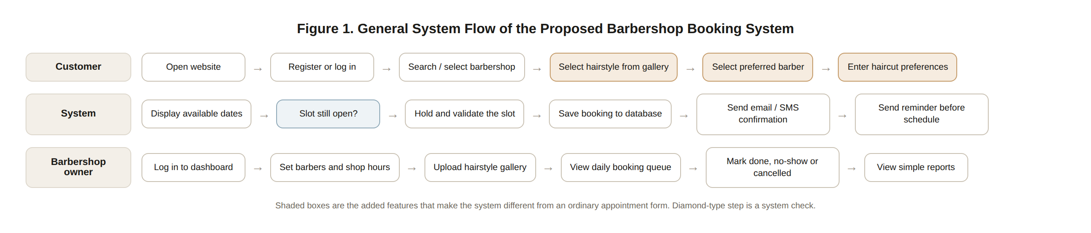
Figure 1. General system flow of the proposed barbershop booking system

X. PROPOSED USER INTERFACE
The following screens are the initial design of the proponents. The layout was kept plain and simple so that customers who are not used to booking apps can still follow the steps. The final colors, photos, and shop names will be finalized after the interview with the partner barbershop.
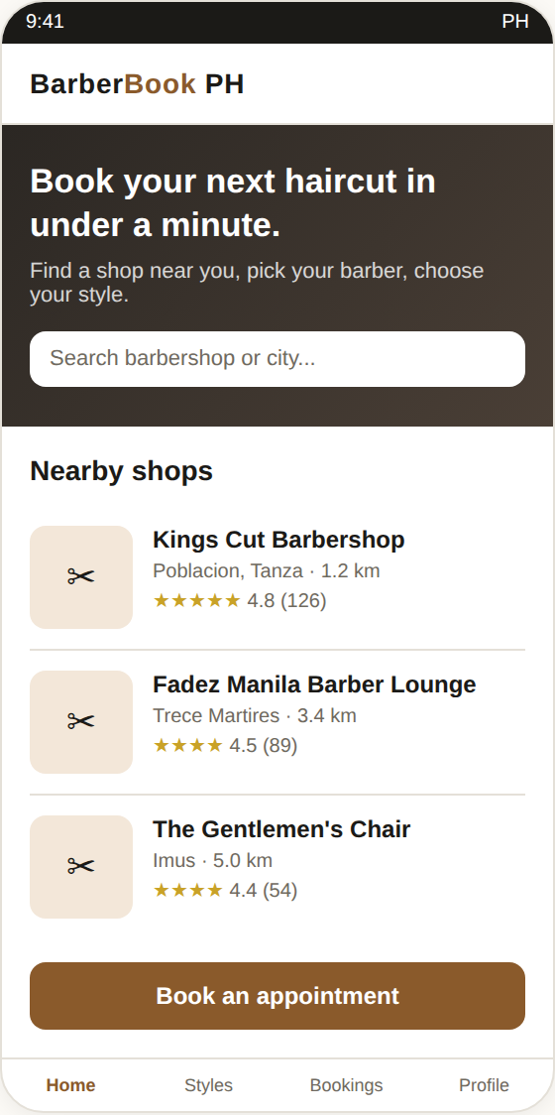  Home and list of nearby shops | 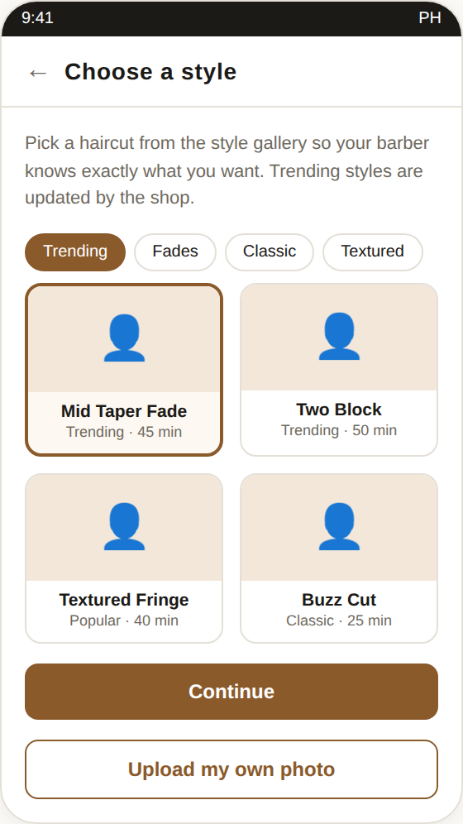  Hairstyle gallery with photos | 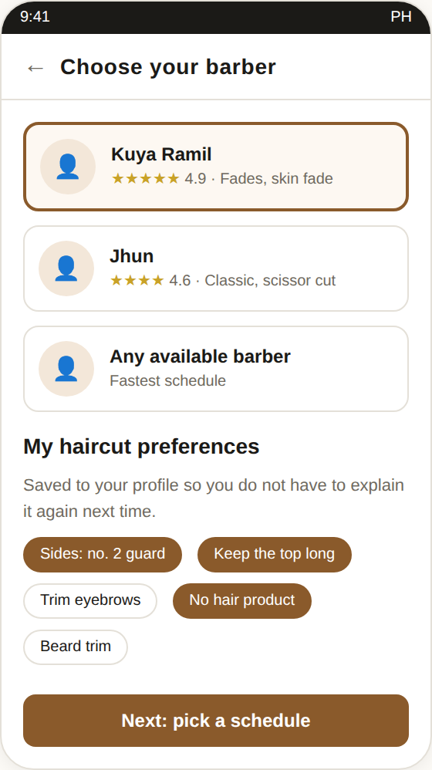  Preferred barber and preferences
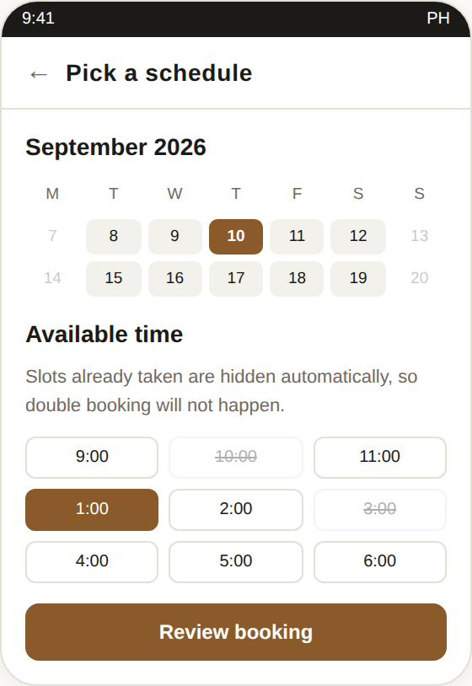  Calendar and available time slots | 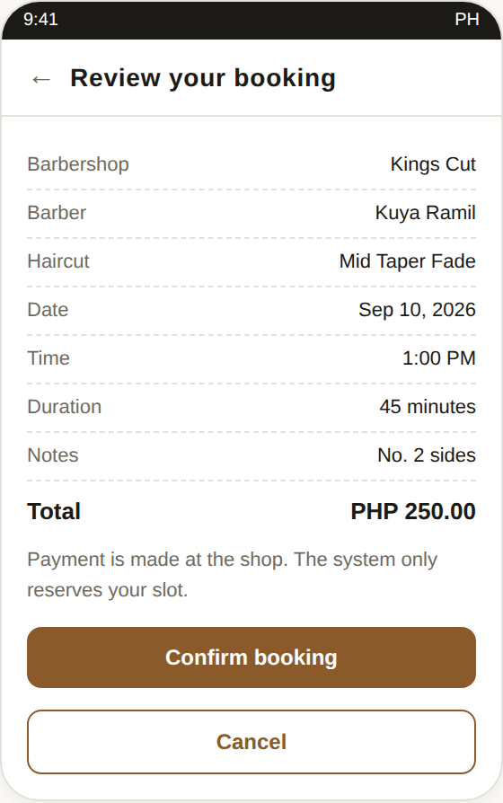  Booking summary before confirming | 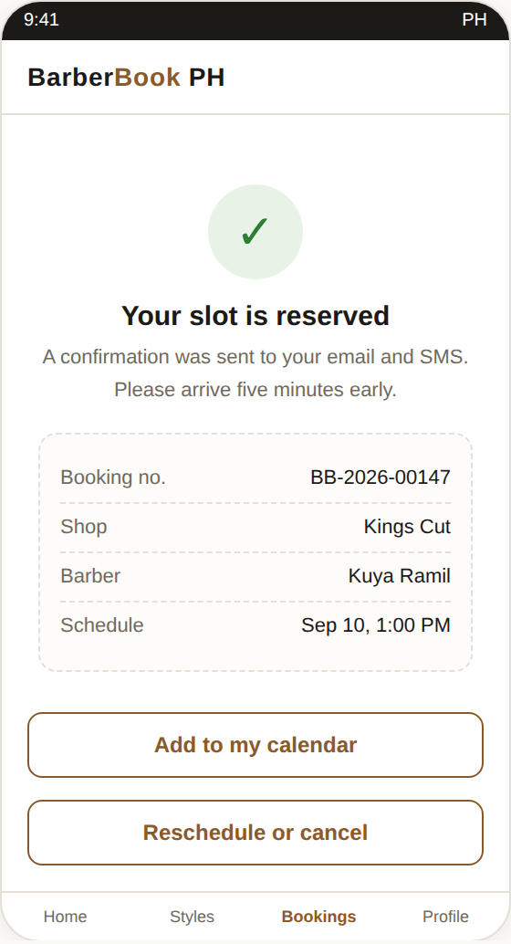  Confirmation and booking record
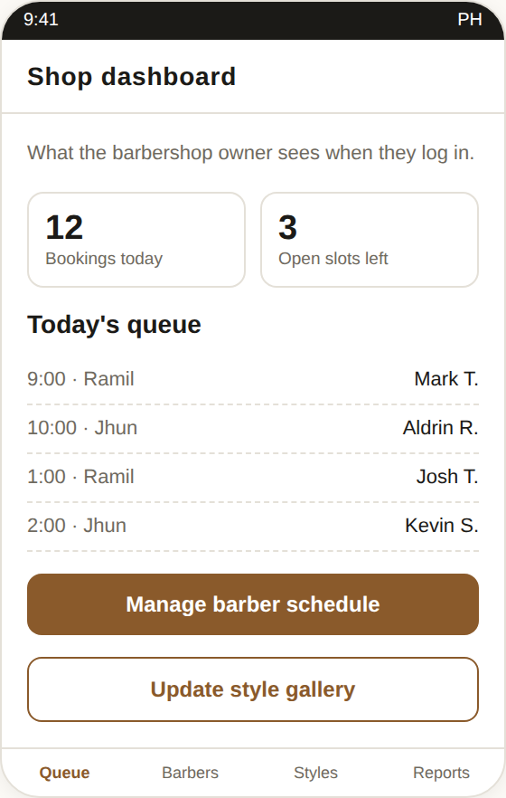
Owner dashboard and daily queue
Figure 2. Proposed user interface of BarberBook PH
XI. METHODOLOGY
The proponents will use the Agile software development model. Agile was chosen because the proponents will be working closely with the partner barbershop, and the owner will most likely have new requests once he sees the first working version. Agile allows the system to be built in small parts, shown to the owner, and improved right away instead of waiting until the very end.
The development will be divided into the following phases:
- Planning and requirements gathering. The proponents will interview the owner and at least one barber of the partner barbershop, and will give a short survey to around thirty regular customers to find out how they book and what they want in a booking website.
- Design. The proponents will prepare the data flow diagram, entity relationship diagram, use case diagram, and the screen designs of the website.
- Development. Coding will be done by sprint. The first sprint will cover registration and booking, the second sprint will cover the hairstyle gallery and preferences, and the third sprint will cover the owner dashboard and the notification feature.
- Testing. Unit testing will be done by the proponents after every sprint. Afterwards, the system will be tested by the owner, the barbers, and a group of customers.
- Evaluation. A survey questionnaire based on ISO/IEC 25010 will be given to the respondents, and the results will be interpreted using the weighted mean.
- Deployment and documentation. The final system will be uploaded to a web host and the complete documentation and user manual will be prepared.
XII. TECHNICAL REQUIREMENTS
Software
- Front end: HTML5, CSS3, JavaScript, and Bootstrap for the responsive layout
- Back end: PHP with the Laravel framework
- Database: MySQL
- Local server for testing: XAMPP
- Code editor and version control: Visual Studio Code and GitHub
- Design tool for the screen layout: Figma
- Notification: an email service such as Gmail SMTP, and a free or low cost SMS gateway if the budget allows
Hardware
- Laptop or desktop computer with at least 8 GB of RAM for development
- Android or iOS mobile phone for testing the responsive design
- Stable internet connection
- Web hosting with a domain name for the final deployment
XIII. RESPONDENTS AND EVALUATION
The respondents of this study will be the owner and barbers of the partner barbershop and selected customers who regularly have their haircut there. The proponents are targeting one owner, three to five barbers, and thirty customers, chosen through purposive sampling.
The developed system will be evaluated using an adapted questionnaire based on the ISO/IEC 25010 software quality characteristics, particularly functional suitability, usability, reliability, and performance efficiency. A four point Likert scale will be used, and the responses will be interpreted using the weighted mean.
XIV. TIMELINE OF ACTIVITIES

Activity | Target period
Topic approval and concept paper | October 2026
Interview, survey, and requirements gathering | October to November 2026
System design and documentation of Chapters 1 to 3 | November to December 2026
Development, Sprint 1 (accounts and booking) | December 2026
Development, Sprint 2 (hairstyle gallery and preferences) | January 2027
Development, Sprint 3 (owner dashboard and notifications) | January to February 2027
Testing and evaluation with the respondents | February 2027
Revision, final documentation, and defense | March 2027

XV. EXPECTED OUTPUT
At the end of the study, the proponents expect to produce a working web based booking system for a local barbershop, a complete set of documentation including the manuscript and user manual, and the results of the user acceptance evaluation showing that the system is acceptable to the target users.
XVI. REFERENCES
International Organization for Standardization. (2011). ISO/IEC 25010:2011, Systems and software engineering, Systems and software Quality Requirements and Evaluation (SQuaRE), System and software quality models. ISO.
Pressman, R. S., & Maxim, B. R. (2020). Software engineering: A practitioner’s approach (9th ed.). McGraw-Hill Education.
Sommerville, I. (2016). Software engineering (10th ed.). Pearson Education.
Satzinger, J. W., Jackson, R. B., & Burd, S. D. (2016). Systems analysis and design in a changing world (7th ed.). Cengage Learning.
[Add two to three local related studies or theses on online booking, scheduling, or reservation systems from your school library or from Google Scholar, following the citation style required by your department.]

ENDORSEMENT AND APPROVAL
This concept paper is submitted for review and approval.
Prepared by:

MARK JOSHUA TIEMPO, Proponent

[FULL NAME OF MEMBER 2], Proponent

[FULL NAME OF MEMBER 3], Proponent

[FULL NAME OF MEMBER 4], Proponent
Noted and endorsed by:

[NAME OF PROFESSOR / ADVISER], Adviser
Approved by:

[NAME OF DEAN / PROGRAM CHAIR], [Position]
Date: __________________________

