GLOBAL MALARIA INCIDENCE AND DEATHS ANALYSIS (2010-2017)
Tumusiime Deus
School of Computing and Informatics Technology, Department of Computer Sciences, Makerere University, Kampala, Uganda.
Email: deus.mal@gmail.com, tumusiime.deus@students.mak.ac.ug
Registration Number: 2025/HD05/26375U
__________________________________________________________________
I. INTRODUCTION
Malaria is a life-threatening infectious disease caused by Plasmodium parasites and transmitted to humans via infected female Anopheles mosquitoes. Despite global containment efforts, it remains a severe public health burden. This report analyzes the World Health Organization (WHO) estimated malaria dataset (DS30), which covers 107 countries over eight years from 2010 to 2017. The dataset contains 856 records and 10 columns detailing national caseloads, deaths, and associated uncertainty intervals. To evaluate the transmission dynamics, this analysis addresses three core questions: first, how global and regional estimates shifted temporally; second, which regions carried the highest disease concentration; and third, how estimated cases, deaths, and uncertainty ranges correlated across countries.
II. METHODOLOGY
The programmatic analysis was conducted using Python 3, leveraging standard scientific libraries: Pandas and NumPy for preprocessing, Matplotlib and Seaborn for static plots, Plotly for interactive web visualizations, and SciPy for statistical testing. During data quality auditing, missing uncertainty bounds (representing 36.45% of cases and 38.79% of deaths) were identified as point estimates reported without ranges. These missing bounds were programmatically imputed by mapping them to their corresponding median estimates. Character encoding anomalies in country names (e.g., Côte d'Ivoire) were standardized. Extreme values were preserved to capture genuine high-burden realities, and a log-transformation (log1p) was applied to reduce skewness. Four features were engineered: case and death uncertainty ranges, deaths-to-cases ratios (handling zero-case divisions), and quartile-based burden categories. To address dependencies, regional hypothesis testing was performed on country-level historical averages. Regional caseload disparities were evaluated using a non-parametric Kruskal-Wallis H-test. Paired temporal shifts (2010 vs. 2017) were analyzed via a Wilcoxon signed-rank test. A Chi-square test of independence and Cramér’s V assessed the association between WHO regions and burden categories in 2017.
III. KEY FINDINGS
Exploratory analysis shows right-skewed estimated cases and deaths. In log-transformed space, case distribution reveals a bimodal pattern, separating low-burden or malaria-free countries from highly endemic settings (FIGURE 1). Regional boxplots demonstrate that cases are heavily elevated in the WHO African Region (AFRO) (FIGURE 2).
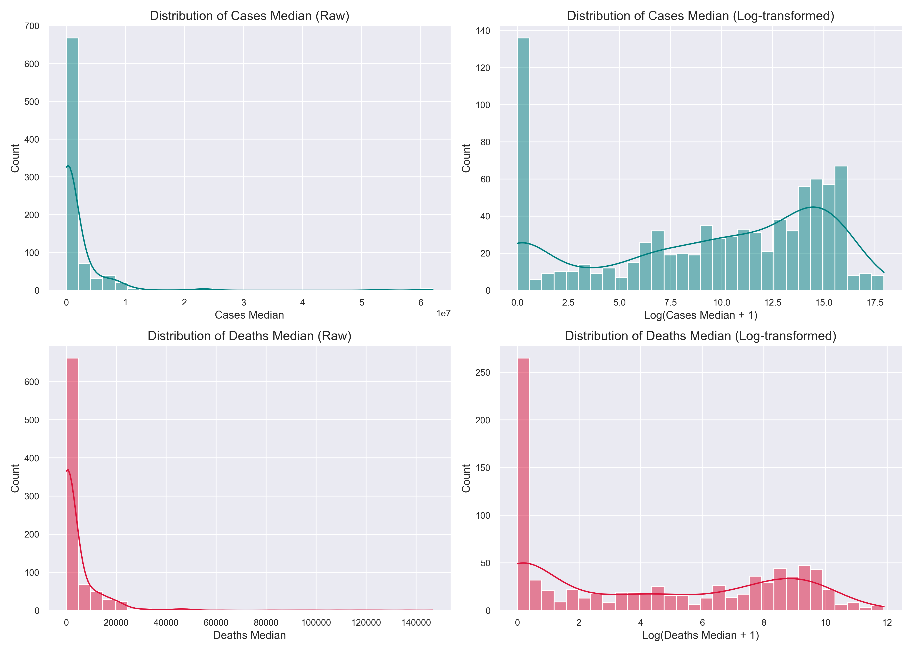
FIGURE 1. Distribution of estimated malaria cases and deaths (raw vs. log-transformed).
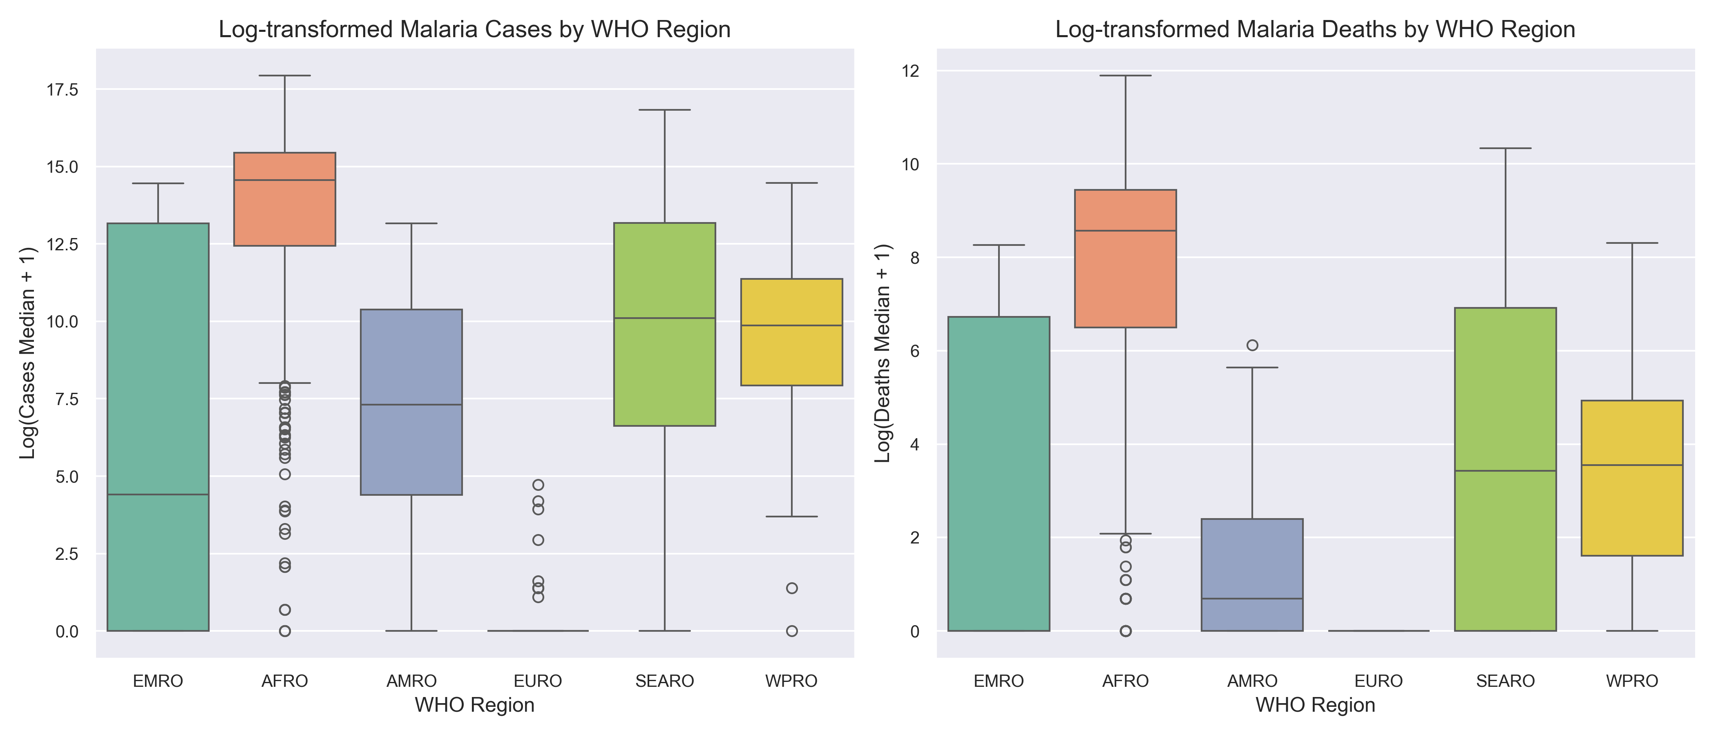
FIGURE 2. Regional boxplots of estimated malaria cases and deaths by WHO region.
Bivariate analysis indicates a strong positive association between estimated cases and deaths. The Pearson correlation (r = 0.969) and Spearman correlation (ρ = 0.970, p < 0.001) demonstrate this relationship (FIGURE 3). Although malaria infection is biologically necessary for death, this country-level analysis cannot independently establish causality because mortality is also influenced by healthcare access, treatment availability, immunity, and surveillance quality. The rank-based association suggests that higher-burden settings tend to report higher estimated deaths-to-cases ratios. Possible explanations include differences in healthcare access, treatment availability, and surveillance quality, but these mechanisms cannot be tested directly.
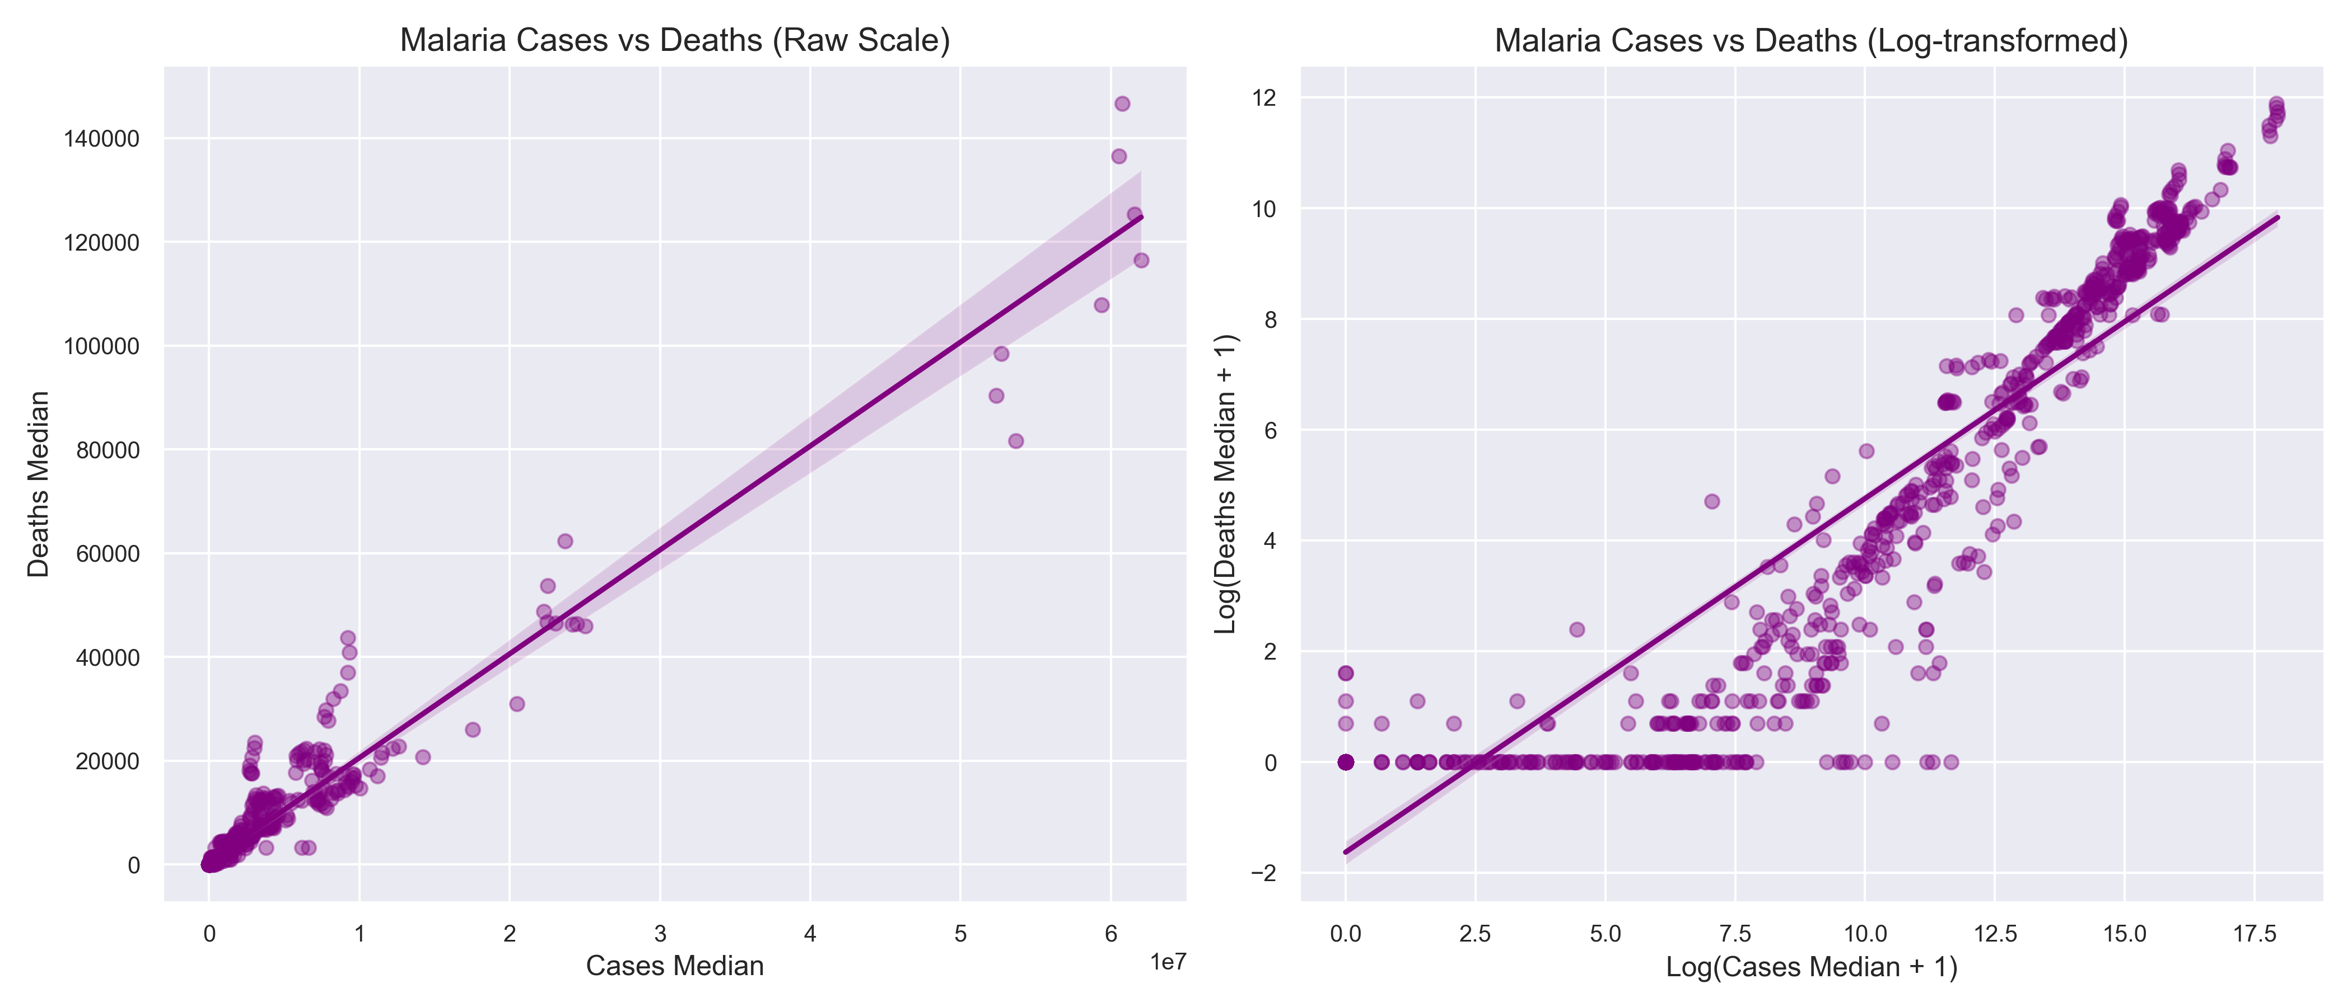
FIGURE 3. Scatter plot of estimated cases vs. deaths on raw and log-transformed scales.
A Kruskal-Wallis H-test on country averages confirms that regional disparities in estimated cases are significant (H = 54.17, p < 0.001). A Chi-square test on 2017 data confirms an association between region and burden category (χ² = 85.39, p < 0.001, Cramér's V = 0.516). Estimated global caseloads declined from 238.8 million in 2010 to a minimum of 214.2 million in 2015, before rising slightly to 219.0 million in 2017, whereas estimated deaths steadily declined (FIGURE 4). A paired Wilcoxon signed-rank test comparing country-level estimates in 2010 vs. 2017 returned a non-significant result (p = 0.152), indicating that paired changes were highly heterogeneous. Finally, the geographic distribution of estimated cases in 2017 (FIGURE 5) highlights the spatial concentration of malaria across endemic regions.
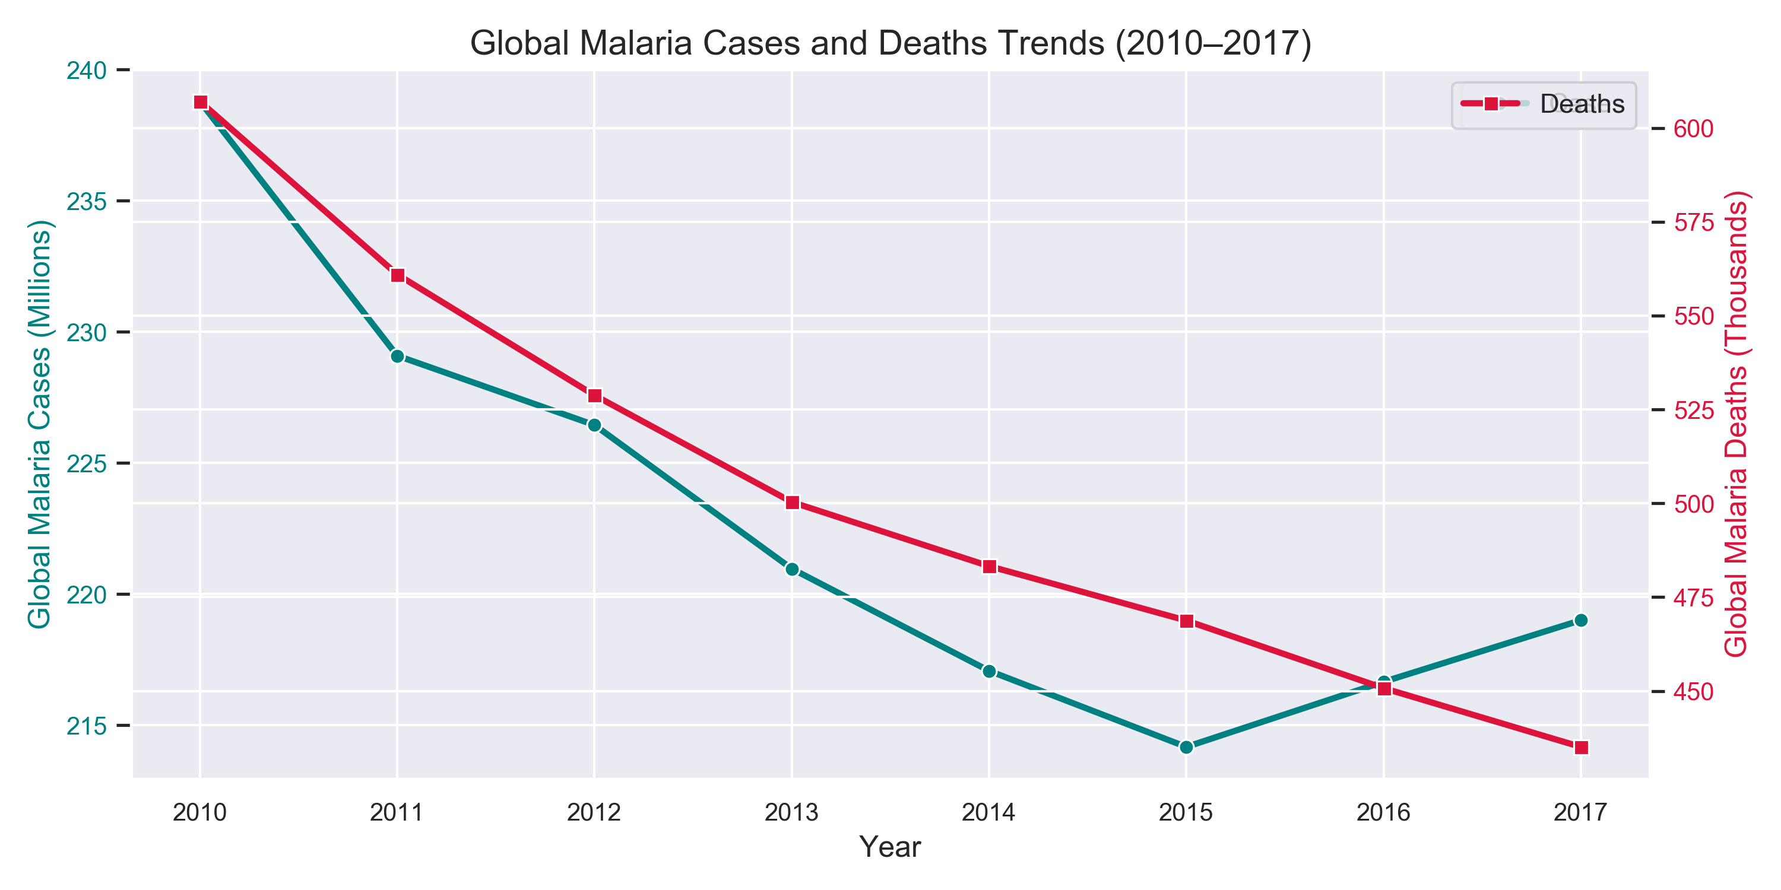
FIGURE 4. Global temporal trends of estimated malaria cases and deaths.
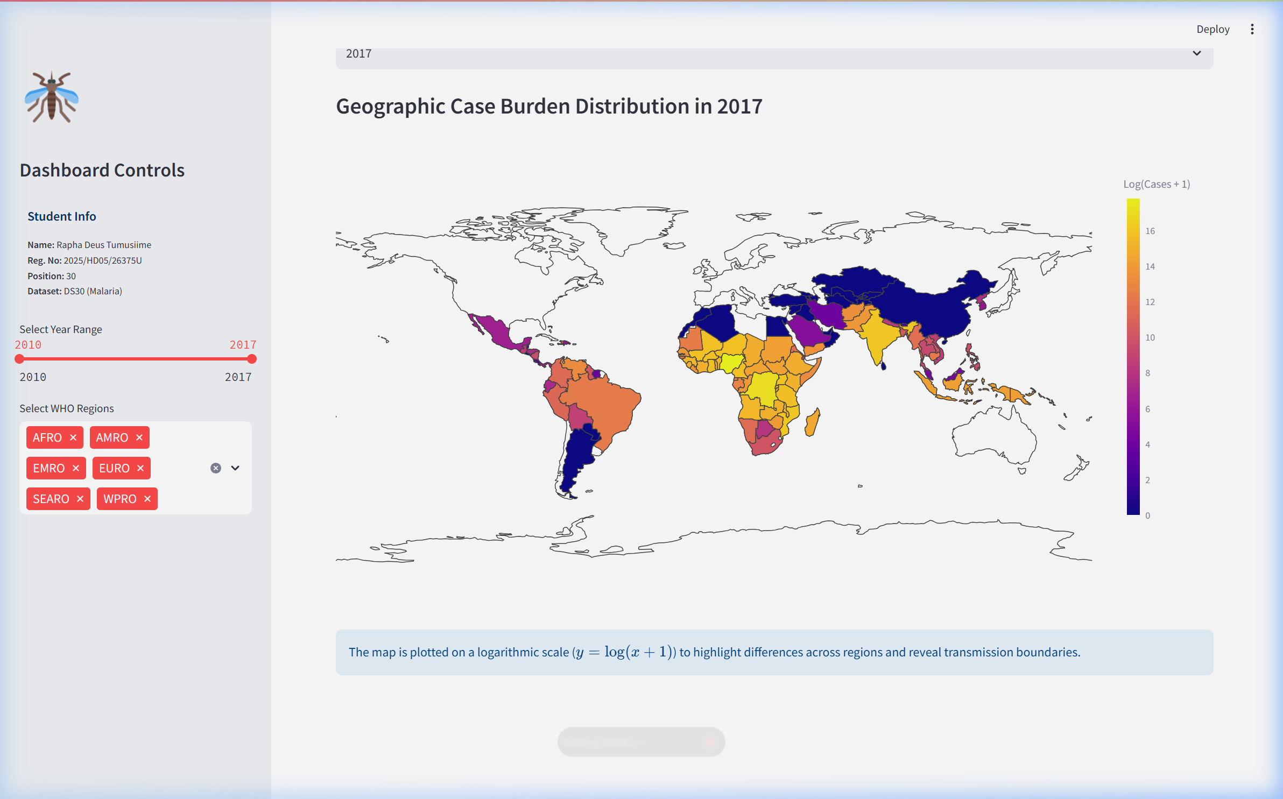
FIGURE 5. Geographic distribution of estimated malaria cases in 2017.
IV. CONCLUSION AND LIMITATIONS
In conclusion, the WHO malaria estimates reveal global progress: estimated deaths declined more consistently than estimated cases, suggesting improvement in malaria mortality outcomes, although the dataset cannot identify the specific clinical or health-system mechanisms responsible. The burden remains heavily concentrated in Sub-Saharan Africa (AFRO), which carries a disproportionate share of both absolute numbers and higher estimated deaths-to-cases ratios. Two primary limitations are: first, the data consists of model-based national estimates rather than raw clinical counts, which smooths out localized outbreaks and seasonal variation; and second, the estimates rely on national reporting, which is highly dependent on diagnostic capacities and introduces systematic reporting bias. Future work should integrate localized meteorological variables (temperature and precipitation) with historical estimated caseloads to predict geographic transmission shifts under climate change. This integration will help target resource allocation to settings facing the highest risk of transmission resurgence.
V. OPTIONAL INTERACTIVE DASHBOARD
An interactive Streamlit dashboard was developed to support the exploration of estimated malaria cases, deaths, regional trends, geographic distributions, correlations, and filtered records. Users can dynamically filter the dataset by WHO region and year, select Pearson or Spearman correlation methods, apply logarithmic scales, and download filtered records as a CSV file. The deployed application is available at: https://global-malaria-trends.streamlit.app/.
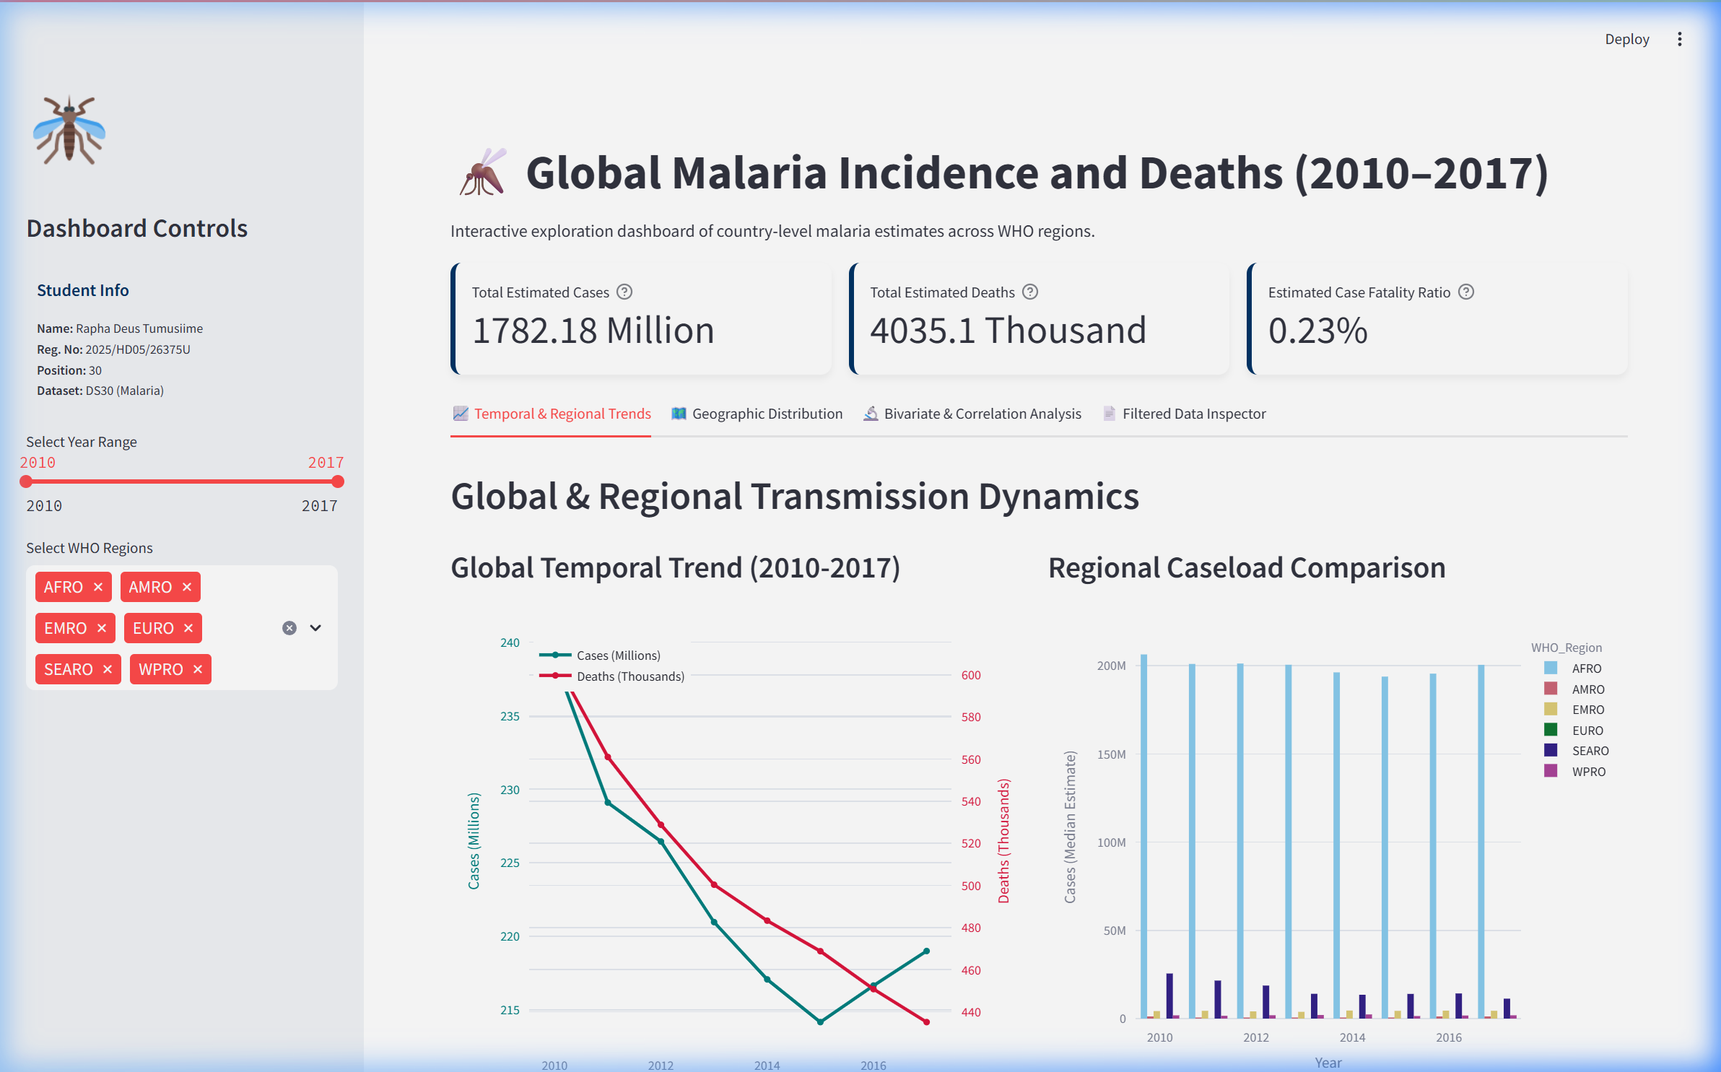
FIGURE 6. Main dashboard showing sidebar filters and malaria burden KPI cards.
REFERENCES
[1] World Health Organization (WHO), "WHO Global Health Observatory Data," Geneva, Switzerland, 2020. [Online]. Available: https://apps.who.int/gho/data/node.main.A1363
[2] imdevskp, "Malaria Dataset," Kaggle, 2020. [Online]. Available: https://www.kaggle.com/datasets/imdevskp/malaria-dataset
[3] World Health Organization (WHO), "WHO Regional Classifications," Geneva, Switzerland, 2020. [Online]. Available: https://www.who.int/about/who-we-are/regional-offices
[4] W. McKinney, "Data Structures for Statistical Computing in Python," in Proc. 9th Python in Sci. Conf., 2010, pp. 56-61.
[5] C. R. Harris et al., "Array programming with NumPy," Nature, vol. 585, no. 7825, pp. 357-362, Sep. 2020.
[6] P. Virtanen et al., "SciPy 1.0: Fundamental Algorithms for Scientific Computing in Python," Nature Methods, vol. 17, pp. 261-272, Mar. 2020.
[7] J. D. Hunter, "Matplotlib: A 2D graphics environment," Comput. Sci. Eng., vol. 9, no. 3, pp. 90-95, May 2007.
[8] M. L. Waskom, "seaborn: statistical data visualization," J. Open Source Softw., vol. 6, no. 60, p. 3021, Apr. 2021.
[9] Plotly Technologies Inc., "Collaborative data science," Montreal, QC, 2015. [Online]. Available: https://plot.ly
[10] Streamlit Inc., "Streamlit Creator Dashboard," 2020. [Online]. Available: https://streamlit.io

