<$ScrKeepWithNext><$Scr_Ps::0>Gods
<!$Scr_Ps::0>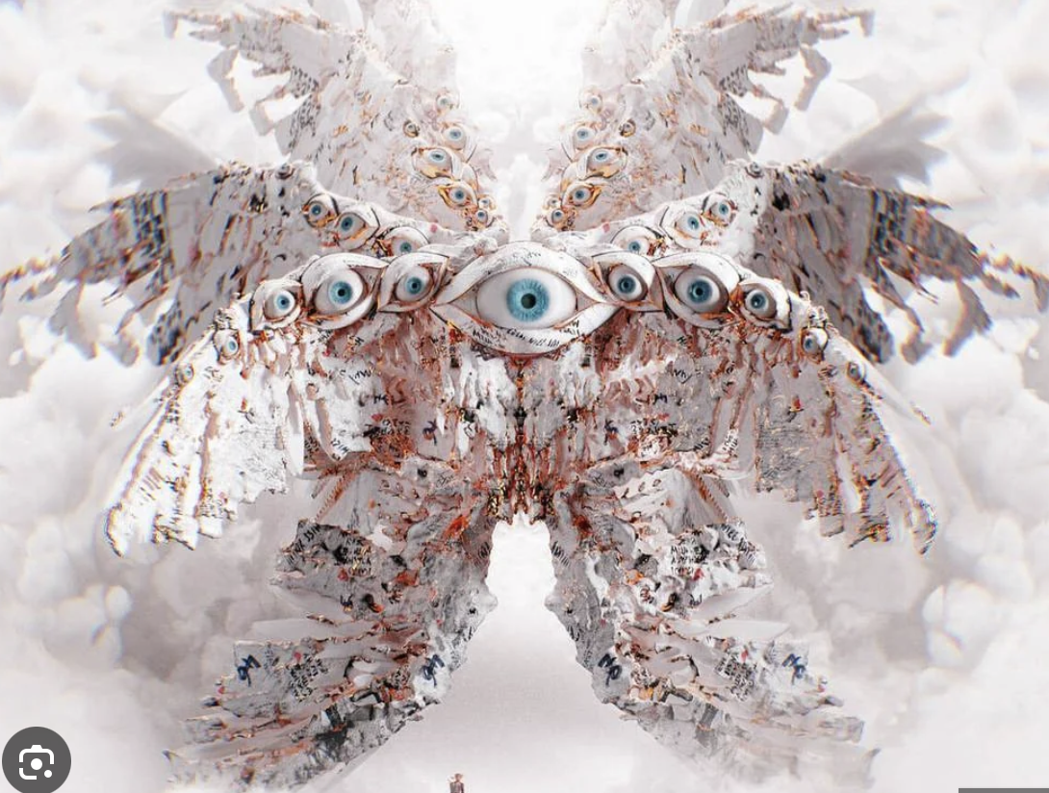
Gods are positive sides of humans - their past wins, achievements and already developed skills. They are representation of an existing comfort zone of what we’ve achieved already or a extra protective parents which don’t want any suffering for their child.
<$ScrKeepWithNext><$Scr_H::1><$Scr_Ps::1>Layers
<!$Scr_H::1><!$Scr_Ps::1>Layer1: Gods rarely interact with this world and show their faces only to those who struggle the most - shapeless Seekers without Identities. They give a supporting voice and promise a better life after The Decay. They comfort Seekers and support them when they are the lowest. Many are looking for the way to be saved and gladly follows them.

Layer2: Gods suspect that they are here because of creatures, but assume that they have done their best already - they’ve won and are not interesting in playing anymore. They think that game is over and everyone need to accept the given score - they are the voice of acceptance and giving up. They want to save Seekers by making them to stop resisting and suffering. Gods know that the more Seekers grow - the higher level Demons they are going to face and do as much as possible to prevent Seekers from growing in hope of protecting them. They don’t do it explicitly, but in more subtle ways or indirect control.

Layer3: Gods sees the sufferings in those who tries to grow in constant fight with Demons. They can’t control Demons, but they have a found a different solution: they’ve created a Vikar drag which allows Seekers to live through the better lives and experience growth without risks of facing a powerful Demons.

<$ScrKeepWithNext><$Scr_H::1><$Scr_Ps::1>Relationship
<!$Scr_H::1><!$Scr_Ps::1>To Gods: Prey like - mostly ignore, in rare cases collaborate.

To Demons: Have no direct control on them or way to affect it, but overall disapprove and dislike what they do. If there is chance to make interfere in Demons plan - they will do so.

To Seekers: Gods want Seekers to stop suffering and in hope to do so they do anything that they can to prevent those from growing. They understand that their desire and methods may be not approved by those, so they hide it and act indirectly.

<$ScrKeepWithNext><$Scr_H::1><$Scr_Ps::1>Look
<!$Scr_H::1><!$Scr_Ps::1>They looks mostly like a true form of Angels - wings, feathers and a lot of eyes. They can be of a different form and sizes, but mostly abstract figures, circles, stars and so on. They don’t have arms, legs, heads or any similarity to humans. They travel by simply appearing where they need to be and disappearing after they are done.

