COMP4870 Assignment 3

Chris Wood – A00741285 – chriswood.ca@gmail.com

Lindsay Fester – A00732122 – Lindsay_F@hotmail.com

Completed/Not Completed

All requirements Completed

Major Challenges

Changing port number of the WCF service was no apparent at the beginning of the assignment which made it difficult to work on multiple machines.

Instructions to run

1. Open Visual Studio 2010 with the following additional components installed:
   1. Silverlight SDK
   2. Windows Phone 7 SDK
   3. Silverlight Toolkit
   4. Windows Phone 7 Toolkit
2. File > Open Website … Navigate to **OptionsWebsite** included in this package and open that.
3. File > Add > Existing Project … Navigate to **OptionsSilverlight** included in the package and choose **OptionsSilverlight.csproj**
4. File > Add Existing Project … Navigate to **OptionsWP7** included in the package and choose **OptionsWP7.csproj**
5. Now that all 3 projects are in 1 solution, click on the head node for the Website and hit F4 to open properties. Ensure the following options are set as per the screen shot below

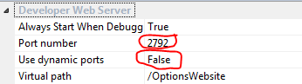

1. In the website, Right click on **StudentOptionsService.svc** and click **View In Browser**, the following web server should start on *port 2792*

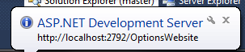

1. To view the Silverlight portion of the assignment, Right click on **OptionsSilverlightTestPage.aspx** and click **View In Browser**.
2. To view the WP7 portion of the assignment, Click on the head node of the WP7 project and run with **F5** or **Ctrl + F5**.