COMP8006 Assignment 1
Chris Wood
A00741285
Objective: To implement and test a simple personal Linux firewall.

Firewall rules:
Incoming/outgoing SSH (port 22) packets are ACCEPT
Incoming/outgoing www (port 80 and 443) packets are ACCEPT
Incoming connections to port 80 from ports 0-1023 are DROP
Incoming connections to port 0 are DROP
Incoming connections from port 0 are DROP

All other incoming/forwarded/outgoing packets are DROP

Other common incoming malformed packets should also be DROP. Examples of these packets include
- Only URG flag set
- SYN FIN flags set
- SYN RST flags set
- SYN FIN PSH flags set
- SYN FIN RST PSH flags set
- Only FIN flag set
- FIN URG PSH flags set
- All flags set (xmas tree)
- No flags set (null)
- Incoming SYN packets
Script “fw” outputs the following rules with iptables -L
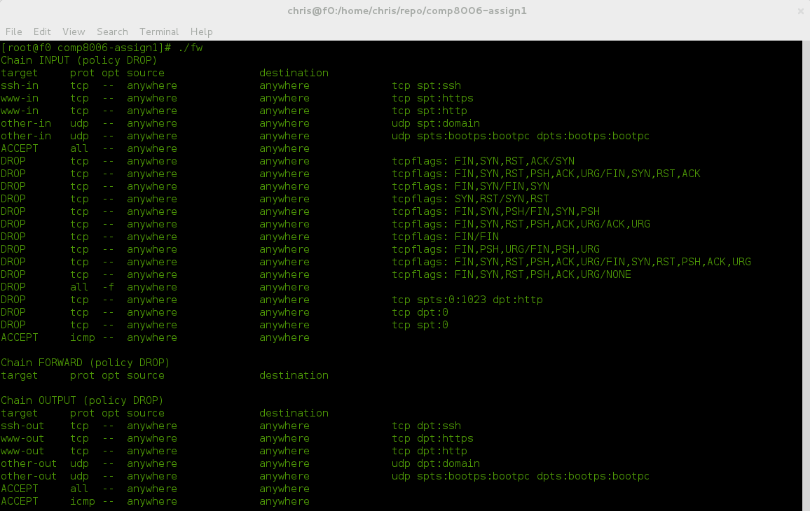
Files:
“fw” -- firewall script
“revert” -- reverts iptables back to no entries

Testing:
The environment for setting is as follows:
name OS version internal IP system type external IP
f0 Fedora 17 32bit 192.168.1.101 host OS 24.87.47.120
cent0 centOS 6.3 32bit DHCP assigned VM on f0 24.87.47.120
deuterium89 centOS 6.0 32bit n/a external VPS 209.141.54.90

note: due to the fact that cent0 is hosted on f0, ip accounting data may appear double than expected.

ssh Test scenario #1 | Expected Result
Connect via ssh from external machine | SSH connection successful
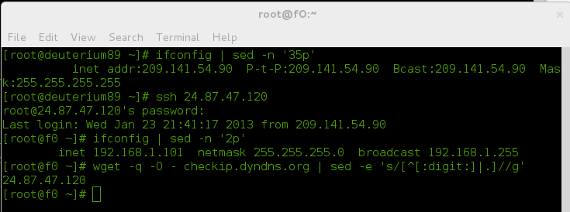
Test command | Result and comments
See above screenshot | Able to successfully connect from external host

ssh Test scenario #2 | Expected Result
Crafted packet from port 22 | 100% reply, no lost packets

Test command | Result and comments
Hping 192.168.1.101 -S -c 5 -p 22 | 100% reply, 0% packet loss

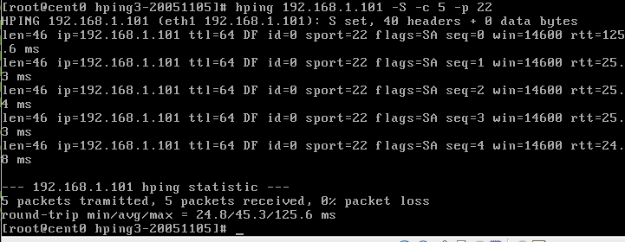

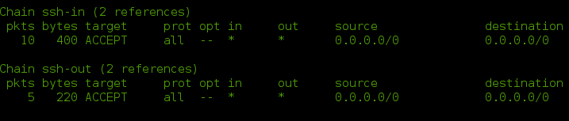
Further analysis of the IP accounting user-defined chains show 10 pkts in ssh-in 5 going to f0 and 5 going in to cent0 running hping3 (DHCP assigned VM running on same host). 5 pkts on ssh-out is the communication out from f0 > cent0.

www Test scenario #1 | Expected Result
Internet browser to www.bcit.ca | Page loads without problem



Test command | Result and comments
See above screenshot | Page loads without problem. One thing to note was that did not intially account for https(port 443) and could not load google and spend a large period of time thinking something was wrong

www Test scenario #2 | Expected Result
Crafted packet from port 80 | 100% reply, no lost packets

Test command | Result and comments
Hping 192.168.1.101 -S -c 5 -p 80 | 5 reply, 0% packet loss
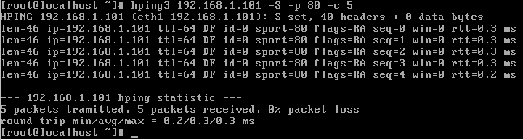
www Test scenario #3 | Expected Result
Crafted packed from port 443 | 100% reply, no lost packets

Test command | Result and comments
Hping 192.168.1.101 -S -c 5 -p 443 | 5 reply, 0% packet loss
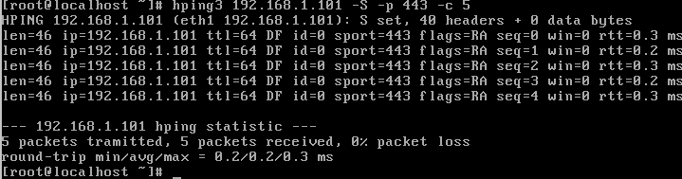

dport 80 from sport 0:1024 Test scenario # 1 | Expected Result
Crafted packet to port 80 from port 22 | Dropped; no reply

Test command | Result and comments
Hping3 192.168.1.101 -S -p 80 -s 22 -c 5 | 0 packet received, 100% packet loss
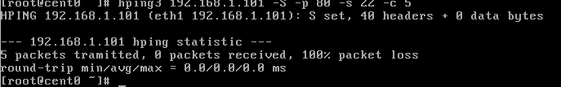
dport 80 from sport 0:1024 Test scenario # 2 | Expected Result
Crafted packet to port 80 from port 666 | Dropped; no reply

Test command | Result and comments
Hping3 192.168.1.101 -S -p 80 -s 666 -c 5 | 0 packets received, 100% packet loss

dport 80 from sport 0:1024 Test scenario # 3 | Expected Result
Crafted packet to port 80 from port 1010 | Dropped; no reply

Test command | Result and comments
Hping3 192.168.1.101 -S -p 80 -s 1010 -c 5 | 0 packets received, 100% packet loss

sport 0 Test scenario # 1 | Expected Result
Crafted sport 0 packet | Dropped; no reply

Test command | Result and comments
Hping3 192.168.1.101 -S -s 0 -c 5 | 0 packets received, 100% packet loss
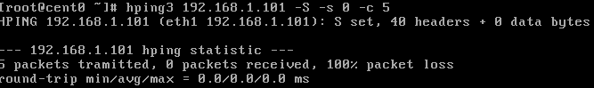

dport 0 Test scenario # 1 | Expected Result
Crafted dport 0 packet | Dropped; no reply

Test command | Result and comments
Hping3 192.168.1.101 -S -p 0 -c 5 | 0 packets received, 100% packet loss
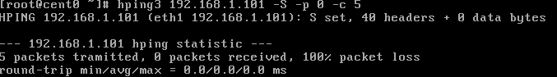

Bad packet scenario # 1 | Expected Result
Crafted xmas packet | Dropped; no reply

Test command | Result and comments
Hping3 192.168.1.101 -X -c 5 | 0 packets received, 100% packet loss

Bad packet scenario # 2 | Expected Result
Crafted SYNFIN packet | Dropped; no reply

Test command | Result and comments
Hping3 192.168.1.101 -S -F -c 5 | 0 packets received, 100% packet loss

Bad packet scenario # 3 | Expected Result
Crafted URG packet | Dropped; no reply

Test command | Result and comments
Hping3 192.168.1.101 -U -c 5 | 0 packets received, 100% packet loss

Other test | Expected Result
Nonclassified connections port 47390 | Dropped; no reply

Test command | Result and comments
Hping3 192.168.1.101 -S -p 47390 | 0 packets received, 100% packet loss
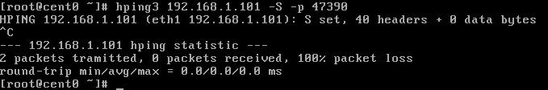
IP Accounting
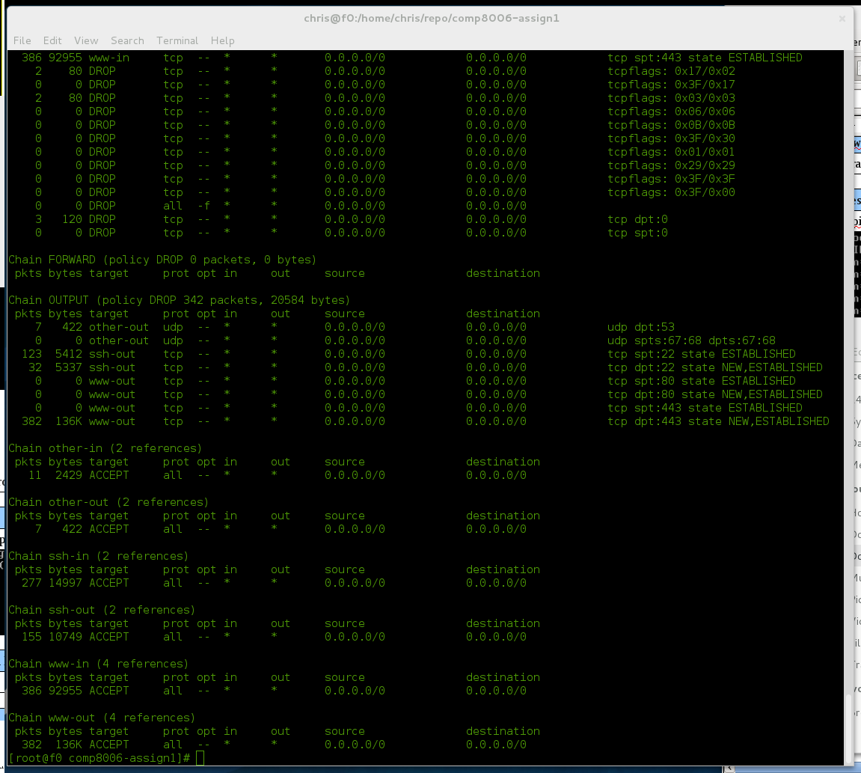
User-defined chains helped in tracking expected and unexpected connections in iptables. In combination with hping, setting the number of packets to bet sent allowed statistical tracking of items being dropped and accepted.

Conclusion
- Order of iptables entries in script matters in behavior of firewall
- stateful module helpful in dodging weird behavior with rules for stateful connections like ssh and www
- user-defined chains useful for tracking packets when used in proper set up

Examples of bad tcp packets found from http://books.google.ca/books?id=PyqjvNNltqYC&pg=PA113&lpg=PA113&dq=list+of+bad+tcp+flags&source=bl&ots=XDmO7vUAfP&sig=wgIsucpaXc6Mheo2DR4NNOHVwl0&hl=en&sa=X&ei=VLoAUc2fGc3siQKr64DgBw&ved=0CC4Q6AEwAA#v=onepage&q=list%20of%20bad%20tcp%20flags&f=false

