Following information is required for drafting of patent application.

- Full name, nationality and address of applicant(s):

Full Name | Nationality | Address
Vishwakarma Institute of Technology | Indian | 666, Upper Indiranagar, Bibwewadi, Pune, Maharashtra, India – 411 037

- Full name (including middle name), nationality, address (VIT/VIIT address), mail id, and phone number of inventor(s):

Full Name (Including middle name) (Min. two faculty names) | Nationality | VIT/VIIT Address (Start with full dept. name followed by full institute name) (For ex.) | Mail ID | Phone No.
Prathamesh Prakash Katole | Indian |  | prathamesh.1251070781@vit.edu | 9309791149
Priyal Pramod Tiwari | Indian |  | priyal.1251070502@vit.edu | 7738270977
Purushottam Sopan Kale | Indain |  | purushottam.1251070794@vit.edu | 7249442781

Copy and paste clear soft copy of signatures of all inventors in the following table: (Insert or delete the cells as per number of inverters)

 |  | 
Name 1: Prathamesh Katole | Name 2 : Priyal Tiwari | Name 3: Purushottam Kale

- Title of the invention:

RFID-Authenticated Quadcopter-Based Autonomous Medicine Delivery System
It is an unmanned aerial vehicle (UAV) system that combines autonomous quadcopter flight control with an RFID-secured cargo release mechanism, enabling secure, contactless delivery of medical supplies to authorized recipients.
- Technical field of the invention:

This invention pertains to the fields of unmanned aerial vehicle (UAV) engineering, embedded real-time control systems, and medical logistics automation. Specifically, it integrates PID-stabilized quadcopter flight control with a radio-frequency identification (RFID)-based secure cargo locking and release mechanism for last-mile medicine delivery, operating entirely on a single low-cost ATmega328P microcontroller.

- Prior art:
- Existing drone delivery systems, such as those developed by Wing (Alphabet) and Amazon Prime Air, employ high-cost proprietary autopilot hardware, GPS waypoint navigation, and advanced computer vision for package release. These systems are prohibitively expensive and rely on proprietary components that are inaccessible for small-scale or developing-world healthcare applications.

- Some academic prototypes use Arduino-based flight controllers for basic hover stabilization, but they lack any form of secure payload authentication or controlled release. The cargo is typically dropped via simple servo actuation without verifying the identity of the recipient, creating a significant security gap for sensitive medical payloads.
- RFID-based access control systems exist independently in door locks, inventory management, and warehouse automation, but they have not been integrated into a UAV airframe for in-flight or on-landing cargo authentication and release.
- No existing solution combines real-time PID-stabilized quadcopter flight, interrupt-driven receiver decoding, IMU sensor fusion, and RFID-authenticated timed cargo release into a single, affordable, open-source microcontroller platform.

- Object:

- To design a quadcopter-based medicine delivery system that integrates autonomous PID-stabilized flight control (pitch, roll, and yaw stabilization using MPU6050 IMU sensor fusion) with an RFID-authenticated secure cargo locking and timed release mechanism, all operating on a single Arduino UNO microcontroller.
- To enable secure, contactless delivery of medical supplies where only authorized recipients bearing a pre-registered RFID tag can unlock the delivery compartment.
- To provide a low-cost, reproducible, and open-source UAV delivery platform suitable for deployment in rural healthcare facilities, disaster relief zones, and resource-constrained medical logistics scenarios.

- Synopsis:

- The invention is a quadcopter-based medicine delivery drone that combines real-time flight stabilization with an RFID-authenticated secure cargo release system. The platform is built around a single Arduino UNO (ATmega328P) microcontroller that simultaneously executes a 250 Hz PID stabilization loop and manages the cargo lock state machine.
- The Flight Control Subsystem uses an MPU6050 inertial measurement unit (accelerometer and gyroscope) to compute real-time pitch and roll angles via a complementary filter (98% gyroscope, 2% accelerometer). Independent PID controllers for roll, pitch, and yaw generate correction signals that are mixed with the pilot throttle command and distributed to four 30A electronic speed controllers (ESCs) driving 1000kV brushless DC motors in a standard X-configuration. An FS-CT6B 6-channel 2.4 GHz transmitter provides manual flight inputs via interrupt-driven pulse capture.

- The Secure Cargo Subsystem comprises an MFRC522 RFID reader module and a high-torque servo motor actuating the medicine container latch. Upon landing at the delivery site, the RFID reader scans for a 13.56 MHz passive tag. If the scanned UID matches the pre-authorized credential (stored in firmware), the cargo servo rotates to 90° (unlocked position) for exactly 10 seconds, after which it automatically returns to 0° (locked position). The pilot retains a manual override capability via a transmitter auxiliary switch.
Experiments confirmed stable hover with less than ±2° attitude deviation, reliable RFID tag detection at distances up to 4 cm, and consistent 10-second timed release cycles. The system provides a unified, low-cost, and secure solution for last-mile medical delivery compared to existing standalone UAV or RFID technologies.

- Brief description of drawings :

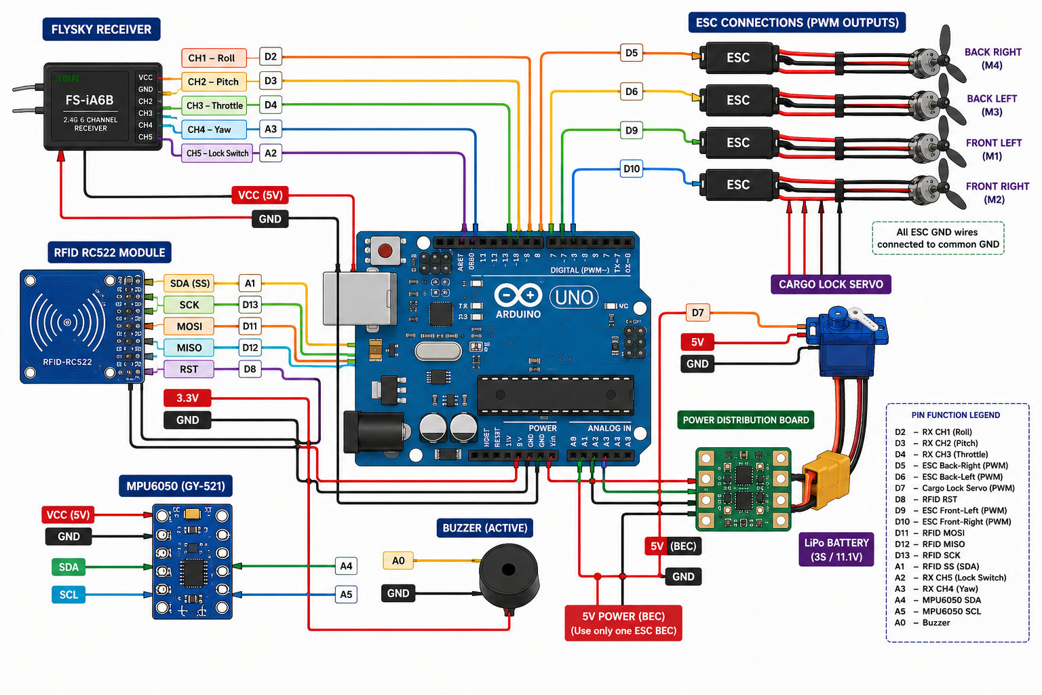
Description of the invention:
The invention's technical field -
The present invention belongs to the fields of unmanned aerial vehicle (UAV) engineering, embedded real-time control systems, and automated medical logistics. More precisely, the invention provides a quadcopter medicine delivery drone system that uses a single Arduino UNO microcontroller, an MPU6050 inertial measurement unit, an MFRC522 RFID reader, and four brushless DC motor/ESC assemblies to combine PID-stabilized quadcopter flight control with RFID-authenticated secure cargo locking and timed release. Through the integration of real-time attitude estimation, interrupt-driven radio receiver decoding, and contactless cargo authentication into a single embedded platform, the system enables safe, secure, and autonomous delivery of medical supplies to verified recipients.

Subsystem for Flight Control and Stabilization
The central processing unit for all flight operations is the Arduino UNO microcontroller (ATmega328P, 16 MHz, 32 KB flash).
An MPU6050 six-axis inertial measurement unit, communicating over I2C at 400 kHz, provides raw accelerometer and gyroscope data at a 1 kHz internal sample rate. The firmware applies a software low-pass filter (α = 0.90) to the accelerometer-derived angles and a complementary filter (98% gyroscope integration, 2% filtered accelerometer) to compute drift-free pitch and roll estimates at the 250 Hz control loop rate.
An FS-CT6B 6-channel 2.4 GHz transmitter and receiver provides pilot manual control inputs. Roll and pitch channels are captured on hardware external interrupts (INT0 on D2, INT1 on D3), while throttle, yaw, and auxiliary switch channels are captured via AVR pin-change interrupts (PCINT) with direct port register reading for minimal latency.
Independent PID controllers compute correction signals for roll, pitch, and yaw axes with tuned gains (Kp=1.4, Ki=0.02, Kd=3.5 for roll/pitch; Kp=2.5, Ki=0.06, Kd=0.0 for yaw rate). The derivative term includes a low-pass filter (α = 0.70) to suppress high-frequency noise. Integral windup is prevented by clamping the accumulated integral to ±400.
Four 30A electronic speed controllers (ESCs) drive four 1000kV brushless DC motors in an X-configuration. PID outputs are mixed with the base throttle using the standard quadcopter motor mixing equations. Output pulse widths are clamped between 1100 µs (minimum spin to prevent stutter) and 1900 µs (safety ceiling).

Subsystem for Secure Cargo Locking and Release
The secure cargo subsystem is managed by the same Arduino UNO microcontroller as a non-blocking background task.
An MFRC522 RFID reader module, connected via the SPI bus (SS on A1, RST on D8, MOSI on D11, MISO on D12, SCK on D13), continuously scans for 13.56 MHz ISO 14443A passive RFID tags. When a tag is detected, its 4-byte UID is compared against a pre-authorized credential stored in firmware flash memory.
Upon successful UID verification, a high-torque servo motor (connected to D7) rotates from the locked position (0°) to the unlocked position (90°), releasing the medicine compartment latch. The servo remains in the unlocked position for exactly 10,000 milliseconds (10 seconds), tracked using non-blocking millis()-based timing. After the hold period expires, the servo automatically returns to 0° (locked position). If an unauthorized tag is scanned, the system logs the rejection and the cargo remains locked.
A manual override is provided via the transmitter's auxiliary switch (Channel 5). When the pilot toggles the switch (pulse width > 1600 µs), the cargo lock is forced open regardless of RFID state. When toggled back (pulse width < 1600 µs), the lock returns to RFID-controlled mode. Servo write commands are gated to execute only on state transitions, preventing continuous timer interrupts from introducing jitter into the ESC motor signals.

Power Distribution and Regulation
A 3S lithium polymer (LiPo) battery (11.1V nominal, 2200 mAh, 30C discharge rate) provides the primary power source for the entire system.
A DIY power distribution board (PDB) splits the raw battery voltage into parallel feeds for the four ESCs and a 5V Battery Eliminator Circuit (BEC). The BEC provides a regulated 5V supply to the Arduino UNO, MPU6050, RFID module, and cargo servo, filtering out high-frequency electromagnetic interference (EMI) from the ESC switching circuits.

No. | Part Name | Description
1 | Arduino UNO (ATmega328P) | Central microcontroller executing the 250 Hz flight stabilization loop, receiver signal decoding, RFID authentication, and cargo servo control.
2 | MPU6050 IMU Sensor | Six-axis accelerometer and gyroscope providing real-time pitch, roll, and yaw rate measurements over I2C at 400 kHz.
3 | MFRC522 RFID Module | 13.56 MHz SPI-based RFID reader for contactless scanning of passive ISO 14443A tags for cargo authentication.
4 | FS-CT6B Transmitter/Receiver | 6-channel 2.4 GHz AFHDS radio control system providing pilot manual inputs for throttle, roll, pitch, yaw, and auxiliary switches.
5 | 1000kV BLDC Motors (×4) | Brushless outrunner motors providing quadcopter propulsion in X-configuration.
6 | 1045 Propellers (×4) | 10-inch diameter, 4.5-inch pitch propellers (2× CW, 2× CCW) generating aerodynamic lift.
7 | 30A ESCs (×4) | Electronic speed controllers translating Arduino PWM signals (1000–2000 µs) to three-phase BLDC motor drive.
8 | High-Torque Servo Motor | Actuates the mechanical latch of the medicine cargo compartment (0° locked, 90° unlocked).
9 | 3S LiPo Battery (11.1V, 2200 mAh) | Primary power source providing high current capacity for motors and regulated logic power.
10 | Battery Eliminator Circuit (BEC) | Switching voltage regulator stepping down 11.1V to stable 5V for logic components.
11 | Power Distribution Board (PDB) | DIY copper bus board distributing raw battery power to ESCs and BEC.
12 | Active Piezo Buzzer | Provides audio feedback for system status: startup confirmation, arming/disarming, and low battery warning.
13 | F450 Quadcopter Frame | Structural airframe housing all electronic components with bottom-mounted cargo compartment.
14 | Medicine Cargo Container | Secure enclosure attached below the airframe for storing and protecting medical payload during transit.

Validation and Experiments
- Flight Stability Testing: The PID-stabilized quadcopter maintained hover with less than ±2° pitch and roll deviation under calm indoor conditions. The complementary filter effectively rejected high-frequency vibration noise from the propellers, and the sponge-mounted MPU6050 sensor provided clean attitude readings. The 250 Hz loop rate ensured responsive correction with no observable control lag.
- Receiver Signal Integrity: Interrupt-driven pulse capture on all five receiver channels (roll, pitch, throttle, yaw, auxiliary switch) provided consistent signal decoding with no dropped frames. The signal validation range (800–2200 µs) successfully rejected noise spikes and power-on transients.
- RFID Authentication Accuracy: The MFRC522 module reliably detected and authenticated authorized RFID tags at distances up to 4 cm. Unauthorized tags were correctly rejected with zero false positives. The 10-second timed release cycle operated consistently using non-blocking millis()-based timing without interfering with the flight stabilization loop.

- Cargo Lock Mechanism: The servo latch reliably engaged and disengaged the medicine compartment. The manual transmitter override functioned correctly, and the state-change-gated servo write logic prevented observable jitter on the ESC motor signals.
- Battery Performance: The 3S 2200 mAh LiPo battery provided approximately 8–10 minutes of flight time under moderate throttle, sufficient for short-range delivery missions within a 500-meter radius.

Best method of performance of the invention:

The best method of performing the invention involves assembling the flight control and cargo security subsystems on a single Arduino UNO microcontroller in a structured manner. The MPU6050 IMU sensor is connected via the I2C bus (SDA on A4, SCL on A5) and configured for ±250°/s gyroscope sensitivity and ±2g accelerometer sensitivity with the internal DLPF set to 42 Hz. The FS-CT6B receiver channels are connected to interrupt-capable pins (D2, D3 for external interrupts; D4, A2, A3 for pin-change interrupts). Four 30A ESCs are connected to PWM-capable pins (D5, D6, D9, D10) and initialized at 1000 µs (disarmed state) with a 3-second arming delay. The MFRC522 RFID reader is connected via the SPI bus (SS on A1, RST on D8) and the cargo servo is connected to D7. During operation, the 250 Hz main loop reads raw IMU data, computes calibrated gyroscope rates and accelerometer angles, applies the complementary filter to estimate pitch and roll, computes PID correction outputs for all three axes, mixes the corrections with the pilot throttle command, and writes the resulting pulse widths to the four ESCs. Concurrently, the RFID reader polls for new tags and, upon matching the stored authorized UID, commands the cargo servo to unlock for 10 seconds. The pilot retains manual override capability through the transmitter auxiliary switch. The entire system is powered by a 3S LiPo battery through a PDB and BEC, and is mounted on an F450 quadcopter frame with the medicine container secured underneath.

- CLAIMS:
- A medicine delivery drone system comprising an Arduino UNO-based flight control unit integrating an MPU6050 IMU sensor, a complementary filter for attitude estimation, independent PID controllers for roll, pitch, and yaw stabilization, and four ESC-driven brushless DC motors in X-configuration.
- A secure cargo release subsystem comprising an MFRC522 RFID reader module connected via SPI bus, a servo-actuated mechanical latch, and a firmware-controlled 10-second timed release mechanism that unlocks only upon successful UID verification.
- An interrupt-driven receiver signal decoding system utilizing AVR external interrupts and pin-change interrupts with direct port register reading for zero-latency capture of 6-channel 2.4 GHz radio control inputs.
- A combined system that integrates real-time PID-stabilized quadcopter flight control with RFID-authenticated secure cargo locking and timed release into a single embedded microcontroller platform for autonomous medicine delivery.\

- Inventive step of your invention:

The present invention offers a single integrated system that combines real-time PID-stabilized quadcopter flight control, interrupt-driven multi-channel radio receiver decoding, IMU sensor fusion, and RFID-authenticated timed cargo release on a single low-cost ATmega328P microcontroller, in contrast to conventional drone delivery systems that rely on expensive proprietary autopilot hardware and lack recipient authentication. In contrast to the majority of prior art, the system integrates contactless RFID verification directly into the UAV airframe, ensuring that medical payloads are released only to authorized recipients. Utilizing readily available sensors and an inexpensive Arduino UNO microcontroller, the invention provides a portable, reproducible, and cost-effective solution that can be widely adopted in resource-constrained healthcare environments while guaranteeing payload security and flight safety.

- Industrial application:

The invention finds application in the domains of medical logistics, emergency healthcare delivery, and pharmaceutical supply chain automation, where it can be employed as a low-cost autonomous aerial delivery platform for transporting medicines, vaccines, blood samples, and diagnostic kits to remote or underserved locations. Because it offers RFID-authenticated secure cargo release, it is especially advantageous for controlled-substance delivery where recipient identity verification is mandatory. Additionally, the system can be deployed for disaster relief medical supply drops, hospital-to-clinic inter-facility transfers, and rural primary healthcare center resupply operations. The open-source Arduino-based design makes the invention ideal for both institutional adoption and widespread replication in developing healthcare ecosystems.

- Abstract:

This invention discloses a quadcopter-based medicine delivery drone system that combines real-time PID-stabilized flight control with an RFID-authenticated secure cargo release mechanism. The flight control subsystem uses an Arduino UNO microcontroller with an MPU6050 IMU sensor, a complementary filter, and independent PID controllers for roll, pitch, and yaw stabilization, driving four brushless DC motors via ESCs in X-configuration. The secure cargo subsystem uses an MFRC522 RFID reader to verify recipient credentials and a servo-actuated latch that unlocks for exactly 10 seconds upon authorized tag detection. An FS-CT6B 6-channel 2.4 GHz radio control system provides pilot manual inputs with a manual cargo override switch. For autonomous medicine delivery applications, the invention enhances payload security, delivery reliability, and recipient authentication at low cost.

