# SCHOOL OF COMPUTER SCIENCE AND ENGINEERING DEPARTMENT OF INTELLIGENT SYSTEM

**LOVELY PROFESSIONAL UNIVERSITY, JALANDHAR**

## FORMAT FOR PREPARING PROJECT REPORT

The purpose of the report is to explain overall working of the project. The report should contain an account of the activity for whole of project and as well as implementation of its working.

1. First Page (Appendix 1)
2. Declaration Page (Appendix 2)
3. Table of Contents (Appendix 3)
4. Bonafide Certificate for Supervisor Details (Appendix 4)
5. Background and objectives of the project assigned.

An introductory description (2-3 pages) of the project with respect to: Background, motivation and outcome of project and concrete goals and objectives.

1. Description of Project

The students are required to provide description in terms of modules and prepare pictorial flow of project.

1. Description of Work Division in terms of Roles among Students.

Here students are required to explain the work done by each student for roles allotted in project.

1. Implementation of scheduled work of Project

The students are required to provide implementation of project in terms of its working and provide screenshots of code and outputs with proper explanation.

1. Technologies and Framework to be used.

The students are required to mention the technology and platform to be used in project.

1. SWOT Analysis achieved in project.

Include an analysis of project in terms of Strengths, Weaknesses, Opportunities and Threats. Strengths and weaknesses refer to the internal capabilities of the project, .e. are under its control, and should be regarded relative to competitors, whereas opportunities and threats are found in the external environment, usually outside the control of the project.

Typing Instructions:

The impression on the typed copies should be black in color. One and a half spacing should be used for typing the text, and shall be typed in the Font style ‘Times New Roman’ and Font size 12, unless otherwise stated explicitly.

## APPENDIX 1

**TIC-TAC-TOE GAME WITH TIMER**

PROJECT REPORT

Submitted

***by***

**NAME OF THE CANDIDATE(S)**

Suren Rana

Saroj Lamsal

Nirmal Chhetri

Section:K19PB

Roll-Number(s):21,51,45



**Department of Information Technology**

**School of Computer Science Engineering**

**Lovely Professional University, Jalandhar**

Month-Year-NOVEMBER-2020

## APPENDIX 2

**Student Declaration**

This is to declare that this report has been written by us. No part of the report is copied from other sources. All information included from other sources have been duly acknowledged.

Suren Rana

Roll number: 45

Saroj Lamshal

Roll Number:21

**APPENDIX 3**

(A typical specimen of table of contents)

<Font Style Times New Roman>

**TABLE OF CONTENTS**

**TITLE PAGE NO.**

|  |  |
| --- | --- |
| **1. Background and objectives of project assigned** | **1** |
| **1.1 What is tkinter ?** | **1** |
| **1.1.1 MySql** | **2** |
| **1.1.2 How it works** | **2** |

**Background and objectives of project assigned**

**What is an Job Application Portal?**

A job application is an official form that employers ask all applicants for a position to fill out. You may fill out the application through a third-party job listing site or by visiting the website of the potential employer. Some employers may ask you to fill out a paper application.

**What is tkinter ?**

This program use tkinter framework of python to create GUI interface. Tkinter is Python's de-facto standard GUI (Graphical User Interface) package. It is a thin object-oriented layer on top of **[Tcl/Tk](http://www.tcl.tk/)**

**MySql**

MySQL Database Service is a fully managed database service to deploy cloud-native applications using the world’s most popular open source database. It is 100% developed, managed and supported by the MySQL Team.

**How it works**

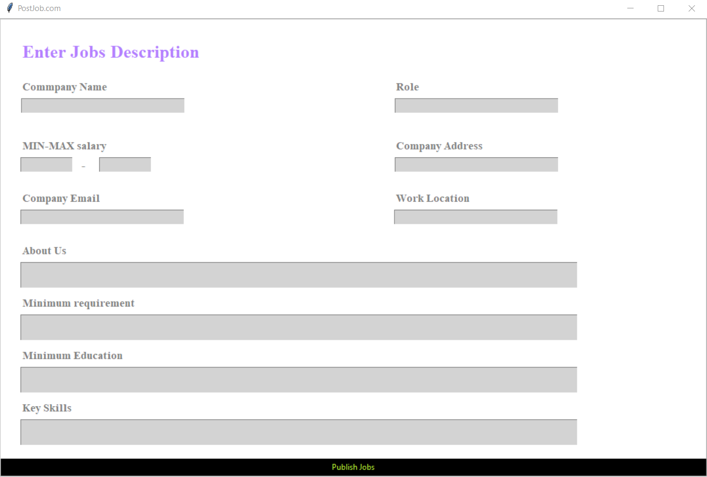

This is a simple interface with all the things necessary for a company to post a job online. This this gui is connected with Mysql databases to do to store its all information in it. In this field where we can entry the data and post the data .