

**CENTRO UNIVERSITÁRIO DE JAGUARIÚNA**

**VINICIUS FACCINI DE OLIVEIRA RA: 11819501**

**VINICIUS MONTEIRO ORLANDI RA: 11820741**

**GUSTAVO CARLINI RA: 11820741**

**REDES DE COMPUTADORES**

**JAGUARIÚNA**

**2019**

**TOPOLOGIA DE REDES DA SPEECH TECH CORPORATION S/A**

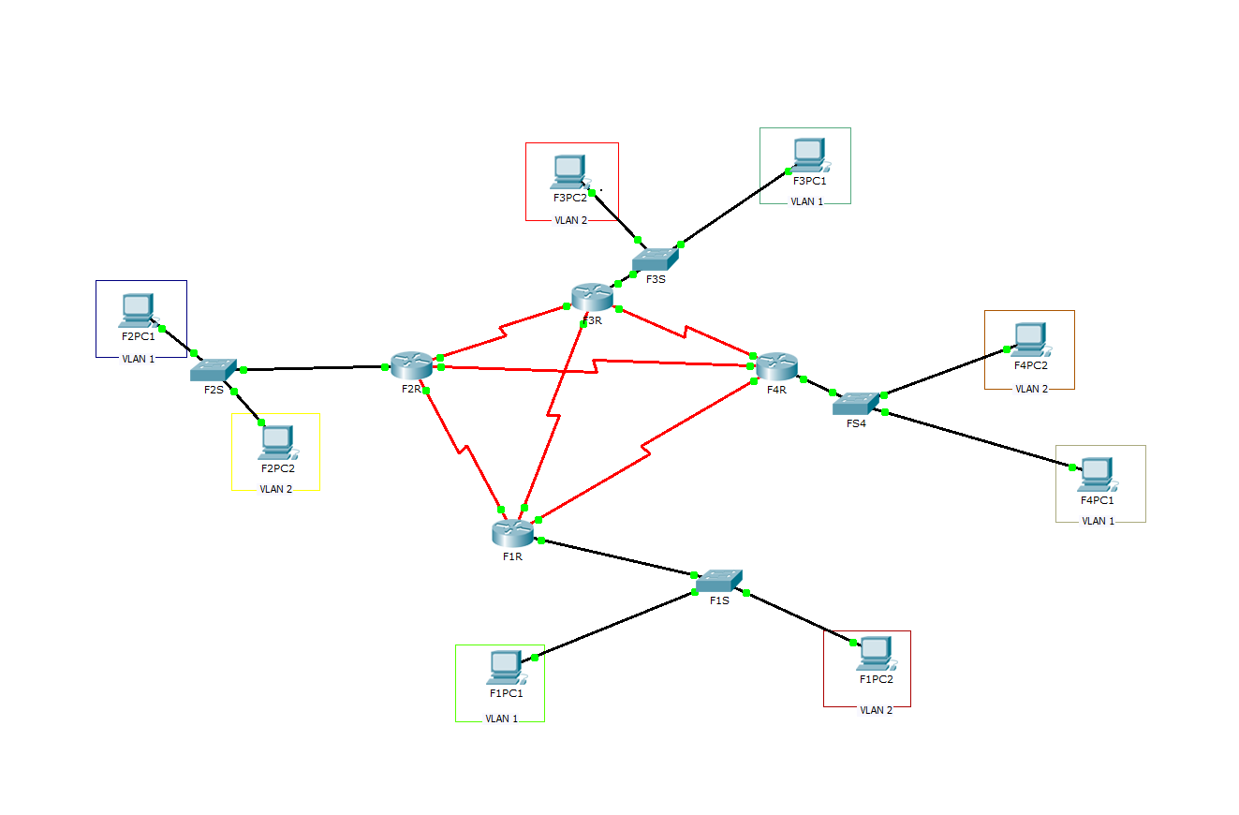

De acordo com os requisitos deveria haver quatro roteadores conectados entre si. Cada roteador pertence a uma filial da empresa, onde cada filial deveria possuir duas VLANs e cada VLAN ter um computador pertencente a ela.

**INFORMAÇÕES GERAIS DO PROJETO**

* Informações das subredes das filiais da Speech Tech Corporation S/A

|  |  |  |  |
| --- | --- | --- | --- |
| **Localização** | **ID da Rede da Subrede** | **Máscara da Subrede** | **Intervalo Válido** |
| **F1** | 164.13.10.0/25 | 255.255.255.128 | 164.13.10.1/25 - 164.13.10.126/25 |
| **F2** | 164.13.8.0/23 | 255.255.254.0 | 164.13.8.1/23 - 164.13.9.254/23 |
| **F3** | 164.13.10.128/26 | 255.255.255.192 | 164.13.10.129/26 - 194.13.10.190/26 |
| **F4** | 164.13.0.0/21 | 255.255.248.0 | 164.13.0.1/21 - 164.13.7.254/21 |

* Informações das vlans de cada filial

|  |  |  |  |  |
| --- | --- | --- | --- | --- |
| **Localização** | **VLAN** | **ID da Rede da Subrede** | **Máscara da Subrede** | **Intervalo Válido** |
| **F1** | VLAN 1 | 164.13.10.0/26 | 255.255.255.192 | 164.13.10.0/26 - 194.13.10.63/26 |
| VLAN 2 | 164.13.10.64/26 | 164.13.10.65/26 - 194.13.10.126/26 |
| **F2** | VLAN 1 | 164.13.8.0/24 | 255.255.255.0 | 164.13.8.1/24 - 164.13.8.254/24 |
| VLAN 2 | 164.13.9.0/24 | 164.13.9.1/24 - 164.13.9.254/24 |
| **F3** | VLAN 1 | 164.13.10.128/27 | 255.255.255.224 | 164.13.10.129/27 - 164.13.10.158/27 |
| VLAN 2 | 164.13.10.160/27 | 164.13.10.161/27 - 164.13.10.190/27 |
| **F4** | VLAN 1 | 164.13.0.0/22 | 255.255.252.0 | 164.13.0.1/22 - 164.13.3.254/22 |
| VLAN 2 | 164.13.4.0/22 | 164.13.4.1/22 - 164.13.7.254/22 |

* Designações das portas dos switchs de cada filial

|  |  |  |  |
| --- | --- | --- | --- |
| **Localização** | **VLAN** | **Portas** | **Atribuições** |
| F1S | VLAN 1 | Fa0/4 - Fa0/13 | 1 e default |
| VLAN 2 | Fa0/14 – Fa0/24 | 2 e VLAN0002 |
| F2S | VLAN 1 | Fa0/4 - Fa0/13 | 1 e default |
| VLAN 2 | Fa0/14 – Fa0/24 | 2 e VLAN0002 |
| F3S | VLAN 1 | Fa0/4 - Fa0/13 | 1 e default |
| VLAN 2 | Fa0/14 – Fa0/24 | 2 e VLAN0002 |
| F4S | VLAN 1 | Fa0/4 - Fa0/13 | 1 e default |
| VLAN 2 | Fa0/14 – Fa0/24 | 2 e VLAN0002 |

* Subredes ponto a ponto da Speech Tech Corporation S/A

|  |  |  |  |  |
| --- | --- | --- | --- | --- |
| **Ponto a Ponto** | **Interface** | **Endereço IP** | **ID da Rede da Subrede** | **Máscara da Subrede** |
| **F1R**  **F2R** | Se0/1/0 | 164.13.10.193/30 | 164.13.10.192/30 | 255.255.255.252 |
| Se0/1/0 | 164.13.10.194/30 |
| **F1R**  **F3R** | Se0/2/0 | 164.13.10.197/30 | 164.13.10.196/30 | 255.255.255.252 |
| Se0/1/0 | 164.13.10.198/30 |
| **F1R**  **F4R** | Se0/3/0 | 164.13.10.201/30 | 164.13.10.200/30 | 255.255.255.252 |
| Se0/1/0 | 164.13.10.202/30 |
| **F2R**  **F3R** | Se0/2/0 | 164.13.10.205/30 | 164.13.10.204/30 | 255.255.255.252 |
| Se0/2/0 | 164.13.10.206/30 |
| **F2R**  **F4R** | Se0/3/0 | 164.13.10.209/30 | 164.13.208/30 | 255.255.255.252 |
| Se0/2/0 | 164.13.10.210/30 |
| **F3R**  **F4R** | Se0/3/0 | 164.13.10.213/30 | 164.13.212/30 | 255.255.255.252 |
| Se0/3/0 | 164.13.10.214/30 |

**INFORMAÇÕES ESPECÍFICAS DE CADA FILIAL**

|  |  |  |  |  |
| --- | --- | --- | --- | --- |
| **Filial 1** | **Interfaces** | **Endereço IP** | **Máscara subrede** | **Gateway padrão** |
| VLAN 1 | Fa0/4 – Fa0/13 | 164.13.10.1/26 | 255.255.255.192 | - |
| VLAN 2 | Fa0/14 – Fa0/24 | 16.13.10.65/26 | 255.255.255.192 | - |
| F1PC1(VLAN1) | Fa0 | 164.13.10.2/26 | 255.255.255.192 | 164.13.10.1 |
| F1PC2(VLAN2) | Fa0 | 164.13.10.66/26 | 255.255.255.192 | 164.13.10.65 |
| F1R | Fa0/0.1 | 164.13.10.1/26 | 255.255.255.192 | - |
| Fa0/0.2 | 16.13.10.65/26 | 255.255.255.192 | - |
| Se0/1/0 | 164.13.10.193/30 | 255.255.255.252 | - |
| Se0/2/0 | 164.13.10.197/30 | 255.255.255.252 | - |
| Se0/3/0 | 164.13.10.201/30 | 255.255.255.252 | - |

|  |  |  |  |  |
| --- | --- | --- | --- | --- |
| **Filial 2** | **Interfaces** | **Endereço IP** | **Máscara subrede** | **Gateway padrão** |
| VLAN 1 | Fa0/4 – Fa0/13 | 164.13.8.1/24 | 255.255.255.0 | - |
| VLAN 2 | Fa0/14 – Fa0/24 | 16.13.9.1/24 | 255.255.255.0 | - |
| F2PC1(VLAN1) | Fa0 | 164.13.8.2/24 | 255.255.255.0 | 164.13.8.1 |
| F2PC2(VLAN2) | Fa0 | 164.13.9.2/24 | 255.255.255.0 | 164.13.9.1 |
| F2R | Fa0/0.1 | 164.13.8.1/24 | 255.255.255.0 | - |
| Fa0/0.2 | 16.13.9.1/24 | 255.255.255.0 | - |
| Se0/1/0 | 164.13.10.194/30 | 255.255.255.252 | - |
| Se0/2/0 | 164.13.10.205/30 | 255.255.255.252 | - |
| Se0/3/0 | 164.13.10.209/30 | 255.255.255.252 | - |

|  |  |  |  |  |
| --- | --- | --- | --- | --- |
| **Filial 3** | **Interfaces** | **Endereço IP** | **Máscara subrede** | **Gateway padrão** |
| VLAN 1 | Fa0/4 – Fa0/13 | 164.13.10.129/27 | 255.255.255.224 | - |
| VLAN 2 | Fa0/14 – Fa0/24 | 164.13.10.161/27 | 255.255.255.224 | - |
| F3PC1(VLAN1) | Fa0 | 164.13.10.130/27 | 255.255.255.224 | 164.13.10.129 |
| F3PC2(VLAN2) | Fa0 | 164.13.10.162/27 | 255.255.255.224 | 164.13.10.161 |
| F3R | Fa0/0.1 | 164.13.10.129/27 | 255.255.255.224 | - |
| Fa0/0.2 | 164.13.10.161/27 | 255.255.255.224 | - |
| Se0/1/0 | 164.13.10.198/30 | 255.255.255.252 | - |
| Se0/2/0 | 164.13.10.206/30 | 255.255.255.252 | - |
| Se0/3/0 | 164.13.10.213/30 | 255.255.255.252 | - |

|  |  |  |  |  |
| --- | --- | --- | --- | --- |
| **Filial 4** | **Interfaces** | **Endereço IP** | **Máscara subrede** | **Gateway padrão** |
| VLAN 1 | Fa0/4 – Fa0/13 | 164.13.0.1/22 | 255.255.252.0 | - |
| VLAN 2 | Fa0/14 – Fa0/24 | 164.13.4.1/22 | 255.255.252.0 | - |
| F4PC1(VLAN1) | Fa0 | 164.13.0.2/22 | 255.255.252.0 | 164.13.0.1 |
| F4PC2(VLAN2) | Fa0 | 164.13.4.2/22 | 255.255.252.0 | 164.13.4.1 |
| F4R | Fa0/0.1 | 164.13.0.1/22 | 255.255.252.0 | - |
| Fa0/0.2 | 164.13.4.1/22 | 255.255.252.0 | - |
| Se0/1/0 | 164.13.10.202/30 | 255.255.255.252 | - |
| Se0/2/0 | 164.13.10.210/30 | 255.255.255.252 | - |
| Se0/3/0 | 164.13.10.214/30 | 255.255.255.252 | - |

**CONFIGURAÇÕES DOS ROTEADORES E SWITCHS DE CADA FILIAL**

|  |  |  |
| --- | --- | --- |
| **F1S**  **F2S**  **F3S**  **F4S** | Fa0/1 - 2 | Router> enable  Router# configure terminal  Router (config)# vlan 3  Router (config)# interface range Fa0/1 - 2  Router (config-if- range)# switchport access vlan 3  Router (config-if)# exit |
| Fa0/14 - 24 | Router (config)# vlan 2  Router (config)# interface range Fa0/14 - 24  Router (config-if- range)# switchport access vlan 2  Router (config-if)# exit |
| Fa0/1 | Router (config)# interface Fa0/1  Router (config-if- range)# switchport mode trunk  Router (config-if)# exit |

|  |  |  |
| --- | --- | --- |
| **F1R** | Fa0/0 | Router> enable  Router# configure terminal  Router (config)# interface Fa0/0  Router (config-if)# no shutdown  Router (config-if)# exit |
| Fa0/0.1 | Router (config)# interface Fa0/0.1  Router (config-subif)# encapsulation dot1q 1  Router(config-subif)#ip address 164.13.10.1 255.255.255.192  Router(config-subif)#exit |
| Fa0/0.2 | Router (config)# interface Fa0/0.2  Router (config-subif)# encapsulation dot1q 2  Router(config-subif)#ip address 164.13.10.65 255.255.255.192  Router(config-subif)#exit |
| Se0/1/0 | Router (config)# interface Se0/1/0  Router (config-if)# ip address 164.13.10.193 255.255.255.252  Router (config-if)# no shutdown  Router (config-if)# exit |
| Se0/2/0 | Router (config)# interface Se0/2/0  Router (config-if)# ip address 164.13.10.197 255.255.255.252  Router (config-if)# no shutdown  Router (config-if)# exit |
| Se0/3/0 | Router (config)# interface Se0/3/0  Router (config-if)# ip address 164.13.10.201 255.255.255.252  Router (config-if)# no shutdown  Router (config-if)# exit |

|  |  |  |
| --- | --- | --- |
| **F2R** | Fa0/0 | Router> enable  Router# configure terminal  Router (config)# interface Fa0/0  Router (config-if)# no shutdown  Router (config-if)# exit |
| Fa0/0.1 | Router (config)# interface Fa0/0.1  Router (config-subif)# encapsulation dot1q 1  Router(config-subif)#ip address 164.13.8.1 255.255.255.0  Router(config-subif)#exit |
| Fa0/0.2 | Router (config)# interface Fa0/0.2  Router (config-subif)# encapsulation dot1q 2  Router(config-subif)#ip address 164.13.9.1 255.255.255.0  Router(config-subif)#exit |
| Se0/1/0 | Router (config)# interface Se0/1/0  Router (config-if)# ip address 164.13.10.194 255.255.255.252  Router (config-if)# no shutdown  Router (config-if)# exit |
| Se0/2/0 | Router (config)# interface Se0/2/0  Router (config-if)# ip address 164.13.10.205 255.255.255.252  Router (config-if)# no shutdown  Router (config-if)# exit |
| Se0/3/0 | Router (config)# interface Se0/3/0  Router (config-if)# ip address 164.13.10.209 255.255.255.252  Router (config-if)# no shutdown  Router (config-if)# exit |

|  |  |  |
| --- | --- | --- |
| **F3R** | Fa0/0 | Router> enable  Router# configure terminal  Router (config)# interface Fa0/0  Router (config-if)# no shutdown  Router (config-if)# exit |
| Fa0/0.1 | Router (config)# interface Fa0/0.1  Router (config-subif)# encapsulation dot1q 1  Router(config-subif)#ip address 164.13.10.129 255.255.255.224  Router(config-subif)#exit |
| Fa0/0.2 | Router (config)# interface Fa0/0.2  Router (config-subif)# encapsulation dot1q 2  Router(config-subif)#ip address 164.13.10.161 255.255.255.224  Router(config-subif)#exit |
| Se0/1/0 | Router (config)# interface Se0/1/0  Router (config-if)# ip address 164.13.10.198 255.255.255.252  Router (config-if)# no shutdown  Router (config-if)# exit |
| Se0/2/0 | Router (config)# interface Se0/1/0  Router (config-if)# ip address 164.13.10.206 255.255.255.252  Router (config-if)# no shutdown  Router (config-if)# exit |
| Se0/3/0 | Router (config)# interface Se0/1/0  Router (config-if)# ip address 164.13.10.213 255.255.255.252  Router (config-if)# no shutdown  Router (config-if)# exit |

|  |  |  |
| --- | --- | --- |
| **F4R** | Fa0/0 | Router> enable  Router# configure terminal  Router (config)# interface Fa0/0  Router (config-if)# no shutdown  Router (config-if)# exit |
| Fa0/0.1 | Router (config)# interface Fa0/0.1  Router (config-subif)# encapsulation dot1q 1  Router(config-subif)#ip address 164.13.0.1 255.255.252.0  Router(config-subif)#exit |
| Fa0/0.2 | Router (config)# interface Fa0/0.2  Router (config-subif)# encapsulation dot1q 2  Router(config-subif)#ip address 164.13.4.1 255.255.252.0  Router(config-subif)#exit |
| Se0/1/0 | Router (config)# interface Se0/1/0  Router (config-if)# ip address 164.13.10.202 255.255.255.252  Router (config-if)# no shutdown  Router (config-if)# exit |
| Se0/2/0 | Router (config)# interface Se0/1/0  Router (config-if)# ip address 164.13.10.210 255.255.255.252  Router (config-if)# no shutdown  Router (config-if)# exit |
| Se0/3/0 | Router (config)# interface Se0/1/0  Router (config-if)# ip address 164.13.10.214 255.255.255.252  Router (config-if)# no shutdown  Router (config-if)# exit |

* Rotas estáticas de cada roteador da Speech Tech Corporation S/A

|  |
| --- |
| **F1R** |
|
|
| S 164.13.0.0/22 Via 164.13.10.202  S 164.13.4.0/22 Via 164.13.10.202  S 164.13.8.0/24 Via 164.13.10.194  S 164.13.9.0/24 Via 164.13.10.194  C 164.13.10.0/26 FastEthernet0/0.1  C 164.13.10.64/26 FastEthernet0/0.2  S 164.13.10.128/27 Via 164.13.10.198  S 164.13.10.160/27 Via 164.13.10.198  C 164.13.10.192/30 Serial0/1/0  C 164.13.10.196/30 Serial0/2/0  C 164.13.10.200/30 Serial0/3/0 |

|  |
| --- |
| **F2R** |
|
|
| S 164.13.0.0/22 Via 164.13.10.210  S 164.13.4.0/22 Via 164.13.10.210  C 164.13.8.0/24 FastEthernet0/0.1  C 164.13.9.0/24 FastEthernet0/0.2  S 164.13.10.0/26 Via 164.13.10.193  S 164.13.10.64/26 Via 164.13.10.193  S 164.13.10.128/27 Via 164.13.10.206  S 164.13.10.160/27 Via 164.13.10.206  C 164.13.10.192/30 Serial0/1/0  C 164.13.10.204/30 Serial0/2/0  C 164.13.10.208/30 Serial0/3/0 |

|  |
| --- |
| **F3R** |
|
|
| S 164.13.0.0/22 Via 164.13.10.214  S 164.13.4.0/22 Via 164.13.10.214  S 164.13.8.0/24 Via 164.13.10.205  S 164.13.9.0/24 Via 164.13.10.205  S 164.13.10.0/26 Via 164.13.10.197  S 164.13.10.64/26 Via 164.13.10.197  C 164.13.10.128/27 FastEthernet0/0.1  C 164.13.10.160/27 FastEthernet0/0.2  C 164.13.10.196/30 Serial0/1/0  C 164.13.10.204/30 Serial0/2/0  C 164.13.10.212/30 Serial0/3/0 |

|  |
| --- |
| **F4R** |
|
|
| C 164.13.0.0/22 FastEthernet0/0.1  C 164.13.4.0/22 FastEthernet0/0.2  S 164.13.8.0/24 Via 164.13.10.209  S 164.13.9.0/24 Via 164.13.10.209  S 164.13.10.0/26 Via 164.13.10.201  S 164.13.10.64/26 Via 164.13.10.201  S 164.13.10.128/27 Via 164.13.10.213  S 164.13.10.160/27 Via 164.13.10.213  C 164.13.10.200/30 Serial0/1/0  C 164.13.10.208/30 Serial0/2/0  C 164.13.10.212/30 Serial0/3/0 |