**BIM312 DATABASE MANAGEMENT SYSTEM**

Abdullah Enes Kocabuğa – 62125459644

Muhammed Hasan Günay – 18410394954

**Courier Management System**

**Götür A.Ş.**

2022

**What is the purpose of the database? What Should it do?**

The aim of the Courier Management System is to ensure that customers' deliveries are delivered in the fastest and most reliable way. It is aimed to process and manage the data to be used in the system in a healthy way. Basically, the program consists of 5 separate parts; Customer, payment transaction, delivery, admin and courier. Customer must cover personal information, payment must be made after the customer adds delivery. Customer can enter delivery and all these operations should be managed by admin. Admin must have separate couriers and deliveries must be forwarded by couriers.

**Who are the users and what are their information needs?**

The users are customers, admin and couriers. Admin and couriers are company users.

**How the system works as simple?**

The customer makes the delivery entry into the system. The request is controlled and processed by the admin. Delivery is transmitted by courier.

**What are we going to with data?**

Data will be used to quickly and reliably control the entire process from the receipt of the delivery to the time of transmission. In case of a possible mishap, problems will be easily resolved. It will allow the system to be easily updated according to the progress of the process.

**Who should access the data?**

Access to the data is open to admin and courier users. Access may be granted depending on the situation.

**What input data is available to the database?**

Customer, courier, delivery, payment and admin

**What are the problems that the system should solve?**

• Loss of cargo and confusion

• Identification of the same delivery to couriers working in the same workplace

• Fast and durable delivery of cargo

**Relation Schema**

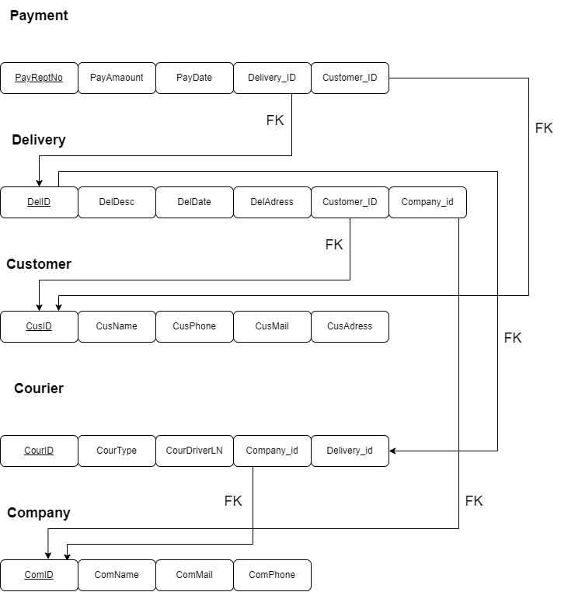

**E/R Diagram**

We changed and improved the e/r diagram

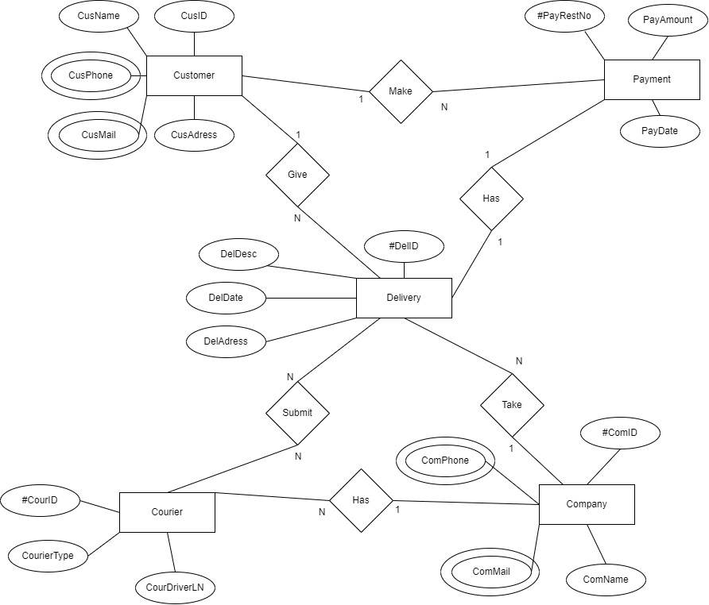

**Queries**

• The courier that delivered the most in August 2021

• City with the most deliveries

• Number of customers with more than 10 delivery entries per month

• Number of shipments with a fee of more than 200 TL

• Number of deliveries returned in the last 2 years

**Database Schema**

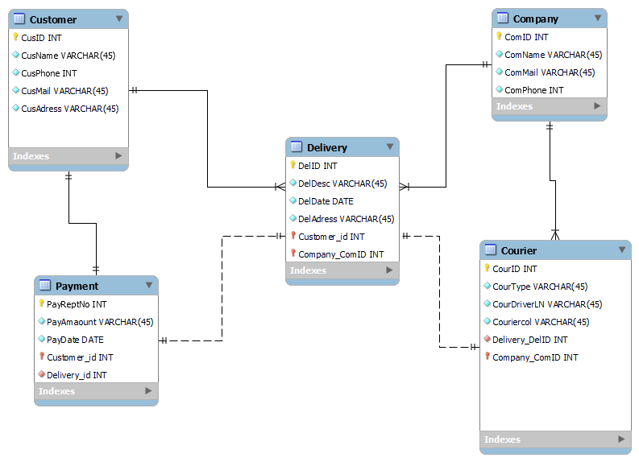

In the diagram we made, each table holds the specific properties of the class it specifies and the keys required for connection. We tried to build our database around the delivery table.

Note: The data to be added is given as a separate .sql file for the data of each table.

**Insert New Data**

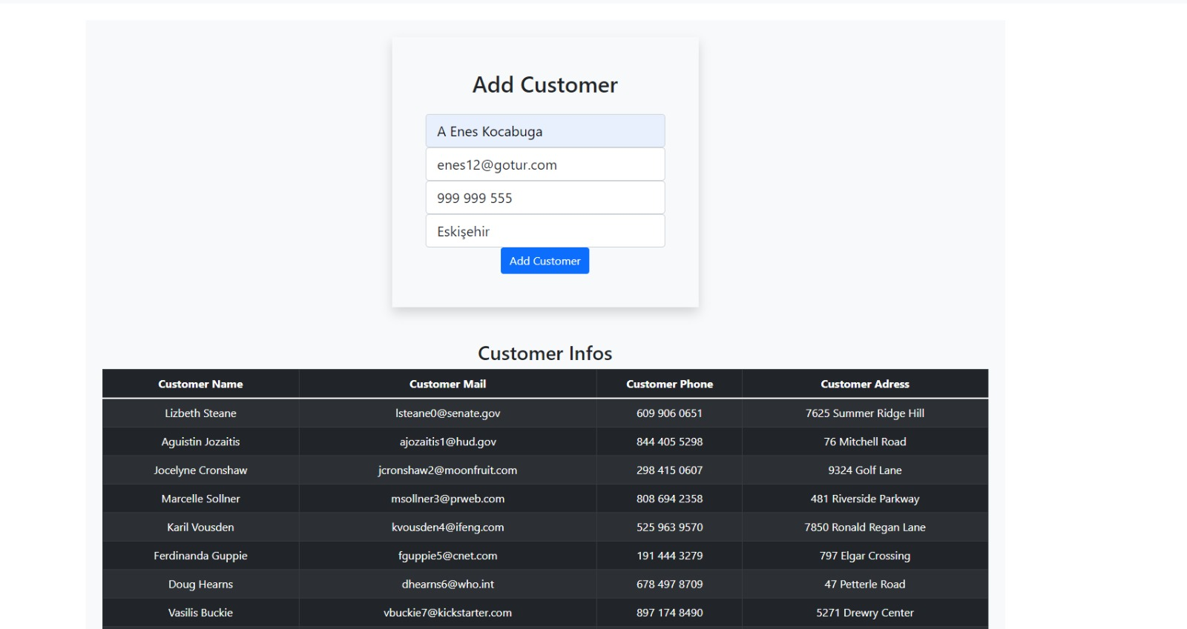

Fill in the required fields and click the button.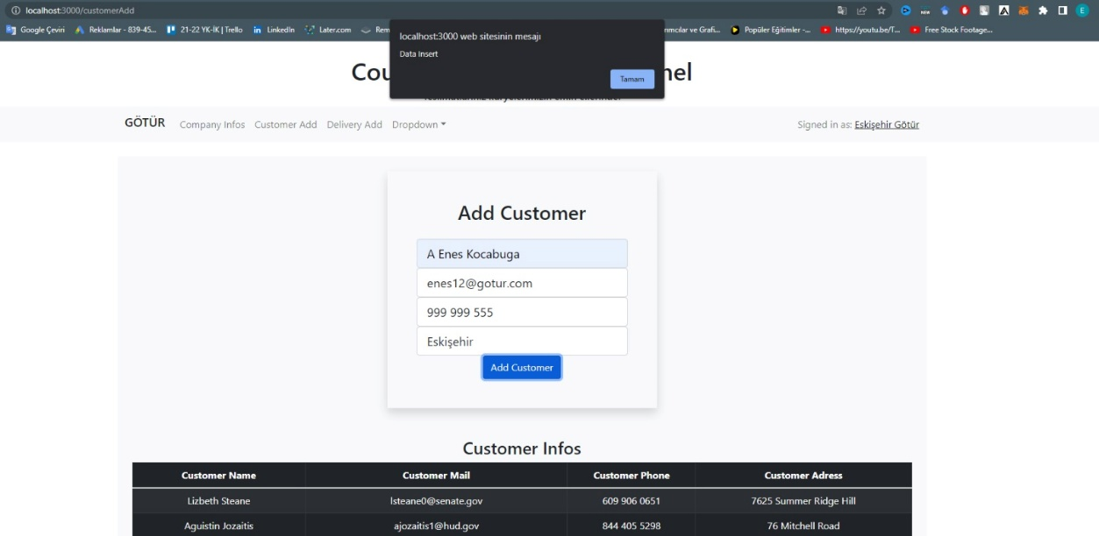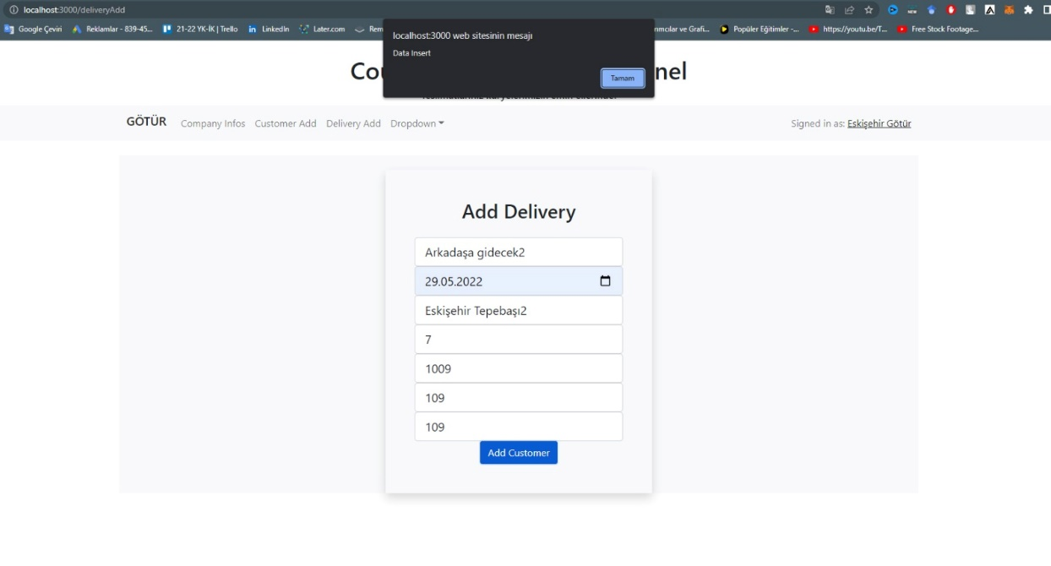

The system sends us a notification about the transaction.

**Database, Frontend and Backend Images**

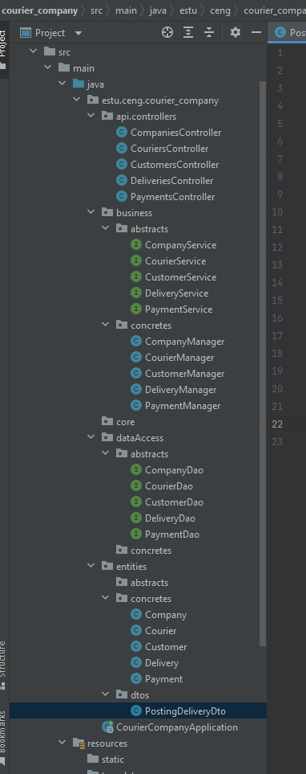 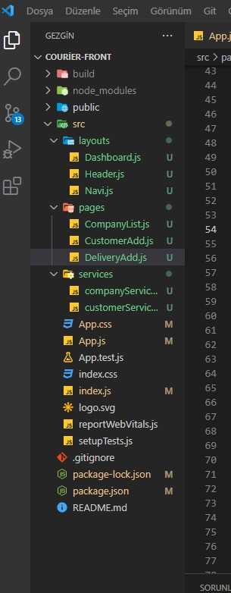

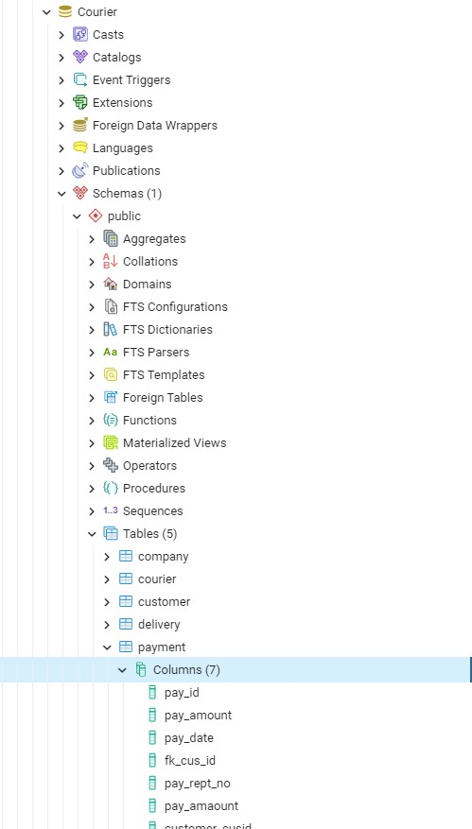

Here we wanted to show the architectures.

**Query Image**

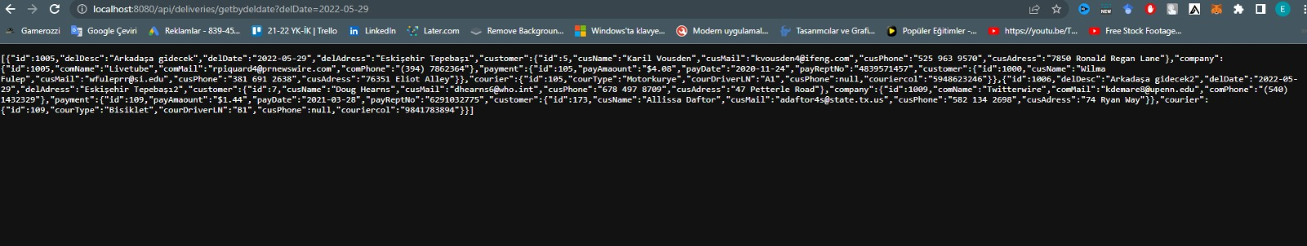

The queries are running on the backend, but we cannot display the frontend as a result of an error.

**Company Info Table**

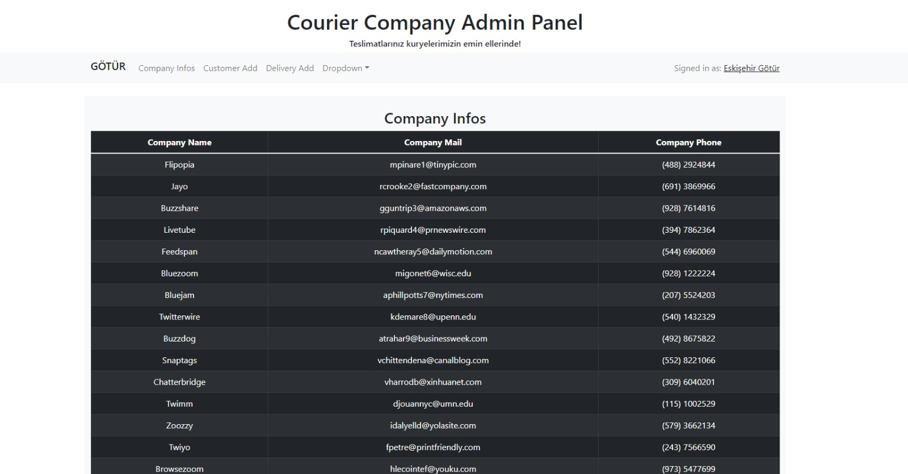

Tables where we show the data.

We used Postgresql for database, React for frontend and Java Spring Boot for backend.