COMSATS University Islamabad
Attock Campus


Department Of Computer Science
Semester Project Report
RSA FILE ENCRYPTION TOOL USING PYTHON
Submitted To | Ms. Ambreen Gull

Student Details

Registration No. | Name
FA24-BSE-013 | Ahmad Raza
FA24-BSE-024 | Ismail Ahmed

RSA FILE ENCRYPTION TOOL
Acknowledgement

We would like to express our sincere gratitude to our course instructor for providing guidance and support throughout this project. We also thank our university for providing the opportunity to learn practical implementation of cryptographic algorithms in Information Security.

Introduction

Information security is an important part of modern computing systems. Encryption techniques are used to protect sensitive information from unauthorized access. RSA is one of the most widely used asymmetric encryption algorithms for secure communication and data protection.
This project implements an RSA-based file encryption and decryption tool using Python. The system allows users to encrypt text files using a public key and decrypt them using a private key.

Objectives

- To understand RSA encryption algorithm
- To implement RSA in Python
- To encrypt and decrypt files securely
- To study public and private key cryptography
- To understand real-world security applications

Problem Statement

Sensitive data stored in files can be accessed by unauthorized users if proper security mechanisms are not applied. The purpose of this project is to develop a secure file encryption system using RSA algorithm to protect file contents from unauthorized access.

RSA Algorithm Overview

RSA is an asymmetric cryptographic algorithm developed by Rivest, Shamir, and Adleman. It uses two different keys:
- Public Key for encryption
- Private Key for decryption
RSA provides secure communication by ensuring that only authorized users can decrypt the encrypted information.

Working Methodology

Step 1:
Generate RSA public and private keys.
Step 2:
Read data from text file
.
Step 3:
Encrypt file using public key.
Step 4:
Store encrypted data in encrypted file.
Step 5:
Decrypt encrypted file using private key.
Step 6:
Display original data after decryption.

System Flowchart

Start
↓
Generate Keys
↓
Read File
↓
Encrypt File
↓
Save Encrypted File
↓
Decrypt File
↓
Save Decrypted File
↓
End

Python Implementation

- Key_generator.py

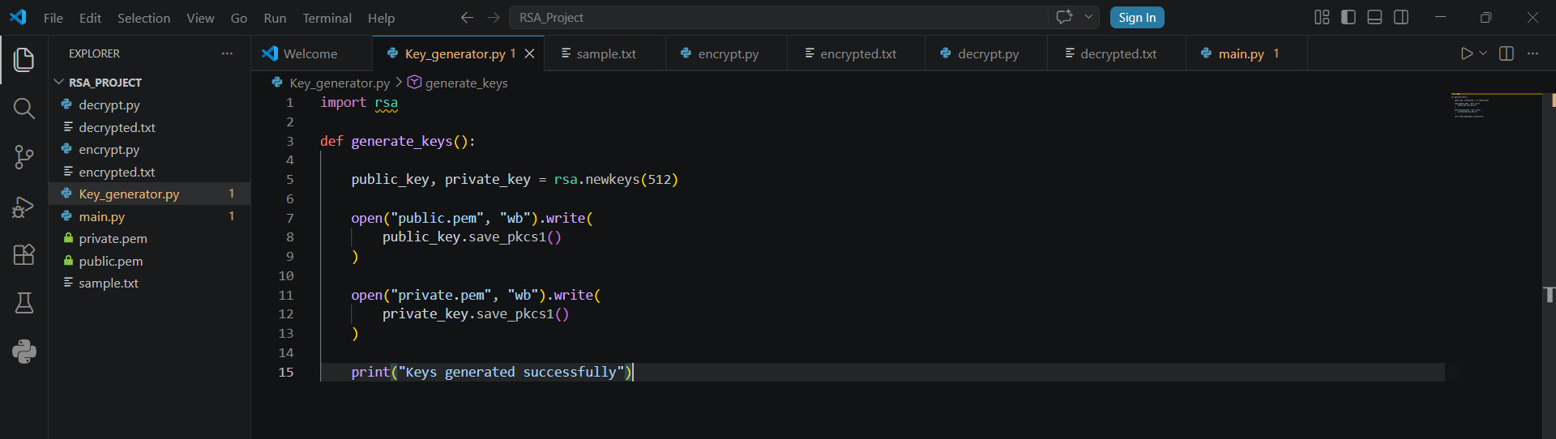

- encrypt.py

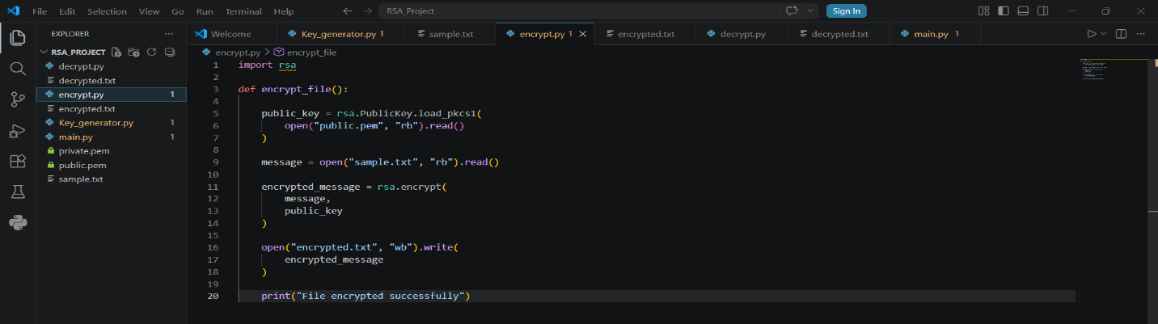

- decrypy.py

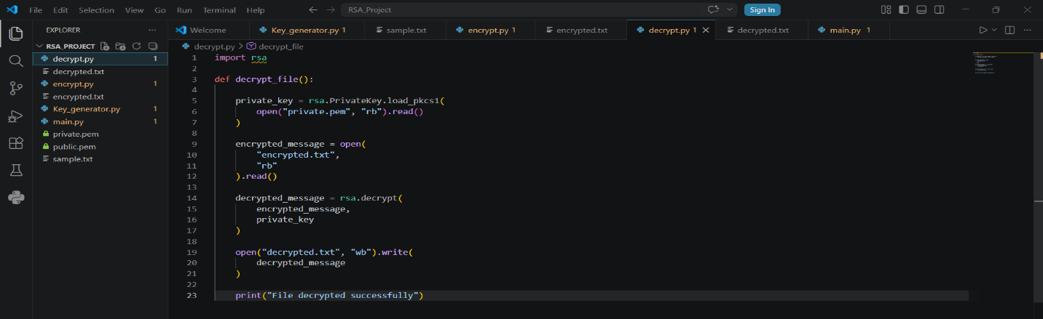

- main.py

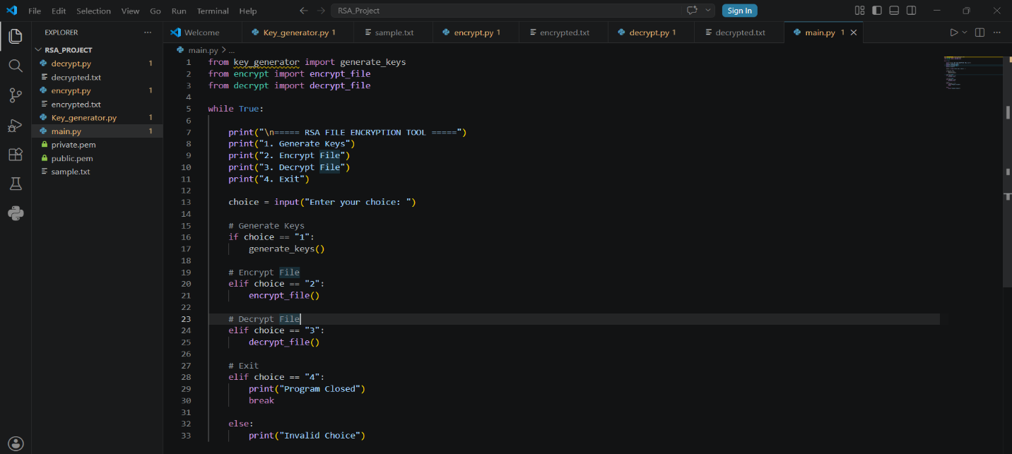
Advantages

- High level security
- Uses asymmetric cryptography
- Secure communication
- Widely used worldwide
- Public and private key mechanism

Disadvantages

- Slow for large files
- Complex mathematical operations
- Larger key sizes require more processing power
- Not suitable for encrypting huge data directly

Real-World Applications
RSA is used in:
- HTTPS websites
- Online banking
- Secure email systems
- Digital signatures
- VPN security
- E-commerce systems

RESULTS / OUTPUT

- Generated keys

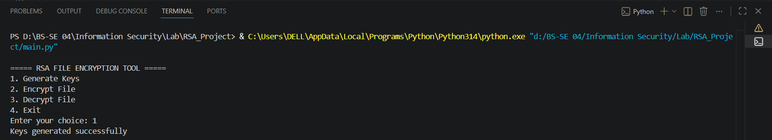

Public Key:

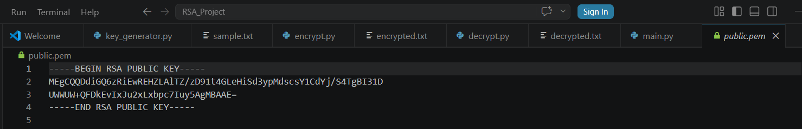

Private Key:

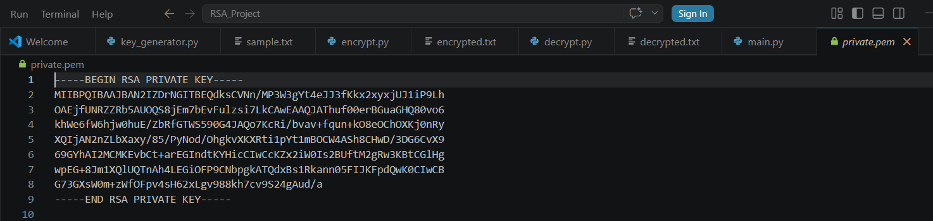

- Encryption output

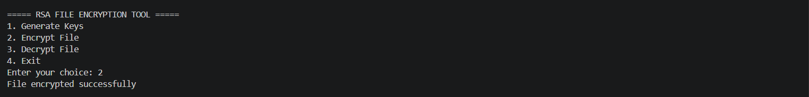

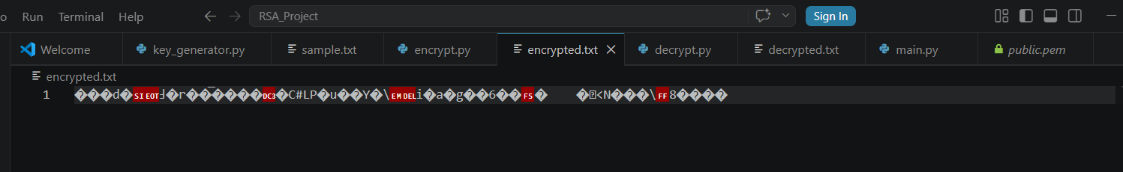

- Decryption output

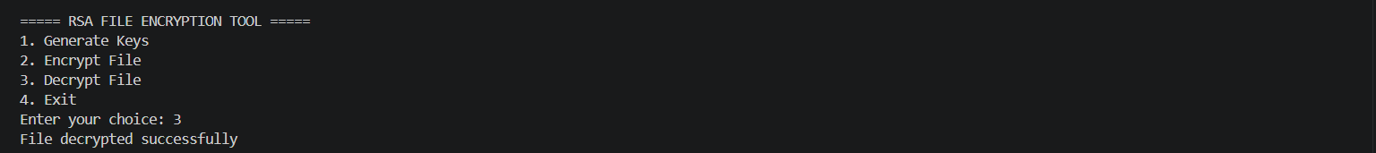

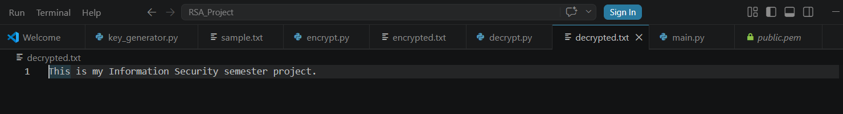

- Menu system

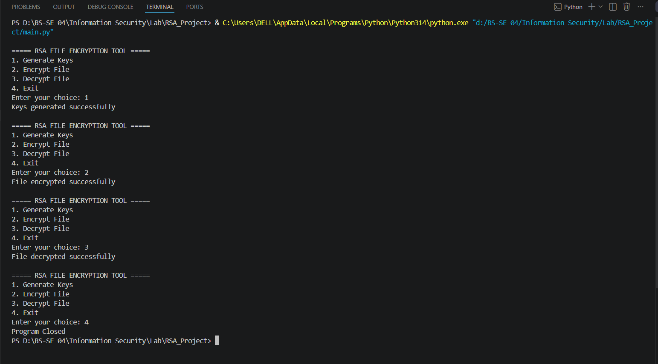

The project successfully encrypted and decrypted text files using RSA algorithm. The original data was recovered successfully after decryption.

Conclusion

This project successfully demonstrated the implementation of RSA encryption algorithm using Python. The system was able to securely encrypt and decrypt files using public and private keys. The project helped in understanding practical applications of asymmetric cryptography in information security.

References

- Python Official Documentation
- RSA Cryptography Documentation
- Information Security Lab Manual
- Lecture Notes

