COMSATS University Islamabad
Attock Campus
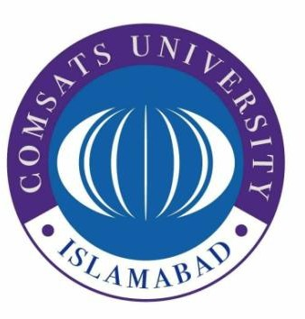

Department Of Computer Science

Course | IS(LAB)
Instructor | Ms. Ambreen Gul
Home Tasks | 30-03-2026

Student Details

Registration No. | Name
FA24-BSE-013 | Ahmad Raza

Home Task 6:

Code Input

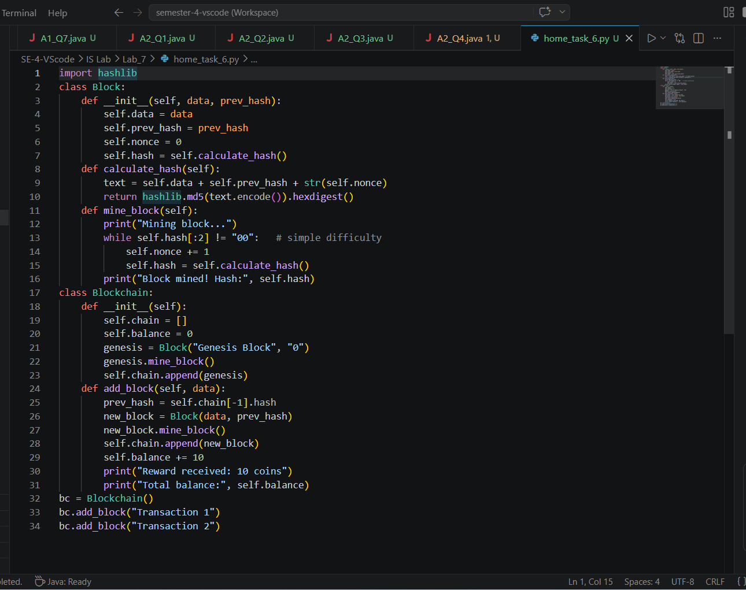

Code Output

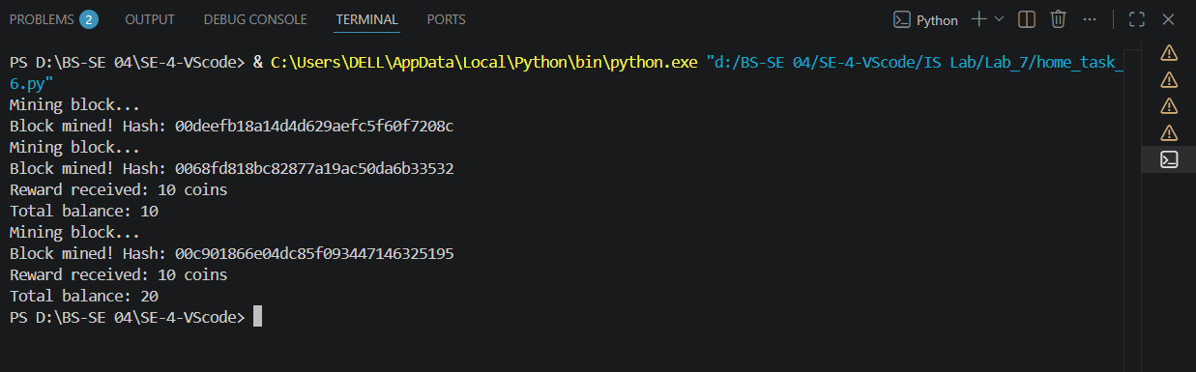

Home Task 7:

Code Input

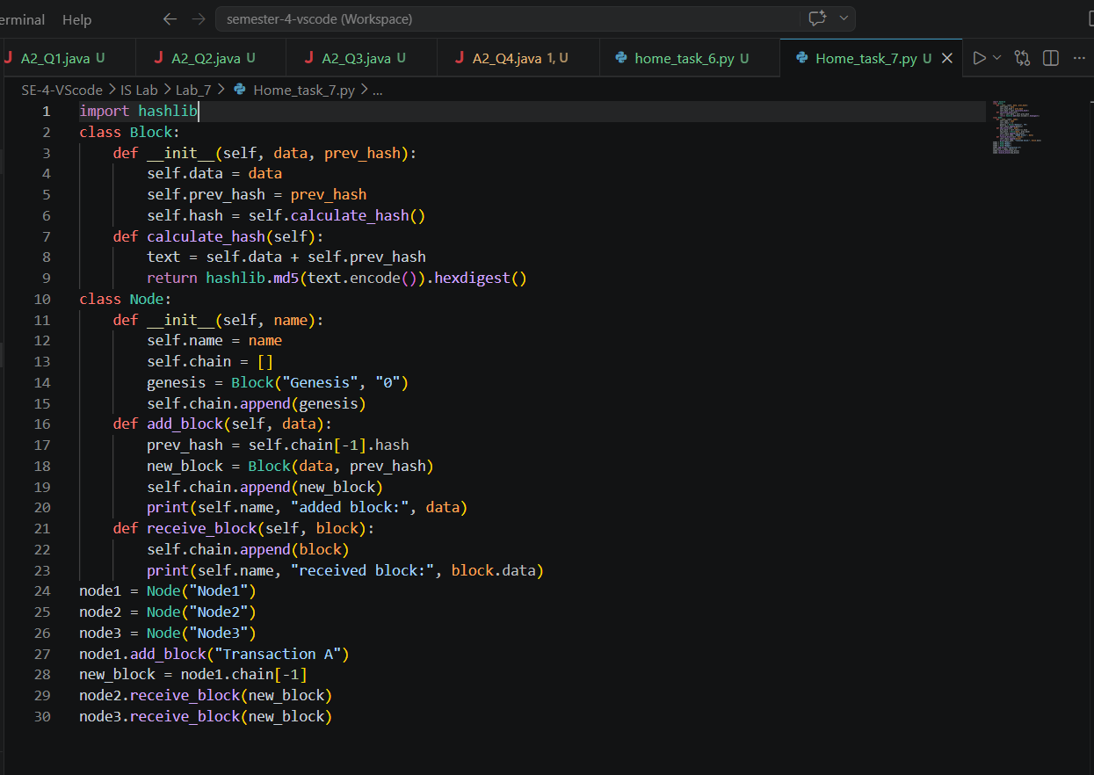

Code Output

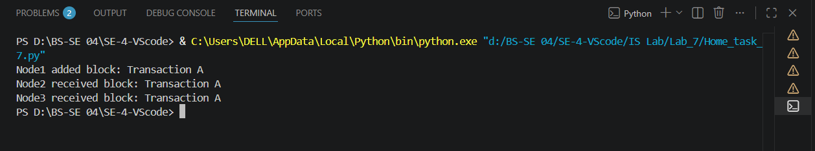

THE END

