COMSATS University Islamabad
Attock Campus

Department of Computer Science
Course: Software Quality Engineering (SQE)
Lab Assignment 4

Development, Testing, and Security Analysis of a Python-Based Library Management System

Submitted By
Registration No. | Name
FA24-BSE-013 | Ahmad Raza
FA24-BSE-024 | Ismail Ahmad
FA24-BSE-023 | M Bilal
FA24-BSE-0 | Tehseen

Submitted To
Instructor Name: Ms. Munazza Mushtaq
Semester
Spring 2026
Submission Date
May 18, 2026

1. Introduction
The Library Management System is a Python-based application developed for the Software Quality Engineering (SQE) course project. The purpose of this system is to manage books in a library environment efficiently. The system allows users to add books, search books, issue books, return books, and view available books.
This project was developed to understand software development practices, testing methodologies, code quality analysis, security analysis, and version control systems.

2. Project Objectives
The objectives of this project are:
- To develop a functional Python-based software system.
- To apply manual testing techniques.
- To implement automated testing using Python unittest.
- To identify and report software bugs.
- To perform code quality analysis using SonarQube.
- To perform security analysis using Snyk.
- To use GitHub for version control and project management.

3. System Development
The Library Management System was developed using Python programming language. The project was designed using modular programming concepts and includes multiple functionalities for efficient library management.
The following programming concepts were used:
- Variables
- Lists and Dictionaries
- Functions
- If-Else Conditions
- Loops (for and while)
- File Handling
- Exception Handling
The system uses a menu-driven interface where users can interact with the application through different options.
Main Features
- Add Book
- View Books
- Search Book
- Issue Book
- Return Book
- Save and Load Book Data

4. Functionalities of the System
4.1 Add Book
This functionality allows users to add a new book into the system by entering:
- Book ID
- Book Title
- Author Name
Validation checks were implemented to prevent empty inputs and duplicate book IDs.
4.2 View Books
This functionality displays all books available in the system along with their issue status.
4.3 Search Book
Users can search for a book using the Book ID.
4.4 Issue Book
This functionality allows issuing a book to a user. The system prevents issuing an already issued book.
4.5 Return Book
Users can return issued books back to the library.
5. Technologies Used
Technology | Purpose
Python | System Development
GitHub | Version Control
SonarQube | Code Quality Analysis
Snyk | Security Analysis
unittest | Automated Testing
VS Code | Code Editor

6. File Handling Implementation
File handling was implemented to store book records permanently using a text file named books.txt.
Implemented Features
- Saving books into file
- Loading books automatically on program start
- Maintaining persistent storage
The Python json module was used to store structured book data.
Advantages of File Handling
- Prevents data loss
- Improves usability
- Makes the system more realistic

7. Unit Testing
Automated testing was implemented using Python unittest framework.
Tested Functionalities
- Add Book
- Search Book
- Issue Book
- Duplicate Validation
Unit Test Results
All unit tests executed successfully.
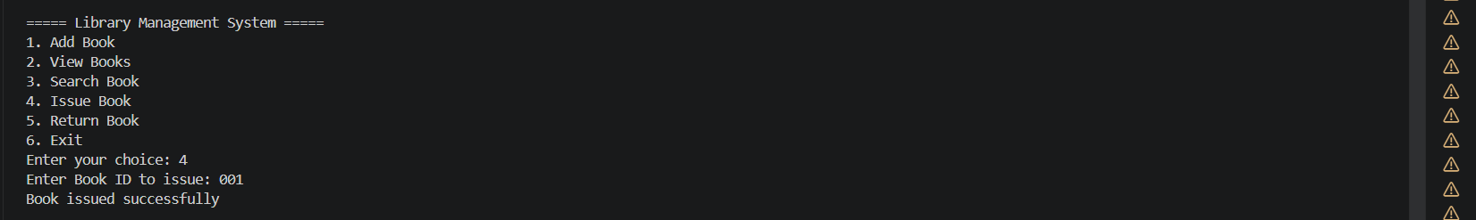
Benefits of Unit Testing
- Detects bugs early
- Improves software reliability
- Ensures functional correctness

8. Code Quality Analysis Using SonarQube
SonarQube was used to analyze the quality and maintainability of the source code.
Analysis Results
The analysis identified:
- Code Smells
- Maintainability Issues
- Minor Bugs
- Duplicate Code Segments
Common Issues Found
Issue Type | Description | Suggested Fix
Code Smell | Long functions | Split into smaller functions
Maintainability | Repeated logic | Refactor reusable code
Validation Issue | Missing input validation | Add proper validation
Benefits of SonarQube
- Improves code quality
- Detects maintainability issues
- Encourages clean coding practices
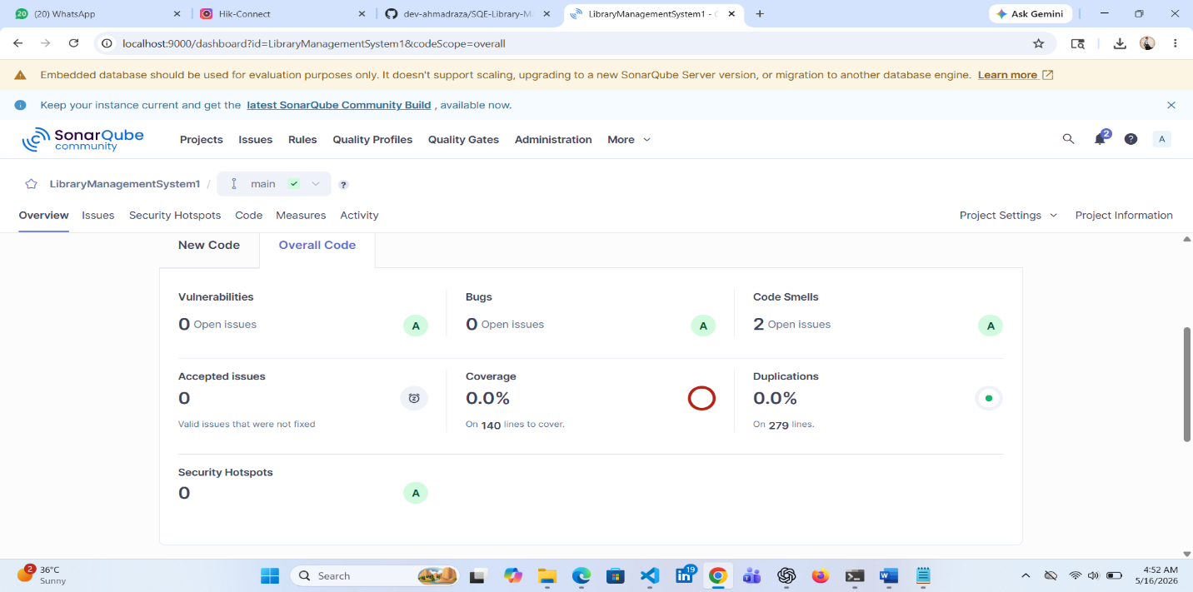
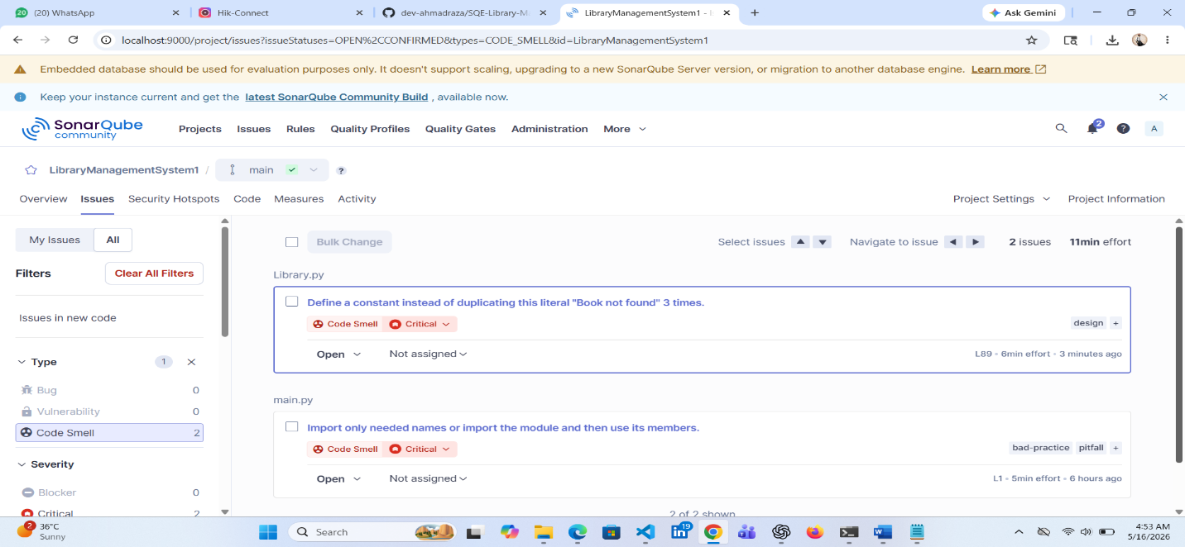

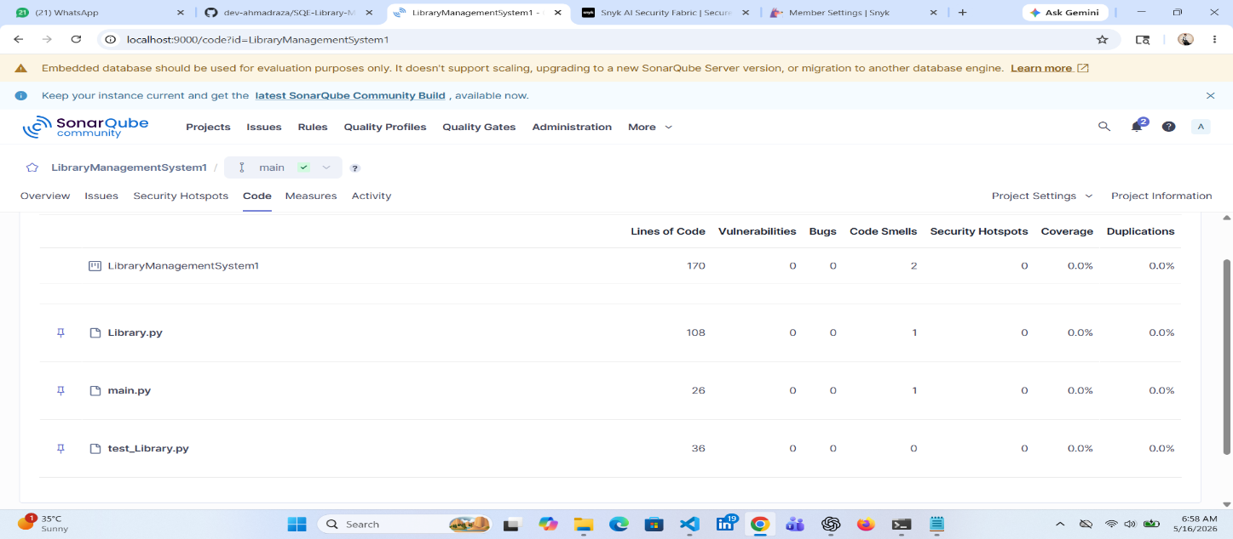
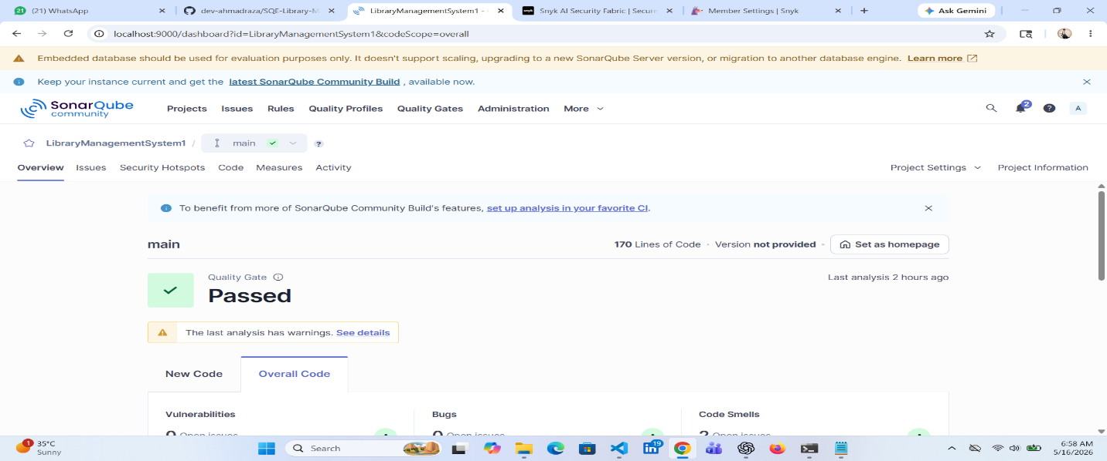

9. Security Analysis Using Snyk
Snyk was used to perform security analysis of the project.
Security Issues Identified
Security Issue | Risk Level | Suggested Fix
Hardcoded Credentials | High | Use environment variables
Missing Input Validation | Medium | Add validation and exception handling
No Authentication System | High | Implement login system
Plain Text Data Storage | Medium | Use encrypted storage
No Access Control | Medium | Implement user roles
Benefits of Security Analysis
- Identifies vulnerabilities
- Improves application security
- Encourages secure coding practices
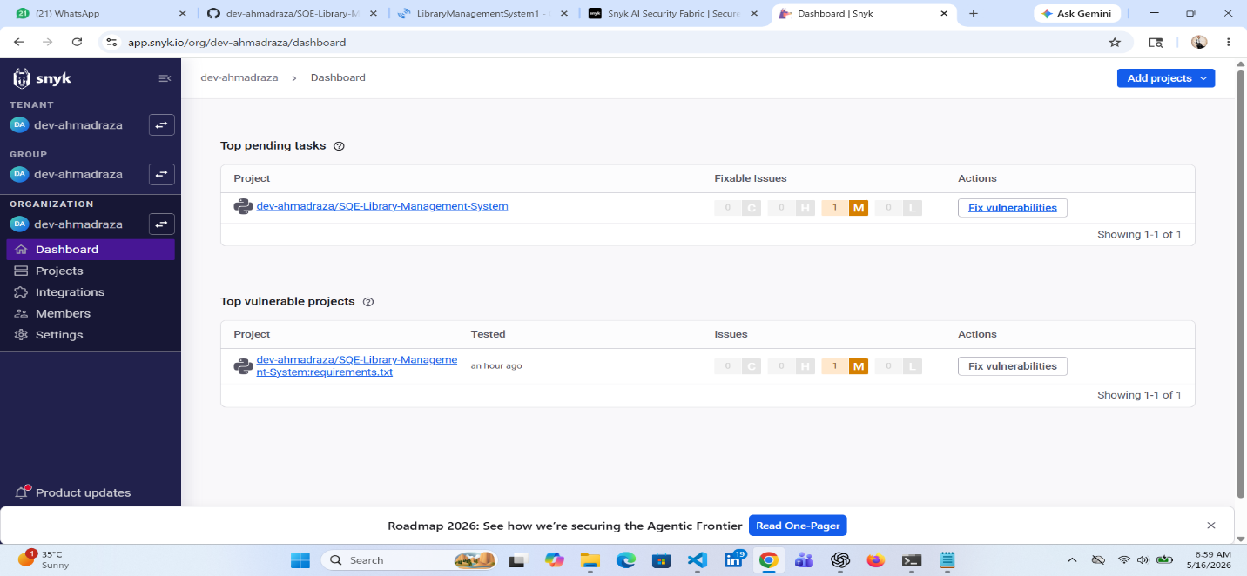
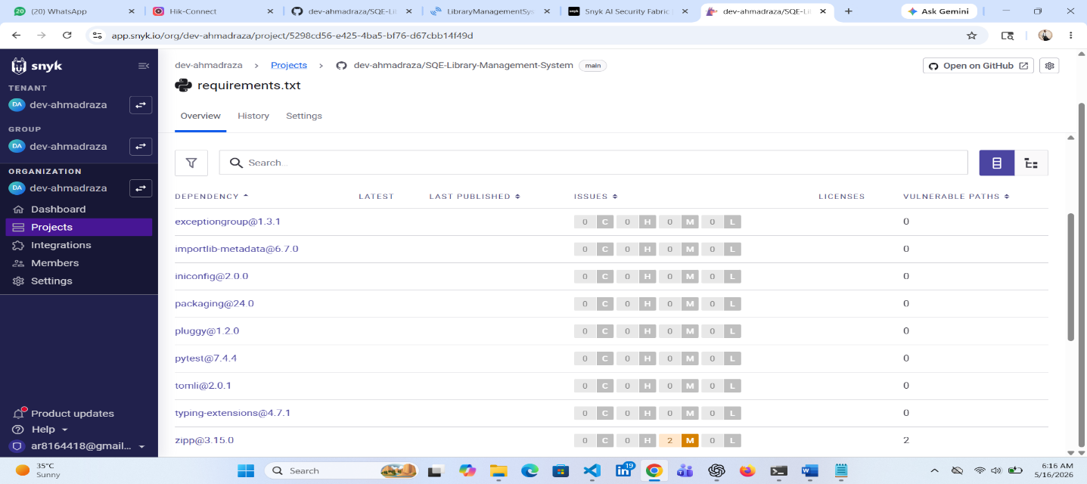

10. GitHub Version Control
GitHub was used for version control and project management.
GitHub Activities
- Repository Creation
- Commit Management
- Source Code Upload
- Documentation Upload
- Version Tracking
Benefits of GitHub
- Maintains project history
- Supports collaboration
- Tracks development progress
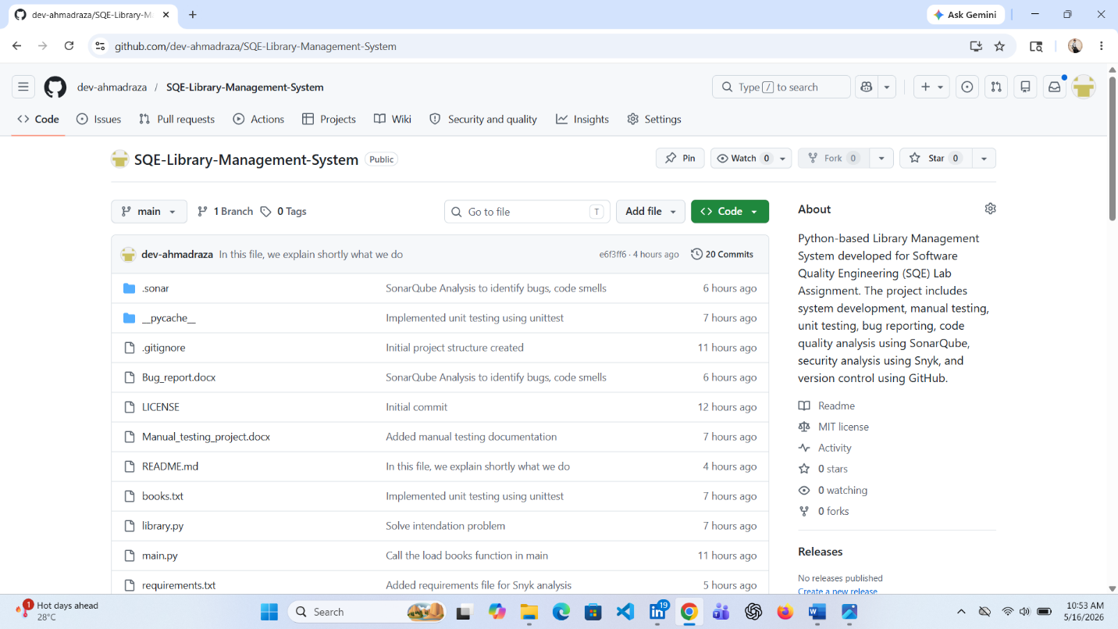

11. Conclusion
This project provided practical experience in software development, testing, debugging, code quality analysis, security analysis, and version control.
The Library Management System was developed successfully with multiple functionalities and proper testing mechanisms. Different software quality engineering concepts were implemented throughout the project including manual testing, automated testing, bug reporting, security analysis, and version control.
This project helped improve understanding of professional software engineering practices and development methodologies.
12. References
- Python Official Documentation
- GitHub Documentation
- SonarQube Documentation
- Snyk Documentation
- Software Quality Engineering Course Material

THE END

