COMSATS University Islamabad
Attock Campus


Department Of Computer Science

Course | IS(LAB)
Instructor | Ms. Ambreen Gul
Assignment No. | 01

Student Details

Registration No. | Name
FA24-BSE-013 | Ahmad Raza

Manual Testing - Test Cases

TEST CASE 1 — Add Book Successfully

TC ID | Scenario | Input | Expected Result | Actual Result | Status
TC-01 | Add new book | ID=001, Title=Python, Author=Ali | Book added successfully | Book added successfully | Pass

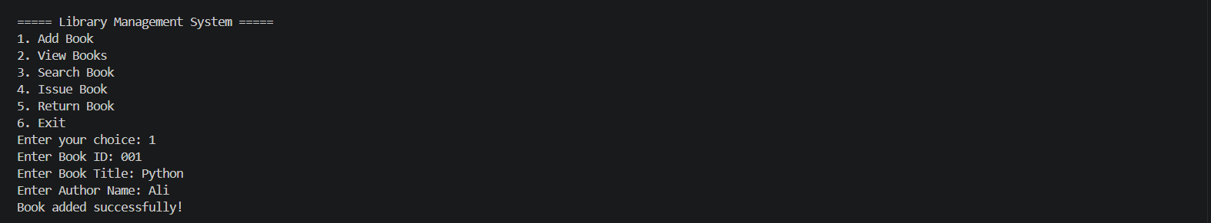

TEST CASE 2 — Empty Input

TC ID | Scenario | Input | Expected Result | Actual Result | Status
TC-02 | Add book with empty fields | Empty title | Error message displayed | Error message displayed | Pass

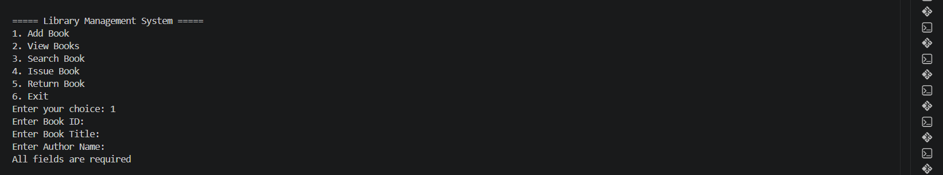

TEST CASE 3 — Duplicate Book ID

TC ID | Scenario | Input | Expected Result | Actual Result | Status
TC-03 | Add duplicate book ID | Existing ID | Book ID already exists | Book ID already exists | Pass

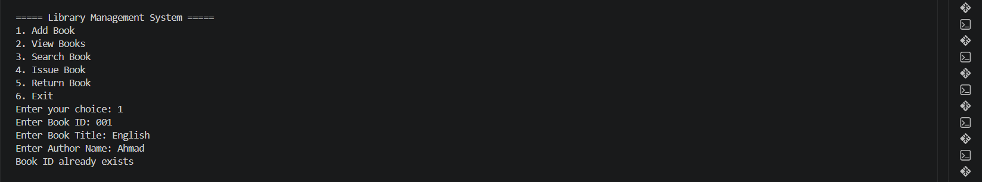

TEST CASE 4 — View Books

TC ID | Scenario | Input | Expected Result | Actual Result | Status
TC-04 | View all books | Type 2 on menu | Book list displayed | Book list displayed | Pass

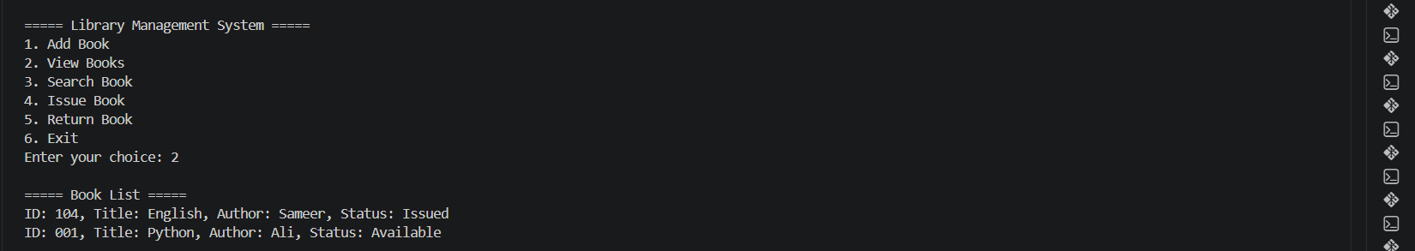

TEST CASE 5 — Search Existing Book

TC ID | Scenario | Input | Expected Result | Actual Result | Status
TC-05 | Search valid books | Book ID=001 | Book found | Book found | Pass

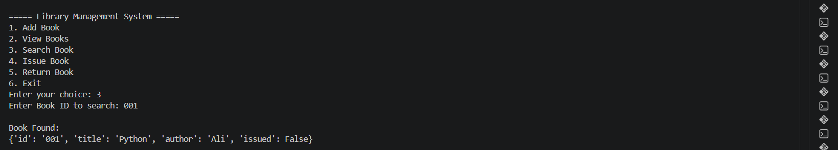

TEST CASE 6 — Search Invalid Book

TC ID | Scenario | Input | Expected Result | Actual Result | Status
TC-06 | Search invalid books | Book ID=991 | Book not found | Book not found | Pass

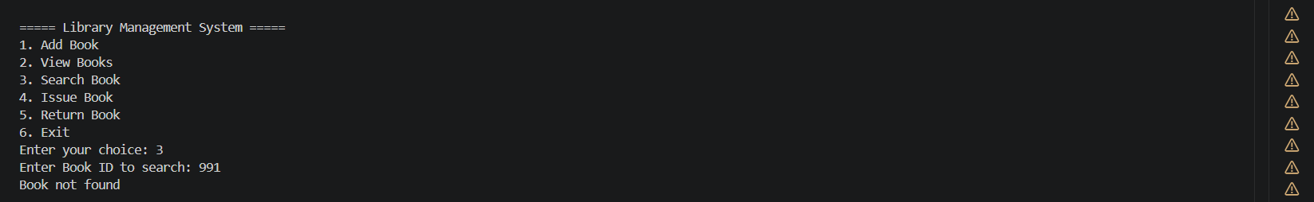

TEST CASE 7 — Issue Book

TC ID | Scenario | Input | Expected Result | Actual Result | Status
TC-07 | Issue available book | Book ID=001 | Book issue successfully | Book issue successfully | Pass

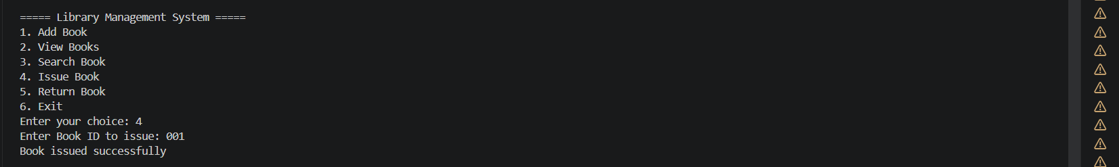

TEST CASE 8 — Issue Already Issued Book

TC ID | Scenario | Input | Expected Result | Actual Result | Status
TC-08 | Issue already issued book | Book ID=001 | Book already issued | Book already issued | Pass

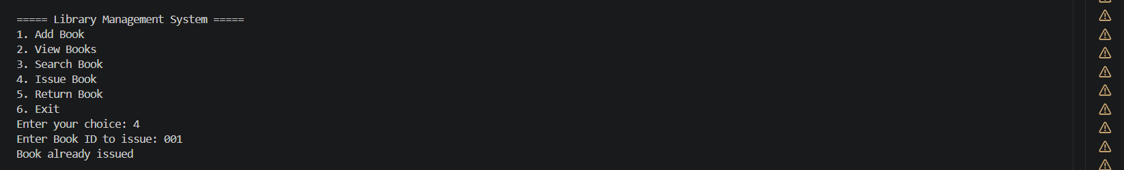

TEST CASE 9 — Return Book

TC ID | Scenario | Input | Expected Result | Actual Result | Status
TC-09 | Return issued book | Book ID=001 | Book returned successfully | Book returned successfully | Pass

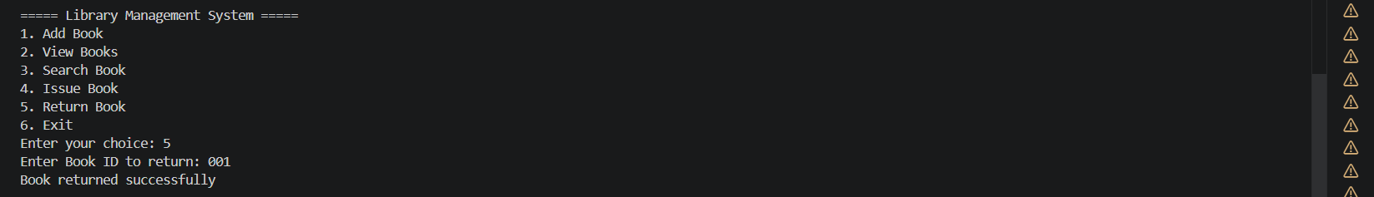

TEST CASE 10 — Invalid Menu Choice

TC ID | Scenario | Input | Expected Result | Actual Result | Status
TC-10 | Enter invalid menu option | Book ID=10 | Invalid choice message | Invalid choice message | Pass

