MIRA TRAVEL / DESIGNER IMPLEMENTATION BRIEF
Mira Visual Language
Designer Brief for San
From approved identity to a scalable brand-expression system
The objective is not to redesign Mira. The objective is to create the visual language that allows the approved Mira identity to live consistently across destinations, journeys, editorial content and digital touchpoints.
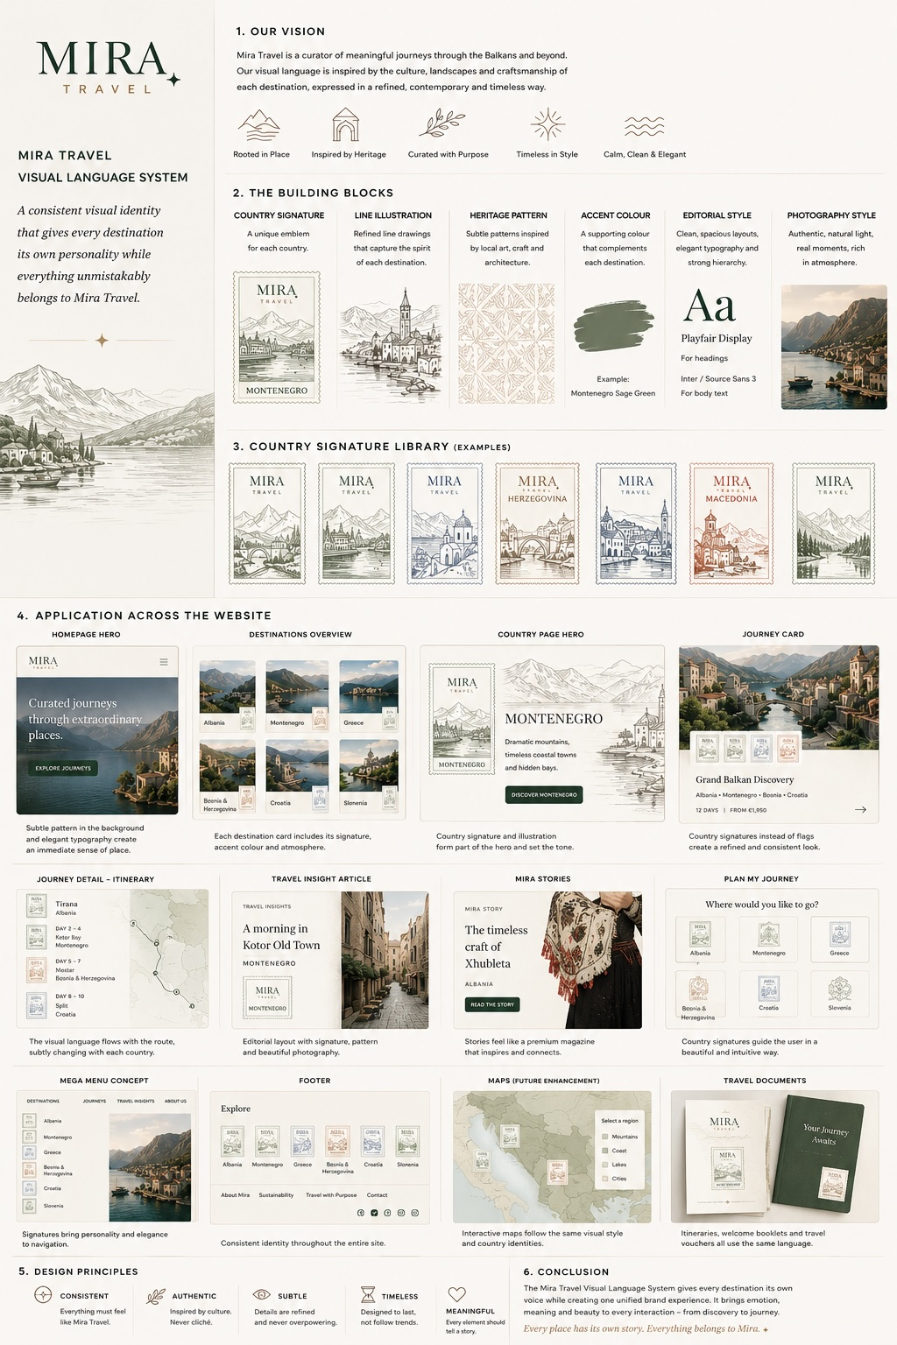
Conceptual reference only - not final design direction.
Mira Travel | Version 1.0 | 2026

1 | Start Here

What is already approved
Mira Travel already has an approved core identity. This assignment starts where that identity ends. The following elements are fixed foundations and are not being redesigned:
• Primary Mira logo and wordmark
• Mira monogram
• Official Mira star
• Corporate colour palette
• Corporate typography and core brand style
THE APPROVED FOUNDATION | THE NEW ASSIGNMENT
Logo  Monogram  Star  Core colours  Typography | Destination expression  Editorial devices  Journey expression  Map language  Scalable usage rules

The design challenge
Mira should always feel like one coherent premium brand, while each destination is allowed to develop a distinctive sense of place. The system must therefore create variation without creating sub-brands.
Mira remains the constant. The destination provides variation.

2 | What We Need You to Create
Please develop a coherent, scalable Mira Brand Expression System that can be consistently applied by our web designer, developers and content team. The system should be concrete enough to implement, but flexible enough to expand to new countries later.

Design sequence
 | SYSTEM | OUTPUT
01 | Country Expression | Stamp, heritage pattern, line illustration, accent colour
02 | Mira Editorial Devices | Mira Note, Mira Recommends, Approved by Mira, The Mira Difference
03 | Journey Expression | Signature Journey, chapter system, country transitions, map language
04 | Applications | Country, journey, editorial and functional contexts
05 | Rules & Handover | Restraint, responsive behaviour, assets and documentation

3 | Country Expression System
Phase 1 proof countries: Albania, Montenegro and Greece. These three should be different enough to prove that the system can express cultural variation without losing Mira consistency.

3.1 Country Stamp
Destination signature: Create one master stamp architecture with a consistent grid, typography, scale and Mira signature. Each country may vary through its illustration, motif and accent colour. The stamp is not a map marker and not an approval seal.

3.2 Heritage Pattern
Cultural texture: Research a culturally grounded source, abstract it into a Mira motif, and create a restrained repeat pattern. Avoid obvious national cliches, flags and unresearched pseudo-folklore.

3.3 Line Illustration
Atmosphere: Develop a refined, consistent line-art language. The illustration should interpret landscape, architecture and character rather than act as a tourist skyline. Create modular wide, cropped and mobile-friendly variants.

3.4 Country Accent Colour
Recognition: Each country receives one supporting accent colour and one light editorial tint. Mira owns the palette; destinations add an accent. Country colours never replace Mira colours for CTAs, core UI, Mira Notes or Approved by Mira.
The Country Visual Language is a toolkit, not a checklist.
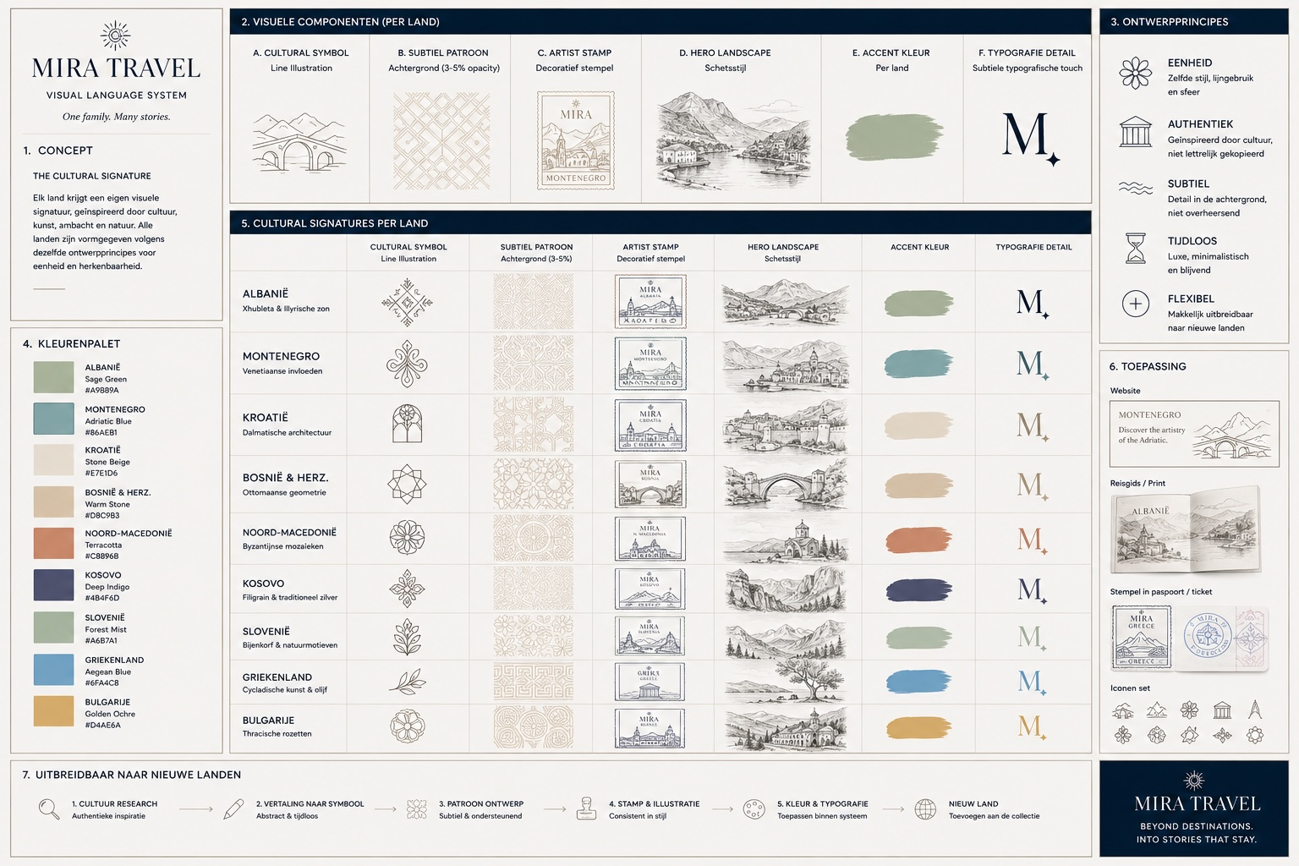
Existing exploratory direction for country-level visual language. Use as conceptual reference, not as finished artwork.

4 | Mira Editorial & Curation Devices
These devices should not look like variations of the same badge. Each has one primary meaning and should receive a distinct treatment.
DEVICE | MEANING | DESIGN DIRECTION
Mira Note | Guidance | A short, personal Mira insight. The official Mira star is the primary marker. Small, editorial, concise and useful.
Mira Recommends | Editorial recommendation | A considered choice from Mira. More editorial than badge-like, often with text and optional photography.
Approved by Mira | Formal endorsement | A true seal of confidence for selected accommodations, experiences or partners. It must look clearly different from the Country Stamp and should use Mira corporate colours.
The Mira Difference | Curatorial reasoning | A typography-led, often numbered component showing the deliberate choices behind a Mira journey. No seal is needed.

Important
Not every Mira expression should become a badge. Why We Created This Journey, Mira Stories and Travel Insights need strong editorial typography and layout, not new logos or seals.
One device. One primary meaning.

5 | Journey Classification Language
Journey classification is information architecture, not sub-branding. Your role is to establish a refined visual hierarchy when these layers appear together.
LAYER | VOCABULARY | ROLE
Status | Mira Signature Journey / no label | Curatorial distinction. Signature is reserved exclusively for journeys.
Personality | Culture & Heritage; Nature & Landscapes; Food & Wine; Local Life; Active & Outdoors | What primarily draws the traveller.
Setting | Coast & Islands; Mountains; Countryside & Villages; Cities & Towns | The environments the traveller is drawn to.
Travel Style | Self-drive; Private Driver | How the traveller moves through the journey.
Pace | Relaxed; Balanced; Fuller | The rhythm and density of the itinerary.
Destination | Country -> Region | Geographic context.
Duration | Exact number of days | Factual attribute; e.g. 15 days.
One taxonomy. Different interfaces. Taxonomy may be complex; presentation must remain simple.

Signature Journey treatment
Please create a typography-led treatment for Mira Signature Journey and demonstrate the hierarchy on a regular journey card, a Signature journey card, a regular journey hero and a Signature journey hero. Do not create a separate Signature logo, seal, symbol or colour palette.

6 | Journey Expression System
A Mira Journey should be understood as a sequence of meaningful chapters, not simply as a long list of days.
LEVEL | QUESTION | DESIGN NEED
Journey | Where am I going? | Hero, positioning, duration, map
Chapter | What part of the journey am I entering? | Chapter title, days, short intro, country context
Day | What exactly happens today? | Practical itinerary, travel time, overnight, optional Mira guidance

6.1 Journey Chapter
Design a repeatable chapter component that creates hierarchy between journey, chapter and day. Clear first, evocative second.

6.2 Country Transition
Create a restrained editorial transition for meaningful country changes. It may use a Country Stamp plus either illustration or pattern, but not all destination devices at once.

6.3 Journey Map Language
Design a minimal map language for route line, overnight marker, visit/stop marker, start/end, country boundaries, transport variation and labels. Country Stamps, flags, heritage patterns, stars and monograms are not map markers.
The map explains the journey. It does not decorate it.
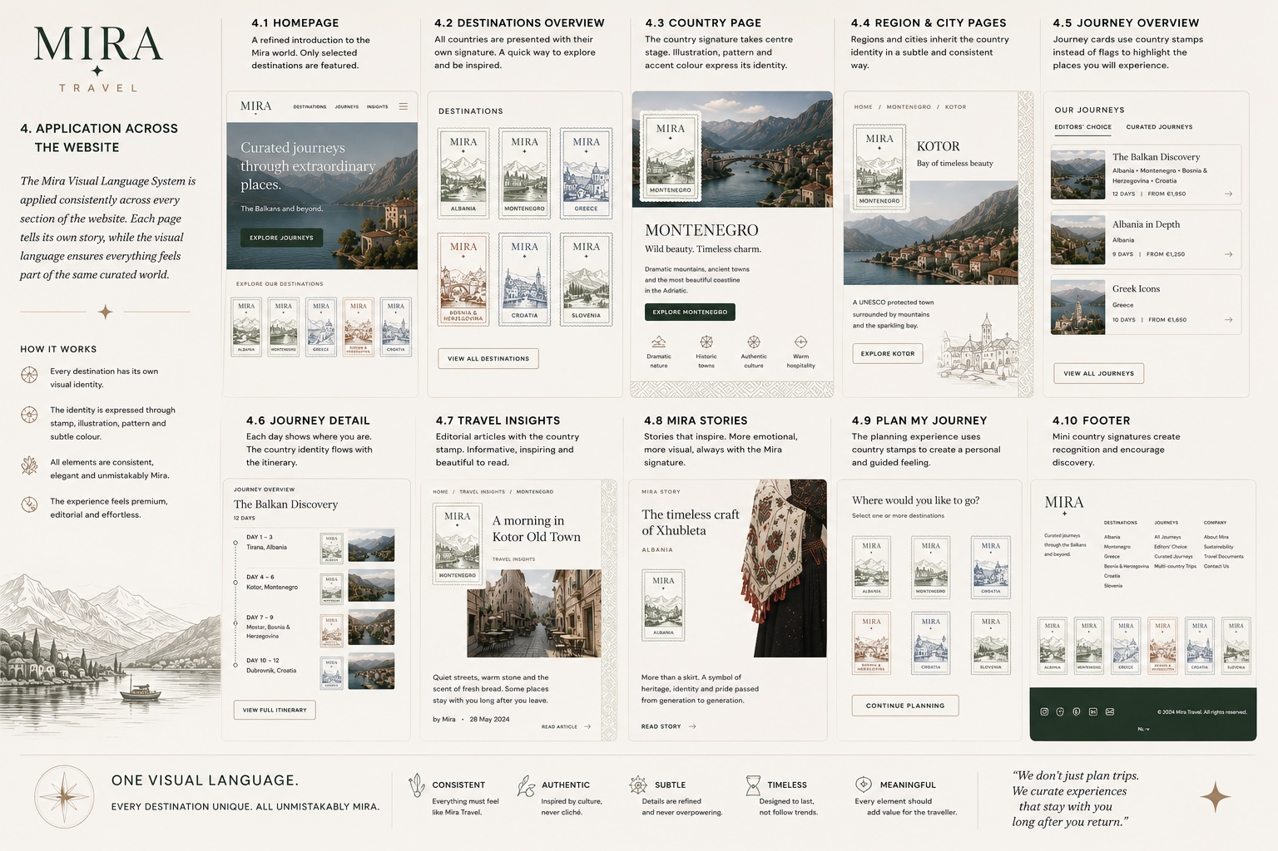
Existing exploratory applications. Particularly note that map use should now be simplified: full Country Stamps should not be used as map markers.

7 | Applications to Demonstrate
You are not being asked to redesign every Mira page. Please use a limited set of master applications to prove that the visual system works.
APPLICATION | PROOF CASE | WHAT TO TEST
A. Country | Albania recommended | Photography + Country Stamp + controlled pattern/illustration + accent colour
B. Single-country Journey | Albania recommended | Journey intro, Why We Created This Journey, Mira Difference, map, chapter, day, Mira Note/Recommends
C. Multi-country Journey | Croatia -> Montenegro -> Albania | Multi-country map, chapter structure, country transition, controlled accent changes
D. Editorial | Mira Story vs Travel Insight | Show expressive editorial storytelling versus restrained informational editorial design
E. Functional Mira | Plan My Journey or Account/Login | Show how Mira remains recognisable when destination expression becomes intentionally quiet

8 | Design Principles & Restraint
Mira first: The corporate identity remains the constant. Destinations add character; they do not become sub-brands.
Meaning before decoration: Every device must have a clear role.
1 + 1 rule: Within one visual moment, use one primary expression device and, if needed, one supporting device.
Photography wins: When photography and graphic expression compete, photography wins.
Recognition without repetition: A stamp, star or monogram does not need to repeat throughout a page to remain recognisable.
Mira authority / destination place: Mira colours and devices communicate authority. Country devices communicate place.
Functional quiet zones: Forms, account, checkout and practical UI should be dominated by the core Mira identity, not destination decoration.
Remove before reducing: On small screens, remove non-essential expression before shrinking everything.
GOOD COMBINATIONS | AVOID
Photography + Country Stamp  Line Illustration + Accent Colour  Mira Note + official Star  Product photography + Approved by Mira | Stamp + Pattern + Illustration + Star + Monogram in one section  Country colour on CTAs  Multiple full stamps on maps  New icons or badges for every taxonomy label

9 | Photography Direction
Please define the photographic direction rather than produce a photo library. Mira photography should make the traveller imagine being there, not simply admire an advertisement.
• Sense of Place - landscapes and destinations with depth and atmosphere
• Human Presence - candid and observational rather than posed influencer imagery
• Local Life - people and communities represented with dignity and context
• Detail & Texture - craft, architecture, materials, food and small moments
• Stay & Experience - what staying or doing something feels like, not only product documentation
Refined reality, not filtered reality.

10 | Deliverables & Phasing
The work should be developed as a system first, proved on a limited number of destinations, and only then rolled out.
Phase 1A - Core expression
Country Stamp system; Approved by Mira; Mira Note; Mira Recommends; The Mira Difference; Journey Chapter; Country Transition
Phase 1B - Destination proof
Albania, Montenegro and Greece: Stamp, Pattern, Line Illustration, Accent Colour
Phase 1C - Journey system
Single-country and multi-country map language; chapter/day hierarchy; transition behaviour
Phase 1D - Master applications
Country, Journey, Editorial and Functional proof applications
Phase 2 - Rollout
After approval, apply the approved system to Croatia, Bosnia & Herzegovina, North Macedonia, Kosovo, Slovenia and Bulgaria

Final documentation
Please deliver a Mira Brand Expression Guide as an extension to the existing Brand Style Guide. It should document the system, usage rules, responsive considerations, do/don't examples and country asset sheets.

Master files
Editable vector/source files are required for all applicable assets, together with production-ready exports. Suggested formats: AI/SVG for digital assets, PDF/EPS where relevant for print, PNG only as an export - never as the sole master.

11 | Scope Boundaries
This is a brand-expression assignment, not a second full website-design project.
IN SCOPE | NOT YOUR RESPONSIBILITY
Brand-expression components  Destination visual system  Journey visual hierarchy  Map visual language  Photography direction  Responsive expression rules  Master application examples  Expression guide and assets | Complete website redesign  UX architecture  CMS architecture  Frontend development  Booking/account logic  SEO  Copywriting of Stories/Insights  Operational Approved by Mira criteria

12 | Creative Freedom & Approval
The architecture defines what each element needs to achieve; the final visual solution is your design responsibility. We want your professional interpretation and encourage you to challenge visual solutions where you see a stronger approach.
You may challenge the execution. Please do not silently redefine the architecture.
If you recommend changing an established relationship - for example the use of the monogram in a Country Stamp, the role of an accent colour, or the structure of an editorial device - please present the alternative with a short rationale before rolling it through the system.

13 | Conceptual References
The following exploratory visuals were created to develop and test the architecture. They communicate ideas, relationships and possible applications. They are not finished design directions and should not be copied literally.
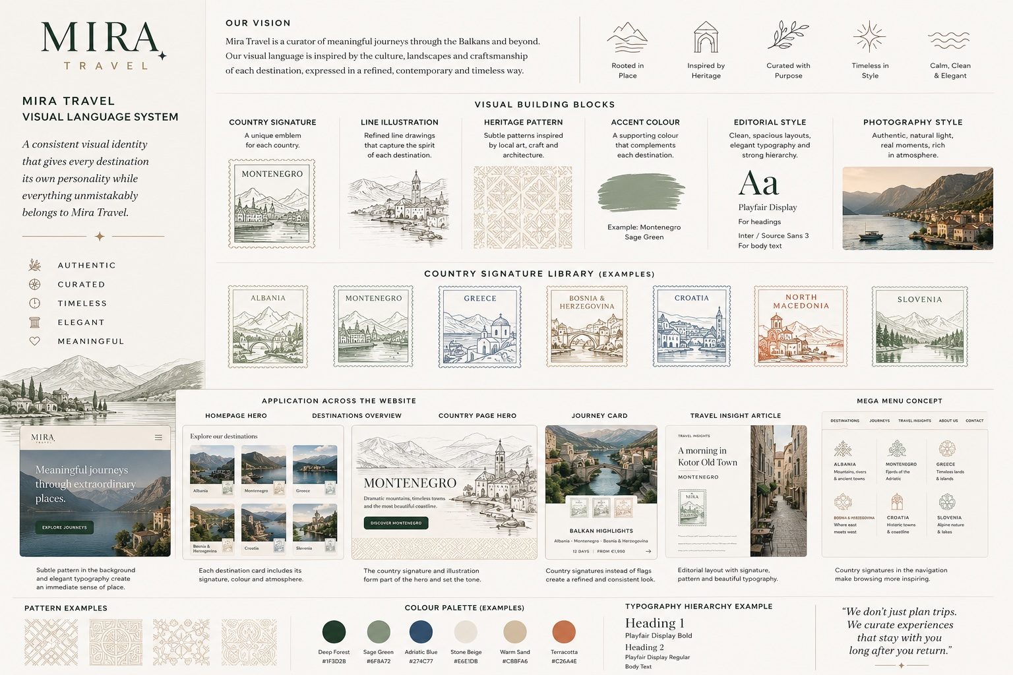
Exploratory visual-language board: building blocks and website applications.
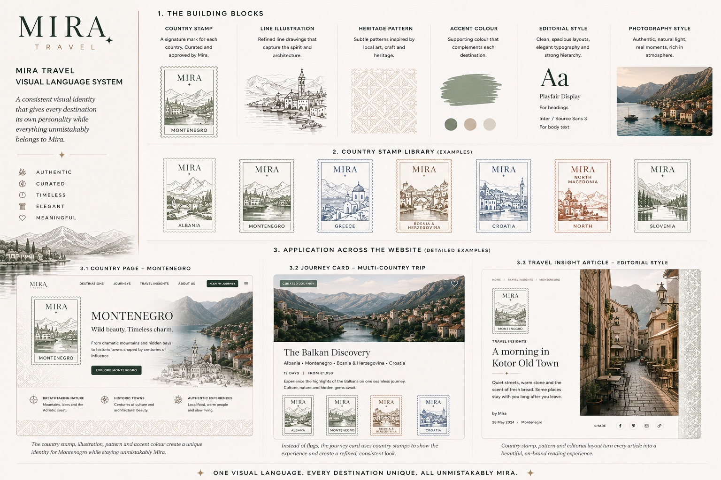
Exploratory stamp system and country/journey applications.

14 | Success Criteria
The system will be considered successful if it passes the following six tests:
Mira Test: Does everything feel unmistakably part of one brand?
Destination Test: Do Albania, Montenegro and Greece feel distinct without becoming sub-brands?
Restraint Test: Does the system still work when only one or two devices are used?
Multi-country Test: Does a three-country journey remain calm, legible and coherent?
Mobile Test: Does the identity remain recognisable after decorative elements are removed?
Scalability Test: Can a new country be added without redesigning Mira?
SYSTEM FIRST. PROOF SECOND. SCALE THIRD.
Presence without excess.

