Q-12 PROGRAM TO PRINT ASCII CODE OF ANY CHARACTER.

#include<stdio.h>
int main(){
char x;
printf("Enter a charcter : ");
scanf("%c",&x);
printf("the ASCII code of %c is %d",x,x);
return 0;
}

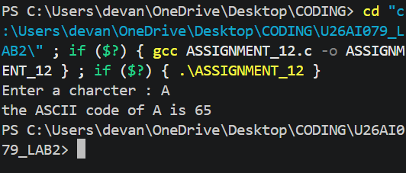

Q-13 PROGRAM TO CHECK WHETHER A NO. IS EVEN OR ODD.

#include<stdio.h>
int main(){
int x;
printf("enter the number : ");
scanf("%d",&x);
if(x%2==0)
printf("the given number %d is EVEN",x);

else
printf("the given number %d is ODD",x);
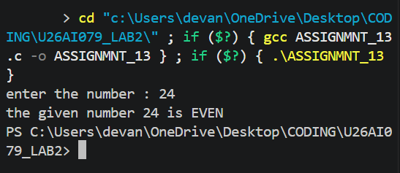
return 0;
}
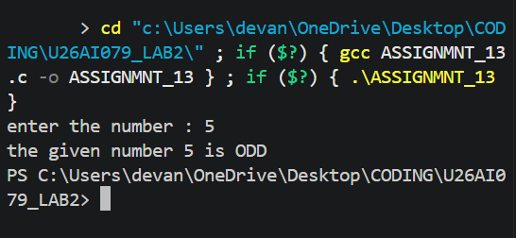

Q-14 PROGRAM TO CHECK WHETHER A GIVEN CHARACTER IS CAPITAL,

LETTER, SMALL.
#include<stdio.h>
int main(){
char x;
printf("enter the charcater : ");
scanf("%c",&x);
if(x>=65 && x<=90)
printf("the given charcter %c is CAPITAL LETTER",x);
else if(x>=97 && x<=122)
printf("the given charcter %c is SMALL LETTER",x);
else if(x>=49 && x<=57)
printf("the given charcter %c is DIGITS",x);
else
printf("the given charcter %c is a SPECIAL SYMBOL",x);
return 0;
}
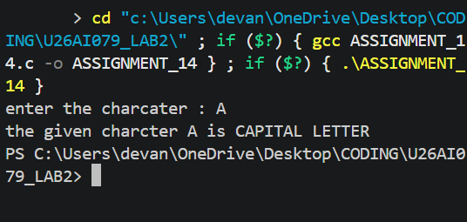
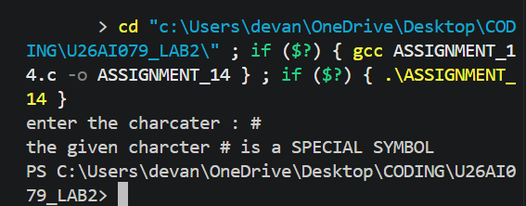

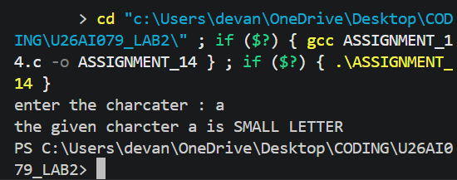
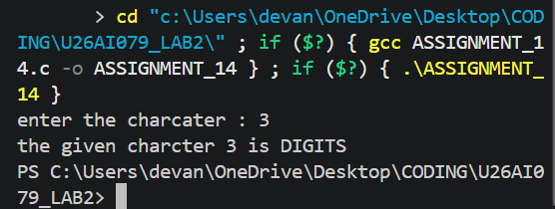

Q-15 PROGRAM TO READ MARKS OF FIVE SUBJECT AND PRINT DIVISION.
#include<stdio.h>
int main(){
int m1,m2,m3,m4,m5;
double percentage;
printf("enter the marks in five subjects : ");
scanf("%d%d%d%d%d",&m1,&m2,&m3,&m4,&m5);
percentage=(m1+m2+m3+m4+m5)/5.0;
if(percentage>=80)
printf("FIRST DIVISION");

else if(percentage>=60)
printf("SECOND DIVISION");

else if(percentage>=50)
printf("THIRD DIVISION");

else if(percentage>=40)
printf("FOURTH DIVISION");

else printf("FAIL");
return 0;

}

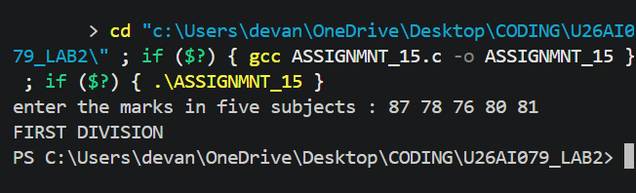

Q-16 PROGRAM TO READ THREE NOS. AND PRINT MAX.
#include<stdio.h>
int main(){
int x,y,z;
printf("enter the first number : ");
scanf("%d",&x);
printf("enter the second number : ");
scanf("%d",&y);
printf("enter the third number : ");
scanf("%d",&z);
if(x>y){
if(x>z) printf("the max number is %d",x);
else printf("the max number is %d",z);
}
else{
if(y>z) printf("the max number is %d",y);
else printf("the max number is %d",z);

}
return 0;
}
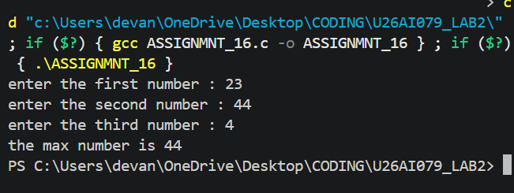

Q-17 PROGRAM TO READ THREE NOS. AND PRINT MAX USING LOGICAL

OPERATOR.(&&)
#include<stdio.h>
int main(){
int x,y,z;
printf("enter the first number : ");
scanf("%d",&x);
printf("enter the second number : ");
scanf("%d",&y);
printf("enter the third number : ");
scanf("%d",&z);
if(x>y && x>z)
printf("the max number is %d",x);

else if(y>z && y>x)
printf("the max number is %d",y);

else
printf("the max number is %d",z);

return 0;
}
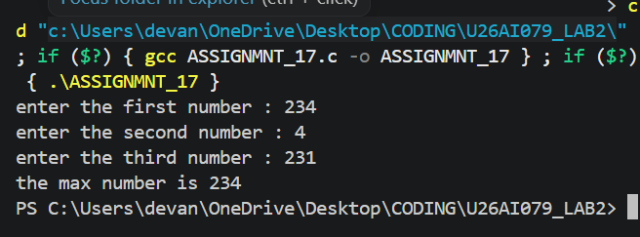

Q-18 PROGRAM TO READ THREE NOS. AND PRINT MAX USING CONDITIONAL

(? :)OPERATOR.
#include<stdio.h>
int main(){
int x1,x2,x3;
printf("enter the 1st number : ");
scanf("%d",&x1);
printf("enter the 2nd number : ");
scanf("%d",&x2);
printf("enter the 3rd number : ");
scanf("%d",&x3);
int max=(x1>x2 && x1>x3)?x1:(x2>x3)?x2:x3;
printf("the maximun number is %d",max);

return 0;
}
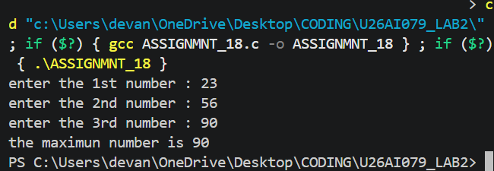

Q-19 PROGRAM TO READ A CHARACTER AND CHECK WHETHER IT IS A SMALL

CASE.
#include<stdio.h>
int main(){
char c;
printf("enter a character : ");
scanf("%c",&c);
if(c>=97 && c<=122) printf("the entered character %c is in small caps",c);
else printf("the entered character %c is not in small caps",c);
return 0;
}
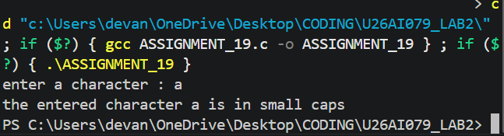
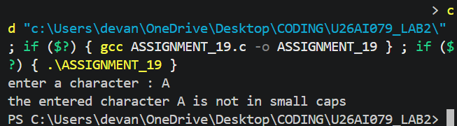

Q-20 PROGRAM WHICH WILL WORK LIKE A SIMPLE CALCULATOR USING

SWITCH-CASE.
#include<stdio.h>
int main(){
int a,b;
float op;
printf("enter the 1st number : ");
scanf("%d",&a);
printf("enter the 2nd number : ");
scanf("%d",&b);

int operation;
printf("enter 1 for Addition, 2 for Substraction, 3 for Multipication, 4 for Division : ");
scanf(" %d",&operation);
switch(operation){
case 1:
op=a+b;
printf("SUM=%f",op);
break;
case 2:
op=a-b;
printf("DIFFERENCE=%f",op);
break;
case 3:
op=a*b;
printf("MULTIPLY=%f",op);
break;
case 4:
op=a/(b+0.0);
printf("DIVIDE=%f",op);
break;
default:printf("invalid input");

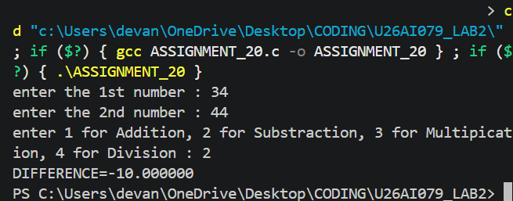
}
return 0;
}

Q-21 PROGRAM TO READ TWO NOS. AND PERFORM SPECIFIC TASK (USING ARITHMETIC OPERATOR)AND THIS PERFORM USING SWITCH-CASE.(CASE IN CHAR FORM).
#include<stdio.h>
int main(){
int a,b;
float op;
printf("enter the 1st number : ");
scanf("%d",&a);
printf("enter the 2nd number : ");
scanf("%d",&b);

char operation;
printf("enter A for Addition, B for Substraction, C for Multipication, D for Division : ");
scanf(" %c",&operation);
switch(operation){
case 'A':
op=(a+b);
printf("SUM=%f",op);
break;
case 'B':
op=a-b;
printf("DIFFERENCE=%f",op);
break;
case 'C':
op=a*b;
printf("MULTIPLY=%f",op);
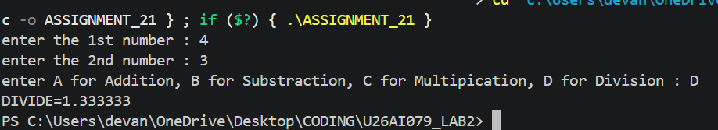
break;
case 'D':
op=a/(b+0.0);
printf("DIVIDE=%f",op);
break;
default:printf("invalid input");

}
return 0;
}

Q-22 PROGRAM TO CALCULATE FACTORIAL OF A NO.
#include<stdio.h>
int main(){
int n,factorial=1;
printf("enter the number : ");
scanf("%d",&n);
for(int i=1;i<=n;i++){
factorial=factorial*i;
}
printf("the factorial of %d is %d ",n,factorial);
return 0;
}

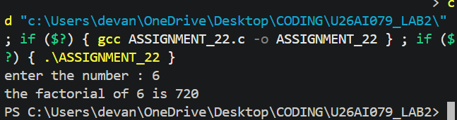

Q-23 PROGRAM TO READ TWO NOS. AND CALCULATE POWER WITHOUT

USING HEADERFILE(<MATH.H>).

int main(){
int a,b,power=1;
printf("enter the 1st number : ");
scanf("%d",&a);
printf("enter the 2nd number : ");
scanf("%d",&b);
for(int i=1;i<=b;i++){
power=power*a;
}

printf("the power of %d raised to power %d is %d",a,b,power);
return 0;
}
