WEEK 4 TASK
Predictive Modeling and Optimization in Logistics Systems
Name: Bhavesh Sawant
Program: B.Sc. Computer Science
Project Area: Logistics Data Analysis

1. Problem Definition
The selected logistics prediction problem is forecasting delivery time for a shipment. Accurate delivery-time prediction can support route planning, transportation selection, resource allocation, delay prevention and customer service. The target variable is Delivery_Time_days.

2. Dataset and Features
A hypothetical dataset of 100 shipment records was used. It contains categorical and numerical logistics features and is intended for academic demonstration.
Feature | Description | Role
Region | Shipment region | Input
Transport_Mode | Road, Rail or Air | Input
Shipment_Volume | Shipment quantity | Input
Distance_km | Travel distance | Input
Transportation_Cost | Estimated transportation cost | Input
Delivery_Time_days | Actual delivery time | Target

3. Model Selection and Implementation
Linear Regression was used as a simple baseline because it is easy to interpret. Random Forest Regression was selected as the main model because logistics relationships may be non-linear and involve interactions among distance, volume, transport mode and cost. Categorical variables were one-hot encoded and numerical variables were passed directly to the models. The data was split into 80% training and 20% testing sets.

4. Model Performance
Model | MAE | RMSE | R²
Linear Regression | 0.655 | 0.787 | 0.706
Random Forest | 0.590 | 0.728 | 0.748
Random Forest produced the lower test RMSE and was selected for the optimization scenario. Its 5-fold cross-validation mean RMSE was 0.896 days. Cross-validation helps check whether the result is reasonably stable across different data splits.

5. Evaluation Metrics
MAE measures the average absolute prediction error. RMSE penalizes larger errors more strongly. R² measures the proportion of target variation explained by the model. Lower MAE/RMSE and higher R² are preferred.

Actual vs Predicted Delivery Time
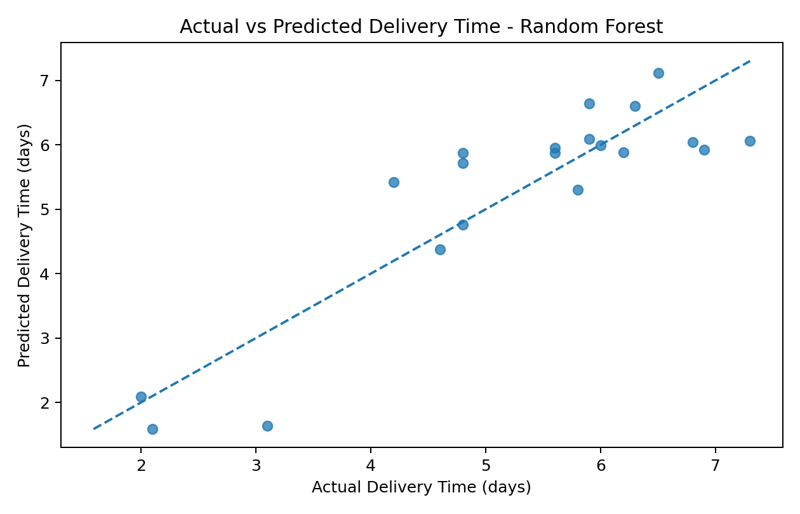
Interpretation: Points close to the diagonal line represent accurate predictions.

Residual Analysis
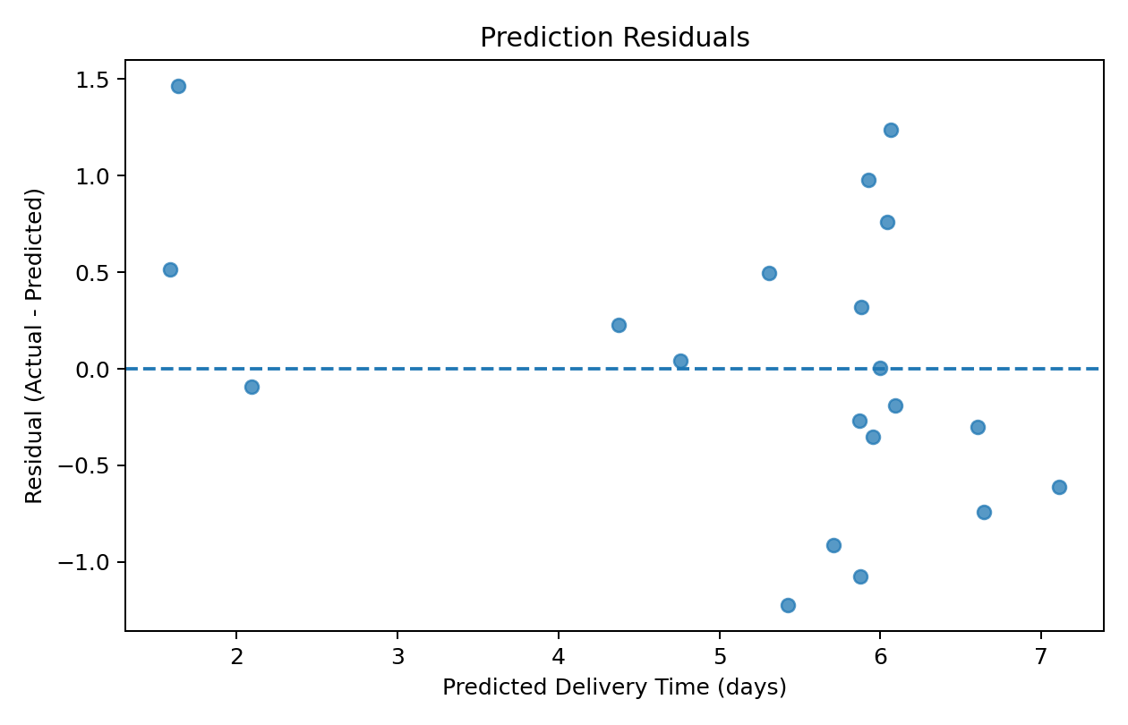
Interpretation: Residuals near zero indicate smaller errors; a random spread around zero is desirable.

Relationships with Delivery Time
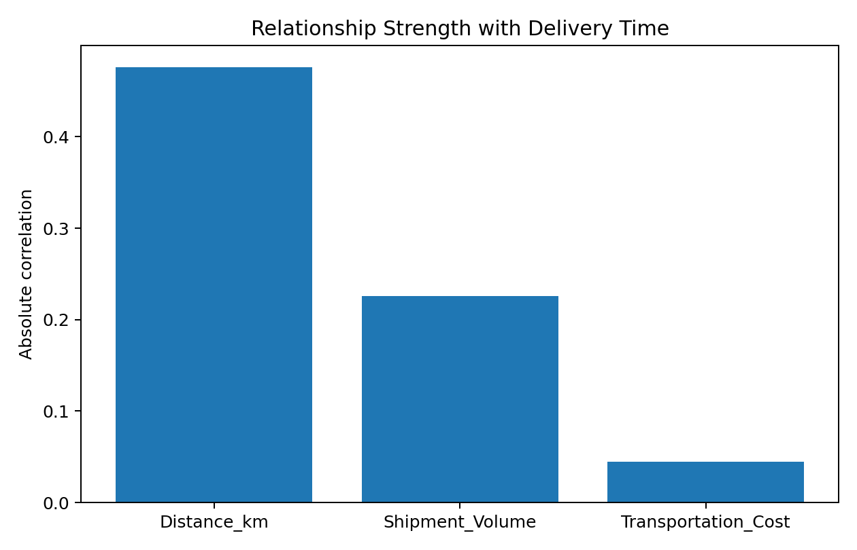
Interpretation: The chart highlights the strength of relationships between numerical inputs and delivery time.

6. Optimization Strategy
Prediction can be converted into an operational decision-support process. For a planned shipment, the organization can compare transportation modes using predicted delivery time and estimated cost. If a shipment is predicted to miss a service target, the planner can consider a faster mode, earlier dispatch, alternative routing or additional capacity.
Mode | Predicted Delivery (days) | Reference Cost
Road | 5.86 | 893.20
Rail | 5.01 | 893.20
Air | 3.18 | 893.20

7. Optimization Recommendations
- Flag shipments predicted to exceed service-level targets before dispatch.
- Compare Road, Rail and Air using both predicted delivery time and transportation cost.
- Review route and capacity plans for shipments with high predicted delivery time.
- Allocate vehicles and manpower according to predicted shipment demand.
- Monitor model performance and retrain periodically as new data becomes available.
- Use cross-validation and unseen test data to reduce the risk of overestimating model quality.

8. Sample Python Code
from sklearn.ensemble import RandomForestRegressor
from sklearn.model_selection import train_test_split
from sklearn.metrics import mean_absolute_error, mean_squared_error, r2_score
X_train, X_test, y_train, y_test = train_test_split(
X, y, test_size=0.20, random_state=42)
model = RandomForestRegressor(
n_estimators=200, max_depth=8,
min_samples_leaf=2, random_state=42)
model.fit(X_train, y_train)
prediction = model.predict(X_test)
mae = mean_absolute_error(y_test, prediction)
rmse = mean_squared_error(y_test, prediction) ** 0.5
r2 = r2_score(y_test, prediction)
print(mae, rmse, r2)

9. Conclusion
This project applied predictive modeling to a logistics delivery-time problem. Linear Regression and Random Forest Regression were compared using MAE, RMSE and R². Random Forest was selected based on test RMSE and checked with 5-fold cross-validation. The predictions can support transportation selection, early delay detection, capacity allocation and route planning. Because the dataset is hypothetical, the results demonstrate the methodology rather than real company performance.

10. Deliverables
• DOC report with methodology, model evaluation, charts and optimization recommendations.
• Python script for data preparation, model training, evaluation and optimization scenarios.
• Logistics dataset used for the predictive model.

