COLPCI-5221-DEVELOPER-TEST-NOTES
================================

Before:
=======
Head over to PAYMENTBATCH: 25120A30195
- The record shows 2 MATCHED
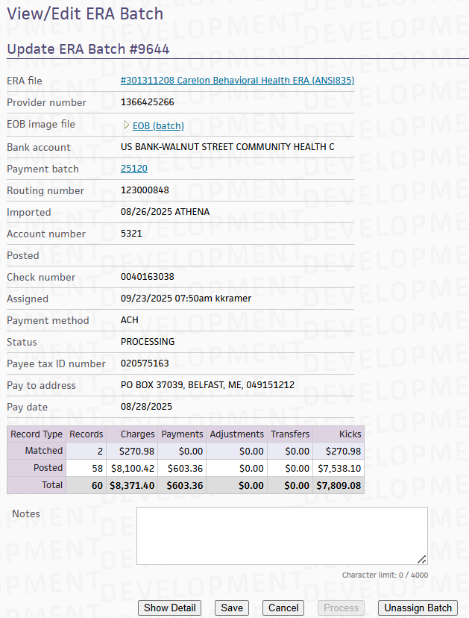
- but when we un-assign the batch, the status becomes PREPOSTED
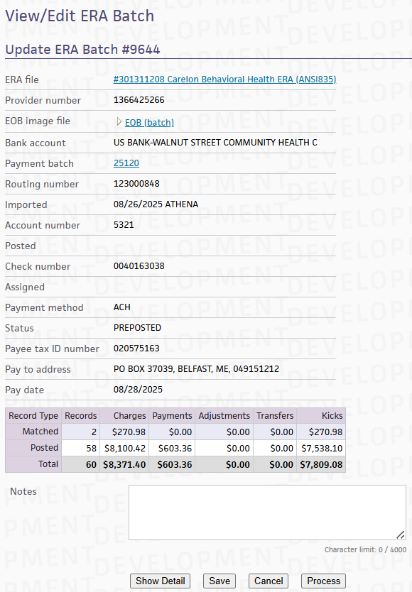
- DB screenshot from the terminal
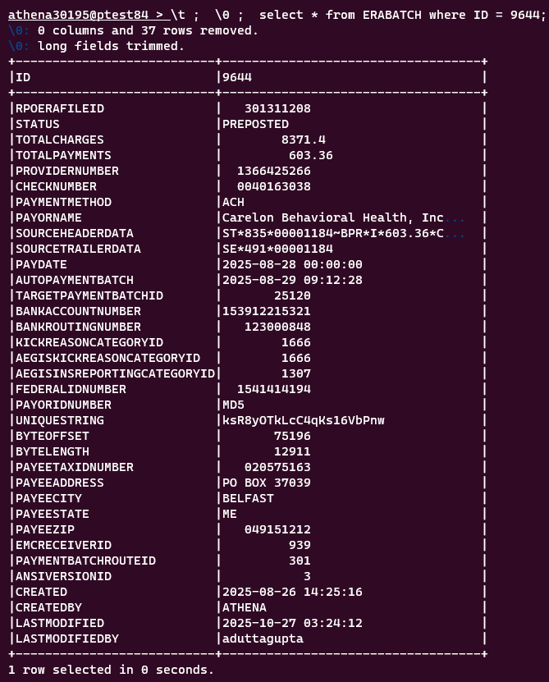
- If we click the ‘Process’ button, this is displayed
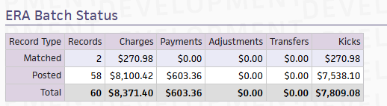
and in the left-pane, this message is displayed
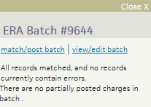

Running the DML:
================
dabhinab@preprod512511:~/dabhinab_streams$ perl scripts/build/patch_harness.pl PTEST1 techops/collector/dailydml/20251204_COLPCI_5402_dml.pl –allowxtest
---------------
Checking Environment
$ENV{ATHENA_HOME} set to /home/dabhinab/dabhinab_streams/prod
Is this correct? (Waiting for a y/n ...):y
Time: 10/24/2025 02:21AM, continuing on...
Done Checking Environment
---------------
---------------
Checking Script Options Found
{
SQLCUBEUSERPASS=> sqlcube/sqlcube,
ALLOWXTEST=> 1,
ROOTUSERPASS=> athena1/athena1,
SQLCUBESID=> PREPORT1,
QUEUESID=> PQUEUE1,
WORKLISTENGINESID=> PQUEUE4,
WORKLISTENGINEUSERPASS=> worklistengine/worklistengine,
PROVIDERDIRECTORYSID=> PQUEUE5,
PATIENTIDENTITYUSERPASS=> patientidentity/patientidentity,
INTERFACEQUEUE01SID=> PQUEUE2,
ECRDIRECTSID=> PQUEUE3,
SCRIBE=> DEFAULT,
DEVROPLUSUSERPASS=> devroplus/devroplus,
ROOTSID=> PTEST1,
SKIPSNAPSHOTS=> 1,
PATIENTIDENTITYSID=> PQUEUE5,
ECRDIRECTUSERPASS=> ecrdirect/ecrdirect,
DEVROPLUSSID=> PQUEUE4,
CONSUMERENGAGEMENTSID=> PQUEUE3,
GLOBALSCHEDULINGUSERPASS=> globalscheduling/globalscheduling,
PAPERCLAIMSSID=> PQUEUE4,
PLACEHOLDER01SID=> PQUEUE4,
PROVIDERDIRECTORYUSERPASS=> providerdirectory/providerdirectory,
GLOBALSCHEDULINGSID=> PQUEUE5,
AUTOCLAIMWIZARDSID=> PQUEUE4,
PLACEHOLDER01USERPASS=> placeholder01/placeholder01,
IMPORTUSERPASS=> import/import,
PAPERCLAIMSUSERPASS=> paperclaims/paperclaims,
IMPORTSID=> PQUEUE4,
INTERFACEQUEUE01USERPASS=> interfacequeue01/interfacequeue01,
AUTOCLAIMWIZARDUSERPASS=> autoclaimwizard/autoclaimwizard,
MASTERPATIENTINDEXUSERPASS=> masterpatientindex/masterpatientindex,
CONSUMERENGAGEMENTUSERPASS=> consumerengagement/consumerengagement,
ECOSYSTEMSID=> PQUEUE3,
WAREHOUSEUSERPASS=> warehouse/warehouse,
QUEUEUSERPASS=> queue/queue,
MASTERPATIENTINDEXSID=> PQUEUE3,
ECOSYSTEMUSERPASS=> ecosystem/ecosystem,
WAREHOUSESID=> PREPORT1,
}
Is this correct? (Waiting for a y/n ...):y
Time: 10/24/2025 02:21AM, continuing on...
Done Checking Script Options Found
---------------
---------------
Checking DXL Found
{
PRACTICEDXL=>
[
{
DXLID=> 0,
MESSAGE=> COLPCI-5221 & COLPCI-5290: Update for PAYMENTBATCHES 25120A30195 & 25460A30195,
DML=>
update
ERARECORD
set
CHARGEID = '76582',
CLAIMID = '15030',
MATCHED = '',
MATCHEDBY = '',
lastmodified = sysdate,
lastmodifiedby = 'DBA_PATCH_20251024'
where
ID in (142955)
and MATCHED is not null
,
OWNEREMAIL=> dabhinab@athenahealth.com,SECOLPCIDev@athenahealth.com,
MAINTENANCESTATUS=> MAINTENANCEON,
IGNOREERROR=> ,
PRACTICEID=> 30195,
},
{
DXLID=> 1,
MESSAGE=> COLPCI-5221 & COLPCI-5290: Update for PAYMENTBATCHES 25120A30195 & 25460A30195,
DML=>
update
ERARECORD
set
CHARGEID = '1036516',
CLAIMID = '567228',
MATCHED = '',
MATCHEDBY = '',
lastmodified = sysdate,
lastmodifiedby = 'DBA_PATCH_20251024'
where
ID in (145020)
and MATCHED is not null
,
OWNEREMAIL=> dabhinab@athenahealth.com,SECOLPCIDev@athenahealth.com,
MAINTENANCESTATUS=> MAINTENANCEON,
IGNOREERROR=> ,
PRACTICEID=> 30195,
},
{
DXLID=> 2,
MESSAGE=> COLPCI-5221 & COLPCI-5290: Update for PAYMENTBATCHES 25120A30195 & 25460A30195,
DML=>
update
ERARECORD
set
CHARGEID = '1036533',
CLAIMID = '567243',
MATCHED = '',
MATCHEDBY = '',
LASTMODIFIED = sysdate,
LASTMODIFIEDBY = 'DBA_PATCH_20251024'
where
ID in (145035)
and MATCHED is not null
,
OWNEREMAIL=> dabhinab@athenahealth.com,SECOLPCIDev@athenahealth.com,
MAINTENANCESTATUS=> MAINTENANCEON,
IGNOREERROR=> ,
PRACTICEID=> 30195,
},
],
}
Is this correct? (Waiting for a y/n . ):y
Time: 10/24/2025 02:22AM, continuing on...
Done Checking DXL Found
---------------
---------------
Running Generated Practice DML script, DXLID(s) => 0, 1, 2
/usr/local/bin/perl /home/dabhinab/dabhinab_streams/prod/scripts/run_script_in_all_practices.pl --parallel 3 --parallelinstances 2 --outputdir /tmp/20251024_COLPCI_5221_COLPCI_5290_ERARECORD_dml.pl_3123087_0 --scribecategory patch_harness-PTEST1 --sqlfilter id=30195 /tmp/20251024_COLPCI_5221_COLPCI_5290_ERARECORD_dml.pl_3123087_0_codedir/practice_MAINTENANCEON_DML_1.pl
Logging output in /tmp/20251024_COLPCI_5221_COLPCI_5290_ERARECORD_dml.pl_3123087_0
Do you want to continue? (Waiting for a y/n ...):y
Time: 10/24/2025 02:22AM, continuing on...
Connecting to the random instance at PTEST1
Executing /tmp/20251024_COLPCI_5221_COLPCI_5290_ERARECORD_dml.pl_3123087_0_codedir/practice_MAINTENANCEON_DML_1.pl with arguments :
Executing { { { perl /tmp/20251024_COLPCI_5221_COLPCI_5290_ERARECORD_dml.pl_3123087_0_codedir/practice_MAINTENANCEON_DML_1.pl PTEST84 ATHENA30195 ; } |tee -a /tmp/20251024_COLPCI_5221_COLPCI_5290_ERARECORD_dml.pl_3123087_0/practice_MAINTENANCEON_DML_1.pl_ATHENA30195_out |sed 's/^/[practice_MAINTENANCEON_DML_1.pl_ATHENA30195_out] /' |scribe_cat.pl --category=patch_harness-PTEST1 ; } 2>&1 ; } |tee -a /tmp/20251024_COLPCI_5221_COLPCI_5290_ERARECORD_dml.pl_3123087_0/practice_MAINTENANCEON_DML_1.pl_ATHENA30195_err |sed 's/^/[practice_MAINTENANCEON_DML_1.pl_ATHENA30195_err] /' |scribe_cat.pl --category=patch_harness-PTEST1
ListUtil.c: loadable library and perl binaries are mismatched (got handshake key 0xc180000, needed 0xe180000)
sed: couldn't flush stdout: Broken pipe
Intercepting email (dabhinab@athenahealth.com -> dabhinab@athenahealth.com)
Done
Intercepting email (dabhinab@athenahealth.com,SECOLPCIDev@athenahealth.com -> dabhinab@athenahealth.com)
Intercepting email (dabhinab@athenahealth.com,SECOLPCIDev@athenahealth.com -> dabhinab@athenahealth.com)
Intercepting email (dabhinab@athenahealth.com,SECOLPCIDev@athenahealth.com -> dabhinab@athenahealth.com)
Done Running Generated Practice DML script, DXLID(s) => 0, 1, 2
---------------
---------------
All DML required to run while Maintenance is ON has completed!
You can begin restarting production
---------------
---------------
Completed Megapatch
---------------
Intercepting email

After:
======
Go to Financials > Payment Batches > (provide payment-batch-id) Filter> View Era File > Unassign the Batch > Process button
On un-assigning the Batch and clicking the Process button, the Batch gets to POSTED status
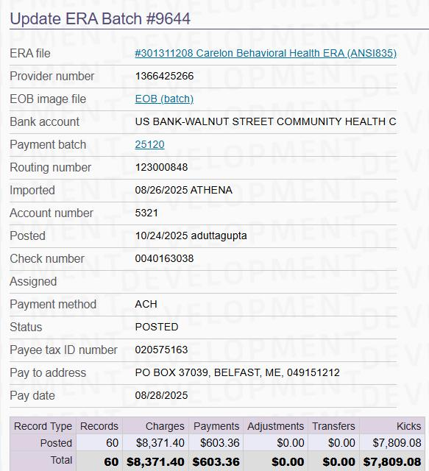
On doing the above operation, we can see the Batch POSTED.
We can confirm the Data with the DB as well:
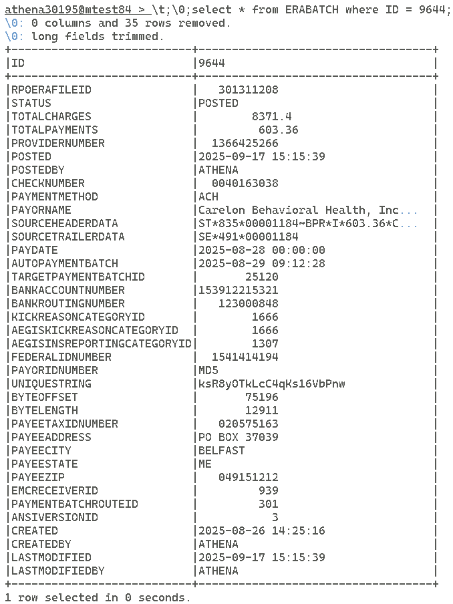

COLPCI-5290 has also been addressed in the same DML, after running the DML we can go to the PAYMENTBATCH: 25460A30195
Then, click on View ERA, unassign and click ‘Process’ button, we can the see the BATCH as POSTED:
