COLPCI-5233 || GA for Toggle COLPCI_5233_ASSERT_FIX
==============================================
- Beta contexts
  - beta-contexts
    - 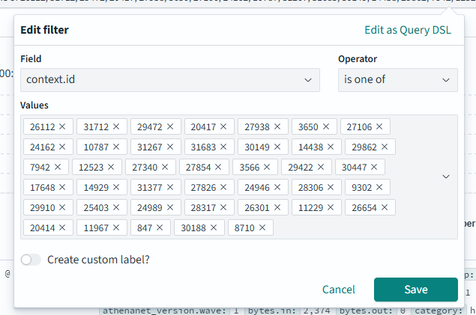
  - with status code 200
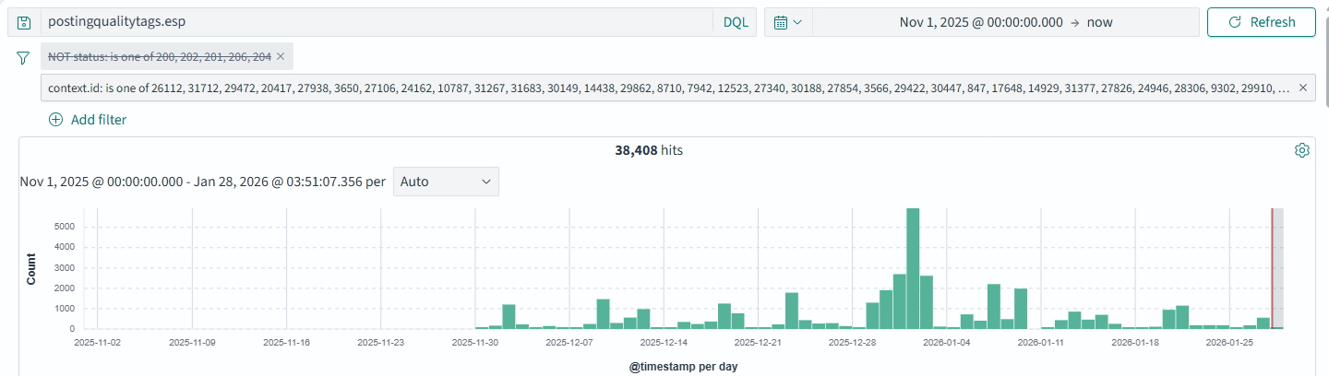
  - Without status code 200
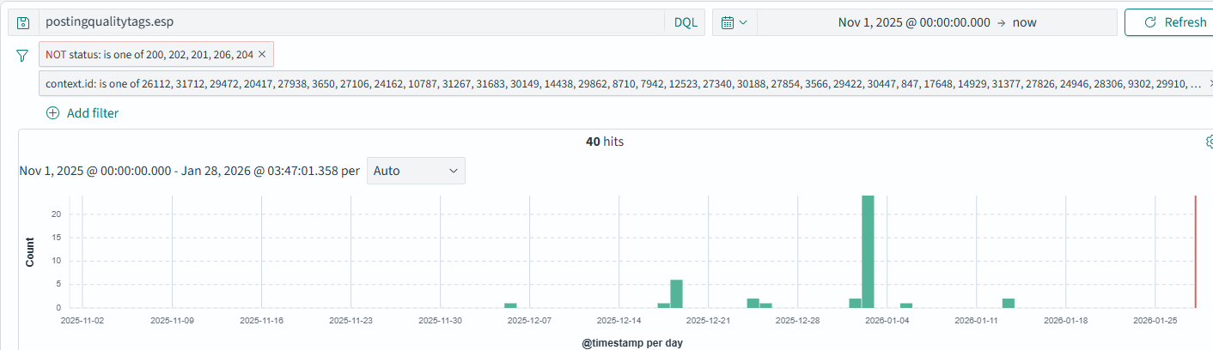
- Alpha-contexts
  - alpha-contexts:
    - 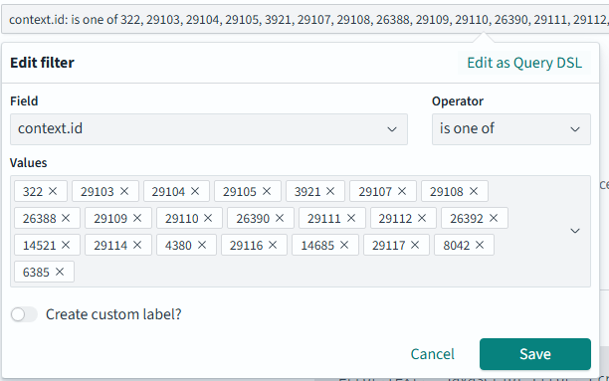
  - With status code 200
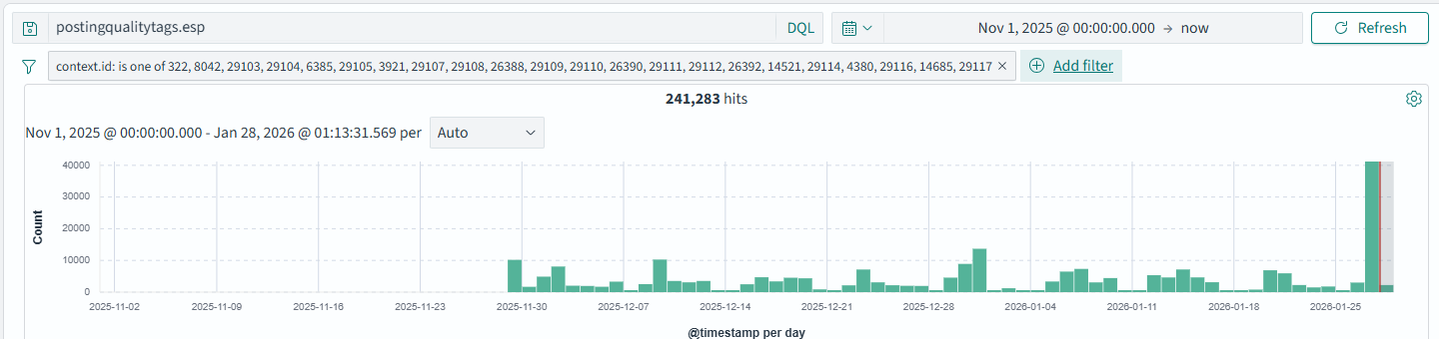
  - Without status code 200
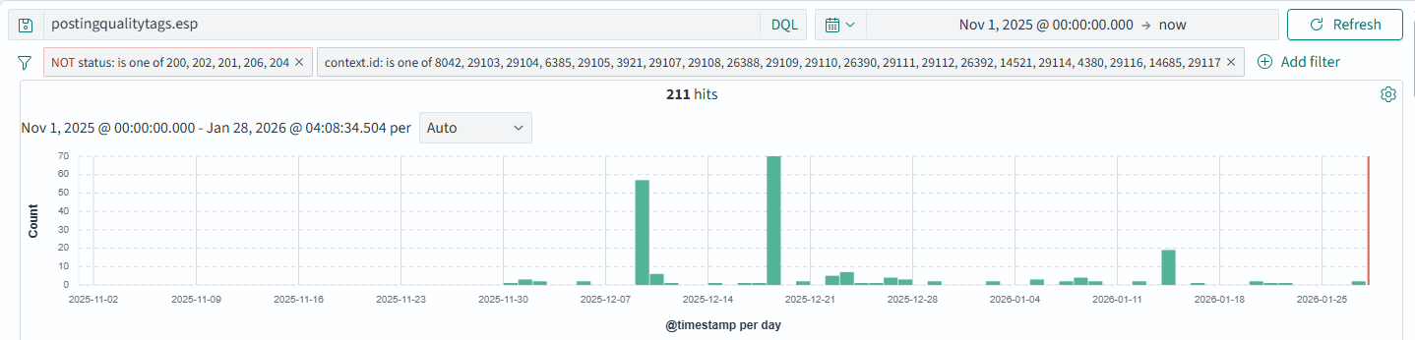

- Alpha contexts had reported errors with the status code below:
  - 6385(500)
    - 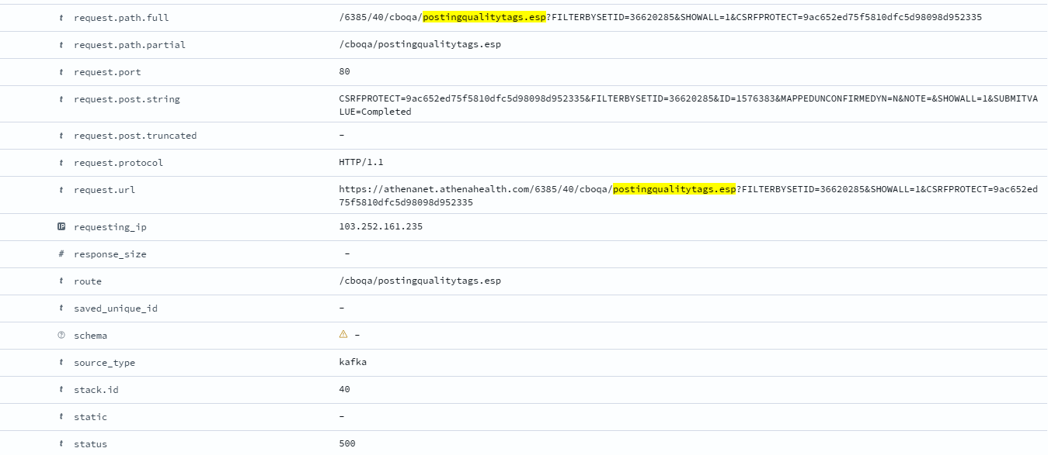
    - 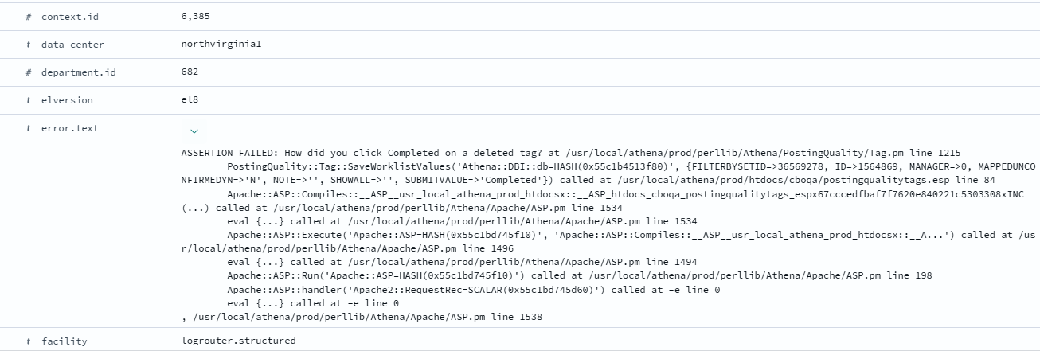
    - The above error is not related to the toggle fix hence, it can go for GA
  - 8042(500)
    - 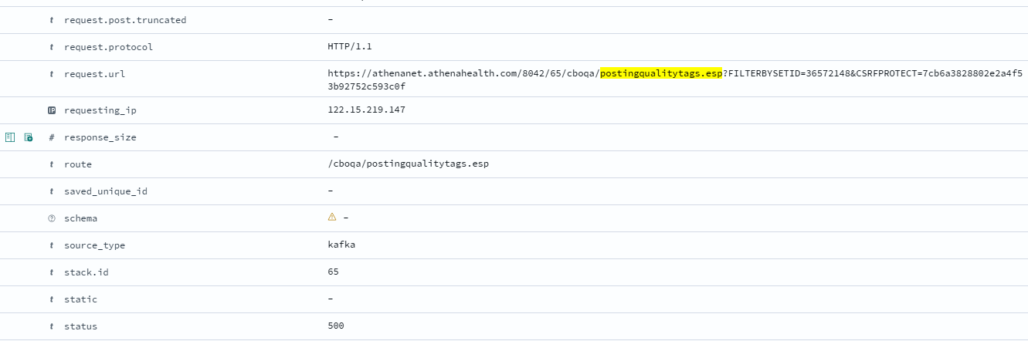
    - 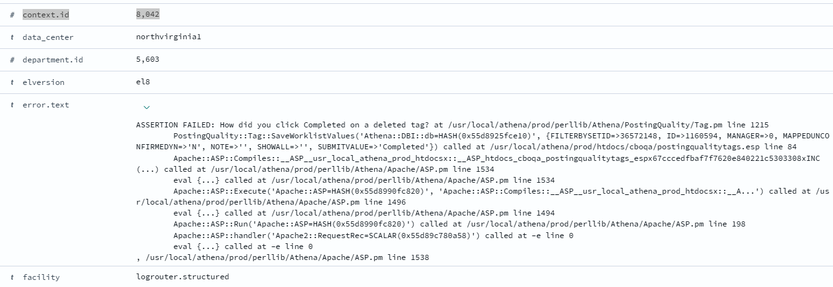
    - The above error is not related to the toggle fix hence, it can an go for GA
  - 14521(302)
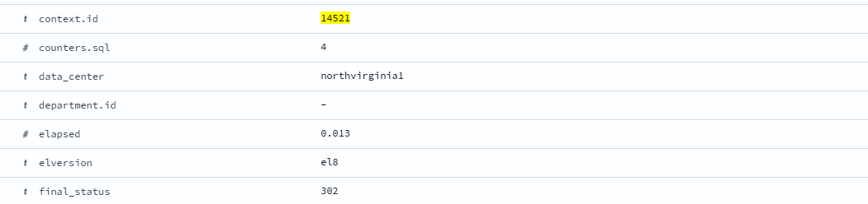
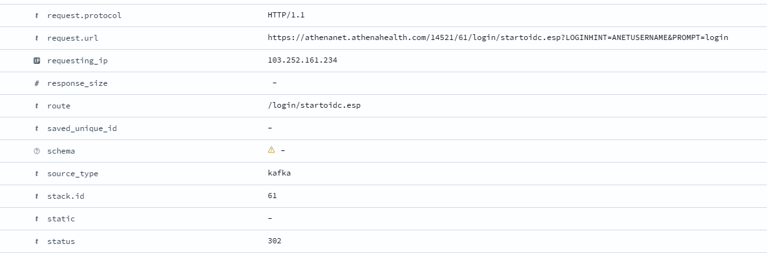
- Error was observed for the following beta-contexts:
  - 847(302 & 500)
    - 302
      - 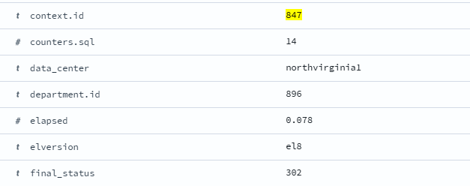
      - We can verify from the status code this error is not related to the toggle fix
    - 500
      - 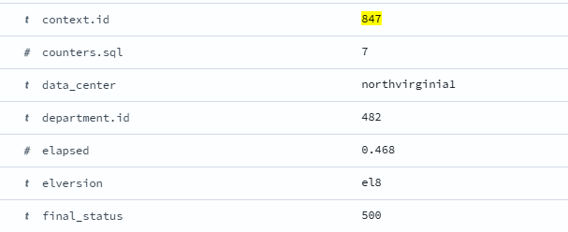
      - 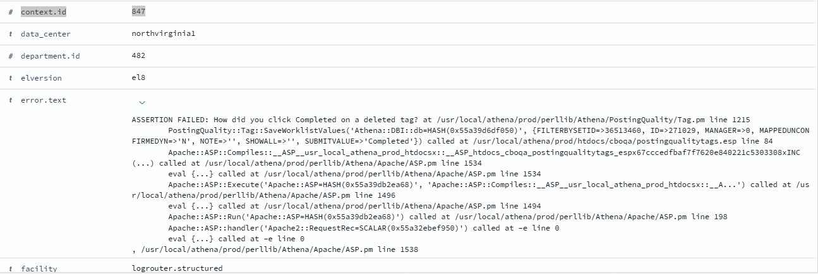
      - The above error is not related to the toggle fix hence, it can process for GA release
  - 30188 (302)
    - 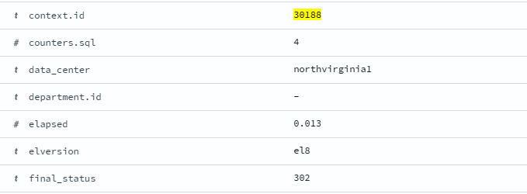
    - We can verify from the status code this error is not related to the toggle fix
  - 9302 (302)
    - 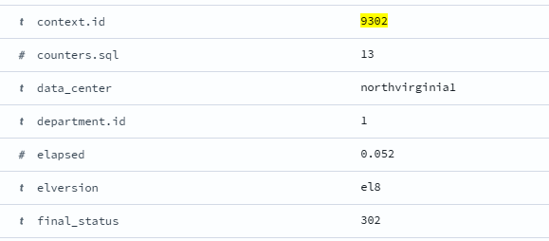
    - We can verify from the status code this error is not related to the toggle fix
  - 8710 (302)
    - 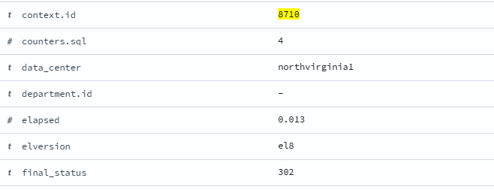
    - We can verify from the status code this error is not related to the toggle fix
  - 9302 (302)
    - 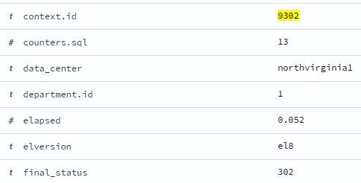
    - We can verify from the status code this error is not related to the toggle fix
  - 14929 (500)
    - 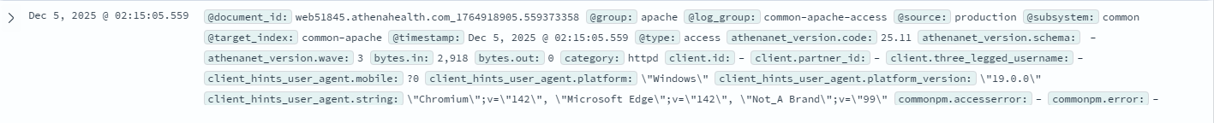
    - 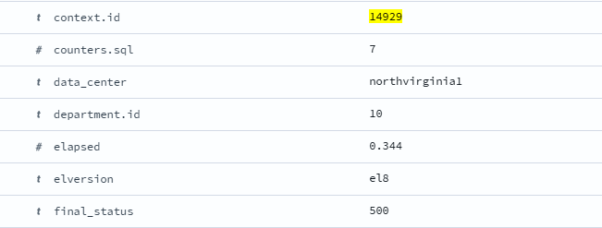
    - Beta contexts went live from 9th December, and this error occurred on 5th December hence, can proceed for GA release
- Error was not encountered for alpha contexts before November 4th
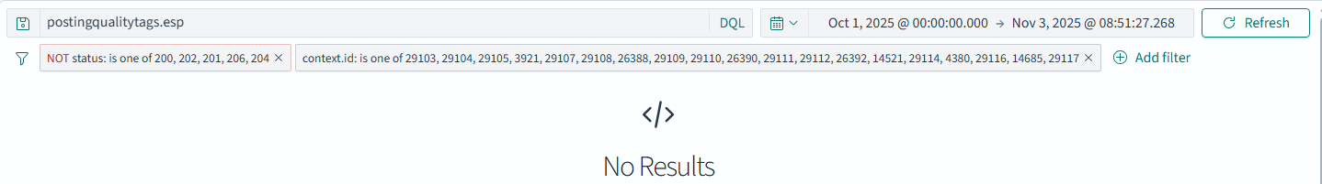
- Error was not encountered for beta contexts before December
