COLPCI-4961 code-check
Before:
Gear->Posting->Posting Dashboard
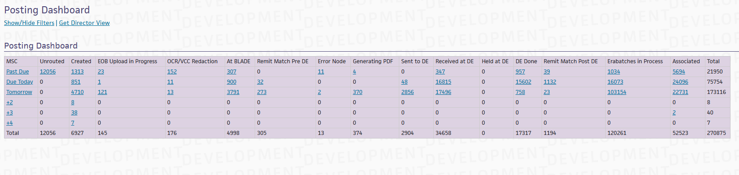
posting-dashboard
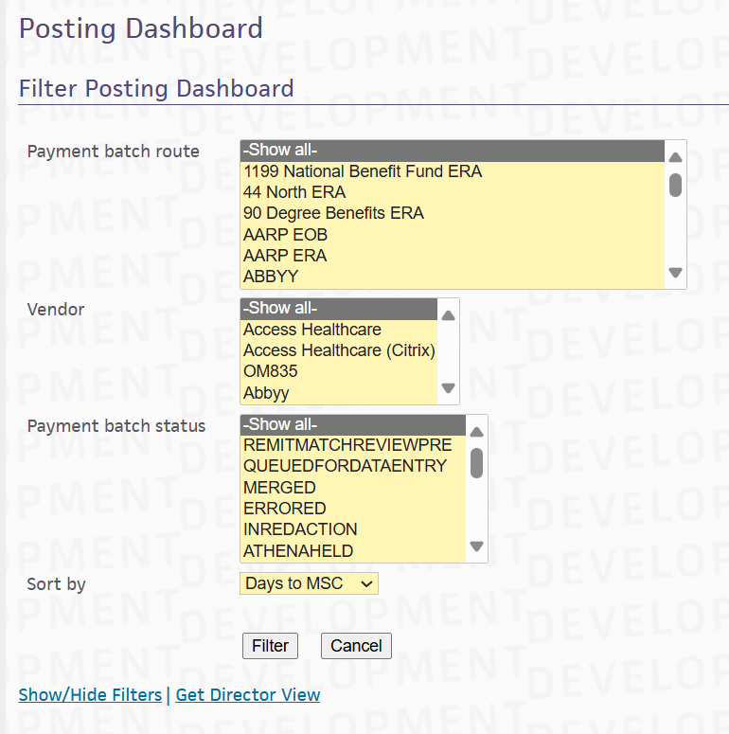
select the payment batch route and payment batch status
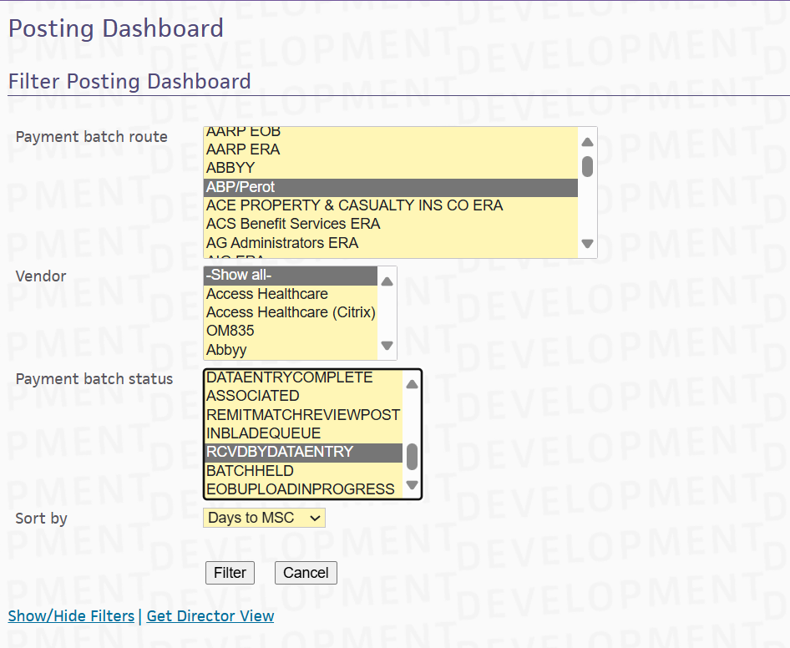
click on Filter
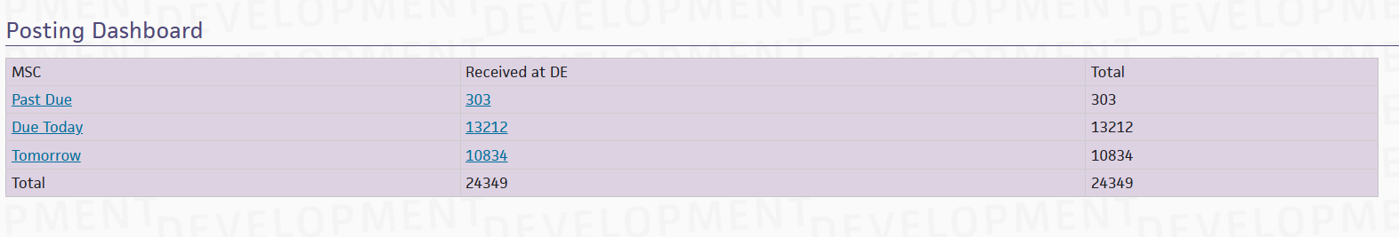
click on the hyper link 303 at “received at DE”
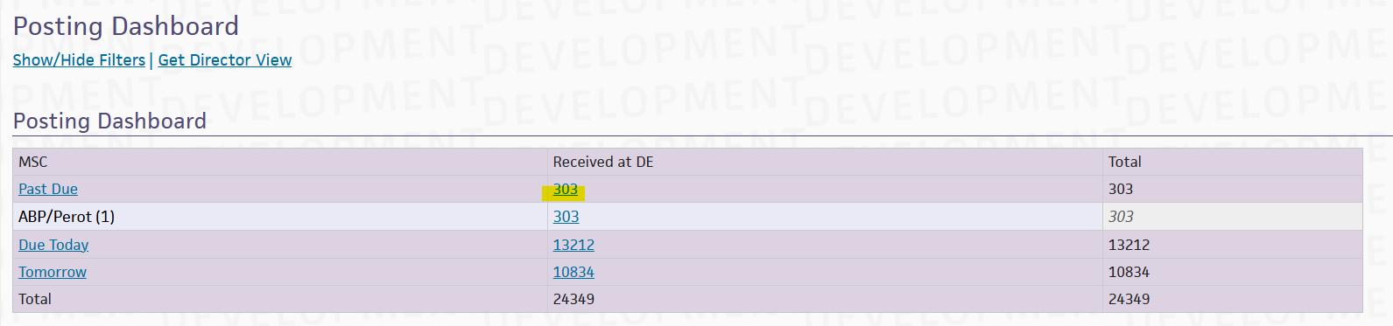
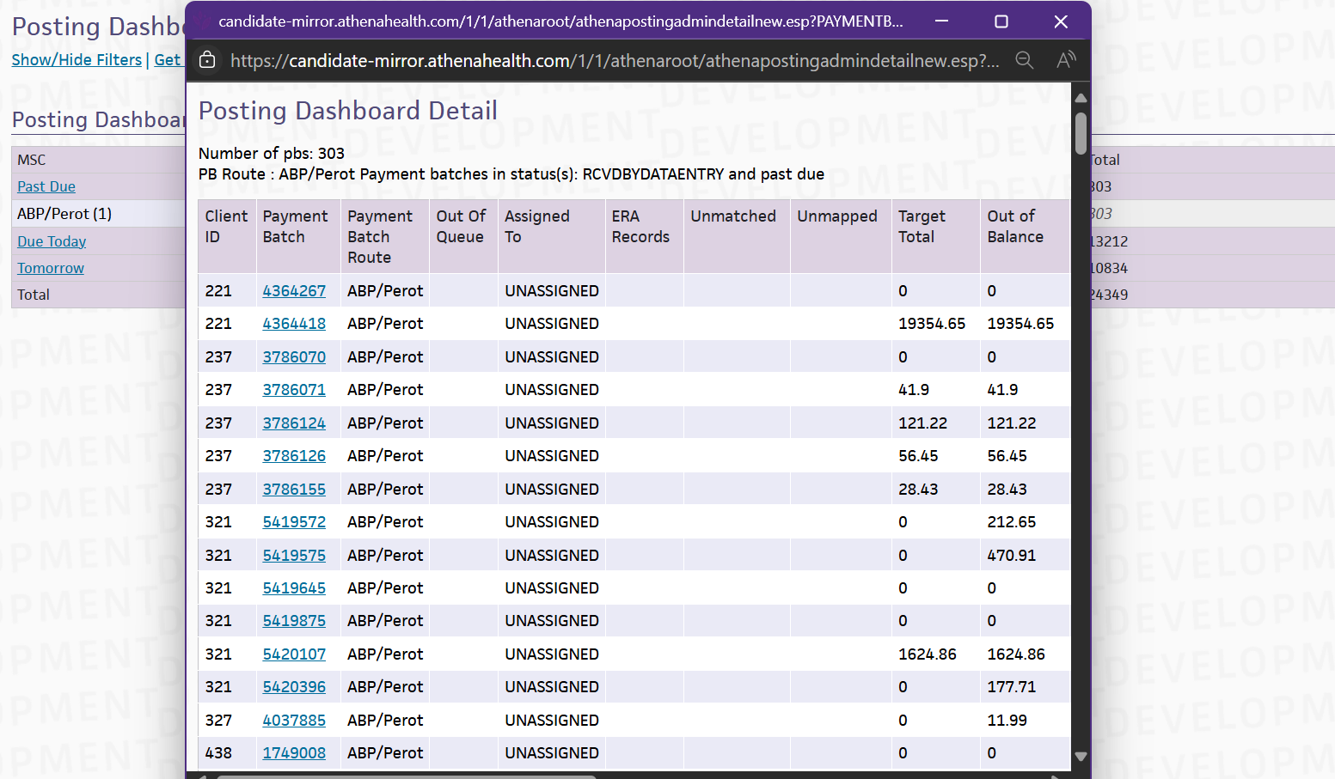
click the download-csv button
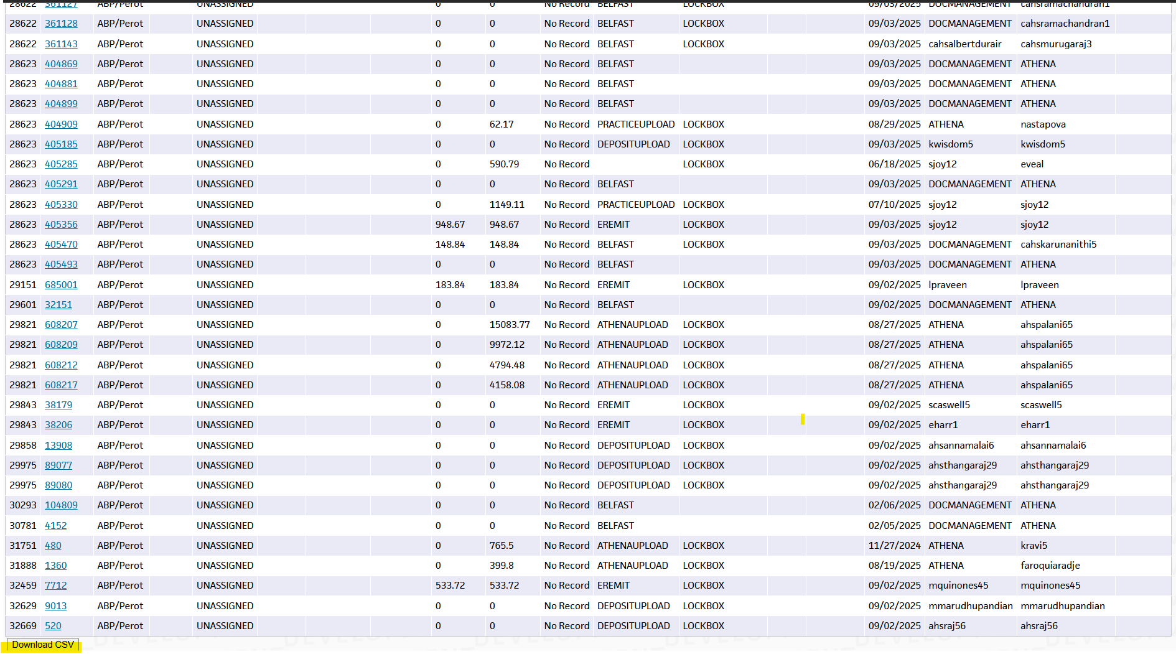
when the Toggle : OFF
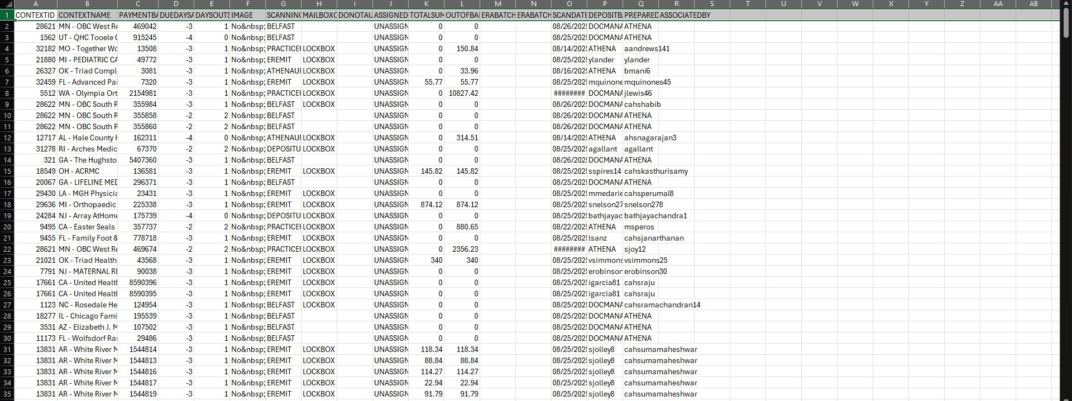
In This CSV file there is no such column - Payment Batch Route Name.

After:
When Toggle is ON
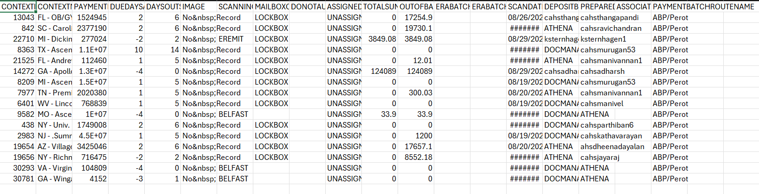In CSV file the PAYMENTBATCHROUTENAME column added

