QA-TEST-NOTES
=============
Before:
=======
PAYMENTBATCH
============
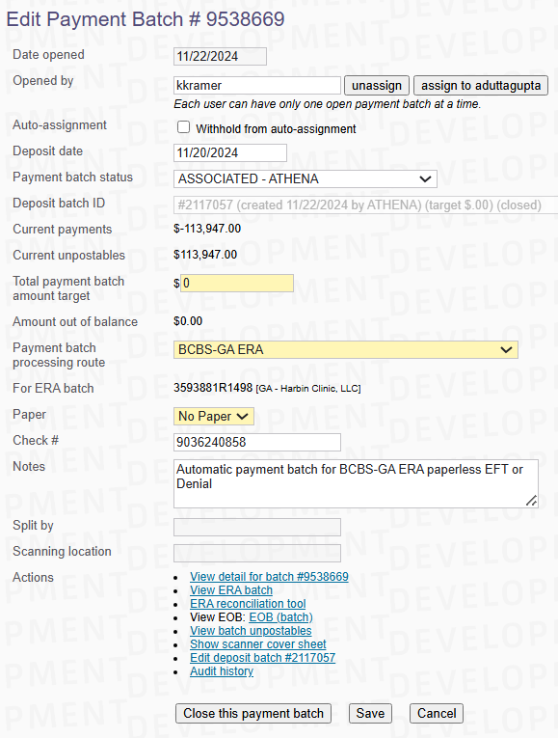
ERABATCH
========
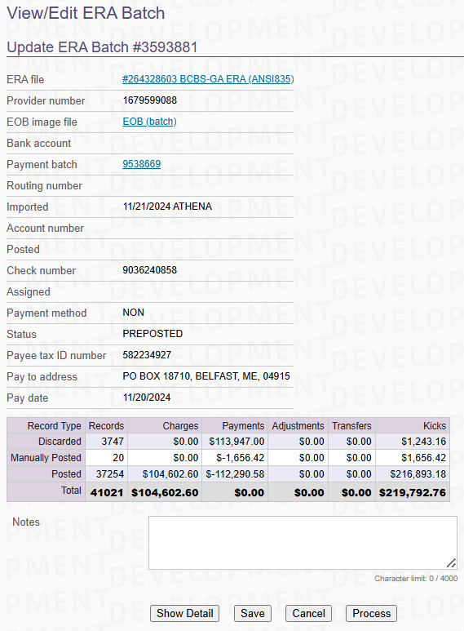

Update Query to make the ERABATCH PREPOSTED
===========================================
dabhinab@preprod512511:~/dabhinab_streams$ sql++
sql++ version 18p1. \h for help, for more search 'sql++' in the wiki. \q or ^D to exit.
athena1@ptest1 > \u 1498
athena1498@ptest19 > update erabatch set status = 'PREPOSTED' ,POSTED = '' ,POSTEDBY = '' where id = 3593881;
1 row updated in 0 seconds.
athena1498@ptest19 > update erarecord set applied= '' ,appliedby = '' where erabatchid in (3593881) and claimid = 1131675;
0 rows updated in 0 seconds.
athena1498@ptest19 > update paymentbatch set statusid = 10 ,closed = ''where erabatchid in (3593881);
1 row updated in 0 seconds.
athena1498@ptest19 > commit;
Commit

Click Process button
====================
Process button was clicked on 14:39PM
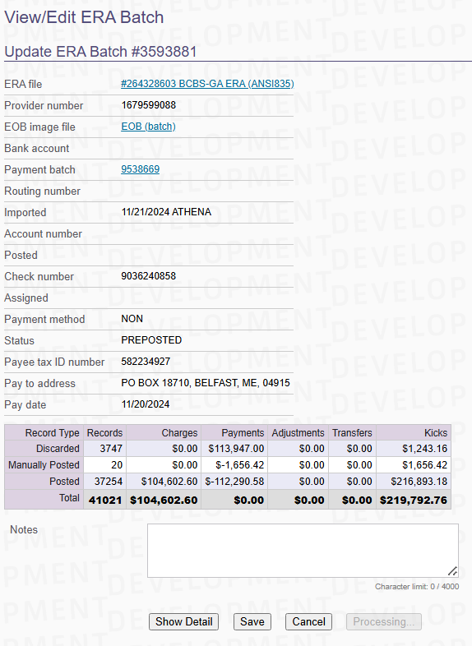
Processing was completed by 14:41PM => took 2 minutes to Process the Batch

After:
======
Closed the PAYMENTBATCH
=======================
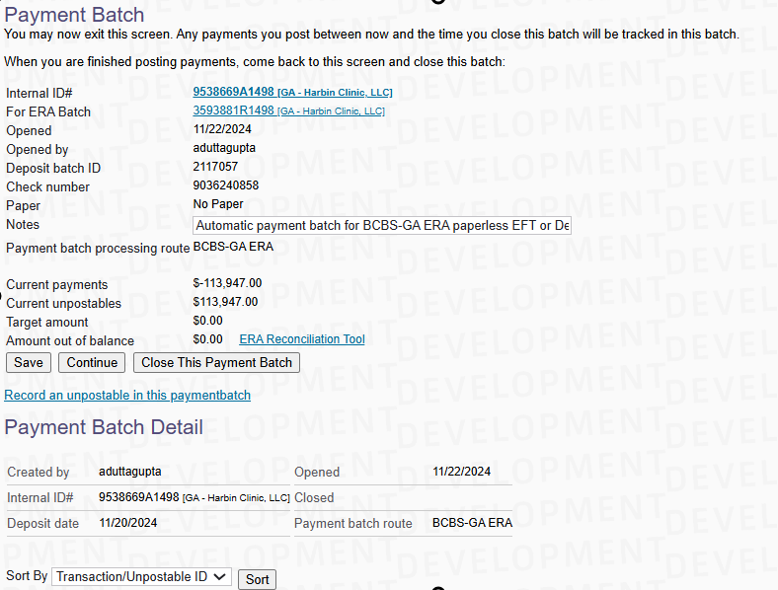
It took 4 minutes to close the PAYMENTBATCH
ERABATCH
========
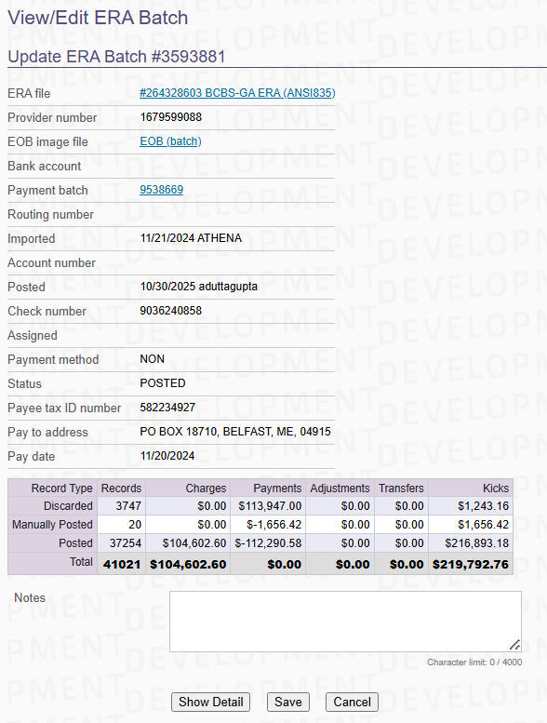
Batch got POSTED successfully

SQL-PLAN-STATS
==============
QUERY:
======
SELECT
claimid,
transfertype
FROM
Erarecord
WHERE
( erabatchid = ? )
GROUP BY
claimid,
transfertype
HAVING
( sum(case
when erarecord.reversalflag = 'Y'
then -payment
else payment end) = ? )
AND ( sum(case when erarecord.reversalflag = 'Y' then 1 else 0 end) > 0 );
Plan Stats
==========
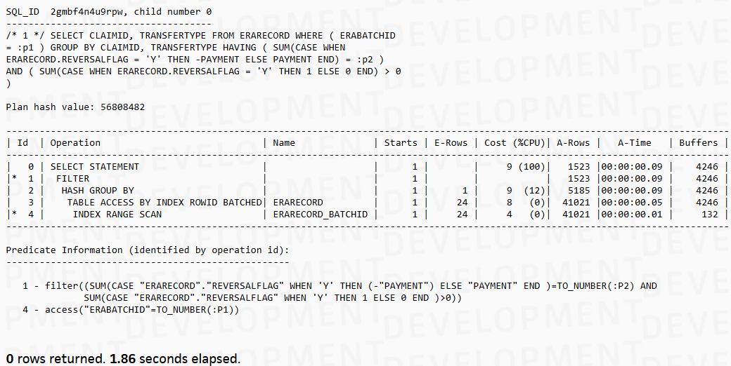
SQL_ID 2gmbf4n4u9rpw, child number 0
-------------------------------------
/* 1 */ SELECT CLAIMID, TRANSFERTYPE FROM ERARECORD WHERE ( ERABATCHID
= :p1 ) GROUP BY CLAIMID, TRANSFERTYPE HAVING ( SUM(CASE WHEN
ERARECORD.REVERSALFLAG = 'Y' THEN -PAYMENT ELSE PAYMENT END) = :p2 )
AND ( SUM(CASE WHEN ERARECORD.REVERSALFLAG = 'Y' THEN 1 ELSE 0 END) > 0
)
Plan hash value: 56808482
----------------------------------------------------------------------------------------------------------------------------------
| Id | Operation | Name | Starts | E-Rows | Cost (%CPU)| A-Rows | A-Time | Buffers |
----------------------------------------------------------------------------------------------------------------------------------
| 0 | SELECT STATEMENT | | 1 | | 9 (100)| 1523 |00:00:00.09 | 4246 |
|* 1 | FILTER | | 1 | | | 1523 |00:00:00.09 | 4246 |
| 2 | HASH GROUP BY | | 1 | 1 | 9 (12)| 5185 |00:00:00.09 | 4246 |
| 3 | TABLE ACCESS BY INDEX ROWID BATCHED| ERARECORD | 1 | 24 | 8 (0)| 41021 |00:00:00.05 | 4246 |
|* 4 | INDEX RANGE SCAN | ERARECORD_BATCHID | 1 | 24 | 4 (0)| 41021 |00:00:00.01 | 132 |
----------------------------------------------------------------------------------------------------------------------------------

Predicate Information (identified by operation id):
---------------------------------------------------
1 - filter((SUM(CASE "ERARECORD"."REVERSALFLAG" WHEN 'Y' THEN (-"PAYMENT") ELSE "PAYMENT" END )=TO_NUMBER(:P2) AND
SUM(CASE "ERARECORD"."REVERSALFLAG" WHEN 'Y' THEN 1 ELSE 0 END )>0))
4 - access("ERABATCHID"=TO_NUMBER(:P1))

