# Lost & Found (LAF) – User Stories

## As Account A (creator) I want to create a new lost item on the LAF registry

* Ensure I can navigate to the **I lost something** page (<http://localhost:3000/newlost>)
* Ensure I can complete the new item form
* Filling Title, Details, Country, State/Province fields will present Nearest City/Landmark, Reward amount and image drag/drop (click to browse) file upload fields
* Selecting an image file will upload the image to IPFS – ensure the image preview AND Submit button is displayed after upload
* Clicking on the **Submit** button should present a MetaMask transaction notification
* A confirmed transaction should result in the form being cleared

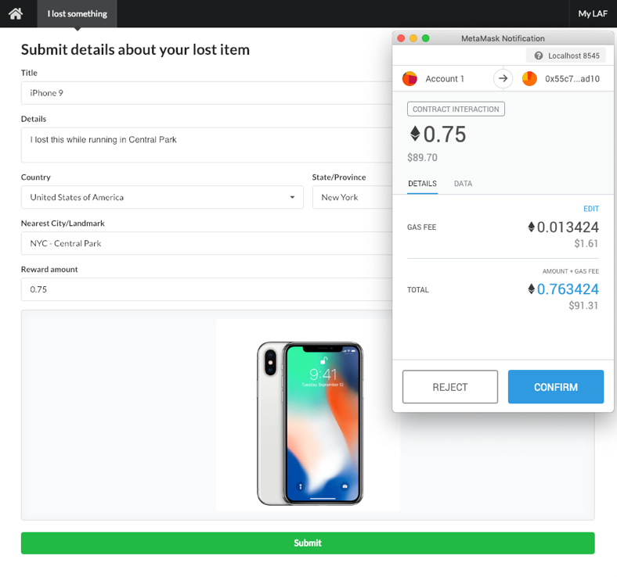

## As any account I want to find lost items in my Geo, or all items in the LAF registry

* Ensure I can navigate to the Home page (<http://localhost:3000>)
* Clicking **Find by Geo** with only Country or Country & State/Province should display lost items in the chosen geo
* Clicking **Find All** should display all items in the registry
* Selecting **See details** on one of the displayed items should navigate to the item’s detail view page

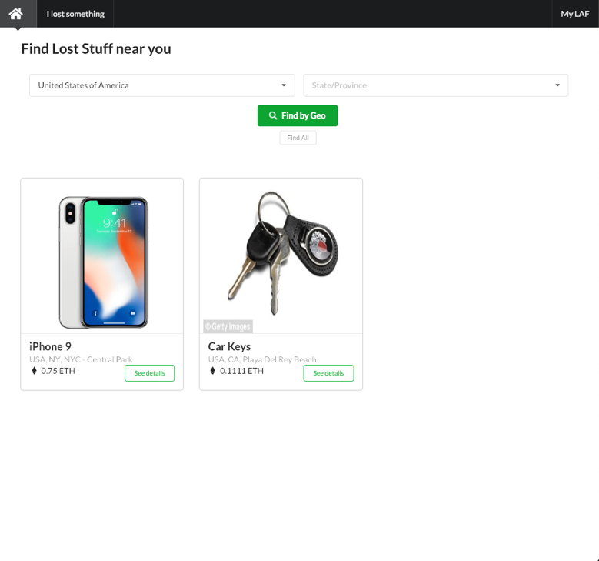

## As Account A (creator) I want to cancel a previously created item listing

* Ensure you can navigate to a listing you created (reference previous story)
* Ensure the item status towards the top of the page is **Lost**
* Ensure a red **Cancel** button is visible
* Clicking on the Cancel button should present a MetaMask transaction notification
* A confirmed transaction should result in the **Your item has not been found** message changing to reflect the cancelled state

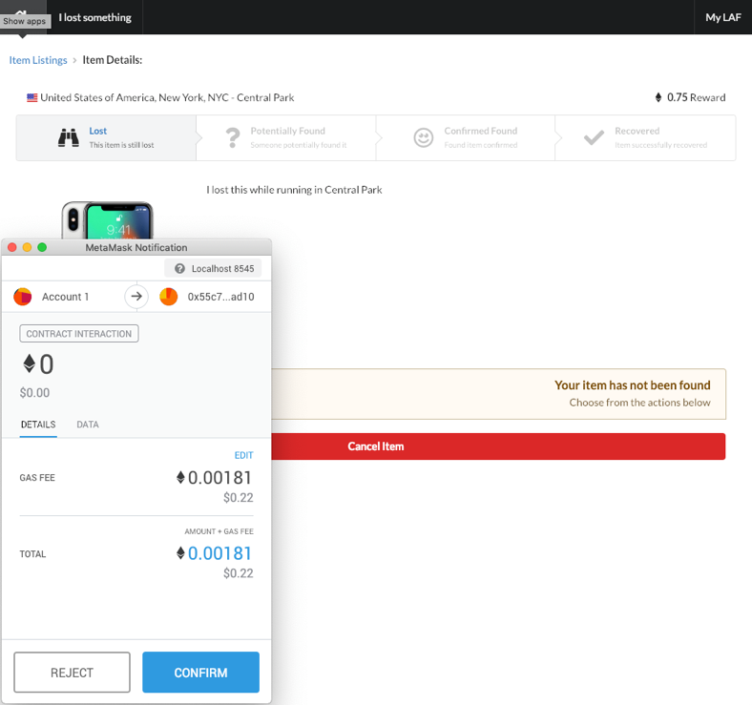

### As Account B (matcher) I want to submit a claim that I have found a listed item

* Ensure you can navigate to a listing someone else (another account) created (reference previous story)
* Ensure the item status towards the top of the page is **Lost**
* Ensure **Have you found this?** Message is shown, along with a text area for **Details of this item…** and image drag/drop (click to browse) file upload fields
* Supplying text in the **Details of this item…** text area & selecting an image file will upload the image to IPFS should result in the **Submit** button is displayed after upload
* Clicking on the **Submit** button should present a MetaMask transaction notification
* A confirmed transaction should result in the item’s status and message changing to **Potentially Found** and **Waiting for response from owner** respectively

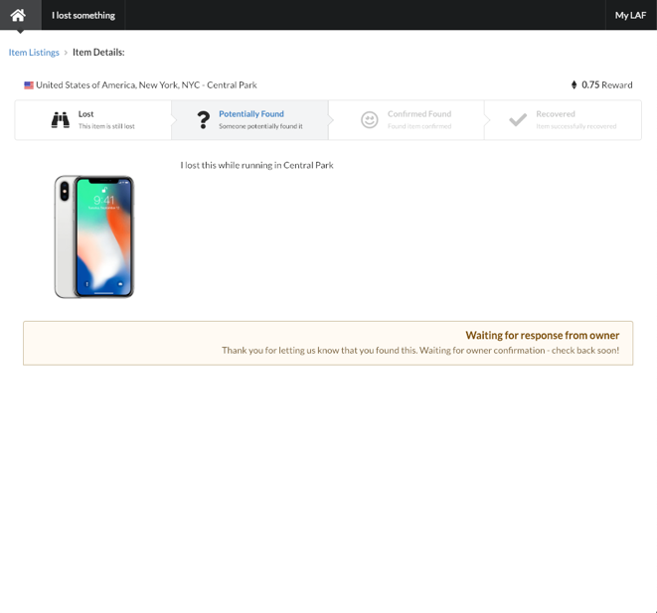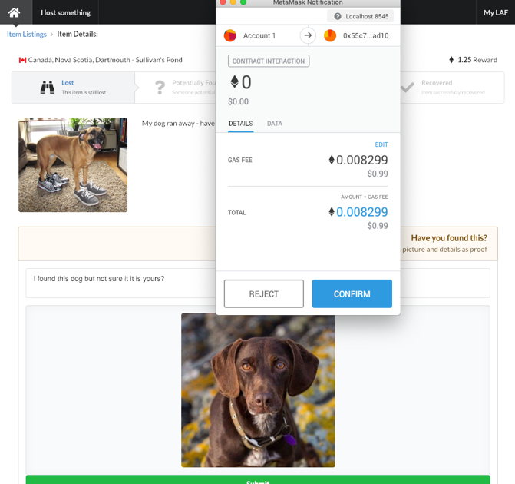

### As Account A (creator) I want confirm or reject a claim by Account B (matcher) that they have found my item based on the proof submitted

* Ensure you can navigate to a listing you created (reference previous story)
* Clicking on Yes, this is my item should present a model with text area for exchange details
* Entering details and clicking **Submit** should present a MetaMask transaction notification
* A confirmed transaction should result in the item’s status and message changing to **Confirmed Found** and **Waiting for response from owner** respectively