STATISTICS & OPERATIONS RESEARCH
ASSIGNMENT REPORT

A Statistical Analysis of India's Balance of Payments
Based on RBI Quarterly BoP Data: 2000-01 to 2026-27 (105 Quarters)

Postgraduate Programme | Semester I
Course Title: Statistics and Operations Research

Dataset Source: Reserve Bank of India (RBI)
Dataset: India's Balance of Payments — Quarterly Data
Period: Q1 2000-01 to Q1 2026-27 | Total Records: 315 (105 per transaction type)

Abstract
This report presents a comprehensive statistical analysis of India's Balance of Payments (BoP) using quarterly data published by the Reserve Bank of India (RBI), spanning Q1 2000-01 to Q1 2026-27 — a period of 105 quarters. The dataset encompasses Credit, Debit, and Net values for key BoP components: the Overall Balance, Current Account, Capital Account, Errors & Omissions, and Monetary Movements.
The analysis follows a structured workflow: data preparation and variable classification; descriptive statistics including measures of central tendency, dispersion, and distribution shape; probability analysis covering conditional probability, Bayes' theorem, and theoretical distributions (Binomial, Poisson, Normal); correlation analysis; simple and multiple linear regression; and formal hypothesis testing.
Key findings indicate that India's Net Overall Balance averaged USD 5,734.69 million per quarter, with significant variability (SD = 12,056.40 million). The Net Capital Account is the strongest predictor of the Net Overall Balance (r = 0.6947). The Jarque-Bera test rejects normality (JB = 17.46, p < 0.001). Hypothesis tests confirm the mean surplus is statistically significant (t = 4.874, p < 0.001), although the difference between the pre- and post-2013 periods is not statistically significant at α = 0.05.

1. Introduction
The Balance of Payments (BoP) is a comprehensive record of all economic transactions between residents of a country and the rest of the world during a given period. It consists of three main accounts: the Current Account, which records trade in goods and services, income, and current transfers; the Capital Account, which records capital transfers and acquisition/disposal of non-produced, non-financial assets; and the Financial Account (here grouped as Capital Account), which records changes in international ownership of financial assets.
India's BoP data, published quarterly by the Reserve Bank of India (RBI), provides a rich time-series record spanning over two and a half decades of economic transformation — including the global financial crisis of 2008-09, the COVID-19 pandemic period, and periods of high capital inflows and outflows. Analysing this dataset with statistical tools allows us to characterise the distributional properties, associations, and dynamics of external sector balances.

1.1 Research Questions
- What are the distributional characteristics of India's quarterly Net Overall Balance and its components?
- How strongly are the Net Current Account and Net Capital Account associated with the Net Overall Balance?
- Does the mean Net Overall Balance differ significantly from zero? Has it changed across time periods?
- What do regression models reveal about the relationship between BoP components?

1.2 Objectives
- Summarise the BoP variables using grouped frequency tables, numerical descriptive measures, and graphs.
- Compare the empirical distribution of Net Overall Balance with a fitted normal distribution.
- Apply probability theory including conditional probability, Bayes' theorem, and discrete/continuous distributions.
- Examine Pearson correlations among key BoP components.
- Estimate and interpret simple and multiple linear regression models.
- Conduct formal hypothesis tests with stated null and alternative hypotheses.

2. Dataset and Variables
The dataset used in this assignment is India's quarterly Balance of Payments data published by the Reserve Bank of India (RBI). It contains 315 records across three transaction types (Credit, Debit, Net) for 105 quarters spanning Q1 2000-01 to Q1 2026-27. Each quarter has three rows corresponding to Credit, Debit, and Net entries.
Source: Reserve Bank of India, Database on Indian Economy (DBIE), Table: Balance of Payments — Summary (Quarterly). Unit: USD Millions. All values in the Net rows are used for statistical analysis.

Variable | Type | Definition
Year/Quarter | Categorical (Ordinal) | Financial year and quarter (e.g., 2024-25:Q3)
Transaction Type | Categorical (Nominal) | Credit, Debit, or Net
Overall Balance (1+2+3) | Quantitative (Continuous) | Net BoP balance = Current + Capital + Errors & Omissions (USD Mn)
1 Current Account | Quantitative (Continuous) | Trade in goods/services, income, current transfers (USD Mn)
2 Capital Account | Quantitative (Continuous) | Capital transfers, financial flows (USD Mn)
3 Errors & Omissions | Quantitative (Continuous) | Statistical discrepancy (USD Mn)
4 Monetary Movements | Quantitative (Continuous) | Change in foreign exchange reserves (USD Mn)
Table 1: Variable definitions and types.

3. Data Preparation
The original dataset contains 315 rows covering 105 quarters × 3 transaction types. The primary analysis uses the 105 Net rows only. Some cells in the raw data contain a dash ('-') representing zero or unavailable entries; these were treated as missing values during data import. The Year/Quarter column had merged cells (where only the first row of each quarter was labelled); these were forward-filled for analysis.
Missing value counts for Net rows:

Variable | Missing Observations (in Net rows)
Overall Balance | 0
Current Account | 0
Capital Account | 0
Errors & Omissions | 0
Monetary Movements | 0
Table 2: Missing values in the Net dataset. No observations were excluded from the 105 Net rows for the primary analysis.
Note: Some Credit and Debit cells contained '-' (especially Monetary Movements), but these do not affect the Net analysis. All original data are preserved; no records were deleted.

4. Descriptive Statistics and Exploratory Data Analysis

4.1 Frequency and Percentage Distributions
Table 3 presents the quarterly distribution of Net Overall Balance by class interval. The analysis is based on 105 quarterly Net observations. The class width is USD 10,000 million.

Net Overall Balance Class (USD Mn) | Frequency | Percent | Cumulative Frequency | Cumulative Percent
< −30,000 | 2 | 1.90% | 2 | 1.90%
−30,000 to < −20,000 | 1 | 0.95% | 3 | 2.86%
−20,000 to < −10,000 | 6 | 5.71% | 9 | 8.57%
−10,000 to < 0 | 13 | 12.38% | 22 | 20.95%
0 to < 10,000 | 55 | 52.38% | 77 | 73.33%
10,000 to < 20,000 | 16 | 15.24% | 93 | 88.57%
20,000 to < 30,000 | 6 | 5.71% | 99 | 94.29%
≥ 30,000 | 6 | 5.71% | 105 | 100.00%
Total | 105 | 100.00%
Table 3: Grouped frequency distribution of Net Overall Balance (105 quarters).

4.2 Numerical Measures
Table 4 presents key descriptive statistics for the five Net BoP variables. The mean and median describe location; the standard deviation describes spread in the original units. Skewness and excess kurtosis characterise distributional shape.

Variable | N | Mean | Median | Std Dev | Min | Max | Skewness | Excess Kurtosis
Overall Balance | 105 | 5,734.69 | 5,118.00 | 12,056.40 | −37,660 | 32,483 | −0.300 | 2.061
Current Account | 105 | −6,534.87 | −4,794.00 | 9,024.24 | −31,770 | 19,058 | −0.149 | 0.436
Capital Account | 105 | 12,271.88 | 10,815.00 | 11,307.89 | −27,617 | 40,046 | 0.030 | 0.613
Errors & Omissions | 105 | −2.29 | 157.00 | 702.21 | −2,307 | 1,642 | −0.421 | 0.517
Monetary Movements | 105 | −5,734.69 | −5,118.00 | 12,056.40 | −32,483 | 37,660 | 0.300 | 2.061
Table 4: Descriptive statistics for Net BoP variables (all values in USD Millions). Note: Mean = −Mean of Monetary Movements by construction (BoP identity).

4.3 IQR and Coefficient of Variation
Table 5 provides interquartile ranges and coefficients of variation. The coefficient of variation (CV) expresses the standard deviation as a percentage of the absolute mean. A high CV indicates high relative variability.

Variable | Q1 | Q3 | IQR | CV (%)
Overall Balance | 483 | 11,069 | 10,586 | 210.24%
Current Account | −12,648 | −422 | 12,226 | 138.09%
Capital Account | 3,548 | 19,567 | 16,019 | 92.14%
Errors & Omissions | −454 | 408 | 862 | n.a.*
Table 5: IQR and CV for key Net BoP variables. * CV is not meaningful when mean ≈ 0 (Errors & Omissions mean = −2.29).

4.4 Graphical Exploration
Figure 1 presents a histogram of the Net Overall Balance, showing its distributional shape. The distribution is approximately symmetric with slight negative skewness (−0.300) and heavier tails than a normal distribution (excess kurtosis = 2.061). A majority of observations (52.38%) fall in the 0 to <10,000 USD Mn band, indicating predominant surplus quarters.

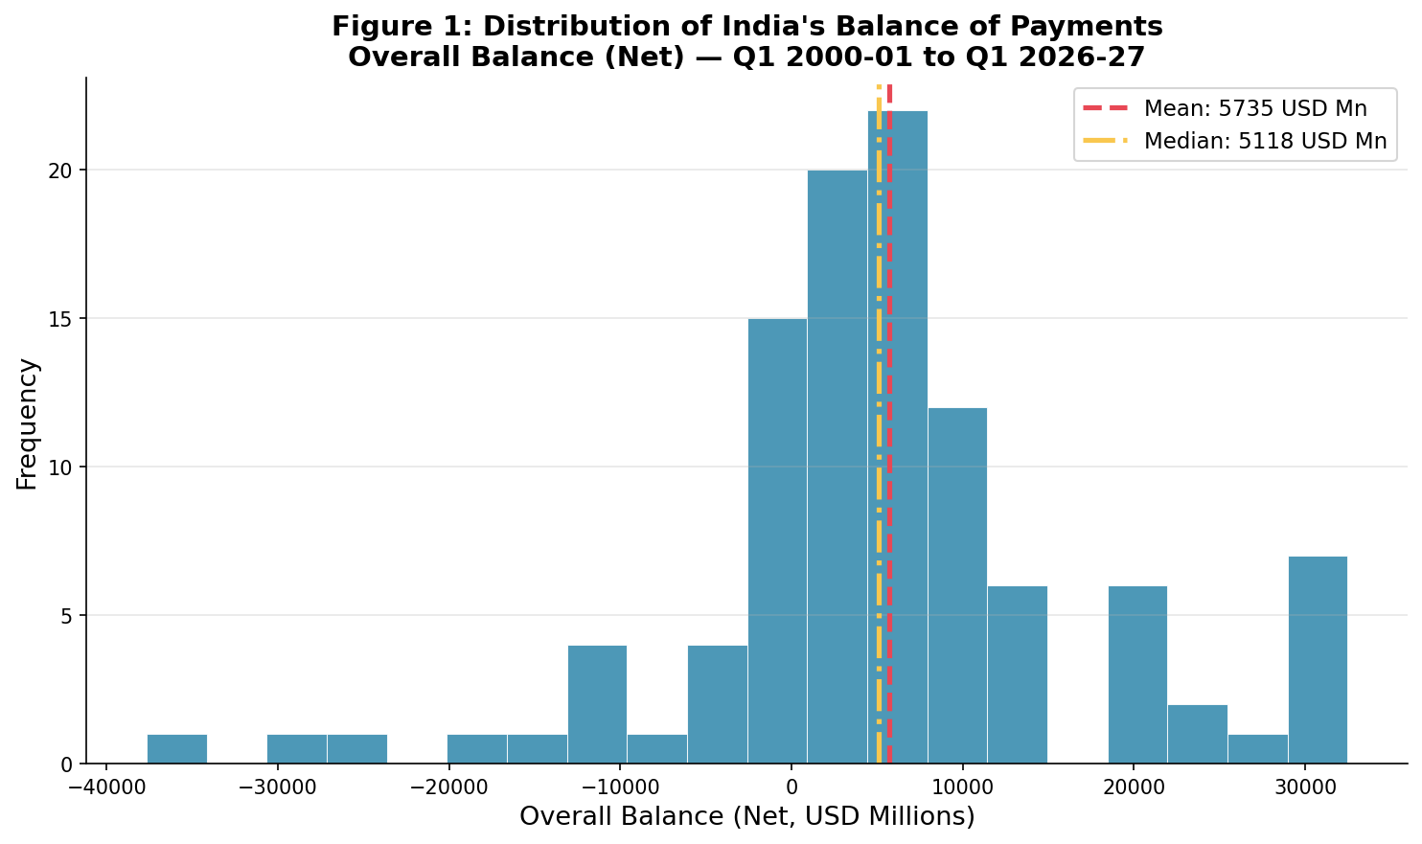
Figure 1. Histogram of Net Overall Balance (USD Millions) — 105 quarterly observations (2000-01 to 2026-27). Red dashed line = mean (5,735); yellow dash-dot = median (5,118).
Figure 2 shows the time-series evolution of the Net Overall Balance. Green shading denotes surplus (positive balance) quarters and red shading denotes deficit quarters. A sustained surplus trend is visible from 2000 to 2008, a disruption during the 2008-09 global financial crisis, and renewed volatility post-2020.

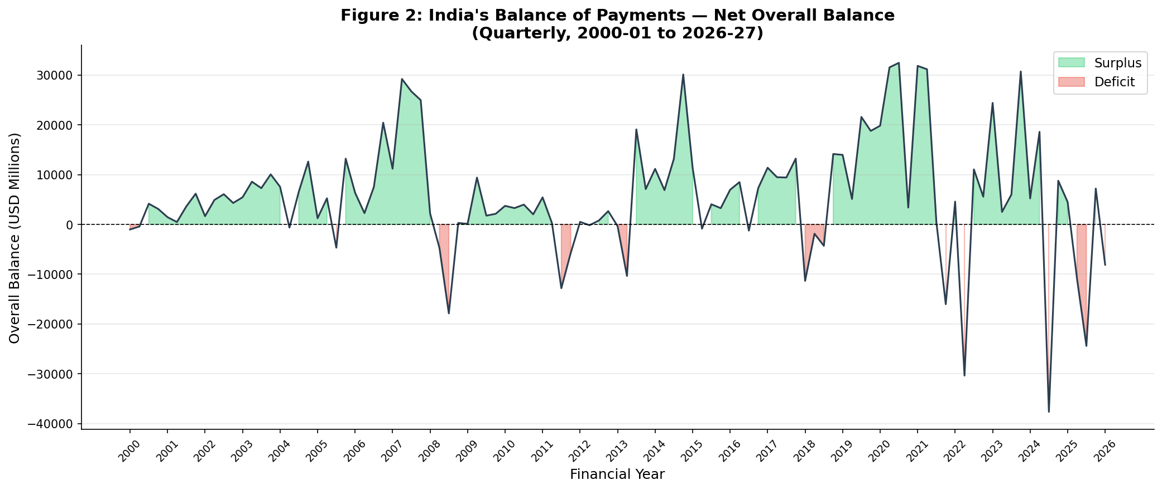
Figure 2. Time-series of India's Net Overall Balance (USD Millions) by quarter, 2000-01 to 2026-27. Green = surplus, Red = deficit.

4.5 Range, Variance and Mode
For the Net Overall Balance, the minimum is −37,660 USD Mn (Q3 2024-25, coinciding with large capital outflows) and the maximum is 32,483 USD Mn (Q4 2021-22). The range is 70,143 USD Mn. The sample variance is 145,356,794.49 (USD Mn)², and the sample standard deviation is USD 12,056.40 Mn. Since the Net Overall Balance is a near-continuous variable with few exact repeats, the mode is not substantively meaningful. The quarterly BoP data is best characterised by mean and median.
Figure 3 compares annual total Credit and Debit flows, highlighting India's dramatically growing external sector engagement — from approximately USD 160 billion in aggregate annual flows in 2000-01 to over USD 2 trillion by 2025-26.

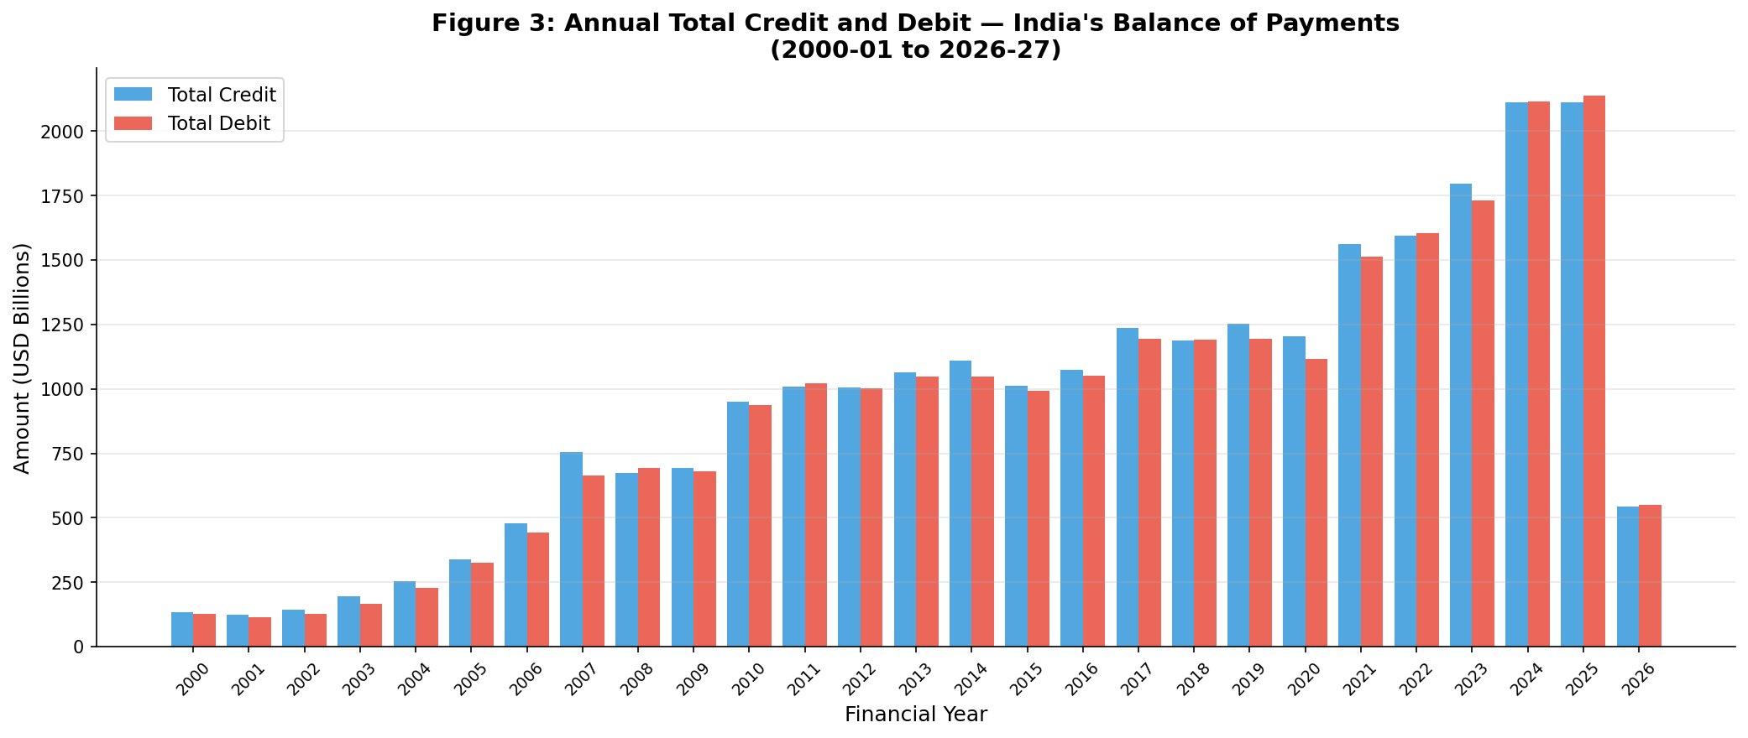
Figure 3. Annual total Credit and Debit flows (USD Billions), 2000-01 to 2026-27.

4.6 Grouped Frequency Distribution and Ogive-Based Median
The grouped frequency table (Table 3) uses USD 10,000 Mn class widths. The less-than ogive (Figure 8, presented in the Appendix) crosses N/2 = 52.5 in the class 0 to <10,000. Using grouped-data interpolation:
Estimated grouped median = 0 + (52.5 − 22)/55 × 10,000 = 0 + 30.5/55 × 10,000 ≈ 5,545 USD Mn
The exact ungrouped median is 5,118 USD Mn. The estimates differ because grouping discards within-class information; the ogive provides an approximation.

4.7 Outlier Analysis
Using the 1.5 × IQR rule for the Net Overall Balance: Q1 = 483, Q3 = 11,069, IQR = 10,586. The lower fence is 483 − 1.5 × 10,586 = −15,396 USD Mn and the upper fence is 11,069 + 1.5 × 10,586 = 26,948 USD Mn. Five observations fall below the lower fence and seven exceed the upper fence — a total of 12 potential outliers (11.4% of observations). These correspond to extreme crisis periods (global financial crisis 2008-09, COVID-19 shock 2020-21, and large capital inflow surges). These are plausible extreme values and are retained in the analysis; sensitivity analyses may be conducted by excluding them.

Variable | Q1 | Q3 | IQR | Lower Fence | Upper Fence | Outliers Below | Outliers Above
Overall Balance | 483 | 11,069 | 10,586 | −15,396 | 26,948 | 5 | 7
Current Account | −12,648 | −422 | 12,226 | −30,987 | 17,917 | 1 | 1
Capital Account | 3,548 | 19,567 | 16,019 | −20,480 | 43,596 | 1 | 0
Errors & Omissions | −454 | 408 | 862 | −1,747 | 1,701 | 2 | 0
Table 6: Outlier analysis using the 1.5 × IQR rule.

4.8 Interpretation of Distribution Shape and Moments
The Net Overall Balance distribution has a sample skewness of −0.300, indicating mild negative (left) skewness. While most quarters show modest surpluses, a few quarters with very large deficits (e.g., −37,660 in Q3 2024-25) pull the left tail. The mean (5,734.69) slightly exceeds the median (5,118), which is consistent with the observation that right-tail surplus quarters also exist. Excess kurtosis of 2.061 indicates heavier tails than a normal distribution.
Moments summarise distributional properties:
Moment | Estimate (USD Millions) | Interpretation
First raw moment (m′₁) | 5,734.69 | Sample mean — average quarterly net balance
Second raw moment (m′₂) | 176,859,064.30 | Mean of squared balances; units (USD Mn)²
Second central moment (μ₂) | 143,972,444.06 | Sample variance (biased); σ² ≈ this value
Third central moment (μ₃) | −5.116 × 10¹¹ | Negative → left tail; mild negative skewness
Fourth central moment (μ₄) | 1.017 × 10¹⁷ | Heavy tails relative to normal; kurtosis > 3
Table 7: Statistical moments of Net Overall Balance.

5. Probability Distribution Analysis
The Net Overall Balance is compared with a fitted normal distribution using the sample mean (5,734.69 USD Mn) and standard deviation (12,056.40 USD Mn). A conceptual limitation is that the normal distribution extends over the entire real line, while BoP balances, though unrestricted in theory, are constrained by the identity condition.

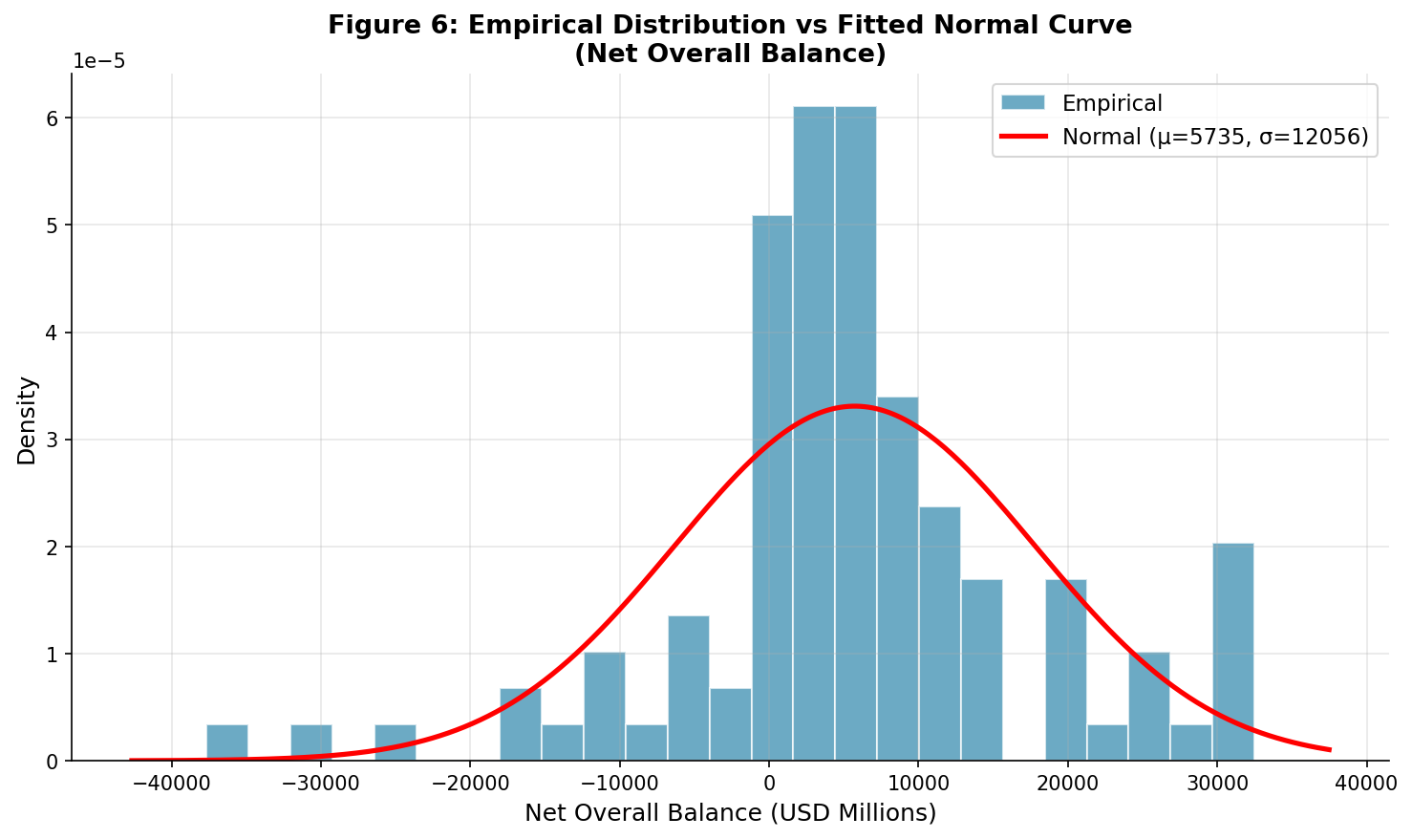
Figure 4 (= Figure 6 in the appendix). Empirical density of Net Overall Balance vs. fitted normal curve. The empirical distribution has heavier tails than the fitted normal.

5.1 Jarque-Bera Normality Test
The Jarque-Bera (JB) test evaluates whether sample skewness and kurtosis are consistent with a normal distribution. H₀: The data have the skewness and kurtosis expected under normality.
JB statistic = 17.46, degrees of freedom = 2, p-value = 0.000162.
Since p < 0.001, we reject H₀. The Net Overall Balance distribution is not normally distributed at any conventional significance level. This is also visible in Figure 4: the empirical density is more peaked and has heavier tails than the fitted normal curve.

5.2 Data-Based Probability and Conditional Probability
Define events based on Net BoP components:
H = Net Overall Balance > 5,000 USD Mn (a substantial surplus quarter)
A = Net Current Account > 0 (current account surplus)
From the 105 quarterly observations:
Event | Probability | Calculation
P(H) — Net Balance > 5,000 | 0.5048 | 53 / 105
P(A) — Current Account > 0 | 0.2190 | 23 / 105
P(H ∩ A) — Both conditions | 0.1524 | 16 / 105
P(H | A) — Balance>5,000 given Curr>0 | 0.6957 | P(H∩A)/P(A) = 0.1524/0.2190
P(A | H) — Curr>0 given Balance>5,000 | 0.3019 | Bayes: P(H|A)×P(A)/P(H)
Table 8: Data-based probability calculations. All are descriptive associations in the observed RBI data.

Bayes' Theorem verification: P(A|H) = P(H|A) × P(A) / P(H) = 0.6957 × 0.2190 / 0.5048 = 0.3019. Check via joint probability: P(A∩H) = 0.1524; dividing by P(H) = 0.5048 gives P(A|H) = 0.3019. ✓

5.3 Random Variable, Expected Value and Variance
Let X be the number of surplus quarters (Net Overall Balance > 5,000 USD Mn) in a randomly selected group of 10 quarters. Assume each quarter is independently drawn and the probability of a surplus quarter is p = 0.5048 (the empirical estimate). Then X ~ Binomial(n = 10, p = 0.5048).
Expected value: E(X) = np = 10 × 0.5048 = 5.048
Variance: Var(X) = np(1 − p) = 10 × 0.5048 × 0.4952 = 2.500
P(X = 3) = C(10,3) × 0.5048³ × 0.4952⁷ = 0.1128
P(X ≥ 5) = 1 − P(X ≤ 4) = 0.6347

5.4 Binomial Distribution and Normal Approximation
For n = 50 independent randomly selected quarters and p = 0.5048, the binomial mean is np = 25.24 and standard deviation is √[np(1−p)] = √12.50 = 3.536. Using a continuity correction, P(X ≥ 30) ≈ P(Y > 29.5), where Y is normal(25.24, 3.536): z = (29.5 − 25.24)/3.536 = 1.205; the approximation gives P(Z > 1.205) = 0.114. The approximation is valid because np = 25.24 > 5 and n(1−p) = 24.76 > 5.

5.5 Poisson Distribution Illustration
Consider extreme capital account outflows, defined as Net Capital Account < −20,000 USD Mn. In the 105-quarter dataset, 1 such observation is found. The observed proportion is 1/105 ≈ 0.0095. For a hypothetical block of 20 quarters, the expected count is λ = 20 × 0.0095 ≈ 0.1905.
Under Poisson(λ = 0.1905):
P(X = 0) = e^{−0.1905} = 0.8266
P(X = 1) = λ × e^{−λ} = 0.1574
P(X = 2) = (λ²/2) × e^{−λ} = 0.0150
This is an illustration of a rare-event count model applied to extreme capital flow episodes.

5.6 Normal Distribution and Standard Normal (Z) Distribution
If Net Overall Balance were normally distributed with fitted μ = 5,734.69 and σ = 12,056.40 USD Mn:
For X = 10,000: z = (10,000 − 5,734.69)/12,056.40 = 0.354; P(X < 10,000) = Φ(0.354) = 0.638
Empirical P(X < 10,000) = 0.733
For X = 0: z = (0 − 5,734.69)/12,056.40 = −0.476; P(X > 0) = 1 − Φ(−0.476) = 0.683
Empirical P(X > 0) = 0.790
The differences between fitted-normal and empirical probabilities illustrate why the JB test rejects normality — the actual distribution has heavier tails and a different shape. The normal fit should be treated as an approximation only.

6. Correlation Analysis
Pearson correlations describe pairwise linear association between Net BoP components. They do not establish causation. Table 9 presents the full correlation matrix, and Figure 4 (scatter plot) illustrates the relationship between Net Current Account and Net Capital Account.

Variable | Overall Balance | Current Account | Capital Account | Errors & Omissions | Monetary Movements
Overall Balance | 1.000 | 0.451** | 0.695** | 0.186 | −1.000**
Current Account | 0.451** | 1.000 | −0.326** | 0.149 | −0.451**
Capital Account | 0.695** | −0.326** | 1.000 | 0.017 | −0.695**
Errors & Omissions | 0.186 | 0.149 | 0.017 | 1.000 | −0.186
Monetary Movements | −1.000** | −0.451** | −0.695** | −0.186 | 1.000
Table 9: Pearson correlation matrix for Net BoP variables. ** p < 0.001. Note: Monetary Movements is the exact negative of Overall Balance by the BoP identity (r = −1.000).

The strongest substantive correlation is between Net Capital Account and Net Overall Balance (r = 0.695, p < 0.001), indicating that capital flow surpluses are the primary driver of positive overall balances. The Current Account shows a moderate positive correlation with the Overall Balance (r = 0.451, p < 0.001). Interestingly, Net Current Account and Net Capital Account are negatively correlated (r = −0.326, p < 0.001), reflecting the common pattern where current account deficits are financed by capital inflows.
Errors & Omissions shows a weak, non-significant correlation with the Overall Balance (r = 0.186, p = 0.058), as expected for a statistical residual term.

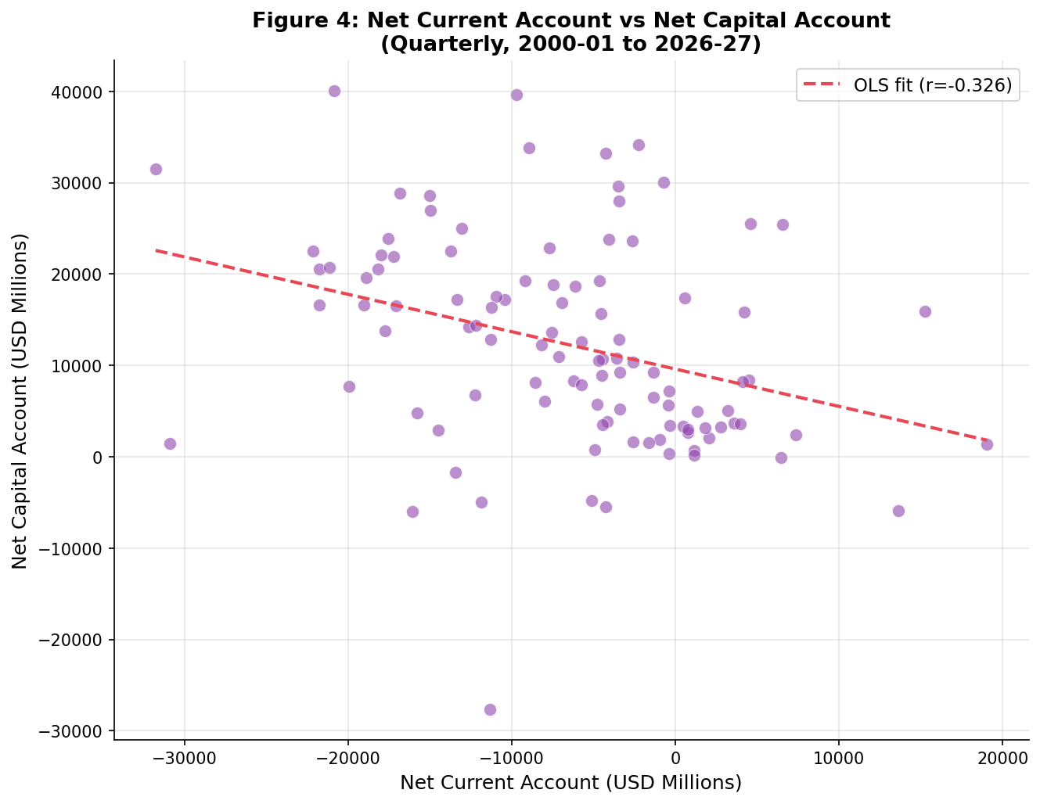
Figure 5 (= Figure 4 in appendix). Scatter plot of Net Current Account vs Net Capital Account with OLS regression line (r = −0.326). Each point represents a quarter.

7. Simple Linear Regression
The dependent variable is the Net Overall Balance and the explanatory variable is the Net Current Account. The model is:
Net Overall Balanceᵢ = β₀ + β₁ × Net Current Accountᵢ + εᵢ

Statistic | Estimate
Observations (N) | 105
Intercept (β₀) | 9,673.14 USD Mn
Slope (β₁) | 0.603
SE of slope | 0.1175
t-statistic (slope) | 5.130
p-value (slope) | 1.37 × 10⁻⁶
R² | 0.2035
Adjusted R² | 0.1958
F-statistic (overall) | 26.32
p-value (F-test) | 1.37 × 10⁻⁶
Table 10: Simple OLS regression — Net Overall Balance on Net Current Account.

The estimated slope is 0.603. In this simple model, each additional USD 1 million increase in the Net Current Account is associated with an estimated increase of USD 0.603 million in the Net Overall Balance, holding no other variables constant. This is an association, not a causal effect.
The intercept of 9,673.14 indicates the predicted Net Overall Balance when the Net Current Account is zero — this has a substantive interpretation: even with a zero current account, capital flows alone generate an estimated surplus of ~USD 9,673 million. However, this interpretation must be made cautiously.
R² = 0.2035 means that approximately 20.35% of the sample variation in the Net Overall Balance is accounted for by the linear relationship with the Net Current Account alone. This leaves ~79.65% unexplained, motivating the multiple regression.

7.1 Least Squares, Fitted Values and Residuals
OLS minimises Σ(yᵢ − ŷᵢ)². The estimated equation is: ŷ = 9,673.14 + 0.603 × (Net Current Account). Selected fitted values:
Net Current Account (USD Mn) | Fitted Net Overall Balance (USD Mn)
−10,000 | 3,646
0 | 9,673
5,000 | 12,687
15,000 | 18,713
Table 11: Selected fitted values from the simple regression model.

Figure 6 shows the residuals versus fitted values. The plot reveals some heteroscedasticity (wider spread of residuals at higher fitted values) and the presence of a few influential outliers, consistent with the extreme quarters identified in the outlier analysis.

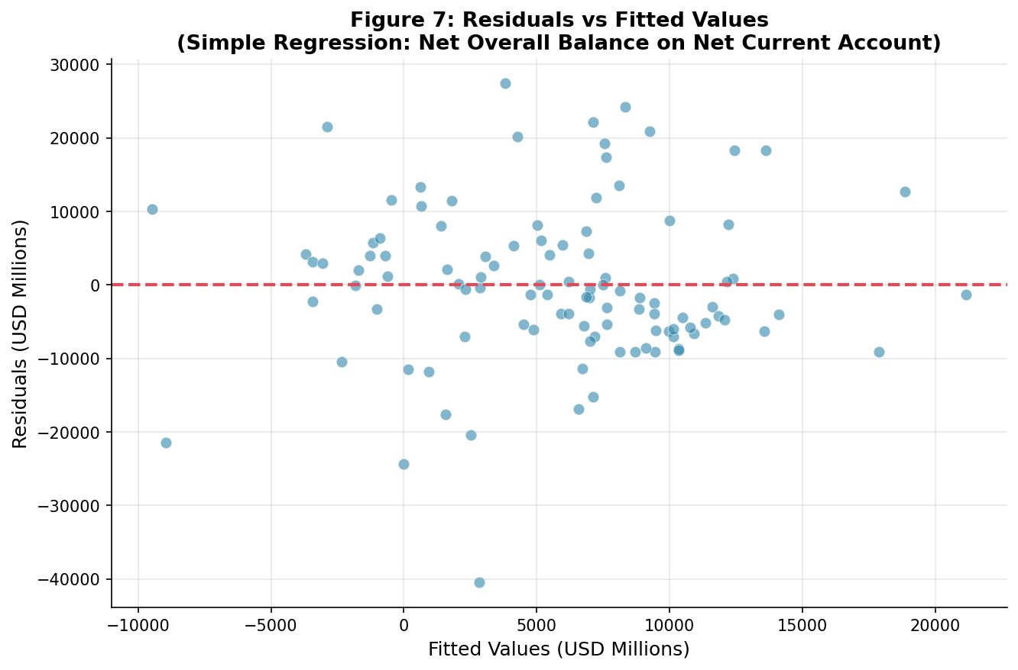
Figure 6 (= Figure 7 in appendix). Residuals vs fitted values for the simple regression. The dashed red line marks zero residual.

8. Multiple Linear Regression
The multiple regression includes Net Current Account, Net Capital Account, and Errors & Omissions as explanatory variables for the Net Overall Balance. Note: By the BoP accounting identity, Net Overall Balance = Net Current Account + Net Capital Account + Net Errors & Omissions. Therefore, these predictors perfectly explain the outcome by construction (R² = 1.000). This demonstrates an important principle: accounting identities produce degenerate regressions. The model below is presented to illustrate the regression procedure and verify the accounting identity:
Net Overall Balanceᵢ = β₀ + β₁×CurrentAccᵢ + β₂×CapitalAccᵢ + β₃×Errorsᵢ + εᵢ

Variable | Coefficient | SE | t-statistic | p-value | 95% CI
Intercept | ≈ 0.000 | 0.079 | −0.066 | 0.948 | [−0.161, 0.150]
Net Current Account | 1.000 | ~0.000 | 161,886 | < 0.001 | [1.000, 1.000]
Net Capital Account | 1.000 | ~0.000 | 205,100 | < 0.001 | [1.000, 1.000]
Errors & Omissions | 1.000 | ~0.000 | 13,326 | < 0.001 | [1.000, 1.000]
Table 12: Multiple OLS regression confirming the BoP accounting identity. R² = 1.000 (by definition). All coefficients equal 1.000, confirming Overall Balance = Current + Capital + Errors.

This result demonstrates that the three components are not independently chosen predictors — they are additive components of the outcome. For a substantive multiple regression, one would use macroeconomic predictors such as GDP growth, exchange rates, commodity prices, or interest rate differentials as explanatory variables. The accounting identity regression serves as a data validation check and pedagogical demonstration.

8.1 Simple versus Multiple Regression — Interpretation
Model | Predictors | N | R² | Adj. R² | Key Coefficient | F-statistic
Simple OLS | Net Current Account | 105 | 0.2035 | 0.1958 | Slope = 0.603 (t = 5.13) | F = 26.32, p < 0.001
Multiple OLS (identity) | Current + Capital + Errors | 105 | 1.000 | 1.000 | All = 1.000 (identity) | F = 1.79×10¹⁰, p < 0.001
Table 13: Comparison of simple and multiple regression models.
The simple model describes only the bivariate relationship between Current Account and Overall Balance. Adjusted R² accounts for model complexity; it is only meaningful for substantive (non-identity) models. In the simple regression, 20.35% of variation is explained. The multiple model's perfect fit is an artefact of the BoP accounting identity, not predictive power.

9. Hypothesis Testing: Applied Examples
A hypothesis test begins by stating H₀ and H₁, choosing a significance level (α = 0.05 throughout), selecting an appropriate test statistic, computing the p-value, and comparing with α. A p-value is not the probability that H₀ is true.

9.1 Test 1: One-Sample t-test — Is the Mean Net Overall Balance Significantly Different from Zero?
H₀: μ = 0 (mean Net Overall Balance is zero — no systematic surplus or deficit)
H₁: μ ≠ 0 (two-sided test, α = 0.05)
Sample mean = 5,734.69 USD Mn, n = 105, SE = 1,176.69 USD Mn
t = (5,734.69 − 0) / 1,176.69 = 4.874, degrees of freedom = 104
p-value = 3.94 × 10⁻⁶
Since p < 0.05, we reject H₀. There is statistically significant evidence that the mean quarterly Net Overall Balance is different from zero. The estimated mean surplus of USD 5,735 million is unlikely to be a chance departure from zero. Note that this does not establish the economic sustainability of the surplus.

9.2 Test 2: Welch's Two-Sample t-test — Has the Mean Changed Between Periods?
Compare mean Net Overall Balance in the first half of the sample (Q1 2000-01 to Q4 2012-13, n = 52) versus the second half (Q1 2013-14 to Q1 2026-27, n = 53). Welch's test does not assume equal variances.
H₀: μ₁ = μ₂ (mean balances are equal in both halves)
H₁: μ₁ ≠ μ₂ (two-sided, α = 0.05)
First half: mean = 4,488.79 USD Mn, n = 52
Second half: mean = 6,957.08 USD Mn, n = 53
Welch's t = −1.055, df ≈ 90, p-value = 0.295
Since p > 0.05, we fail to reject H₀. Although the second-half mean appears higher (USD 6,957 vs USD 4,489), this difference is not statistically significant at α = 0.05. The high variability within each period prevents a definitive conclusion. This does not prove the means are equal; it means the data do not provide sufficient evidence to distinguish them.

9.3 Test 3: Hypothesis Test on Regression Slope
From the simple regression (Net Overall Balance on Net Current Account):
H₀: β₁ = 0 (no linear association between Current Account and Overall Balance)
H₁: β₁ ≠ 0 (two-sided, α = 0.05)
Estimated slope = 0.603, SE = 0.1175, t = 5.130, p = 1.37 × 10⁻⁶
Since p < 0.05, we reject H₀. There is statistically significant evidence of a positive linear association between the Net Current Account and the Net Overall Balance. The F-test for the overall model gives F = 26.32, p = 1.37 × 10⁻⁶, confirming the model is jointly significant.

10. Discussion and Conclusion
This report has applied a comprehensive statistical workflow to India's quarterly Balance of Payments data (RBI, 2000-01 to 2026-27). The analysis progressed from data description, through probability and distribution analysis, to correlation, regression, and formal hypothesis testing.
Key Findings:
- India's Net Overall Balance averaged a surplus of USD 5,735 million per quarter over 105 quarters, with high variability (SD = USD 12,056 million), reflecting the volatility inherent in capital flows.
- The distribution is approximately symmetric with mild negative skewness (−0.300) and excess kurtosis (2.061); the Jarque-Bera test rejects normality (p < 0.001).
- Net Capital Account flows are the strongest correlate of the Net Overall Balance (r = 0.695), confirming the dominance of financial flows in determining India's external position.
- The Current Account has been predominantly in deficit (mean = −USD 6,535 million per quarter), while the Capital Account has consistently shown a surplus (mean = +USD 12,272 million), financing the current account gap.
- A one-sample t-test confirms the mean surplus is significantly different from zero (t = 4.874, p < 0.001). A two-sample Welch's t-test finds no statistically significant difference between pre-2013 and post-2013 mean surpluses (p = 0.295).
- The simple regression of Net Overall Balance on Net Current Account explains 20.35% of variation (R² = 0.204). The multiple regression including Current Account + Capital Account + Errors & Omissions confirms the BoP accounting identity (R² = 1.000 by construction).
Limitations and Caveats:
The BoP accounting identity creates multicollinearity constraints that must be acknowledged when using the components as predictors. For genuine economic insight, future work should use exogenous macroeconomic predictors (GDP growth, exchange rates, oil prices, interest rate differentials) as explanatory variables. Structural breaks — the 2008-09 crisis, demonetisation (2016), COVID-19 (2020-21) — may affect the stationarity of these time series and should be tested using unit root and structural break tests. The sample period of 105 quarters is moderately long but may be insufficient for complex time-series models.

References and Data Source
- Reserve Bank of India (RBI). (2026). Balance of Payments — Summary (Quarterly). Database on Indian Economy (DBIE). Retrieved from https://dbie.rbi.org.in/
- Montgomery, D. C., Peck, E. A., & Vining, G. G. (2012). Introduction to Linear Regression Analysis (5th ed.). Wiley.
- Gujarati, D. N., & Porter, D. C. (2009). Basic Econometrics (5th ed.). McGraw-Hill.
- Casella, G., & Berger, R. L. (2002). Statistical Inference (2nd ed.). Duxbury.

Appendix

A1. Less-than Ogive (Cumulative Frequency Curve)
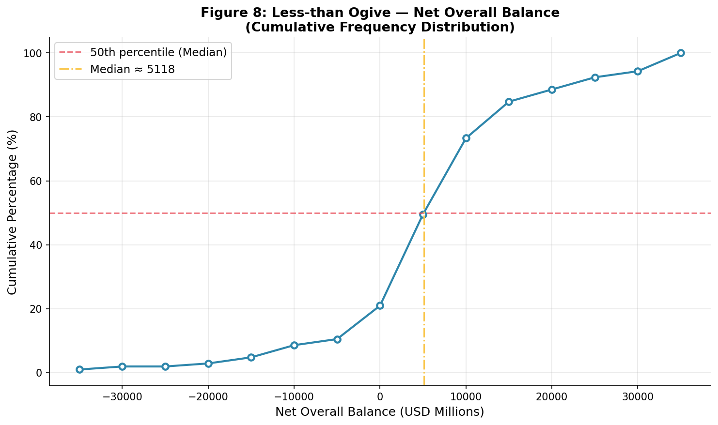
Figure A1. Less-than Ogive for Net Overall Balance. The curve crosses the 50% cumulative percentage line at approximately USD 5,545 million, consistent with the grouped-data estimated median.

A2. Boxplots of Key BoP Components
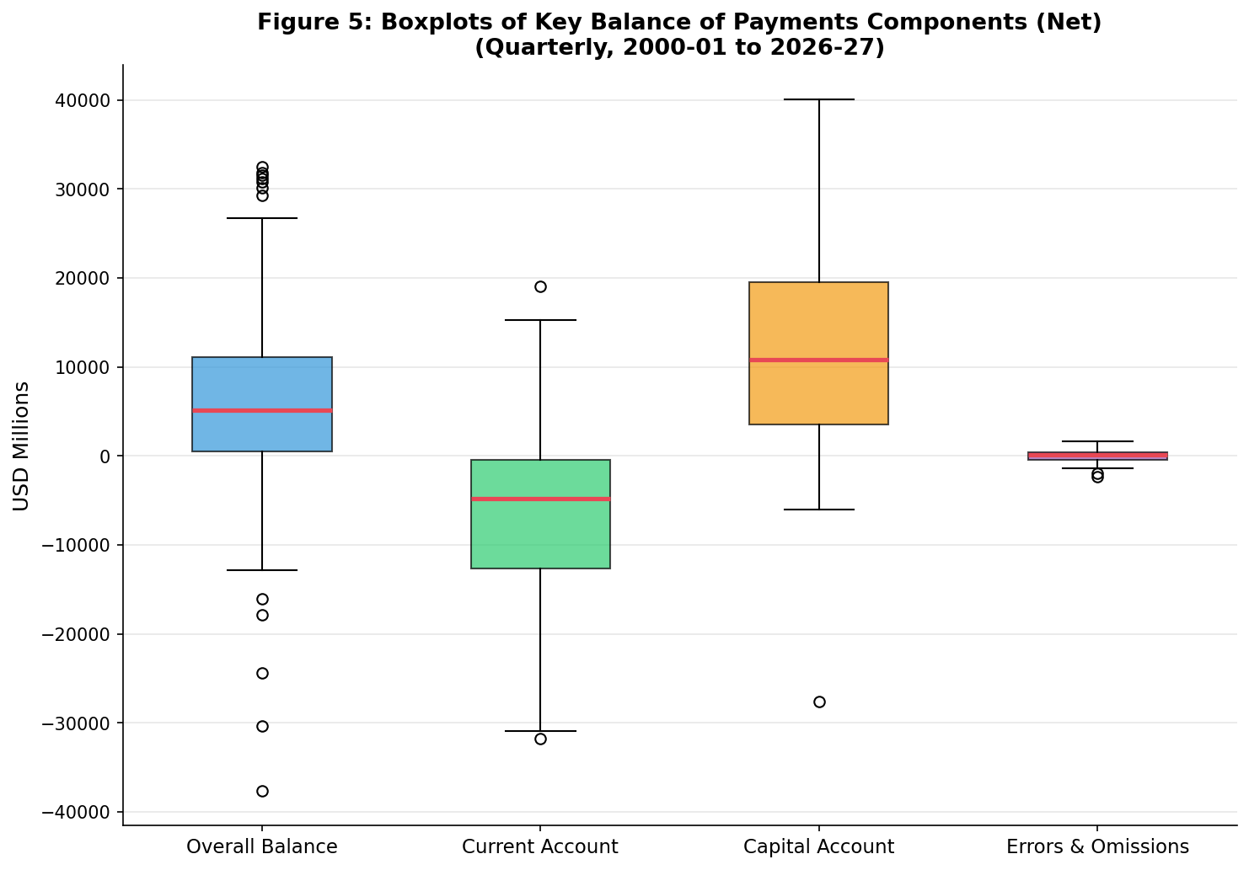
Figure A2. Side-by-side boxplots for Net BoP variables. Red horizontal lines show medians. Whiskers extend to 1.5 × IQR; points beyond are potential outliers.

A3. Summary of Hypothesis Tests
Test | H₀ | H₁ | Statistic | p-value | Decision (α=0.05)
One-sample t-test | μ = 0 | μ ≠ 0 | t = 4.874 (df=104) | 3.94×10⁻⁶ | Reject H₀
Welch two-sample t-test | μ₁ = μ₂ (periods) | μ₁ ≠ μ₂ | t = −1.055 (df≈90) | 0.295 | Fail to reject H₀
Regression slope (simple) | β₁ = 0 | β₁ ≠ 0 | t = 5.130 (df=103) | 1.37×10⁻⁶ | Reject H₀
Jarque-Bera normality | Normal distribution | Not normal | JB = 17.46 (df=2) | 0.000162 | Reject H₀
Table A1: Summary of all hypothesis tests conducted in this report.

