STATISTICS & OR
SAMPLE ASSIGNMENT REPORT
A Statistical Analysis of Monthly Earnings and Their Correlates
Illustrative report based on 1,200 simulated observations
Postgraduate Programme | Semester I
Course Title: Statistics and Operations Research

Abstract
.
.
.
..

1. Introduction
Earnings may vary with education, work experience, working hours and labour-market context. This report illustrates how descriptive and inferential statistical methods can be used to examine these relationships. Its purpose is to demonstrate analytical workflow and report writing, not to draw conclusions about actual workers.

1.1 Research questions
- What are the distributional characteristics of monthly earnings and selected variables?
- How are earnings associated with education and work experience?
- How do estimates change when additional explanatory variables are included?

1.2 Objectives
- Summarise variables using tables, numerical measures and graphs.
- Compare the empirical earnings distribution with a fitted normal distribution.
- Examine correlations among selected quantitative variables.
- Estimate and interpret simple and multiple linear regression models.

2. Dataset and Variables
The demonstration dataset contains 1200 records and 8 variables. Each record represents a hypothetical worker. Variables include monthly earnings in rupees, education, years of education, work experience, residence, gender, weekly working hours and age.
Variable | Type | Definition
Monthly earnings | Quantitative | Monthly earnings in ₹
Education | Categorical, ordinal | Secondary or below; Graduate; Postgraduate
Years of education | Quantitative | Years of schooling
Work experience | Quantitative | Years of experience
Residence | Categorical | Urban or Rural
Gender | Categorical | Female or Male
Weekly working hours | Quantitative | Hours per week
Age | Quantitative | Age in years

In an actual assignment, students must provide the publisher, direct URL, study period, geographic coverage, target population, unit of observation, sampling information where available, and data-use conditions.

3. Data Preparation
The original dataset has 1200 observations. A small number of values were deliberately set to missing for demonstration. The main analysis excludes records missing monthly earnings, experience or weekly hours, leaving 1179 observations. The original data should be preserved and all cleaning decisions documented.
Variable | Missing observations
monthly_earnings_inr | 9
experience_years | 7
weekly_work_hours | 5
Potential outliers should be investigated rather than removed automatically. Different analyses may have different sample sizes if they require different variables.

4. Descriptive Statistics and Exploratory Data Analysis

4.1 Frequency and percentage distributions
Variables | Frequency | Percentage
Gender
Female | 606 | 51.4%
Male | 573 | 48.6%
Residence
Urban | 701 | 59.5%
Rural | 478 | 40.5%
Education
Secondary or below | 566 | 48.0%
Graduate | 451 | 38.3%
Postgraduate | 162 | 13.7%
Total | Xxxxx | xxxxx

The table summarises the composition of the analytical sample by gender, residence, education. Percentages use the analytical sample as the denominator.

4.2 Numerical measures
Variable | N | Mean | Median | SD | Min | Max | Skewness | Excess kurtosis
Monthly earnings (₹) | 1179 | 8,620.48 | 7,581.03 | 4,499.14 | 1,732.03 | 46,630.46 | 2.082 | 8.742
Experience (years) | 1179 | 12.90 | 11.70 | 7.16 | 0.30 | 35.00 | 0.847 | 0.486
Weekly hours | 1179 | 45.94 | 45.60 | 7.72 | 22.00 | 71.50 | 0.105 | 0.002
Age (years) | 1179 | 39.75 | 38.60 | 8.84 | 18.60 | 65.00 | 0.560 | 0.111
Education (years) | 1179 | 12.87 | 15.00 | 2.84 | 10.00 | 17.00 | 0.084 | -1.757

The mean and median describe location; the standard deviation describes spread in the original units. Positive skewness indicates a longer right tail. Excess kurtosis is reported, for which a normal distribution has a reference value of zero. Interpret all values in relation to the variable and its scale.

4.3 IQR and coefficient of variation
Variable | Q1 | Q3 | IQR | CV
Monthly earnings (₹) | 5,551.40 | 10,750.94 | 5,199.55 | 52.2%
Experience (years) | 7.60 | 16.85 | 9.25 | 55.5%
Weekly hours | 41.00 | 50.90 | 9.90 | 16.8%
Age (years) | 33.60 | 45.10 | 11.50 | 22.2%

The coefficient of variation expresses standard deviation as a percentage of the mean. It is most useful for variables with a meaningful zero and positive mean; it should not be compared mechanically across unrelated measurement scales.

4.4 Graphical exploration
Figure 1 shows the distribution of monthly earnings. The histogram helps assess concentration, skewness and possible extreme values.
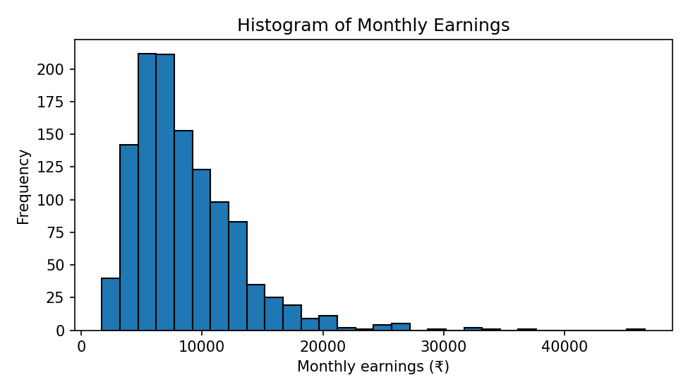
Figure 1. Histogram of monthly earnings (simulated data).
Figure 2 compares earnings by gender. Differences in medians or spread are descriptive and do not by themselves establish statistical significance or causation.
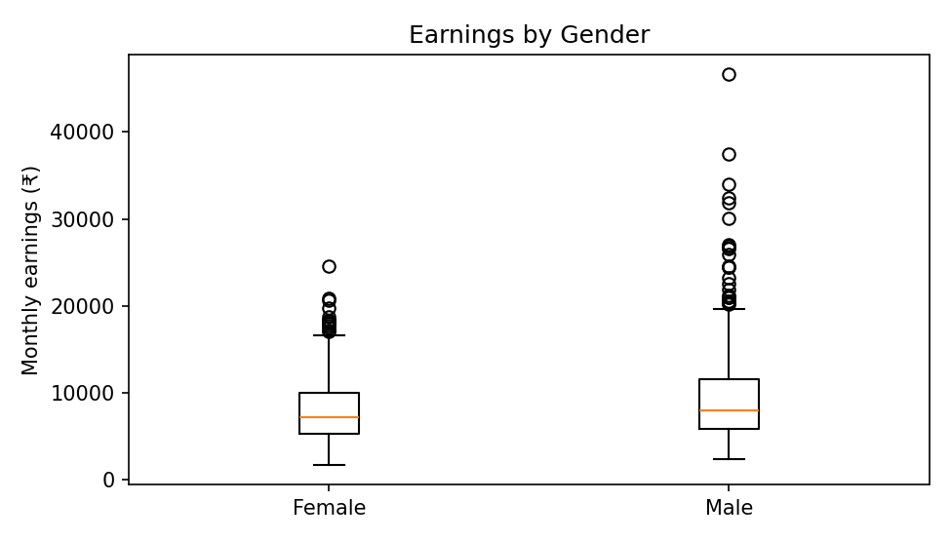
Figure 2. Monthly earnings by gender (simulated data).

4.5 Range, variance and mode
For monthly earnings, the minimum is ₹1,732.03 and the maximum is ₹46,630.46; therefore, the range is ₹44,898.43. The sample variance is 20,154,631.78 rupees squared, and the sample standard deviation is ₹4,489.39. Variance is expressed in squared units, while standard deviation returns to the original unit. Since earnings are recorded as a near-continuous numeric variable and nearly every value is distinct, a single sample mode is not substantively informative; mode is more useful for categorical variables or discrete values with repeated observations.

4.6 Grouped frequency distribution and ogive-based median
The following grouped table uses ₹5,000 class widths. Percentages and cumulative percentages are calculated using the 1,191 non-missing earnings observations.
Monthly earnings class | Frequency | Percent | Cumulative frequency | Cumulative percent
₹0–<₹5,000 | 220 | 18.47% | 220 | 18.47%
₹5,000–<₹10,000 | 616 | 51.72% | 836 | 70.19%
₹10,000–<₹15,000 | 272 | 22.84% | 1108 | 93.03%
₹15,000–<₹20,000 | 55 | 4.62% | 1163 | 97.65%
₹20,000–<₹25,000 | 17 | 1.43% | 1180 | 99.08%
₹25,000–<₹30,000 | 5 | 0.42% | 1185 | 99.50%
₹30,000–<₹35,000 | 4 | 0.34% | 1189 | 99.83%
₹35,000–<₹40,000 | 1 | 0.08% | 1190 | 99.92%
₹40,000–<₹45,000 | 0 | 0.00% | 1190 | 99.92%
₹45,000–<₹50,000 | 1 | 0.08% | 1191 | 100.00%

The less-than ogive crosses N/2 = 595.5 at the median class ₹5,000–<₹10,000. Using grouped-data interpolation, the estimated median is ₹8,047.89. The exact median from the ungrouped observations is ₹7,581.03. The estimates differ because grouping discards within-class information; the ogive gives an approximate median rather than the exact sample median.
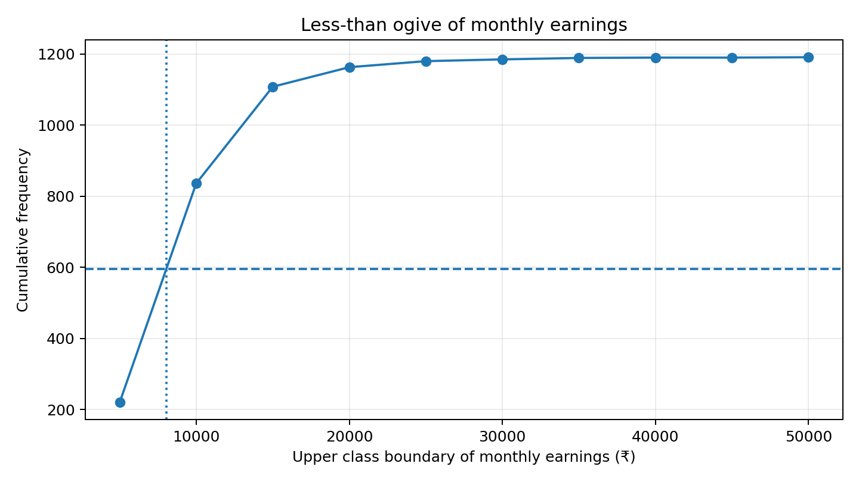
Figure A1. Less-than ogive used to estimate the median.

4.7 Outlier analysis
Using the 1.5×IQR rule, Q1 = ₹5,557.55, Q3 = ₹10,761.12, and IQR = ₹5,203.57. The lower fence is ₹-2,247.80 and the upper fence is ₹18,566.47. Because earnings cannot be negative in this sample, the lower fence does not flag observations; 33 observations exceed the upper fence. These are potential statistical outliers, not automatically errors. They should be checked against the source and data-entry rules, retained if plausible, and considered in sensitivity analyses because high values can influence the mean, variance, correlation and regression.
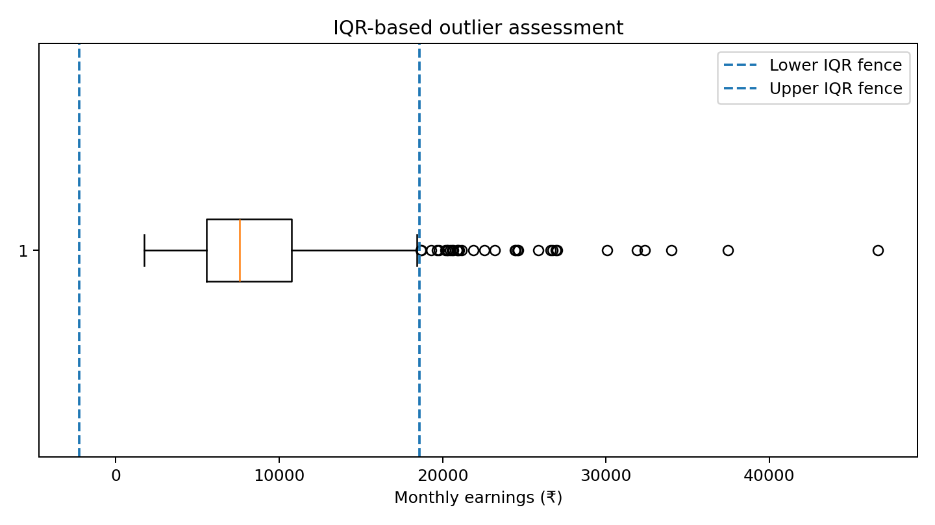
Figure A2. Boxplot and IQR fences for monthly earnings.

4.8 Interpretation of distribution shape and moments
The distribution is strongly right-skewed (sample skewness = 2.076). This means most observations are concentrated at lower-to-middle earnings levels while a relatively small number of large values form a long right tail. The mean (₹8,619.59) exceeds the median (₹7,581.03), consistent with right skewness. Pearson kurtosis is 11.733 (excess kurtosis = 8.733), indicating heavier tails/more extreme observations than a normal distribution under this measure.
Moments summarise distributional properties. The first raw moment about the origin is E(X); the second raw moment is E(X²). Central moments are calculated around the mean: μ₂ = E[(X−μ)²] (variance), μ₃ = E[(X−μ)³] (asymmetry-related), and μ₄ = E[(X−μ)⁴] (tail/peakedness-related).
Moment | Estimate (earnings in ₹) | Interpretation
First raw moment, m′₁ | 8,619.59 | Sample mean
Second raw moment, m′₂ | 94,434,990.88 | Mean of squared earnings; units ₹²
Third raw moment, m′₃ | 1.348e+12 | Mean of cubed earnings; units ₹³
Fourth raw moment, m′₄ | 2.570e+16 | Mean of fourth-power earnings; units ₹⁴
Second central moment, μ₂ | 20,137,709.34 | Variance using denominator n for the empirical moment
Third central moment, μ₃ | 1.873e+11 | Positive value is consistent with right skewness
Fourth central moment, μ₄ | 4.741e+15 | Used in standardised kurtosis

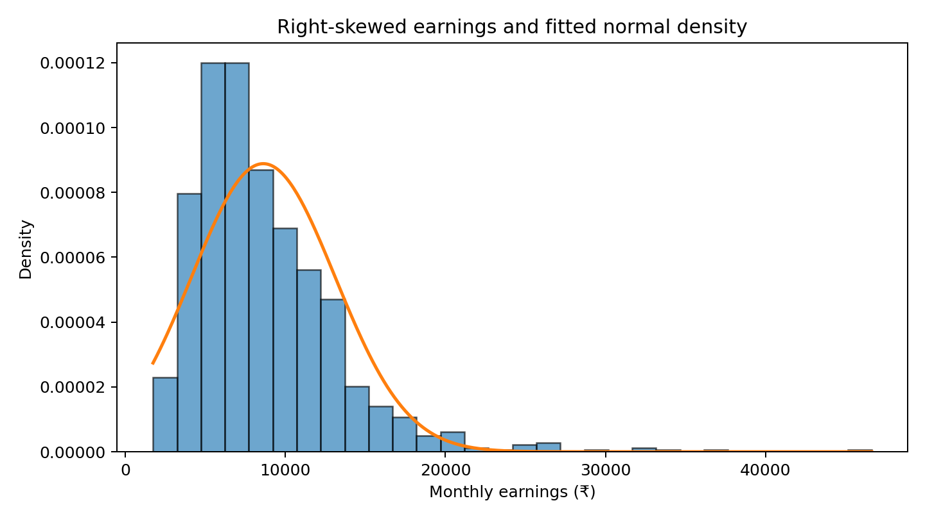
Figure A3. Histogram and fitted normal density; the mismatch reflects the earnings distribution's right tail.
The fitted normal curve is a comparison, not a claim that earnings are normally distributed. The Jarque–Bera test in the original report rejects normality at conventional levels (report the result as p < 0.001 rather than p = 0).

5. Probability Distribution Analysis
Monthly earnings are compared with a fitted normal distribution using the sample mean (₹8,620.48) and standard deviation (₹4,499.14). A conceptual limitation is that earnings are non-negative, while the normal distribution extends over the entire real line.
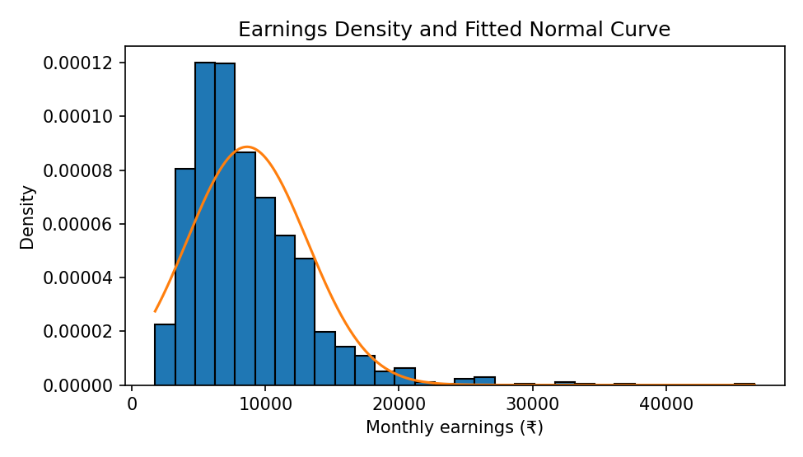
Figure 3. Empirical earnings density and fitted normal curve (simulated data).
The Jarque–Bera test statistic is 4567.36, with p-value <0.001. The null hypothesis is that the data have the skewness and kurtosis expected under normality. A small p-value is evidence against normality. This test should be interpreted alongside graphs and substantive reasoning; it is not a substitute for checking whether the distribution is appropriate.
Do not fit every theoretical distribution to every variable. A binomial model requires a suitable fixed number of trials, a Poisson model is for suitable count data, and an exponential model is for appropriate non-negative waiting times. If no theoretical distribution is defensible, explain why and describe the empirical distribution.

5.1 Data-based probability and conditional probability
Define H as monthly earnings above ₹10,000 and U as living in an urban area. In the analytical sample, P(H) = 0.298, P(U) = 0.595, and P(H|U) = 0.335. Conditional probability is the proportion satisfying H among observations in U; its denominator is the urban subgroup, not the full sample.
Residence | Earnings ≤ ₹10,000 | Earnings > ₹10,000 | Total
Rural | 362 | 116 | 478
Urban | 466 | 235 | 701
Total | 828 | 351 | 1179

Bayes' theorem reverses the conditioning: P(U|H) = P(H|U)P(U)/P(H). Here, P(U|H) = 0.670. In words, about 67.0% of observations with earnings above ₹10,000 are urban. This is a descriptive association in simulated data and is not a causal claim.
Check using joint probability: P(U∩H) = 0.199; dividing by P(H) = 0.298 gives P(U|H) = 0.670.

5.2 Random variable, expected value and variance
Let X be the number of workers earning more than ₹10,000 in a randomly selected group of five workers. For an illustrative binomial model, assume each selection is independent and the probability of high earnings is the empirical estimate p = 0.298. Then X ~ Binomial(n = 5, p = 0.298).
The expected value is E(X) = np = 1.489; the variance is Var(X) = np(1−p) = 1.045. The probability of exactly two high earners is P(X=2) = C(5,2)p²(1−p)³ = 0.307. These are model-based calculations; independence and a stable p are assumptions.

5.3 Binomial distribution and normal approximation
For n = 100 independent selections and p = 0.298, the binomial mean is np = 29.77 and standard deviation is √[np(1−p)] = 4.57. The exact binomial probability of at least 35 high earners is 0.1507. Using a continuity correction, P(X ≥ 35) ≈ P(Y > 34.5), where Y is normal with the same mean and variance; the approximation is 0.1505. The approximation is useful when np and n(1−p) are sufficiently large; the continuity correction improves the approximation for discrete counts.

5.4 Poisson distribution illustration
The dataset's observed proportion with earnings above ₹25,000 is 0.0093. For a hypothetical group of 50 workers, the expected count is λ = np = 0.466. If the event is rare and selections are approximately independent, a Poisson model can approximate the number of such workers. Under Poisson(λ = 0.466), P(X=0) = 0.627, P(X=1) = 0.293, and P(X=2) = 0.068. This is an illustration of a rare-event count model, not proof that the observed earnings variable itself follows a Poisson distribution.

5.5 Normal distribution and standard normal (Z) distribution
If earnings were normally distributed with fitted mean μ = ₹8,619.59 and standard deviation σ = ₹4,489.39, the standard score for ₹10,000 would be z = (10,000−μ)/σ = 0.307. The fitted-normal probability P(X < ₹10,000) would be Φ(0.307) = 0.621, compared with the empirical proportion 0.702. For ₹15,000, z = 1.421; the fitted-normal P(X > ₹15,000) is 0.078, compared with the empirical proportion 0.070. The differences illustrate why the normal fit should be interpreted cautiously for right-skewed earnings.
The standard normal variable is Z = (X−μ)/σ, with mean 0 and variance 1. Z-scores express values in standard-deviation units. A Z table or standard normal CDF is used to obtain probabilities; the relevant tail must match the question (left tail, right tail or between two values).

5.6 Exponential distribution illustration
The exponential distribution is suitable for non-negative waiting times when events occur at a constant average rate and the waiting-time process has the memoryless property. As a separate worked illustration—not a fitted result from this dataset—suppose the mean waiting time between events is 6 months. Then λ = 1/6 per month, P(T > 12) = exp(−λ×12) = 0.135, and P(T < 3) = 1−exp(−λ×3) = 0.393. State the assumed rate and units whenever using this model.

6. Correlation Analysis
Pearson correlations describe pairwise linear association; they do not establish causation.
Variable | Earnings | Experience | Weekly hours | Education years | Age
Earnings | 1.000 | 0.391 | -0.012 | 0.385 | 0.411
Experience | 0.391 | 1.000 | 0.017 | -0.047 | 0.803
Weekly hours | -0.012 | 0.017 | 1.000 | -0.056 | -0.004
Education years | 0.385 | -0.047 | -0.056 | 1.000 | 0.189
Age | 0.411 | 0.803 | -0.004 | 0.189 | 1.000

The Pearson correlation between earnings and experience is 0.391; between earnings and years of education it is 0.385. The sign indicates direction and the magnitude indicates strength of linear association. Scatter plots and potential outliers should be considered.
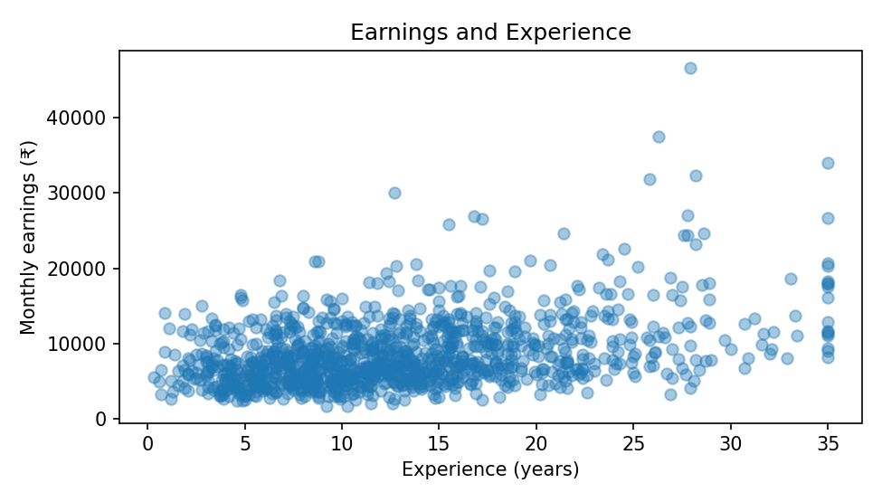
Figure 4. Monthly earnings and work experience (simulated data).

7. Simple Linear Regression
The dependent variable is monthly earnings and the explanatory variable is work experience. The model is Earningsᵢ = β₀ + β₁ Experienceᵢ + εᵢ.
Statistic | Estimate
Intercept | 5,451.45
Experience coefficient | 245.72
Standard error | 16.86
95% CI for experience | [212.64, 278.81]
p-value | 2.408e-44
R-squared | 0.153
Observations | 1179

The estimated slope is 245.72. In this simple model, one additional year of experience is associated with an estimated ₹245.72 difference in monthly earnings. This is an association, not a causal effect. The R-squared of 0.153 indicates the proportion of sample variation accounted for by the fitted linear relationship.
The intercept is the predicted value at zero experience and may not have substantive meaning if that point is uncommon or outside the useful range of the model.
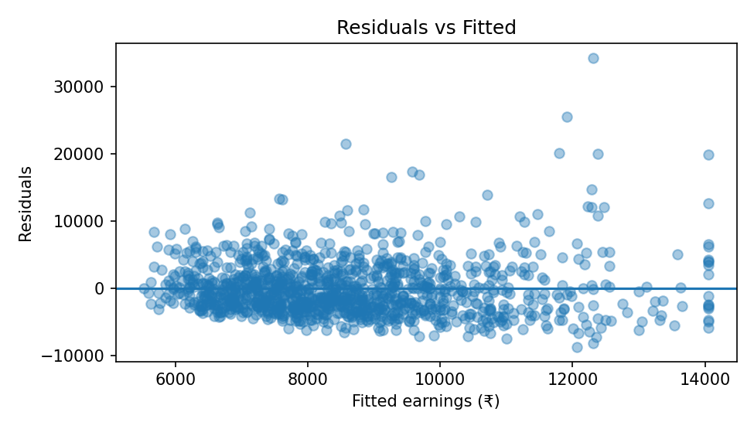
Figure 5. Residuals versus fitted values for the simple regression. Residual patterns can indicate non-linearity or changing variance; this plot does not assess every model assumption.

8. Multiple Linear Regression
The multiple regression includes years of education, experience, weekly working hours, gender and residence. Male and Rural are reference categories for the indicator variables.
Model: Earningsᵢ = β₀ + β₁ Educationᵢ + β₂ Experienceᵢ + β₃ Hoursᵢ + β₄ Femaleᵢ + β₅ Urbanᵢ + εᵢ.
Variable | Coefficient | SE | 95% CI lower | 95% CI upper | p-value
Intercept | -2,483.11 | 865.64 | -4,181.49 | -784.74 | 0.004198
Education years | 656.95 | 37.41 | 583.54 | 730.35 | 1.85e-61
Experience | 253.92 | 14.79 | 224.89 | 282.94 | 4.367e-59
Weekly hours | -6.14 | 13.75 | -33.12 | 20.85 | 0.6555
Female vs Male | -1,582.47 | 212.47 | -1,999.34 | -1,165.60 | 1.833e-13
Urban vs Rural | 784.22 | 215.35 | 361.71 | 1,206.73 | 0.0002827

Model statistic | Value
Observations | 1179
R-squared | 0.353
Adjusted R-squared | 0.350
F-statistic | 128.03
Overall model p-value | 2.65e-108

Holding the other included variables constant, the estimated coefficient for each additional year of education is ₹656.95; the estimated experience coefficient is ₹253.92 per year. The female indicator compares women with men, and the urban indicator compares urban with rural observations, conditional on the included covariates.
The adjusted R-squared is 0.350. R-squared typically cannot fall when predictors are added, so compare models thoughtfully. Coefficients are conditional associations; omitted variables, measurement error, selection and model misspecification may affect estimates. Causal interpretation requires a defensible research design.

8.1 Least squares, fitted values and residuals
Ordinary least squares (OLS) chooses coefficients to minimise the sum of squared residuals: Σ(yᵢ−ŷᵢ)². For each observation, the fitted value is ŷᵢ = b₀+b₁xᵢ in simple regression; the residual is eᵢ = yᵢ−ŷᵢ. A residual is the observed-minus-predicted difference, not a value selected in advance.
For the simple model, the estimated equation is ŷ = 5451.45 + 245.72×Experience. At 10 years of experience, the fitted monthly earnings are ₹7,908.66. This is a fitted conditional mean, not a guarantee of an individual's earnings. Avoid predictions far outside the observed experience range.

8.2 Simple versus multiple regression
The simple model describes the bivariate association between earnings and experience. The multiple model estimates the experience association conditional on education, working hours, gender and residence. Coefficients can change when additional covariates are included because the models answer different questions.
Model | Predictors | N | R² | Adjusted R² | Experience coefficient | Overall model test
Simple OLS | Experience | 1179 | 0.153 | 0.152 | ₹245.72 | F=212.34, p=2.41e-44
Multiple OLS | Education years, experience, weekly hours, female, urban | 1179 | 0.353 | 0.350 | ₹253.92 | F=128.03, p=2.65e-108

The multiple-regression experience coefficient is interpreted holding the other included variables constant. R² should not be compared without noting that the multiple model has more predictors; adjusted R² accounts for model size to a degree.

9. Hypothesis testing: an applied example
A hypothesis test begins by stating H₀ and H₁, choosing a significance level (for example α = 0.05), selecting a statistic appropriate to the design and assumptions, and comparing the p-value with α. A p-value is not the probability that H₀ is true.
Example: compare mean monthly earnings for male and female observations using Welch's two-sample t-test, which does not assume equal population variances.
H₀: μ_{Male} = μ_{Female} against H₁: μ_{Male} ≠ μ_{Female}.
The test is two-sided with α = 0.05.
The male mean is ₹9,343.43 (n=573); the female mean is ₹7,936.90 (n=606). Welch's t statistic is 5.376, with approximately 1009.2 degrees of freedom, and p = 9.47e-08. Since p < 0.05, reject H₀ for this simulated sample. The estimated mean difference is ₹1,406.53. This does not establish that gender causes the difference; confounding variables and the simulated nature of the data must be acknowledged.

9.1 Hypothesis tests in regression
For the simple regression slope, test H₀: β₁ = 0 against H₁: β₁ ≠ 0. The estimated slope is tested using t = estimated coefficient / standard error. A small p-value provides evidence of a linear association in the population represented by the model, subject to model assumptions; it does not prove causality.
In the simple model, the experience slope is 245.72, its standard error is 16.86, t = 14.57, p = 2.41e-44, and R² = 0.153. The overall model F-test evaluates whether the explanatory coefficients are jointly zero. For the multiple model, F = 128.03 with p = 2.65e-108; the null that all five slope coefficients are zero is rejected at α = 0.05.

10. Discussion and Conclusion
This example demonstrates a workflow from data description to regression modelling. Frequency tables describe sample composition; descriptive measures and graphs summarise location, variability and shape; distribution analysis compares empirical patterns with a theoretical model; correlation summarises pairwise association; and regression examines conditional linear relationships.
All data and numerical findings are simulated and must not be interpreted as evidence about an actual labour market. A real student report must answer its own research questions using a documented real dataset, acknowledge uncertainty, explain limitations and avoid unsupported causal claims.

References and Data Source
.
.
.

Appendix
.
.
.

