**Open Search Setup Documentation**

Connecting to Opensearch dashboard

Open OpenSearch Domain dashboard in your favorite browser (link may be vary if we re-create domain)

<https://search-electrolite-search-cxzzzftfs5hphfe5akdgpn7mui.ap-south-1.es.amazonaws.com/_dashboards/app/home#/>

UserName: admin

Password: --- (check in aws secret manager for OpenSearchAdminPwd)

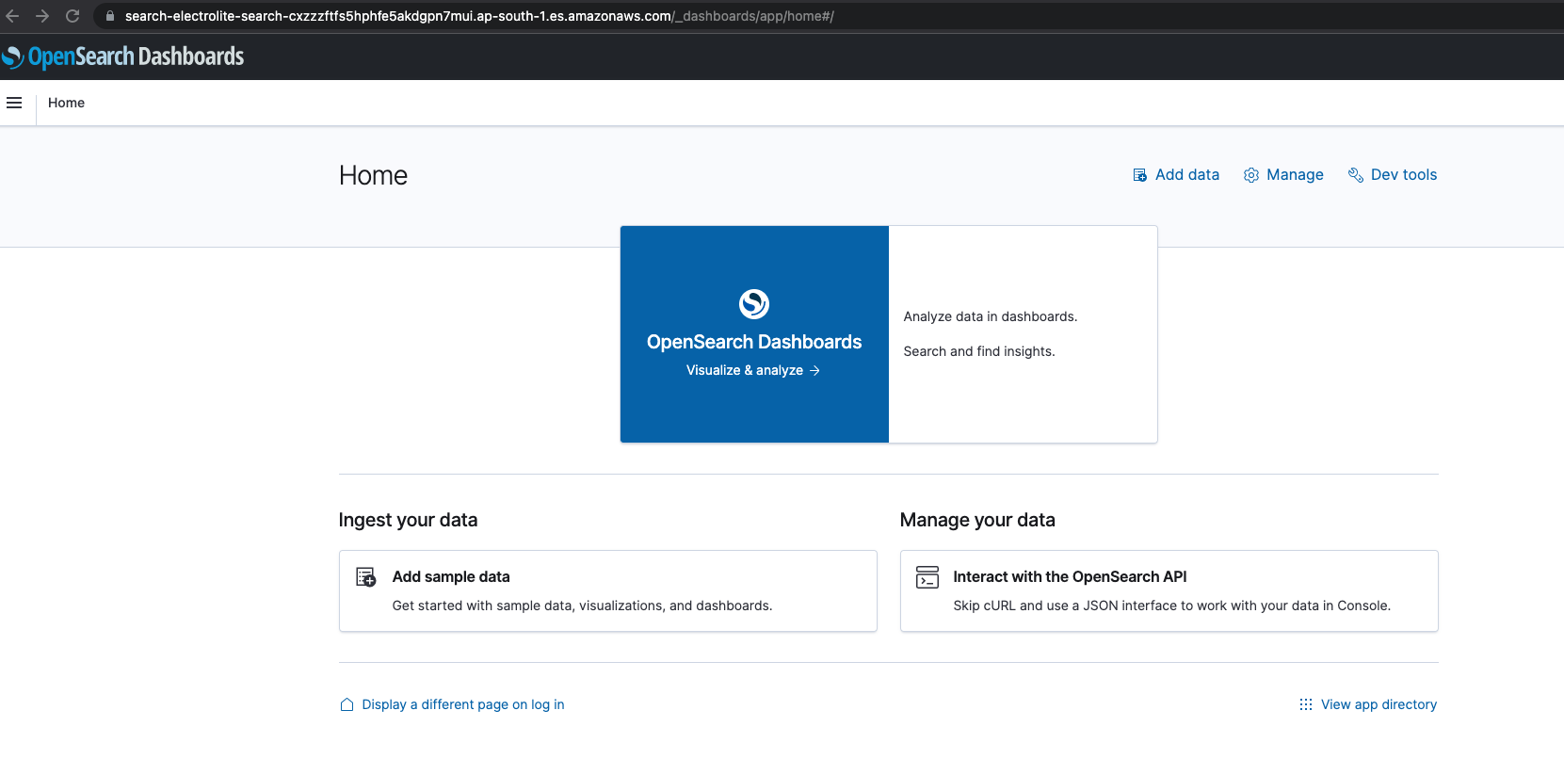

Go to DevTool from Left Menu

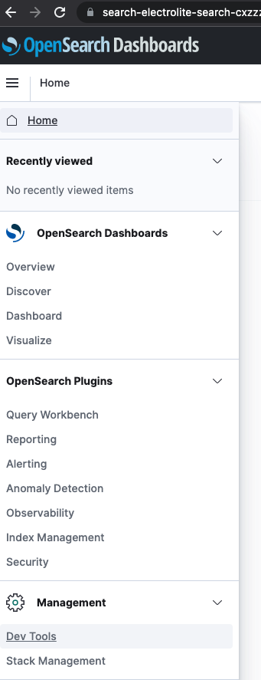

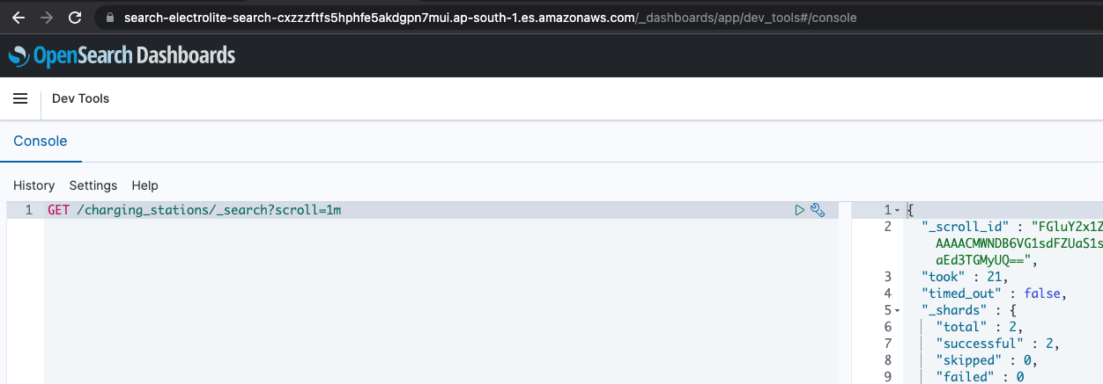

Creating Index

PUT /charging_stations/

{

"settings": {

"index": {

"number_of_shards": 2,

"number_of_replicas": 2

}

},

"mappings": {

"properties": {

"name": {

"type": "text"

},

"address_line": {

"type": "text"

},

"state": {

"type": "text"

},

"town": {

"type": "text"

},

"country": {

"type": "text"

},

"postal_code": {

"type": "text"

},

"geo_address": {

"type": "geo_point"

},

"is_ocpp": {

"type": "boolean"

},

"rating.avg_rating": {

"type": "float"

},

"station_status": {

"type": "text"

},

"available_chargers.charger_point_type": {

"type": "text"

},

"available_chargers.power_capacity": {

"type": "text"

},

"available_chargers.connectors.status": {

"type": "integer"

}

}

},

"aliases": {

"sample-alias1": {}

}

}

Respnse:

{

"acknowledged" : true,

"shards_acknowledged" : true,

"index" : "charging_stations"

}

Get Index Information

GET /charging_stations/

Response:

{

"charging_stations" : {

"aliases" : {

"sample-alias1" : { }

},

"mappings" : {

"properties" : {

"address_line" : {

"type" : "text"

},

"available_chargers" : {

"properties" : {

"charger_point_type" : {

"type" : "text"

},

"connectors" : {

"properties" : {

"status" : {

"type" : "integer"

}

}

},

"power_capacity" : {

"type" : "text"

}

}

},

"country" : {

"type" : "text"

},

"geo_address" : {

"type" : "geo_point"

},

"is_ocpp" : {

"type" : "boolean"

},

"name" : {

"type" : "text"

},

"postal_code" : {

"type" : "text"

},

"rating" : {

"properties" : {

"avg_rating" : {

"type" : "float"

}

}

},

"state" : {

"type" : "text"

},

"station_status" : {

"type" : "text"

},

"town" : {

"type" : "text"

}

}

},

"settings" : {

"index" : {

"creation_date" : "1661954893916",

"number_of_shards" : "2",

"number_of_replicas" : "2",

"uuid" : "6mv-j8ctRTup6SPt50g4SQ",

"version" : {

"created" : "136237827"

},

"provided_name" : "charging_stations"

}

}

}

}

Indexing Document

POST /charging_stations/_doc

{

"station_id": "10",

"vendor_id": "chargemod",

"address_line": "Bangalore, Varthur Rd Vill Sidapur",

"available_chargers": [

{

"charger_point_type": "AC",

"connectors": [

{

"connector_point_id": 1,

"relay_number": 111,

"status": 1,

"tariff": 125

}

],

"id": 1,

"power_capacity": "240VAC, 15A"

}

],

"country": "india",

"distance_unit": null,

"is_ocpp": false,

"geo_address": [

12.942873468781595,

77.72697865942747

],

"name": "Harikrishna Fuel Station (Bharat Petroleum)",

"postal_code": "560087",

"qr_code": "CM-S00115-4RXJJRGTXU",

"rating": {

"1": 0,

"2": 0,

"3": 0,

"4": 0,

"5": 0,

"avg_rating": 0

},

"state": "Karnataka",

"station_status": "not_connected",

"station_time": {

"end_time": "11:59 PM",

"start_time": "12:00 AM"

},

"total_connectors_available": 0,

"town": "Bangalore"

}

Response:

{

"_index" : "charging_stations",

"_type" : "_doc",

"_id" : "ROreJoMBZrhZq16vMVmy",

"_version" : 1,

"result" : "created",

"_shards" : {

"total" : 3,

"successful" : 1,

"failed" : 0

},

"_seq_no" : 6,

"_primary_term" : 1

}

Bulk Index documents

POST /charging_stations/_bulk

{ "index":{"_index": "charging_stations" } }

{"station_id":"9","vendor_id":"chargemod","address_line":"Bangalore, Whitefield","available_chargers":[{"charger_point_type":"AC","connectors":[{"connector_point_id":1,"relay_number":111,"status":1,"tariff":125}],"id":1,"power_capacity":"240VAC, 15A"}],"country":"india","distance_unit":null,"is_ocpp":false,"geo_address":[12.979674351725993,77.76699899955365],"name":"Isha Misty Green","postal_code":"560067","qr_code":"CM-S00115-4RXJJRGTXU","rating":{"1":0,"2":0,"3":0,"4":0,"5":0,"avg_rating":0},"state":"Karnataka","station_status":"not_connected","station_time":{"end_time":"11:59 PM","start_time":"12:00 AM"},"total_connectors_available":0,"town":"Bangalore"}

{ "index":{"_index": "charging_stations" } }

{"station_id":"10","vendor_id":"chargemod","address_line":"Bangalore, Hoskete","available_chargers":[{"charger_point_type":"AC","connectors":[{"connector_point_id":1,"relay_number":111,"status":1,"tariff":125}],"id":1,"power_capacity":"240VAC, 15A"}],"country":"india","distance_unit":null,"is_ocpp":false,"geo_address":[12.990087064406595,77.78135038968186],"name":"MVR Service Station","postal_code":"562114","qr_code":"CM-S00115-4RXJJRGTXU","rating":{"1":0,"2":0,"3":0,"4":0,"5":0,"avg_rating":0},"state":"Karnataka","station_status":"not_connected","station_time":{"end_time":"11:59 PM","start_time":"12:00 AM"},"total_connectors_available":0,"town":"Bangalore"}

{ "index":{"_index": "charging_stations" } }

{"station_id":"3","vendor_id":"chargemod","address_line":"Bangalore, Samethanahalli","available_chargers":[{"charger_point_type":"AC","connectors":[{"connector_point_id":1,"relay_number":111,"status":1,"tariff":125}],"id":1,"power_capacity":"240VAC, 15A"}],"country":"india","distance_unit":null,"is_ocpp":false,"geo_address":[12.987159850469807,77.78109289762105],"name":"Hindustan Petroleum Corporation Limited","postal_code":"560067","qr_code":"CM-S00115-4RXJJRGTXU","rating":{"1":0,"2":0,"3":0,"4":0,"5":0,"avg_rating":0},"state":"Karnataka","station_status":"not_connected","station_time":{"end_time":"11:59 PM","start_time":"12:00 AM"},"total_connectors_available":0,"town":"Bangalore"}

{ "index":{"_index": "charging_stations" } }

{"station_id":"4","vendor_id":"chargemod","address_line":"Bangalore, Channasandra Main road","available_chargers":[{"charger_point_type":"AC","connectors":[{"connector_point_id":1,"relay_number":111,"status":1,"tariff":125}],"id":1,"power_capacity":"240VAC, 15A"}],"country":"india","distance_unit":null,"is_ocpp":false,"geo_address":[12.985278051867823,77.773668543201],"name":"Bharat Petroleum Corporation ltd","postal_code":"560067","qr_code":"CM-S00115-4RXJJRGTXU","rating":{"1":0,"2":0,"3":0,"4":0,"5":0,"avg_rating":0},"state":"Karnataka","station_status":"not_connected","station_time":{"end_time":"11:59 PM","start_time":"12:00 AM"},"total_connectors_available":0,"town":"Bangalore"}

{ "index":{"_index": "charging_stations" } }

{"station_id":"5","vendor_id":"chargemod","address_line":"Bangalore, Kadugudi","available_chargers":[{"charger_point_type":"AC","connectors":[{"connector_point_id":1,"relay_number":111,"status":1,"tariff":125}],"id":1,"power_capacity":"240VAC, 15A"}],"country":"india","distance_unit":null,"is_ocpp":false,"geo_address":[12.997125078426626,77.76815593210857],"name":"Manva Gas Agency","postal_code":"560067","qr_code":"CM-S00115-4RXJJRGTXU","rating":{"1":0,"2":0,"3":0,"4":0,"5":0,"avg_rating":0},"state":"Karnataka","station_status":"not_connected","station_time":{"end_time":"11:59 PM","start_time":"12:00 AM"},"total_connectors_available":0,"town":"Bangalore"}

{ "index":{"_index": "charging_stations" } }

{"station_id":"6","vendor_id":"chargemod","address_line":"Bangalore, Nagondanahalli","available_chargers":[{"charger_point_type":"AC","connectors":[{"connector_point_id":1,"relay_number":111,"status":1,"tariff":125}],"id":1,"power_capacity":"240VAC, 15A"}],"country":"india","distance_unit":null,"is_ocpp":false,"geo_address":[12.997125078426626,77.76815593210857],"name":"Hindustan Petroleum Corporation Limited","postal_code":"560066","qr_code":"CM-S00115-4RXJJRGTXU","rating":{"1":0,"2":0,"3":0,"4":0,"5":0,"avg_rating":0},"state":"Karnataka","station_status":"not_connected","station_time":{"end_time":"11:59 PM","start_time":"12:00 AM"},"total_connectors_available":0,"town":"Bangalore"}

{ "index":{"_index": "charging_stations" } }

{"station_id":"7","vendor_id":"chargemod","address_line":"Bangalore, Hagadur Main road","available_chargers":[{"charger_point_type":"AC","connectors":[{"connector_point_id":1,"relay_number":111,"status":1,"tariff":125}],"id":1,"power_capacity":"240VAC, 15A"}],"country":"india","distance_unit":null,"is_ocpp":false,"geo_address":[12.965042362727385,77.75298267571591],"name":"Indian Oil Petrol Station (PKV FILLING STATION)","postal_code":"560066","qr_code":"CM-S00115-4RXJJRGTXU","rating":{"1":0,"2":0,"3":0,"4":0,"5":0,"avg_rating":0},"state":"Karnataka","station_status":"not_connected","station_time":{"end_time":"11:59 PM","start_time":"12:00 AM"},"total_connectors_available":0,"town":"Bangalore"}

{ "index":{"_index": "charging_stations" } }

{"station_id":"8","vendor_id":"chargemod","address_line":"Bangalore, Nallurahalli Main road","available_chargers":[{"charger_point_type":"AC","connectors":[{"connector_point_id":1,"relay_number":111,"status":1,"tariff":125}],"id":1,"power_capacity":"240VAC, 15A"}],"country":"india","distance_unit":null,"is_ocpp":false,"geo_address":[12.968636355467007,77.73401677575632],"name":"HP Fuel Station","postal_code":"560066","qr_code":"CM-S00115-4RXJJRGTXU","rating":{"1":0,"2":0,"3":0,"4":0,"5":0,"avg_rating":0},"state":"Karnataka","station_status":"not_connected","station_time":{"end_time":"11:59 PM","start_time":"12:00 AM"},"total_connectors_available":0,"town":"Bangalore"}

Get All Indexed documents

**GET /charging_stations/_search**

**Response:**

{

"took" : 646,

"timed_out" : false,

"_shards" : {

"total" : 2,

"successful" : 2,

"skipped" : 0,

"failed" : 0

},

"hits" : {

"total" : {

"value" : 10,

"relation" : "eq"

},

"max_score" : 1.0,

"hits" : [

{

"_index" : "charging_stations",

"_id" : "i8FO9IIBeAEXGAvyWmFP",

"_score" : 1.0,

"_source" : {

"station_id" : "3",

"vendor_id" : "chargemod",

"address_line" : "Bangalore, Samethanahalli",

"available_chargers" : [

{

"charger_point_type" : "AC",

"connectors" : [

{

"connector_point_id" : 1,

"relay_number" : 111,

"status" : 1,

"tariff" : 125

}

],

"id" : 1,

"power_capacity" : "240VAC, 15A"

}

],

"country" : "india",

"distance_unit" : null,

"is_ocpp" : false,

"geo_address" : [

12.987159850469807,

77.78109289762105

],

"name" : "Hindustan Petroleum Corporation Limited",

"postal_code" : "560067",

"qr_code" : "CM-S00115-4RXJJRGTXU",

"rating" : {

"1" : 0,

"2" : 0,

"3" : 0,

"4" : 0,

"5" : 0,

"avg_rating" : 0

},

"state" : "Karnataka",

"station_status" : "not_connected",

"station_time" : {

"end_time" : "11:59 PM",

"start_time" : "12:00 AM"

},

"total_connectors_available" : 0,

"town" : "Bangalore"

}

},

{

"_index" : "charging_stations",

"_id" : "m8FP9IIBeAEXGAvyXmEN",

"_score" : 1.0,

"_source" : {

"station_id" : "7",

"vendor_id" : "chargemod",

"address_line" : "Bangalore, Hagadur Main road",

"available_chargers" : [

{

"charger_point_type" : "AC",

"connectors" : [

{

"connector_point_id" : 1,

"relay_number" : 111,

"status" : 1,

"tariff" : 125

}

],

"id" : 1,

"power_capacity" : "240VAC, 15A"

}

],

"country" : "india",

"distance_unit" : null,

"is_ocpp" : false,

"geo_address" : [

12.965042362727385,

77.75298267571591

],

"name" : "Indian Oil Petrol Station (PKV FILLING STATION)",

"postal_code" : "560066",

"qr_code" : "CM-S00115-4RXJJRGTXU",

"rating" : {

"1" : 0,

"2" : 0,

"3" : 0,

"4" : 0,

"5" : 0,

"avg_rating" : 0

},

"state" : "Karnataka",

"station_status" : "not_connected",

"station_time" : {

"end_time" : "11:59 PM",

"start_time" : "12:00 AM"

},

"total_connectors_available" : 0,

"town" : "Bangalore"

}

},

{

"_index" : "charging_stations",

"_id" : "n8FP9IIBeAEXGAvylWG-",

"_score" : 1.0,

"_source" : {

"station_id" : "8",

"vendor_id" : "chargemod",

"address_line" : "Bangalore, Nallurahalli Main road",

"available_chargers" : [

{

"charger_point_type" : "AC",

"connectors" : [

{

"connector_point_id" : 1,

"relay_number" : 111,

"status" : 1,

"tariff" : 125

}

],

"id" : 1,

"power_capacity" : "240VAC, 15A"

}

],

"country" : "india",

"distance_unit" : null,

"is_ocpp" : false,

"geo_address" : [

12.968636355467007,

77.73401677575632

],

"name" : "HP Fuel Station",

"postal_code" : "560066",

"qr_code" : "CM-S00115-4RXJJRGTXU",

"rating" : {

"1" : 0,

"2" : 0,

"3" : 0,

"4" : 0,

"5" : 0,

"avg_rating" : 0

},

"state" : "Karnataka",

"station_status" : "not_connected",

"station_time" : {

"end_time" : "11:59 PM",

"start_time" : "12:00 AM"

},

"total_connectors_available" : 0,

"town" : "Bangalore"

}

},

{

"_index" : "charging_stations",

"_id" : "o8FP9IIBeAEXGAvy9WEa",

"_score" : 1.0,

"_source" : {

"station_id" : "9",

"vendor_id" : "chargemod",

"address_line" : "Bangalore, Varthur Rd Vill Sidapur",

"available_chargers" : [

{

"charger_point_type" : "AC",

"connectors" : [

{

"connector_point_id" : 1,

"relay_number" : 111,

"status" : 1,

"tariff" : 125

}

],

"id" : 1,

"power_capacity" : "240VAC, 15A"

}

],

"country" : "india",

"distance_unit" : null,

"is_ocpp" : false,

"geo_address" : [

12.96010478557062,

77.73092687102658

],

"name" : "Shell",

"postal_code" : "560066",

"qr_code" : "CM-S00115-4RXJJRGTXU",

"rating" : {

"1" : 0,

"2" : 0,

"3" : 0,

"4" : 0,

"5" : 0,

"avg_rating" : 0

},

"state" : "Karnataka",

"station_status" : "not_connected",

"station_time" : {

"end_time" : "11:59 PM",

"start_time" : "12:00 AM"

},

"total_connectors_available" : 0,

"town" : "Bangalore"

}

},

{

"_index" : "charging_stations",

"_id" : "gsFN9IIBeAEXGAvyAmHz",

"_score" : 1.0,

"_source" : {

"station_id" : "1",

"vendor_id" : "chargemod",

"address_line" : "Bangalore, Whitefield",

"available_chargers" : [

{

"charger_point_type" : "AC",

"connectors" : [

{

"connector_point_id" : 1,

"relay_number" : 111,

"status" : 1,

"tariff" : 125

}

],

"id" : 1,

"power_capacity" : "240VAC, 15A"

}

],

"country" : "india",

"distance_unit" : null,

"is_ocpp" : false,

"geo_address" : [

12.979674351725993,

77.76699899955365

],

"name" : "Isha Misty Green",

"postal_code" : "560067",

"qr_code" : "CM-S00115-4RXJJRGTXU",

"rating" : {

"1" : 0,

"2" : 0,

"3" : 0,

"4" : 0,

"5" : 0,

"avg_rating" : 0

},

"state" : "Karnataka",

"station_status" : "not_connected",

"station_time" : {

"end_time" : "11:59 PM",

"start_time" : "12:00 AM"

},

"total_connectors_available" : 0,

"town" : "Bangalore"

}

},

{

"_index" : "charging_stations",

"_id" : "h8FN9IIBeAEXGAvye2Ge",

"_score" : 1.0,

"_source" : {

"station_id" : "2",

"vendor_id" : "chargemod",

"address_line" : "Bangalore, Hoskete",

"available_chargers" : [

{

"charger_point_type" : "AC",

"connectors" : [

{

"connector_point_id" : 1,

"relay_number" : 111,

"status" : 1,

"tariff" : 125

}

],

"id" : 1,

"power_capacity" : "240VAC, 15A"

}

],

"country" : "india",

"distance_unit" : null,

"is_ocpp" : false,

"geo_address" : [

12.990087064406595,

77.78135038968186

],

"name" : "MVR Service Station",

"postal_code" : "562114",

"qr_code" : "CM-S00115-4RXJJRGTXU",

"rating" : {

"1" : 0,

"2" : 0,

"3" : 0,

"4" : 0,

"5" : 0,

"avg_rating" : 0

},

"state" : "Karnataka",

"station_status" : "not_connected",

"station_time" : {

"end_time" : "11:59 PM",

"start_time" : "12:00 AM"

},

"total_connectors_available" : 0,

"town" : "Bangalore"

}

},

{

"_index" : "charging_stations",

"_id" : "j8FO9IIBeAEXGAvynGFO",

"_score" : 1.0,

"_source" : {

"station_id" : "4",

"vendor_id" : "chargemod",

"address_line" : "Bangalore, Channasandra Main road",

"available_chargers" : [

{

"charger_point_type" : "AC",

"connectors" : [

{

"connector_point_id" : 1,

"relay_number" : 111,

"status" : 1,

"tariff" : 125

}

],

"id" : 1,

"power_capacity" : "240VAC, 15A"

}

],

"country" : "india",

"distance_unit" : null,

"is_ocpp" : false,

"geo_address" : [

12.985278051867823,

77.773668543201

],

"name" : "Bharat Petroleum Corporation ltd",

"postal_code" : "560067",

"qr_code" : "CM-S00115-4RXJJRGTXU",

"rating" : {

"1" : 0,

"2" : 0,

"3" : 0,

"4" : 0,

"5" : 0,

"avg_rating" : 0

},

"state" : "Karnataka",

"station_status" : "not_connected",

"station_time" : {

"end_time" : "11:59 PM",

"start_time" : "12:00 AM"

},

"total_connectors_available" : 0,

"town" : "Bangalore"

}

},

{

"_index" : "charging_stations",

"_id" : "k8FO9IIBeAEXGAvy3GGn",

"_score" : 1.0,

"_source" : {

"station_id" : "5",

"vendor_id" : "chargemod",

"address_line" : "Bangalore, Kadugudi",

"available_chargers" : [

{

"charger_point_type" : "AC",

"connectors" : [

{

"connector_point_id" : 1,

"relay_number" : 111,

"status" : 1,

"tariff" : 125

}

],

"id" : 1,

"power_capacity" : "240VAC, 15A"

}

],

"country" : "india",

"distance_unit" : null,

"is_ocpp" : false,

"geo_address" : [

12.997125078426626,

77.76815593210857

],

"name" : "Manva Gas Agency",

"postal_code" : "560067",

"qr_code" : "CM-S00115-4RXJJRGTXU",

"rating" : {

"1" : 0,

"2" : 0,

"3" : 0,

"4" : 0,

"5" : 0,

"avg_rating" : 0

},

"state" : "Karnataka",

"station_status" : "not_connected",

"station_time" : {

"end_time" : "11:59 PM",

"start_time" : "12:00 AM"

},

"total_connectors_available" : 0,

"town" : "Bangalore"

}

},

{

"_index" : "charging_stations",

"_id" : "l8FP9IIBeAEXGAvyH2EO",

"_score" : 1.0,

"_source" : {

"station_id" : "6",

"vendor_id" : "chargemod",

"address_line" : "Bangalore, Nagondanahalli",

"available_chargers" : [

{

"charger_point_type" : "AC",

"connectors" : [

{

"connector_point_id" : 1,

"relay_number" : 111,

"status" : 1,

"tariff" : 125

}

],

"id" : 1,

"power_capacity" : "240VAC, 15A"

}

],

"country" : "india",

"distance_unit" : null,

"is_ocpp" : false,

"geo_address" : [

12.997125078426626,

77.76815593210857

],

"name" : "Hindustan Petroleum Corporation Limited",

"postal_code" : "560066",

"qr_code" : "CM-S00115-4RXJJRGTXU",

"rating" : {

"1" : 0,

"2" : 0,

"3" : 0,

"4" : 0,

"5" : 0,

"avg_rating" : 0

},

"state" : "Karnataka",

"station_status" : "not_connected",

"station_time" : {

"end_time" : "11:59 PM",

"start_time" : "12:00 AM"

},

"total_connectors_available" : 0,

"town" : "Bangalore"

}

},

{

"_index" : "charging_stations",

"_id" : "p8FQ9IIBeAEXGAvyOWHD",

"_score" : 1.0,

"_source" : {

"station_id" : "10",

"vendor_id" : "chargemod",

"address_line" : "Bangalore, Varthur Rd Vill Sidapur",

"available_chargers" : [

{

"charger_point_type" : "AC",

"connectors" : [

{

"connector_point_id" : 1,

"relay_number" : 111,

"status" : 1,

"tariff" : 125

}

],

"id" : 1,

"power_capacity" : "240VAC, 15A"

}

],

"country" : "india",

"distance_unit" : null,

"is_ocpp" : false,

"geo_address" : [

12.942873468781595,

77.72697865942747

],

"name" : "Harikrishna Fuel Station (Bharat Petroleum)",

"postal_code" : "560087",

"qr_code" : "CM-S00115-4RXJJRGTXU",

"rating" : {

"1" : 0,

"2" : 0,

"3" : 0,

"4" : 0,

"5" : 0,

"avg_rating" : 0

},

"state" : "Karnataka",

"station_status" : "not_connected",

"station_time" : {

"end_time" : "11:59 PM",

"start_time" : "12:00 AM"

},

"total_connectors_available" : 0,

"town" : "Bangalore"

}

}

]

}

}

Query Indexed document with pagination

**POST /charging_stations/_search?scroll=1m**

{

"size": 2,

"query": {

"match_all": {}

}

}

**Response:**

{

"_scroll_id" : "FGluY2x1ZGVfY29udGV4dF91dWlkDnF1ZXJ5VGhlbkZldGNoAhZiSjNlNFZ3MFNLU3l0X1RoWS1OVVdRAAAAAAAAABMWM2E2TW93T3BSZG12ZjRpdWtvVERtdxZiSjNlNFZ3MFNLU3l0X1RoWS1OVVdRAAAAAAAAABQWM2E2TW93T3BSZG12ZjRpdWtvVERtdw==",

"took" : 9,

"timed_out" : false,

"_shards" : {

"total" : 2,

"successful" : 2,

"skipped" : 0,

"failed" : 0

},

"hits" : {

"total" : {

"value" : 10,

"relation" : "eq"

},

"max_score" : 1.0,

"hits" : [

{

"_index" : "charging_stations",

"_id" : "i8FO9IIBeAEXGAvyWmFP",

"_score" : 1.0,

"_source" : {

"station_id" : "3",

"vendor_id" : "chargemod",

"address_line" : "Bangalore, Samethanahalli",

"available_chargers" : [

{

"charger_point_type" : "AC",

"connectors" : [

{

"connector_point_id" : 1,

"relay_number" : 111,

"status" : 1,

"tariff" : 125

}

],

"id" : 1,

"power_capacity" : "240VAC, 15A"

}

],

"country" : "india",

"distance_unit" : null,

"is_ocpp" : false,

"geo_address" : [

12.987159850469807,

77.78109289762105

],

"name" : "Hindustan Petroleum Corporation Limited",

"postal_code" : "560067",

"qr_code" : "CM-S00115-4RXJJRGTXU",

"rating" : {

"1" : 0,

"2" : 0,

"3" : 0,

"4" : 0,

"5" : 0,

"avg_rating" : 0

},

"state" : "Karnataka",

"station_status" : "not_connected",

"station_time" : {

"end_time" : "11:59 PM",

"start_time" : "12:00 AM"

},

"total_connectors_available" : 0,

"town" : "Bangalore"

}

},

{

"_index" : "charging_stations",

"_id" : "m8FP9IIBeAEXGAvyXmEN",

"_score" : 1.0,

"_source" : {

"station_id" : "7",

"vendor_id" : "chargemod",

"address_line" : "Bangalore, Hagadur Main road",

"available_chargers" : [

{

"charger_point_type" : "AC",

"connectors" : [

{

"connector_point_id" : 1,

"relay_number" : 111,

"status" : 1,

"tariff" : 125

}

],

"id" : 1,

"power_capacity" : "240VAC, 15A"

}

],

"country" : "india",

"distance_unit" : null,

"is_ocpp" : false,

"geo_address" : [

12.965042362727385,

77.75298267571591

],

"name" : "Indian Oil Petrol Station (PKV FILLING STATION)",

"postal_code" : "560066",

"qr_code" : "CM-S00115-4RXJJRGTXU",

"rating" : {

"1" : 0,

"2" : 0,

"3" : 0,

"4" : 0,

"5" : 0,

"avg_rating" : 0

},

"state" : "Karnataka",

"station_status" : "not_connected",

"station_time" : {

"end_time" : "11:59 PM",

"start_time" : "12:00 AM"

},

"total_connectors_available" : 0,

"town" : "Bangalore"

}

}

]

}

}

Filter Indexed Documents

**GET /charging_stations/_search?scroll=1m**

{

"size": 100,

"query": {

"match": {

"name": {

"query": "Hindustan Petroleum Corporation Limited",

"fuzziness": "AUTO",

"analyzer": "standard"

}

}

}

}

**Response:**

{

"_scroll_id" : "FGluY2x1ZGVfY29udGV4dF91dWlkDnF1ZXJ5VGhlbkZldGNoAhZiSjNlNFZ3MFNLU3l0X1RoWS1OVVdRAAAAAAAAABcWM2E2TW93T3BSZG12ZjRpdWtvVERtdxZiSjNlNFZ3MFNLU3l0X1RoWS1OVVdRAAAAAAAAABgWM2E2TW93T3BSZG12ZjRpdWtvVERtdw==",

"took" : 169,

"timed_out" : false,

"_shards" : {

"total" : 2,

"successful" : 2,

"skipped" : 0,

"failed" : 0

},

"hits" : {

"total" : {

"value" : 4,

"relation" : "eq"

},

"max_score" : 4.688036,

"hits" : [

{

"_index" : "charging_stations",

"_id" : "i8FO9IIBeAEXGAvyWmFP",

"_score" : 4.688036,

"_source" : {

"station_id" : "3",

"vendor_id" : "chargemod",

"address_line" : "Bangalore, Samethanahalli",

"available_chargers" : [

{

"charger_point_type" : "AC",

"connectors" : [

{

"connector_point_id" : 1,

"relay_number" : 111,

"status" : 1,

"tariff" : 125

}

],

"id" : 1,

"power_capacity" : "240VAC, 15A"

}

],

"country" : "india",

"distance_unit" : null,

"is_ocpp" : false,

"geo_address" : [

12.987159850469807,

77.78109289762105

],

"name" : "Hindustan Petroleum Corporation Limited",

"postal_code" : "560067",

"qr_code" : "CM-S00115-4RXJJRGTXU",

"rating" : {

"1" : 0,

"2" : 0,

"3" : 0,

"4" : 0,

"5" : 0,

"avg_rating" : 0

},

"state" : "Karnataka",

"station_status" : "not_connected",

"station_time" : {

"end_time" : "11:59 PM",

"start_time" : "12:00 AM"

},

"total_connectors_available" : 0,

"town" : "Bangalore"

}

},

{

"_index" : "charging_stations",

"_id" : "l8FP9IIBeAEXGAvyH2EO",

"_score" : 4.631414,

"_source" : {

"station_id" : "6",

"vendor_id" : "chargemod",

"address_line" : "Bangalore, Nagondanahalli",

"available_chargers" : [

{

"charger_point_type" : "AC",

"connectors" : [

{

"connector_point_id" : 1,

"relay_number" : 111,

"status" : 1,

"tariff" : 125

}

],

"id" : 1,

"power_capacity" : "240VAC, 15A"

}

],

"country" : "india",

"distance_unit" : null,

"is_ocpp" : false,

"geo_address" : [

12.997125078426626,

77.76815593210857

],

"name" : "Hindustan Petroleum Corporation Limited",

"postal_code" : "560066",

"qr_code" : "CM-S00115-4RXJJRGTXU",

"rating" : {

"1" : 0,

"2" : 0,

"3" : 0,

"4" : 0,

"5" : 0,

"avg_rating" : 0

},

"state" : "Karnataka",

"station_status" : "not_connected",

"station_time" : {

"end_time" : "11:59 PM",

"start_time" : "12:00 AM"

},

"total_connectors_available" : 0,

"town" : "Bangalore"

}

},

{

"_index" : "charging_stations",

"_id" : "j8FO9IIBeAEXGAvynGFO",

"_score" : 1.6609943,

"_source" : {

"station_id" : "4",

"vendor_id" : "chargemod",

"address_line" : "Bangalore, Channasandra Main road",

"available_chargers" : [

{

"charger_point_type" : "AC",

"connectors" : [

{

"connector_point_id" : 1,

"relay_number" : 111,

"status" : 1,

"tariff" : 125

}

],

"id" : 1,

"power_capacity" : "240VAC, 15A"

}

],

"country" : "india",

"distance_unit" : null,

"is_ocpp" : false,

"geo_address" : [

12.985278051867823,

77.773668543201

],

"name" : "Bharat Petroleum Corporation ltd",

"postal_code" : "560067",

"qr_code" : "CM-S00115-4RXJJRGTXU",

"rating" : {

"1" : 0,

"2" : 0,

"3" : 0,

"4" : 0,

"5" : 0,

"avg_rating" : 0

},

"state" : "Karnataka",

"station_status" : "not_connected",

"station_time" : {

"end_time" : "11:59 PM",

"start_time" : "12:00 AM"

},

"total_connectors_available" : 0,

"town" : "Bangalore"

}

},

{

"_index" : "charging_stations",

"_id" : "p8FQ9IIBeAEXGAvyOWHD",

"_score" : 0.60338706,

"_source" : {

"station_id" : "10",

"vendor_id" : "chargemod",

"address_line" : "Bangalore, Varthur Rd Vill Sidapur",

"available_chargers" : [

{

"charger_point_type" : "AC",

"connectors" : [

{

"connector_point_id" : 1,

"relay_number" : 111,

"status" : 1,

"tariff" : 125

}

],

"id" : 1,

"power_capacity" : "240VAC, 15A"

}

],

"country" : "india",

"distance_unit" : null,

"is_ocpp" : false,

"geo_address" : [

12.942873468781595,

77.72697865942747

],

"name" : "Harikrishna Fuel Station (Bharat Petroleum)",

"postal_code" : "560087",

"qr_code" : "CM-S00115-4RXJJRGTXU",

"rating" : {

"1" : 0,

"2" : 0,

"3" : 0,

"4" : 0,

"5" : 0,

"avg_rating" : 0

},

"state" : "Karnataka",

"station_status" : "not_connected",

"station_time" : {

"end_time" : "11:59 PM",

"start_time" : "12:00 AM"

},

"total_connectors_available" : 0,

"town" : "Bangalore"

}

}

]

}

}